Answers

1. Scatter Plot is the best visual to show how discount varies with price range.

A scatter plot allows us to:
1.See whether higher prices tend to receive higher or lower discounts
2.Detect clusters, outliers, and trends
3.Add a trend line to show correlation
4.Spot non-linear patterns

Why the other charts are NOT ideal
--Histogram--
Used for one variable, not relationships.
It shows distribution of prices or discounts individually, not their relationship.

--Line Chart--
Used for time-series or ordered sequences.
Price is not a “sequence”, so using a line is misleading and visually incorrect.

--Heatmap--
Works best when you have two categorical / binned variables or matrix data.
For continuous vs continuous, you would need to bin both variables first
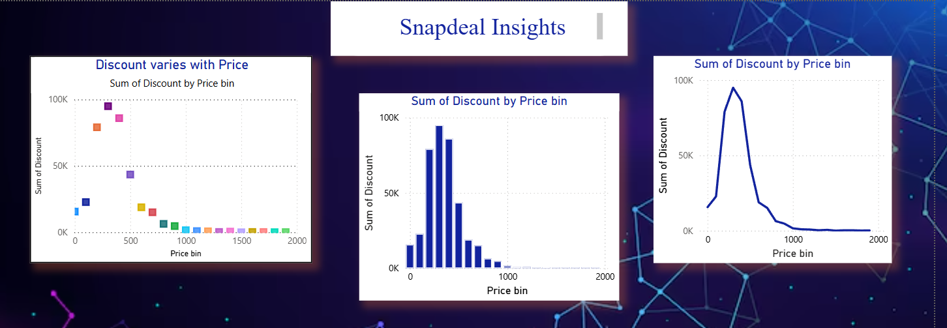

2. This helps you instantly identify:
- Best deals
- Weak deals
- Poor-quality products
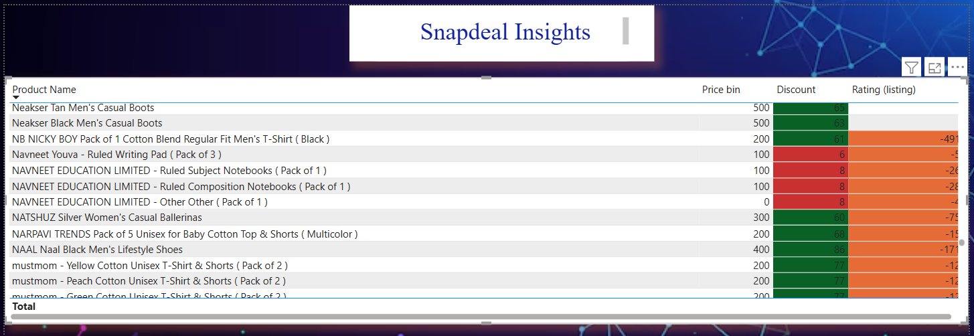
3. I would use a scatter plot with Average Price on the X-axis and Average Rating on the Y-axis, because it clearly shows the relationship between two continuous variables across subcategories. If expensive categories show lower ratings, it indicates customers feel the products do not justify their price. This suggests quality issues, incorrect pricing strategy, or over-promising by sellers. It is a key signal to review the high-price categories for quality and customer experience improvements.
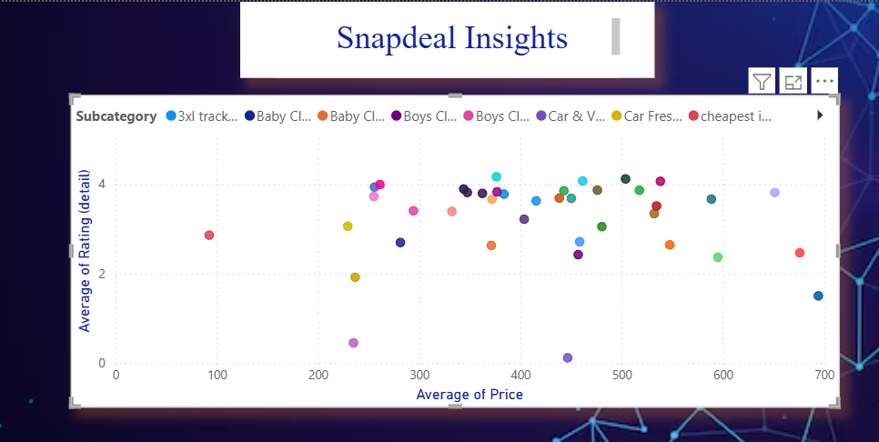

4. To verify whether higher discounts lead to higher ratings, I would use a Scatter Chart plotting Discount vs Rating with a Trend Line, which visually shows the relationship between the two continuous variables
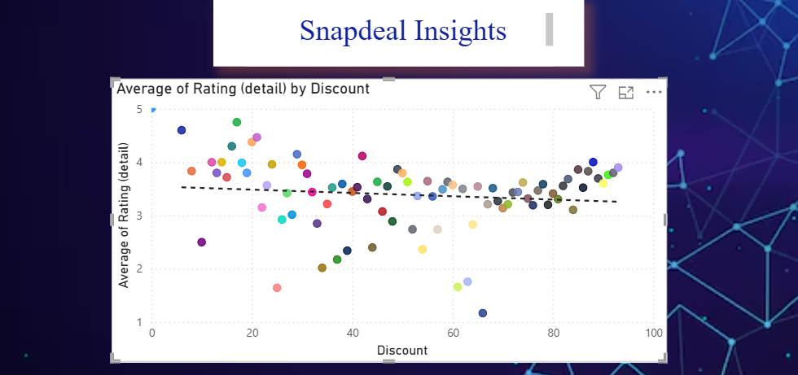

5. To track how average discount changes over time, I would use a Line Chart, because it is the most effective visualization for continuous time-series data
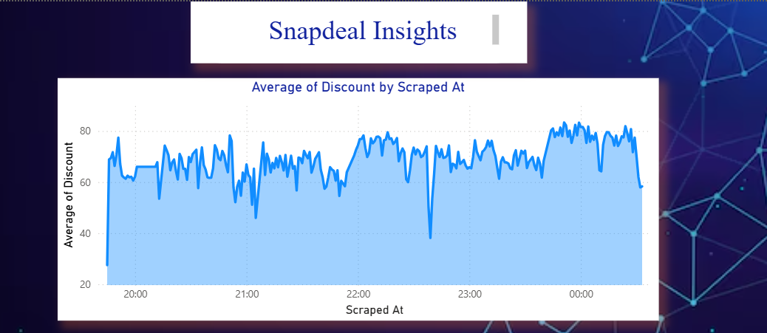

6. The business is depending heavily on discounts, but customer satisfaction is only average.
To grow sustainably, it must focus on:
- Category-level quality improvements
- Optimizing discount strategy
- Enhancing product value perception
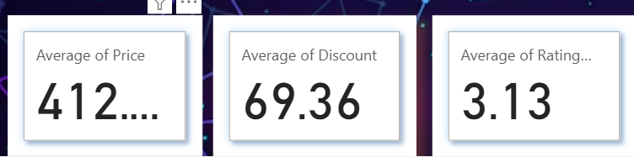

Overall
