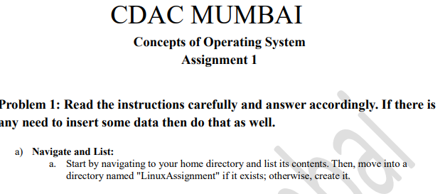

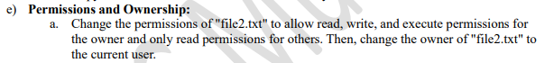

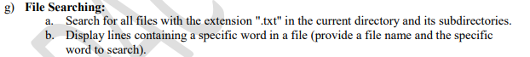

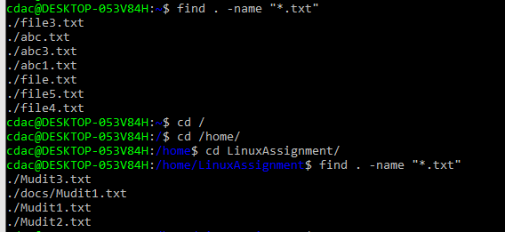

b.

b.

a.



b.

