DIJITAL BRAINS
Employee / Internee Management System
Making Ideas Happen

SOFTWARE QUALITY ENGINEERING
Manual Functional Testing — Test Summary Report
Application Version: v0.1.0 (Web-based)
Document Version: 1.0
Testing Date: 11 October 2026
Field | Details
Group Member 1 | Muhammad Hassan Ahmad — 24F-3101
Group Member 2 | Muhammad Ahmad Asghar — 24F-3016
Course | Software Quality Engineering
Instructors | Mr. Fraz Zaheer and Mr. Talha Dar
Test Environment | Windows 11 Pro; Google Chrome; Next.js 16 dev server (localhost:3000); MySQL 9.7
Repository | github.com/3101hasann/Empolyee-Management-System
Assignment Deadline | 12 October 2026

Document Control
Version | Date | Author(s) | Description
1.0 | 11 Oct 2026 | M. Hassan Ahmad; M. Ahmad Asghar | Initial Test Summary Report — planning, design, execution, defects.

Confidentiality: Prepared for academic assessment (SQE). Describes functional testing of a locally-run build; no production systems were accessed.

Table of Contents
Document Control 2
Table of Contents 2
1. Executive Summary 4
2. Introduction 4
3. Test Planning and Requirement Analysis 5
3.1 Objectives, Scope and Out-of-Scope 5
3.2 Test Approach 5
3.3 Test Environment 6
3.4 Entry and Exit Criteria 6
3.5 Risks and Assumptions 6
3.6 Roles and Responsibilities 7
3.7 Task Allocation 7
4. Test Approach and Strategy — Design Techniques 7
4.1 Equivalence Partitioning (EP) 7
4.2 Boundary Value Analysis (BVA) 7
4.3 Decision Table Testing 7
4.4 State Transition Testing 8
4.5 Error Guessing 8
4.6 Technique Coverage 8
5. Test Execution Summary 8
5.1 Module-wise Results 9
5.2 Charts 9
5.3 Interpretation 10
6. Defect Summary 10
6.1 By Severity and Priority 10
6.2 By Module and Status 10
6.3 Top Defects 11
7. Observations and Recommendations 11
7.1 Functional Quality Assessment 11
7.2 Prioritised Recommendations 11
7.3 Future Non-Functional Testing (out of scope here) 12
8. Conclusion and Sign-off 12
Appendix A — Detailed Test Plan 13
Appendix B — Functional Requirements and Traceability 14
B.1 Functional Requirements Catalogue 14
B.2 Requirement Traceability Matrix (RTM) 15
Appendix C — Complete Test Case Catalogue 17
Appendix D — Defect Log and Detailed Defect Reports 22
D.1 Defect Log 22
D.2 Detailed Defect Reports 23
Appendix E — Exploratory Testing Notes 27
Appendix F — Evidence Index and Screenshots 28
F.1 Evidence Index 28
F.2 Screenshots 29
Appendix G — Group Contribution and Task Allocation 33
Appendix H — Reflection 33
Appendix I — 10-Minute Viva / Demo Script 33

(In Microsoft Word, right-click the table above and choose 'Update Field' to populate page numbers.)

1. Executive Summary
This report documents a manual functional-testing effort carried out on the DIJITAL BRAINS Employee / Internee Management System (EMS), an admin-only web application for managing internship batches, internees and their tenures. The testing was performed against a live, locally-run build of the application using the seeded administrator account, so every result below reflects observed application behaviour rather than code inspection alone.
Six modules were covered — Authentication, Dashboard, Batches, Internees, Tenures and Lookups. Fifty-two test cases were designed across positive, negative and edge-case scenarios, applying all five required test-design techniques. Fifty were executed; two (account lockout and Remember-Me duration) could not be reliably reproduced within the session and are reported as Not Executed with justification.
Of the 50 executed test cases, 42 passed and 8 failed, giving a pass rate of 84% (Passed ÷ Executed). Eight valid, reproducible defects were logged: two Major, three Minor and three Trivial; no Critical defects were found.
The application's core strengths are strong input validation, case-insensitive email uniqueness, safe soft-delete with clear confirmation dialogs, accurate dashboard counts that update after data changes, and security-conscious authentication (a single generic login error that prevents user enumeration, plus server-side rate-limiting). The most significant findings are: (DEF-001) the internee list's Batch chip can contradict the active batch filter, and (DEF-002) certificate start/end dates accept a reversed range because no date-ordering validation exists, allowing illogical data to be saved.
Final quality assessment & release recommendation: READY WITH CONDITIONS. The application is functionally solid with no Critical defects, but release should be gated on fixing the two Major defects (DEF-001, DEF-002) and is recommended to also address the Minor display/validation-feedback issues. Non-functional testing (performance, security, usability, compatibility, accessibility) was out of scope and should be planned separately.

2. Introduction
Purpose. This report presents the plan, approach, execution and results of manual functional testing of the EMS application, and provides an evidence-based recommendation on its readiness.
Application overview. EMS is a dark-themed admin panel (Next.js 16 / React 19 / Prisma 7 / MySQL / Auth.js). It lets a single administrator manage batches (internship cohorts), internees (people), and tenures (an internee's engagement in a batch), supported by lookup master data (cities, institutes, degrees) and a dashboard of key metrics. There is no self-registration; the only user is the seeded admin.
Objectives. Verify that each module behaves according to its documented and observable requirements for valid, invalid and boundary inputs; confirm data integrity across create/edit/delete; and surface functional defects with reproducible evidence.
Selected modules & rationale.
- Authentication — the single entry point and the only security boundary in v1; a failure here affects everything.
- Dashboard — summarises all data; incorrect counts would mislead decisions.
- Batches — core CRUD with rich validation (dates, times, weekday bitmask, status).
- Internees — the richest data-entry module (validation, uniqueness, file uploads, cascade delete).
- Tenures — the relational heart of the system, with the most business rules (score, semester, date ranges, unique pairing).
- Lookups — master data that every internee/tenure form depends on.
Intended audience. The project team and course instructors; written for both technical and non-technical readers.

3. Test Planning and Requirement Analysis

3.1 Objectives, Scope and Out-of-Scope
Objectives. Validate the functional correctness of the six selected modules through manual execution of designed test cases, and document defects with evidence and traceability.
In scope (functional):
- Authentication: login, logout, validation, route protection, rate-limiting behaviour.
- Dashboard: KPI accuracy and chart data; updates after data changes.
- Batches: create, read, edit, soft-delete, search, filter, pagination, validation.
- Internees: create, read, edit, soft-delete, validation, email uniqueness, uploads, cascade.
- Tenures: add, edit, delete, validation (score/semester/dates), unique pairing.
- Lookups: availability and persistence of dropdown master data.
Out of scope (explicitly excluded):
- Performance / load / stress testing.
- Security penetration testing (only functional auth behaviour was observed).
- Usability, compatibility (cross-browser/device) and accessibility testing.
- The AI Assistant chatbot — excluded at the stakeholder's instruction; it also depends on an external paid API that returned a billing error ('429 – no credits'), which is an environment limitation, not an application defect.
- Automated / unit / integration testing.

3.2 Test Approach
Testing was manual and black-box. The application was run locally (Next.js dev server on localhost:3000 against a seeded MySQL database) and driven through Google Chrome exactly as an end user would. Each test case's preconditions were verified, the numbered steps performed with the specified data, and the actual behaviour observed and compared against the expected result. Database queries were used only to independently confirm persisted outcomes (e.g. cascade soft-deletes and stored date values), never as a substitute for executing the UI.

3.3 Test Environment
Item | Detail
Operating System | Windows 11 Pro (10.0.26200)
Browser | Google Chrome (desktop)
Application | EMS v0.1.0 — Next.js 16.2.12 (Turbopack), React 19, Prisma 7, Auth.js v5
Server | Local dev server at http://localhost:3000
Database | MySQL Server 9.7 (localhost:3306), seeded demo data
Seed data | 100 internees, 6 batches, 124 tenures, 15 cities, 14 institutes, 8 degrees
Test account | admin@db.com (seeded administrator)

3.4 Entry and Exit Criteria
Entry criteria:
- Application builds and runs locally; login page reachable.
- Database running and seeded; admin credentials valid.
- Test cases designed and reviewed; test data prepared.
Exit criteria:
- All designed test cases executed at least once, or marked Blocked/Not Executed with a reason.
- No open Critical defects.
- All Major defects logged, triaged and reported to the team.
- Results, defects and metrics documented and internally consistent.
Status against exit criteria: 50 of 52 cases executed (2 Not Executed, justified); 0 Critical defects; 2 Major defects open and reported. Entry and exit criteria are therefore met except for the two open Major defects, which drive the 'Ready with conditions' recommendation.

3.5 Risks and Assumptions
- The AI Assistant could not be tested (out of scope + external API billing error), so no assurance is provided for it.
- Account lockout and Remember-Me duration are time/threshold dependent and were not force-reproduced through the UI; they are verified only at the configuration level.
- Testing used seeded demo data on a single machine; behaviour at production scale is unverified (out of scope).
- Only one role (admin) exists in v1, so role-based access could not be exercised.
- Assumption: observable behaviour and in-app messages represent the intended requirements where no separate specification was provided.

3.6 Roles and Responsibilities
Member | Primary Responsibilities
M. Hassan Ahmad (24F-3101) | Test planning; Authentication, Dashboard & Batches modules; execution metrics & charts; report authoring and consistency audit.
M. Ahmad Asghar (24F-3016) | Requirement analysis & RTM; Internees, Tenures & Lookups modules; defect logging; evidence collection; exploratory testing; reflection.

3.7 Task Allocation
Task | Owner | Start | End | Status
Application inspection & environment setup | H | 09 Oct | 09 Oct | Done
Requirement analysis & RTM | A | 09 Oct | 10 Oct | Done
Test plan & task allocation | H | 09 Oct | 10 Oct | Done
Test-case design (52) | H + A | 10 Oct | 10 Oct | Done
Manual execution — Auth/Dashboard/Batches | H | 11 Oct | 11 Oct | Done
Manual execution — Internees/Tenures/Lookups | A | 11 Oct | 11 Oct | Done
Defect logging & evidence | A | 11 Oct | 11 Oct | Done
Exploratory testing | A | 11 Oct | 11 Oct | Done
Metrics, charts & report | H | 11 Oct | 11 Oct | Done
Final consistency & completeness audit | H + A | 11 Oct | 11 Oct | Done
Note: the Requirement Traceability Matrix is provided in Appendix B; the full functional-requirements catalogue is in Appendix B as well.

4. Test Approach and Strategy — Design Techniques
All five required black-box test-design techniques were applied. Each is illustrated below with a concrete example tied to a real EMS feature; the technique-coverage table maps every technique to the test cases that embody it.

4.1 Equivalence Partitioning (EP)
Inputs were divided into classes expected to behave alike, testing one representative per class. Example — internee email: a valid class ('name@example.com' → accepted, TC-033) and an invalid class ('invalidemail', no '@' → rejected, TC-027). Email uniqueness adds a 'already-exists' class (TC-031).

4.2 Boundary Value Analysis (BVA)
At the edges of known ranges we tested just-inside and just-outside values. Example — tenure score (0–100): 101 is rejected ('Score must be 0-100') while 85 is accepted (TC-042); semester (1–20): 21 rejected, 6 accepted (TC-043); phone length (≥7 digits): 6 digits rejected, 7 accepted (TC-028/029); batch name length (≤100): 101 rejected (TC-019).

4.3 Decision Table Testing
Login outcome was modelled as combinations of conditions:
Email valid? | Email exists? | Password correct? | Expected outcome
No | — | — | Inline 'Enter a valid email address' (TC-003)
Yes | No | — | Generic 'Invalid email or password' (TC-002 class)
Yes | Yes | No | Generic 'Invalid email or password' (TC-002)
Yes | Yes | Yes | Login succeeds → dashboard (TC-001)
The identical generic message for the three failing rows is intentional (prevents user enumeration) and was confirmed during execution.

4.4 State Transition Testing
Batch status is a state with values Upcoming, Active and Closed. We exercised a transition Upcoming → Closed (TC-020) and confirmed it persists. The application permits any status-to-any-status change (no enforced workflow); this was verified and treated as intended behaviour. Record lifecycle states were also exercised: Active → Soft-Deleted for batches (TC-021), internees (TC-035, cascading tenures to Soft-Deleted) and tenures (TC-049).

4.5 Error Guessing
Drawing on experience, we probed likely weak spots: whitespace-only names (TC-030), duplicate records in different letter-case (TC-032), a non-existent record URL (TC-036), an out-of-range page number (TC-038), repeated login submissions (TC-006/007), and reversed certificate/degree date ranges (TC-047/048). These guesses directly uncovered DEF-003, DEF-006, DEF-007 and DEF-008.

4.6 Technique Coverage
Technique | Representative Test Cases
Equivalence Partitioning | TC-027, TC-031, TC-033, TC-041, TC-051
Boundary Value Analysis | TC-019, TC-028, TC-029, TC-042, TC-043
Decision Table | TC-001, TC-002, TC-003 (login condition combinations)
State Transition | TC-020, TC-021, TC-035, TC-045, TC-049
Error Guessing | TC-006, TC-030, TC-032, TC-036, TC-038, TC-047, TC-048

5. Test Execution Summary
Pass percentage is defined as Passed ÷ Executed × 100. Blocked and Not-Executed cases are excluded from the denominator. Executed = Passed + Failed + Blocked. When zero cases are executed the pass percentage is reported as N/A.
Metric | Value
Total test cases designed | 52
Executed | 50
Passed | 42
Failed | 8
Blocked | 0
Not Executed | 2
Pass percentage (Passed ÷ Executed) | 84.0%
Approx. execution effort | ≈ 16 person-hours (planning 3, design 4, execution 5, defects 2, reporting 2)

5.1 Module-wise Results
Module | Designed | Executed | Passed | Failed | Not Exec.
Authentication | 8 | 6 | 5 | 1 | 2
Dashboard | 5 | 5 | 5 | 0 | 0
Batches | 11 | 11 | 9 | 2 | 0
Internees | 16 | 16 | 13 | 3 | 0
Tenures | 10 | 10 | 8 | 2 | 0
Lookups | 2 | 2 | 2 | 0 | 0
Total | 52 | 50 | 42 | 8 | 2

5.2 Charts
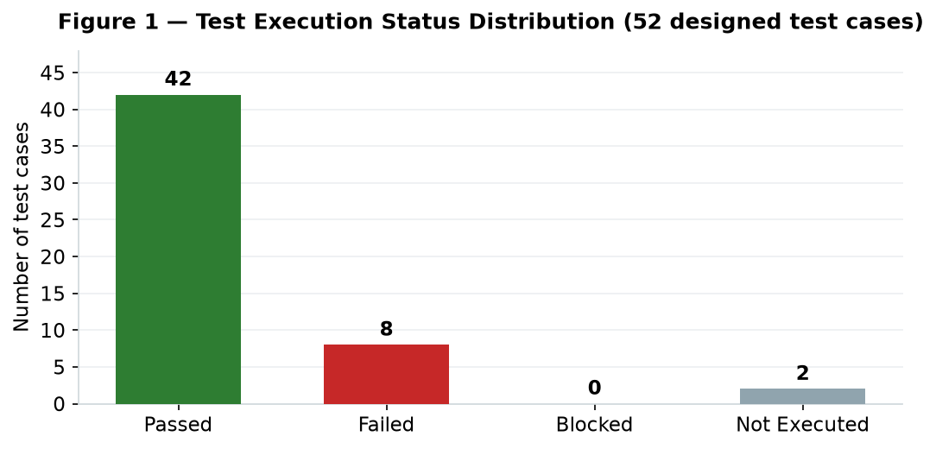
Figure 1 — Execution-status distribution across the 52 designed test cases.
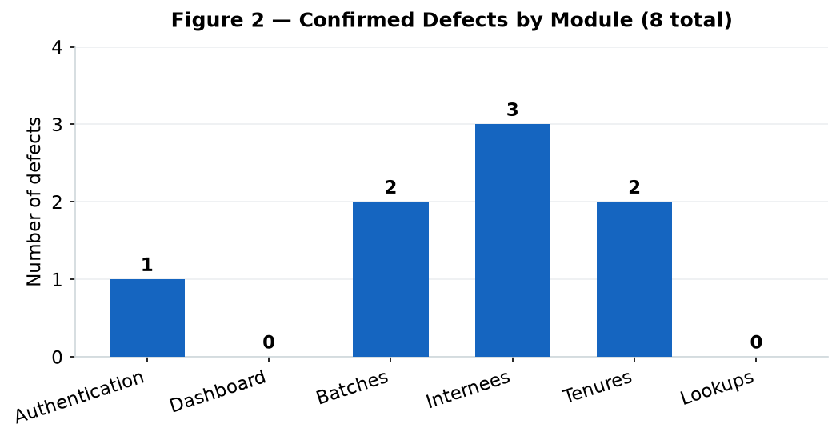
Figure 2 — Confirmed defects by module (8 total).

5.3 Interpretation
Execution was high: 50 of 52 cases ran, with only the time/threshold-dependent lockout and Remember-Me cases deferred. The 84% pass rate, with zero Blocked and zero Critical defects, indicates a stable application. Failures cluster in Internees (3) and are split between Batches and Tenures (2 each); Dashboard and Lookups were defect-free. The two Major defects both concern data correctness (a misleading list chip and missing certificate-date validation) rather than crashes, which is consistent with the overall picture of a working system that needs validation and display polish.

6. Defect Summary
Eight valid, reproducible defects were confirmed. Distribution:

6.1 By Severity and Priority
Severity | Count | Priority | Count
Critical | 0 | High | 2
Major | 2 | Medium | 2
Minor | 3 | Low | 4
Trivial | 3

6.2 By Module and Status
Module | Defects | Status
Authentication | 1 (DEF-007) | Open
Batches | 2 (DEF-004, DEF-006) | Open
Internees | 3 (DEF-001, DEF-005, DEF-008) | Open
Tenures | 2 (DEF-002, DEF-003) | Open
Dashboard / Lookups | 0 | —
Total | 8 | 8 Open
All defects are newly discovered and therefore Open; none has been retested as Fixed or Closed, so no such status is claimed.

6.3 Top Defects
ID | Title | Severity | Impact
DEF-001 | Internee Batch chip contradicts the active batch filter | Major | Misleading data
DEF-002 | Certificate dates accept a reversed (illogical) range | Major | Corrupt data saved
DEF-008 | Out-of-range page number → invalid 'Showing' counter | Minor | Confusing empty page
DEF-003 | Degree date error shows generic message, no field highlight | Minor | Poor error feedback
DEF-004 | 'Days Of Week' column shows a number, not the days | Minor | Hidden schedule info
Trend: the dominant theme is validation/presentation completeness — rules that are enforced for some fields (tenure dates, required fields) are missing or inconsistently surfaced for related fields (certificate/degree dates, list displays). No defect caused a crash or data loss.

7. Observations and Recommendations

7.1 Functional Quality Assessment
Based on the executed tests, EMS is a well-engineered application. Validation is generally thorough and user-friendly, destructive actions are guarded by clear confirmation dialogs that explain soft-delete semantics, data integrity holds across create/edit/delete (verified against the database), and authentication is security-conscious. The defects found are refinements rather than fundamental faults.

7.2 Prioritised Recommendations
High priority (fix before release):
- DEF-002: add certificate start/end date-order validation (and surface it inline), both client- and server-side.
- DEF-001: make the internee list's Batch column reflect the active batch filter (or show all of an internee's batches) so the display cannot contradict the filter.
Medium priority:
- DEF-008: clamp out-of-range page numbers to the last valid page and correct the 'Showing X to Y' counter.
- DEF-003: surface degree (and certificate) date-order errors as field-level messages, consistent with tenure dates.
Low priority (polish):
- DEF-004: show weekday names (or abbreviations) in the Batches list instead of a count.
- DEF-005: correct the CV upload label to list all accepted formats (jpeg, png, webp, pdf).
- DEF-006: replace the raw 'Too big…' message with a friendly length message.
- DEF-007: clear stale server errors when re-validating the login form.

7.3 Future Non-Functional Testing (out of scope here)
Separately plan: performance/load testing at realistic data volumes; a security assessment (session handling, file-upload hardening, authorization once more roles exist); usability testing; cross-browser/device compatibility; and accessibility (WCAG) testing. These were explicitly excluded from this functional effort.

8. Conclusion and Sign-off
The six in-scope modules were tested manually against a live build. Fifty of fifty-two designed cases were executed (two deferred with justification), yielding an 84% pass rate and eight reproducible defects (two Major, three Minor, three Trivial; zero Critical). Exit criteria are met except for the two open Major defects.
Release recommendation: READY WITH CONDITIONS — resolve DEF-001 and DEF-002 (and retest), and ideally the Minor issues, before release. This report does not constitute formal release approval; it is an evidence-based recommendation for the project owners.
Remaining limitations: the AI Assistant, account-lockout threshold, Remember-Me duration, and all non-functional qualities were not validated here.

Role | Name | Date / Signature
Tester / Author | Muhammad Hassan Ahmad (24F-3101) | 11 Oct 2026 __________
Tester / Reviewer | Muhammad Ahmad Asghar (24F-3016) | 11 Oct 2026 __________
Instructor (acceptance) | Mr. Fraz Zaheer / Mr. Talha Dar | ____________ __________

Appendix A — Detailed Test Plan
The full test plan is embodied in Section 3 (objectives, scope, out-of-scope, approach, environment, entry/exit criteria, risks, roles and task allocation). Key points, consolidated:
- Goal: validate functional correctness of Authentication, Dashboard, Batches, Internees, Tenures and Lookups.
- Method: manual black-box execution through Chrome against a seeded local build; DB used only to confirm persistence.
- Deliverables: RTM (App. B), test-case catalogue (App. C), defect reports & log (App. D), exploratory notes (App. E), evidence index (App. F), contribution table (App. G), reflection (App. H).
- Entry/Exit criteria and risks: see Sections 3.4–3.5.

Appendix B — Functional Requirements and Traceability

B.1 Functional Requirements Catalogue
Source of requirements: the application's observable behaviour and in-app messages, the project README/AGENTS documentation, and the data model. Where intent was not independently specified, the requirement reflects observed behaviour.

ID | Module | Requirement | Expected Behaviour | Pri.
FR-001 | Authentication | Authenticate an admin with valid credentials. | Valid email+password → redirect to dashboard; JWT session established. | High
FR-002 | Authentication | Reject invalid credentials without revealing which field failed. | One generic error for wrong email, wrong password, disabled or rate-limited account. | High
FR-003 | Authentication | Validate login form inputs. | Email must be present & well-formed; password required. | Medium
FR-004 | Authentication | Log the user out and clear the session. | Logout → /login; protected routes no longer reachable. | Medium
FR-005 | Authentication | Protect application routes from unauthenticated access. | Unauthenticated request to app route → redirect to /login. | High
FR-006 | Authentication | Rate-limit repeated failed logins. | ≥5 failures within 15 min per email are blocked. | Medium
FR-007 | Authentication | Remember-Me controls session lifetime. | 24 h by default; 30 days when checked. | Low
FR-008 | Dashboard | Show accurate KPI counts. | Total/Active/Closed batches and total internees match the database (non-deleted). | High
FR-009 | Dashboard | Visualise monthly batch/internee trends. | Charts reflect records created per month for the selected year. | Medium
FR-010 | Dashboard | List recent batches. | Latest 5 batches by creation date with intern counts. | Low
FR-011 | Batches | Create a batch. | Persist name, status, dates, times and weekdays. | High
FR-012 | Batches | Validate batch inputs. | Required fields; end date ≥ start; end time > start; ≥1 weekday; name ≤100 chars. | High
FR-013 | Batches | Edit a batch and change its status. | Updates (incl. Upcoming/Active/Closed) persist. | Medium
FR-014 | Batches | Soft-delete a batch. | Batch hidden from lists; interns' tenure records retained. | Medium
FR-015 | Batches | Search, filter and paginate the batch list. | Query by name, filter by status, paginate. | Medium
FR-016 | Batches | Display the batch schedule in the list. | Show weekdays, times and intern count. | Low
FR-017 | Internees | Create an internee with optional file uploads. | Person + Internee records persisted; optional profile picture/CV. | High
FR-018 | Internees | Validate internee inputs. | Required first/last name, gender, email, phone; valid email & phone formats. | High
FR-019 | Internees | Enforce a unique email (case-insensitive). | Duplicate email rejected with a clear message. | High
FR-020 | Internees | Edit an internee. | Updates persist; email uniqueness still enforced. | Medium
FR-021 | Internees | Soft-delete an internee, cascading to tenures. | Internee + its tenures soft-deleted; batch counts update. | Medium
FR-022 | Internees | Search, filter and paginate the internee list. | Query, batch filter, gender filter, pagination. | Medium
FR-023 | Internees | Validate file uploads by type and size. | Accept jpeg/png/webp/pdf; enforce size limits. | Medium
FR-024 | Tenures | Add a tenure linking an internee to a batch. | Tenure persisted against the internee and batch. | High
FR-025 | Tenures | Validate tenure inputs. | Required batch & dates; score 0–100; semester 1–20; end date ≥ start. | High
FR-026 | Tenures | Enforce a unique (internee, batch) pairing. | A second tenure in the same batch is rejected. | Medium
FR-027 | Tenures | Edit and delete a tenure. | Edits persist; delete soft-deletes the tenure. | Medium
FR-028 | Tenures | Validate certificate and degree date ranges. | Degree and certificate end dates ≥ their start dates. | Medium
FR-029 | Lookups | Provide master data for dropdowns. | Cities, Institutes, Degrees and Batches available as options. | Low

B.2 Requirement Traceability Matrix (RTM)
Req ID | Requirement | Module | Linked Test Cases | Execution Status | Defects
FR-001 | Authenticate an admin with valid credentials. | Authentication | TC-001 | Executed – Pass | —
FR-002 | Reject invalid credentials without revealing which field failed. | Authentication | TC-002 | Executed – Pass | —
FR-003 | Validate login form inputs. | Authentication | TC-003, TC-006 | Executed – Fail present | DEF-007
FR-004 | Log the user out and clear the session. | Authentication | TC-004 | Executed – Pass | —
FR-005 | Protect application routes from unauthenticated access. | Authentication | TC-005 | Executed – Pass | —
FR-006 | Rate-limit repeated failed logins. | Authentication | TC-007 | Not Executed | —
FR-007 | Remember-Me controls session lifetime. | Authentication | TC-008 | Not Executed | —
FR-008 | Show accurate KPI counts. | Dashboard | TC-009, TC-010 | Executed – Pass | —
FR-009 | Visualise monthly batch/internee trends. | Dashboard | TC-011, TC-012 | Executed – Pass | —
FR-010 | List recent batches. | Dashboard | TC-013 | Executed – Pass | —
FR-011 | Create a batch. | Batches | TC-018 | Executed – Pass | —
FR-012 | Validate batch inputs. | Batches | TC-015, TC-016, TC-017, TC-019 | Executed – Fail present | DEF-006
FR-013 | Edit a batch and change its status. | Batches | TC-020 | Executed – Pass | —
FR-014 | Soft-delete a batch. | Batches | TC-021 | Executed – Pass | —
FR-015 | Search, filter and paginate the batch list. | Batches | TC-014, TC-022, TC-023 | Executed – Pass | —
FR-016 | Display the batch schedule in the list. | Batches | TC-024 | Executed – Fail present | DEF-004
FR-017 | Create an internee with optional file uploads. | Internees | TC-033 | Executed – Pass | —
FR-018 | Validate internee inputs. | Internees | TC-026, TC-027, TC-028, TC-029, TC-030 | Executed – Pass | —
FR-019 | Enforce a unique email (case-insensitive). | Internees | TC-031, TC-032 | Executed – Pass | —
FR-020 | Edit an internee. | Internees | TC-034 | Executed – Pass | —
FR-021 | Soft-delete an internee, cascading to tenures. | Internees | TC-035 | Executed – Pass | —
FR-022 | Search, filter and paginate the internee list. | Internees | TC-025, TC-036, TC-037, TC-038, TC-039 | Executed – Fail present | DEF-001, DEF-008
FR-023 | Validate file uploads by type and size. | Internees | TC-040 | Executed – Fail present | DEF-005
FR-024 | Add a tenure linking an internee to a batch. | Tenures | TC-044, TC-050 | Executed – Pass | —
FR-025 | Validate tenure inputs. | Tenures | TC-041, TC-042, TC-043, TC-046 | Executed – Pass | —
FR-026 | Enforce a unique (internee, batch) pairing. | Tenures | TC-045 | Executed – Pass | —
FR-027 | Edit and delete a tenure. | Tenures | TC-049 | Executed – Pass | —
FR-028 | Validate certificate and degree date ranges. | Tenures | TC-047, TC-048 | Executed – Fail present | DEF-002, DEF-003
FR-029 | Provide master data for dropdowns. | Lookups | TC-051, TC-052 | Executed – Pass | —

Appendix C — Complete Test Case Catalogue
All 52 test cases with full fields. Tester initials: H = M. Hassan Ahmad (24F-3101), A = M. Ahmad Asghar (24F-3016). Execution date for all executed cases: 11 Oct 2026. Priority = urgency to fix; Severity = impact if it fails (shown for failed cases).

ID | Module | Req | Title | Steps | Test Data | Expected | Actual | Status | Pri | Sev | Ev
TC-001 | Authentication | FR-001 | Valid admin login | 1) Open /login 2) Enter email 3) Enter password 4) Click Login | admin@db.com / testadmin11 | Redirect to /dashboard; 'Hello Admin' shown | Logged in and dashboard displayed | Pass | High | - | EV-10
TC-002 | Authentication | FR-002 | Login with wrong password | 1) Enter valid email 2) Enter wrong password 3) Login | admin@db.com / wrongpass99 | Generic 'Invalid email or password…'; stays on login | Generic error shown; no user enumeration | Pass | High | Major | EV-09
TC-003 | Authentication | FR-003 | Login with empty fields | 1) Leave email & password empty 2) Click Login | (empty) | Inline 'Enter a valid email address' + 'Password is required' | Both inline errors shown | Pass | Medium | - | -
TC-004 | Authentication | FR-004 | Logout clears session | 1) Log in 2) Click Logout | (session) | Redirect to /login | Redirected to /login | Pass | Medium | - | -
TC-005 | Authentication | FR-005 | Route guard for unauthenticated user | 1) Log out 2) Navigate to /dashboard | URL /dashboard | Redirect to /login | Redirected to /login | Pass | High | - | -
TC-006 | Authentication | FR-003 | Stale server error cleared on new validation | 1) Trigger wrong-pw server error 2) Clear fields 3) Submit empty | admin@db.com then empty | Old server error removed when new validation runs | Previous 'Invalid email or password' persists below new inline errors | Fail | Low | Trivial | -
TC-007 | Authentication | FR-006 | Account lockout after 5 failed attempts | 1) Submit 6 wrong logins for one email 2) Submit correct pw | admin@db.com x6 | 6th attempt blocked even with correct password | Not reproduced via UI (rapid submits debounced; only 4/6 registered). Limiter present in code (5/15min). | Not Executed | Medium | - | -
TC-008 | Authentication | FR-007 | Remember-Me session duration | 1) Login with Remember-Me 2) Inspect session lifetime | Remember-Me on/off | 30-day vs 24-hour session | Time-dependent; not executable in session window | Not Executed | Low | - | -
TC-009 | Dashboard | FR-008 | KPI counts match database | 1) Open dashboard 2) Compare KPIs to DB counts | Seed data | 6 batches / 1 active / 4 closed / 100 internees | All four match DB exactly | Pass | High | - | EV-01
TC-010 | Dashboard | FR-008 | KPIs update after creating an internee | 1) Note total 2) Create internee 3) Re-open dashboard | New internee | Total 101; '+1 this month' | Updated to 101 (+1); Fall 2026 interns 4→5 | Pass | Medium | - | -
TC-011 | Dashboard | FR-009 | Comparison chart matches year data | 1) Open dashboard 2) Read internee bars 3) Compare to DB (2026) | 2026 records | Bars = Jan 18, May 23, Sep 4 (=45) | Matches 2026 subset exactly | Pass | Medium | - | EV-01
TC-012 | Dashboard | FR-009 | Stats chart series toggle | 1) Toggle Batches/Internees on Stats chart | - | Chart switches series; year label shown | Toggle & 'This Year · 2026' label work | Pass | Low | - | -
TC-013 | Dashboard | FR-010 | Recent batches list | 1) View 'Recent Batches' panel | - | Latest 5 batches by creation with counts | 5 most-recent batches shown with intern counts | Pass | Low | - | -
TC-014 | Batches | FR-015 | Batch list renders with pagination | 1) Open /batches | - | All batches listed; 'Showing 1 to 6 out of 6' | 6 rows + correct footer | Pass | Medium | - | -
TC-015 | Batches | FR-012 | Create batch – required fields empty | 1) Open /batches/new 2) Click Save | (empty) | Errors: name, dates, times, ≥1 day | All five inline errors shown | Pass | High | - | EV-02
TC-016 | Batches | FR-012 | Create batch – end date before start | 1) Fill name/day 2) End date < start date 3) Save | start 10-Jun, end 01-Jun 2026 | 'End date must be on or after the start date' | Error shown; save blocked | Pass | High | - | -
TC-017 | Batches | FR-012 | Create batch – end time ≤ start time | 1) Start 10:00 End 09:00 2) Save | 10:00 / 09:00 | 'End time must be after the start time' | Error shown; save blocked | Pass | Medium | - | -
TC-018 | Batches | FR-011 | Create a valid batch | 1) Fill all valid fields 2) Save | QA Automation Batch, Mon+Wed | 'Batch saved'; appears in list | Batch #7 created; Days=2; Upcoming | Pass | High | - | -
TC-019 | Batches | FR-012 | Batch name length boundary (100/101) | 1) Enter 101-char name 2) Save | 101 chars | Rejected with user-friendly message | Rejected but with raw 'Too big: expected string to have <=100 characters' | Fail | Low | Trivial | -
TC-020 | Batches | FR-013 | Edit batch – status transition | 1) Open batch 2) Status Upcoming→Closed 3) Save | Batch #7 | Status updates to Closed | 'Batch saved'; status Closed in list | Pass | Medium | - | -
TC-021 | Batches | FR-014 | Delete batch (confirm + soft) | 1) Click delete 2) Confirm | Batch #7 | Confirm dialog; batch removed from list | Dialog shown; row removed (soft delete) | Pass | Medium | - | -
TC-022 | Batches | FR-015 | Search + empty state | 1) Search 'Summer' 2) Search 'zzznomatch' | 'Summer' / 'zzz…' | 2 rows; then 'No batches found' | 2 Summer rows; empty state shown | Pass | Medium | - | -
TC-023 | Batches | FR-015 | Filter by status | 1) Filter status = Active | ACTIVE | Only Active batches | 1 row (Summer 2026) | Pass | Medium | - | -
TC-024 | Batches | FR-016 | 'Days Of Week' shows the days | 1) View Days Of Week column | Seed batches | Column shows day names (e.g. Mon, Wed) | Shows a numeric count (2,5,3); names only in hover tooltip | Fail | Low | Minor | EV-03
TC-025 | Internees | FR-022 | Internee list renders with pagination | 1) Open /internees | - | 100 internees; paginated | 100 rows; pages 1–10 | Pass | Medium | - | EV-05
TC-026 | Internees | FR-018 | Create internee – required fields empty | 1) Open /internees/new 2) Save & Next | (empty) | Errors: name, gender, email, phone | All required errors shown | Pass | High | - | EV-04
TC-027 | Internees | FR-018 | Invalid email format (EP – invalid class) | 1) Email 'invalidemail' 2) Save | invalidemail | 'Enter a valid email address' | Error shown | Pass | Medium | - | -
TC-028 | Internees | FR-018 | Phone below minimum (BVA 6 digits) | 1) Phone '123456' 2) Save | 123456 | 'Enter a valid phone number' | Error shown (min 7) | Pass | Medium | - | -
TC-029 | Internees | FR-018 | Phone at minimum boundary (7 digits) | 1) Phone with 7+ digits 2) Save | +923001234567 | Accepted | Accepted | Pass | Low | - | -
TC-030 | Internees | FR-018 | Whitespace-only first name | 1) First name ' ' 2) Save | ' ' | 'First name is required' (trimmed) | Error shown | Pass | Medium | - | -
TC-031 | Internees | FR-019 | Duplicate email (exact) | 1) Use existing email 2) Save | hussain.malik.13@example.com | 'A person with this email already exists.' | Rejected with that message | Pass | High | - | -
TC-032 | Internees | FR-019 | Duplicate email (uppercase, case-insensitive) | 1) Use UPPERCASE of existing email 2) Save | HUSSAIN.MALIK.13@EXAMPLE.COM | Rejected (case-insensitive) | Rejected – case-insensitive uniqueness works | Pass | High | - | -
TC-033 | Internees | FR-017 | Create a valid internee | 1) Fill valid personal info 2) Save & Next | qa.tester.001@example.com | Internee created; redirect to tenure tab | Internee #101 created; 'Internee saved' | Pass | High | - | -
TC-034 | Internees | FR-020 | Edit internee personal info | 1) Open internee 2) Change email to unique 3) Save | unique email | Update persists | Update accepted | Pass | Medium | - | -
TC-035 | Internees | FR-021 | Delete internee cascades to tenures | 1) Delete internee 2) Check tenure & counts | Internee #101 | Internee+tenure soft-deleted; counts revert | DB: both soft-deleted; total 100; Fall 2026 =4 | Pass | Medium | - | -
TC-036 | Internees | FR-022 | Non-existent internee route | 1) Open /internees/999999 | id 999999 | Clean 404 page | '404 — This page could not be found.' | Pass | Low | - | -
TC-037 | Internees | FR-022 | Search by email substring | 1) Search 'qa.tester' | qa.tester | Matching internee listed | Found Test Internee by email | Pass | Medium | - | -
TC-038 | Internees | FR-022 | Out-of-range page number | 1) Open /internees?page=999 | page=999 | Clamp to last page or sensible message | Empty list + invalid footer 'Showing 9981 to 101 out of 101 records' | Fail | Medium | Minor | EV-07
TC-039 | Internees | FR-022 | Batch chip matches active batch filter | 1) Filter by Summer 2025 2) Read Batch chips | batchId=2 | Each row chipped with the filtered batch | Chips show latest tenure (Fall 2025 / Summer 2026) – mismatched | Fail | High | Major | EV-06
TC-040 | Internees | FR-023 | CV upload label matches accepted types | 1) Read 'Supported formats' label vs accepted types | - | Label lists all accepted types | Label says 'jpeg, pdf' but input also accepts png & webp | Fail | Low | Trivial | EV-04
TC-041 | Tenures | FR-025 | Tenure – required fields empty | 1) Open tenure tab 2) Save | (empty) | Errors: 'Select a batch' + dates required | All required errors shown | Pass | High | - | -
TC-042 | Tenures | FR-025 | Score boundary (BVA: 101 vs 85) | 1) Score 101 2) Save; then 85 | 101 / 85 | 101 rejected 'Score must be 0-100'; 85 ok | 101 rejected; 85 accepted | Pass | High | - | -
TC-043 | Tenures | FR-025 | Semester boundary (BVA: 21 vs 6) | 1) Semester 21 2) Save; then 6 | 21 / 6 | 21 rejected 'Semester must be 1-20'; 6 ok | 21 rejected; 6 accepted | Pass | High | - | -
TC-044 | Tenures | FR-024 | Create a valid tenure | 1) Select batch+dates 2) Save | Fall 2026, valid dates | 'Tenure added'; row in list | Tenure #125 created & listed | Pass | High | - | -
TC-045 | Tenures | FR-026 | Duplicate (internee, batch) | 1) Add same batch again 2) Save | Fall 2026 again | Rejected with friendly message | 'This internee already has a tenure in that batch.' | Pass | Medium | - | -
TC-046 | Tenures | FR-025 | Tenure end date before start date | 1) End date < start date 2) Save | end<start | Inline 'End date must be on or after the start date' | Inline error shown (client cross-field) | Pass | Medium | - | -
TC-047 | Tenures | FR-028 | Degree end date before start date | 1) Degree start 09/2026, end 01/2026 2) Save | degree end<start | Field-level 'Degree end must be on or after its start' | Generic 'Invalid data. Please review the form.'; no field highlighted | Fail | Medium | Minor | EV-08
TC-048 | Tenures | FR-028 | Certificate end date before start date | 1) Cert start 01-Dec-2026, end 01-Jan-2026 2) Save | cert end<start | Rejected (invalid date range) | Saved successfully – no cert-date validation (DB-verified) | Fail | High | Major | -
TC-049 | Tenures | FR-027 | Delete tenure (confirm + soft) | 1) Delete tenure 2) Confirm | Tenure #127 | Confirm dialog; tenure removed | Dialog shown; tenure soft-deleted | Pass | Medium | - | -
TC-050 | Tenures | FR-024 | Inline '+ Create a new batch' modal | 1) Click + next to batch select | - | Modal opens with batch form | Create-Batch modal opens correctly | Pass | Low | - | -
TC-051 | Lookups | FR-029 | Dropdowns populated from seed data | 1) Open internee/tenure forms 2) Open dropdowns | - | Cities/Institutes/Degrees/Batches listed | 15 cities, 14 institutes, 8 degrees, 6 batches | Pass | Low | - | -
TC-052 | Lookups | FR-029 | Selected lookup persists on record | 1) Pick city/institute 2) Save 3) Reopen | - | Selection stored and shown | Lookup selections persist on saved records | Pass | Low | - | -

Appendix D — Defect Log and Detailed Defect Reports

D.1 Defect Log
ID | Title | Module | TC | Severity | Priority | Status | Reporter | Date | Evidence
DEF-001 | Internee Batch chip contradicts the active batch filter | Internees | TC-039 | Major | High | Open | A | 2026-10-11 | EV-06
DEF-002 | Certificate start/end dates accept an illogical (reversed) range | Tenures | TC-048 | Major | High | Open | A | 2026-10-11 | -
DEF-003 | Degree date-order error shows a generic message with no field highlight | Tenures | TC-047 | Minor | Medium | Open | A | 2026-10-11 | EV-08
DEF-004 | Batches list 'Days Of Week' shows a number instead of the days | Batches | TC-024 | Minor | Low | Open | H | 2026-10-11 | EV-03
DEF-005 | CV upload 'Supported formats' label is incomplete | Internees | TC-040 | Trivial | Low | Open | H | 2026-10-11 | EV-04
DEF-006 | Over-length batch name shows a raw validation message | Batches | TC-019 | Trivial | Low | Open | H | 2026-10-11 | -
DEF-007 | Previous login error persists after a new client-side validation | Authentication | TC-006 | Trivial | Low | Open | H | 2026-10-11 | -
DEF-008 | Out-of-range page number yields an invalid 'Showing' counter | Internees | TC-038 | Minor | Medium | Open | A | 2026-10-11 | EV-07

D.2 Detailed Defect Reports

DEF-001 — Internee Batch chip contradicts the active batch filter
Field | Detail
Module / Feature | Internees
Severity / Priority / Status | Major / High / Open
Related Requirement / Test Case | FR-022 / TC-039
Reporter / Date | M. Ahmad Asghar / 2026-10-11
Environment | EMS v0.1.0, Chrome, localhost:3000, MySQL 9.7 (Windows 11)
Preconditions | Logged in; internees exist in multiple batches (e.g. internee in Summer 2025 & Summer 2026).
Steps to Reproduce | 1) Open /internees 2) Set the Batch filter to 'Summer 2025' 3) Inspect the Batch chip on each returned row.
Test Data | Filter batch = Summer 2025 (batchId 2).
Expected Result | Every row's Batch chip shows the filtered batch (Summer 2025), or all of the internee's batches.
Actual Result | Rows correctly match the filter, but several chips read 'Fall 2025' or 'Summer 2026' (the latest tenure), contradicting the filter.
Evidence | EV-06 (Appendix F)
Impact & Rationale | Misleading data: a user filtering by a batch sees rows labelled with a different batch, undermining trust in the list and any decisions based on it.

DEF-002 — Certificate start/end dates accept an illogical (reversed) range
Field | Detail
Module / Feature | Tenures
Severity / Priority / Status | Major / High / Open
Related Requirement / Test Case | FR-028 / TC-048
Reporter / Date | M. Ahmad Asghar / 2026-10-11
Environment | EMS v0.1.0, Chrome, localhost:3000, MySQL 9.7 (Windows 11)
Preconditions | Logged in; an internee exists.
Steps to Reproduce | 1) Open an internee's Tenure tab 2) Select a batch and valid tenure dates 3) Set Cert Start Date = 01-Dec-2026 and Cert End Date = 01-Jan-2026 4) Click Save.
Test Data | certStartDate 2026-12-01, certEndDate 2026-01-01.
Expected Result | The form rejects the reversed certificate date range.
Actual Result | 'Tenure added' – the record saved. DB confirms certStartDate 2026-12-01 > certEndDate 2026-01-01.
Evidence | Database query / observed in app (see Appendix F)
Impact & Rationale | Corrupt certificate data (end before start) is persisted, producing wrong durations in any certificate report or export.

DEF-003 — Degree date-order error shows a generic message with no field highlight
Field | Detail
Module / Feature | Tenures
Severity / Priority / Status | Minor / Medium / Open
Related Requirement / Test Case | FR-028 / TC-047
Reporter / Date | M. Ahmad Asghar / 2026-10-11
Environment | EMS v0.1.0, Chrome, localhost:3000, MySQL 9.7 (Windows 11)
Preconditions | Logged in; an internee exists.
Steps to Reproduce | 1) Open the Tenure tab 2) Enter a valid batch & tenure dates 3) Set Degree Start Date after Degree End Date 4) Save.
Test Data | degreeStartDate 2026-09-01, degreeEndDate 2026-01-01.
Expected Result | Field-level error, e.g. 'Degree end must be on or after its start', on the degree date fields.
Actual Result | Generic 'Invalid data. Please review the form.' toast; no field is highlighted, so the user cannot tell what to fix.
Evidence | EV-08 (Appendix F)
Impact & Rationale | Poor, inconsistent error feedback (tenure dates get inline errors; degree/cert dates do not), increasing user error and support load.

DEF-004 — Batches list 'Days Of Week' shows a number instead of the days
Field | Detail
Module / Feature | Batches
Severity / Priority / Status | Minor / Low / Open
Related Requirement / Test Case | FR-016 / TC-024
Reporter / Date | M. Hassan Ahmad / 2026-10-11
Environment | EMS v0.1.0, Chrome, localhost:3000, MySQL 9.7 (Windows 11)
Preconditions | Logged in; batches exist.
Steps to Reproduce | 1) Open /batches 2) Read the 'Days Of Week' column.
Test Data | Seed batches.
Expected Result | The column communicates which days (e.g. 'Mon, Wed').
Actual Result | The column shows a bare count (2, 5, 3…). Day names appear only on mouse hover (not discoverable and unavailable on touch).
Evidence | EV-03 (Appendix F)
Impact & Rationale | Users cannot see a batch's schedule days from the list; the column header is misleading.

DEF-005 — CV upload 'Supported formats' label is incomplete
Field | Detail
Module / Feature | Internees
Severity / Priority / Status | Trivial / Low / Open
Related Requirement / Test Case | FR-023 / TC-040
Reporter / Date | M. Hassan Ahmad / 2026-10-11
Environment | EMS v0.1.0, Chrome, localhost:3000, MySQL 9.7 (Windows 11)
Preconditions | Logged in.
Steps to Reproduce | 1) Open Create Internee 2) Read the 'Upload CV' helper text vs the file-picker's accepted types.
Test Data | -
Expected Result | The label lists every accepted format.
Actual Result | Label reads 'Supported formats: jpeg, pdf' while PNG and WEBP are also accepted.
Evidence | EV-04 (Appendix F)
Impact & Rationale | Minor confusion; users may convert or reject valid files unnecessarily.

DEF-006 — Over-length batch name shows a raw validation message
Field | Detail
Module / Feature | Batches
Severity / Priority / Status | Trivial / Low / Open
Related Requirement / Test Case | FR-012 / TC-019
Reporter / Date | M. Hassan Ahmad / 2026-10-11
Environment | EMS v0.1.0, Chrome, localhost:3000, MySQL 9.7 (Windows 11)
Preconditions | Logged in.
Steps to Reproduce | 1) Open Create Batch 2) Enter a 101-character name 3) Save.
Test Data | 101-character name.
Expected Result | A user-friendly message, e.g. 'Batch name must be 100 characters or fewer'.
Actual Result | Shows 'Too big: expected string to have <=100 characters' (raw Zod default), inconsistent with the friendly 'Batch name is required'.
Evidence | Database query / observed in app (see Appendix F)
Impact & Rationale | Unprofessional, developer-oriented wording shown to end users.

DEF-007 — Previous login error persists after a new client-side validation
Field | Detail
Module / Feature | Authentication
Severity / Priority / Status | Trivial / Low / Open
Related Requirement / Test Case | FR-003 / TC-006
Reporter / Date | M. Hassan Ahmad / 2026-10-11
Environment | EMS v0.1.0, Chrome, localhost:3000, MySQL 9.7 (Windows 11)
Preconditions | On the login page.
Steps to Reproduce | 1) Submit a wrong password (server error appears) 2) Clear both fields 3) Submit empty.
Test Data | admin@db.com + wrong pw, then empty.
Expected Result | The stale server error is cleared; only the current inline errors show.
Actual Result | 'Invalid email or password…' remains below the new 'Enter a valid email address' / 'Password is required' messages.
Evidence | Database query / observed in app (see Appendix F)
Impact & Rationale | Mildly confusing stacked/contradictory error messages.

DEF-008 — Out-of-range page number yields an invalid 'Showing' counter
Field | Detail
Module / Feature | Internees
Severity / Priority / Status | Minor / Medium / Open
Related Requirement / Test Case | FR-022 / TC-038
Reporter / Date | M. Ahmad Asghar / 2026-10-11
Environment | EMS v0.1.0, Chrome, localhost:3000, MySQL 9.7 (Windows 11)
Preconditions | Logged in; 101 internees (11 pages at size 10).
Steps to Reproduce | 1) Navigate to /internees?page=999.
Test Data | page=999.
Expected Result | Clamp to the last valid page (11) or show a clear 'page out of range' state.
Actual Result | Empty list with footer 'Showing 9981 to 101 out of 101 records' (start > end > total). Also affects the batches list.
Evidence | EV-07 (Appendix F)
Impact & Rationale | Confusing, mathematically impossible counter; a mistyped/stale page URL shows an empty page instead of data.

Appendix E — Exploratory Testing Notes
Session | Date / Duration | Tester | Module / Charter | Actions & Observations | Defects | Evidence
EX-01 | 11 Oct 2026, ~25 min | A | Internees — list & filters — Probe how the Batch column behaves for internees in multiple batches and for out-of-range pages. | Filtered by several batches; paged beyond the last page; inspected chips for repeat internees. Observed: Rows matched filters correctly, but chips showed the latest tenure, not the filtered batch; page=999 produced an invalid 'Showing 9981 to 101' footer. Follow-up: EV-06, EV-07 | DEF-001, DEF-008 | Confirm clamp behaviour on batches list too (same pattern observed).
EX-02 | 11 Oct 2026, ~20 min | A | Tenures — date fields — Guess at missing date-range validation for degree and certificate dates. | Entered reversed degree dates, then reversed certificate dates, with otherwise valid data. Observed: Degree reversal → generic 'Invalid data' toast (no field shown); certificate reversal → saved with no error (confirmed in DB). Follow-up: EV-08 | DEF-003, DEF-002 | Audit all date pairs for consistent client+server validation.
EX-03 | 11 Oct 2026, ~15 min | H | Authentication — error handling — Explore login error behaviour and repeated submissions. | Wrong password, empty submit, rapid repeated submits, correct password. Observed: Generic error prevents enumeration (good); a stale server error lingered after a later client-side validation; lockout not reproduced via rapid UI submits. Follow-up: EV-09 | DEF-007 | Retest lockout with deliberate, spaced attempts.
EX-04 | 11 Oct 2026, ~15 min | H | Batches — list display & create modal — Check schedule display and the inline create-batch modal. | Read the Days Of Week column; opened the '+' create-batch modal from the tenure form. Observed: Days Of Week shows a count, not day names (names only on hover); the inline create-batch modal opens and renders the full form correctly. Follow-up: EV-03 | DEF-004 | Consider weekday abbreviations in the list cell.

Appendix F — Evidence Index and Screenshots

F.1 Evidence Index
Evidence ID | Related TC / Defect | Description | File Name | Observation
EV-01 | TC-009 / TC-011 | Dashboard with KPI cards and charts | EV-01_dashboard.jpg | KPIs (6/1/4/100) match DB; charts match 2026 data.
EV-02 | TC-015 | Create Batch — empty-form validation | EV-02_create-batch-validation.jpg | Required-field errors for name, dates, times, weekday.
EV-03 | TC-024 / DEF-004 | Batches list — 'Days Of Week' column | EV-03_batches-list-daysofweek.jpg | Column shows a count (2,5,3), not day names.
EV-04 | TC-026 / TC-040 / DEF-005 | Create Internee — validation & CV label | EV-04_create-internee-validation.jpg | Required errors; 'Supported formats: jpeg, pdf' label.
EV-05 | TC-025 | Internees list with filters & pagination | EV-05_internees-list.jpg | 100 internees, batch/gender filters, pagination.
EV-06 | TC-039 / DEF-001 | Internees filtered by Summer 2025 | EV-06_DEF02_batch-filter-mismatch.jpg | Chips show Fall 2025 / Summer 2026 — contradict the filter.
EV-07 | TC-038 / DEF-008 | Internees ?page=999 (out of range) | EV-07_DEF01_pagination-out-of-range.jpg | Empty list; footer 'Showing 9981 to 101 out of 101'.
EV-08 | TC-047 / DEF-003 | Tenure — reversed degree dates | EV-08_DEF03_degree-date-generic-error.jpg | Generic 'Invalid data' toast; no field highlighted.
EV-09 | TC-002 | Login — wrong password | EV-09_login-wrong-password.jpg | Generic 'Invalid email or password' (no enumeration).
EV-10 | TC-001 | Successful login — dashboard | EV-10_login-success-dashboard.jpg | Valid credentials land on the dashboard.

F.2 Screenshots
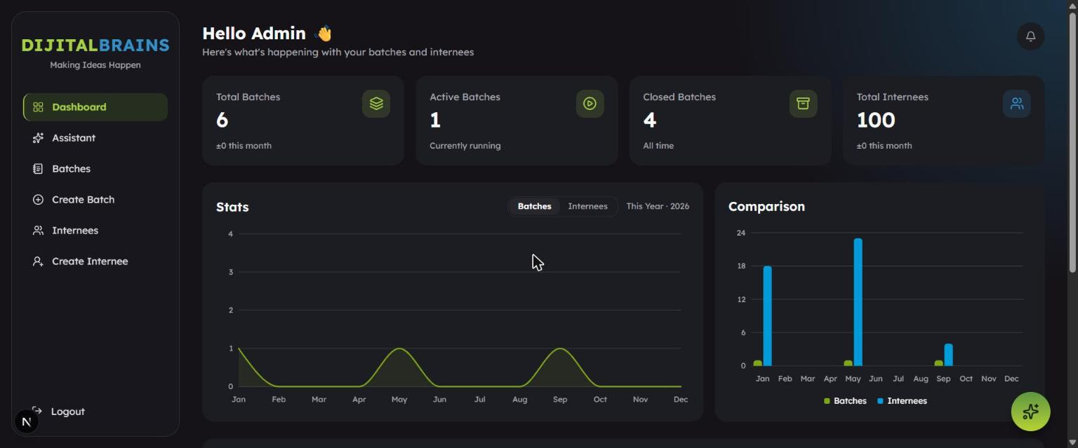
EV-01 — Dashboard with KPI cards and charts. KPIs (6/1/4/100) match DB; charts match 2026 data.
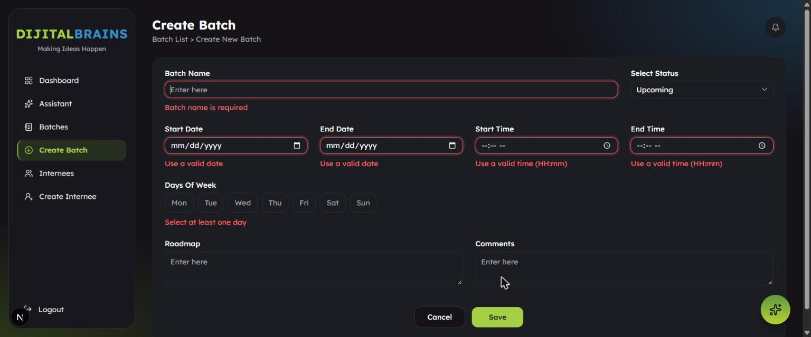
EV-02 — Create Batch — empty-form validation. Required-field errors for name, dates, times, weekday.
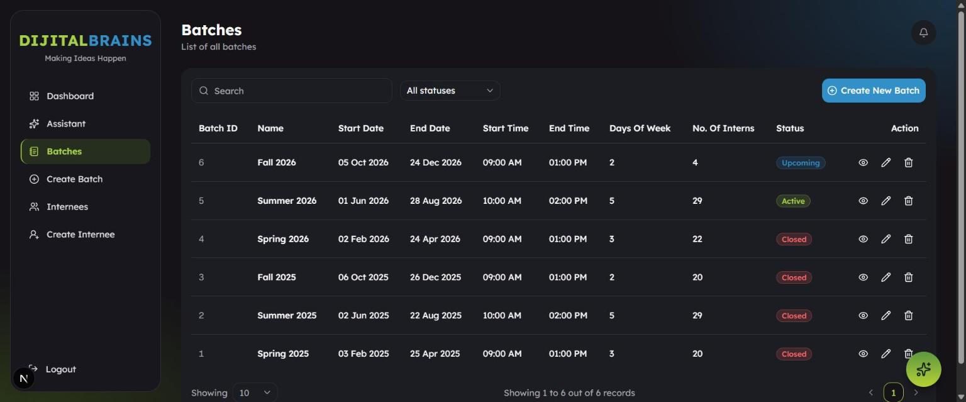
EV-03 — Batches list — 'Days Of Week' column. Column shows a count (2,5,3), not day names.
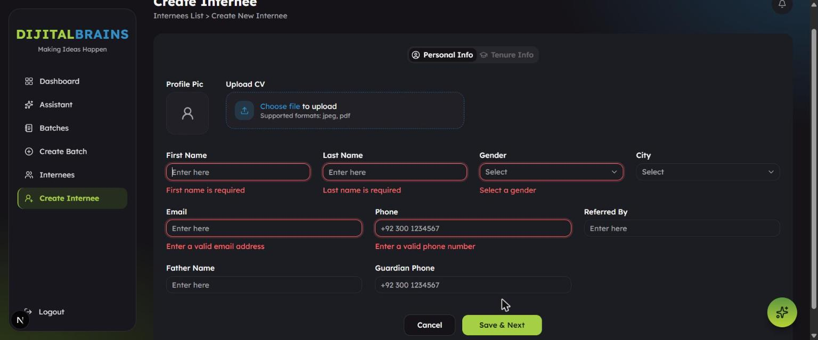
EV-04 — Create Internee — validation & CV label. Required errors; 'Supported formats: jpeg, pdf' label.
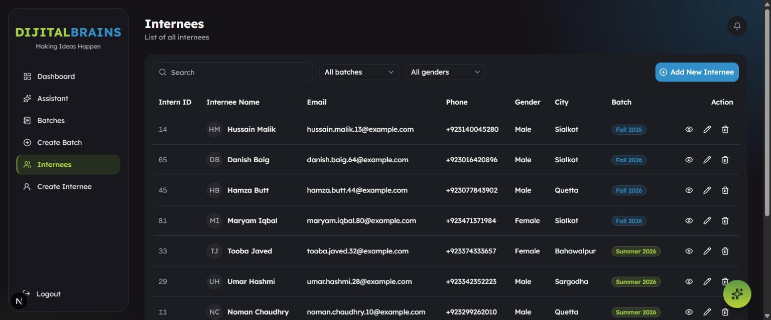
EV-05 — Internees list with filters & pagination. 100 internees, batch/gender filters, pagination.
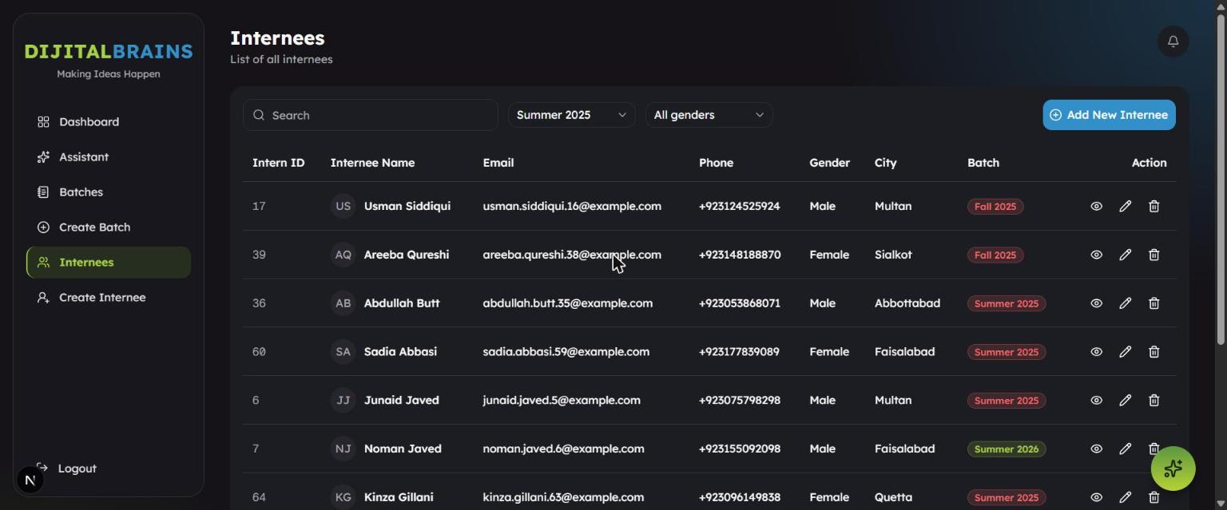
EV-06 — Internees filtered by Summer 2025. Chips show Fall 2025 / Summer 2026 — contradict the filter.
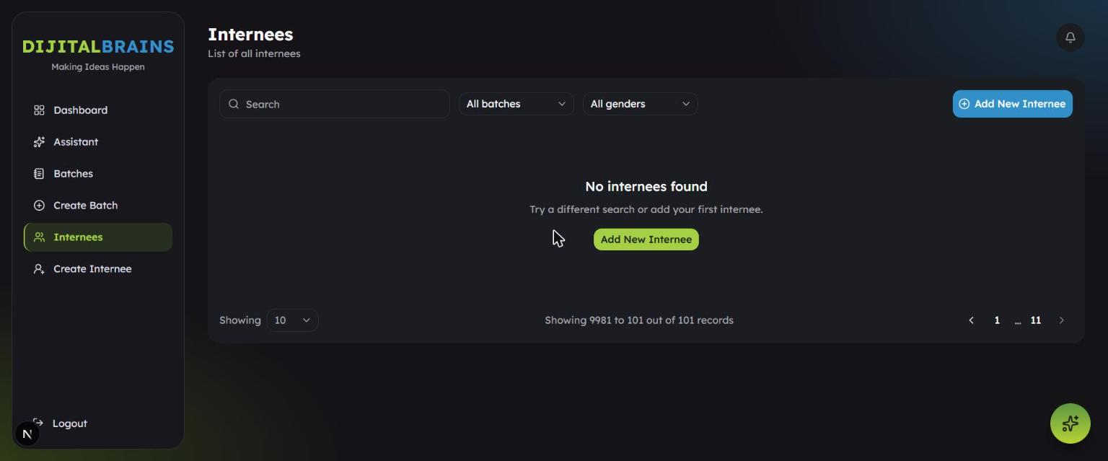
EV-07 — Internees ?page=999 (out of range). Empty list; footer 'Showing 9981 to 101 out of 101'.
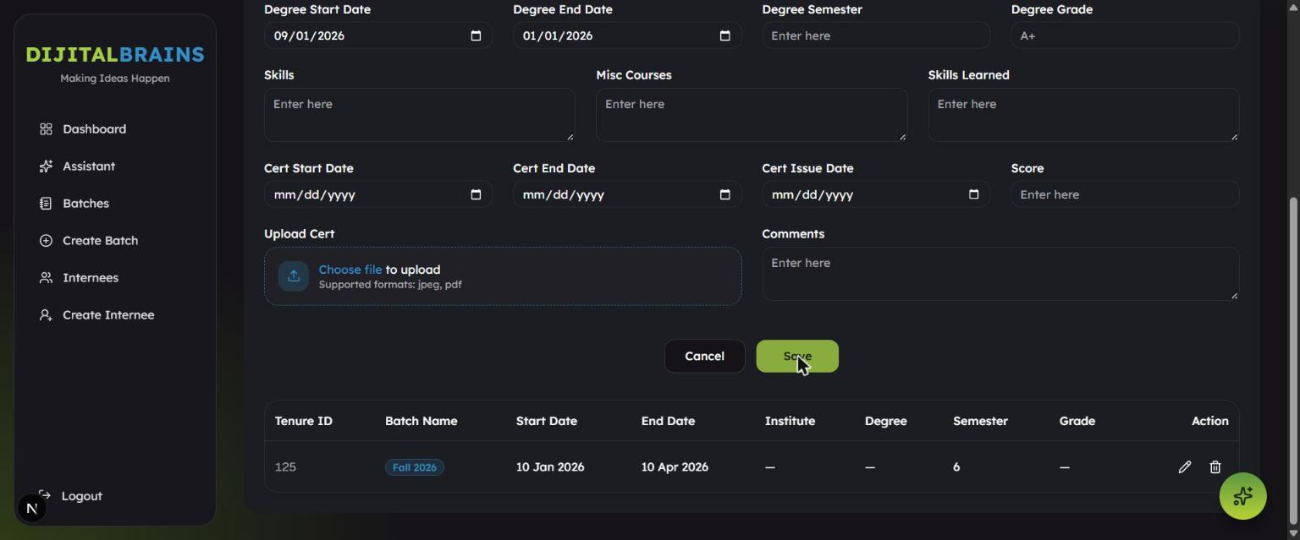
EV-08 — Tenure — reversed degree dates. Generic 'Invalid data' toast; no field highlighted.
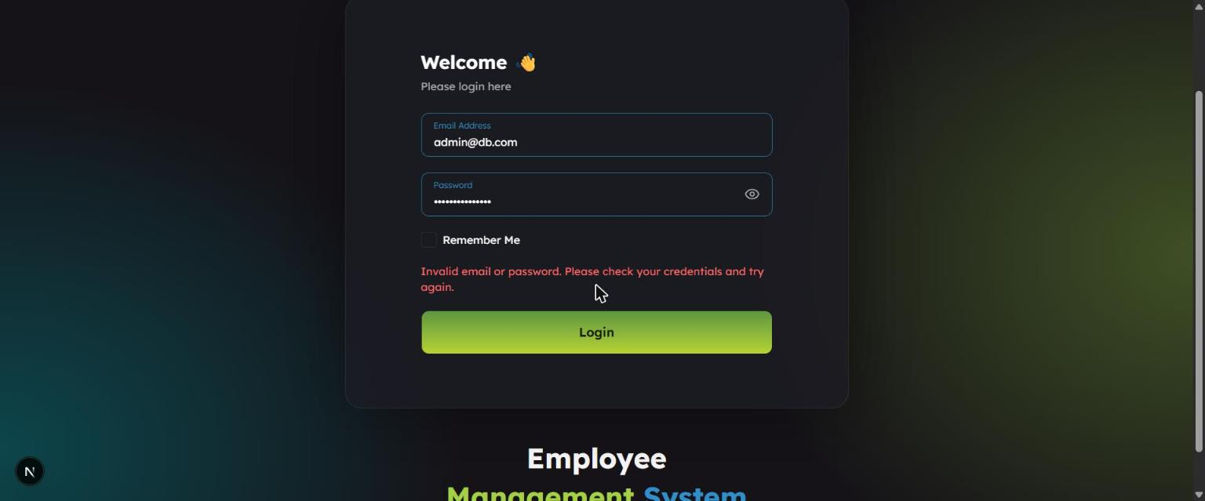
EV-09 — Login — wrong password. Generic 'Invalid email or password' (no enumeration).
EV-10 — Successful login — dashboard. Valid credentials land on the dashboard.

Appendix G — Group Contribution and Task Allocation
Member | Contribution Areas | Share
M. Hassan Ahmad (24F-3101) | Environment setup; Authentication, Dashboard, Batches testing; test-case design; metrics & charts; report authoring; consistency audit. | 50%
M. Ahmad Asghar (24F-3016) | Requirement analysis & RTM; Internees, Tenures, Lookups testing; defect logging; evidence collection; exploratory testing; reflection. | 50%
Both members jointly reviewed the test-case design, the defect list and the final report for consistency.

Appendix H — Reflection
What we learned. Running the application for real — rather than reasoning about it — changed what we found. Our most valuable defects (the batch-filter chip mismatch and the missing certificate-date validation) only became visible by combining a reading of the data model with deliberate, hands-on exploration, then confirming the outcome in the database. We also learned to distinguish an application defect from an environment limitation: the AI Assistant's failure was an external API billing error, not a bug, and we were careful not to log it as one.
Challenges. Getting the application to run took real debugging: the database connection string pointed at the wrong port and used credentials that did not exist on the running server, so no one could log in until the environment was corrected. During execution, UI timing caught us out — rapid, automated-style clicks were debounced by the 'Signing in…' state, which initially made the rate-limit test look inconclusive; we learned to pace actions and verify each step. We also had to design negative tests carefully to avoid corrupting the shared seed data, cleaning up every record we created.
Limitations. We tested one role on one machine with seeded data; account-lockout and Remember-Me are threshold/time dependent and were only configuration-verified; and all non-functional qualities were out of scope.
Lessons for defect detection & reporting. Boundary values and error-guessing produced the highest yield per test. Writing precise, reproducible steps — and attaching a screenshot or a database query as proof — made each defect credible and actionable. Finally, honest reporting matters: we found 8 genuine defects rather than inflating the count, and we clearly separated confirmed defects from intended behaviour and from items needing clarification.

Appendix I — 10-Minute Viva / Demo Script
Time | Segment | What to show / say
0:00–1:00 | Application & context | Open localhost:3000, log in as admin@db.com. Introduce EMS: admin-only internee management (batches, internees, tenures) + dashboard. Name the 6 tested modules.
1:00–2:30 | Testing approach | Explain manual black-box testing; 52 cases; all 5 techniques (give one live example: tenure score BVA 101 vs 85).
2:30–4:00 | Execution results | Show the metrics table & Figure 1: 50 executed, 42 passed = 84%, 0 Critical. Mention module-wise split and Figure 2 (defects by module).
4:00–7:00 | Key defects (live) | Demo DEF-002: add a tenure with Cert End before Cert Start → it saves (show DB). Demo DEF-001: filter internees by Summer 2025 → chips show other batches. Show DEF-008: /internees?page=999 → invalid footer. Mention DEF-003/004 briefly.
7:00–8:00 | Positive findings | Show generic login error (no enumeration), confirm-dialog soft delete, KPI update after a create.
8:00–9:00 | Charts & traceability | Show RTM linking requirements→tests→defects; Figures 1–2.
9:00–10:00 | Limitations & recommendation | State out-of-scope items; give the verdict: 'Ready with conditions' — fix DEF-001 & DEF-002 first. Take questions.

