6-11

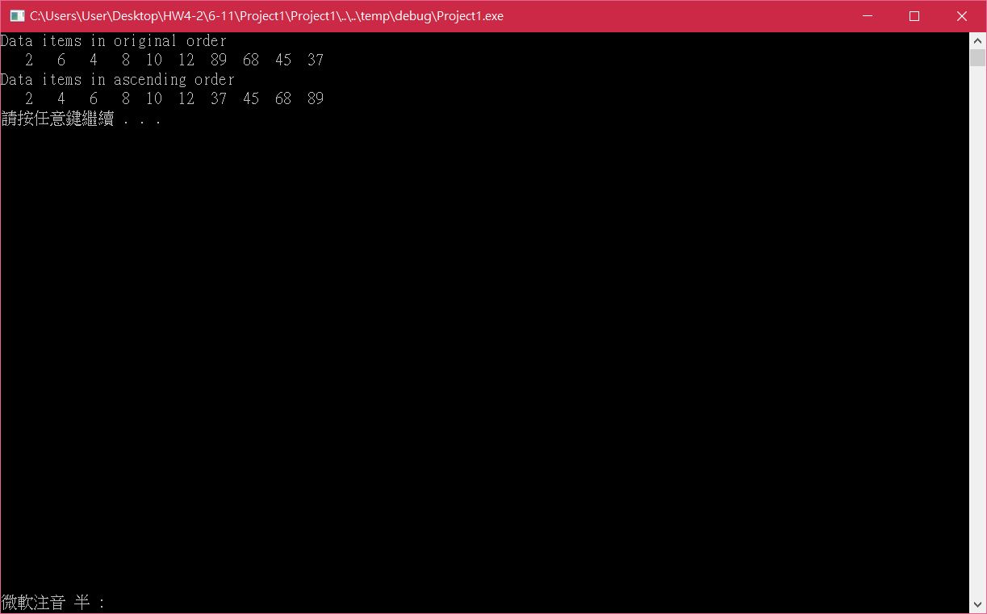

#include<stdio.h>

#include<stdlib.h>

#define SIZE 10

int main(void)

{

int a[SIZE] = { 2,6,4,8,10,12,89,68,45,37 };

int pass,hold,z,y=1;

size_t i;

puts("Data items in original order");

for (i = 0; i < SIZE; ++i)

printf("%4d", a[i]);

for ( pass = 1; pass < SIZE; pass++)

{

z = 1;

for (i = 0; i < SIZE - y; ++i)

{

if (a[i] > a[i + 1])

{

hold = a[i];

a[i] = a[i + 1];

a[i + 1] = hold;

}

else

z++;

}

if (z == (SIZE - y))

pass = SIZE;

y++;

}

puts("\nData items in ascending order");

for (i = 0; i < SIZE; ++i)

printf("%4d", a[i]);

puts("");

system("pause");

return 0;

}

git