P14

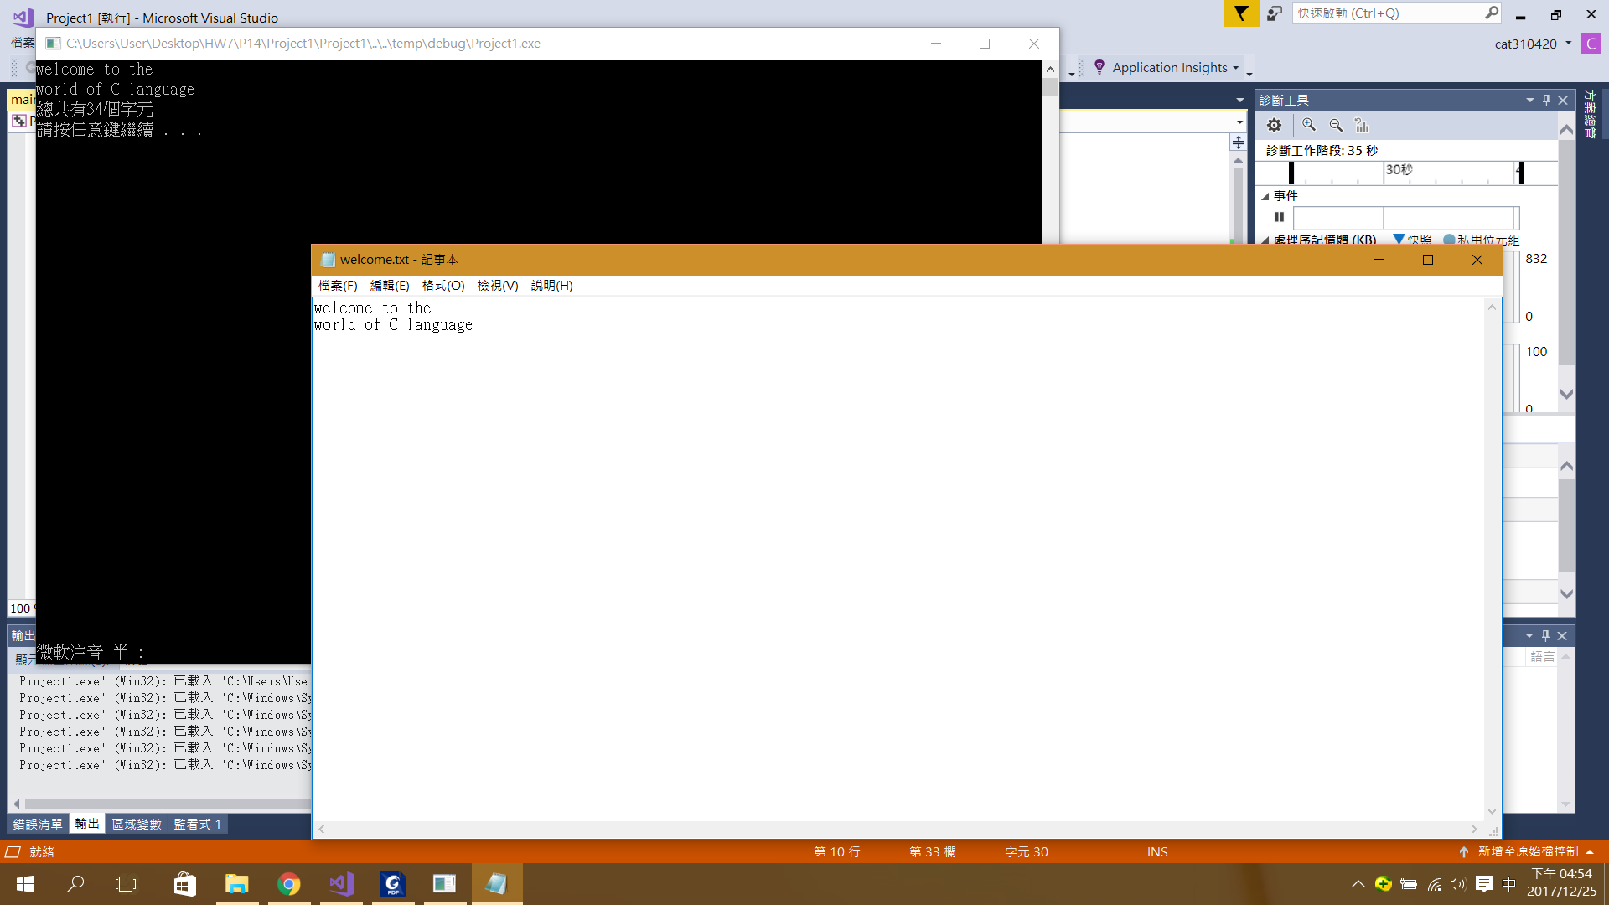

#include <stdio.h>

#include<stdlib.h>

int main(void)

{

FILE \*fptr;

char ch;

int count = 0;

fptr = fopen("D://welcome.txt", "r");

if (fptr != NULL)

{

while ((ch = getc(fptr)) != EOF)

{

printf("%c", ch);

count++;

}

fclose(fptr);

printf("\n總共有%d個字元\n", count);

}

else

printf("檔案開啟失敗!!\n");

system("pause");

return 0;

}

P15

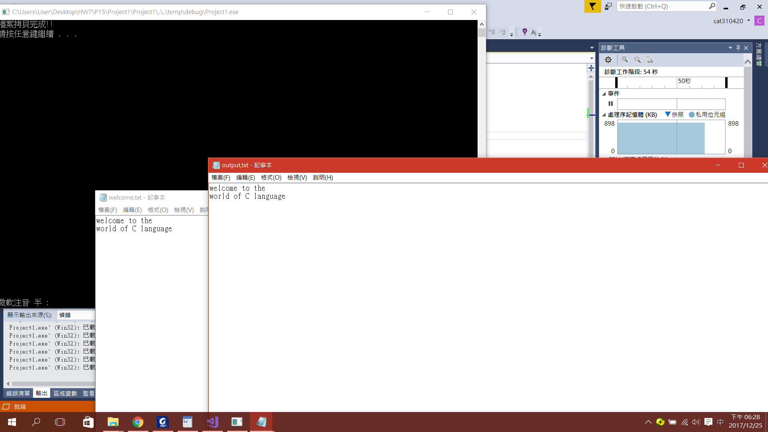

#include<stdio.h>

#include<stdlib.h>

int main(void)

{

FILE \*fptr1, \*fptr2;

char ch;

fptr1 = fopen("D://welcome.txt", "r");

fptr2 = fopen("D://output,txt", "w");

if ((fptr1 != NULL) && (fptr2 != NULL))

{

while ((ch = getc(fptr1)) != EOF)

putc(ch, fptr2);

fclose(fptr1);

fclose(fptr2);

printf("檔案拷貝完成!!\n");

}

else

printf("檔案開啟失敗!!\n");

system("pause");

return 0;

}

P16

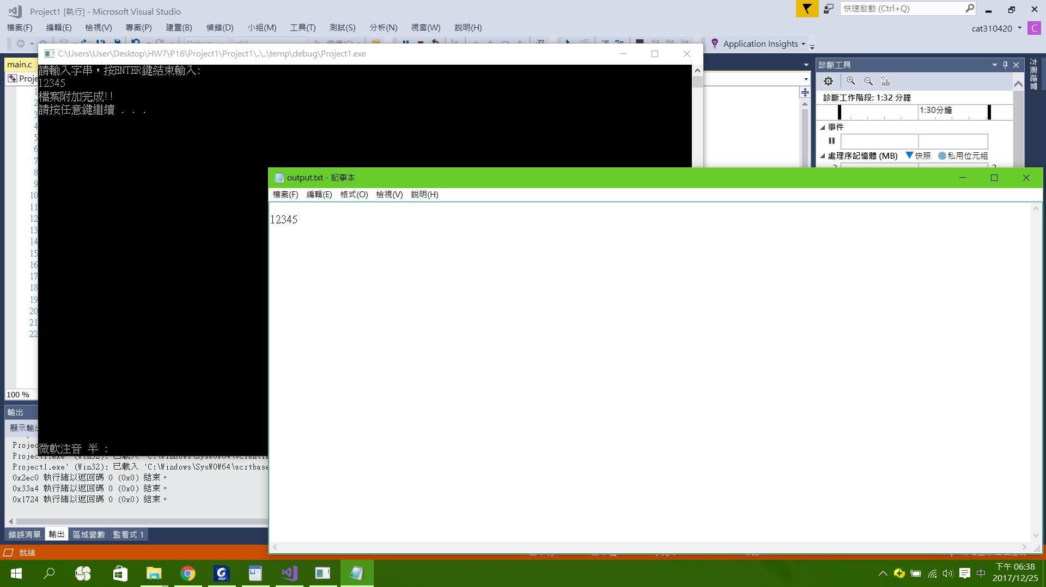

#include<stdio.h>

#include<conio.h>

#include<stdlib.h>

#define ENTER 13

#define MAX 80

int main(void)

{

FILE \*fptr;

char str[MAX], ch;

int i = 0;

fptr = fopen("D://output.txt", "a");

printf("請輸入字串，按ENTER鍵結束輸入:\n");

while ((ch = getche()) != ENTER && i < MAX)

str[i++] = ch;

putc('\n', fptr);

fwrite(str, sizeof(char), i, fptr);

fclose(fptr);

printf("\n檔案附加完成!!\n");

system("pause");

return 0;

}

P17

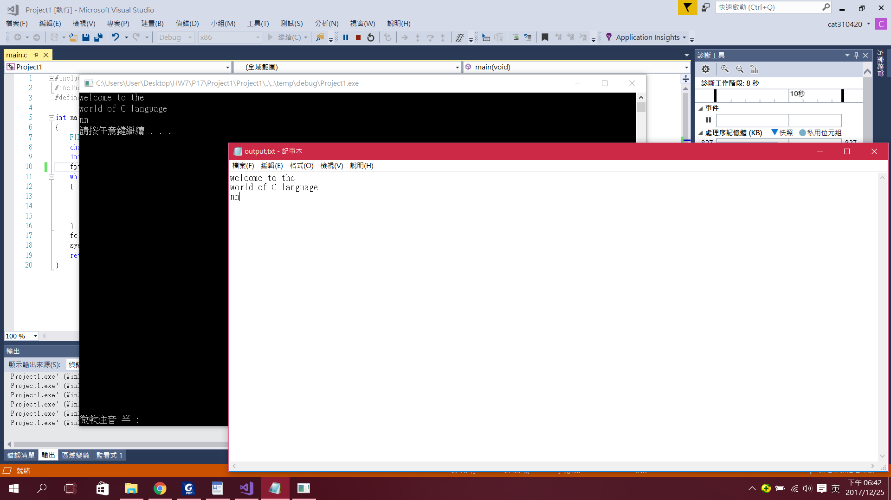

#include<stdio.h>

#include<stdlib.h>

#define MAX 80

int main(void)

{

FILE \*fptr;

char str[MAX];

int bytes;

fptr = fopen("D://output,txt", "r");

while (!feof(fptr))

{

bytes = fread(str, sizeof(char), MAX - 1, fptr);

str[bytes] = '\0';

printf("%s\n", str);

}

fclose(fptr);

system("pause");

return 0;

}

P18

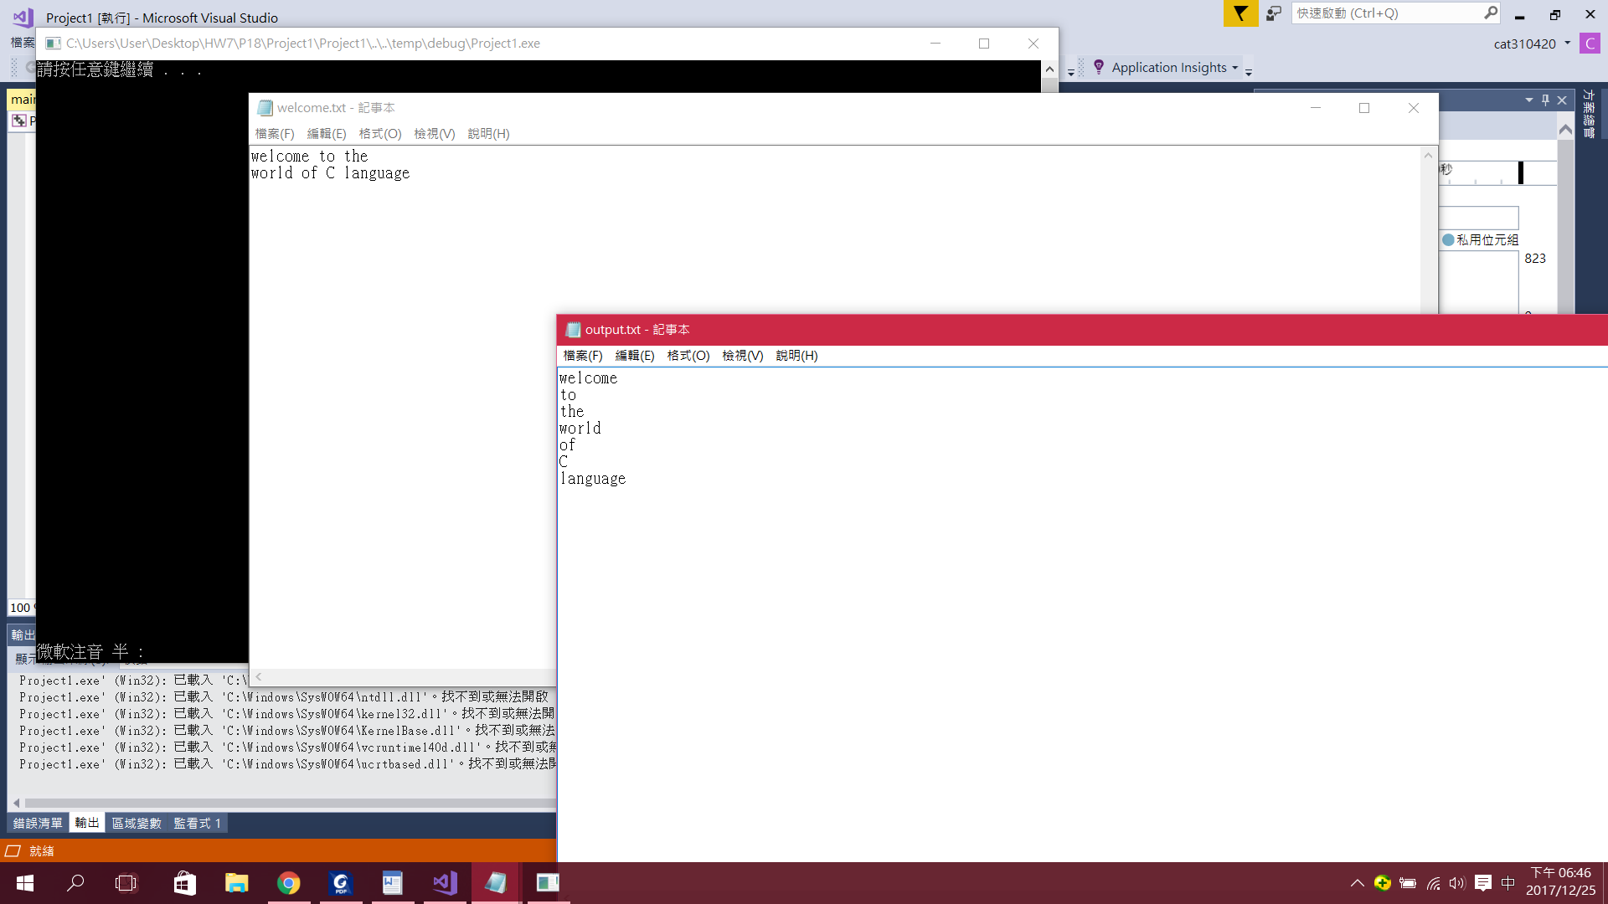

#include<stdio.h>

#include<stdlib.h>

int main(void)

{

FILE \*in, \*out;

int cnt;

char str[100];

in = fopen("D://welcome.txt", "r");

out = fopen("D://output.txt", "w");

while (!feof(in))

{

cnt = fscanf(in, "%s", str);

if (cnt > 0)

fprintf(out, "%s\n", str);

}

fclose(in);

fclose(out);

system("pause");

return 0;

}

Git

心得:

這次學到關於開啟以及修改檔案的基本技巧，讓我對C語言有更進一步的了解，感謝老師與助教的教導。