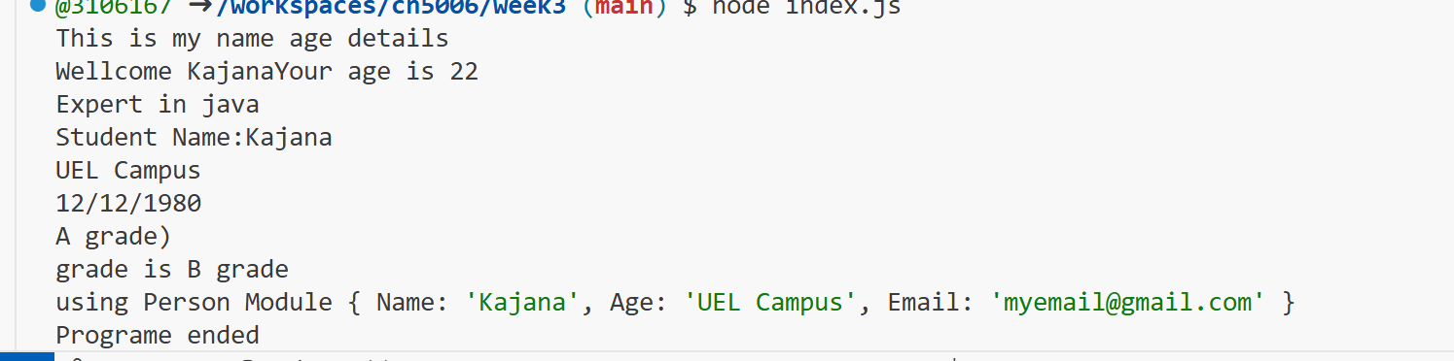

I learned how to run the code in GitHub.

