Section 2.2: Recursion
Programming exercises to practise recursion
These exercises will also test your problem-solving abilities! In some cases, there may be both iterative and recursive ways of solving these problems. You may like to implement both and see which you think is most efficient.

Exercise 1: Sum of numbers

Write a recursively-defined function SumTo which sums the first n positive non-zero integers. Incorporate this function into a program and test your program for n = 3, 6 and 4.
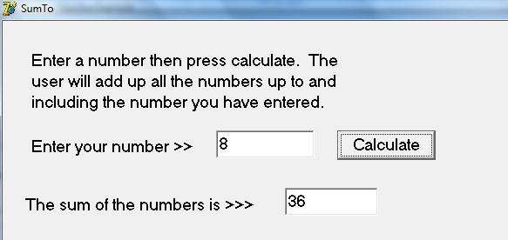

Exercise 2: Palindrome
Write a recursive function which checks if a word is a palindrome or not.
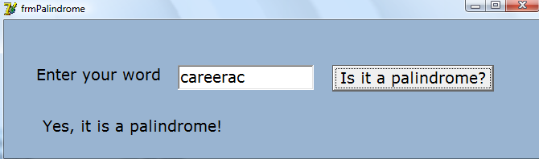
Exercise 3: PyramidCount
Write a recursively-defined function PyramidCount which calculates the number of billiard balls that can be stacked on top of each other if the base layer is contained in an equilateral triangle of side n balls. Incorporate this function into a program and test your program for n = 3, 6 and 4.
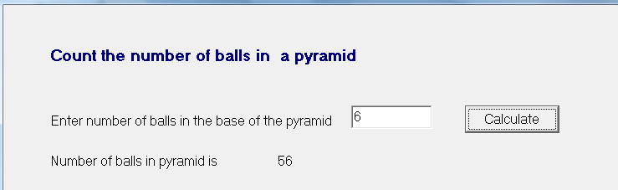
Exercise 4: Real Numbers
The language for expressing real numbers is defined as follows:

< digit > ::= 0|1|2|3|4|5|6|7|8|9
< number string > ::= < digit > | < digit > < number string >
< real number > ::= < number string > . < number string>
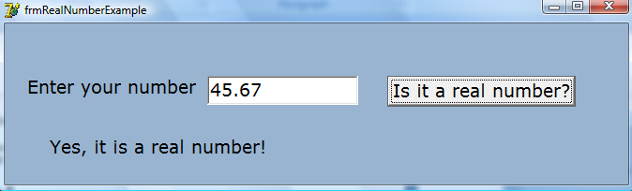
Write a program to test if an input string is a real number. You should use a function IsRealNumber which returns True or False.

