OBJECT MANAGEMENT GROUP (OMG) UNIFIED MODELING LANGUAGE SPECIFICATION
UML ARCHITECTURE & DESIGN SPECIFICATION
NeuroVerse: Adaptive Cognitive Health & Neuro-Rehabilitation Platform
Property | Value
Document Identifier | UML-NV-2026-V1.0
System Name | NeuroVerse (Edge Autonomous Mobile & Telehealth Cloud)
Specification Standard | OMG Unified Modeling Language (UML) Version 2.5.1
Architecture Pattern | Clean Architecture (Presentation, Domain Services, Hive Local, Firebase Cloud)
Scope of Diagrams | Use Case, Class, Sequence (5), Activity (3), State Machine (3), Component, Deployment
Project | Smart India Hackathon (SIH) 2026 — Prototype
Release Baseline | v1.0.0 Production-Ready Architecture
TABLE OF CONTENTS
1. Architectural Principles & Overview 3
2. Use Case Model & System Actors 3
2.1 Actor Taxonomy 3
2.2 Master Use Case Diagram 5
2.3 Detailed Use Case Specifications 7
3. Static Structural Model (Class Diagrams) 8
3.1 Core Domain Models 8
3.2 Core Services & AI Reinforcement Engine 9
3.3 State & Mediator Layer 10
3.4 Class Relationship Matrix 11
4. Dynamic Behavioral Model (Sequence Diagrams) 12
4.1 Sequence 1: Patient Adaptive Game Session Lifecycle 12
4.2 Sequence 2: Multilingual Offline-Resilient Voice Assistant Loop 13
4.3 Sequence 3: Fail-Safe Emergency SOS & Caregiver Interception 14
4.4 Sequence 4: Connect Code Handshake & Telemetry Sync 15
4.5 Sequence 5: ASHA Doorstep Screening & Doctor Clinical Triage 16
5. Behavioral Workflow Model (Activity Diagrams) 17
5.1 Activity 1: Q-Learning State Discretization, Reward & Frustration Defense 17
5.2 Activity 2: Offline-First Dual Mode Data Synchronization Workflow 19
5.3 Activity 3: Quiet Hours & Adherence Reminder Scheduling 20
6. State Machine Diagrams 21
6.1 State Machine 1: Patient Game Difficulty Lifecycle 21
6.2 State Machine 2: Rural Elder Cognitive Risk Stratification 22
6.3 State Machine 3: SOS Alert Event Lifecycle 23
7. Implementation & Deployment Architecture 24
7.1 Component Diagram (Clean Architecture Layering) 24
7.2 Deployment Diagram (Hardware Nodes & Cloud Topology) 25

1. Architectural Principles & Overview
This document details the complete UML 2.5.1 architectural and design specification for NeuroVerse, a high-reliability tele-rehabilitation platform. NeuroVerse is constructed under strict Clean Architecture patterns:
- Edge Autonomy: Core cognitive training, reinforcement learning, speech recognition fallback, and data persistence execute 100% offline.
- Separation of Concerns: Presentation (features/) ↔ State Mediator (AppProvider) ↔ Intelligent Services (core/services/) ↔ Encrypted Local Vault (HiveService) ↔ Remote Cloud Telemetry (FirestoreService).
- Hardware Redundancy: Safety-critical workflows (such as Emergency SOS) combine native Android hardware baseband (SmsManager) with cloud Firestore streams to ensure delivery under complete cellular data loss.

2. Use Case Model & System Actors

2.1 Actor Taxonomy
NeuroVerse defines five primary actors interacting with the system across four operational boundaries. The generalization hierarchy and key operations of each actor are shown below.
Actor Name | Domain / Role | System Responsibilities & Touchpoints
Elderly Patient | Primary Edge User | Plays cognitive mini-games, interacts with multilingual Voice AI companion, receives daily habit reminders, triggers Emergency SOS.
Family Caregiver | Remote Health Monitor | Pairs with patient via 6-character Connect Code, monitors real-time telemetry accordions, manages Face Recall Family Album photos, reviews Smart Alerts, schedules remote medication and hydration reminders.
ASHA Worker | Frontline Community Worker | Conducts doorstep 3-minute stealth cognitive screening tests, registers rural village elders with ABHA IDs, logs standardized skip reasons, syncs offline logs.
PHC Medical Officer | Clinical Authority (Doctor) | Supervises regional health center (PHC-JHT-108), approves ASHA registrations, schedules village field drives with equal workload division, triages critical cognitive decline alerts, issues hospital referral tokens.
System Administrator | Platform Governance | Monitors platform health distributions, manages account suspension/reactivation, broadcasts platform-wide announcements. No access to individual clinical health data.
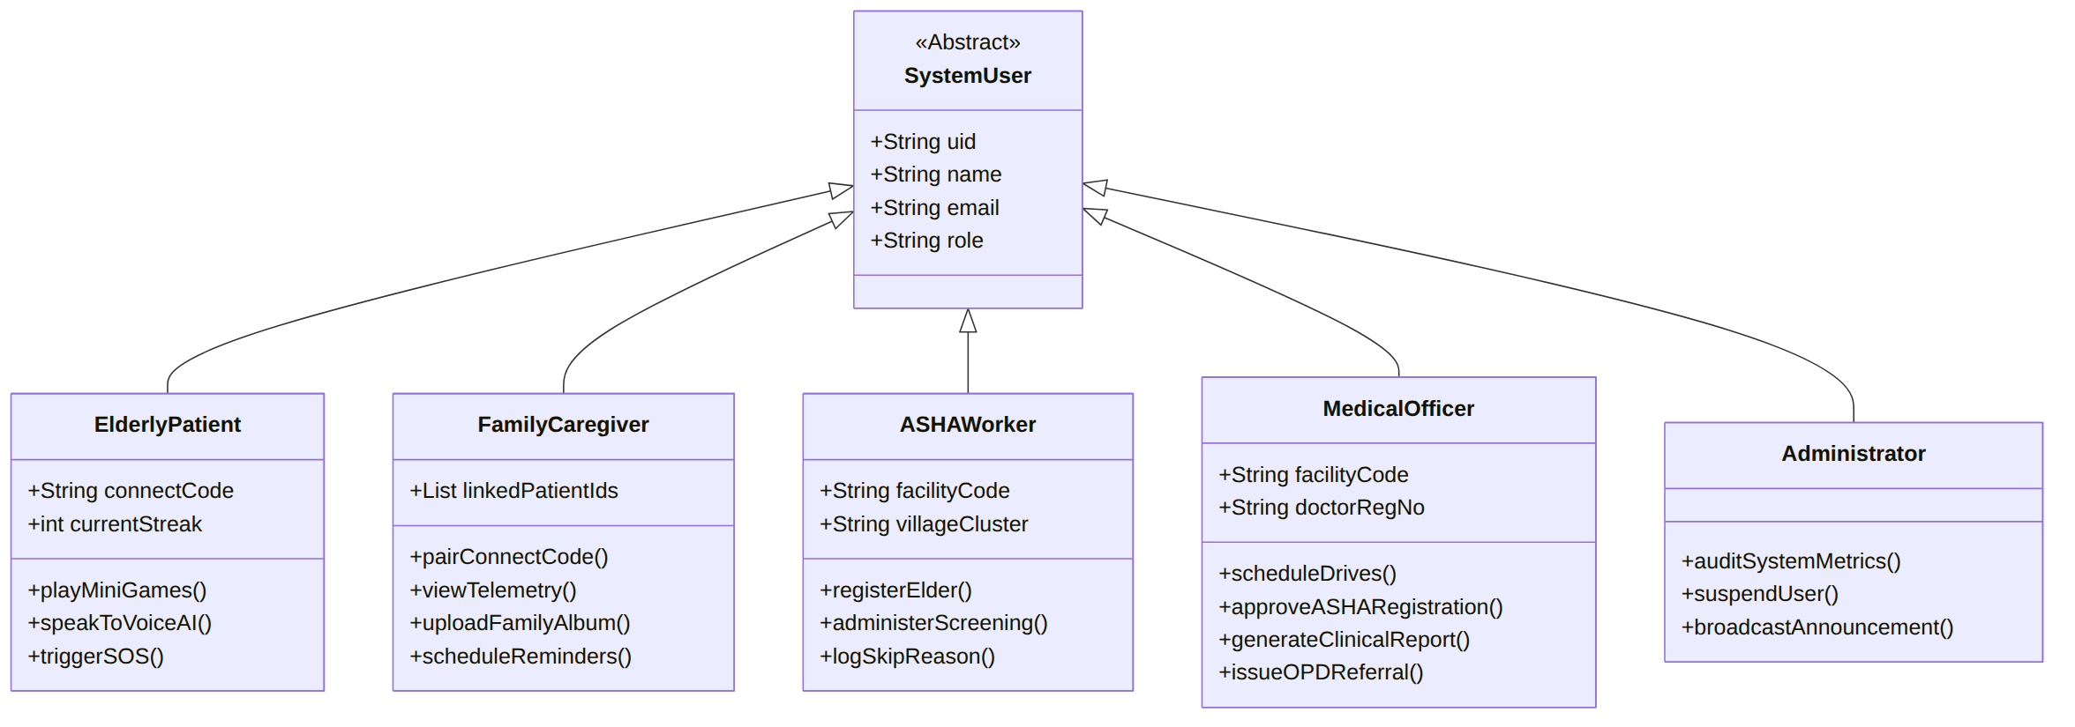
Figure 1: Actor Taxonomy

2.2 Master Use Case Diagram
The master use case model is shown in two parts for legibility. Part A covers the Elderly Patient and Family Caregiver; Part B covers the ASHA Worker, PHC Medical Officer and Administrator. UC-01 (Authenticate & Select Language) is shared by all actors.
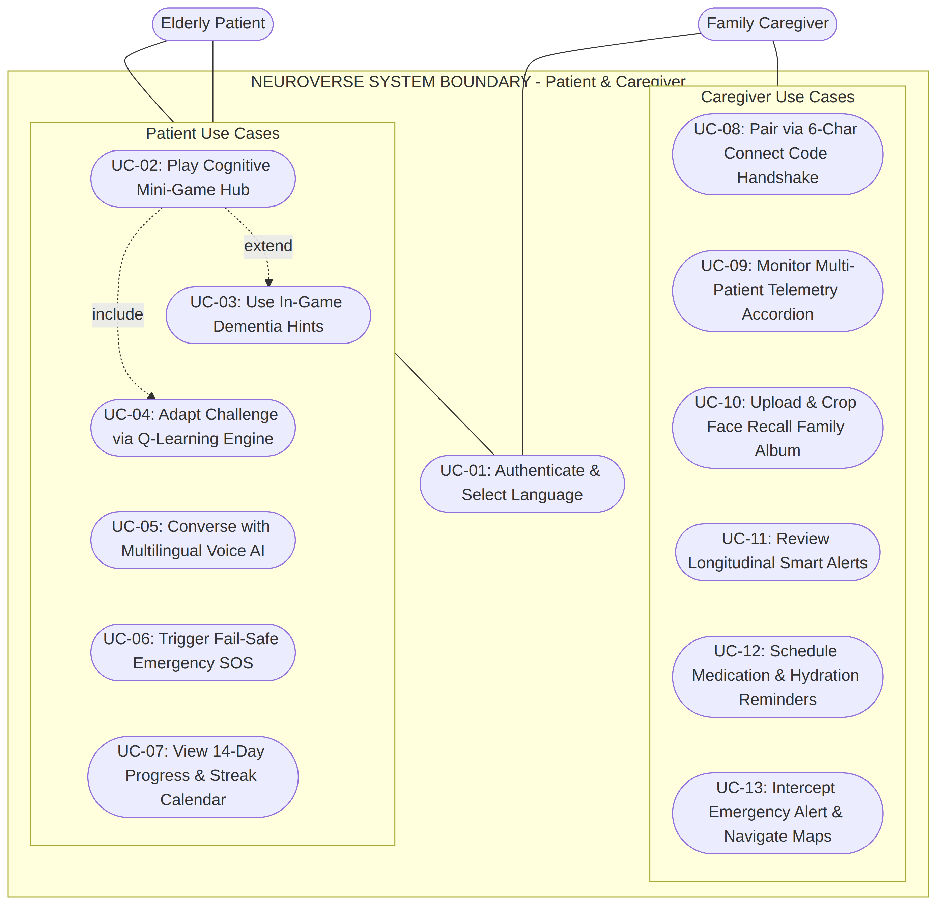
Figure 2: Master Use Case Diagram, Part A: Patient & Caregiver
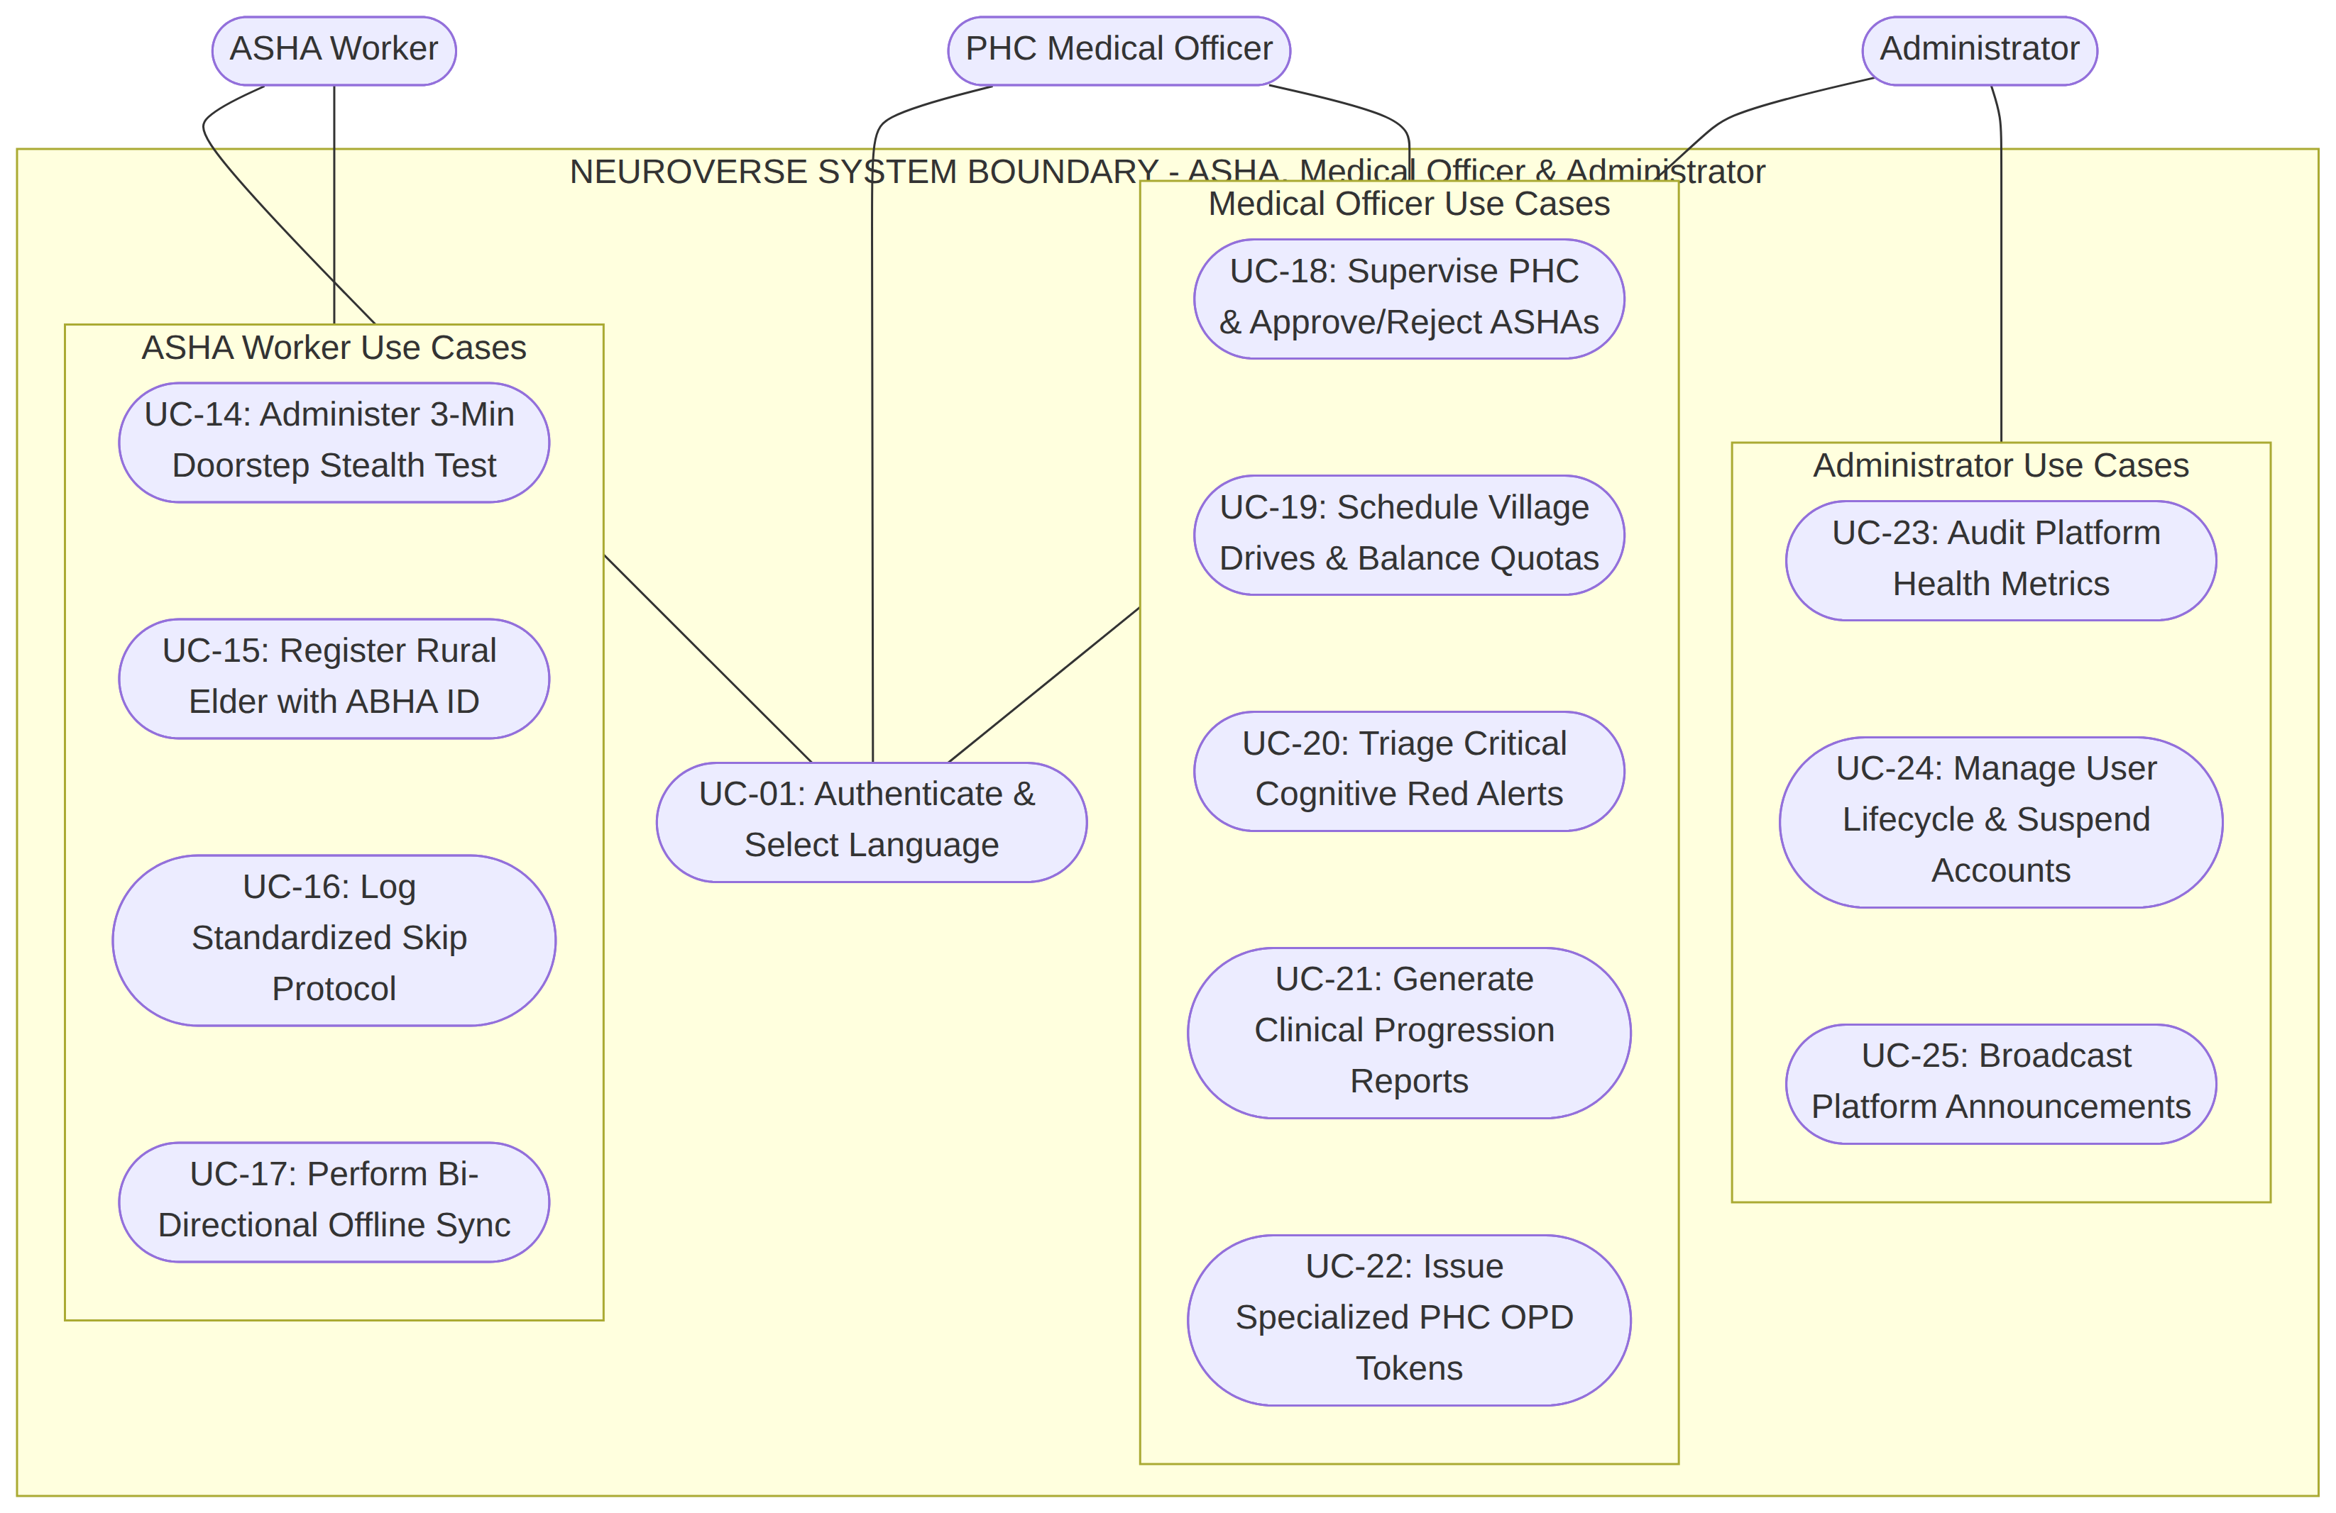
Figure 3: Master Use Case Diagram, Part B: ASHA Worker, Medical Officer & Administrator

2.3 Detailed Use Case Specifications
ID | Use Case | Primary Actor
UC-01 | Authenticate & Select Language | All actors
UC-02 | Play Cognitive Mini-Game Hub | Elderly Patient
UC-03 | Use In-Game Hints | Elderly Patient
UC-04 | Adapt Difficulty via Q-Learning Engine | Elderly Patient
UC-05 | Converse with Multilingual Voice AI | Elderly Patient
UC-06 | Trigger Fail-Safe Emergency SOS Lifeline | Elderly Patient
UC-07 | View 14-Day Progress & Active Streak Calendar | Elderly Patient
UC-08 | Pair via 6-Character Connect Code Handshake | Family Caregiver
UC-09 | Monitor Multi-Patient Telemetry Accordion | Family Caregiver
UC-10 | Upload & Label Face Recall Family Album | Family Caregiver
UC-11 | Review Longitudinal Smart Alerts [Struggle, Gaps, Plunge] | Family Caregiver
UC-12 | Schedule Medication & Hydration Reminders | Family Caregiver
UC-13 | Intercept Emergency SOS Call & Navigate via Google Maps | Family Caregiver
UC-14 | Administer 3-Minute Doorstep Stealth Cognitive Screening | ASHA Worker
UC-15 | Register Village Elder with ABHA ID & Guardian Info | ASHA Worker
UC-16 | Log Standardized Skip Reason [Floods, Farmwork, Ill, Refusal] | ASHA Worker
UC-17 | Perform Bi-Directional Offline Queue Cloud Sync | ASHA Worker
UC-18 | Supervise PHC Facility & Approve/Reject ASHA Registrations | PHC Medical Officer
UC-19 | Schedule Village Drives with Equal Patient Workload Division | PHC Medical Officer
UC-20 | Triage Critical Cognitive Decline Red Alerts | PHC Medical Officer
UC-21 | Generate Clinical Progression & ASHA Supervision Reports | PHC Medical Officer
UC-22 | Issue Specialized PHC OPD Clinical Referral Tokens | PHC Medical Officer
UC-23 | Audit Platform Health & Active User Distributions | System Administrator
UC-24 | Manage User Lifecycle & Enforce Account Suspensions | System Administrator
UC-25 | Broadcast Platform-Wide Administrative Bulletins | System Administrator

3. Static Structural Model (Class Diagrams)

3.1 Core Domain Models
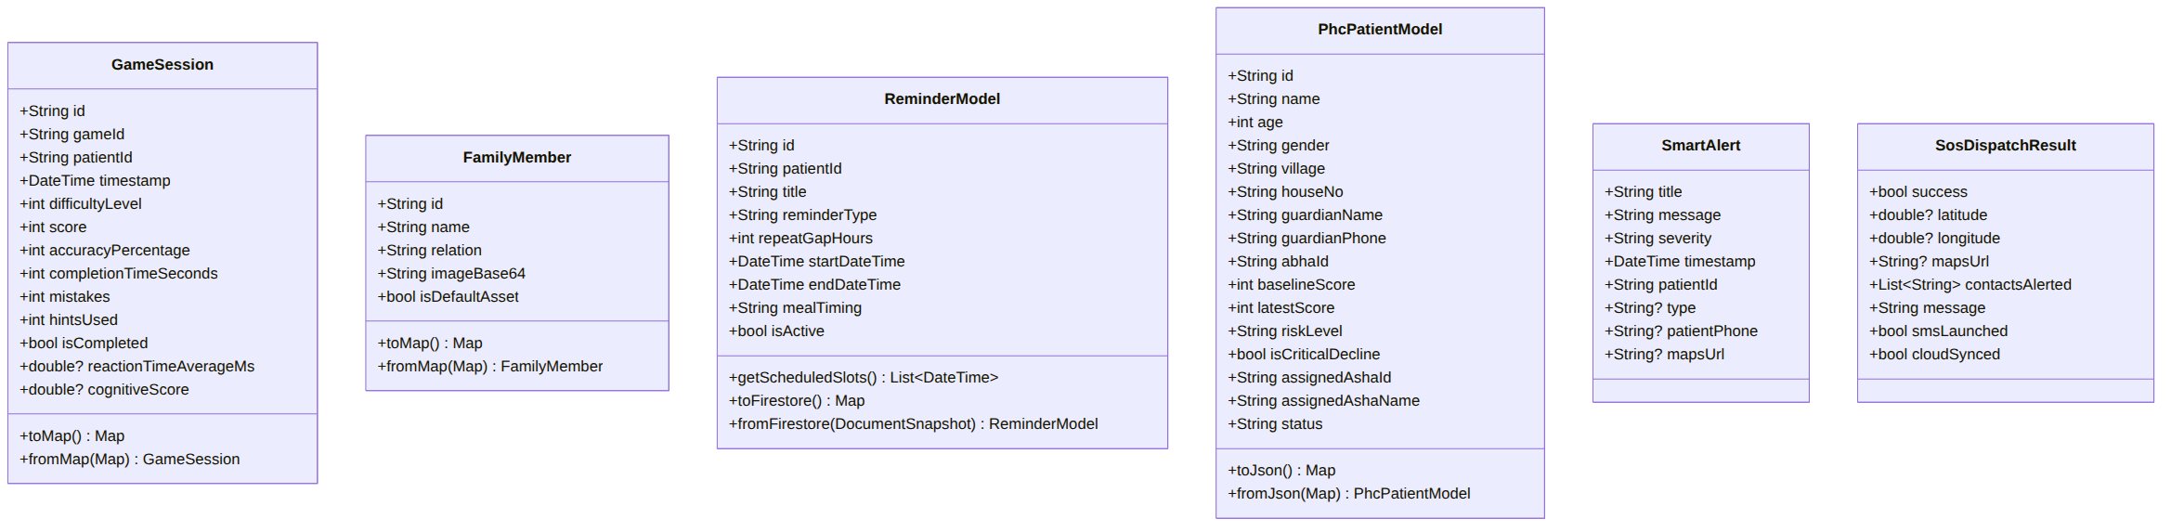
Figure 4: Core Domain Models

3.2 Core Services & AI Reinforcement Engine
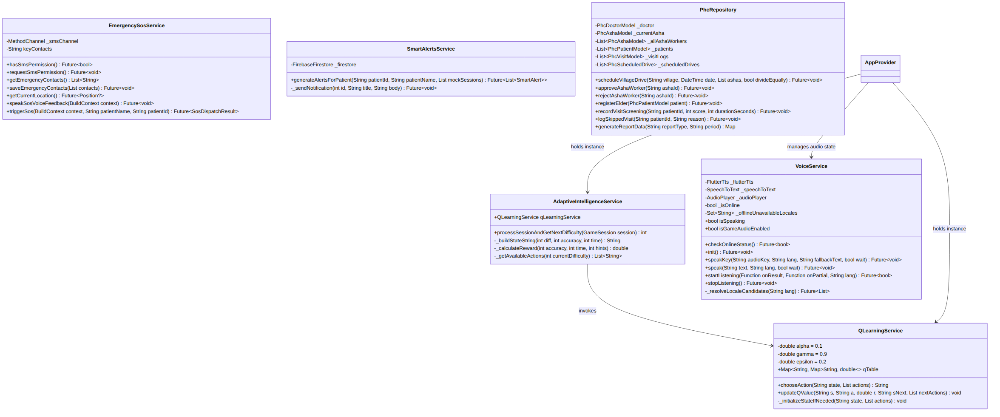
Figure 5: Core Services & AI Reinforcement Engine

3.3 State & Mediator Layer
AppProvider is the ChangeNotifier-based mediator between the presentation layer and the intelligent services. It holds the QLearningService, AdaptiveIntelligenceService and VoiceService instances, brokers all reads and writes to the encrypted HiveService vault, and exposes the isDataSynced flag that drives the green/orange cloud indicator.
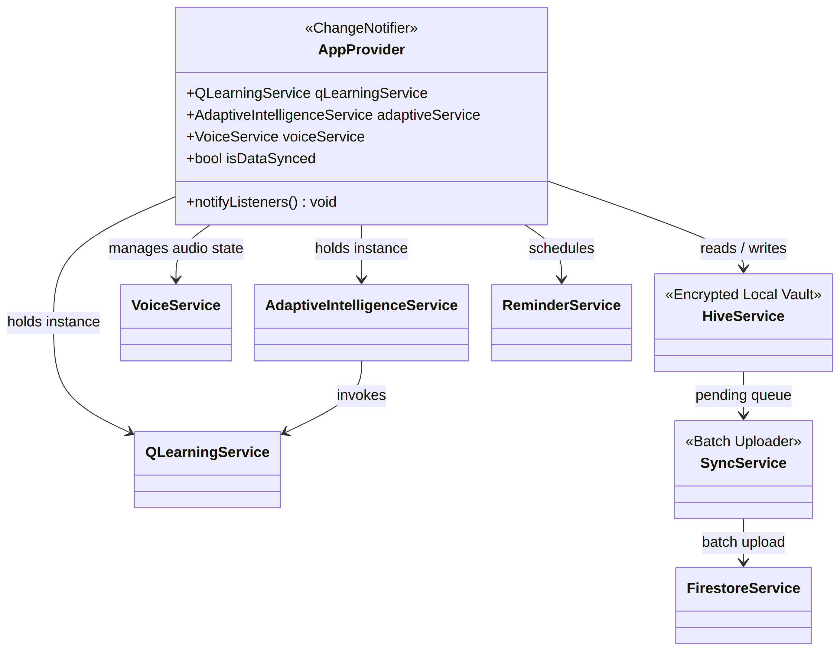
Figure 6: State & Mediator Layer

3.4 Class Relationship Matrix
Class / Unit | Architectural Layer | Primary Collaborators | Design Pattern Employed
QLearningService | Domain Intelligence | AdaptiveIntelligenceService, Hive Box | Strategy / Value Iteration MDP Policy
VoiceService | Hardware Adapter / Audio | speech_to_text, flutter_tts, audioplayers | Facade & Resilient Fallback Pattern
EmergencySosService | Safety Critical Service | geolocator, SmsManager MethodChannel, Firestore | Command / Chain of Responsibility
SmartAlertsService | Longitudinal Telemetry | FirestoreService, NotificationService, Hive | Observer / Metric Evaluator
PhcRepository | Domain Aggregate | PhcAshaModel, PhcDoctorModel, PhcPatientModel | Repository & Change Notifier Hub
AppProvider | Application State Hub | HiveService, ReminderService, VoiceService | Provider / Mediator Pattern

4. Dynamic Behavioral Model (Sequence Diagrams)

4.1 Sequence 1: Patient Adaptive Game Session Lifecycle
Traces the execution of an elderly cognitive session from difficulty calculation to reward computation, Q-table updating, encrypted Hive caching, and asynchronous background Firestore batch sync.
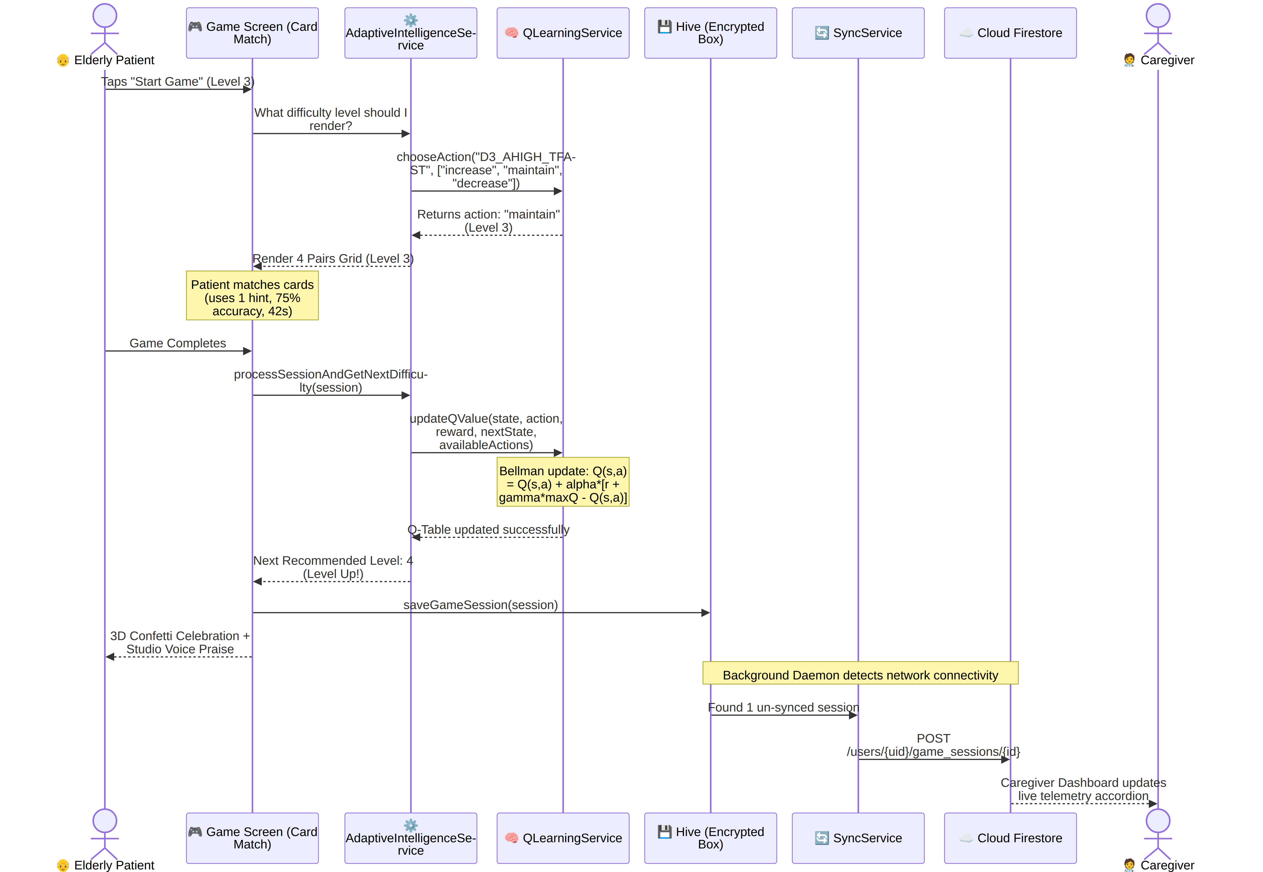
Figure 7: Sequence 1: Patient Adaptive Game Session Lifecycle

4.2 Sequence 2: Multilingual Offline-Resilient Voice Assistant Loop
Illustrates speech capture, online/offline acoustic model resolution, Unicode character dialect classification, and dual audio dispatch.
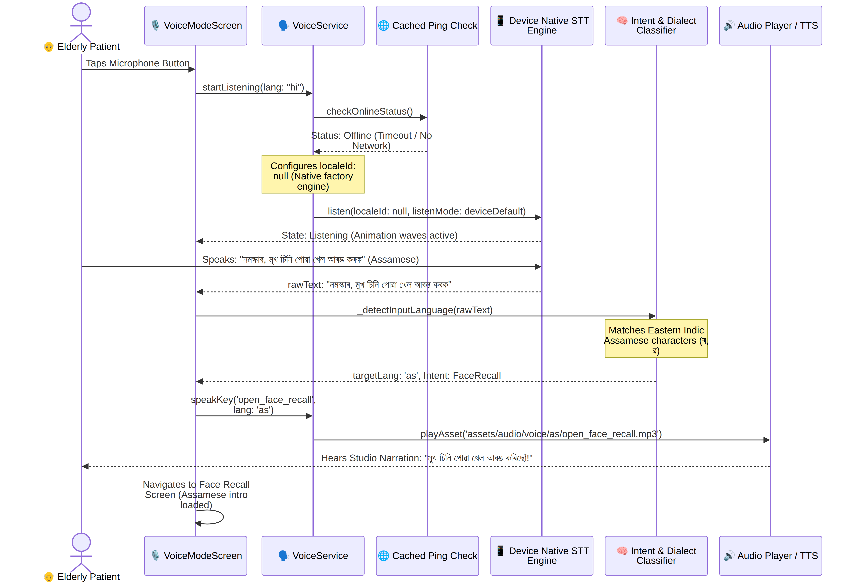
Figure 8: Sequence 2: Multilingual Offline-Resilient Voice Assistant Loop

4.3 Sequence 3: Fail-Safe Emergency SOS & Caregiver Interception
Depicts the multi-channel emergency distress sequence combining local voice feedback, satellite GPS locking, silent baseband SMS transmission, and cloud alert dialog interception.
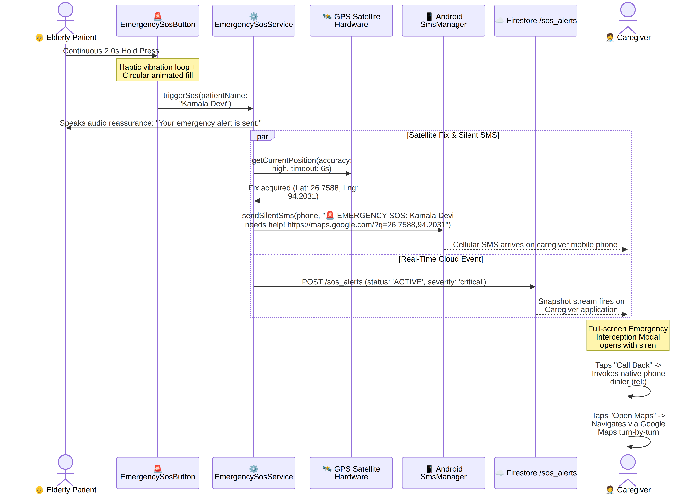
Figure 9: Sequence 3: Fail-Safe Emergency SOS & Caregiver Interception

4.4 Sequence 4: Connect Code Handshake & Telemetry Sync
Shows how a caregiver pairs with a patient using the 6-character Connect Code and how live telemetry begins streaming after the patient accepts.
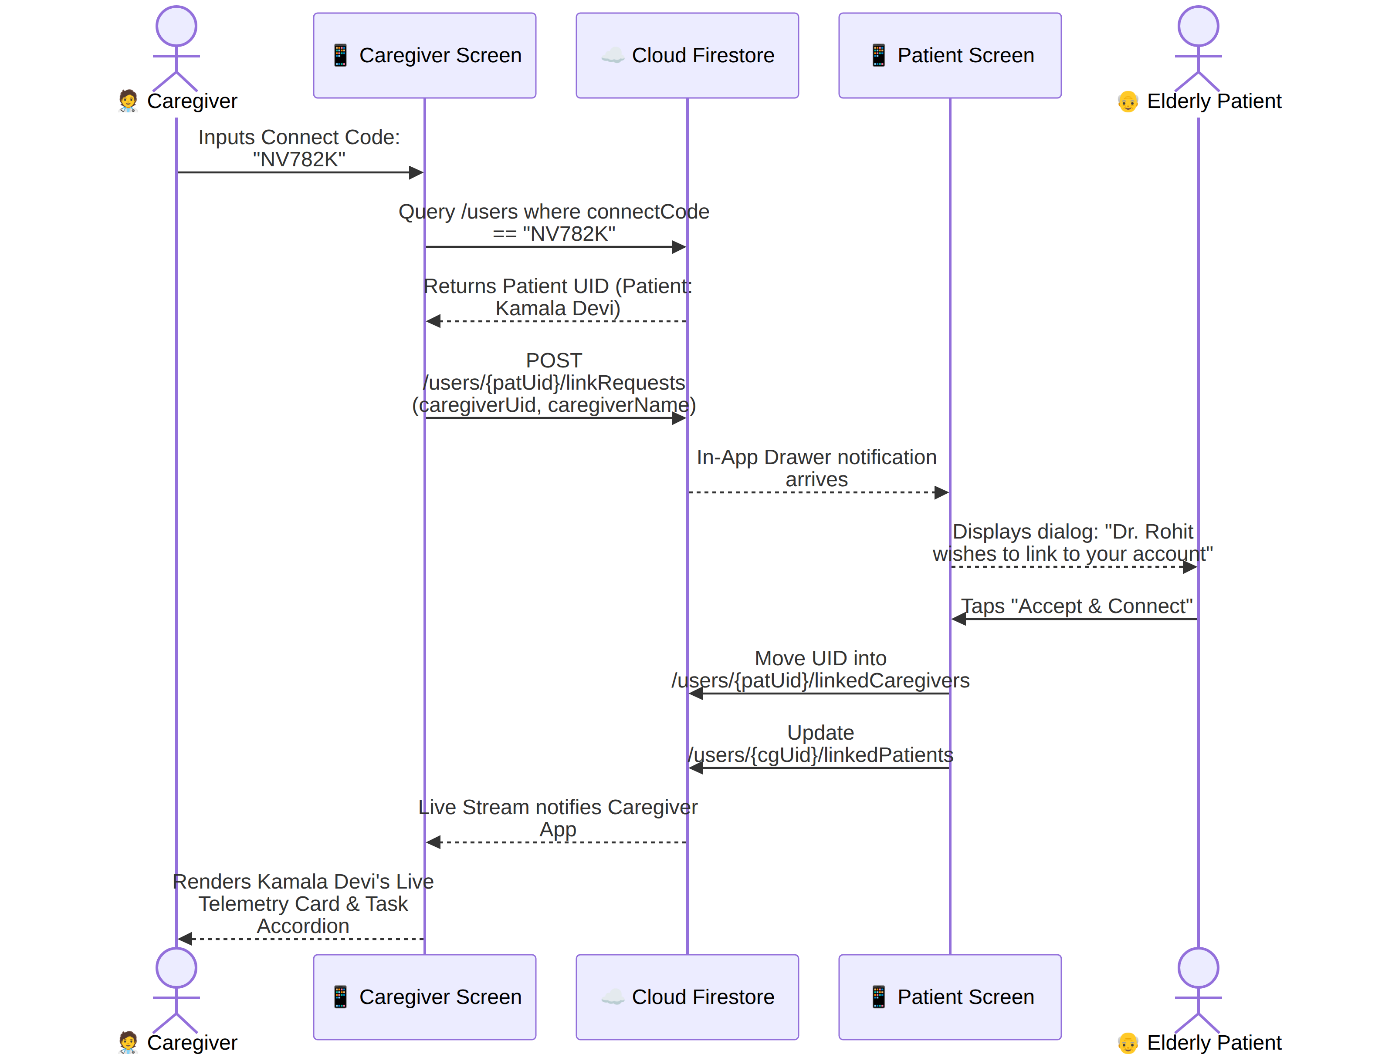
Figure 10: Sequence 4: Connect Code Handshake & Telemetry Sync

4.5 Sequence 5: ASHA Doorstep Screening & Doctor Clinical Triage
Follows a village drive from scheduling by the doctor, through the ASHA doorstep screening, to the red-alert triage and referral token issue.
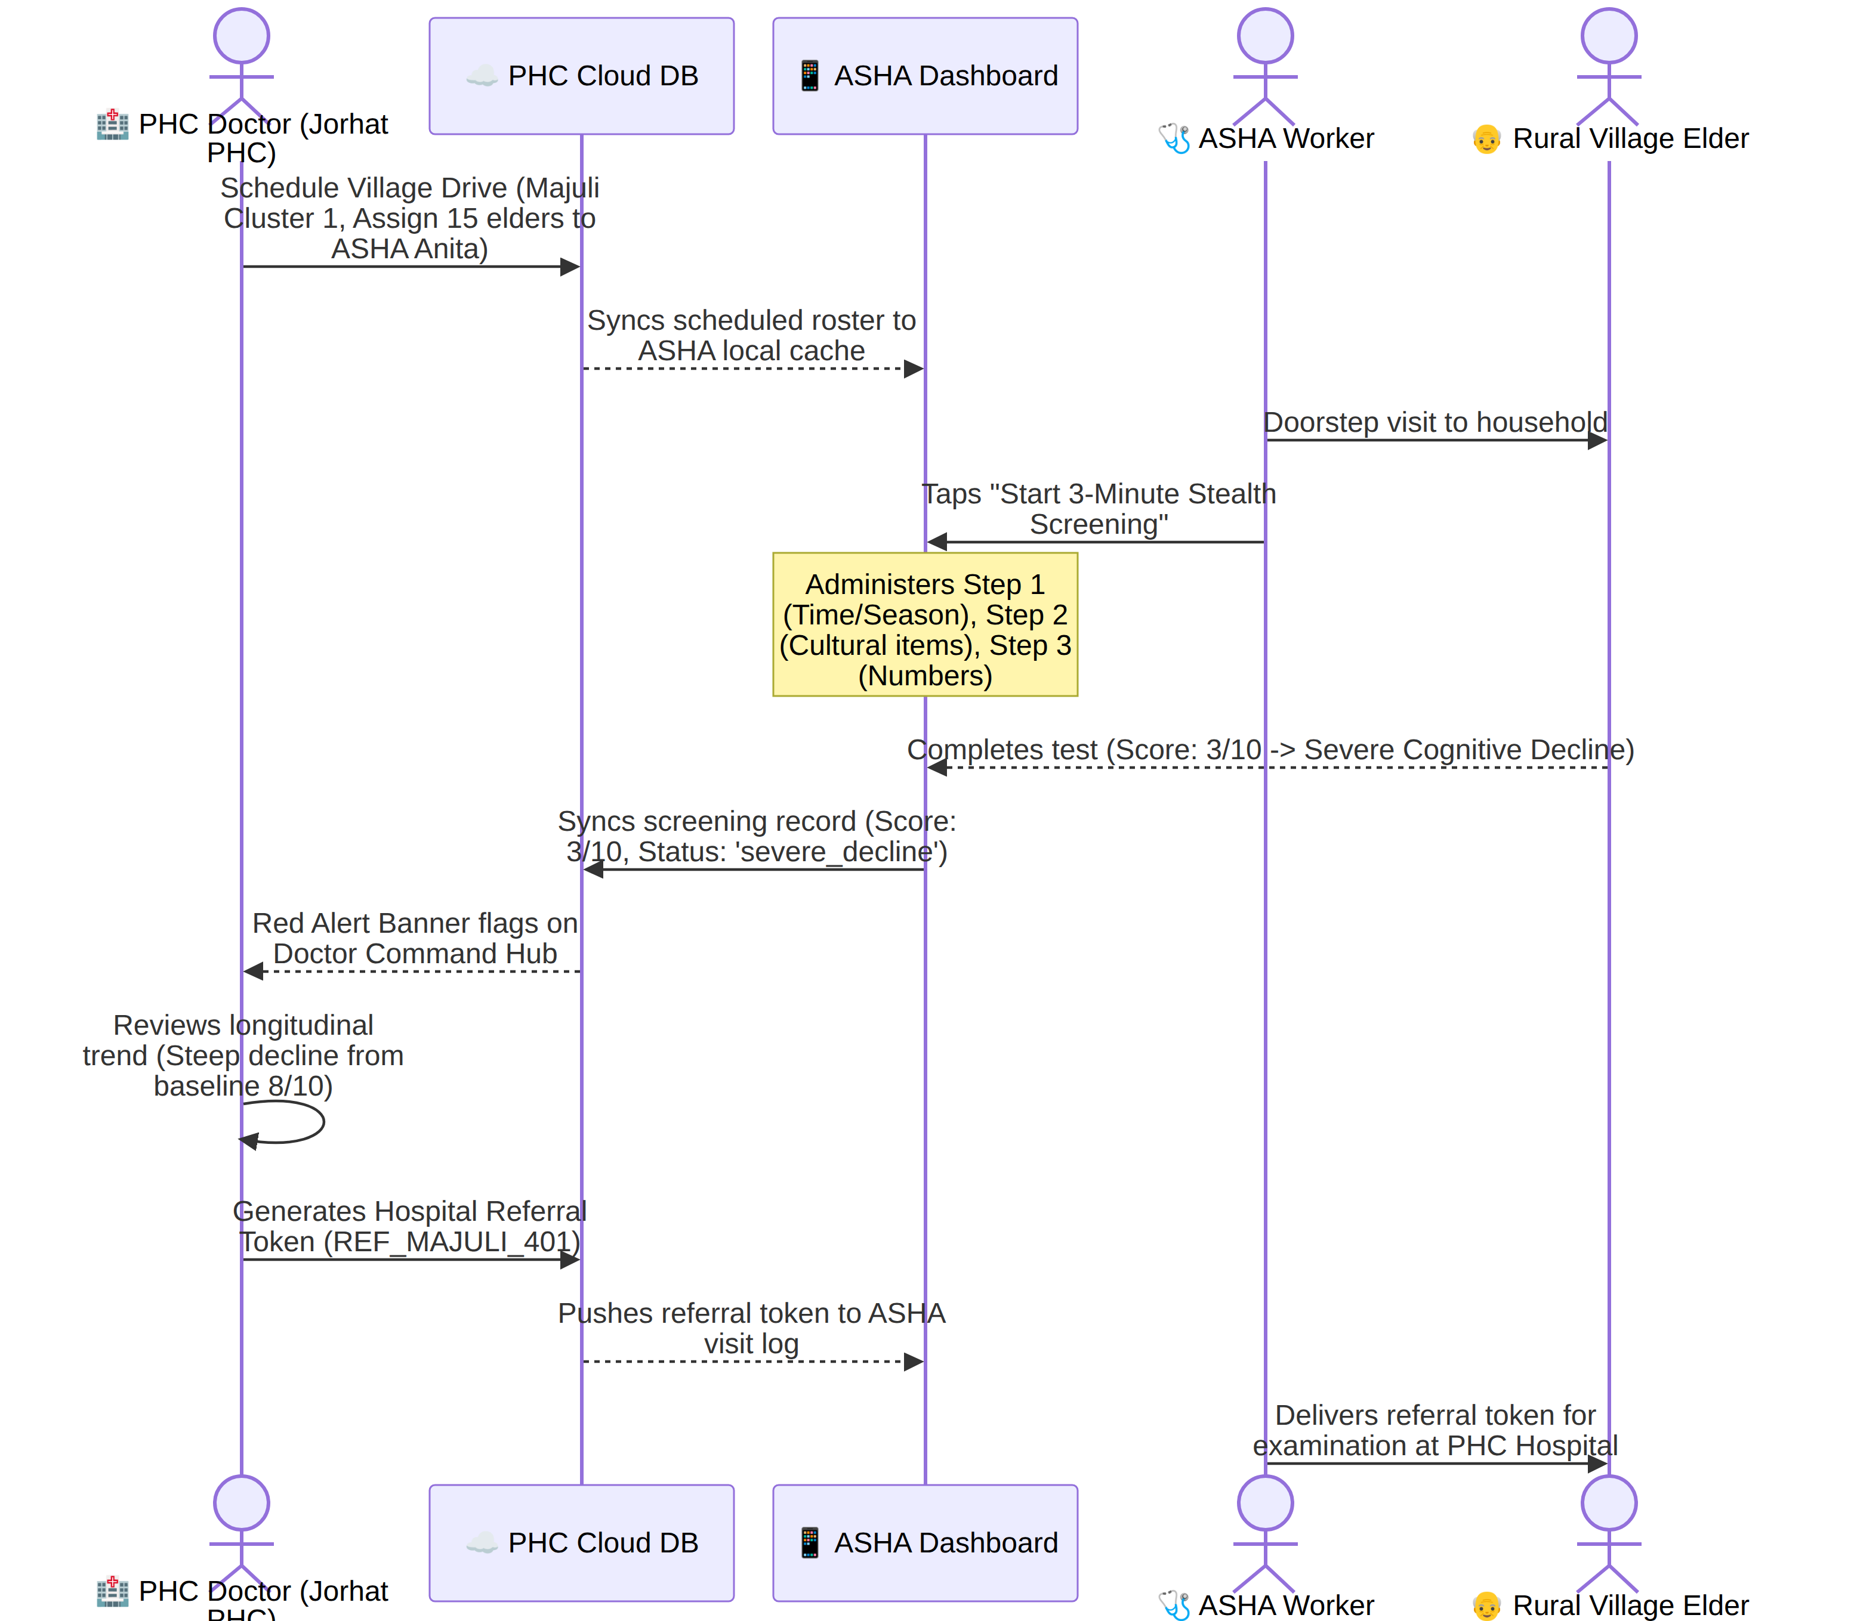
Figure 11: Sequence 5: ASHA Doorstep Screening & Doctor Clinical Triage

5. Behavioral Workflow Model (Activity Diagrams)

5.1 Activity 1: Q-Learning State Discretization, Reward & Frustration Defense
The workflow is split across two figures: Part A discretizes accuracy and time into the Q-learning state; Part B selects the next difficulty, computes the reward and applies the Bellman update.
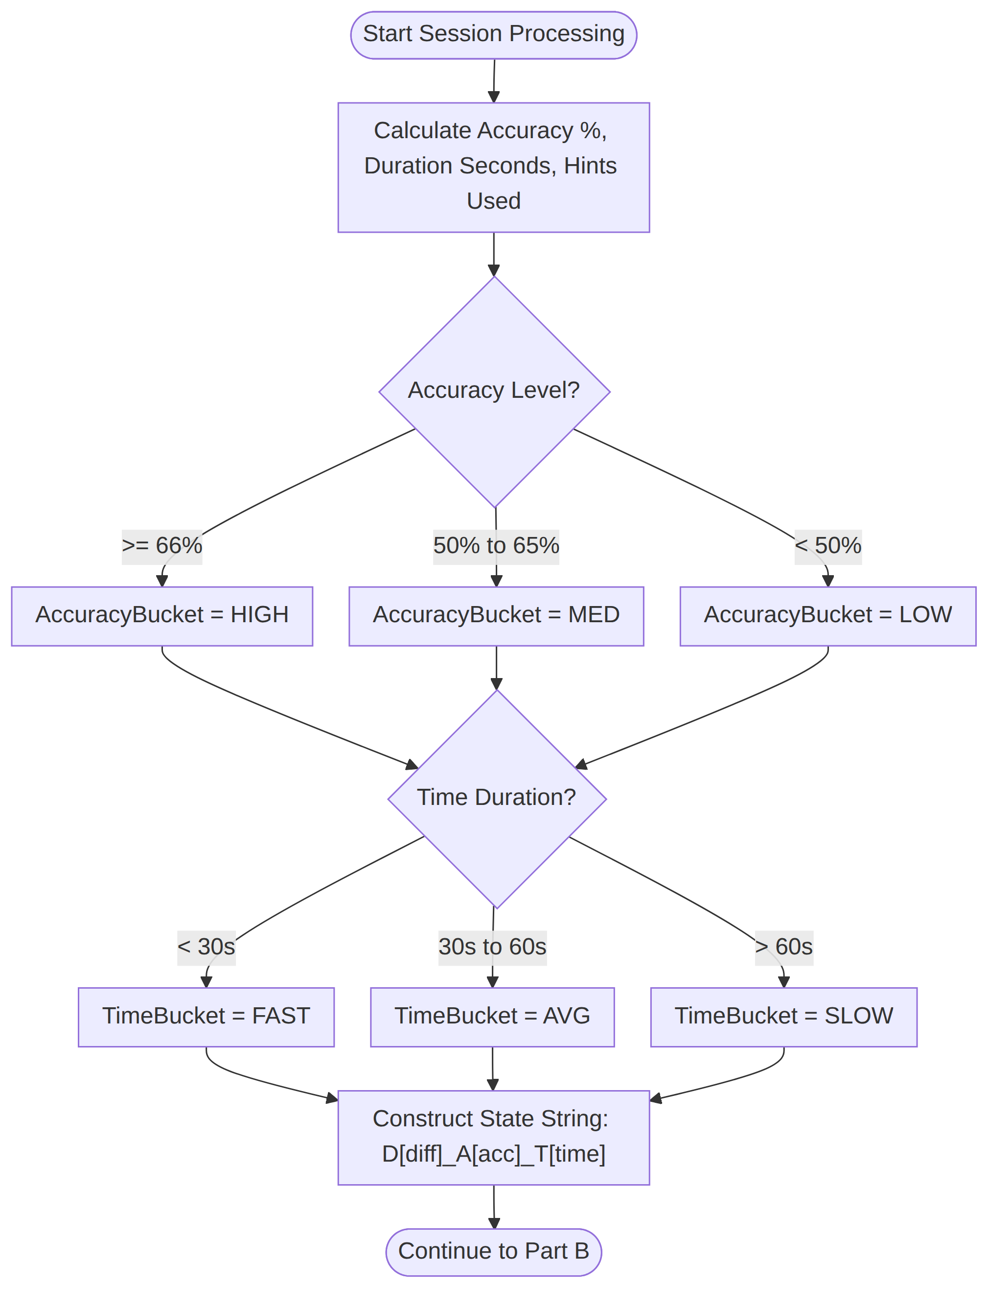
Figure 12: Q-Learning Activity, Part A: State Discretization
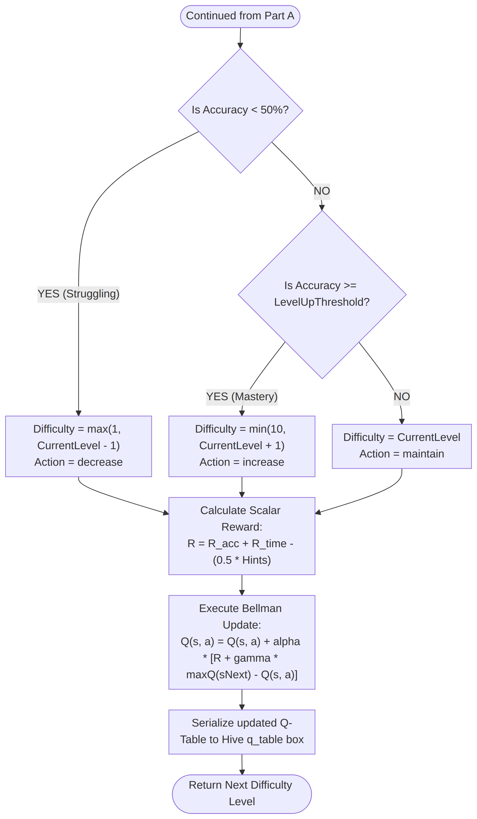
Figure 13: Q-Learning Activity, Part B: Difficulty Decision, Reward & Bellman Update

5.2 Activity 2: Offline-First Dual Mode Data Synchronization Workflow
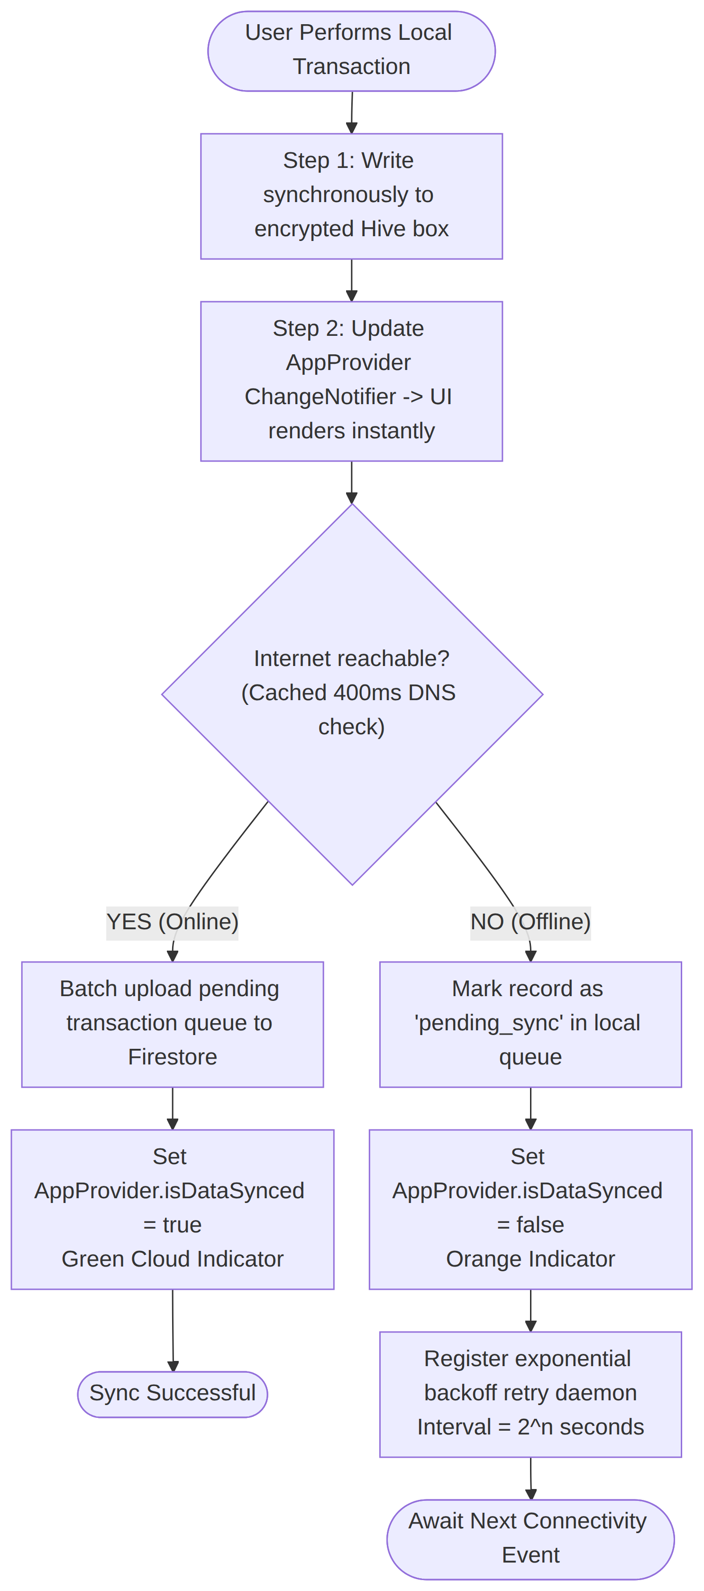
Figure 14: Activity 2: Offline-First Dual Mode Data Synchronization Workflow

5.3 Activity 3: Quiet Hours & Adherence Reminder Scheduling
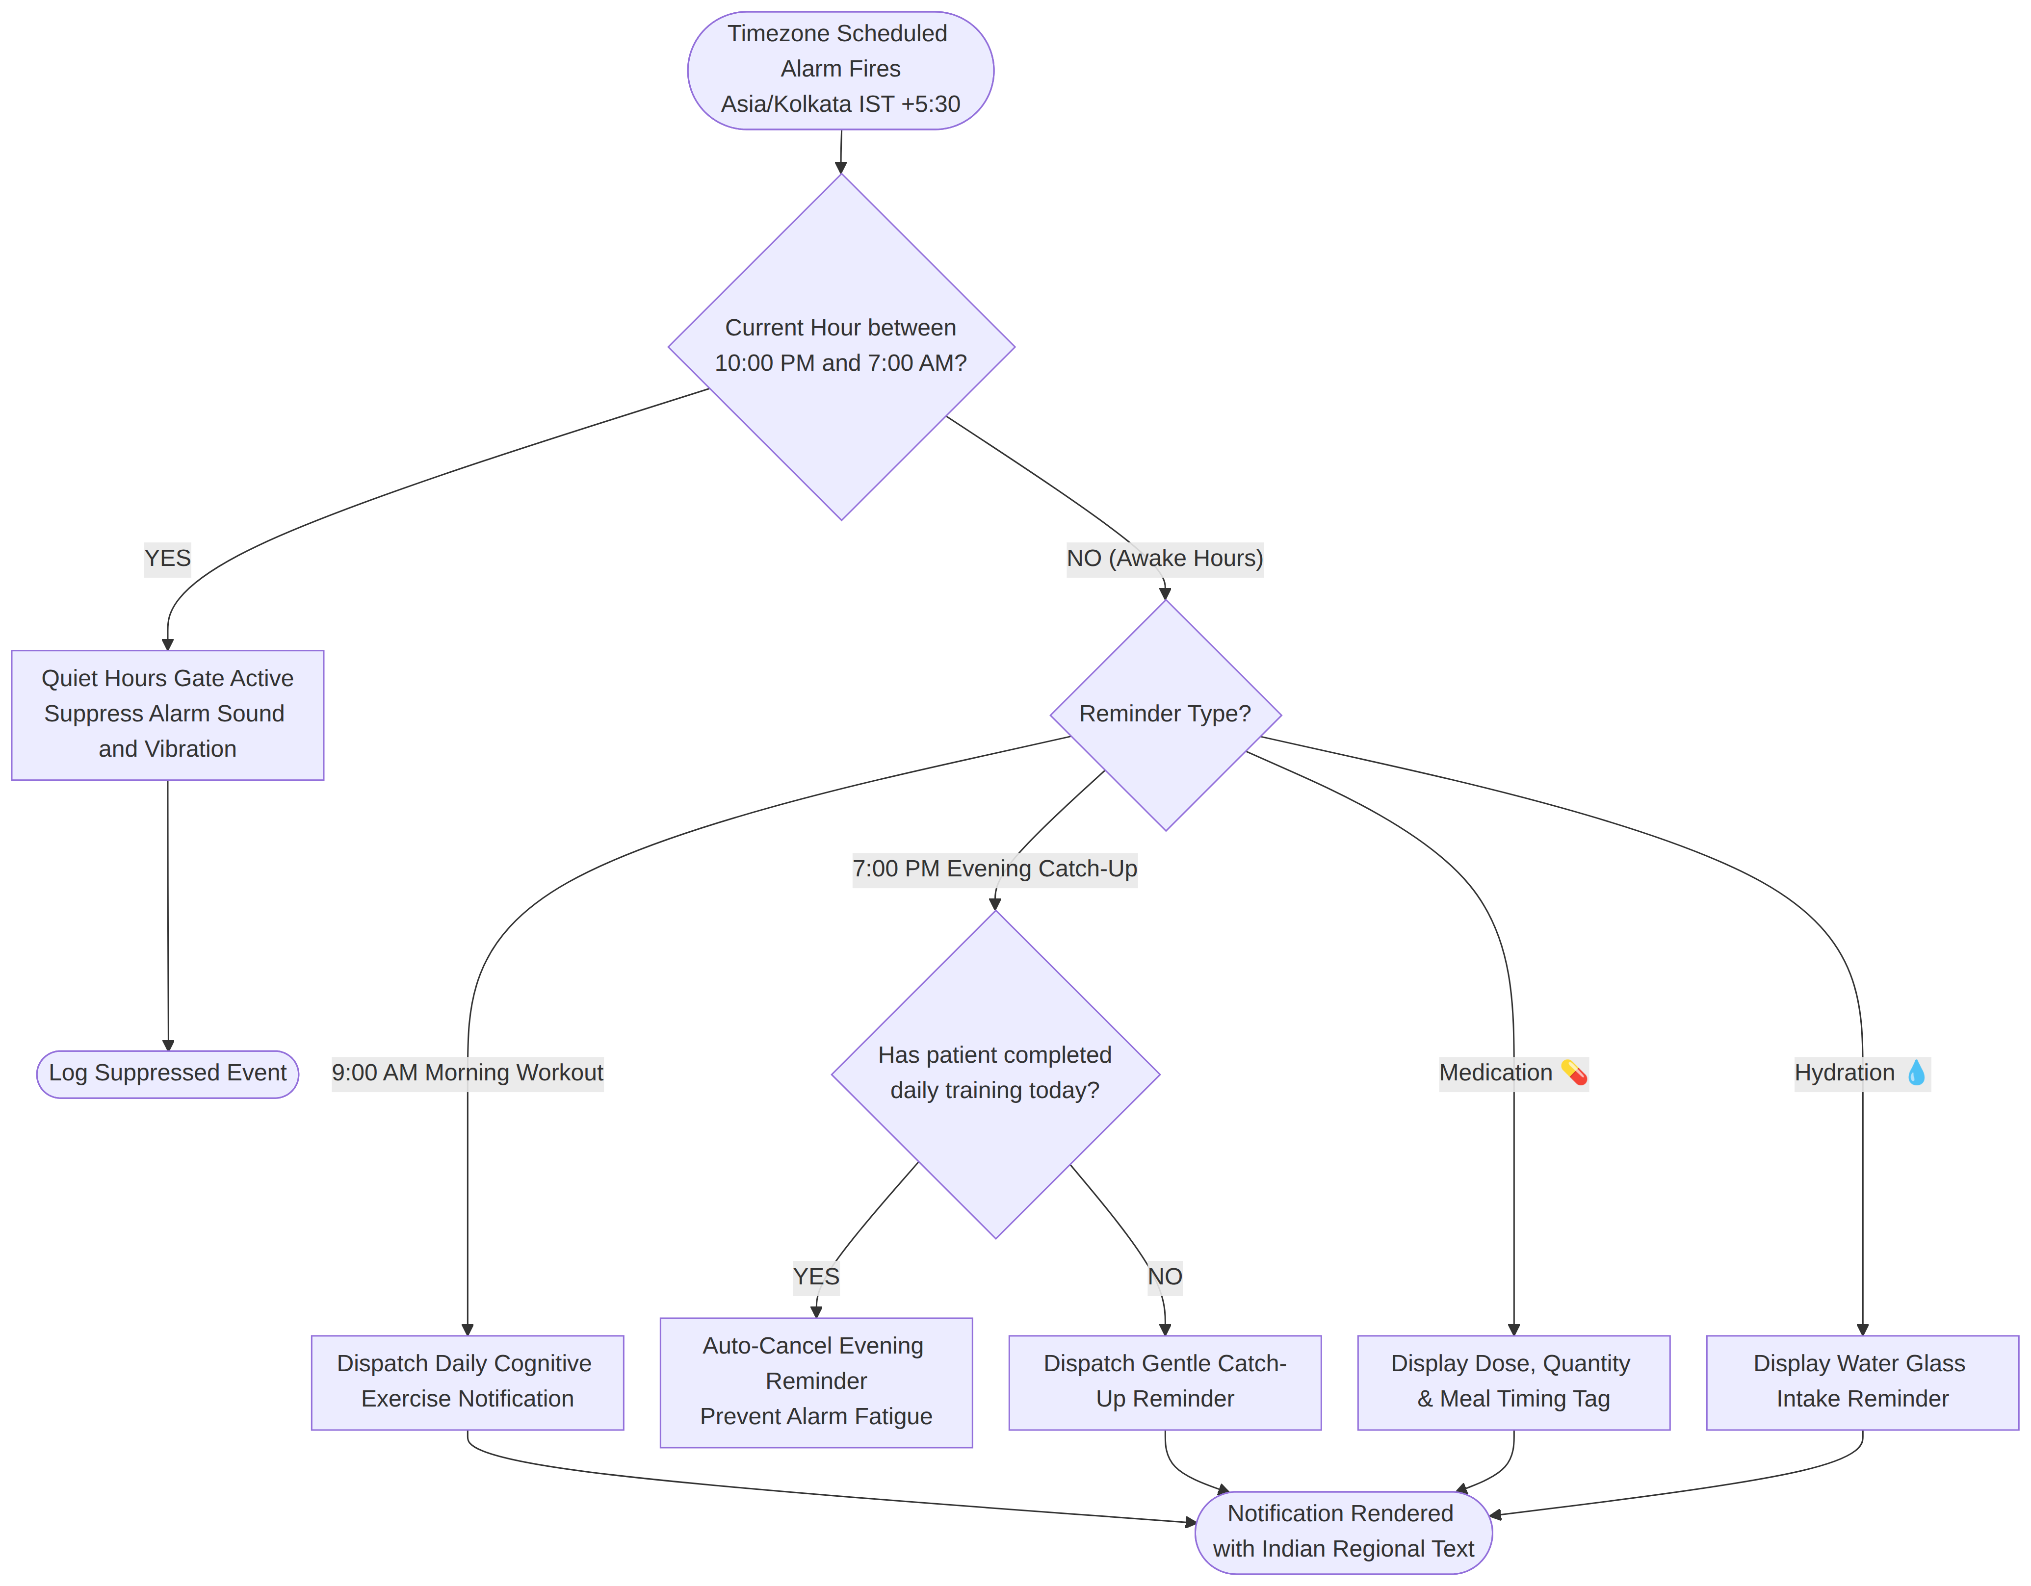
Figure 15: Activity 3: Quiet Hours & Adherence Reminder Scheduling

6. State Machine Diagrams

6.1 State Machine 1: Patient Game Difficulty Lifecycle
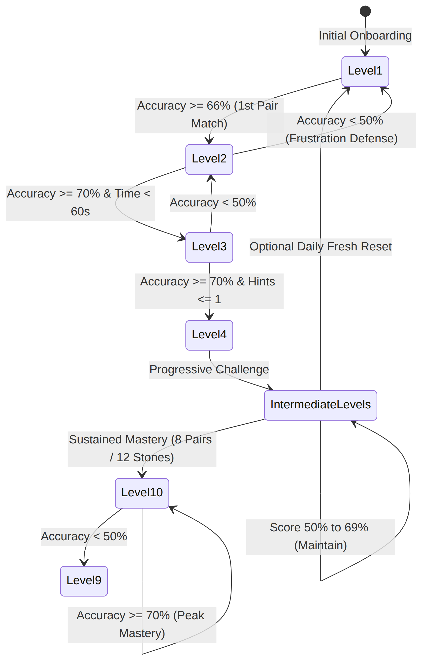
Figure 16: State Machine 1: Patient Game Difficulty Lifecycle

6.2 State Machine 2: Rural Elder Cognitive Risk Stratification
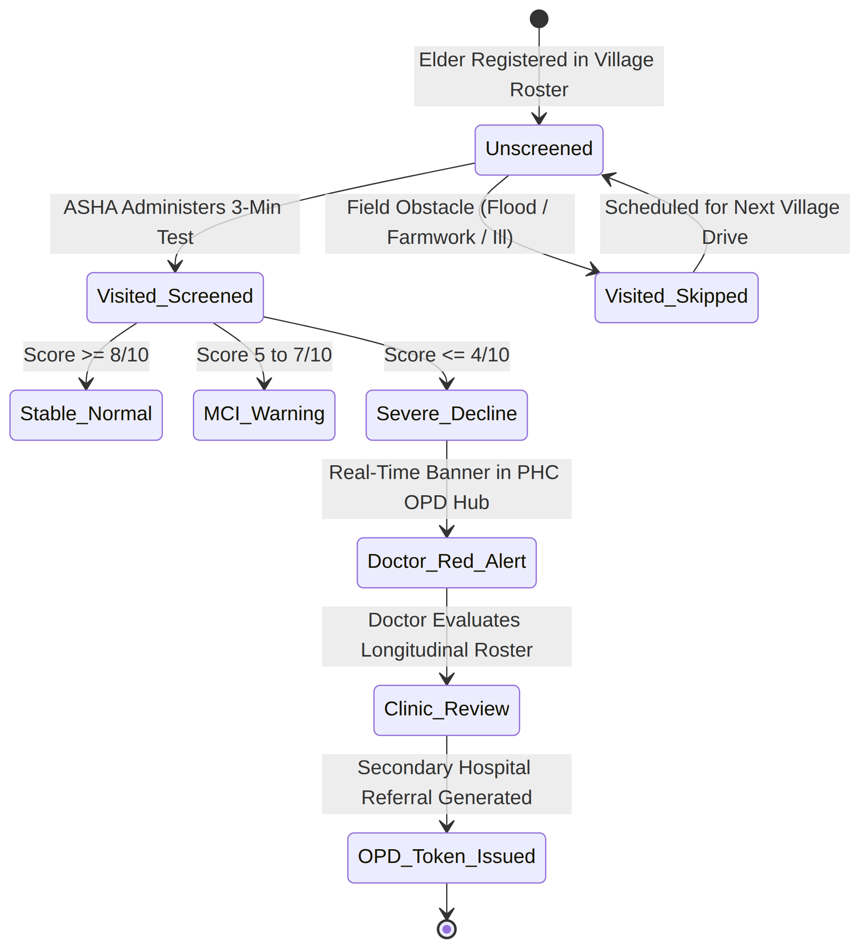
Figure 17: State Machine 2: Rural Elder Cognitive Risk Stratification

6.3 State Machine 3: SOS Alert Event Lifecycle
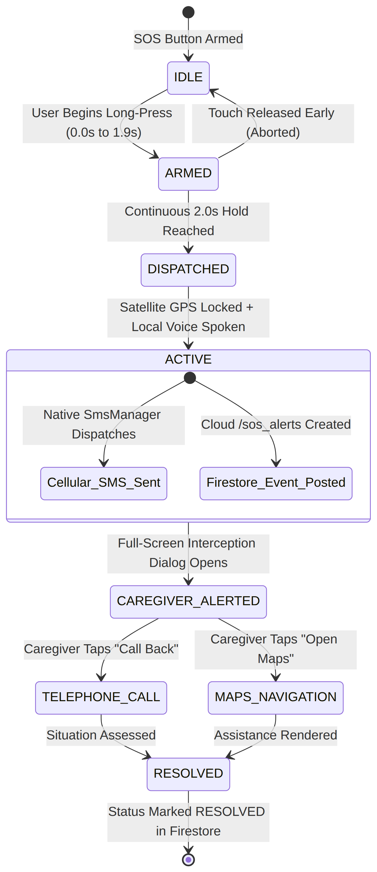
Figure 18: State Machine 3: SOS Alert Event Lifecycle

7. Implementation & Deployment Architecture

7.1 Component Diagram (Clean Architecture Layering)
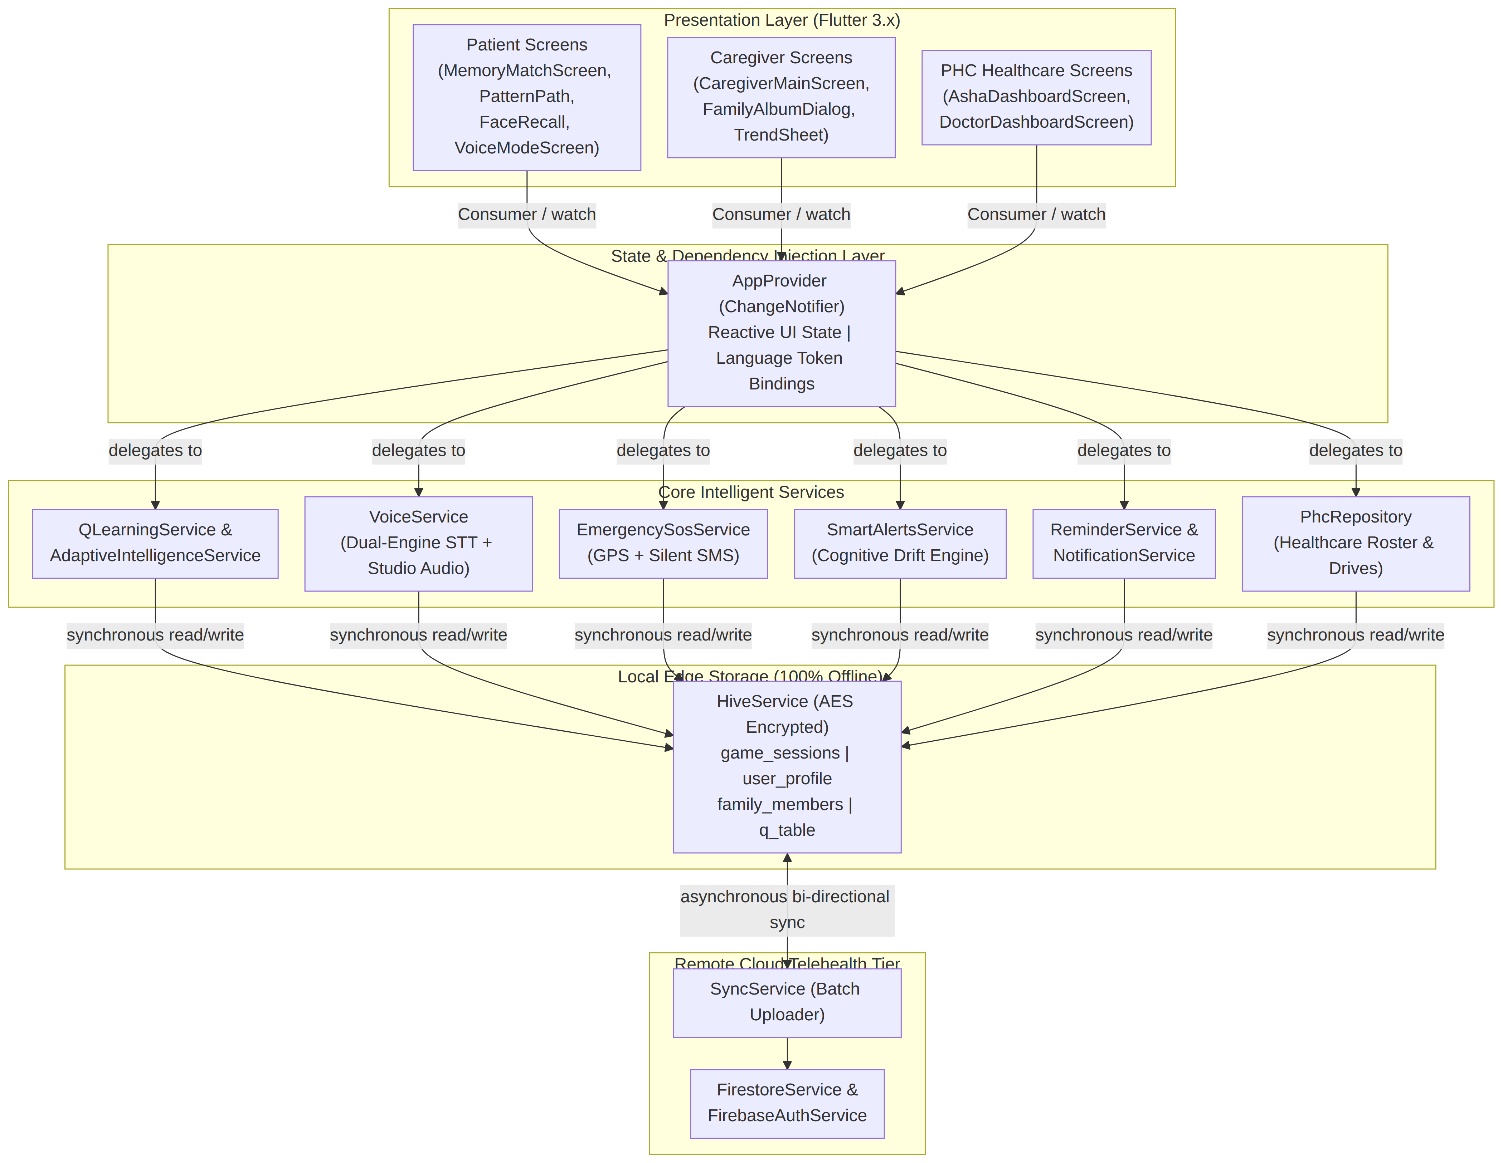
Figure 19: Component Diagram (Clean Architecture Layering)

7.2 Deployment Diagram (Hardware Nodes & Cloud Topology)
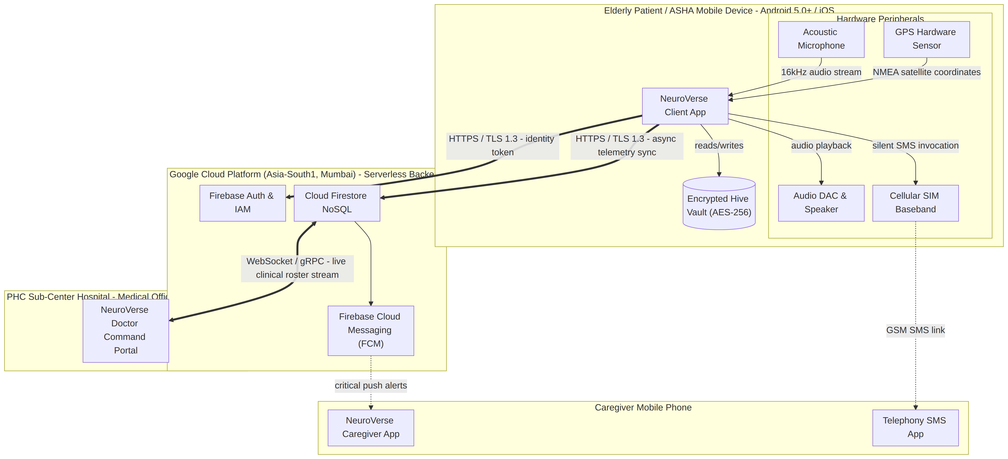
Figure 20: Deployment Diagram (Hardware Nodes & Cloud Topology)
End of UML Architecture & Design Document — NeuroVerse Platform (SIH 2026)

