NeuroVerse SRS — Adaptive Cognitive Health & Neuro-Rehabilitation Platform
Software Requirements Specification for NeuroVerse, an offline-first mobile platform for cognitive screening and tele-rehabilitation of elderly users, caregivers, ASHA workers and PHC doctors (Smart India Hackathon 2026).

Document control
Attribute | Details
Document identifier | SRS-NV-2026-V1.0
Status | Approved baseline
Version | 1.0.0-PROD-SPEC
Project | Smart India Hackathon (SIH) 2026
System | NeuroVerse (mobile edge and telehealth cloud)
Target domain | Geriatric mental health, cognitive tele-rehabilitation, rural frontline public healthcare (NHM / PHC)
Publication date | November 2026
Author | NeuroVerse Systems Architecture & Engineering Core
Audience | Clinical reviewers, SIH evaluators, developers, field health officers
Standards | IEEE Std 830-1998, ISO/IEC/IEEE 29148:2018, DISHA (India), WCAG 2.1 AA

1. Introduction

1.1 Purpose
This SRS states the functional, non-functional, clinical, algorithmic and interface requirements for NeuroVerse. It is the reference for developers, QA engineers, medical officers and field testing teams.

1.2 Scope
NeuroVerse is an edge-first, offline-resilient, cross-platform app for senior citizens with Mild Cognitive Impairment (MCI) or early dementia, their family caregivers, and rural frontline health workers (ASHA workers and PHC Medical Officers). It covers:
- Edge client suite: Flutter mobile app with touch, haptic, audio and conversational voice interfaces.
- On-device machine learning: zero-latency Q-Learning difficulty adaptation.
- Offline multilingual voice AI: 9 languages with automatic language detection.
- Cloud and telemetry service: Firestore-backed asynchronous sync and smart clinical alerts.
- Community PHC module: doorstep cognitive screening, rural skip tracking and medical officer referral workflows.

1.3 Problem statement and clinical rationale
- Cognitive gap: over 8.8 million elderly Indians live with dementia, projected to exceed 14 million by 2036. Over 75% of cases stay undiagnosed because screening infrastructure is missing outside tier-1 cities.
- Stigma and test anxiety: pencil-and-paper tests such as MMSE or MoCA cause anxiety in elderly rural users. NeuroVerse turns evaluation into gentle, culturally grounded mini-games ("stealth assessments").
- Connectivity limits: rural PHCs and Sub-Centers often have intermittent cellular service, so cloud-only tools fail. NeuroVerse enforces edge autonomy: all core capabilities work 100% offline.

1.4 Definitions and abbreviations
Term | Definition
ABHA | Ayushman Bharat Health Account, the 14-digit national digital health ID
ASHA | Accredited Social Health Activist, frontline community health worker under the Ministry of Health & Family Welfare
Clean Architecture | Pattern separating domain logic from UI and data persistence
DISHA | Digital Information Security in Healthcare Act (India)
FCM | Firebase Cloud Messaging
Hive | Encrypted, lightweight NoSQL key-value database for Flutter/Dart
MCI | Mild Cognitive Impairment, the stage between normal ageing and dementia
MMSE / MoCA | Mini-Mental State Examination / Montreal Cognitive Assessment
PHC | Primary Health Centre, the basic unit of rural public health
Q-Learning | Model-free reinforcement learning that values state-action policies
STT / TTS | Speech-to-Text / Text-to-Speech
WCAG | Web Content Accessibility Guidelines

2. Overall description

2.1 Product perspective
NeuroVerse is a decentralized, edge-first hybrid system. The device does all cognitive processing, state evaluation, reinforcement learning updates, voice recognition fallback and encrypted storage. When a network appears, a background daemon (SyncService) pushes telemetry to Google Cloud Firestore without blocking the UI.
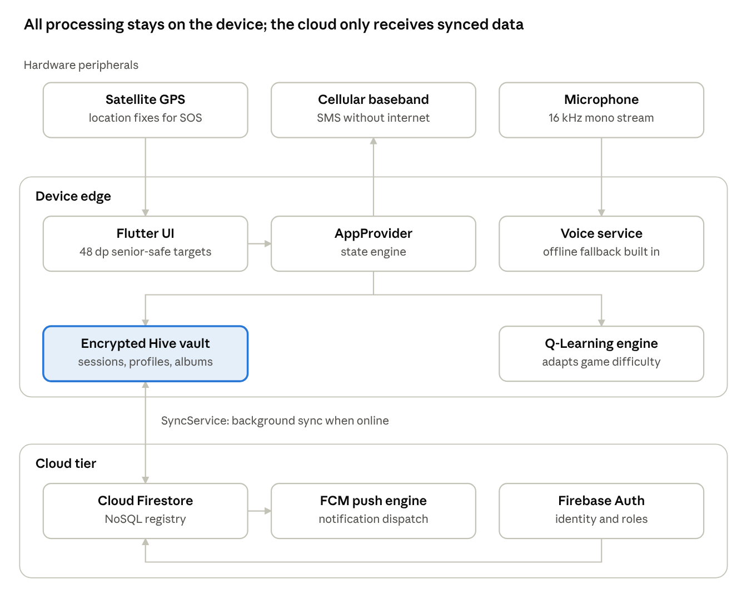
system context · edge, peripherals, cloud
Peripherals feed the UI, voice service and SMS path on the device; only the Hive vault talks to the cloud.

2.2 User classes
Persona | Who they are | What they need
Patient | Senior with visual or physical impairments, memory lapses, low tech literacy | Voice control and large touch targets
Caregiver | Family member or dedicated nurse, anxious about relapses and wandering | Real-time telemetry, SOS alerts, medication and photo management
ASHA worker | Field community health mobilizer covering 1000+ village population | Doorstep stealth screening, 100% offline capability
Doctor | PHC Medical Officer overseeing multiple sub-centers | Supervise ASHA allocations, review cognitive trends and triage
Administrator | Governance and security owner | Audit accounts and broadcasts, with zero access to private health records

2.3 Operating environment
- OS: Android 5.0 (API 21) or higher; iOS 12.0 or higher.
- Hardware: minimum 2.0 GB RAM, ARMv7 or ARM64-v8a, microphone, GPS sensor, active SIM card for SMS dispatch.
- Connectivity: runs indefinitely with no network; queued transactions sync on reconnection.
- Display: phone and tablet screens from 320 dp to 840 dp wide, locked to portrait.

3. System architecture

3.1 Three-tier architecture
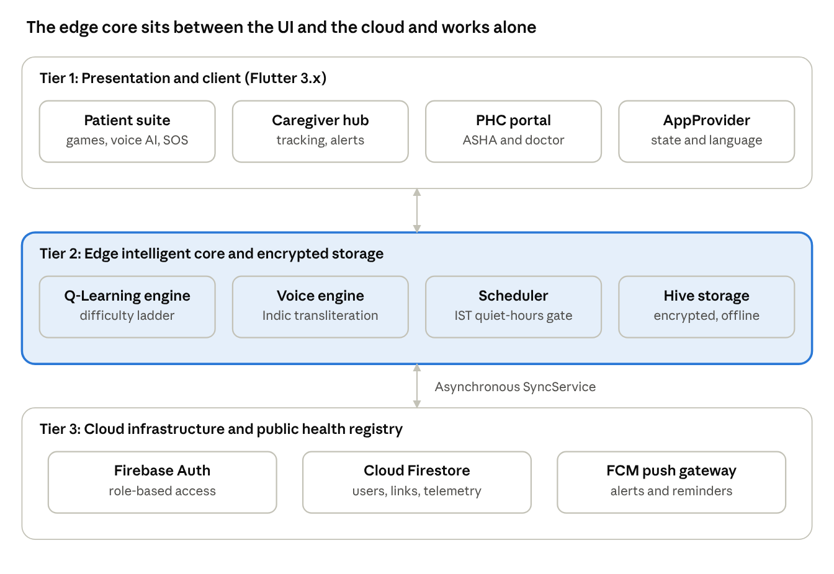
three-tier architecture · client, edge core, cloud
Tier 1 holds the role-specific UIs, Tier 2 does intelligence and encrypted storage on the device, and Tier 3 provides identity, registry and push, reached only through asynchronous sync.

4. Functional requirements

Module 1: Authentication, role-based access and onboarding
ID | Requirement
FR-1.1 | Multi-role registration: the system shall support 4 roles: Patient, Caregiver, ASHA and Doctor.
FR-1.2 | Identity management: Email/Password and Google OAuth2 sign-in, with email verification enforced before profile setup.
FR-1.3 | Role isolation: each authenticated account is routed only to its dashboard (/patient, /caregiver, /asha, /doctor, /admin).
FR-1.4 | Connect Code: every new patient gets a cryptographically generated, unique 6-character alphanumeric pairing token.
FR-1.5 | Consent handshake: a caregiver entering a Connect Code creates a pending invitation in the patient's notifications drawer. No data syncs until the patient accepts.
FR-1.6 | Offline profile caching: name, age, gender, caretaker details and display/speech language are stored synchronously in the encrypted Hive box user_profile.

Module 2: Cognitive training and mini-game hub
ID | Requirement
FR-2.1 | Four independent mini-games: Card Match (visual working memory, 2 to 8 pairs), Pattern Path (sequential spatial memory, lengths 3 to 12), Object Finder (working memory and delayed retrieval of cultural artifacts), Face Recall (biographical memory with personalized family portraits).
FR-2.2 | Culturally grounded themes: all assets reflect North-East Indian heritage (Kopou Orchid, Assam Tea Gardens, Meghalaya Living Root Bridges, Kaziranga wildlife, artifacts such as Jaapi and Dhol).
FR-2.3 | Dementia-friendly hints: Card Match gives a momentary "Peek Reveal"; Pattern Path lights the next stone; Object Finder and Face Recall dim non-target distractors.
FR-2.4 | Session telemetry: at game end, persist accuracyPercentage, completionTimeSeconds, mistakesCount, hintsUsed, reactionTimeAverageMs and difficultyLevel.
FR-2.5 | Positive reinforcement: after any session, show a full-screen 3D confetti animation and localized voice encouragement.

Module 3: On-device Q-Learning reinforcement engine
FR-3.1 State space. The system maps the patient's live performance into a discrete state, where D is difficulty level, A is accuracy band and T is time band. HIGH is accuracy at or above 66%, MED is 50% to 65%, LOW is below 50%.
s = \langle D \in [1,10],\ A \in \{\text{HIGH},\text{MED},\text{LOW}\},\ T \in \{\text{FAST},\text{AVG},\text{SLOW}\} \rangle
FR-3.2 Reward function. Accuracy reward is +2 when A is at least 66% and -2 when A is below 50%. Time reward is +1 when completion is under 30 s and -1 when over 60 s.
R = R_{\text{accuracy}} + R_{\text{time}} - 0.5 \times \text{HintsUsed}
FR-3.3 Bellman update. Q-values update with learning rate 0.1, discount factor 0.9 and initial exploration factor 0.2.
Q(s,a) \leftarrow Q(s,a) + \alpha \left[ R + \gamma \max_{a'} Q(s',a') - Q(s,a) \right], \quad \alpha = 0.1,\ \gamma = 0.9,\ \epsilon = 0.2
ID | Requirement
FR-3.4 | Frustration-free adjustment: if session accuracy drops below 50%, difficulty immediately drops 1 level (minimum level 1).
FR-3.5 | Q-table persistence: the updated Q-table is serialized to the q_table Hive box on session completion.

Module 4: Offline multilingual voice AI companion
ID | Requirement
FR-4.1 | Nine languages for full UI and speech: English (en), Hindi (hi), Bengali (bn), Assamese (as), Manipuri (mni), Mizo (miz), Kannada (kn), Telugu (te), Marathi (mr).
FR-4.2 | 100% spoken priority: whatever the dropdown language, spoken input is classified across Eastern Indic, Devanagari and Latin scripts, and the reply uses the dialect the user spoke.
FR-4.3 | Zero-crash offline recognition: a cached ping to google.com checks connectivity. When offline, STT starts with localeId: null (device default model), which avoids Android ERROR_NETWORK crash loops.
FR-4.4 | Dual audio output: recorded regional MP3 assets (assets/audio/voice/{lang}/{key}.mp3) first, offline hardware TTS (flutter_tts) as fallback for dynamic text.
FR-4.5 | Offline Indic transliteration: pure-Dart phonetic rules convert Romanized family names (Rohan, Sunita, Lakshmi) into Devanagari, Bengali and Assamese scripts.
FR-4.6 | Emotional triage: keywords signalling anxiety, fear, loneliness or confusion ("ghabrahat", "darr", "alone", "bore") get compassionate calming replies.
FR-4.7 | Voice game triggering: commands such as "Start Card Match", "Open Face Recall" or "Rasta dikhao" open the requested game intro screen directly.

Module 5: Emergency lifeline (SOS and caregiver interception)
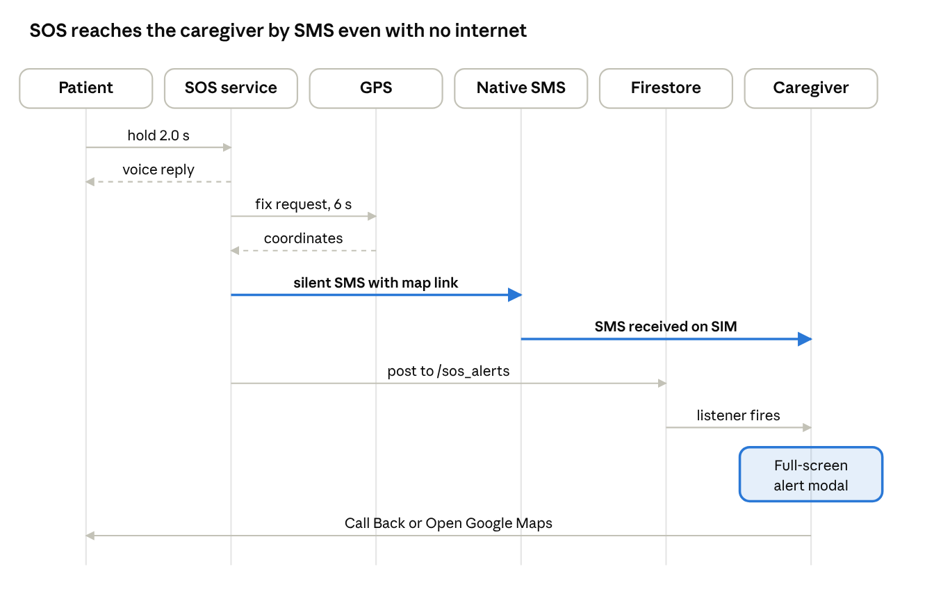
SOS sequence · patient to caregiver
The highlighted SMS path needs no internet; the Firestore post and alert modal add the cloud route when a network exists.
ID | Requirement
FR-5.1 | 2-second hold protection: the SOS trigger needs a continuous 2.0 s hold with a fill animation and haptic vibration, so accidental presses do not fire.
FR-5.2 | Immediate voice reassurance: on trigger, the device speaks a confirmation in the patient's language.
FR-5.3 | Offline satellite GPS lock: query GPS with a 6 s timeout; if a high-accuracy lock is late, fall back to the last known position.
FR-5.4 | Silent background SMS: native Android SmsManager, called over MethodChannel silent_sms, sends coordinates and a Google Maps link to all registered caregiver numbers.
FR-5.5 | Cloud alert broadcast: when online, post an active distress document to /sos_alerts and notify target caregivers directly.
FR-5.6 | Caregiver interception dialog: the caregiver app listens for alerts and shows a dialog with one-tap phone dialer (tel:) and Google Maps navigation (https://maps.google.com/?q=...).

Module 6: Caregiver tele-monitoring, family album and smart alerts
ID | Requirement
FR-6.1 | Multi-patient dashboard: aggregated cards show each linked patient's cognitive health index, daily streak and last active time.
FR-6.2 | Smart alerts engine: evaluate the patient's last 10 sessions and raise the alerts in the table below.
FR-6.3 | Family album: caregivers upload and crop photos, tagging name and relationship (Son, Daughter, Spouse, Grandchild, Friend).
FR-6.4 | Bi-directional album sync: photos are base64-encoded, stored in Firestore under /users/{patientId}/face_recall_members and synced to the patient's Hive cache.
FR-6.5 | Remote reminders: Medicine (Before/With/After Meal tags), Hydration, Brain Training and Wellness Check-in.
FR-6.6 | Quiet hours gate: notifications follow Asia/Kolkata (IST +5:30) time; non-emergency alerts are suppressed from 10:00 PM to 7:00 AM.
FR-6.7 | Auto-canceling reminders: if the patient finishes the daily brain training before the 7:00 PM catch-up reminder, that evening's alarm is cancelled.
Smart alert rules (FR-6.2)
Alert | Severity | Trigger
Repeated Struggle | Critical | Accuracy below 50% across 3 consecutive sessions
Activity Gap | Warning | No session recorded for more than 72 hours
Unusual Decline | Warning | Score drops by more than 30 points between identical mini-games

Module 7: PHC and community healthcare network (ASHA and Doctor)
An elder registered by an ASHA worker is either screened at the doorstep or skipped for a logged field reason and revisited. The score then decides the outcome.
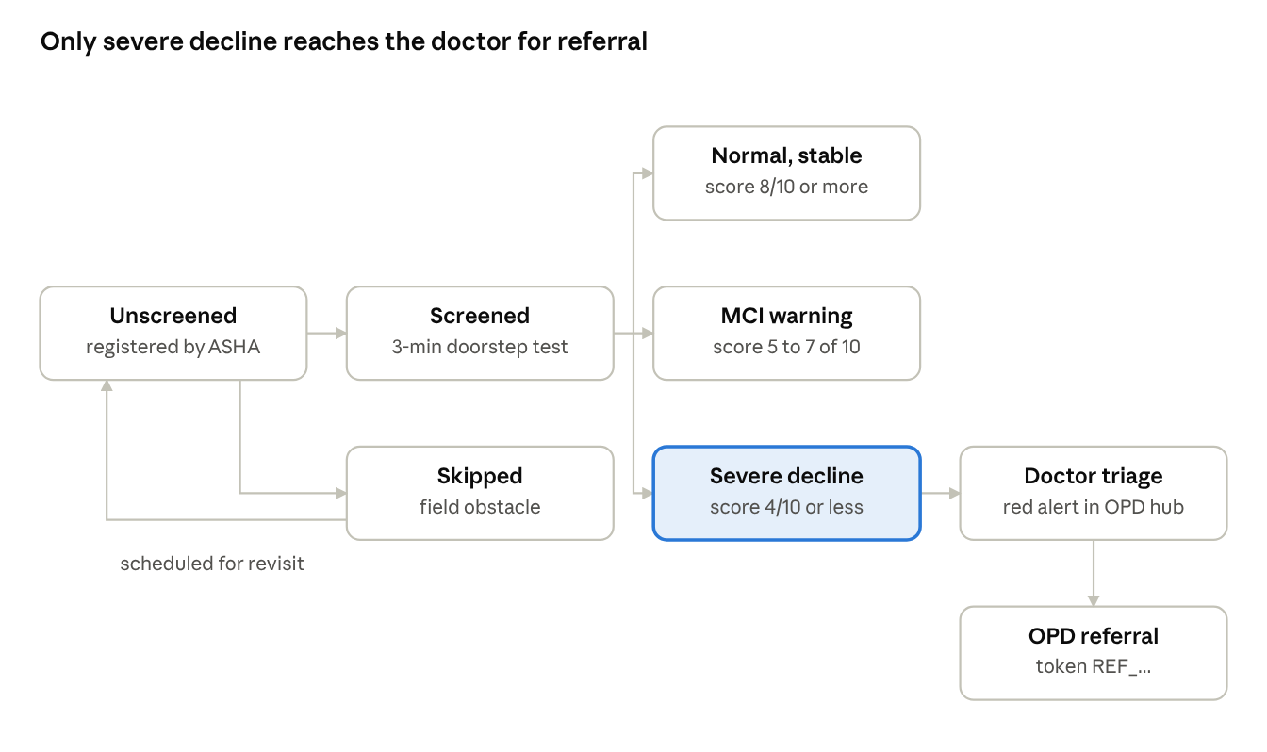
elder screening outcomes · states and referral
ID | Requirement
FR-7.1 | ASHA 3-minute stealth screening in 3 steps: (1) temporal and seasonal orientation (Morning/Afternoon/Night; Monsoon/Winter/Summer); (2) short-term visual recall of 3 regional items (Jaapi, Dhol, Diya); (3) sequential motor-cognitive ordering with an ascending numeric touch test.
FR-7.2 | Rural elder registration offline: name, age (60+), village cluster, house or ward number, family guardian contact and optional ABHA Health ID.
FR-7.3 | Rural skip protocol: log the reason as Not at Home (Farm Work), Unwell / Resting, Weather / Inaccessible Road, or Refused / Reschedule.
FR-7.4 | Doctor PHC command hub: monitor block-wide cognitive coverage, approve or reject ASHA registrations, track screening ratios across villages.
FR-7.5 | Village drive scheduling and workload balancing: doctors pick villages and the system splits patient quotas equally across available ASHA workers.
FR-7.6 | Clinical progression reports: a patient roster split into Stable (8/10 or more), MCI Warning (5 to 7/10) and Severe Decline (4/10 or less), plus ASHA field supervision (completed visits, skipped logs, target coverage ratios).
FR-7.7 | Clinical OPD referral tokens: for acute decline (4/10 or less), the Medical Officer generates a unique tracking token (REF_...) for hospital examination.

Module 8: System administration and governance
ID | Requirement
FR-8.1 | Platform health dashboard: total active patients, caregivers and health workers, plus aggregate game completion distributions.
FR-8.2 | User lifecycle auditing: admins can suspend or reinstate accounts; suspended accounts are signed out in real time.
FR-8.3 | Platform-wide broadcasts: admins send maintenance alerts or health advisories to all connected devices.
FR-8.4 | Privacy governance: the admin console keeps strict data isolation, with zero access to individual patient scores, family photos or medical notes.

5. Non-functional requirements

5.1 Performance and latency targets
Metric | Target | Verification method
Voice processing latency | 800 ms or less, from silence detection to speech start | Audio benchmark harness
Q-Learning update time | 15 ms or less per completed session | Unit performance test
Local Hive read/write | 8 ms or less at the 99th percentile | Automated microbenchmark
GPS fix and SOS dispatch | 6.0 s or less from hold release to SMS dispatch | Physical device field test
App startup time | 1.8 s or less to an interactive splash screen | Cold start macrobenchmark

5.2 Reliability and offline fault tolerance
- Offline autonomy: all patient gameplay, local analytics, voice assistant queries and ASHA screening tools work with no internet.
- Sync resilience: the sync worker uses exponential backoff (2^n seconds, up to 5 minutes) on network failure to prevent battery drain.
- State preservation: after an unexpected termination or low-memory shutdown, the difficulty ladder and un-synced sessions stay intact in Hive.

5.3 Security, privacy and DISHA compliance
- Local encryption: session records, patient details and family member names use encrypted Hive boxes.
- Cloud tenancy: Firestore rules let patients read and write only their own records, caregivers read only patients linked by an approved Connect Code, and medical officers view only elders in their registered PHC jurisdiction.
- Access control: administrative roles cannot view individual healthcare metrics.

5.4 Usability and senior accessibility
- Touch targets: at least 48 x 48 dp with at least 12 dp between elements.
- Contrast: WCAG 2.1 AA, with at least 4.5:1 for body text and 3:1 for graphical widgets.
- Cognitive load: game onboarding uses 3-step cards narrated in the user's regional voice.
- Auditory feedback: every visual change (card flip, correct selection, level advance) pairs with a distinct, gentle audio cue.

6. External interface requirements

6.1 User interfaces
Element | Value
Dark Emerald (base) | #001B17
Vibrant Teal (accent) | #00BFA5
Mint (secondary) | #6EE7B7
Soft Alert Amber | #F59E0B
Senior Emergency Crimson | #DC2626
Typography | High-legibility sans-serif with adjustable scaling

6.2 Hardware interfaces
Interface | Detail
Microphone | 16 kHz mono audio stream via Flutter speech_to_text
GPS receiver | NMEA coordinate streaming via Flutter geolocator
Cellular baseband | Android SmsManager for offline text dispatch
Audio output | audioplayers and native TTS engines

6.3 Software interfaces
Component | Version
Firebase Auth | v5.x
Cloud Firestore | v5.x
Firebase Cloud Messaging | v15.x
Hive with hive_flutter | v2.x
flutter_tts | v4.x
speech_to_text | v7.x

7. Verification and traceability matrix
Requirement | Description | Implementation | Automated test
FR-2.1 / FR-2.4 | Mini-game execution and telemetry logging | memory_match_screen.dart, pattern_path_screen.dart | test/features/patient/games/ner_games_ui_test.dart
FR-3.1 / FR-3.3 | Q-Learning state evaluation and Bellman updates | q_learning_service.dart, adaptive_intelligence_service.dart | test/features/patient/games/game_results_accuracy_test.dart
FR-4.1 / FR-4.2 | Multilingual localization and spoken-language priority | app_translations.dart, voice_mode_screen.dart | test/features/patient/voice/voice_mode_screen_test.dart
FR-4.3 / FR-4.4 | Offline speech fallback and audio output | voice_service.dart | test/core/services/voice_service_test.dart
FR-4.5 | Offline Indic transliteration | indic_transliteration.dart | test/features/patient/games/face_recall_test.dart
FR-5.1 / FR-5.4 | SOS trigger, GPS coordinates and SMS dispatch | emergency_sos_service.dart, sos_emergency_button.dart | test/features/patient/sos_emergency_button_test.dart
FR-6.2 | Longitudinal smart alerts | smart_alerts_service.dart | test/core/services/smart_alerts_service_test.dart
FR-6.6 / FR-6.7 | Quiet hours and adherence alarms | reminder_service.dart, notification_service.dart | test/core/services/reminder_service_test.dart
FR-7.1 / FR-7.3 | ASHA 3-minute screening and skip logs | asha_patient_games_screen.dart, asha_skip_bottom_sheet.dart | test/features/asha/asha_patient_games_screen_test.dart
FR-7.5 / FR-7.6 | Village drive scheduling and report generation | phc_repository.dart, doctor_dashboard_screen.dart | test/features/asha/asha_localization_and_responsive_test.dart

8. Sign-off and approvals
Role | Name and title | Date | Status
Lead Systems Architect | NeuroVerse Technical Lead | 01-Nov-2026 | Approved
Clinical Systems Reviewer | PHC Healthcare Specialist | 01-Nov-2026 | Approved
QA and Verification Lead | Quality Assurance Lead | 01-Nov-2026 | Verified

