Assignment

1. Create 3 components:
   1. LoginComponent

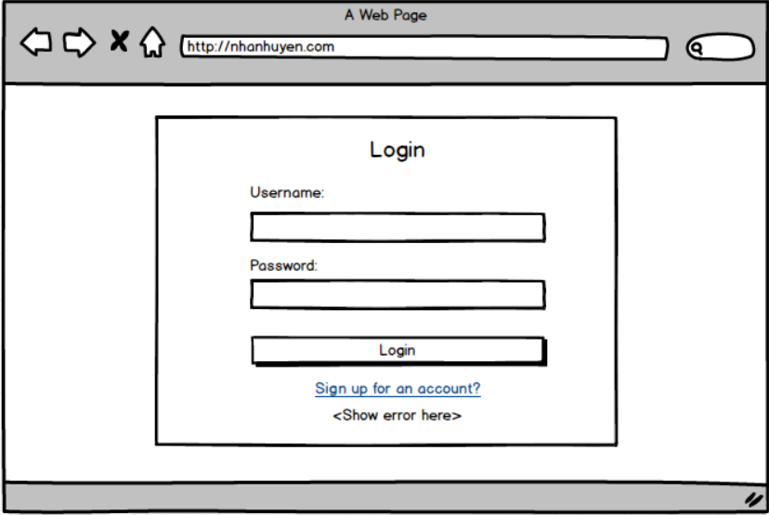

* 1. SignUpComponent

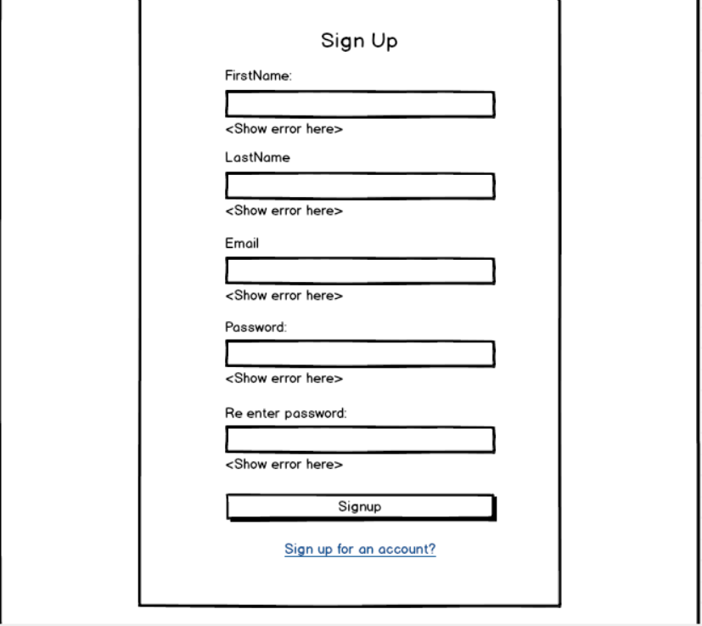

* 1. HomeComponent

Show an {welcome, <firstName> <lastName>}

1. Reactive form: <https://angular.io/guide/reactive-forms>. Requirement: Use formbuilder to create a form for user to input their information.
2. Form validation: <https://angular.io/guide/form-validation>.
   1. Validate user input for SignUpComponent show on screen.
      1. FirstName, LastName: required
      2. Email: required, must matched email format (find online for appropriate regex)
      3. Password: required, use this pattern: ^(?=.\*?[A-Z])(?=.\*?[a-z])(?=.\*?[0-9])(?=.\*?[#?!@$%^&\*-]).{8,}$
      4. Re enter password: required, the same with password
      5. SignUp button: Disabled if the form is invalid otherwise enabled
   2. Create a hard-coded users (admin/admin123). Validate at login, if user login failed => show error on screen.
      1. Username is email, password: required
      2. Login button: Disabled if the form is invalid otherwise enabled
3. Apply bootstrap 4 for user interface.