安装配置手册
FAFAServer2.0基于ejabberd2.1.11版本进行开发，本手册目前仅针对UBUNTU环境下进行FAFAServer2.0的安装配置。
所有安装配置皆以root权限进行操作。

网络拓扑图
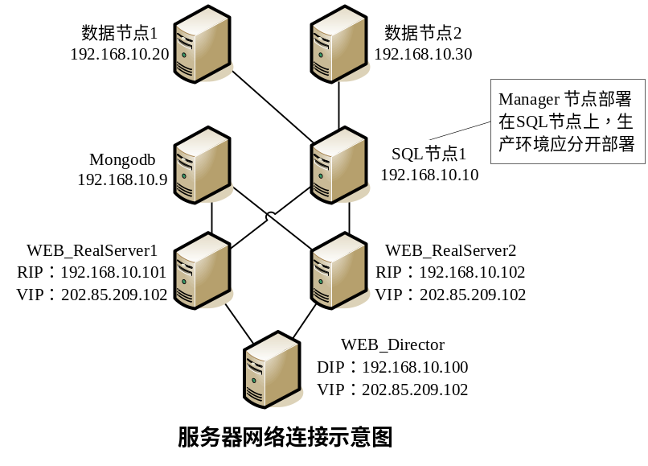
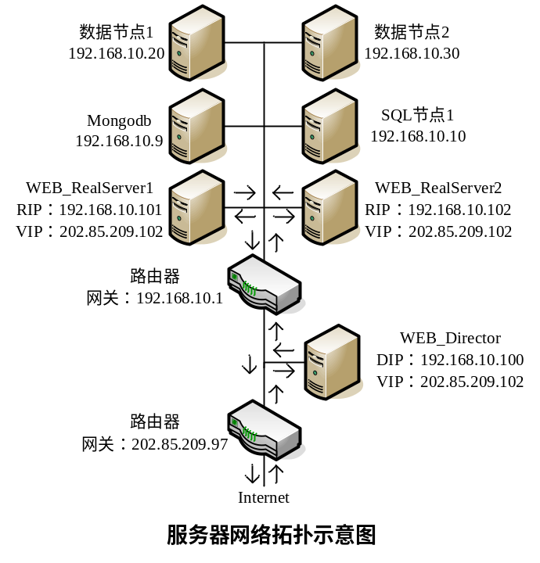

mysql-cluster安装配置

sql/data节点安装
安装libaio包
apt-get update
apt-get install libaio-dev
增加mysql用户及组
groupadd mysql
useradd -g mysql mysql
进入安装包所在目录，如/tmp，解压安装包至/usr/local，增加符号链接/usr/local/mysql
cd /tmp
tar -C /usr/local -xzvf mysql-cluster-gpl-7.2.10-linux2.6-x86_64.tar.gz
ln -s /usr/local/mysql-cluster-gpl-7.2.10-linux2.6-x86_64 /usr/local/mysql
进入mysql目录，初始化数据库
cd /usr/local/mysql
scripts/mysql_install_db --user=mysql
chown -R root .
chown -R mysql data
chgrp -R mysql .
将mysql设置为自动启动
cp support-files/mysql.server /etc/init.d/
chmod +x /etc/init.d/mysql.server
update-rc.d mysql.server defaults

management节点安装
管理节点仅需要将安装包中的ndb_mgm*文件复制至/usr/local/bin下
cd mysql-cluster-gpl****
cp bin/ndb_mgm* /usr/local/bin
cd /usr/local/bin
chmod +x ndb_mgm*
如果managerment节点单独安装，可能无mysql目录，创建之
mkdir /usr/local/mysql

sql/data节点配置
在/etc下增加mysql配置文件my.cnf
vi /etc/my.cnf
并加入以下内容，注意将修改管理节点IP为实际地址
[mysqld]
# Options for mysqld process:
ndbcluster # run NDB storage engine
ndb-connectstring=192.168.10.10 # location of management server
[mysql_cluster]
# Options for ndbd process:
ndb-connectstring=192.168.10.10 # location of management server
将data节点设置为自动启动，sql节点不需要下列设置
vi /etc/init.d/mysql.cluster.ndbd
录入以下内容
/usr/local/mysql/bin/ndbd
加入自启动
chmod +x /etc/init.d/mysql.cluster.ndbd
update-rc.d mysql.cluster.ndbd defaults

management节点配置
在/var/lib下建立mysql-cluster的配置文件
mkdir /var/lib/mysql-cluster
cd /var/lib/mysql-cluster
vi config.ini
加入以下内容，注意修改实际参数，因数据节点号必须小于49，因此管理节点号在此从50开始，预留4个，sql节点号从54开始（sql节点可多配几个，供备份、管理连接使用）
[ndbd default]
# Options affecting ndbd processes on all data nodes:
NoOfReplicas=2 # Number of replicas
DataMemory=80M # How much memory to allocate for data storage
IndexMemory=18M # How much memory to allocate for index storage
# For DataMemory and IndexMemory, we have used the
# default values. Since the "world" database takes up
# only about 500KB, this should be more than enough for
# this example Cluster setup.
MaxNoOfAttributes=5000
MaxNoOfOrderedIndexes=256
MaxNoOfExecutionThreads=8
MaxNoOfTables=256
[tcp default]
# TCP/IP options:
portnumber=2202 # This the default; however, you can use any
# port that is free for all the hosts in the cluster
# Note: It is recommended that you do not specify the port
# number at all and simply allow the default value to be used
# instead
[ndb_mgmd]
# Management process options:
nodeid=50
hostname=192.168.10.10 # Hostname or IP address of MGM node
datadir=/var/lib/mysql-cluster # Directory for MGM node log files
[ndbd]
# (one [ndbd] section per data node)
nodeid=1
hostname=192.168.10.20 # Hostname or IP address
datadir=/usr/local/mysql/data # Directory for this data node's data files
[ndbd]
nodeid=2
hostname=192.168.10.30 # Hostname or IP address
datadir=/usr/local/mysql/data # Directory for this data node's data files
[mysqld]
# SQL node options:
nodeid=54
hostname=192.168.0.10 # Hostname or IP address
# (additional mysqld connections can be
# specified for this node for various
# purposes such as running ndb_restore)
[mysqld]
nodeid=55
hostname=192.168.10.10
[mysqld]
nodeid=56
hostname=192.168.10.10
将management设置为自动启动
vi /etc/init.d/mysql.cluster.mgm
录入以下内容
/usr/local/bin/ndb_mgmd -f /var/lib/mysql-cluster/config.ini
加入自启动
chmod +x /etc/init.d/mysql.cluster.mgm
update-rc.d mysql.cluster.mgm defaults

ejabberd安装
以root权限进入系统，下载ejabberd2.1.11至/tmp，注意是32位还是64位的版本(ejabberd-2.1.11-linux-x86-installer.bin.gz、ejabberd-2.1.11-linux-x86_64-installer.bin.gz)。解压并安装。
cd /tmp
gunzip ejabberd-2.1.11-linux-x86-installer.bin.gz
chmod +x ejabberd-2.1.11-linux-x86-installer.bin
./ejabberd-2.1.11-linux-x86-installer.bin
进入ejabberd安装过程，将该服务安装为集群的一部分，按如下向导过程输入相关内容：
Language Selection

Please select the installation language
[1] Dutch - Nederlands
[2] English - English
[3] French - Fran莽ais
[4] German - Deutsch
[5] Russian - 袪褍褋褋泻懈泄
[6] Simplified Chinese - 绠€浣撲腑鏂?
[7] Spanish - Espa帽ol
Please choose an option [2] :
语言选择第2项：English。
接下来阅读License，一直回车，直到
Do you accept this license? [y/n]:
输入y回车
Please specify the directory where ejabberd will be installed.

Installation Directory [/opt/ejabberd-2.1.11]:
输入安装路径为：/opt/fafa，并回车。
ejabberd server domain

Please enter the desired ejabberd domain name. The domain is the visible attribute that is added to the username to form the Jabber Identifier (for example: user@example.net). This computer must be known on the network with this address name.

ejabberd server domain [ubuntumysqlmaster]:
输入FAFA服务域名：fafacn.com，并回车
Administrator username

Please enter the administrator username for the current ejabberd installation. A Jabber account with this username will be created and granted administrative privileges. Don't use blankspaces in the username.

Administrator username [admin]:
输入管理员帐号，这里默认为admin，直接回车
Administrator password

Please provide a password for the administrator user (at least 5 characters).

Administrator password :
输入管理员口令，如111111，回车，再次输入口令，并回车
Cluster

Will this node be part of a cluster ? (Please note ejabberd clustering is intended for advanced users).

Cluster [y/N]:
选择是否集群的一部分，这里输入Y，并回车
Cluster

Please copy your $HOME/.erlang.cookie file from another node. Warning: For security reason, you are encouraged to block port 4369 from external connections in your firewall.
Press [Enter] to continue :
这里提示复制cookie，直接回车
Cluster node name

Please complete the cluster node name with the primary network name of this computer.

Cluster node name: ejabberd@ [ubuntumysqlmaster]:
输入节点主机名，这里直接输入该机器IP地址，如192.168.10.10，并回车
Setup is now ready to begin installing ejabberd on your computer.

Do you want to continue? [Y/n]:
输入Y，或直接回车确认开始安装。
Setup has finished installing ejabberd on your computer.

View Readme file? [Y/n]:
是否阅读Readme文件，输入n，回车跳过。

FAFAServer2.0配置
从SVN上复制FaFaServer2.0/dev/src/conf/crossdomain.xml、ssl_im.pem文件至安装目录/etc/fafa/conf。
从SVN上复制FaFaServer2.0/dev/src/conf/ejabberd.cfg文件至安装目录/etc/fafa/conf覆盖现有文件，并修改数据库配置
vi /opt/fafa/conf/ejabberd.cfg
找到mysql odbc配置行
{odbc_server, {mysql, "server", "database", "username", "password"}}.
修改数据库主机、数据库名，连接用户及口令，如
{odbc_server, {mysql, "192.168.10.40", "ejabberd", "ejabberd", "111111"}}.
找到mongo配置行，修改mongo数据库连接参数
{mod_ejabberdex_init,[{mongo, {"update.wefafa.com", 27017, we, "", ""}}]},
找到ejabberdex_c2c_odbc的udp配置，修改udp端口及ip地址
{{4478, "202.85.209.102", udp}, ejabberdex_c2c_odbc, []},
找到mod_proxy65的配置，修改主机、端口及ip地址
{mod_proxy65,[{host,"fafaim.com"},{ip,{0,0,0,0}},{port, 7777}]},

修改ejabberdctl文件，配置该节点可连接进集群。
vi /opt/fafa/bin/ejabberdctl
找到ERLANG_OPTS的定义
if [ "$ARCHDIR" = "windows" ] ; then
ERLANG_OPTS="-smp $SMP +P $ERL_PROCESSES $KERNEL_OPTS"
else
ERLANG_OPTS="+K $POLL -smp $SMP +P $ERL_PROCESSES $KERNEL_OPTS"
ulimit -n $ERL_MAX_PORTS 2>/dev/null
fi
增加ERLANG_OPTS选项-hidden -setcookie $COOKIE，如下
COOKIE=MQXTFNFGSHWHXRHGGJME
if [ "$ARCHDIR" = "windows" ] ; then
ERLANG_OPTS="-hidden -setcookie $COOKIE -smp $SMP +P $ERL_PROCESSES $KERNEL_OPTS"
else
ERLANG_OPTS="-hidden -setcookie $COOKIE +K $POLL -smp $SMP +P $ERL_PROCESSES $KERNEL_OPTS"
ulimit -n $ERL_MAX_PORTS 2>/dev/null
fi
找到deubg的定义
debug()
{
echo "--------------------------------------------------------------------"
echo ""
echo "IMPORTANT: we will attempt to attach an INTERACTIVE shell"
echo "to an already running ejabberd node."
echo "If an ERROR is printed, it means the connection was not succesfull."
echo "You can interact with the ejabberd node if you know how to use it."
echo "Please be extremely cautious with your actions,"
echo "and exit immediately if you are not completely sure."
echo ""
echo "To detach this shell from ejabberd, press:"
echo " control+c, control+c"
echo ""
echo "--------------------------------------------------------------------"
echo "Press any key to continue"
read foo
echo ""
$DBG $NAME ejabberd-dbg@${ERLANG_NODE#*@} \
-hidden \
-remsh $ERLANG_NODE
增加-setcookie $COOKIE
$DBG $NAME ejabberd-dbg@${ERLANG_NODE#*@} \
-setcookie $COOKIE -hidden \
-remsh $ERLANG_NODE

找到ctl的定义
ctl()
{
$ERL $NAME ejabberd-ctl@${ERLANG_NODE#*@} \
-hidden \
-noinput \
-s ejabberd_ctl -extra $ERLANG_NODE $@
增加-setcookie $COOKIE
ctl()
{
$ERL $NAME ejabberd-ctl@${ERLANG_NODE#*@} \
-setcookie $COOKIE -hidden \
-noinput \
-s ejabberd_ctl -extra $ERLANG_NODE $@

将ejabberd设置为自动启动
cp /opt/fafa/bin/ejabberd.init /etc/init.d/
vi /etc/init.d/ejabberd.init
将下列行
USER=ejabberd
改为
USER=root
加入自启动
update-rc.d ejabberd.init defaults

从SVN上下载im代码
cd
svn co https://svn.fafacn.com/svn/FaFa_Server/FaFaServer2.0/dev/src fafaim_update
建立自动发布脚本
cd
vi im_deploy.sh
输入如下内容
#!/bin/sh
if [ "`whoami`" != "root" ]; then
echo "must use root run this script!!!"
exit
fi
PWD=`pwd`
cd ~/fafaim_update
svn update
cp -R bson/ebin /opt/fafa/lib/bson/
cp -R bson/include /opt/fafa/lib/bson/
cp -R ejabberd-2.1.11/ebin /opt/fafa/lib/ejabberd-2.1.11/
cp -R ejabberd-2.1.11/include /opt/fafa/lib/ejabberd-2.1.11/
cp -R ejabberd_ex/ebin /opt/fafa/lib/ejabberd_ex/
cp -R ejabberd_ex/include /opt/fafa/lib/ejabberd_ex/
cp -R mongodb/ebin /opt/fafa/lib/mongodb/
cp -R mongodb/include /opt/fafa/lib/mongodb/
cp -R mysql-2011.0825/ebin /opt/fafa/lib/mysql-2011.0825/
cp -R Yaws-1.89 /opt/fafa/lib/

cd /opt/fafa/bin
./ejabberdctl update all

cd $PWD

添加执行权限
chmod +x im_deploy.sh

sed -i 's/192.168.10.10/192.168.10.40/g' /opt/fafa/conf/inetrc /opt/fafa/conf/ejabberdctl.cfg /opt/fafa/doc/start.html /opt/fafa/doc/error.html /opt/fafa/bin/ejabberdctl

LVS配置

Director配置
如果是双网卡，将对外网卡eth0设置为VIP202.85.209.102，对内网卡eth1设置192.168.10.100，并且默认网关设置为eth0，增加192.168.10.0网段的路由（dev eth1）。
在init.d目录建立开机启动脚本lvs_tun
vi /etc/init.d/lvs_tun
输入以下内容，注意替换真实的IP，这里VIP为202.85.209.102
#如果是虚拟网卡，VIP与内部RealServer的IP在同一网段
#ifconfig eth0:110 202.85.209.102 broadcast 202.85.209.102 netmask 255.255.255.255
#route add -host 202.85.209.102 dev eth0:110

ipvsadm -C

#TCP服务，通过MON服务加入具体的RealServer
ipvsadm -A -t 202.85.209.102:80 -s rr -p 300
ipvsadm -a -t 202.85.209.102:80 -r 192.168.10.101 -i
ipvsadm -a -t 202.85.209.102:80 -r 192.168.10.102 -i

ipvsadm -A -t 202.85.209.102:5222 -s rr
ipvsadm -a -t 202.85.209.102:5222 -r 192.168.10.101 -i
ipvsadm -a -t 202.85.209.102:5222 -r 192.168.10.102 -i

ipvsadm -A -t 202.85.209.102:5280 -s rr -p 300
ipvsadm -a -t 202.85.209.102:5280 -r 192.168.10.101 -i
ipvsadm -a -t 202.85.209.102:5280 -r 192.168.10.102 -i

ipvsadm -A -t 202.85.209.102:14478 -s rr
ipvsadm -a -t 202.85.209.102:14478 -r 192.168.10.101 -i

ipvsadm -A -t 202.85.209.102:24478 -s rr
ipvsadm -a -t 202.85.209.102:24478 -r 192.168.10.102 -i

ipvsadm -A -t 202.85.209.102:17777 -s rr
ipvsadm -a -t 202.85.209.102:17777 -r 192.168.10.101 -i

ipvsadm -A -t 202.85.209.102:27777 -s rr
ipvsadm -a -t 202.85.209.102:27777 -r 192.168.10.102 -i

#UDP服务，只能手工加，好像不能通过MON监控
ipvsadm -A -u 202.85.209.102:14478 -s rr
ipvsadm -a -u 202.85.209.102:14478 -r 192.168.10.101 -i
ipvsadm -A -u 202.85.209.102:24478 -s rr
ipvsadm -a -u 202.85.209.102:24478 -r 192.168.10.102 -i
加入开机启动
chmod +x /etc/init.d/lvs_tun
update-rc.d lvs_tun defaults

RealServer配置
RealServer上面应该建立tunl设备，并且关闭Arp响应、源址过滤(rp_filter)，同时应在对应的路由器上关闭源址过滤。
在init.d目录建立开机启动脚本lvs_tun
vi /etc/init.d/lvs_tun
输入以下内容，注意替换真实的IP，这里VIP为202.85.209.102
#ifconfig tunl0 202.85.209.102 broadcast 202.85.209.102 netmask 255.255.255.255 up
#route add -host 202.85.209.102 dev tunl0

echo 1 > /proc/sys/net/ipv4/conf/tunl0/arp_ignore
echo 2 > /proc/sys/net/ipv4/conf/tunl0/arp_announce
echo 1 > /proc/sys/net/ipv4/conf/all/arp_ignore
echo 2 > /proc/sys/net/ipv4/conf/all/arp_announce
echo 0 > /proc/sys/net/ipv4/conf/tunl0/rp_filter
echo 0 > /proc/sys/net/ipv4/conf/all/rp_filter
加入开机启动
chmod +x /etc/init.d/lvs_tun
update-rc.d lvs_tun defaults

Mon配置
在Director上安装mon
apt-get install mon
安装完毕后，修改mon的执行用户用root，否则mon可正常，但监控相关的脚本可能执行不成功
vi /etc/init.d/mon
找到
DAEMONUSER=mon
修改为
DAEMONUSER=root
备份原/etc/mon/mon.cf，并新建
mv /etc/mon/mon.cf /etc/mon/mon.cf.old
vi /etc/mon/mon.cf
加入以下内容，注意修改相关IP，若要监控多台机器，注意增加新的hostgroup和watch
#
# Global options
#
alertdir = /usr/lib/mon/alert.d
mondir = /usr/lib/mon/mon.d
logdir = /var/log/mon
historicfile = /var/log/mon/history.log
maxprocs = 20
histlength = 100
randstart = 60s
dtlogging = yes
dtlogfile = dtlog

#
# Define groups of hosts to monitor
#
hostgroup lvs_http_101 192.168.10.101

watch lvs_http_101
service http
description HTTP service
interval 15s
monitor http.monitor
period
alert ipvs.alert -P tcp -V 202.85.209.102:80 -R 192.168.10.101
upalert ipvs.alert -u -P tcp -V 202.85.209.102:80 -R 192.168.10.101 -W 1 -F tun

#------------------------------------------------
hostgroup lvs_http_102 192.168.10.102

watch lvs_http_102
service http
description HTTP service
interval 15s
monitor http.monitor
period
alert ipvs.alert -P tcp -V 202.85.209.102:80 -R 192.168.10.102
upalert ipvs.alert -u -P tcp -V 202.85.209.102:80 -R 192.168.10.102 -W 1 -F tun

#------------------------------------------------
hostgroup lvs_im_101 192.168.10.101

watch lvs_im_101
service im
description im service
interval 15s
monitor tcp.monitor -p 5222
period
alert ipvs.alert -P tcp -V 202.85.209.102:5222 -R 192.168.10.101
upalert ipvs.alert -u -P tcp -V 202.85.209.102:5222 -R 192.168.10.101 -W 1 -F tun

#------------------------------------------------
hostgroup lvs_im_102 192.168.10.102

watch lvs_im_102
service im
description im service
interval 15s
monitor tcp.monitor -p 5222
period
alert ipvs.alert -P tcp -V 202.85.209.102:5222 -R 192.168.10.102
upalert ipvs.alert -u -P tcp -V 202.85.209.102:5222 -R 192.168.10.102 -W 1 -F tun

#------------------------------------------------
hostgroup lvs_im_tcp_101 192.168.10.101

watch lvs_im_tcp_101
service im_tcp
description im_tcp service
interval 15s
monitor tcp.monitor -p 14478
period
alert ipvs.alert -P tcp -V 202.85.209.102:14478 -R 192.168.10.101
upalert ipvs.alert -u -P tcp -V 202.85.209.102:14478 -R 192.168.10.101 -W 1 -F tun

#------------------------------------------------
hostgroup lvs_im_tcp_102 192.168.10.102

watch lvs_im_tcp_102
service im_tcp
description im_tcp service
interval 15s
monitor tcp.monitor -p 24478
period
alert ipvs.alert -P tcp -V 202.85.209.102:24478 -R 192.168.10.102
upalert ipvs.alert -u -P tcp -V 202.85.209.102:24478 -R 192.168.10.102 -W 1 -F tun

#------------------------------------------------
hostgroup lvs_im_fileproxy_101 192.168.10.101

watch lvs_im_fileproxy_101
service im_fileproxy
description im_fileproxy service
interval 15s
monitor tcp.monitor -p 17777
period
alert ipvs.alert -P tcp -V 202.85.209.102:17777 -R 192.168.10.101
upalert ipvs.alert -u -P tcp -V 202.85.209.102:17777 -R 192.168.10.101 -W 1 -F tun

#------------------------------------------------
hostgroup lvs_im_fileproxy_102 192.168.10.102

watch lvs_im_fileproxy_102
service im_fileproxy
description im_fileproxy service
interval 15s
monitor tcp.monitor -p 27777
period
alert ipvs.alert -P tcp -V 202.85.209.102:27777 -R 192.168.10.102
upalert ipvs.alert -u -P tcp -V 202.85.209.102:27777 -R 192.168.10.102 -W 1 -F tun

#the line above must be blank
修改完毕后须重启mon服务
/etc/init.d/mon restart
若要使配置的监控服务生效（即执行upalert），须首先关闭监控目标服务，等待一个监控间隔时间（interval 15s），再启动服务，即可监控到服务已在线；或者直接启动目标服务，并手动执行相应监控上线脚本（比如：upalert所对应的命令）。

