**Report for Project 5**

# Brief Description

This project is to design and implement a distributed metadata management module. The following figure is from the course, which indicates the structure of the MM module. The API client is to parse commands and send request to MetaData servers.

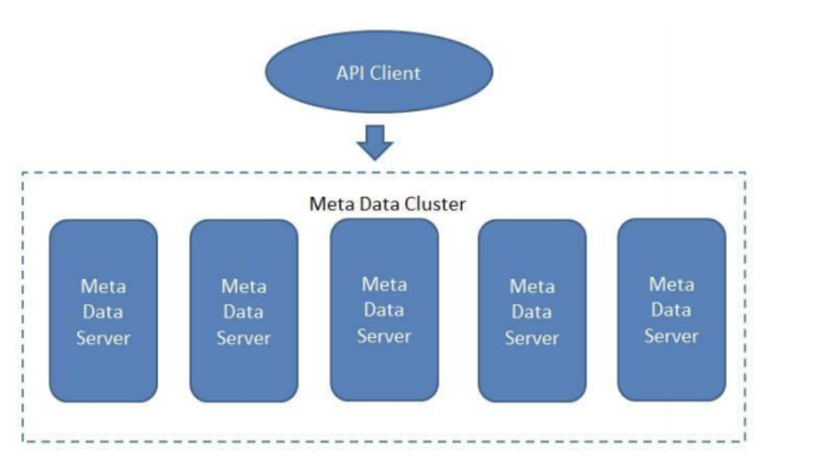

Our implementation supports mkdir, create file, readdir, rm file, stat commands and file handle is be ignored. The demo is put on <https://jbox.sjtu.edu.cn/l/onFVJL>.

# Hash Algorithm

We implement a hash algorithm to distribute the files. Given a file path, we regard it as a string. So, we employ the string hash algorithm to map the file path to the index of metadata server. Specifically, we use BKDR hash algorithm. The algorithm is implemented by following steps.

// BKDR Hash Function

def BKDRHash(path, seed, mod):

hash_value = 0

for ch in path:

hash_value = hash_value * seed + ord(ch)

hash_value %= mod

hash_value = hash_value & 0x7FFFFFFF

hash_value %= mod

return hash_value

# Communication

The communication among computers is implemented by socket programming. Many protocols are designed to finish the task. For example, the query path protocol is designed for stat command to get the metadata of given path. More specific details can be seen on <https://github.com/311dada/MetadataManagement>.

# Acknowledgement

Thanks for the effort of professors and all TAs. Also, thanks for my partners.