MLOps Assignment 01
Heart Disease Prediction
Supporting Report
Course: MLOps AIMLZG523
BITS ID – 2025AE05383
Student: Kartiki Vijaykumar Khoje
GitHub repository: https://github.com/3121kartikikhoje/MLOps-Heart-Disease-Project

1. Executive summary
This project demonstrates a complete, locally deployable MLOps workflow for binary classification using the UCI Heart Disease Cleveland processed dataset. It connects data preparation, exploratory data analysis, model training and comparison, MLflow tracking, automated checks, a FastAPI inference service, Docker packaging, local Kubernetes deployment, and basic request monitoring.
- Dataset: 303 rows, 13 input features, and one binary target.
- Selected model: Logistic Regression, selected by higher test-set ROC-AUC among the two candidates.
- Test metrics: accuracy 88.52%, precision 83.87%, recall 92.86%, ROC-AUC 96.54%.
- Cross-validation: best five-fold ROC-AUC 90.28%.
- Experiment tracking: two MLflow runs stored in the local SQLite tracking database.
- Deployment: Docker container and one-replica local Kubernetes Deployment verified; API accessed using kubectl port-forward.
- Observability: request logging plus Prometheus-compatible request-count and latency metrics.

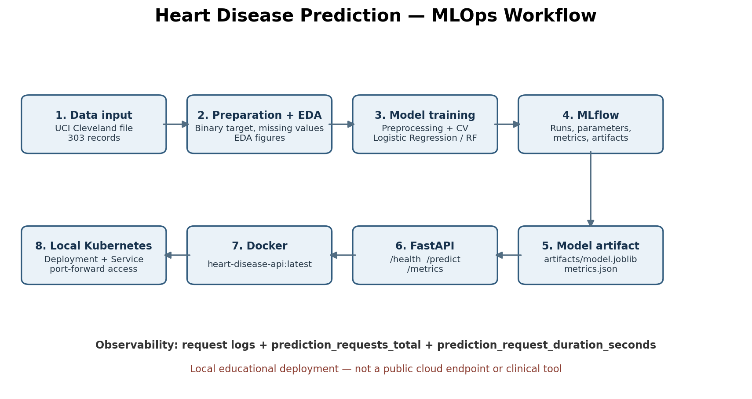

2. Problem, scope and success criteria
The model uses 13 attributes to classify each record into one of two target classes. The supplied Cleveland dataset has original target values 0–4; the code maps 0 to class 0 and values greater than 0 to class 1. This transformation makes the task binary but removes the distinction between disease-severity levels 1–4.
- Prepare the supplied source file into a named CSV and a cleaned dataset.
- Inspect class balance, feature distributions, correlations, and missingness.
- Fit preprocessing inside model pipelines to reduce leakage risk during cross-validation.
- Compare Logistic Regression and Random Forest with grid search and five-fold stratified cross-validation.
- Track parameters, metrics, model objects, and classification reports in MLflow.
- Automate linting, tests, data/EDA/training workflow in GitHub Actions.
- Serve predictions through FastAPI, containerize with Docker, and deploy to local Kubernetes.
- Expose basic request metrics and HTTP request logs.
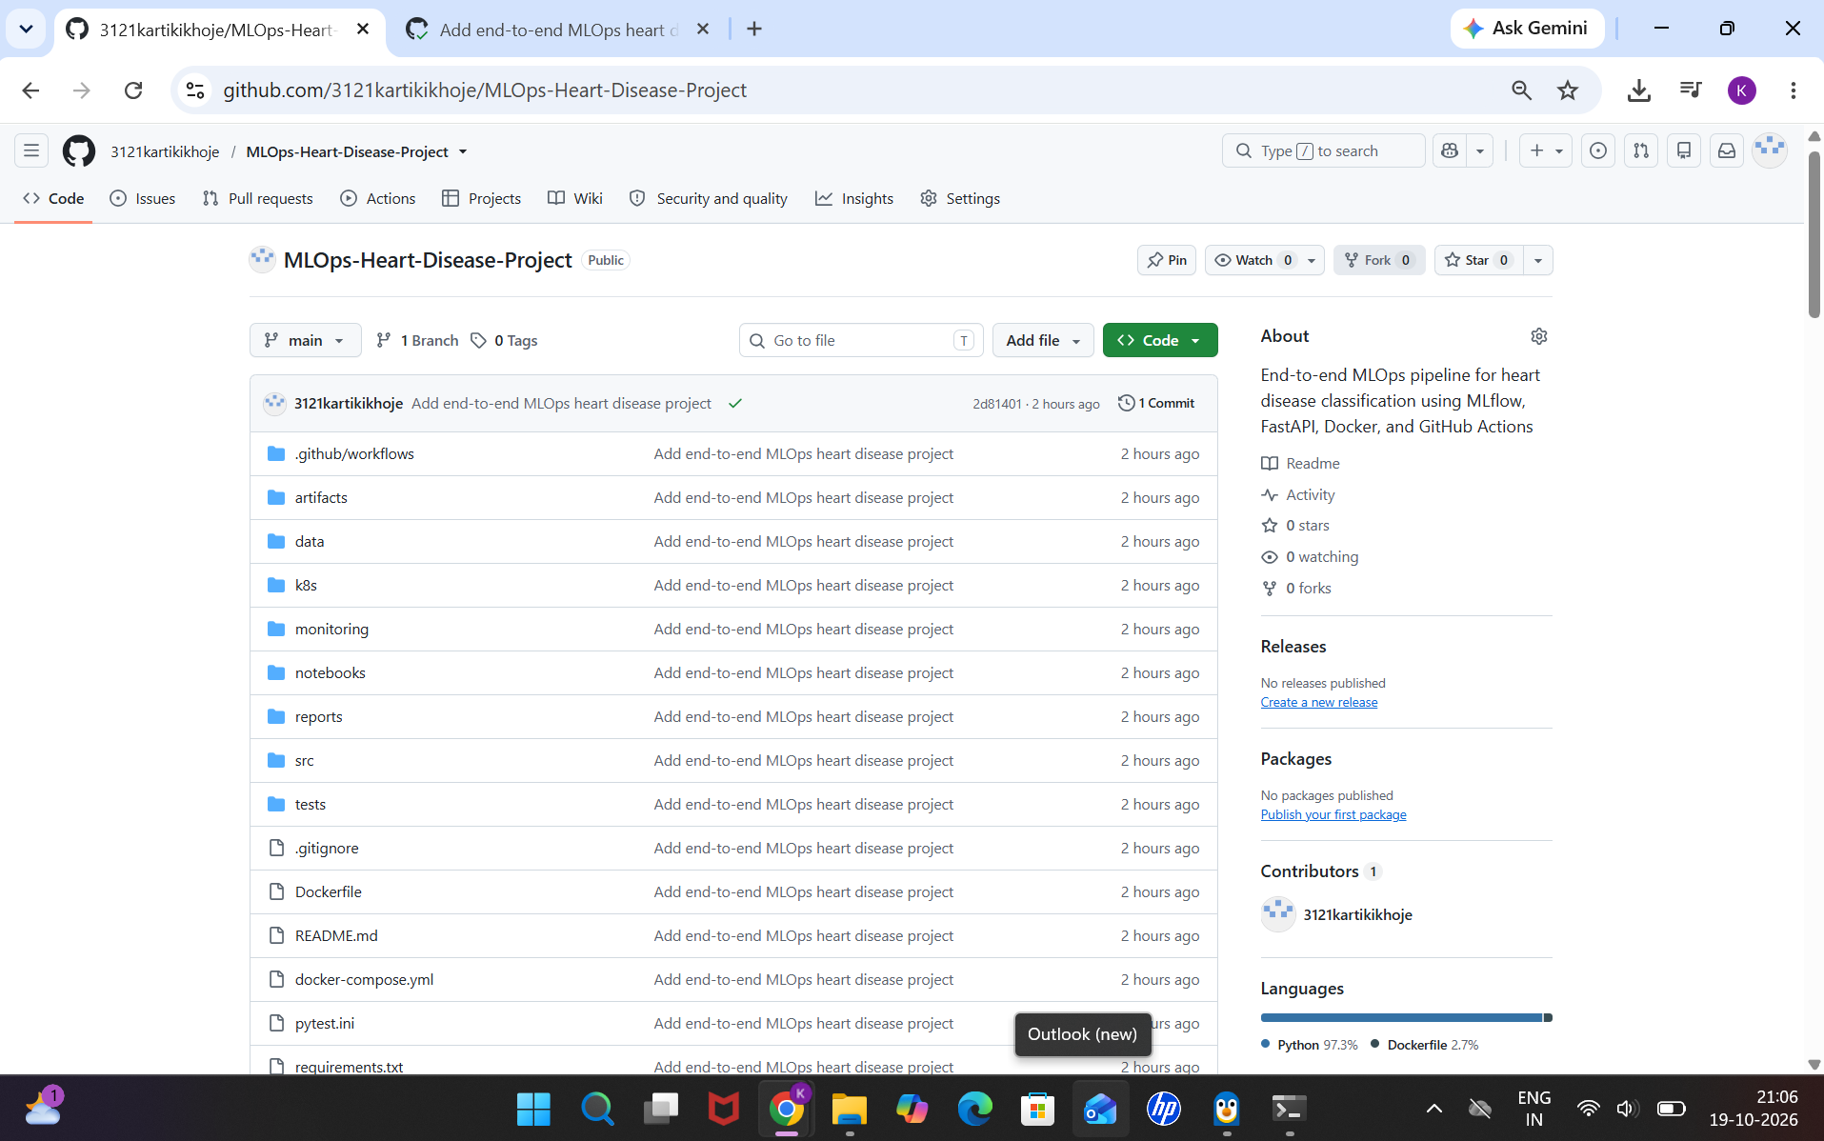

3. Dataset and preparation
The README and src/data.py specify a local source file: data/raw/processed.cleveland.data. The project does not download the dataset at runtime; it expects this file to be present. The preparation command is python -m src.data.
- Dataset source: UCI Machine Learning Repository, Heart Disease (Cleveland subset).
- Source citation/link: https://archive.ics.uci.edu/dataset/45/heart+disease
- Observed shape after loading: 303 rows × 14 columns (13 predictors + target).
- Features: age, sex, cp, trestbps, chol, fbs, restecg, thalach, exang, oldpeak, slope, ca, thal.
- Missingness: ca has 4 missing values; thal has 2; all other columns have 0 after target cleaning.
- Target balance: class 0 = 164 rows (54.13%); class 1 = 139 rows (45.87%).
- Target conversion: (target > 0).astype(int), after dropping rows with a missing target.

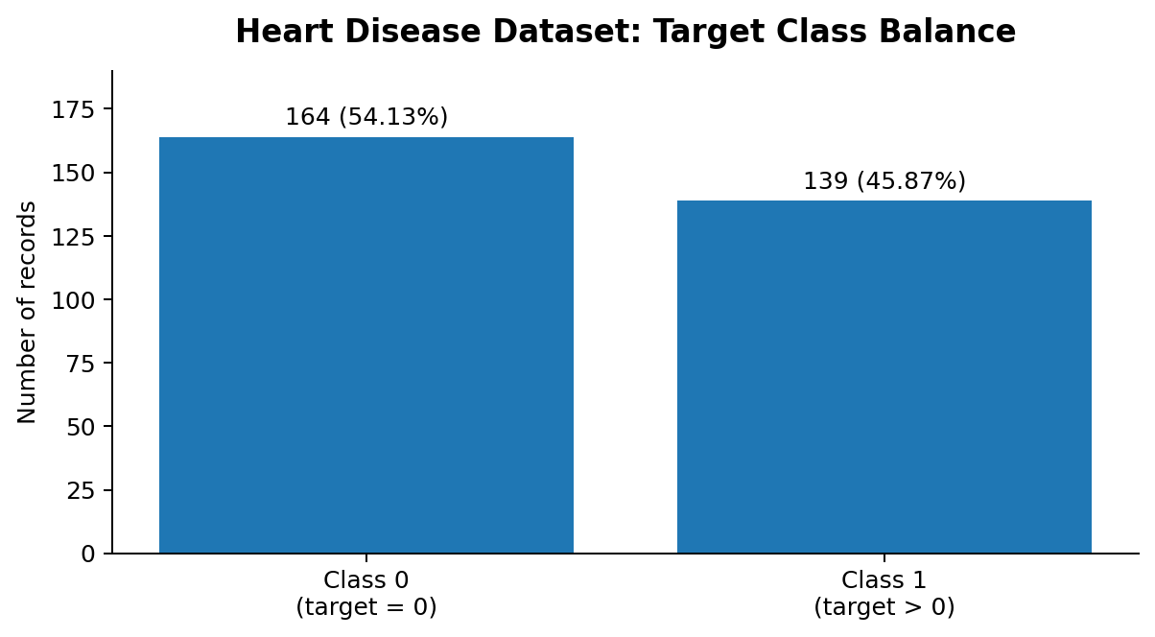

4. Data quality and exploratory analysis
The loader reads '?' as missing values, converts columns to numeric, removes rows with a missing target, and transforms the target. Feature imputation is performed inside the model pipeline, not globally before splitting.
- Numerical fields: age, trestbps, chol, thalach, oldpeak.
- Categorical fields: sex, cp, fbs, restecg, exang, slope, ca, thal.
- EDA outputs are saved in reports/figures/ as feature_histograms.png, correlation_heatmap.png, and class_balance.png.
- Histograms are used to inspect feature ranges and distributions.
- The heatmap summarizes numeric correlations; correlation does not establish causation.
- The class plot shows a relatively balanced target distribution for this sample.

5. Feature engineering and modeling workflow
The project uses a scikit-learn ColumnTransformer inside a Pipeline, so each cross-validation fold fits preprocessing using that fold's training partition. This is a practical way to reduce preprocessing leakage.
- Split: 80% train / 20% test, stratified by target, random_state=42.
- Numerical pipeline: median imputation → StandardScaler.
- Categorical pipeline: most-frequent imputation → OneHotEncoder(handle_unknown='ignore').
- Cross-validation: StratifiedKFold(n_splits=5, shuffle=True, random_state=42).
- Search objective: GridSearchCV with ROC-AUC scoring.
- Logistic Regression: max_iter=2000, class_weight='balanced'; C ∈ {0.1, 1.0, 10.0}.
- Random Forest: random_state=42, class_weight='balanced'; n_estimators ∈ {100, 200}, max_depth ∈ {None, 5, 10}.
- Selection: the candidate with higher held-out test ROC-AUC is saved as artifacts/model.joblib.

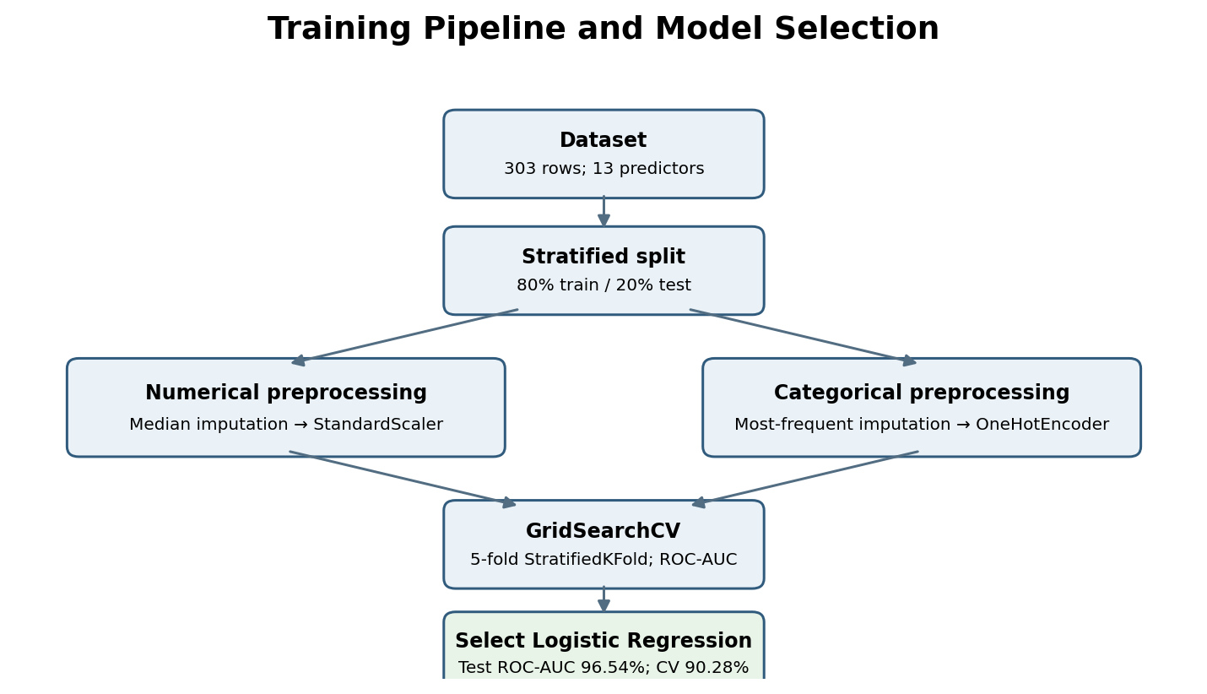

6. Results and model selection
The saved file artifacts/metrics.json and the MLflow run records agree that Logistic Regression is the selected model.
Metric | Logistic Regression | Random Forest
Accuracy | 88.52% | 88.52%
Precision | 83.87% | 83.87%
Recall | 92.86% | 92.86%
Test ROC-AUC | 96.54% | 94.81%
Best CV ROC-AUC | 90.28% | 89.95%

- Selection reason: Logistic Regression has the higher test ROC-AUC and higher best cross-validation ROC-AUC.
- Accuracy, precision, and recall are identical in the recorded runs; ROC-AUC differentiates the candidates here.
- Recall of 92.86% means the model identified a high proportion of positive records in this held-out test split.
- These are experimental dataset metrics, not clinical validation; false positives and false negatives remain possible.

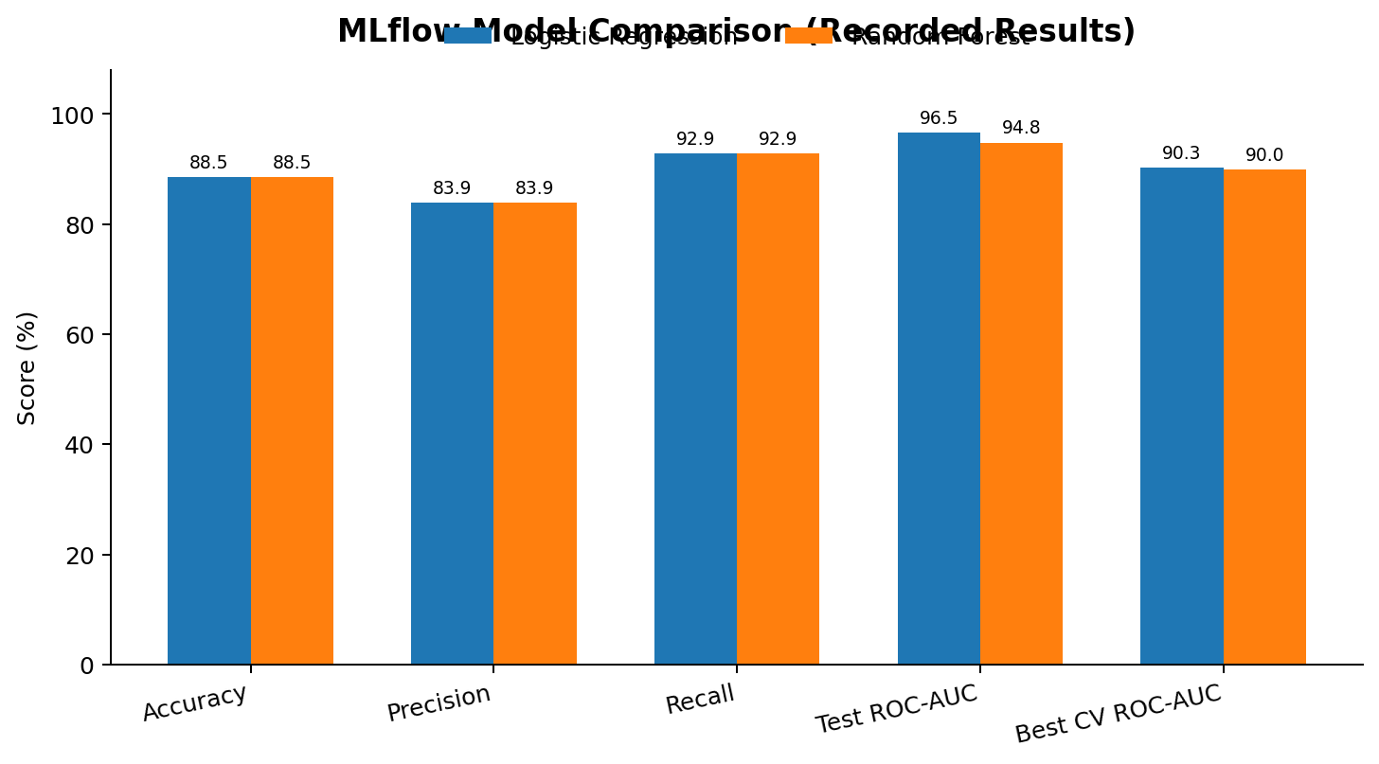

7. MLflow tracking and reproducibility
- Tracking URI: sqlite:///mlflow.db (relative to the project working directory).
- Experiment name: heart-disease-classification.
- Run names: logistic_regression and random_forest.
- Logged parameters: selected GridSearchCV best parameters and model_name.
- Logged metrics: accuracy, precision, recall, test ROC-AUC, and best cross-validation ROC-AUC.
- Logged artifacts: trained scikit-learn model and per-model JSON classification report.
- Local artifacts: artifacts/model.joblib, artifacts/feature_names.json, and artifacts/metrics.json.
- Reproducibility settings include random_state=42 and shuffled five-fold stratified cross-validation.
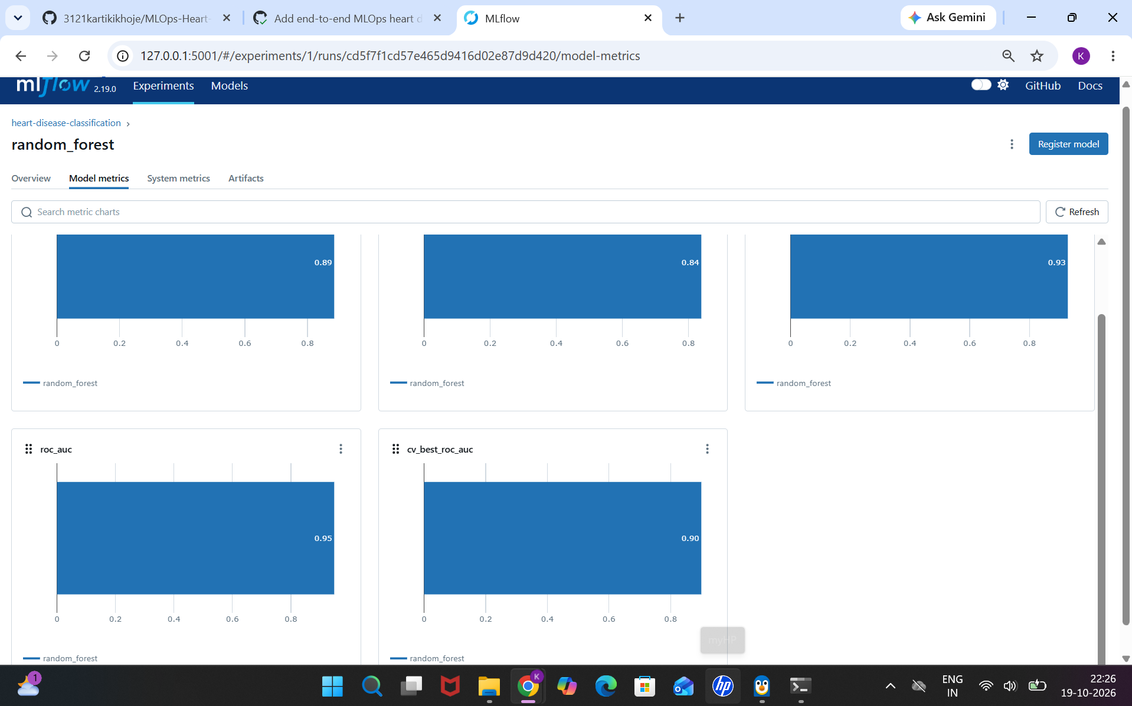
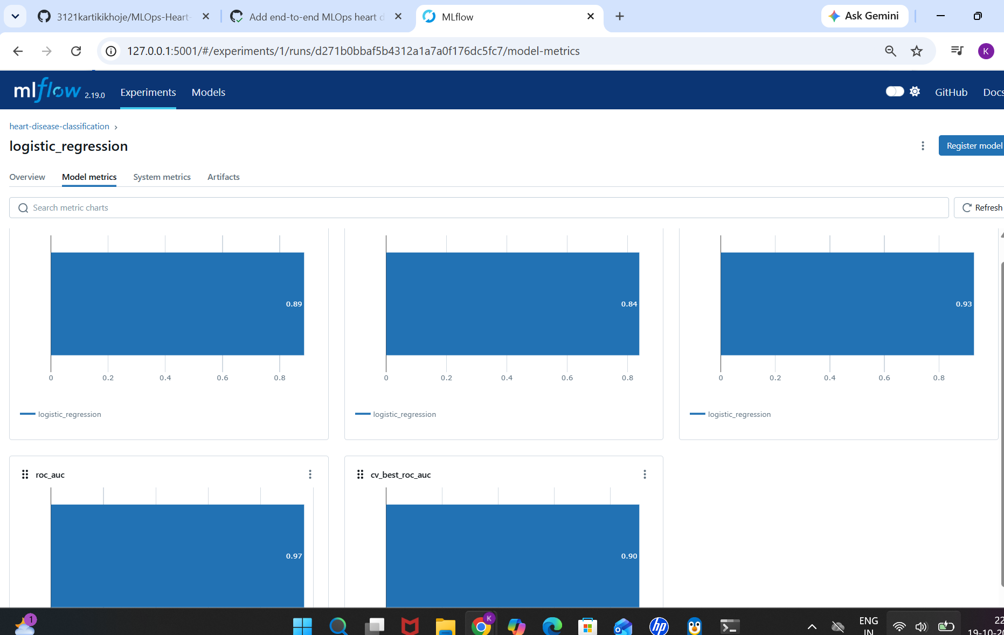

8. Testing, linting and CI workflow
- Unit tests: previously observed result was 4 passed.
- Lint: Ruff previously reported “All checks passed!”.
- GitHub Actions: the project CI workflow was observed to pass.
- Workflow activities reported for the project include linting, tests, data preparation/EDA, training, and artifact upload.
.

9. API, Docker and smoke tests
- FastAPI service: src/api.py; interactive Swagger page: /docs.
- GET /health returns status and whether the model artifact exists.
- POST /predict accepts the 13 features and returns prediction, label, class-1 probability, and educational disclaimer.
- GET /metrics exposes Prometheus-compatible metrics.
- Request logs include HTTP method, path, status, and duration in milliseconds.
- Metrics: prediction_requests_total and prediction_request_duration_seconds.
- Observed smoke tests: health endpoint returned status ok and model_loaded true; Swagger prediction returned HTTP 200; /metrics was checked.
- Docker image: heart-disease-api:latest. Build command: docker build -t heart-disease-api:latest .
Example request body (technical smoke test only):
{
"age": 55, "sex": 1, "cp": 2, "trestbps": 130, "chol": 240,
"fbs": 0, "restecg": 1, "thalach": 150, "exang": 0,
"oldpeak": 1.0, "slope": 1, "ca": 0, "thal": 2
}

10. Local Kubernetes deployment
- Manifest: k8s/deployment.yaml defines a Deployment and a NodePort Service.
- Container port: 8000; NodePort configured as 30080.
- Observed deployment state: one replica available; pod status Running; service endpoint present.
- Direct access to localhost:30080 from Windows failed in this setup; port-forwarding worked.
- Access command: kubectl port-forward service/heart-disease-api 8081:8000.
- Verified at http://127.0.0.1:8081/health and http://127.0.0.1:8081/docs.
- This is local Kubernetes, not a public cloud deployment.

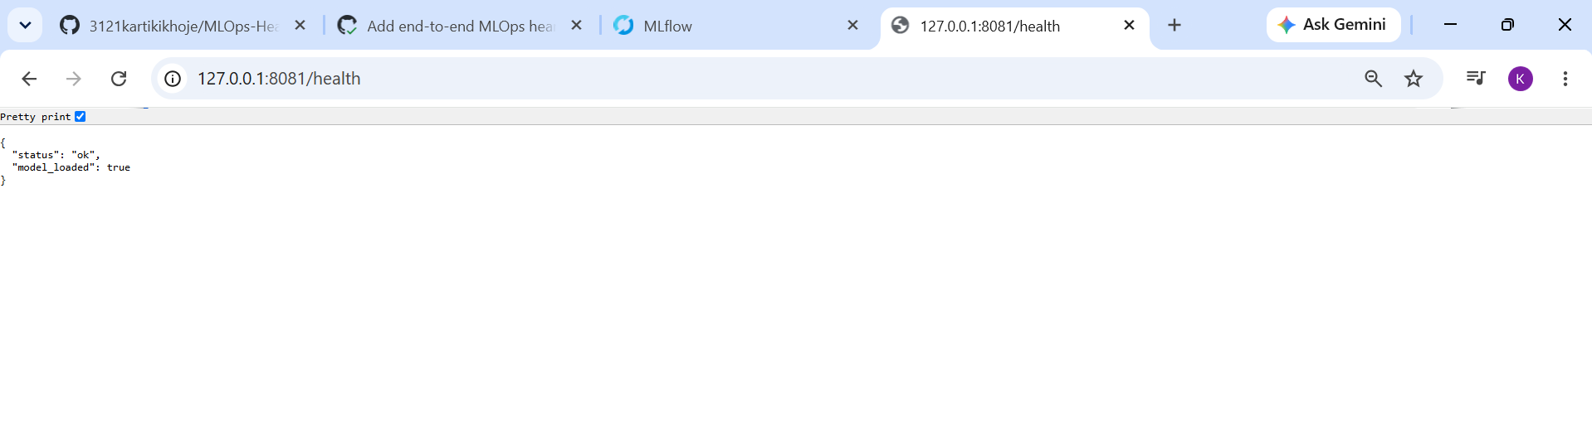
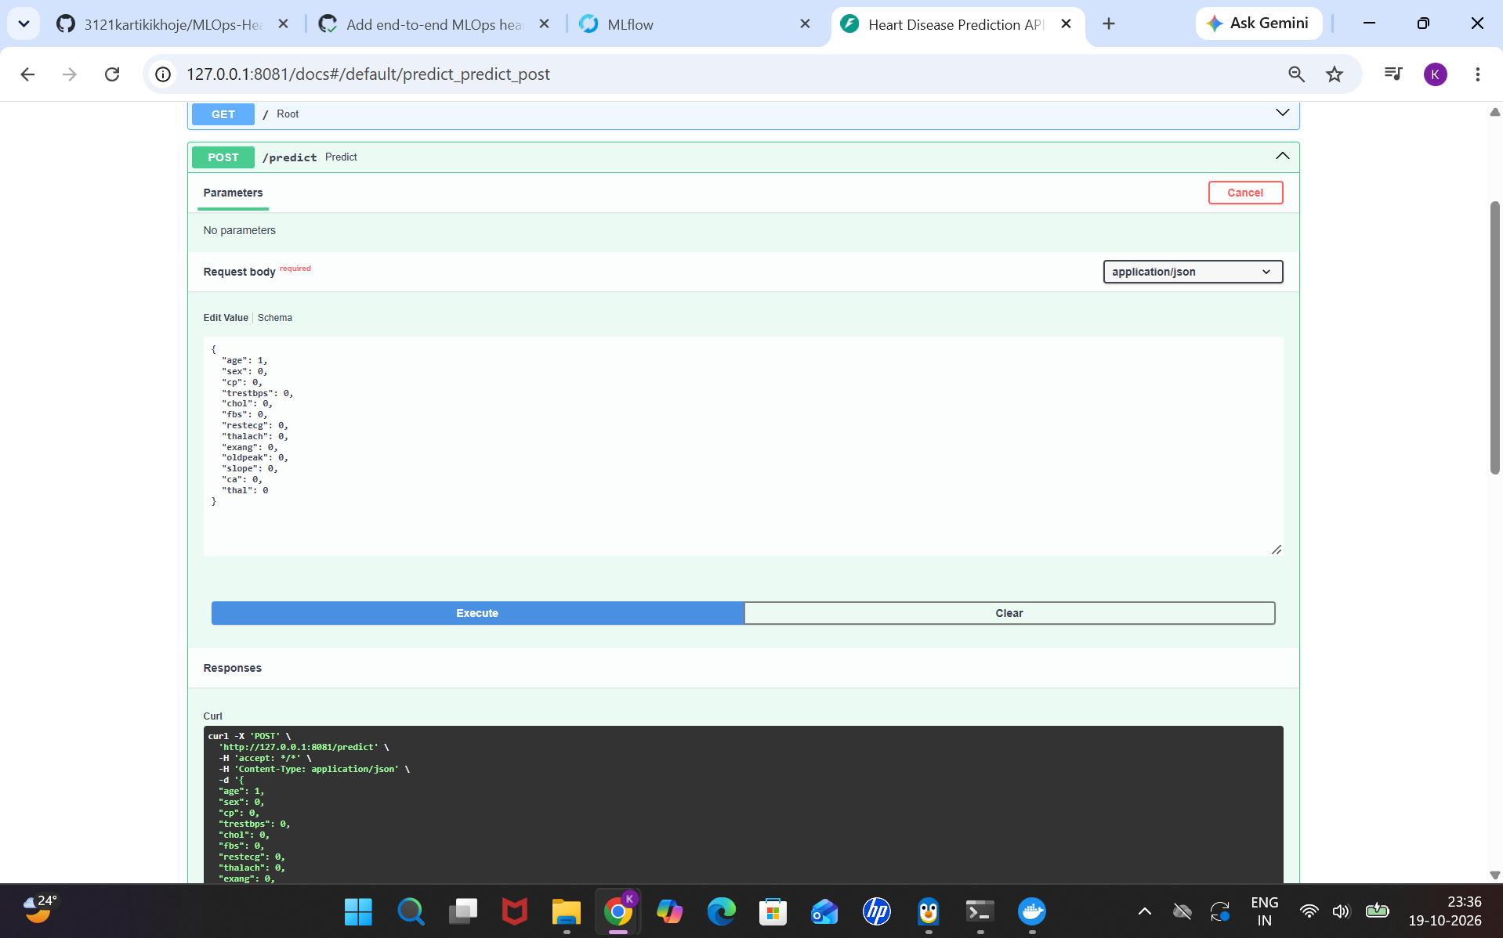

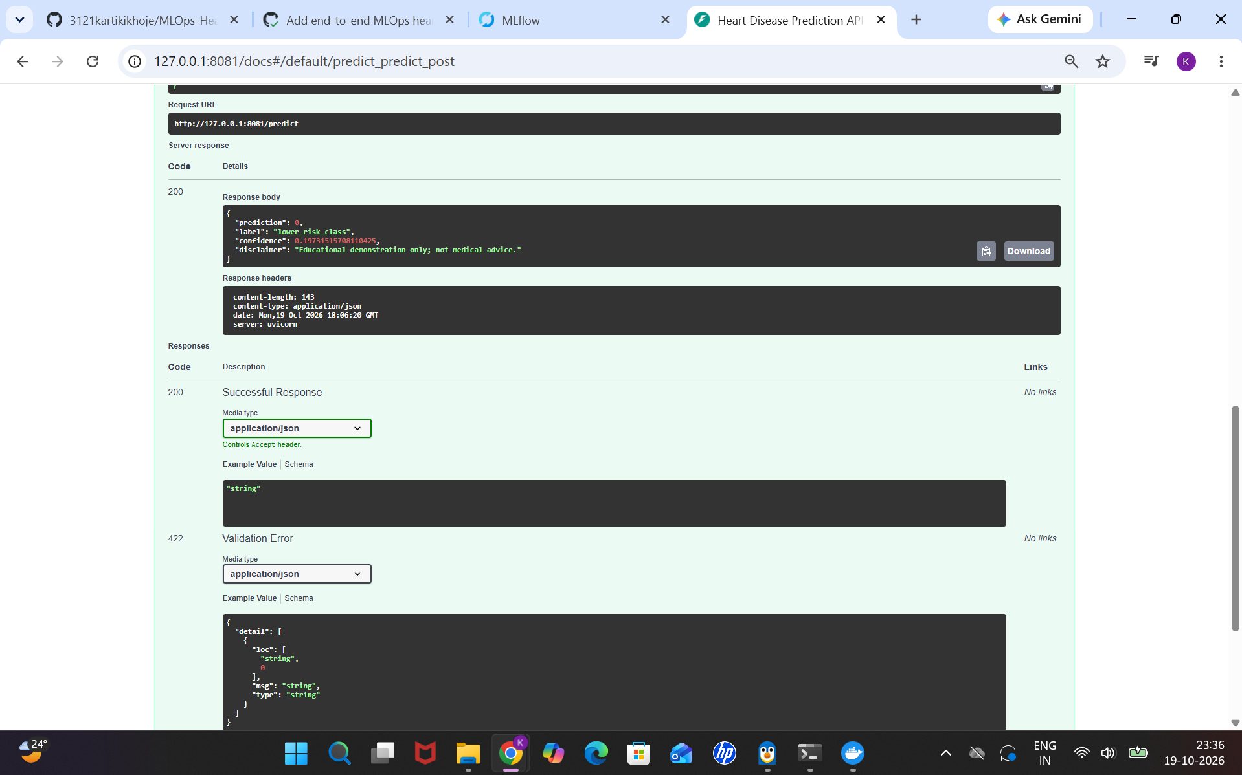

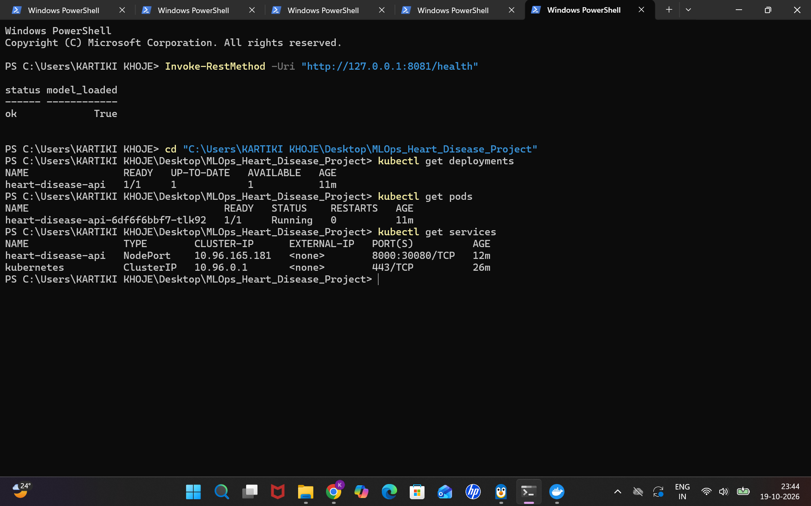

11. Monitoring, limitations and next steps
- Implemented observability: per-request log line with method, path, HTTP status, and duration.
- Prometheus-compatible metrics count prediction requests and measure prediction duration.
- The health endpoint checks model-file existence; it does not guarantee a successful inference.
- The API's confidence field is the model's estimated probability for class 1 and may not be calibrated.
- Not verified: a deployed Prometheus server, Grafana dashboard, alerting, centralized logs, public cloud endpoint, or production-grade security.
- Dataset limitations: small historical cohort, possible sampling/demographic bias, missing features, and target severity collapsed into a binary label.

12. Conclusion
The project connects the major MLOps stages into a working local demonstration: data preparation and EDA, model selection, experiment tracking, testing and CI, API serving, containerization, Kubernetes deployment, and basic observability. Logistic Regression was selected because it achieved test ROC-AUC 96.54% and best cross-validation ROC-AUC 90.28%, outperforming Random Forest on both ROC-AUC measures in the recorded comparison.
The strongest submission evidence is a combination of reproducible code, recorded MLflow runs, a passing CI workflow, successful API smoke tests, a running Kubernetes pod, and genuine screenshots. Results must be interpreted only in the educational context of this dataset.

Appendix A. Architecture diagram

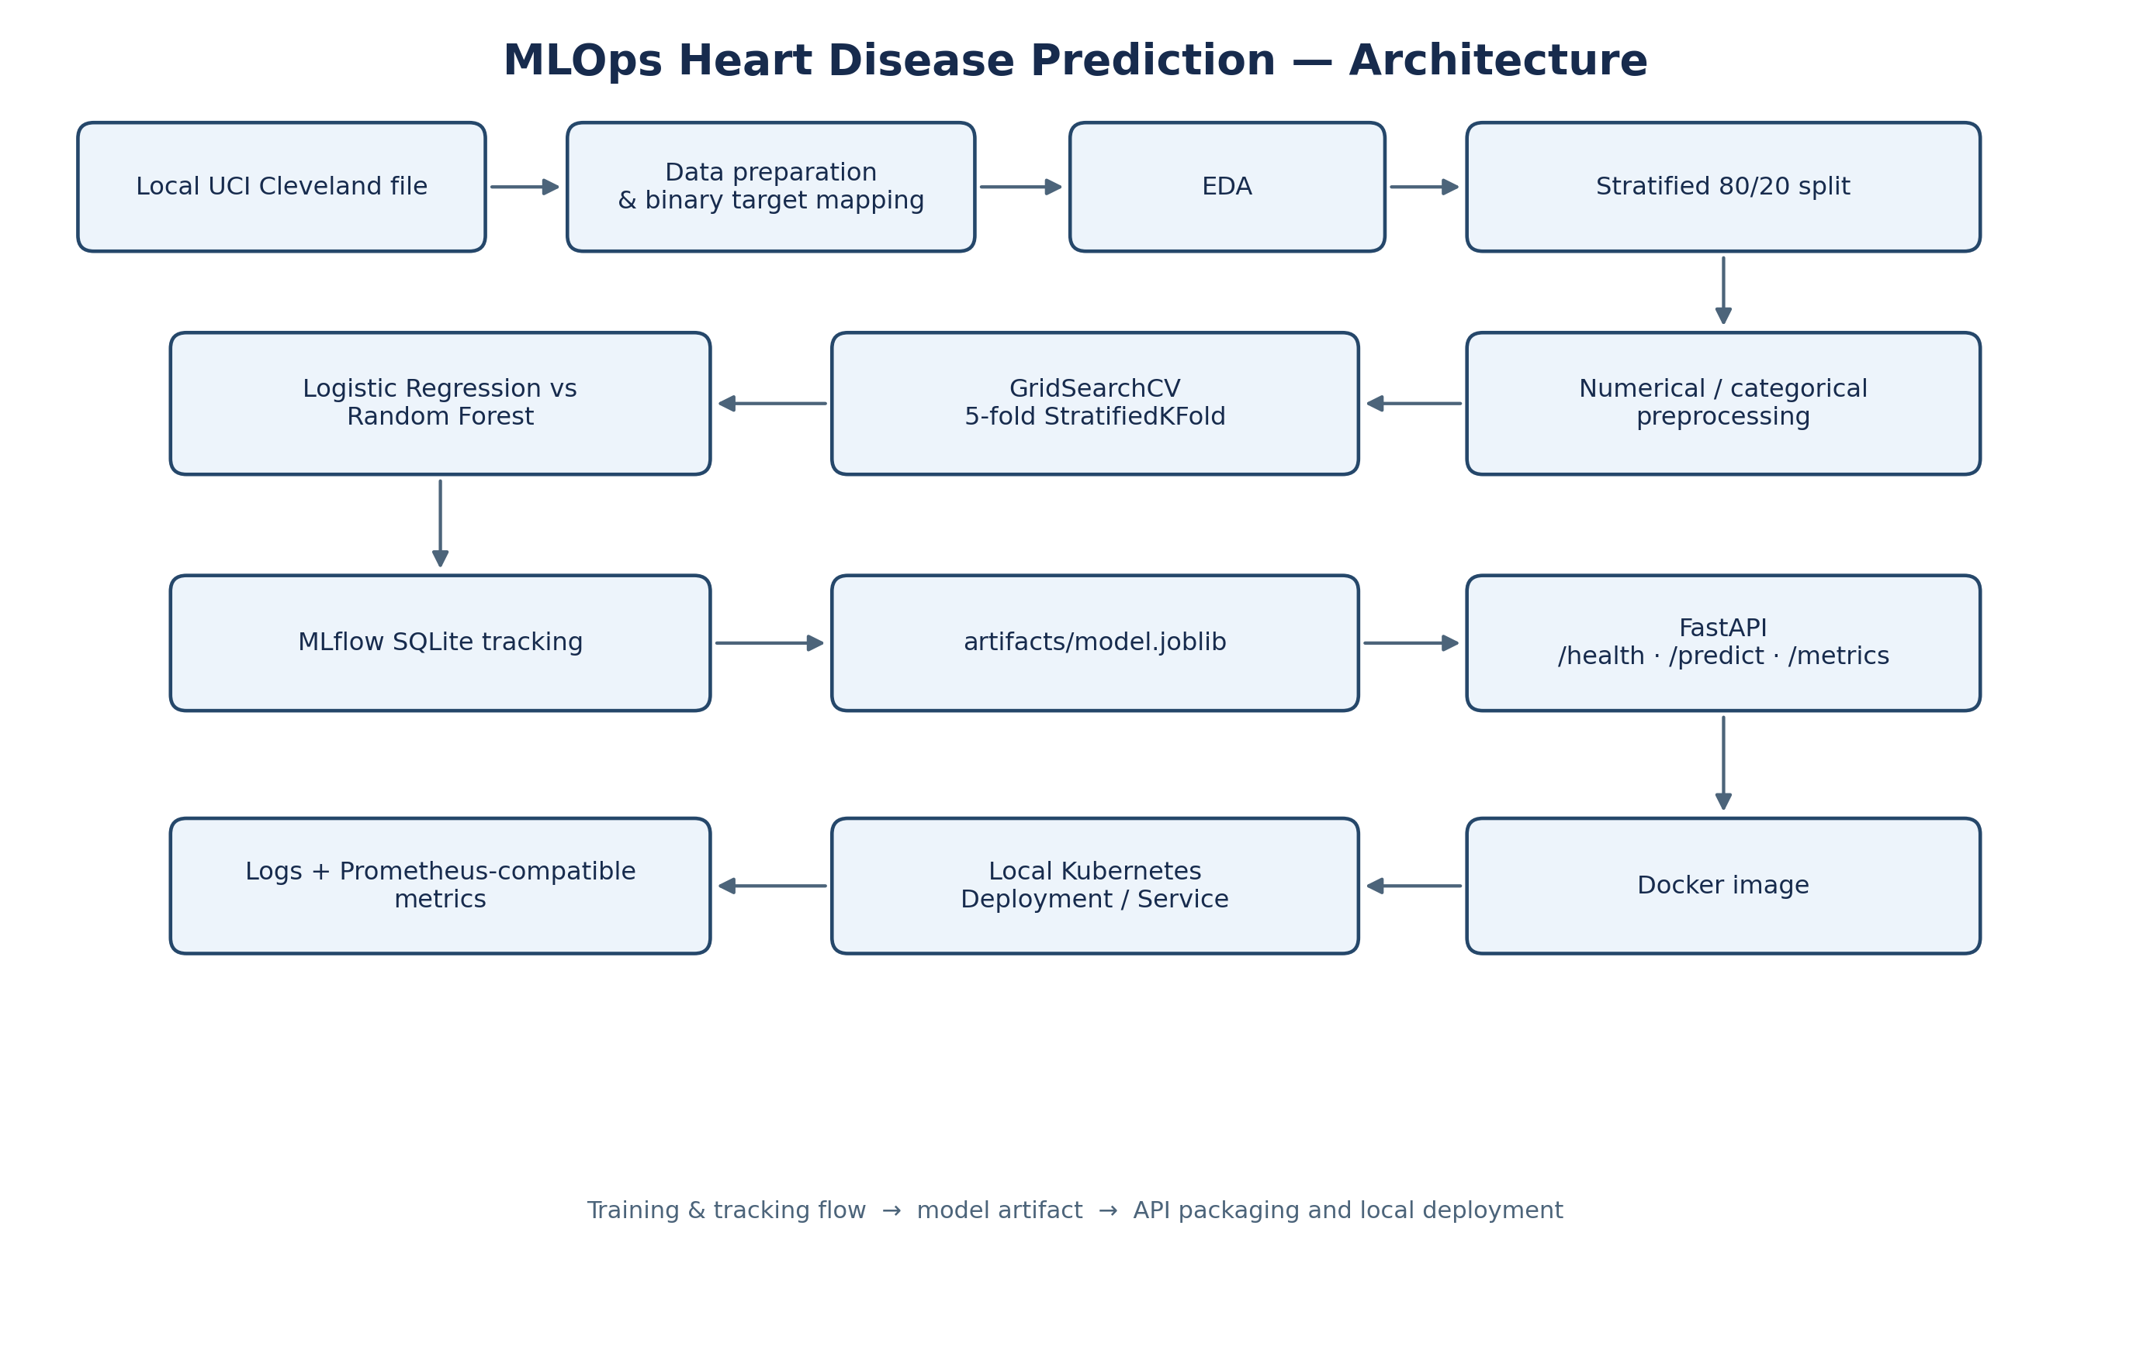

Appendix B. Reproduction commands
From the project root in PowerShell:
python -m src.data
python -m src.eda
python -m src.train
pytest -q
ruff check src tests
docker build -t heart-disease-api:latest .
kubectl apply -f .\k8s\deployment.yaml
kubectl get pods
kubectl get deployments
kubectl get services
kubectl port-forward service/heart-disease-api 8081:8000

Important links-

GitHub repository:https://github.com/3121kartikikhoje/MLOps-Heart-Disease-Project

Evidence folder:
https://github.com/3121kartikikhoje/MLOps-Heart-Disease-Project/tree/78ee9fb94fde680b23c74514652f64888c436d27/reports/evidence

Dataset source: https://archive.ics.uci.edu/dataset/45/heart+disease

