FRTS Ingress Platform
High-Level Design — Master
Version 4.0 · The Manifold Architecture
One self-contained build reference: requirement, architecture, principles, delivery — Go manifold · cellular tenancy · PostgreSQL · Temporal · knowledge-graph context plane
Draft for team baseline · 25 August 2026
Author: Andy Ward, UST Enterprise Architect
CONFIDENTIAL — UST internal. Supersedes all prior HLD versions (v0.8, v1.0, v2.0, v3.x), which are retained as records only.

Contents
1 Document Control 4
1.1 Related documents 4
1.2 Change history 4
2 Executive Summary 5
3 Purpose, Scope and Audience 6
3.1 Purpose 6
3.2 In scope 6
3.3 Out of scope 6
4 Context and Drivers 7
5 Principles (binding) 7
5.1 Platform principles 7
5.2 Agent-first design principles 8
6 Architecture Overview 8
6.1 Service catalogue 9
6.2 Layer responsibilities 10
7 TCG Integration Layer — tcg-service 10
7.1 Pattern 10
7.2 Master data via the FOP APIs 10
7.3 Transactional data via SFTP pull 11
7.4 Durable workflows 12
8 Persistence — the PostgreSQL Data Platform 12
8.1 Canonical: as-is in JSONB, keyed by generated columns 13
8.2 The subscription overlay 14
8.3 Staging, ops, roles and files 14
9 Cellular Tenancy — the ISM Subscriber Layer as Cells 15
10 Curation — the Web Application 15
10.1 Subscribe and enrich 15
10.2 The approval gate 16
10.3 Price and promotion: advisory surveillance 16
10.4 Realisation and personas 16
11 ISM Subscriber Layer — Interface Packs 16
11.1 A pack is the unit of subscriber variability 17
11.2 Dispatch, receipts and the auth edge 17
11.3 Outbound content 17
12 Sales Order Return Path 17
12.1 Flow 18
12.2 Contract shape (FOP spec v0.4.0 / beans worked example) 18
12.3 Timing and the reviewed relay 18
13 Durable Execution — Temporal 18
14 The Knowledge-Graph Context Plane 19
14.1 What it is 20
14.2 The one hard rule: derived, never curated (D9) 20
14.3 How agents use it 20
14.4 Boundaries 20
15 Data Flow Catalogue 21
16 Security Architecture 21
16.1 Identity 21
16.2 Data protection and partitioning 22
16.3 Delivery-time guardrails (binding, from the driving brief) 22
17 Built for Agents: the Local Loop and the Oracles 22
17.1 The compose stack 22
17.2 The oracle suite 22
18 Git Design and Repository Provisioning 23
18.1 Repositories 23
18.2 Policy 23
18.3 The seed pack 24
19 Deployment, Environments and Operations 24
19.1 Environments 25
19.2 Release train 25
19.3 Operations and DR 25
20 Non-Functional Requirements 25
21 Key Design Decisions 26
22 Assumptions, Dependencies and Risks 28
22.1 Assumptions 28
22.2 Dependencies 28
22.3 Risks 28
23 Delivery Approach and Build Sequencing 29
24 Open Items for Team Baseline 30
25 Glossary 30

1 Document Control
Field | Value
Document title | FRTS Ingress Platform — High-Level Design (Master)
Version | 4.0 (Master — draft for team baseline)
Author | Andy Ward, UST Enterprise Architect
Date | 25 August 2026
Audience | UST delivery team (architecture, engineering, BA, test) and UST technical leadership. The delivery boundary is UST-only; ISMs are external requirement contributors and future subscribers with no sight of this document.
Status | MASTER. The single, self-contained build reference for the FRTS Ingress Platform. Repositories are provisioned from section 18; the seed pack (frts-platform-seed.zip) is generated from this document.
Supersedes | HLD v0.8, v1.0, v1.0-draft-2, v2.0 and v3.x. Those documents are retained in delivery-context as historical and evaluation records only; nothing in them is normative where this document speaks, and this document is written to speak completely.

1.1 Related documents
Document | Role
FOP API spec v0.4.0 (OAS 3.0) + FRTS API Guide 0.4.0 | The upstream API contract this platform consumes. Committed to contracts/ in the monorepo in agent-readable form.
FRTS API Data Dictionary 0.4.0 | Field-level definitions for all FOP entities; source for canonical column generation and validation structs.
Beans worked example (TCG sample payloads) | Reference payloads including the sales order 200-rejection and 400-error shapes; the fidelity bar for the FOP mocks and the conformance pack.
FRTS Business Requirements (TCG) | Business context: flows in scope, business clocks, cutover framing, new product identifier structure.
AI-First Delivery Driving Brief v0.2 | The delivery operating model: principles A1–A7, team shape, guardrails, mobilisation plan.
ISM LLD workshop outputs (May 2026) | Open upstream questions and cutover constraints raised by the ISM community.
frts-platform-seed.zip | The seed pack generated from this document: 14 accepted ADRs, DPD stubs, CLAUDE.md, Claude skills, templates (section 18.4).

1.2 Change history
Version | Date | Change
4.0 master | 25 Aug 2026 | Single self-contained master. Consolidates the requirement statement (previously in v1.0), the Manifold architecture (previously in v3.x), and the agent-first principles (previously split across v2.0/v3.x) into one document with no normative back-references. All decisions settled, including Temporal as the durable engine. Prior versions reclassified as records.
v3.x | 18–25 Aug 2026 | Manifold architecture drafts (Option E): Go services, cellular tenancy, context plane; Temporal settled at v3.1.
v2.0 | 18 Aug 2026 | Agentic greenfield evaluation track (Option A+): TypeScript monolith, Postgres RLS, Temporal.
v1.0 | 18 Aug 2026 | Microsoft-stack track: Dataverse, Power Platform, MDDI. Source of the consolidated requirement statement; superseded as architecture.
v0.8 | 31 May 2026 | Pre-productisation UST-internal draft. Historical.

2 Executive Summary
TCG is retiring the legacy NSL product identifier and the 300-plus file feeds that depend on it, replacing them with the FRTS Ordering Platform (FOP): REST APIs for master data and ordering, plus SFTP file feeds for transactional documents. TCG has aligned its cutover to the Deposit Return Scheme go-live in October 2027 and will enforce that date through the Buying Services Agreement. Every ISM in the FRTS buying group must be consuming the new feeds by then — ten societies with heterogeneous downstream estates and limited appetite for bespoke builds of their own.
The FRTS Ingress Platform is UST's product answer: one multi-tenant platform that integrates with TCG exactly once and serves every subscribing society. It is designed on two premises. First, the delivery is fully agentic — AI agents write, test and operate essentially all of the code, with humans gating — so the architecture is chosen to be maximally legible to agents: everything text in git, everything runnable on a laptop, everything proven by deterministic test oracles. Second, the platform is greenfield: no low-code platforms, no inherited frameworks, no forked codebases.
The architecture is a manifold of Go services around a PostgreSQL hub, in four party-aligned layers:
- TCG Integration Layer (tcg-service) — owns every exchange with TCG in both directions: master data pulled from the FOP APIs (OAuth2 JWT on a registered client, concurrent pollers with delta watermarks), transactional files pulled from TCG's SFTP endpoint, and sales orders submitted back to FOP. Inbound payloads are validated against the published contract and stored unchanged — there is no ETL on ingress, because TCG masters this data.
- Persist (PostgreSQL data platform) — canonical TCG data as-is in JSONB with generated key columns; a subscriber overlay (selections, enrichment, decisions) under native row-level security; sales order staging; watermarks, lineage and append-only audit; an object store for the file landing zone and archive.
- Curate (React SPA + curation-bff) — per-entity screens where a subscribing society's commercial user filters the TCG catalogue to what they range and enriches it with the data elements their systems need — above all their own downstream keys. Nothing leaves the platform without a decision recorded here.
- ISM Subscriber Layer (ism-service cells) — one service image deployed as one cell per subscriber, executing that subscriber's interface pack: outbound distribution in their formats, inbound sales orders in their format mapped to the TCG format, per-cell credentials and database role. The auth edge and the tenant partition live here — isolation is enforced twice, in process and in data.
Temporal (Go SDK) carries every durable flow — polling, file feeds, dispatch, the idempotent order relay — as plain Go functions with typed retry policies and full execution history. A knowledge-graph context plane, derived from the monorepo by CI on every merge and exposed read-only over MCP, gives agents structural navigation grep cannot: what writes this table, what breaks if a field disappears, which decision governs this package.
This document is the complete build reference: requirement, contracts, architecture, principles, security, delivery. Section 20 lists the design decisions that bind the implementation; section 18 defines the repositories; section 22 sequences the build from contract-faithful mocks and a walking skeleton.

3 Purpose, Scope and Audience

3.1 Purpose
This HLD describes the FRTS Ingress Platform in sufficient detail for the delivery team to implement it — component responsibilities, integration contracts, the data model, the security model, environments and build order — and it is deliberately self-contained: a reader needs no prior HLD version. It is written to be decomposed directly into agent-ready specifications on the ADO board (specs are the product, principle A2), and it is the source from which the repository seed pack is generated.

3.2 In scope
- Ingestion of all TCG/FRTS master data flows (retail product, wholesale product / catalogue item, wholesale cost, promotion, product hierarchy, supplier) via the FOP APIs, and of transactional flows (EDN, invoices, claims, condition contracts, planogram/RADR and PSA files) via SFTP file pull.
- Persistence of the TCG canonical model in PostgreSQL, stored as-is, with lineage and audit; file content in an object store.
- The curation web application implementing subscribe-and-enrich per data element, with approval flows, advisory price/promotion surveillance and full decision audit.
- The ISM Subscriber Layer as cells executing interface packs: per-destination definitions, typed mappings, dispatch, delivery receipts, inbound sales order intake at the auth edge.
- The sales order return path: ISM-format intake, transformation to TCG format, staging, idempotent submission to FOP, acknowledgement and rejection hand-back.
- Durable execution (Temporal), the knowledge-graph context plane, security architecture, environments, ALM, observability, non-functional requirements, git design and delivery sequencing.

3.3 Out of scope
- Re-implementing TCG functionality. The platform consumes FOP; it does not duplicate or replace it. Upstream truth is upstream truth (P2).
- Order management. The platform validates, transforms and relays sales orders; browsing, composition, amendment and lifecycle stay in the subscriber's P2P (P6).
- Retail pricing decisions. TCG cost and promotion data is advisory. The platform never writes a consumer-facing price (P5).
- Per-subscriber code. Variability lives in packs, cell manifests and configuration — never in code branches or per-tenant stacks (P1, P7).
- In-product AI. AI is the delivery team's build-time capability only; no product feature depends on model inference (KDD-19).
- Commercial framing. Pricing, funding and partner economics are owned by the bid team and are deliberately absent from this document.

4 Context and Drivers
TCG implemented SAP for its core retail estate under the Retail Business Transformation programme, but the wholesale order-to-bill processes serving the FRTS buying group still run on legacy systems keyed on NSL and Retail Line. The NSL Retirement programme replaces this with FOP: API-first master data and ordering on the new Catalogue Item identifier, with JSONL file feeds over SFTP for transactional documents. FOP is built on the existing RBT master-data design, and the programme is explicit that the core design is not reopening.
Drivers that shape this architecture:
- A hard, supplier-enforced deadline. October 2027, aligned to DRS. Not regulatory in origin, but binding in practice through the BSA.
- Ten societies, one obligation, heterogeneous estates. Downstream landscapes range from SymphonyAI Gold and Unit4 to Excel-driven processes. The platform integrates with TCG once and absorbs per-subscriber variability at the edge, in packs and cells.
- TCG masters the data. The ISM-side value is not transformation of TCG data — it is selection (which items a society ranges), enrichment (the keys and attributes their systems need), and reliable, observable delivery.
- A moving upstream contract. The FOP spec is at v0.4.0 with open ISM-community questions (cutover phasing, rejection notifications, rate limits). The design confines contract churn to one generated client package, and delivery starts against contract-faithful mocks because TCG dev endpoints are not expected until roughly week six.
- A fully agentic delivery. The team drives AI agents from shared context; humans gate. The architecture is therefore selected for agent build-and-operate efficiency — the D-principles of section 5 — subject to the unchanged business requirement.

5 Principles (binding)
Two principle sets bind every design and every pull request. The platform principles (P) govern what the product is; the agent-first design principles (D) govern how it is shaped for an agentic delivery. Changing any principle requires an ADR with EA approval. The delivery principles A1–A7 (how the team works its agents) live in the driving brief.

5.1 Platform principles
Ref | Principle | Practical test
P1 | Platform, not projects | If a change can only be met by forking behaviour for one society, the design is wrong. Variability goes to packs, cell manifests, subscription data and configuration — never code branches.
P2 | Upstream truth is upstream truth | Canonical tables are written only by tcg-service's validated upsert path. The overlay references canonical rows by key and never modifies them. Any other write into canonical is a defect.
P3 | One way in, one way out | API and SFTP inbound converge on the same canonical events. Every ISM-side interface — outbound or inbound — is a pack with the same lifecycle, receipts and observability. No side-channels.
P4 | Nothing leaves without a decision | Data exits only after a deliberate human or signed-off rule-based decision recorded in audit. Automation prepares; it does not approve.
P5 | Advisory, never authoritative, on price | TCG cost and promotion data is surveilled and surfaced. The platform never writes a consumer-facing retail price.
P6 | Relay, not order management | Sales orders are validated, transformed and relayed with idempotency. No order composition, amendment or lifecycle screens.
P7 | One platform; isolation in data and cells, never in code | One codebase, one data plane. Subscriber isolation is enforced by the cell (process, credentials, DB role) and by row-level security beneath it — never by per-tenant code or stacks.
P8 | Everything is code, everything is observable | If it was clicked into existence in a portal, it does not exist. Every flow can answer 'where is my record?'.

5.2 Agent-first design principles
Ref | Principle | Practical test
D1 | Everything is text in git | Code, schema, config, infra, seeds, tests, docs, runbooks. Behaviour that lives in a portal, designer canvas or vendor console does not exist.
D2 | The whole platform runs locally | docker compose boots database, workflow engine, object store, FOP mock, SFTP mock, graph and two synthetic subscriber cells. A feature that cannot run and be tested there is rejected at design time.
D3 | Boring, deeply-documented technology | Choose what the models know best: Go, PostgreSQL, React, OpenAPI, Terraform. Novelty buys its way in by ADR — Temporal is the one admitted exception (KDD-11).
D4 | Schema-first with codegen | The FOP OAS and data dictionary generate the client and validation structs; the BFF OAS generates the SPA's TypeScript client. Contract drift is a compile error, not a production incident.
D5 | Deterministic oracles define done | Unit, golden-file, contract, isolation and E2E suites are the acceptance criteria of every spec. An agent's work is finished when the oracles say so, not when the diff looks plausible.
D6 | One language per side of the BFF | Go everywhere behind it; TypeScript only in the SPA, its client generated from the BFF's OpenAPI. The seam is codegen, never hand-kept types.
D7 | Modular manifold over monolith or mesh | Few services, no synchronous service-to-service calls, coordination through Postgres and Temporal only. The schema is the contract; there is no RPC topology to mis-reason about.
D8 | Observability as text | Structured logs, OpenTelemetry traces and Temporal execution histories answer 'where is my record?' from a terminal — the same interface agents debug through.
D9 | Derived knowledge, never curated | Any machine-readable index of the codebase — the knowledge graph above all — is regenerated from source by CI, stamped with the commit SHA, and read-only. Hand-edited indexes are forbidden: a stale index lies to agents with confidence.

6 Architecture Overview
At system-context level the platform sits between TCG/FRTS and the subscriber estate. TCG integration happens exactly once, in one place. Subscribers interact in two ways, both at the auth edge: their commercial users curate data through the web application, and their systems exchange data through their cell. UST operates everything in between.
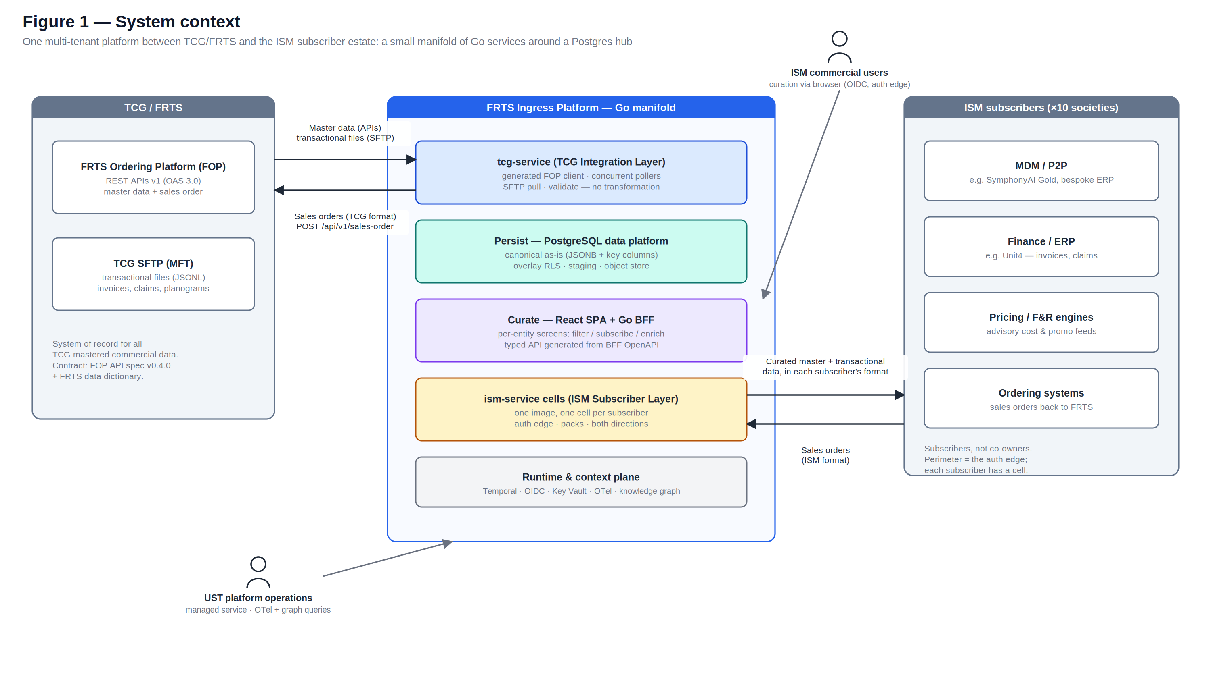
Figure 1 — System context: one multi-tenant platform between TCG/FRTS and the ISM subscriber estate.
Internally the platform is a manifold: three service kinds around a PostgreSQL hub, with Temporal carrying all asynchronous work. The two outer layers are party-aligned — the TCG Integration Layer owns every exchange with TCG in both directions, and the ISM Subscriber Layer owns every exchange with subscribers in both directions. 'Ingress' and 'egress' describe the direction of a flow on an interface, never a layer; the product name FRTS Ingress Platform is brand, not a layer.
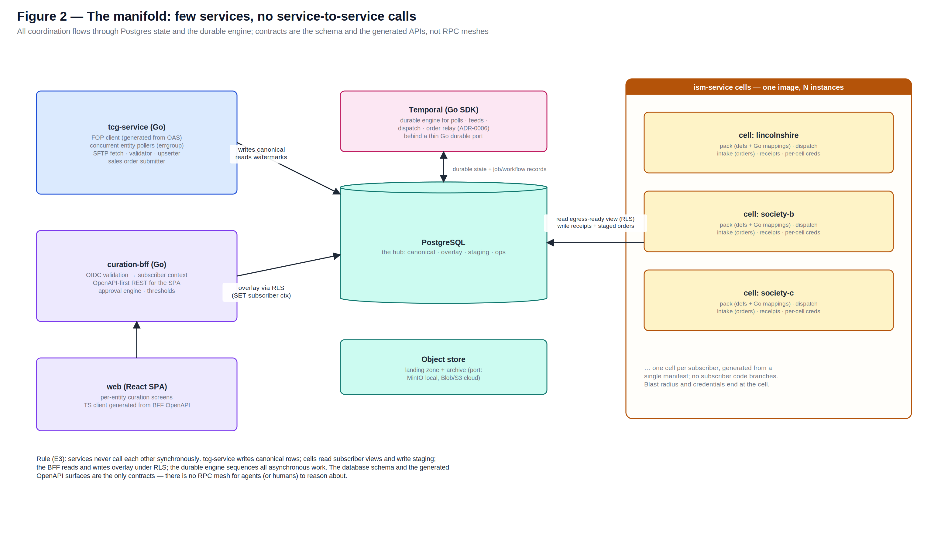
Figure 2 — The manifold: tcg-service, curation-bff + SPA, ism-service cells, Postgres hub, Temporal.

6.1 Service catalogue
Service | Layer | Responsibilities | Instances
tcg-service | TCG Integration | Generated FOP client (token, partnerId, declared egress IP); concurrent entity pollers with watermarks and pagination; SFTP fetch; validation (conformance only); canonical upserts; sales order submission | 1 (scaled vertically; pollers are goroutines)
curation-bff | Curate | OIDC validation → subscriber context; OpenAPI-first REST for the SPA; approval engine; threshold surveillance; delivery console API | 1–2 (stateless)
web (SPA) | Curate | Per-entity screens, bulk subscribe, enrichment panel; TypeScript client generated from the BFF OpenAPI | static assets + CDN
ism-service | ISM Subscriber | Pack execution: outbound dispatch with receipts; inbound order intake and mapping; auth-edge endpoints for its subscriber | 1 cell per subscriber (section 9)

6.2 Layer responsibilities
Layer | Owns | Never does
TCG Integration | Every exchange with TCG, both directions: FOP API polling, SFTP file pull, sales order submission; schema validation; the landing zone; canonical upserts; watermarks. | Transform, filter or enrich data. Approve anything. Talk to a subscriber system.
Persist | Canonical entities as-is; the subscription overlay; sales order staging; lineage, audit, watermarks; the object store. | Accept canonical writes from anywhere except tcg-service's upsert path.
Curate | Per-entity screens; subscribe-and-enrich; approvals; cost/promo surveillance; the delivery console; the optional reviewed-relay view. | Modify canonical rows. Auto-approve without a signed-off rule.
ISM Subscriber | Every exchange with subscribers, both directions: packs, dispatch, receipts, inbound order intake; the auth edge; the cell partition. | Carry subscriber-specific logic in platform code. Read beyond its own egress-ready view. Talk to FOP.

The no-synchronous-calls rule. Services communicate only through Postgres state and Temporal jobs (KDD-10). tcg-service writes canonical and reads watermarks; the BFF reads and writes the overlay under RLS; cells read their egress-ready view and write staging and receipts. There is no internal RPC surface — no internal API versioning, no partial-failure call chains, and exactly two generated HTTP contracts in the system: the BFF's, and each cell's small auth-edge surface.

7 TCG Integration Layer — tcg-service

7.1 Pattern
Master data arrives by API; transactional data arrives as files over SFTP; sales orders go back by API. All connections are platform-initiated outbound — the platform opens no inbound endpoint to TCG. Both inbound paths converge on the same validate → upsert chain, so a record is identical inside the platform whichever way it arrived. Because TCG masters the data, there is no ETL on ingress: validation checks conformance to the published contract and quarantines violations, but never reshapes a payload (KDD-4).

7.2 Master data via the FOP APIs
The FOP client is generated from the committed OAS 3.0 spec (oapi-codegen); the FRTS data dictionary generates the validation structs. When the spec moves, regeneration turns every breaking change into a compile error inside one package. Token acquisition (OAuth2 client credentials — a JWT issued against the platform's registered client, one per environment, secret in Key Vault), partnerId injection, declared-egress-IP routing and back-off on 5xx/540 live in one client wrapper used by every activity; 4xx responses alert immediately as contract or configuration defects.

7.2.1 Endpoints consumed (FOP API spec v0.4.0)
Endpoint | Method | Entity | Notes
/api/v1/retail-products | GET | Retail Product | Delta by 'since' (ISO date, max 7 days back); paginated
/api/v1/retail-product/{productId} | GET | Retail Product | Single-record fetch for reconciliation and replay
/api/v1/wholesale-products | GET | Wholesale Product / Catalogue Item | Orderable unit; cost prices array; the catalogue item identifier
/api/v1/wholesale-product/{catalogueItemId} | GET | Wholesale Product | Single-record fetch
/api/v1/promotions | GET | Promotion | Delta by 'since'; advisory data (P5)
/api/v1/suppliers | GET | Supplier | Delta by 'since'
/api/v1/product-hierarchies | GET | Product Hierarchy | Delta by 'since'
/api/v1/delivery-notifications | GET | EDN | Available via API; baseline EDN path is SFTP (7.4) — this endpoint is a per-feed configuration alternative
/api/v1/sales-order | POST | Sales Order | Outbound relay — section 12

7.2.2 Contract behaviours this layer must honour
- partnerId on every call. Missing or invalid partnerId returns HTTP 406 and is logged identifiably in FOP. The partnerId is environment configuration, never hard-coded.
- Delta semantics. The 'since' parameter may reach back at most 7 days. A watermark that falls further behind (extended outage) must fail loudly into the re-baseline runbook — recovery uses the weekly full SFTP feed or the single-record endpoints — never silently request an invalid window.
- Pagination. Page size is owned and tuned by FOP. Keep requesting incrementing pages while the returned array length is less than the response 'total'; stop on HTTP 204. Both the single-page case (length equals total) and the 204 terminator are covered in the conformance pack.
- Response codes. 200 success; 204 no more data; 400 malformed request; 401/403 authorisation (IP restriction, token, or client registration issue); 404 bad URI; 406 partnerId invalid or function not allowed for this partner; 500 platform error; 505 API version retired; 540 temporarily disabled by FOP configuration. 4xx alerts immediately; 5xx/540 backs off with circuit-breaking.

7.3 Transactional data via SFTP pull
Transactional documents are published by TCG as files (JSONL for structured data) on the TCG-hosted SFTP endpoint. The platform pulls on per-feed schedules aligned to TCG's publication clocks, authenticating with a per-environment SSH key pair (private key in Key Vault, public key registered with TCG). Files land unmodified in the immutable object-store landing zone with hash and manifest recorded; JSONL validation is line-level, quarantining bad lines without discarding the file; originals and PDF artefacts are archived and referenced from the rows they produced. Outbound files (claims, promotional sales volumes) run the same machinery in reverse. If TCG ever prefers to push, the landing zone can expose an SFTP-enabled storage endpoint with no change downstream — the decision is configuration (KDD-5).

7.3.1 File feeds in scope
Feed | Direction | Content
EDN (baseline path) | TCG → platform | Electronic delivery notifications: delivered items, substitutions, quantities, expiry dates
Depot / Direct invoices | TCG → platform | Line-level invoice data (retains the article/NSL/GTIN trio during transition)
Claims (Depot / Direct) | platform → TCG | Outbound claim settlement files on TCG's schedule
Condition contracts | TCG → platform | Settlement information for promotions and supplier funds
Promotional sales volumes | platform → TCG | Outbound weekly volumes for promotional settlement
Planogram / RADR, PSA | TCG → platform | Range and space files; object-store resident, metadata indexed
Weekly full master data | TCG → platform | Recovery source when API watermarks exceed the 7-day delta window

7.4 Durable workflows
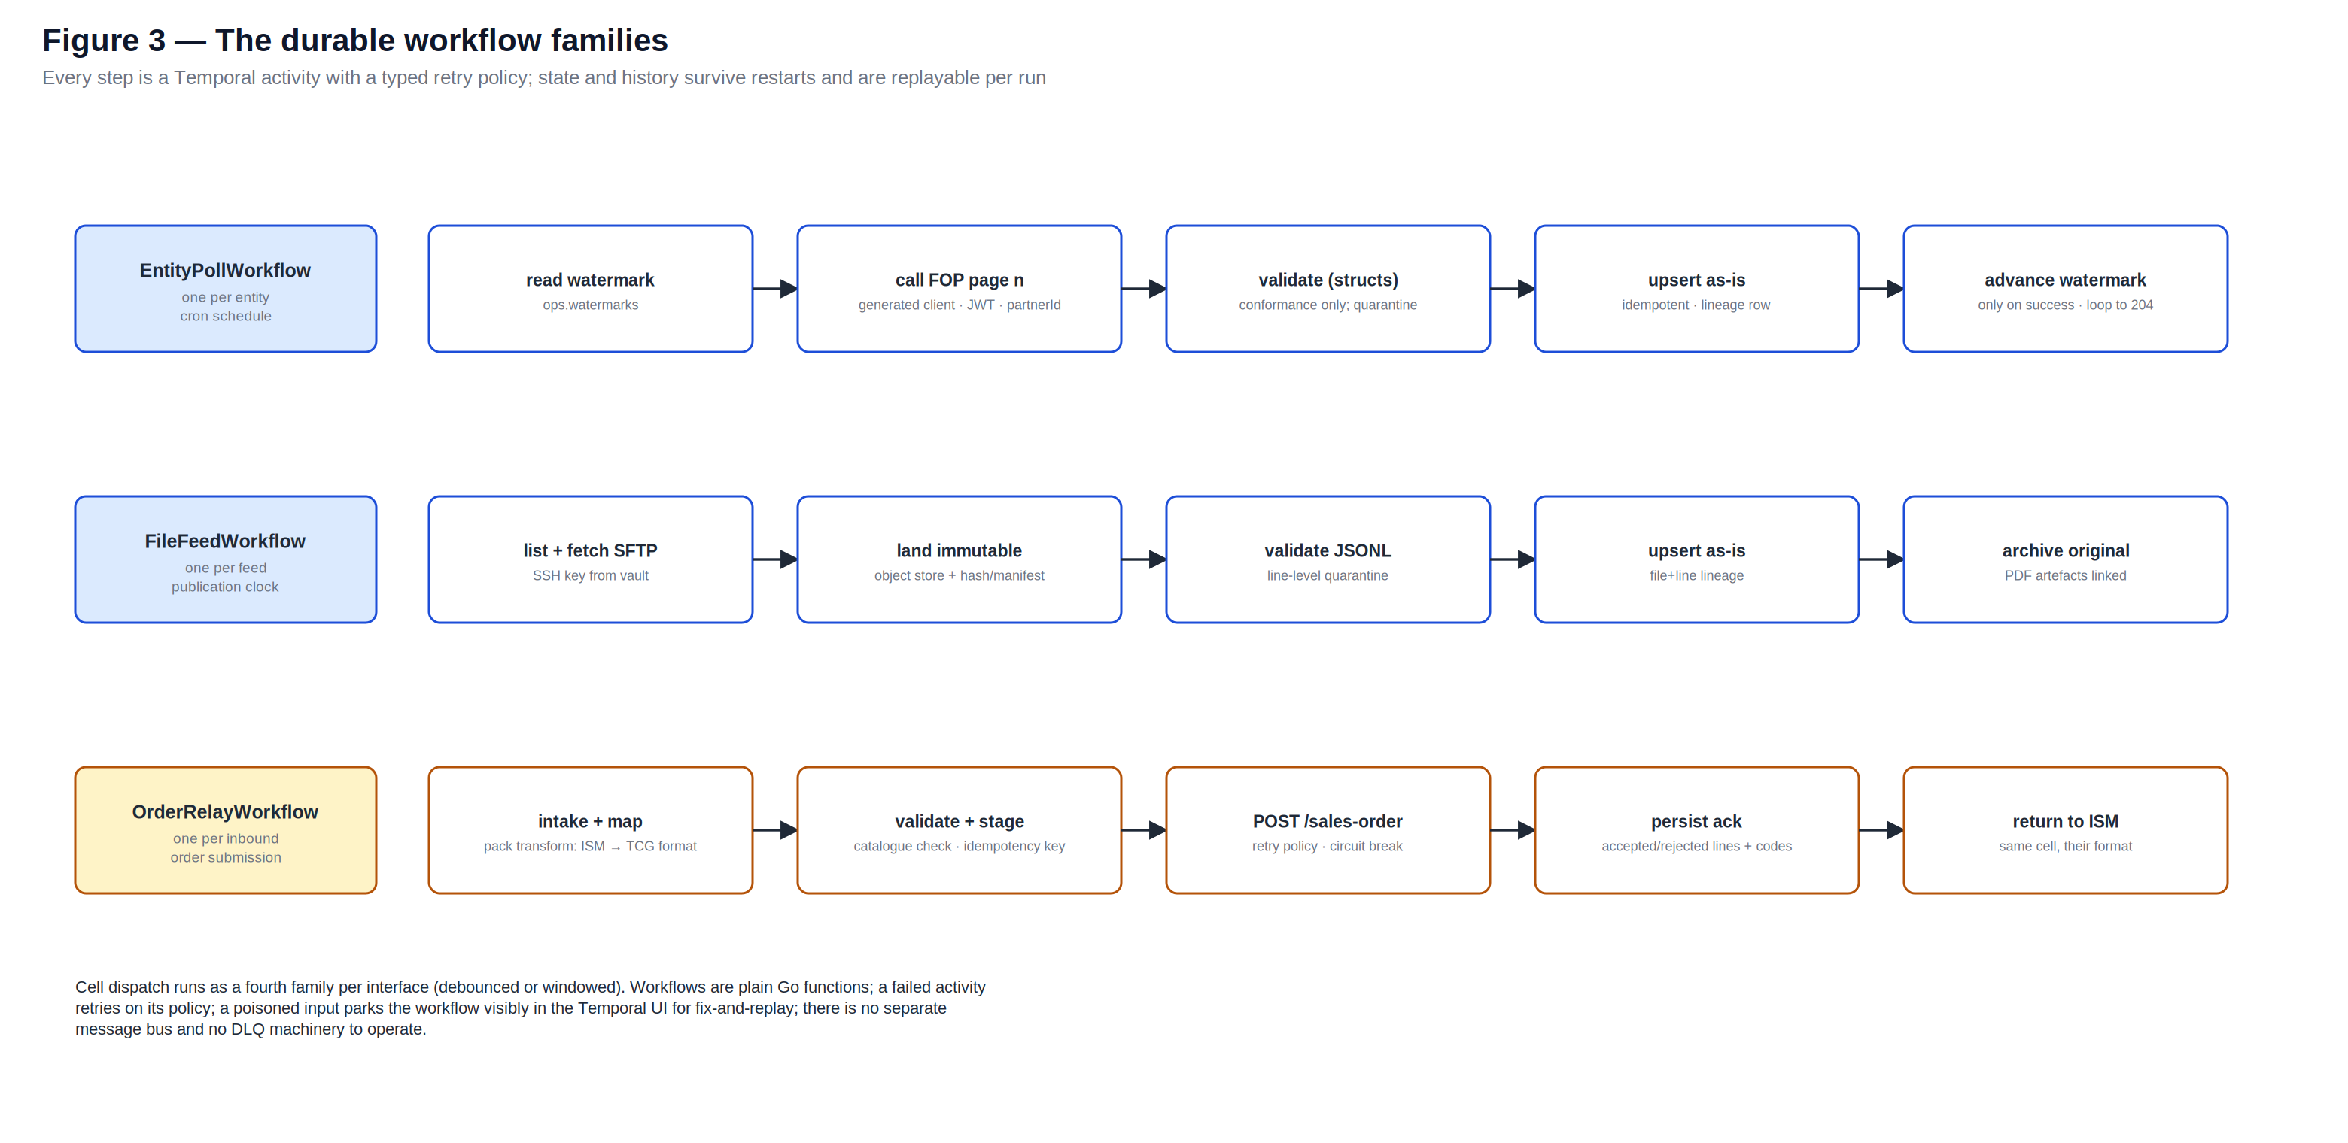
Figure 3 — The durable workflow families; every step an activity with a typed retry policy.
Concurrency is why this layer is Go: each entity's poll cycle is a goroutine under an errgroup with bounded parallelism; pages stream through validation into batched upserts; SFTP fetches run the same way per feed. Durability — watermarks advancing only on success, retry across restarts, exactly-once submission — belongs to Temporal behind the durable port (section 13), never to hand-rolled goroutine state. A failed activity retries on its policy; a poisoned input parks the workflow visibly in the Temporal UI for fix-and-replay; there is no separate message bus and no DLQ machinery to operate.

8 Persistence — the PostgreSQL Data Platform
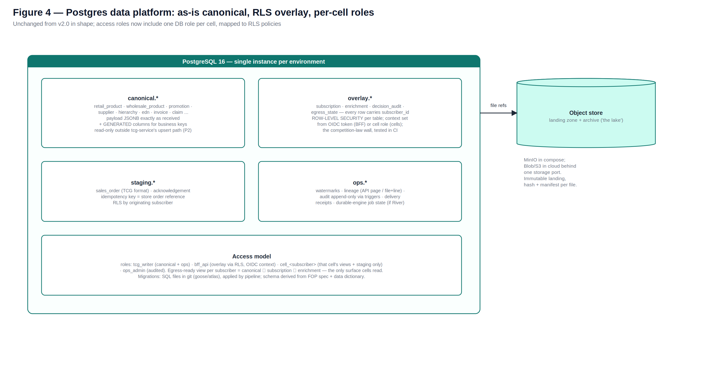
Figure 4 — One database: canonical as-is, overlay under RLS, staging, ops; the object store is the lake.

8.1 Canonical: as-is in JSONB, keyed by generated columns
Each canonical table stores the FOP payload unchanged in a JSONB column, with the business keys extracted as generated, indexed columns. This is the strongest possible form of store-as-is: there is no mapping layer to drift, TCG's own documentation describes our stored rows byte-for-byte, and re-validation after a spec upgrade is a query, not a migration. Table and column derivation is mechanical, from the FOP spec and data dictionary committed to contracts/.

8.1.1 Canonical entities
Entity | Source | Key | Notes
Retail Product | GET /retail-products | Product ID | Consumer-facing product: EANs, packaging, hierarchy reference, selling restrictions, tax category
Wholesale Product | GET /wholesale-products | Catalogue Item ID | Orderable unit: cost prices array, supplier discount, unit conversion, pack/pallet spec, related retail product
Catalogue Item | embedded in Wholesale Product | Catalogue Item ID | The post-NSL identifier and the platform's primary product key (KDD-8)
Price (wholesale cost) | within product payloads | product + effective-from | Effective-dated as published; advisory for retail purposes (P5)
Promotion | GET /promotions | Promotion ID | Type, period, prices, qualifying products, funding attributes
Product Hierarchy | GET /product-hierarchies | Hierarchy node ID | Parent-child mirror of TCG hierarchy
Supplier | GET /suppliers | Supplier code | Name, ANA code, address
EDN | SFTP (API alternative) | Delivery reference | Header + detail lines incl. substitutions, expiry dates
Order Acknowledgement | POST /sales-order response | Store order reference | Accepted/rejected line detail with rejection codes; persisted with the originating staged order
Invoice (Depot/Direct) | SFTP | Invoice reference | Line-level; PDF artefact in the object store where supplied
Claim (Depot/Direct) | platform → TCG SFTP | Claim reference | Outbound; staged and receipted like any egress
Condition Contract | SFTP | Contract reference | Settlement data for promotions and supplier funds
Range/Planogram file | SFTP | File reference | Object-store resident; metadata row in Postgres

8.1.2 Product identity: Catalogue Item first, NSL as alias
Catalogue Item is the canonical product key everywhere inside the platform. NSL is carried as an indexed transitional alias on the wholesale product row for lookup and for transitional documents (invoices retain the article/NSL/GTIN trio during cutover). Curation screens accept either identifier and resolve to Catalogue Item. Nothing new is ever keyed on NSL.

8.2 The subscription overlay
Everything subscriber-specific lives in overlay tables that reference canonical rows by key and carry subscriber_id, under native row-level security. RLS is the data half of the competition-law boundary (the cell is the process half, section 9), and it is proven mechanically: a CI isolation suite demonstrates on every merge that no query path returns another subscriber's rows.
Overlay table | Grain | Content
Subscription | subscriber × canonical row | The subscriber has selected this catalogue item / promotion / supplier; status (candidate, subscribed, suppressed, superseded)
Enrichment | subscriber × canonical row × element | Subscriber-supplied data elements: downstream system key, local category, description override, flags. Element definitions are schema-controlled configuration per subscriber
Decision audit | per change | Who selected/enriched/approved, when, against which rule (P4); append-only
Egress state | subscriber × interface × row | Last delivered version, delivery receipt reference, pending changes

The egress-ready view per subscriber is the join: canonical ⨯ that subscriber's subscriptions ⨯ their enrichment. It is the only surface cells may read, so an unselected item can never leak to a subscriber and an approved selection always carries its enrichment.

8.3 Staging, ops, roles and files
- staging.* holds TCG-format sales orders and their acknowledgements, idempotency-keyed by store order reference, RLS-partitioned by originating subscriber.
- ops.* holds per-entity watermarks, per-record lineage (API page or file+line — 'where is my record?' is a query), append-only audit via triggers, and delivery receipts.
- Database roles: tcg_writer (canonical + ops only), bff_api (overlay via RLS with OIDC-derived context), cell_<subscriber> (that cell's egress-ready view and staging rows only), ops_admin (audited). Migrations are SQL files in git, applied by pipeline before rollout.
- The object store — MinIO in compose, Blob/S3 in cloud behind one storage port — carries the immutable landing zone, the archive of originals, PDF and planogram artefacts. Finance-adjacent retention defaults to 7 years, configurable per subscriber policy.

9 Cellular Tenancy — the ISM Subscriber Layer as Cells
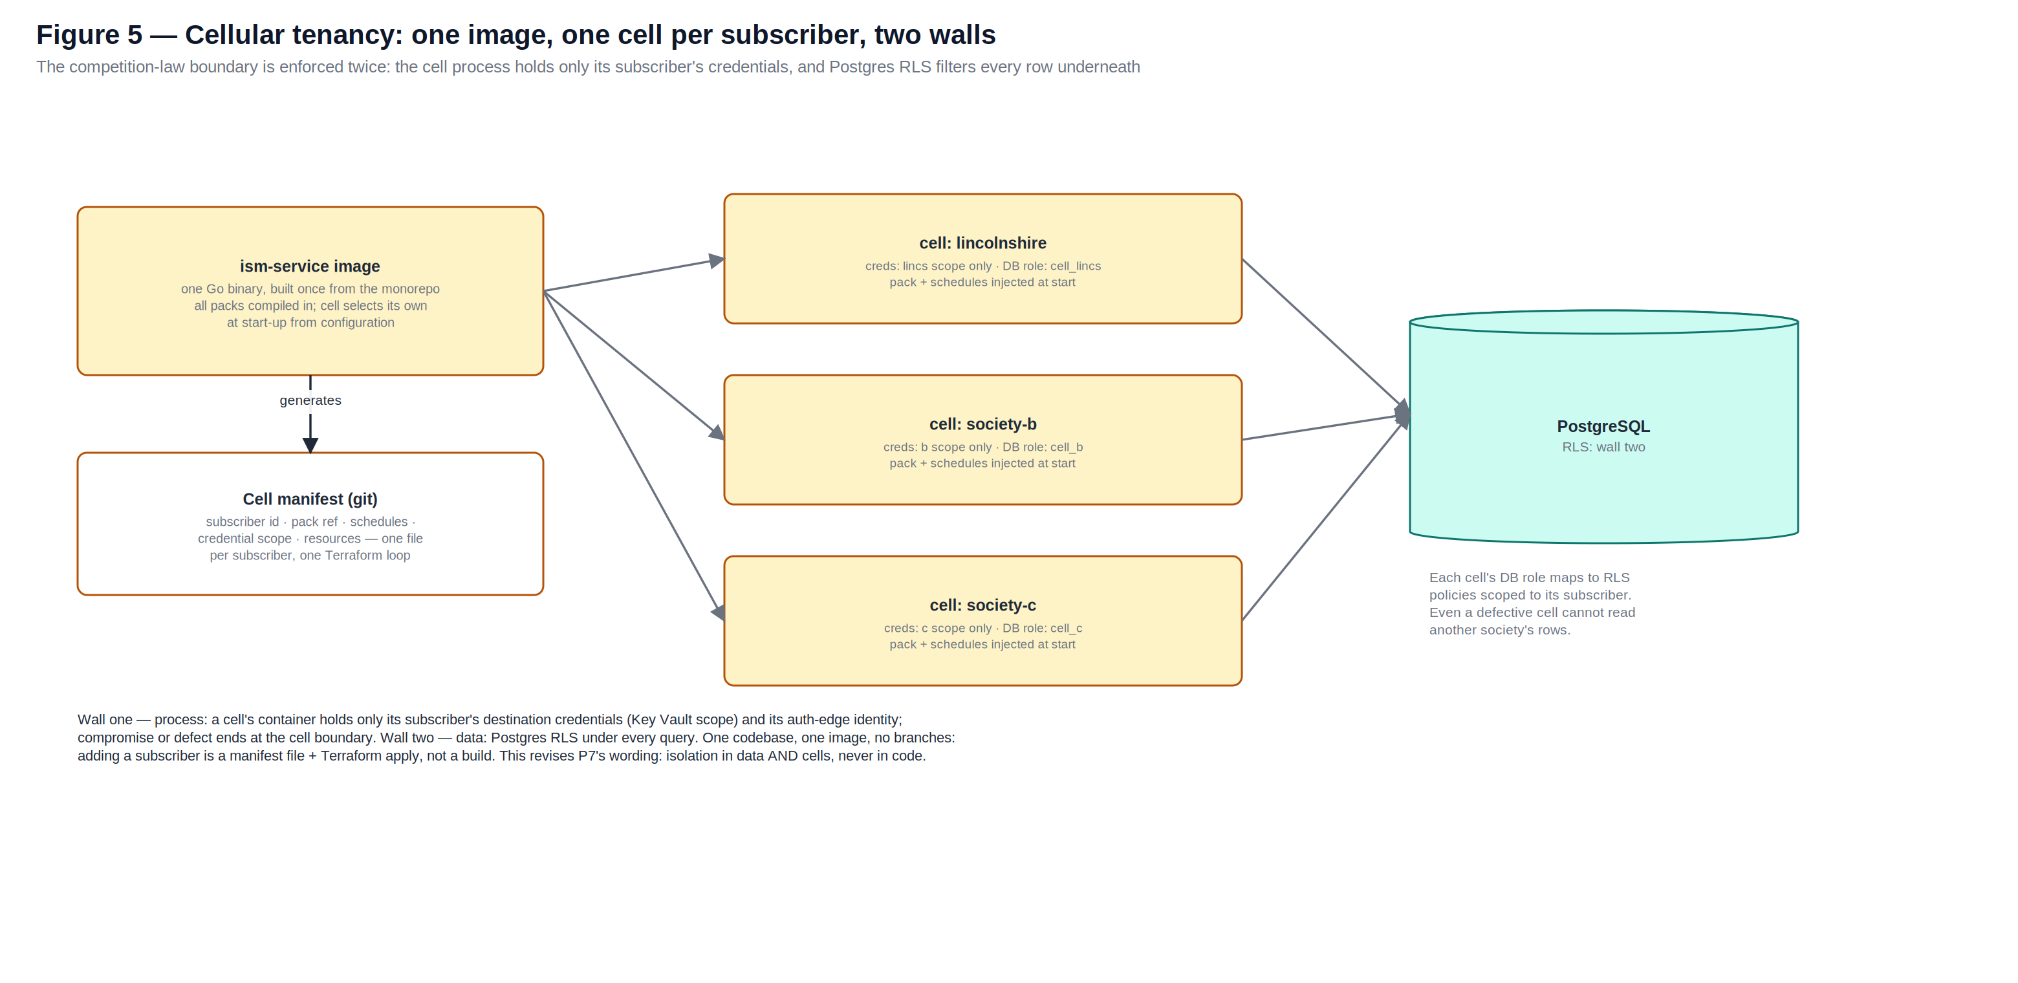
Figure 5 — One image, one cell per subscriber, two isolation walls.
ism-service is built once from the monorepo with every pack compiled in; each deployment — a cell — receives a per-subscriber manifest at start: subscriber identity, pack reference, schedules, credential scope, resource sizing. Manifests live in git (one schema-validated file per subscriber in cells/) and Terraform loops over the directory, so onboarding a society is a pull request plus an apply — never a build, never a branch (P1).
- Wall one — process. A cell's container holds only its subscriber's destination credentials (its Key Vault scope) and its auth-edge identity. A defect, compromise or noisy workload ends at the cell boundary; restarting or scaling one society touches no other.
- Wall two — data. Each cell connects with its own database role, mapped to RLS policies scoped to its subscriber. Even a badly written query inside a cell cannot read another society's rows.
The competition-law boundary is thus enforced twice, independently, and the story to a society's auditor is concrete: your data path runs in a process that physically cannot hold anyone else's keys, over a database that filters every row to you. No cross-subscriber aggregation or analytics surface exists anywhere in the platform.

10 Curation — the Web Application

10.1 Subscribe and enrich
Each data element — product, price, promotion, supplier, hierarchy — has a screen over the canonical tables. A commercial user from a subscribing society works in two gestures:
- Filter and subscribe. Browse the full TCG set (identical for every subscriber), filter by hierarchy, attribute or search, and mark the rows their society wants — the items they range, the promotions they care about, the suppliers they trade with. Bulk selection by hierarchy node or supplier is first-class: a society subscribes a category, not a thousand clicks.
- Enrich. Against any subscribed row, supply the data elements their downstream systems require — above all the subscriber's own key for the record in their MDM/P2P/ERP (the downstream key), plus local category, description overrides or flags. Enrichment element definitions are schema-controlled configuration per subscriber, so a new required element is an administrative change, not a build.
Canonical rows are read-only in every screen; all writes go to the overlay. When TCG changes a subscribed row upstream, the change lands on the next poll and the subscription is flagged for review where the change is material (configurable rules — pack size or EAN changes always flag; description-only changes may auto-pass).

10.2 The approval gate
Nothing reaches a subscriber system without a decision recorded in the platform (P4): subscribe/enrich → validate (enrichment complete, downstream key present and unique) → approve → eligible for egress. Approval is a human action or a rule a named human has signed off (e.g. auto-approve description-only changes). The delivery console shows, per subscriber and interface, what is pending, delivered (with receipts) and failed; replay is a console action with audit.

10.3 Price and promotion: advisory surveillance
Wholesale cost moves are compared against subscriber-defined thresholds and surfaced for acknowledgement — the platform records that a move was seen, not approved, because it is not the platform's price. TCG-funded promotion offers are surfaced for visibility and may be subscribed and forwarded to the society's systems as input. Where a society runs a pricing engine, a pack feeds it; where it does not, threshold alerts are the safety net. No platform component ever writes a consumer-facing retail price (P5).

10.4 Realisation and personas
The workbench is a React SPA (Vite) over curation-bff, a Go OpenAPI-first REST API with the SPA's TypeScript client generated from the contract (D6). The OIDC-validated JWT establishes the subscriber context per request; approvals, thresholds and the console are BFF modules with ordinary Go tests; every decision writes the append-only audit.
Role | Can | Cannot
Reviewer | Browse canonical + own society's overlay; propose subscriptions and enrichment | Approve; see any other society's data
Approver | Everything Reviewer can, plus approve/reject and sign off auto-approve rules | Modify canonical rows; approve own proposals where four-eyes is configured
Subscriber admin | Manage own society's users, enrichment element definitions, thresholds, notification targets | Touch packs or cell manifests (UST-operated)
UST operations | Operate the platform; PIM-elevated, time-bound production access | Act as a commercial approver for any society

11 ISM Subscriber Layer — Interface Packs
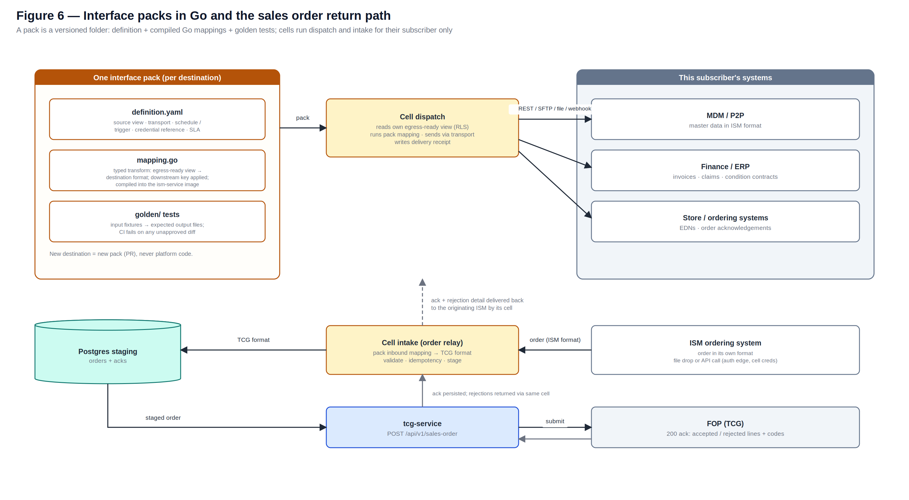
Figure 6 — Packs as Go code with golden tests; cells run dispatch and intake; the order return path.

11.1 A pack is the unit of subscriber variability
A pack is a versioned folder per subscriber destination: definition.yaml (source view, transport binding, schedule or trigger, credential reference, SLA), mapping.go (a typed transform from the egress-ready view to the destination format, applying the subscriber's downstream key), and golden/ fixtures with expected outputs diffed byte-exactly by CI on every merge. Mappings compile into the ism-service image; a cell activates its own pack from its manifest. Onboarding a destination is a pack PR; the platform core never changes (P1, P3). Transports at launch: REST push, SFTP drop, file/object delivery, signed webhook.

11.2 Dispatch, receipts and the auth edge
Dispatch runs as Temporal workflows per interface — event-driven with debounce, or windowed — reading only the cell's egress-ready view, executing the pack mapping, sending via the transport with credentials resolved from the cell's Key Vault scope, and writing a delivery receipt per send (destination, entity, payload hash, latency, downstream response, final status). Retries back off; exhausted failures surface in the delivery console with audited replay. Inbound, subscriber systems authenticate to their society's cell — per-subscriber client credentials for API calls, or file drop on the cell's inbound channel — so the auth edge is per-cell and credential compromise maps to exactly one society.

11.3 Outbound content
- Master data — subscribed product/cost/promotion/supplier/hierarchy rows with enrichment applied, in the destination's format: REST to a SymphonyAI Gold ingest API, CSV to SFTP, files to a share.
- Transactional documents — EDNs and order acknowledgements to store and ordering systems; invoices, claims and condition contract data to finance systems (e.g. Unit4), filtered to the subscriber's own trading data.
- Advisory feeds — cost and promotion data as input to a subscriber's pricing engine where one exists (P5).

12 Sales Order Return Path

12.1 Flow
- 1 · Intake at the auth edge. The ISM ordering system drops an order file on its cell's inbound channel or calls the cell's API endpoint, authenticated with that subscriber's client credentials, in the ISM's own format.
- 2 · Map and validate. The subscriber's pack maps to the TCG sales order format, resolving products to Catalogue Item IDs via the downstream keys captured at enrichment; lines validate against current canonical data; the idempotency key derives from the store order reference, so a resubmitted order is a no-op returning the original acknowledgement.
- 3 · Stage and submit. The TCG-format order is staged in Postgres, then submitted by tcg-service: POST /api/v1/sales-order with the platform JWT and partnerId, retry policy and circuit-breaking on the activity — all inside OrderRelayWorkflow.
- 4 · Acknowledge back. FOP responds 200 with an acknowledgement carrying accepted and rejected arrays — per store, per line, with item rejection codes (e.g. Z6) and store rejection codes (e.g. Z201) — or 400 for a malformed request. The acknowledgement is persisted against the staged order and returned to the originating ISM through the same cell, in their format, with line-level rejection detail.

12.2 Contract shape (FOP spec v0.4.0 / beans worked example)
{ "societyId": "OX", "submissionDate": "2026-05-26", "headOfficeId": "1000000018",
"orderProcessingType": "PTW",
"ordersDetail": [ { "storeId": "2000000018", "storeOrderReference": "OX18914...",
"items": [ { "catalogueItemId": "000000000070005494-C00", "quantity": 3 } ] } ] }
The 200 acknowledgement carries totals plus accepted[] and rejected[] per store order reference with item/store rejection codes mapped from the FOP code tables. The beans worked example's 200-rejection and 400-error payloads are the required fidelity bar for mocks and conformance tests — a build that has never seen a rejection is not done.

12.3 Timing and the reviewed relay
FOP's order cutoff is early morning (TCG has proposed moving 03:30 to 02:00 — under ISM consultation); relay schedules configure per subscriber against the confirmed business clocks, tracked as an upstream dependency. An optional reviewed-relay screen in the curation app lets a society require a human submit/reject click during cutover or for high-value orders — read-only by design: no composition, no amendment (P6).

13 Durable Execution — Temporal
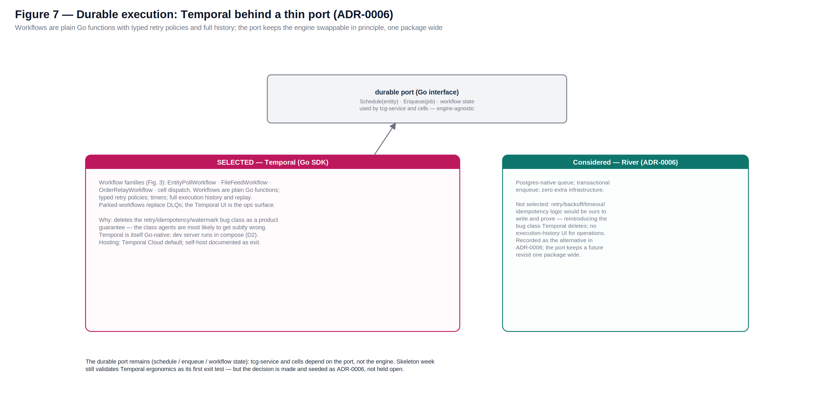
Figure 7 — Temporal behind the durable port; River recorded as the considered alternative (ADR-0006).
Everything asynchronous — entity polls, file feeds, cell dispatch, the order relay — runs behind a thin Go port (schedule, enqueue, workflow state). Temporal (Go SDK) is the engine behind it.
- How it is used. The workflow families of Figure 3 are plain Go functions with typed retry policies, timers, full execution history and replay. Parked workflows replace DLQs; the Temporal UI gives operations a per-run view of any record's journey. Hosting default is Temporal Cloud (removing server operations); self-hosting is documented in iac/ as the exit option; the dev server runs in compose so the loop stays local (D2).
- Why. It deletes the retry/idempotency/watermark bug class as a product guarantee — the code class agents are most likely to get subtly wrong and reviewers least likely to catch. The accepted costs: one more engine (mitigated by Temporal Cloud), and workflow-determinism rules the team must learn (carried in the tcg-service and ism-service DPDs; replay tests in CI catch violations; the walking skeleton exercises them in anger).
- The considered alternative. River (a Postgres-native job queue with transactional enqueue — job and business write committing atomically) was evaluated seriously. It was not selected: retry, backoff, timeout and idempotency logic would be ours to write and prove, reintroducing the deleted bug class, and operations would lose the execution-history view. ADR-0006 records the comparison; the durable port keeps any future revisit one package wide.

14 The Knowledge-Graph Context Plane
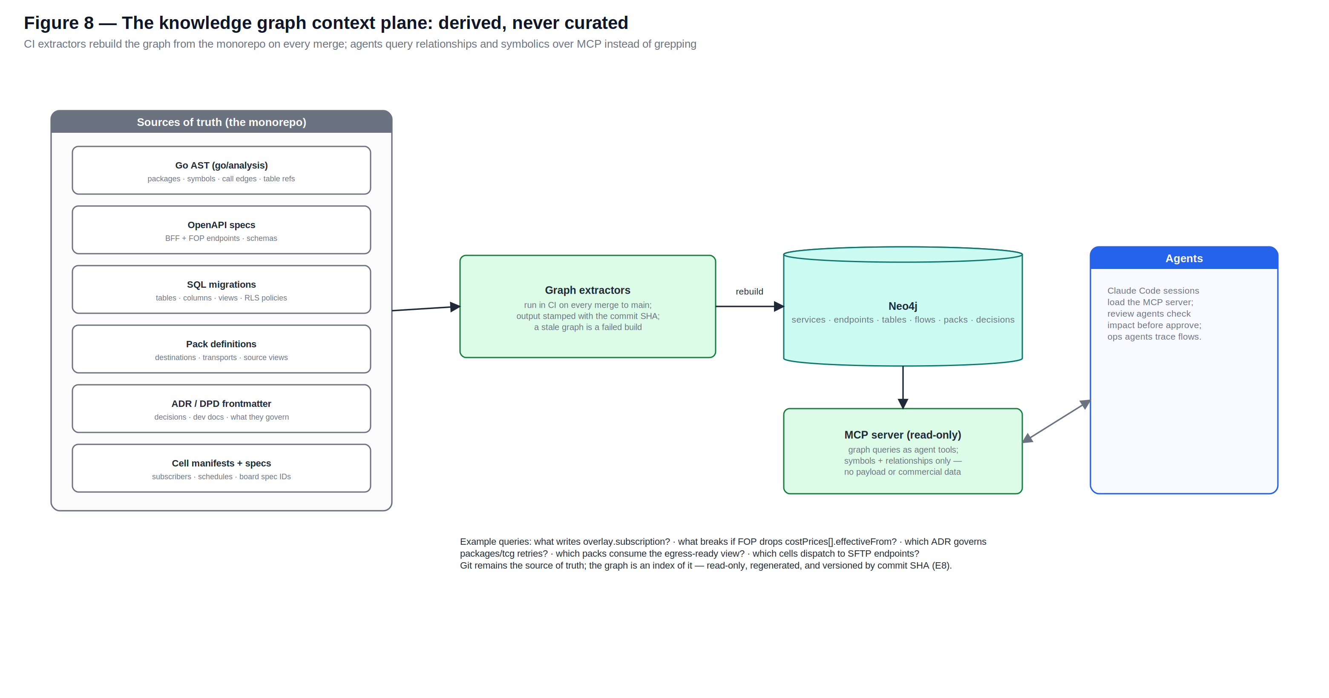
Figure 8 — Derived from the monorepo on every merge; queried by agents over MCP.

14.1 What it is
A Neo4j graph of the platform's relationships and symbolics: services, packages, exported symbols, HTTP endpoints, tables, columns, views, RLS policies, flows, packs, cells, ADRs, DPDs and board spec IDs — and the edges between them (calls, reads, writes, exposes, governs, implements). It is the platform's index of itself, built for the questions agents actually ask: what writes overlay.subscription? what breaks if FOP drops costPrices[].effectiveFrom? which ADR governs retry behaviour in services/tcg? which packs consume the egress-ready view? which cells dispatch over SFTP?

14.2 The one hard rule: derived, never curated (D9)
Every node and edge is extracted mechanically by CI on every merge to main: the Go AST via go/analysis (packages, symbols, call edges, table references), the OpenAPI specs (BFF and FOP alike), the SQL migrations (tables, views, policies), pack definitions, cell manifests, and ADR/DPD frontmatter. The output is stamped with the commit SHA; a graph older than main is a failed build, not a warning. Nothing is ever hand-edited — a curated graph rots into confident lies within weeks, and a lying index is worse for agents than no index. Git remains the sole source of truth; the graph is a view of it.

14.3 How agents use it
- A read-only MCP server exposes graph queries as tools to every Claude Code session and to the automated PR reviewer: impact-of-change, writers-of-table, decisions-governing-path, flow-trace, pack-consumers.
- The PR review gate uses it structurally: a change to a symbol whose downstream edges cross a layer boundary flags the affected specs and DPDs for the human approver.
- Operations agents trace 'where is my record?' across service boundaries by joining graph structure to OTel traces and lineage rows.

14.4 Boundaries
- Symbols and relationships only — never payload data, never subscriber commercial data, never credentials. The graph is structural, so the commercial-data guardrail is untouched.
- Read-only to agents; there is no agent write path. Extractor changes are ordinary PRs through the ordinary gates.
- Neo4j (Aura or a container) plus a small Go MCP server; in compose it runs locally like everything else (D2).

15 Data Flow Catalogue
The complete reference list of platform flows and their mechanisms.
# | Flow | Direction | Mechanism | To subscriber
1 | Retail Product | TCG → platform | EntityPollWorkflow (delta, paginated) | Pack, filtered by subscription + enrichment
2 | Wholesale Product / Catalogue Item | TCG → platform | EntityPollWorkflow | Pack, filtered + mapped (downstream key)
3 | Wholesale cost (price) | TCG → platform | EntityPollWorkflow (in product payloads) | Advisory feed; threshold surveillance in workbench (P5)
4 | Promotion | TCG → platform | EntityPollWorkflow | Advisory; surfaced + optionally fed to pricing engine
5 | Product Hierarchy | TCG → platform | EntityPollWorkflow | Pack, usually weekly full
6 | Supplier | TCG → platform | EntityPollWorkflow | Pack
7 | Range / Planogram / RADR / PSA | TCG → platform | FileFeedWorkflow (SFTP) | Workbench display + object-store link
8 | Sales Order | ISM → platform → TCG | Cell intake → OrderRelayWorkflow → POST /sales-order | Acknowledgement returned via the same cell
9 | Order Acknowledgement | TCG → platform | sales-order 200 response | Pack, to the ISM ordering system
10 | EDN | TCG → platform | FileFeedWorkflow (API endpoint available as per-feed config alternative) | Pack, to store/ordering systems
11 | Depot Invoice | TCG → platform | FileFeedWorkflow | Pack, to finance system
12 | Direct Invoice | TCG → platform | FileFeedWorkflow | Pack, to finance system
13 | Depot Claim | platform → TCG | Outbound FileFeedWorkflow | n/a (originates from subscriber finance via cell intake)
14 | Direct Claim | platform → TCG | Outbound FileFeedWorkflow | n/a
15 | Promotional Sales Volumes | platform → TCG | Outbound FileFeedWorkflow (weekly) | n/a
16 | Condition Contracts | TCG → platform | FileFeedWorkflow | Pack, to finance system

16 Security Architecture

16.1 Identity
- To TCG: OAuth2 client credentials on a per-environment registered client (JWT via the client wrapper) for APIs; a per-environment SSH key pair for SFTP. TCG applies IP restrictions, so all TCG-bound traffic originates from a declared egress IP (NAT on the integration subnet). Production credentials are issued only at cutover and never enter the agent loop or non-production configuration.
- Platform-internal: workload identities for services and cells; workload identity federation for CI service connections; no secrets in pipelines; Key Vault references only, everywhere.
- Subscriber users: OIDC — Entra External ID default, Keycloak drop-in — with MFA and conditional access, mapped to the personas of section 10.4. The human half of the auth edge.
- Subscriber systems: per-subscriber client credentials validated by that society's cell; per-destination credentials (OAuth2, mTLS, SSH) for dispatch, held in the cell's Key Vault scope so compromise of one society's credential cannot touch another's. The system half of the auth edge — per-cell by construction.

16.2 Data protection and partitioning
- TLS in transit everywhere; encryption at rest in Postgres, the object store and Key Vault; customer-managed keys supportable if a subscriber requires it.
- Subscriber isolation is the two walls of section 9 — cell (process, credentials, DB role) and RLS — proven by the CI isolation suite. No cross-subscriber aggregation or analytics surface exists; this is the competition-law boundary.
- Attack surface: one public HTTPS surface (web + BFF + cell auth-edge endpoints) behind the cloud front door/WAF; Postgres, Temporal and Neo4j are private-network only; no inbound path from TCG exists.
- Supply chain: Go modules with checksum verification, distroless images, SBOM per image, signed provenance in the pipeline.

16.3 Delivery-time guardrails (binding, from the driving brief)
- Human approval gates: no merge to main, no environment promotion, no pack or auto-approve rule live without a named human approval.
- Secrets never in context: Key Vault references only, in code, prompts, repos and work items; secret scanning on every push; a leak is a stop-the-line event.
- Commercial data boundary: synthetic and TCG-published sample data only (the beans worked example) until formal test data agreements exist.
- Decisions recorded: architecturally significant choices become ADRs in docs/adr within 48 hours.

17 Built for Agents: the Local Loop and the Oracles

17.1 The compose stack
docker compose boots the entire platform: Postgres (migrations and seeds), the Temporal dev server, MinIO, mock-FOP (generated from the spec, data dictionary and beans — serving every consumed endpoint including the 200-rejection and 400-error shapes), a mock SFTP server publishing sample feeds on a fast clock, Neo4j with the extractor output, and two synthetic subscriber cells — so tenancy, packs and the context plane are all exercised on a laptop. This is principle D2 and it is binding: a feature that cannot run and be tested here is redesigned. Swapping mocks for TCG dev endpoints, when they arrive (~week 6), is configuration only.

17.2 The oracle suite
Oracle | Proves | Runs
go test (unit + workflow) | Service and pack logic; Temporal workflows replayed deterministically in-process | seconds, every save
Golden-file tests (per pack) | Byte-exact destination outputs; unapproved diffs fail CI | every merge
Contract tests | mock-FOP and the generated client conform to the committed OAS; BFF and cell surfaces conform to theirs | every merge + on spec change
RLS + cell isolation suite | No query path — including a cell's own role — reads another subscriber's rows; credential scopes verified | every merge
Playwright E2E | Subscribe → enrich → approve → cell dispatch → receipt, through the real SPA against compose | every merge + nightly full
Conformance pack | The FOP contract behaviours: pagination/204, 7-day delta guard, partnerId/406, idempotent resubmission, rejection round-trip | every merge + against TCG dev endpoints from ~week 6
Graph freshness | Extractors ran; graph SHA equals merge SHA; governance edges exist for changed packages | every merge

These suites are the acceptance criteria referenced by every spec on the board (A2): an agent's task is complete when the oracles pass, and a reviewer's question is not 'does this look right?' but 'is the oracle for this behaviour missing?'.

18 Git Design and Repository Provisioning

18.1 Repositories
Two repositories in the ADO project 'FRTS Ingress'. The monorepo tree is normative — the seed pack instantiates it exactly:
frts-platform/
CLAUDE.md # agent context: map, commands, guardrails, definition of done
README.md · CODEOWNERS · .azuredevops/pull_request_template.md
.claude/skills/ # create-adr · create-interface-pack · onboard-subscriber-cell · agent-spec
services/tcg/ services/bff/ services/ism/ # Go services (one module each)
web/ # React SPA; TS client generated from BFF OpenAPI
packs/<subscriber>/<destination>/ # definition.yaml · mapping.go · golden/
cells/ # one manifest per subscriber + TEMPLATE.yaml (schema-validated)
db/migrations/ # SQL, applied by pipeline; RLS policies live here
contracts/ # FOP OAS v0.4.0 · data dictionary · beans fixtures · BFF OAS
graph/extractors/ # context-plane extractors (Go AST · SQL · OpenAPI · docs frontmatter)
iac/ # Terraform: envs, cells for_each, Temporal Cloud, DR
compose/ # docker-compose + mock-fop + mock-sftp + seeds
docs/adr/ docs/dpd/ docs/principles.md
delivery-context/
hld/ (this master + prior records + diagram sources) · tcg-contract-pack/ · specs/ · README.md

18.2 Policy
- Branch policy (both repos): main protected; short-lived branches; PR requires automated Claude review, the oracle suite green, and one named human approver — two for db/, iac/ and services/tcg. Conventional commit messages; squash merge; images build once on merge and promote by digest.
- CI enforcement from day one: secret scanning; docs discipline (a service change without a DPD touch fails unless a human applies docs-exempt); an ADR link is required when a PR declares a design change; graph freshness once extractors land; golden-diff approval for packs.
- Docs in the monorepo: docs/adr holds one file per architecturally significant decision with frontmatter (id, status, governs) that the graph extractors read; docs/dpd holds one living developer platform doc per service and concern. Writing the docs is the bookkeeping — governance edges in the context plane derive from the frontmatter.
- CODEOWNERS: db/ and iac/ to the EA + lead engineer; services/tcg to the integration owner; packs/ and cells/ to the subscriber onboarding owner; docs/adr to the EA. Seeded with placeholders that block merge until filled at mobilisation.

18.3 The seed pack
frts-platform-seed.zip is generated from this document. Dropping it into the freshly provisioned repos is stage 0, hour one — the ADR process, the docs discipline and the agent setup start populated, not empty:
Seed | Content
docs/adr/ADR-0001 … ADR-0014 | The decisions of section 20 as accepted ADRs with frontmatter (id, status, date, governs) — ADR-0001 records the architecture selection itself; ADR-0006 records Temporal vs River.
docs/adr/ADR-TEMPLATE.md | The template for every subsequent decision: context, decision, consequences, alternatives considered, governs.
docs/dpd/ (9 stubs + template) | One DPD per service and concern (tcg-service, curation-bff, ism-service, web, db, packs, graph, iac, compose): purpose, how it works, run locally, extend, oracles, owned contracts.
CLAUDE.md | The agent context file: architecture in one paragraph, commands, guardrails, definition of done (the oracle suite), docs discipline, context-plane usage.
.claude/skills/ | Four Claude Code skills: create-adr, create-interface-pack, onboard-subscriber-cell, agent-spec.
Templates & policy files | PR template (oracle/docs/guardrail checklist), CODEOWNERS skeleton, cells/TEMPLATE.yaml, docs/principles.md (P1–P8 and D1–D9), root READMEs for both repos.

19 Deployment, Environments and Operations
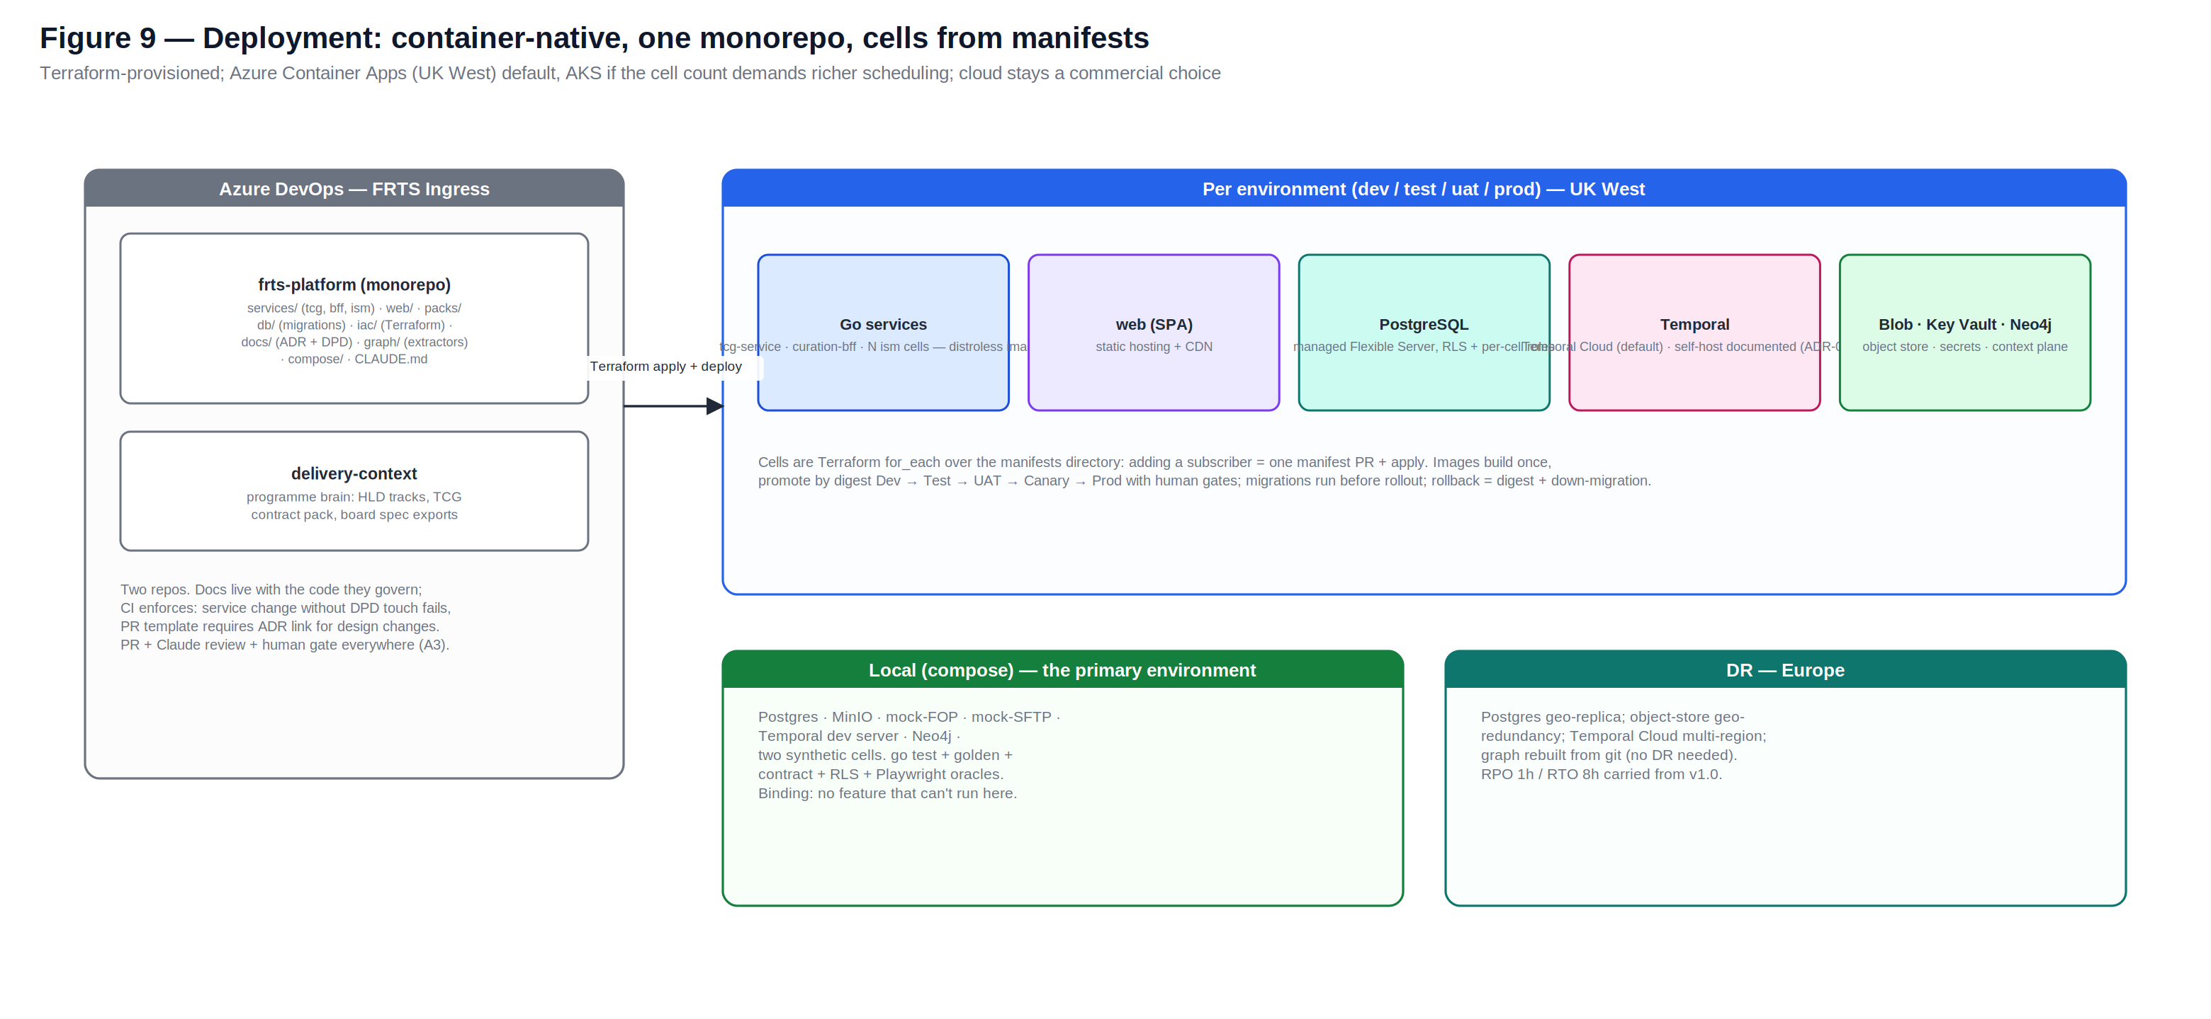
Figure 9 — Containers on a managed runtime; cells from manifests; cloud as a commercial choice.

19.1 Environments
Environment | Purpose | Integration target
local (compose) | Every engineer and agent, all day — the primary environment | mock-FOP, mock-SFTP
frts-dev | Shared cloud dev; first cloud landing of every merge | mock-FOP containers
frts-test | Conformance pack + full oracle suite on cloud infrastructure | mock-FOP; TCG dev endpoints when issued (~week 6)
frts-uat | Acceptance, release rehearsal, cutover rehearsal | TCG dev/test endpoints
frts-prod | Production; canary subscriber first (expected: Lincolnshire Co-op), then rollout | TCG production (credentials at cutover)

Each cloud environment is one Terraform module: containers (tcg-service, curation-bff, N cells, static web) on Azure Container Apps in UK West by default (UK South has known capacity issues), Azure Database for PostgreSQL Flexible Server, Blob storage, Key Vault, Temporal Cloud. Cells are a Terraform for_each over the cells/ manifests — adding a subscriber is a manifest PR plus an apply. The cell count at ten subscribers (~13–15 containers) sits comfortably within Container Apps; AKS is the documented move if orchestration ever demands more. Swapping cloud (AWS Fargate/RDS/S3, GCP Cloud Run/Cloud SQL/GCS) is a Terraform provider swap plus the storage-port binding — application code does not change (KDD-17).

19.2 Release train
Images build once and promote by digest Dev → Test → UAT → Canary → Prod with a human gate per promotion; database migrations run by pipeline before rollout; rollback is the previous digest plus a down-migration. OTel traces and structured logs export to the cloud monitoring backend; the Temporal UI is the flow-state view; per-flow dashboards alert on watermark stall, validation failure rate, parked workflows, receipt failures, SLA breach and FOP 4xx.

19.3 Operations and DR
- Runbooks (versioned with the code): FOP credential rotation, SFTP key rotation, destination credential rotation, watermark re-baseline from the weekly full feed, parked-workflow replay, pack version retirement, subscriber cell onboarding and retirement.
- Support: subscriber administrator first line for commercial/curation questions; UST managed service for platform incidents; production access PIM-elevated and time-bound.
- DR: Postgres geo-replica and object-store geo-redundancy into the paired European region; Temporal Cloud multi-region namespace; the graph rebuilds from git and needs no DR. RPO 1 hour, RTO 8 hours; failover runbooks in iac/ and rehearsed at UAT.

20 Non-Functional Requirements
Area | Requirement (baseline — confirm at team baseline review)
Availability | Platform services 99.5% monthly. The order relay path is the critical window: available and monitored through each subscriber's ordering window ahead of the FOP cutoff (02:00–03:30 area, per confirmed business clocks).
Latency — master data | Change visible in curation screens within 30 minutes of TCG publication (default 15-minute poll + processing).
Latency — distribution | Approved change delivered to the subscriber destination within 30 minutes of approval; per-interface SLA configurable, breach alerts wired to the delivery console.
Latency — sales orders | Order relayed to FOP within 5 minutes of intake completion; acknowledgement returned to the ISM within 5 minutes of the FOP response.
Throughput | Sized for full-catalogue weekly refresh and peak promotional-window deltas across 10 subscribers; FOP owns page sizes — the platform degrades gracefully under FOP rate limiting (back-off honoured, no data loss).
Durability / lineage | No acknowledged inbound record may be lost: the landing zone is immutable, Temporal is the buffer, parked workflows + replay cover failures. Every persisted record traceable to API page or file+line (P8).
Idempotency | All upserts idempotent by business key; sales order submission idempotent by store order reference — duplicate submission is a no-op returning the original acknowledgement.
Recovery | RPO 1 hour, RTO 8 hours for platform data (DR region); the watermark re-baseline runbook covers deltas beyond the 7-day API window.
Auditability | Every commercial decision (subscribe, enrich, approve, acknowledge) attributable to a person or a signed-off rule, retained 7 years by default.
Observability | Per-flow health dashboards; alerting on watermark stall, validation failure rate, parked workflows, receipt failures, SLA breach, FOP 4xx.

21 Key Design Decisions
The complete decision set. Each is seeded as an accepted ADR in the repo (section 18.3); changing one requires a superseding ADR with EA approval.
Ref | Decision | Rationale
KDD-01 | The Manifold architecture is the build track; all prior HLD architectures are records. (ADR-0001) | Selected on the agent-first criteria: strongest isolation, strongest agent loop and context story of the evaluated options; the comparison is preserved in the v2.0/v3.0 records.
KDD-02 | Layers are party-aligned: the TCG Integration Layer and the ISM Subscriber Layer each own both flow directions for their party; ingress/egress are flow labels, never layer names. (ADR-0002) | Ownership, contracts, identity and tenancy cleave by party, not direction. Inbound sales orders live with the pack machinery they use.
KDD-03 | One multi-tenant platform; subscribers at the auth edge; UST-owned and operated. | One data plane, one codebase, one operations model. ISMs are subscribers, not co-owners; the perimeter to each is the auth edge.
KDD-04 | TCG data is stored as-is — no ETL on ingress; validation checks conformance and never reshapes. | TCG masters the data. Contract churn stays confined to the generated client package; TCG documentation describes our stored rows.
KDD-05 | Master data by API; transactional data by SFTP pull from the TCG-hosted endpoint; all connections platform-initiated. EDN-by-API remains a per-feed configuration alternative. (ADR-0013 covers the mock counterpart.) | Matches FOP's publication model; no inbound ports to TCG; an SFTP-enabled storage endpoint is the documented fallback if TCG pushes.
KDD-06 | Go for all services; TypeScript confined to the SPA behind a generated OpenAPI seam. (ADR-0003) | Concurrency fits the workload; static distroless binaries fit cells; gofmt uniformity and explicit errors maximise agent legibility. The second language is contained to one generated boundary (D6).
KDD-07 | A manifold of three service kinds; no synchronous service-to-service calls — coordination via Postgres and Temporal only. (ADR-0004) | The schema is the contract. No internal RPC versioning, no partial-failure chains, no topology to mis-reason about (D7).
KDD-08 | Catalogue Item is the canonical product key; NSL is a transitional, indexed alias only. | Aligns with TCG's target identifier; avoids designing legacy debt back in.
KDD-09 | Cellular tenancy: one ism-service image, one cell per subscriber from a schema-validated git manifest; per-cell credentials and DB role; RLS beneath. (ADR-0005) | Two independent isolation walls; blast radius, credential scope and noisy-neighbour end at the cell; onboarding is a manifest PR + apply (P7).
KDD-10 | PostgreSQL is the only database: canonical JSONB as-is with generated key columns; overlay/staging under RLS; per-cell roles; object store for files behind one port. (ADR-0007) | Strongest form of store-as-is; the competition-law boundary becomes an engine guarantee with a CI proof; one stateful system to operate and seed locally.
KDD-11 | Temporal (Go SDK) is the durable engine, behind a thin Go port; Temporal Cloud default hosting; River evaluated and not selected. (ADR-0006) | Deletes the retry/idempotency/watermark bug class as a product guarantee; Go-native with a local dev server (D2). The port keeps any revisit one package wide. The one admitted exception to D3.
KDD-12 | Interface packs as Go code (definition.yaml + mapping.go + golden tests), compiled into the cell image; new destination = new pack PR. (ADR-0008) | Typed, compiler-checked mappings with byte-exact oracles; packs version and test with the platform (P1, P3).
KDD-13 | Sales orders are relay-only and idempotent by store order reference; acknowledgements and rejections return via the same cell. | Compliance requires relay, not an OMS (P6); duplicates provably no-op.
KDD-14 | TCG price and promotion data is advisory; the platform never writes a retail price. | Retail strategy is each society's own under the BSA (P5).
KDD-15 | Knowledge-graph context plane: Neo4j + read-only MCP, derived by CI extractors on every merge, SHA-stamped, symbols and relationships only. (ADR-0009) | Gives agents navigation grep cannot; derived-only keeps it honest (D9); structural-only keeps the commercial-data guardrail intact.
KDD-16 | ADRs and DPDs live in the monorepo with CI enforcement; two repositories total (frts-platform + delivery-context). (ADR-0010, ADR-0011) | Docs beside the code they govern, kept honest by the pipeline, feeding the context plane for free; the platform versions and tests as one unit.
KDD-17 | Cloud-agnostic containers; Azure Container Apps default; UK West primary, DR into a European region; AKS documented as the scaling move. (ADR-0012) | Nothing in application code binds to a provider (storage port, OIDC, Terraform); UK South has known capacity issues; cloud stays a commercial variable.
KDD-18 | Mocks-first: contract-faithful FOP and SFTP mocks generated from the spec, data dictionary and beans worked example until TCG dev endpoints arrive (~week 6); swap is configuration only. (ADR-0013) | Removes the upstream availability dependency from the critical path; the beans rejection and error payloads set the fidelity bar.
KDD-19 | No in-product AI; local runnability is binding. (ADR-0014) | AI is a build-time capability of the delivery team only; every feature must run and test in the compose stack (D2).

22 Assumptions, Dependencies and Risks

22.1 Assumptions
Ref | Assumption
AS-1 | TCG delivers FOP per the v0.4.0 spec direction: OAuth2 client credentials, delta queries (7-day window), pagination with the 204 terminator, sales order POST, and JSONL SFTP feeds per the published schedule.
AS-2 | TCG registers the platform's clients and SSH keys and issues per-environment credentials and partnerIds, with dev endpoints around week 6.
AS-3 | Each subscriber can receive data through at least one pack transport (REST, SFTP, file, webhook) and can supply the enrichment elements their systems require.
AS-4 | Subscriber commercial teams operate the curation workflow; the platform does not assume a fully automated flow.
AS-5 | The build is greenfield: no mandated reuse of Dataverse, Power Apps, the Lincolnshire Newton fork, or the MDDI framework. (If reuse becomes mandatory, the affected layer decision is revisited by ADR; the requirement statement in this document is runtime-agnostic.)

22.2 Dependencies
Ref | Dependency
D-1 | FOP spec baseline v1.0 and stable JSON Schemas (TCG committed to baseline after ISM feedback); change control thereafter via TCG steerco.
D-2 | TCG cutover/transition template (master-data split, NSL-last-order / catalogue-item-first-EDN scenarios) — shapes the cutover runbooks.
D-3 | Confirmed operating-model clocks: order cutoff (03:30 → 02:00 proposal), master-data change windows, API call cutoff points.
D-4 | FOP rate limits (raised in ISM workshops, unanswered) — finalises polling concurrency and back-off configuration.
D-5 | Per-subscriber destination details and credentials at onboarding time (drives each pack and cell manifest).

22.3 Risks
Ref | Risk | Mitigation
R-1 | FOP contract churn between v0.4.0 and baseline forces rework. | Generated client + validation structs make churn a compile error in one package; mocks version with the spec; canonical stores as-is so churn cost stays at the edge. Track TCG change control.
R-2 | The 7-day delta window is exceeded after an outage, causing silent gaps. | Watermark-stall alerting; loud workflow failure into the re-baseline runbook (weekly full feed + single-record endpoints); never a silent invalid request.
R-3 | Duplicate or lost orders during cutover damage trust. | Idempotency by store order reference proven by oracle; staged orders with full acknowledgement audit; per-subscriber reviewed-relay option; rejection payloads first-class in mocks and tests.
R-4 | Temporal workflow-determinism rules trip up early agent-written workflows. | Determinism rules carried in the tcg-service and ism-service DPDs; replay tests in CI; the walking skeleton exercises them in anger in week one.
R-5 | Cell sprawl: per-subscriber manifests drift into snowflake configuration. | Manifests are schema-validated against one struct; cells are identical binaries; unknown fields fail the build. Divergence beyond the schema is structurally impossible.
R-6 | The knowledge graph drifts from the code or quietly stops rebuilding. | D9 makes staleness a build failure (SHA check); the freshness oracle runs on every merge; no hand-edit path exists.
R-7 | Curation burden is underestimated by subscriber commercial teams. | Bulk subscribe by hierarchy/supplier; auto-approve rules with named sign-off; blind-approval metrics surfaced in the console.
R-8 | TCG dev endpoints slip past week 6. | Mocks-first is the plan of record, not a contingency (KDD-18); swap is configuration only; UAT rehearsal replans against endpoint availability.
R-9 | Competition-law challenge to shared-platform handling of subscriber data. | The two-wall partition (cells + RLS) designed in from day one with a CI proof; no cross-subscriber surface anywhere; legal review of the partition design before canary onboarding.
R-10 | Go skills thinner than TypeScript across the wider UST bench. | The delivery team is agent-first; Go's uniformity narrows the human review burden; DPDs and the context plane shorten onboarding; the managed-service surface is small (containers + managed Postgres + Temporal Cloud).

23 Delivery Approach and Build Sequencing
The operating model is the driving brief: specs are the product, agents generate, humans gate. Epics map to the layers plus Foundations and Conformance & Cutover; every PBI carries the agent-spec template (context links, machine-checkable acceptance naming its oracle, principles touched). Sequencing:
Stage | Content | Exit test
0 · Foundations (wk 1) | Repos provisioned per section 18; seed pack dropped; monorepo scaffold; compose stack (Postgres, Temporal dev server, MinIO, mock-FOP + mock-SFTP from contracts/, Neo4j, two synthetic cells); CI with the oracle skeleton incl. graph extractors; Terraform for frts-dev. | compose up green; first agent PR through the full gate; graph queryable over MCP with SHA = main.
1 · Walking skeleton (wk 1–2) | Wholesale Product end-to-end: poll → canonical → subscribe/enrich/approve in the SPA → one cell + CSV/SFTP pack → receipt; the order-relay slice on Temporal behind the durable port. | A mock TCG change lands in a subscriber-format file with a receipt; lineage answers 'where is my record?'; the isolation suite passes across two cells; workflow replay tests green.
2 · Master data breadth (wk 2–5) | Remaining entities; watermark hardening + re-baseline; bulk subscribe; enrichment element configuration; cost & promo watch; approval rules. | Two synthetic subscribers curate independently with zero cross-visibility and full audit.
3 · Transactional + files (wk 4–7) | FileFeedWorkflows for EDN, invoices, claims, condition contracts, planograms; outbound claim/PSV files; finance-bound packs. | Documents land, link to orders/products, and distribute with receipts; originals archived and referenced.
4 · Order return path (wk 6–9) | Cell intake (file + API); OrderRelayWorkflow hardening; acknowledgement and rejection hand-back; the reviewed-relay view. | Beans rejection scenarios round-trip to the originating mock ISM with codes intact; duplicate submission provably no-ops.
5 · Conformance & cutover (wk 8+) | Conformance pack against TCG dev endpoints (config swap); UAT rehearsal; cutover + rollback runbooks per the TCG transition template; canary cell onboarding playbook. | Full regression green against TCG dev endpoints; cutover rehearsal signed off.

Stages 2–4 parallelise across the team once the skeleton proves the pattern. The skeleton is deliberately narrow and is the first thing agents build end-to-end from specs.

24 Open Items for Team Baseline
- Confirm the NFR baselines of section 20 — set deliberately, not inherited.
- Context plane launch scope: which extractors are stage-0 (Go AST, SQL, OpenAPI proposed) versus fast-follow (ADO spec links); adopt the plane into the driving brief.
- Neo4j hosting: Aura versus a container per environment (the data is derivable, so the bar is convenience).
- Temporal Cloud region and namespace layout for UK data-locality posture (self-host documented as the exit).
- Cell runtime confirmation: Container Apps versus starting on AKS if the team prefers one orchestrator story from day one.
- OIDC provider default: Entra External ID versus Keycloak — the application is indifferent.
- EDN path confirmation (SFTP baseline) once TCG publishes the definitive feed/API availability matrix — a per-feed configuration choice either way.
- CODEOWNERS names, ADR owners and skill owners — placeholders in the seed pack, to fill at mobilisation.

25 Glossary
Term | Meaning
TCG | The Co-operative Group — supplier and data master.
FRTS | Franchise Retail Trading Services — the TCG buying group the ISMs belong to.
FOP | FRTS Ordering Platform — TCG's API + file platform this platform consumes.
ISM | Independent Society Member — a co-operative society in the FRTS buying group; a subscriber of this platform.
NSL | National Stock Listing — the legacy product identifier being retired.
Catalogue Item | The post-NSL orderable product identifier; the platform's canonical product key.
EDN | Electronic Delivery Notification.
DRS | Deposit Return Scheme — October 2027; TCG has aligned its BSA-enforced cutover to it.
BSA | Buying Services Agreement between TCG and the ISMs.
Manifold | The small fixed set of Go services around the Postgres hub, with no synchronous service-to-service calls.
Cell | One deployment of the ism-service image serving exactly one subscriber, configured by a git manifest, holding only that subscriber's credentials and DB role.
Cell manifest | The schema-validated per-subscriber file in cells/ from which Terraform creates the cell; onboarding = manifest PR + apply.
Interface pack | Versioned folder per subscriber destination: definition.yaml + mapping.go + golden tests, compiled into the cell image.
Downstream key | The subscriber's own identifier for a record in their MDM/P2P/ERP, captured at enrichment and applied in pack mapping.
Auth edge | The per-subscriber security and integration perimeter where users (OIDC) and systems (client credentials at their cell) authenticate.
Egress-ready view | The per-subscriber Postgres view (canonical ⨯ subscription ⨯ enrichment) — the only surface cells may read.
Subscription overlay | The per-subscriber selection, enrichment, decision-audit and egress-state tables, under RLS.
RLS | PostgreSQL row-level security — the data wall of the tenant partition.
Durable port | The thin Go interface (schedule/enqueue/workflow state) behind which Temporal sits; keeps any engine revisit one package wide.
Temporal | The durable-execution engine: workflows as replayable Go functions with typed retry policies and full history. Parked workflows replace DLQs.
River | A Postgres-native job queue for Go; evaluated and not selected as the durable engine (ADR-0006).
Context plane | The derived Neo4j knowledge graph of the platform's relationships and symbolics, exposed read-only to agents over MCP.
Symbolics | The extracted symbol-level facts of the codebase: packages, exported identifiers, call edges, table references.
ADR / DPD | Architecture Decision Record / Developer Platform Doc — both resident in docs/ with CI enforcement; frontmatter feeds the context plane.
Oracle | A deterministic automated suite that defines done for agent work: unit, golden-file, contract, isolation, E2E, conformance, graph freshness.
Golden test | A fixture-to-expected-output comparison; the byte-exact oracle for pack mappings.
Beans worked example | TCG-published sample payload set, including sales order rejection and error shapes; the fidelity bar for mocks and conformance tests.
Walking skeleton | The thinnest end-to-end slice (one entity, mock → canonical → curation → one cell → receipt) proving the architecture and the operating model.
Seed pack | frts-platform-seed.zip — ADRs, DPD stubs, CLAUDE.md, skills and templates generated from this document (section 18.3).
Compose stack | The docker compose environment — the platform's primary environment (D2).

