**SAMI IRSHAD**

**Husain Ali Waqar**

**Sibgat Ullah**  
  
  
**Q**

**Table Of Contents**

[Goals Of The Project 3](https://docs.google.com/document/d/1nqmDulOxkeVB0rjUVDXAS33JoE-EFCtPMITUAu1pXD4/edit#heading=h.4ysiz9gv4ivh)

[Approach To Solve The Problem 3](https://docs.google.com/document/d/1nqmDulOxkeVB0rjUVDXAS33JoE-EFCtPMITUAu1pXD4/edit#heading=h.8xneyo0caac)

[What We Learned From The Project 3](https://docs.google.com/document/d/1nqmDulOxkeVB0rjUVDXAS33JoE-EFCtPMITUAu1pXD4/edit#heading=h.5tt7u0ttz3ti)

[How The Project Can Be Improved 4](https://docs.google.com/document/d/1nqmDulOxkeVB0rjUVDXAS33JoE-EFCtPMITUAu1pXD4/edit#heading=h.7dyxr2bbsk46)

[ERD 4](https://docs.google.com/document/d/1nqmDulOxkeVB0rjUVDXAS33JoE-EFCtPMITUAu1pXD4/edit#heading=h.cs2vvoa516lo)

[Screenshots 5](https://docs.google.com/document/d/1nqmDulOxkeVB0rjUVDXAS33JoE-EFCtPMITUAu1pXD4/edit#heading=h.1p8yd9c7cerj)

**Goals Of The Project**

The following are the goals of this project:

* Apply the concepts of Database Systems
* Create different tables in a Database and store data in them efficiently
* Create a 3-tier application which consists of UI, Business Logic and a Database
* Work with a Windows Form Application using C# for business logic and SQL Server to create database
* Create a fully functional replica of Google Classroom

**Approach To Solve The Problem**

We used the follow approach to develop our project:

* Break down each requirement into smaller requirements
* Construct the conceptual schema of the application first
* Design the user interfaces for each screen without adding any functionality
* After completing the design add functionality to each interface/form
* Revise and refactor the business logic

Through this approach we were able to develop our project in a much efficient and convenient way.

**What We Learned From The Project**

This project proved to be a great learning experience. We learned the following things:

* How to make a 3-tier application using C# for Business logic and SQL Server for Database
* Practically apply the concepts learned related to Database Systems
* Work with Windows Forms to create a fully functional Windows Forms application
* Usage of different types of SQL queries in a database

**How The Project Can Be Improved**

There is always room for improvement. The project can be improved in the following ways:

* Improve runtime performance of the application through refactoring the code
* Apply different design patterns to the code

**ERD**

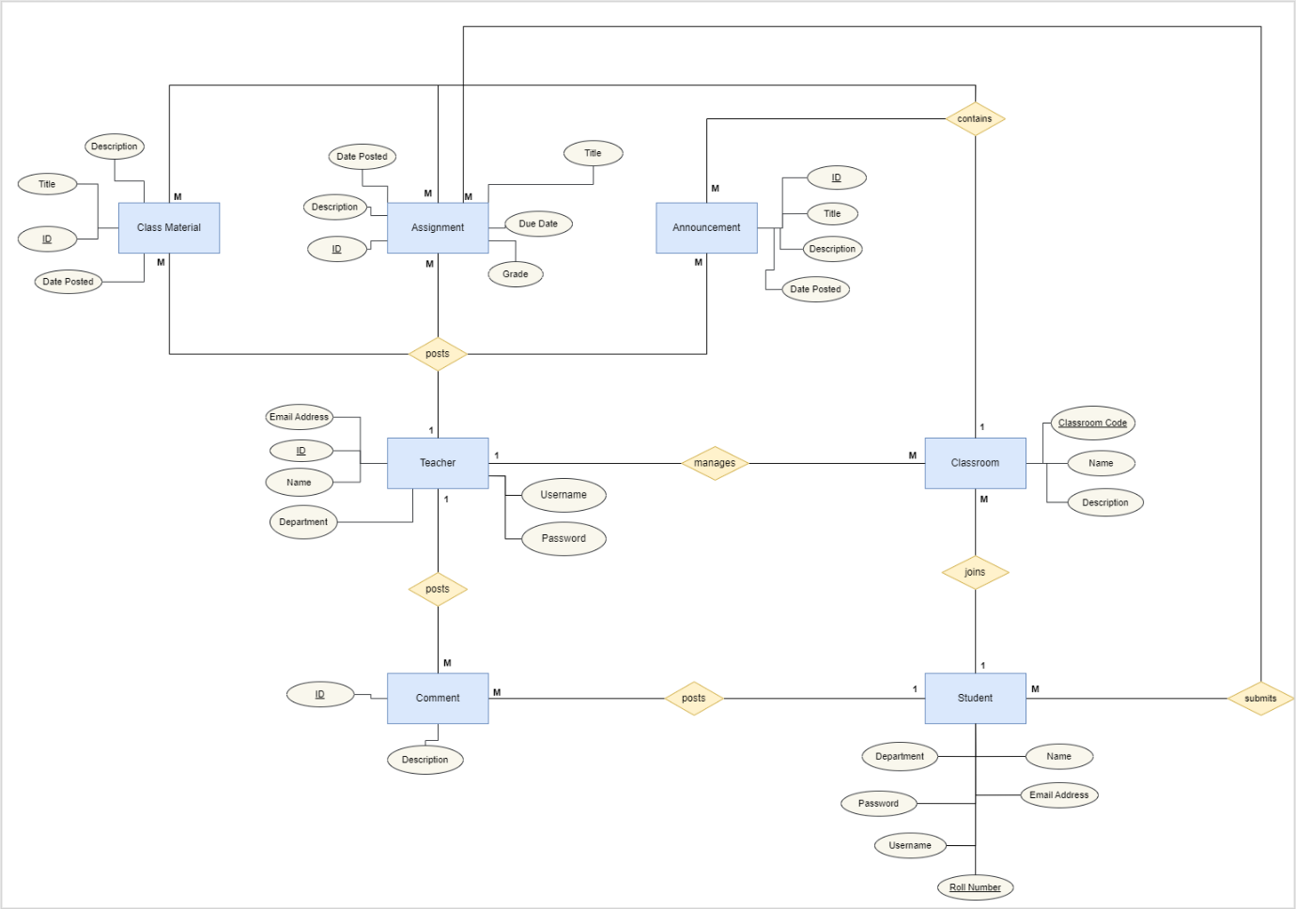

**Screenshots**



