**[#](https://pig4cloud.com/" \l "%E6%BA%90%E7%A0%81%E8%A7%A3%E6%9E%90) 源码解析**

只是给默认的EnableFeignClients 增加了一个默认值。

@Target(ElementType.TYPE)

@Retention(RetentionPolicy.RUNTIME)

@Documented

@EnableFeignClients

public @interface EnablePigxFeignClients {

String[] value() default {};

// 指定默认的扫描范围

String[] basePackages() default {"com.pig4cloud.pigx"};

Class<?>[] basePackageClasses() default {};

Class<?>[] defaultConfiguration() default {};

Class<?>[] clients() default {};

}

[**#**](https://pig4cloud.com/#%E4%BB%A5upms%E4%B8%BA%E4%BE%8B%E5%88%86%E6%9E%90%E5%B0%81%E8%A3%85%E7%9A%84%E5%A5%BD%E5%A4%84) **以UPMS为例分析封装的好处**

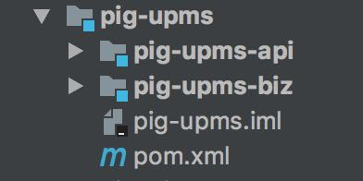

* 如果使用原生的EnableFeignClients 默认的扫描范围是 com.pig4cloud.pig.admin 包的所有FeignClient。
* 而由于微服务拆分所有的feignClient 都在 com.pig4cloud.pig.模块.api包里面，这样默认情况会扫描不到
* 除非明确指定扫描范围 @EnableFeignClients("com.pig4cloud.pig.模块.api")
* 使用了@EnablePigFeignClients 默认扫描 com.pig4cloud.pigx下边的feignClient 更为简洁

[**#**](https://pig4cloud.com/#%40enablefeignclients) **@EnableFeignClients**

@EnableFeignClients

@SpringCloudApplication

public class PigAdminApplication {

}

[**#**](https://pig4cloud.com/#%40enablepigfeignclients) **@EnablePigFeignClients**

@EnablePigFeignClients

@SpringCloudApplication

public class PigAdminApplication {

public static void main(String[] args) {

SpringApplication.run(PigAdminApplication.class, args);

}

}