**[#](https://pig4cloud.com/" \l "%E5%88%86%E5%8C%85%E8%AF%B4%E6%98%8E) 分包说明**

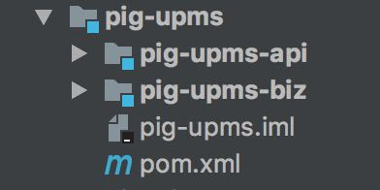具体参考上一章节[EnablePigFeignClients原理解析]

* main类 使用了@EnablePigFeignClients 默认扫描
* 出现FeignClient 调用报错等，请检查你的分包是否符合pig 的标准
* 包名 com.pig4cloud.pig.模块.api

[**#**](https://pig4cloud.com/#%E6%96%B0%E5%A2%9Efeignclient) **新增feignClient**

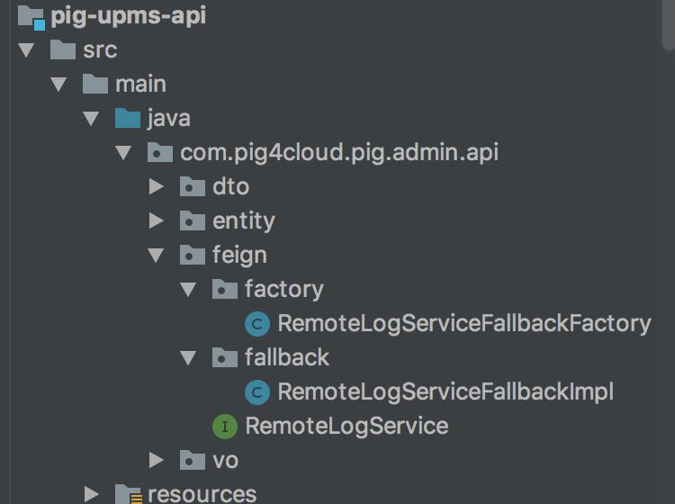

* RemoteXXXService FeignClient 客户端,声明具体的接口和降级工程

@FeignClient(value = ServiceNameConstants.UMPS_SERVICE, fallbackFactory = RemoteLogServiceFallbackFactory.class)

* 降级工厂类，注意这里的@Component 注入到Spring

@Component

public class RemoteLogServiceFallbackFactory implements FallbackFactory<RemoteLogService> {

@Override

public RemoteLogService create(Throwable throwable) {

RemoteLogServiceFallbackImpl remoteLogServiceFallback = new RemoteLogServiceFallbackImpl();

remoteLogServiceFallback.setCause(throwable);

return remoteLogServiceFallback;

}

}

* 具体的降级业务

@Component

public class RemoteLogServiceFallbackImpl implements RemoteLogService {

@Setter

private Throwable cause;

public R<Boolean> saveLog(SysLog sysLog, String from) {

log.error("feign 插入日志失败", cause);

return null;

}

}

[**#**](https://pig4cloud.com/#%E4%B8%BA%E4%BA%86%E4%BF%9D%E8%AF%81%E5%BC%95%E5%85%A5api%E6%A8%A1%E5%9D%97%E5%8F%AF%E4%BB%A5%E7%9B%B4%E6%8E%A5%E4%BD%BF%E7%94%A8%EF%BC%8C%E5%9C%A8spring.factories-%E9%85%8D%E7%BD%AEbean) **为了保证引入api模块可以直接使用，在spring.factories 配置bean**

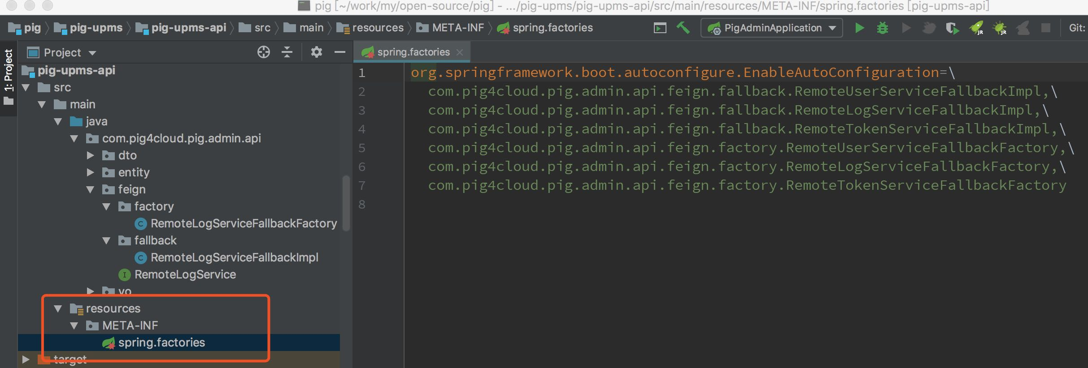

org.springframework.boot.autoconfigure.EnableAutoConfiguration=\

com.pig4cloud.pig.admin.api.feign.fallback.RemoteXXXServiceFallbackImpl,\

com.pig4cloud.pig.admin.api.feign.factory.RemoteXXXServiceFallbackFactory