**[#](https://pig4cloud.com/" \l "%E5%AE%89%E8%A3%85node-%26-npm) 安装node & npm**

官网下载node安装包，内置npm

https://nodejs.org/zh-cn/

[**#**](https://pig4cloud.com/#%E6%A3%80%E6%9F%A5%E5%AE%89%E8%A3%85%E6%98%AF%E5%90%A6%E6%AD%A3%E5%B8%B8) **检查安装是否正常**

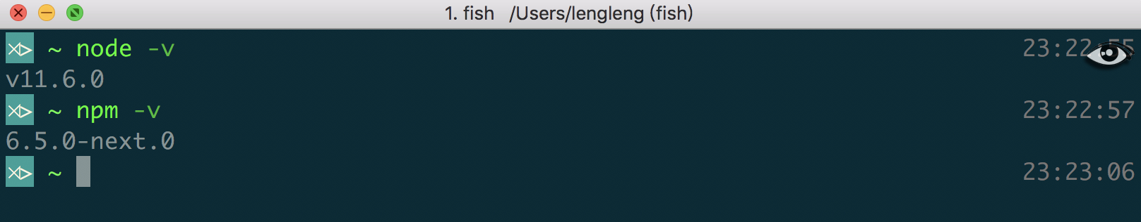

[**#**](https://pig4cloud.com/#%E4%B8%8B%E8%BD%BD%E5%89%8D%E7%AB%AF%E4%BB%A3%E7%A0%81) **下载前端代码**

git clone https://gitee.com/log4j/pig-ui.git

[**#**](https://pig4cloud.com/#%E5%AE%89%E8%A3%85cnpm-%E9%95%9C%E5%83%8F) **安装cnpm 镜像**

npm run pre

[**#**](https://pig4cloud.com/#%E5%AE%89%E8%A3%85%E4%BE%9D%E8%B5%96) **安装依赖**

npm install

[**#**](https://pig4cloud.com/#%E5%90%AF%E5%8A%A8) **启动**

npm run dev

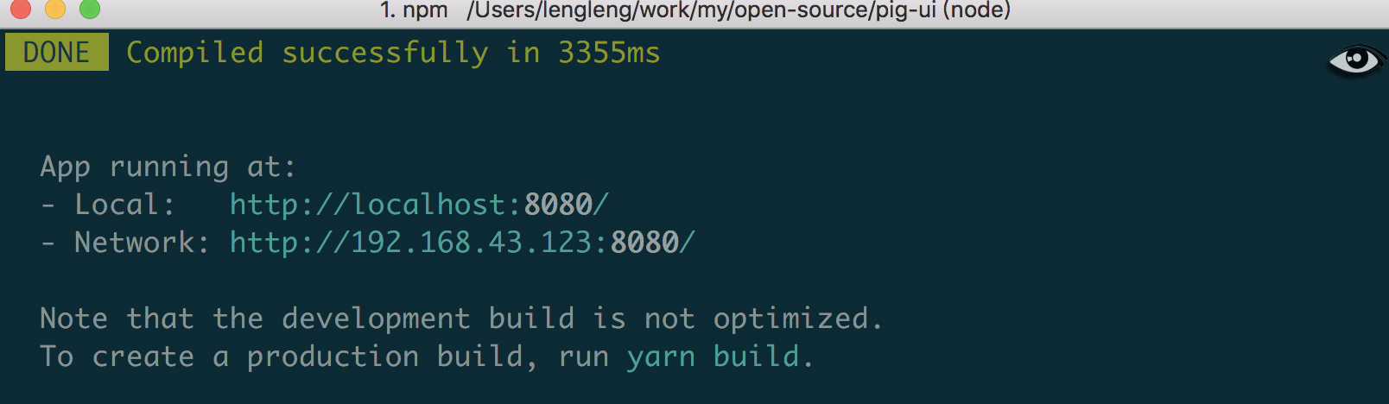

[**#**](https://pig4cloud.com/#%E7%89%B9%E5%88%AB%E8%AF%B4%E6%98%8E) **特别说明**

npm install 过程中可能由于网络关系等，提示报错，请删除 pig-ui 根目录中 node_modules 重写执行 cnpm install 命令即可