Emotion City Map

Transforming Urban Emotions into Data-Driven Spatial Systems
Project theme: An emotional map of the city
Core idea: park = relaxed/open, commercial = stressful/dense, transport = tense/fast
Software environments: Python, Cinema 4D, Processing
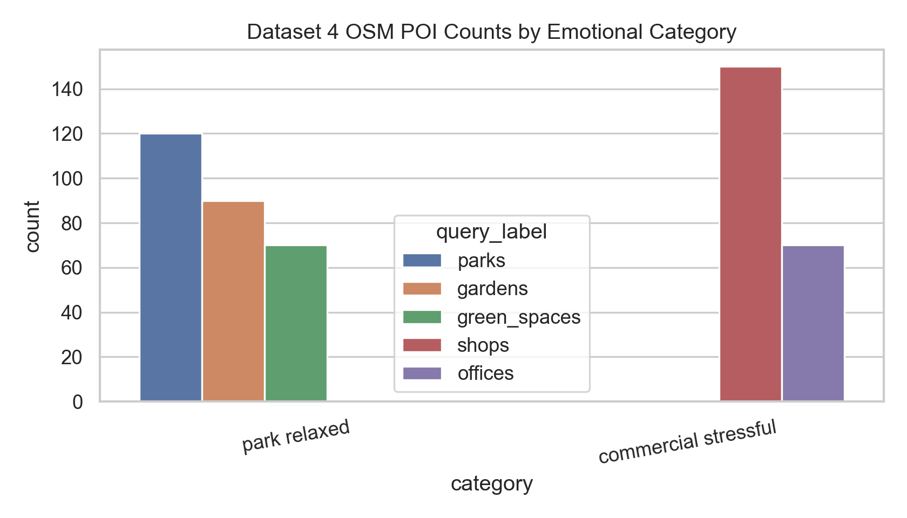
OSM category counts

Project Status

Goal
This project transforms machine-learning outputs, including vector embeddings, clusters, and emotional parameters, into design-driving systems for spatial generation. The project asks how a city can be read as an emotional field. Parks are interpreted as relaxed and open, commercial areas as stressful and dense, and transport nodes as tense and fast.
The final design outcome is an emotional city generator. Each emotional condition becomes a spatial rule:
- Relaxed / open: lower height, wider spacing, slower movement, blue-green tone.
- Stressful / dense: taller height, tighter spacing, faster movement, red-orange tone.
- Tense / fast: directional movement, transitional rhythm, compressed corridors.
The workflow links data collection, vectorisation, machine learning, visualisation, and 3D generation. The data does not remain as analysis only. It is translated into 32 architectural fragments and animated as a one-minute spatial system.

Part 1: Projecting Between Domains

1.1 Web Scraping and Data Collection
The project uses three main datasets from two different domains: Pinterest image data and OpenStreetMap urban point data. A Google Maps review collector is also prepared as an optional extension that can be run with an API key.

Dataset 1: Park / Relaxed Image Dataset
Source: Pinterest
Domain: image / social media image search
Folder: photos1/
Metadata: metadata/pinterest_future_city_metadata.csv
Collected elements: 200 image files
Readable images used in analysis: 188
This dataset represents relaxed and open urban atmospheres. It contains park, garden, landscape, and green-space references. In the design logic, these images support the low-density, slow-moving, open spatial condition.

Dataset 2: Commercial / Stressful Image Dataset
Source: Pinterest
Domain: image / social media image search
Folder: photos2/
Metadata: metadata/pinterest_business environment_metadata.csv
Collected elements: 200 image files
Readable images used in analysis: 199
This dataset represents dense commercial atmospheres. It includes business environments, shopping areas, office-like environments, and visually busier urban references. In the design logic, these images support the high-density, compressed, vertical, and fast-moving condition.

Dataset 3: OpenStreetMap Urban POI Dataset
Source: OpenStreetMap / Overpass API
Domain: live spatial / urban point data
Output: workflow/01_data_collection/dataset4_openstreetmap_poi/outputs/openstreetmap_poi_dataset.csv
Collected elements: 500
Category distribution:
- park relaxed: 280
- commercial stressful: 220
The OpenStreetMap dataset contains real urban elements with names, tags, coordinates, and category labels. It gives the project a spatial anchor: instead of only using atmosphere images, the system also works with actual city locations such as parks, gardens, shops, and offices.
Google Maps Review Extension:
The Google Maps review collector is located at:
workflow/01_data_collection/dataset3_google_maps_reviews/
It is prepared to collect 200-300 real review records using the Google Places API, but it requires GOOGLE_MAPS_API_KEY. Since no key was available in this environment, the review dataset is documented as a prepared extension rather than used as a generated result.

1.2 Dataset Vectorisation
Vectorisation was used to translate both image and text/spatial datasets into machine-readable feature spaces.

Text / POI Vectorisation
Input dataset: OpenStreetMap POI names and tags
Output: workflow/02_vectorisation/outputs/text_vectorisation_tfidf_vs_hashing.csv
Two vectorisation methods were compared:
- TF-IDF + SVD
- HashingVectorizer + SVD
TF-IDF was selected because it is interpretable. It allows the report to connect words and OSM tags such as park, garden, shop, and office back to design decisions. This is useful for a design workflow because the features are not a black box.
HashingVectorizer was selected as a comparison because it is faster and more scalable. It does not store a vocabulary, so it is less readable, but it can process larger streams of text with a fixed feature size.
Result:
- TF-IDF silhouette: 0.235
- Hashing silhouette: 0.109
- Cluster agreement between both methods: ARI 0.490
Interpretation:
TF-IDF performed better for this dataset. OSM tags are short and structured, so the vocabulary itself is meaningful. Hashing was faster but less interpretable and produced weaker separation.
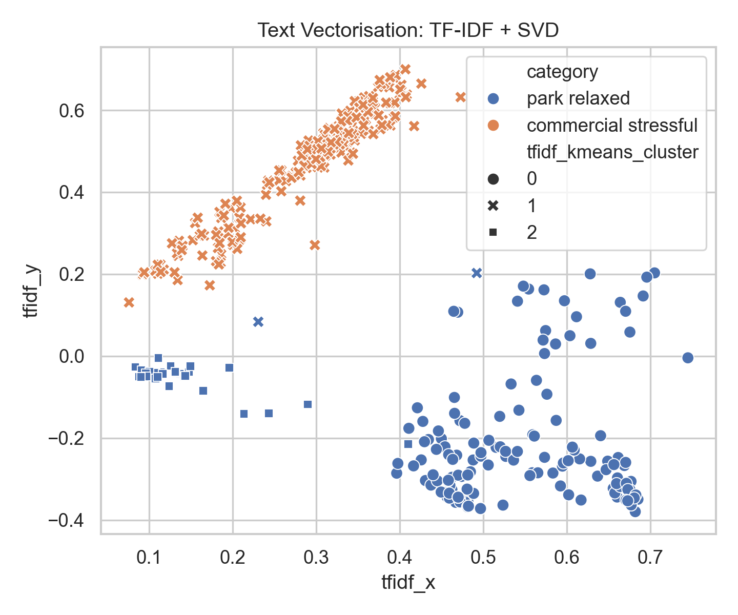
TF-IDF clusters
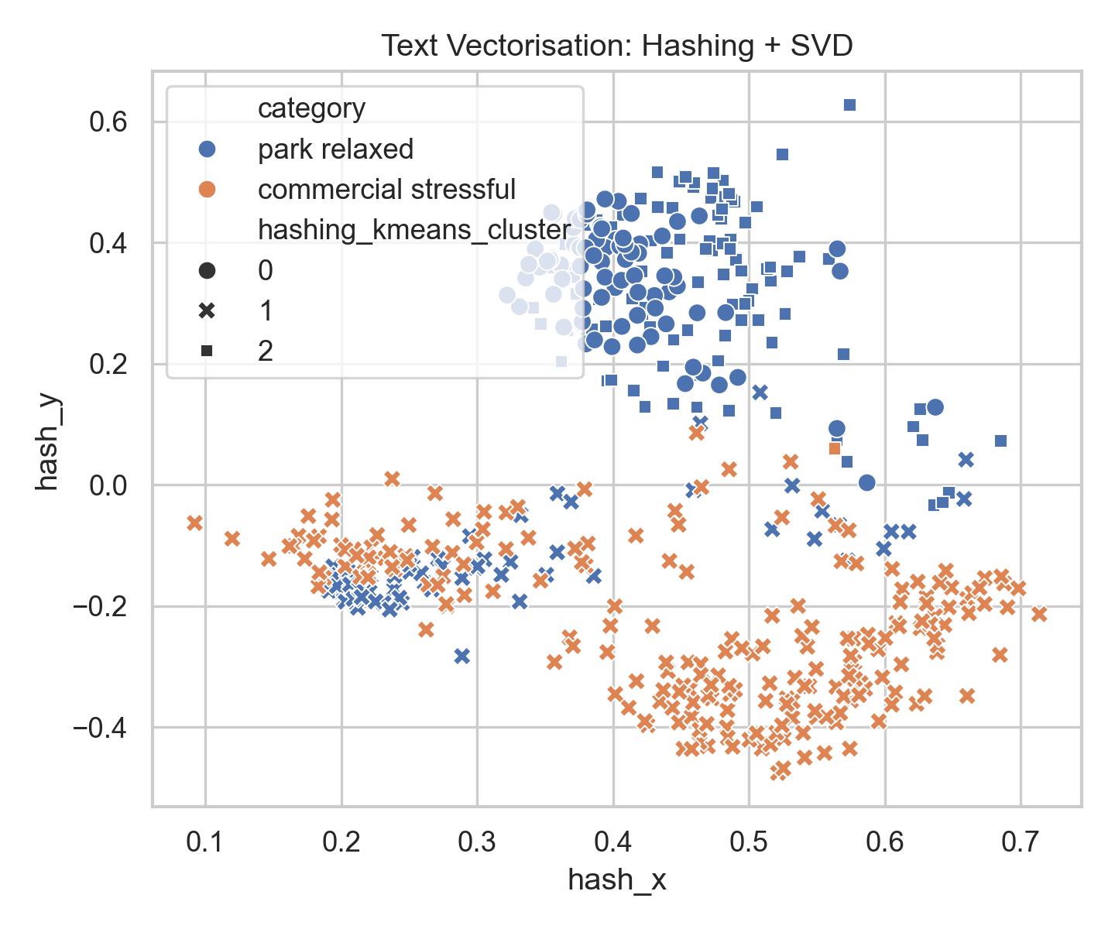
Hashing clusters

Image Vectorisation
Input datasets: Pinterest park images and Pinterest business images
Output: workflow/02_vectorisation/outputs/image_vectorisation_colour_texture.csv
Two image vectorisation strategies were compared:
- Colour statistics and HSV histograms
- Colour + texture / edge features
Colour features were selected because the emotional contrast between park and commercial atmospheres is partly visual: parks tend to contain green-blue, softer, and more open images; commercial environments tend to contain stronger contrast, hard surfaces, signage, glass, and artificial lighting.
Texture and edge features were added as a comparison because commercial spaces often have more hard boundaries, visual clutter, and sharper geometry.
Result:
- Valid images: 387
- Colour feature silhouette: 0.306
- Colour + texture feature silhouette: 0.251
- Cluster agreement: ARI 0.822
Interpretation:
Colour separated the datasets more strongly than texture. Texture added detail, but also noise, because some park images include paths, buildings, and hard edges, while some commercial images have smooth surfaces.
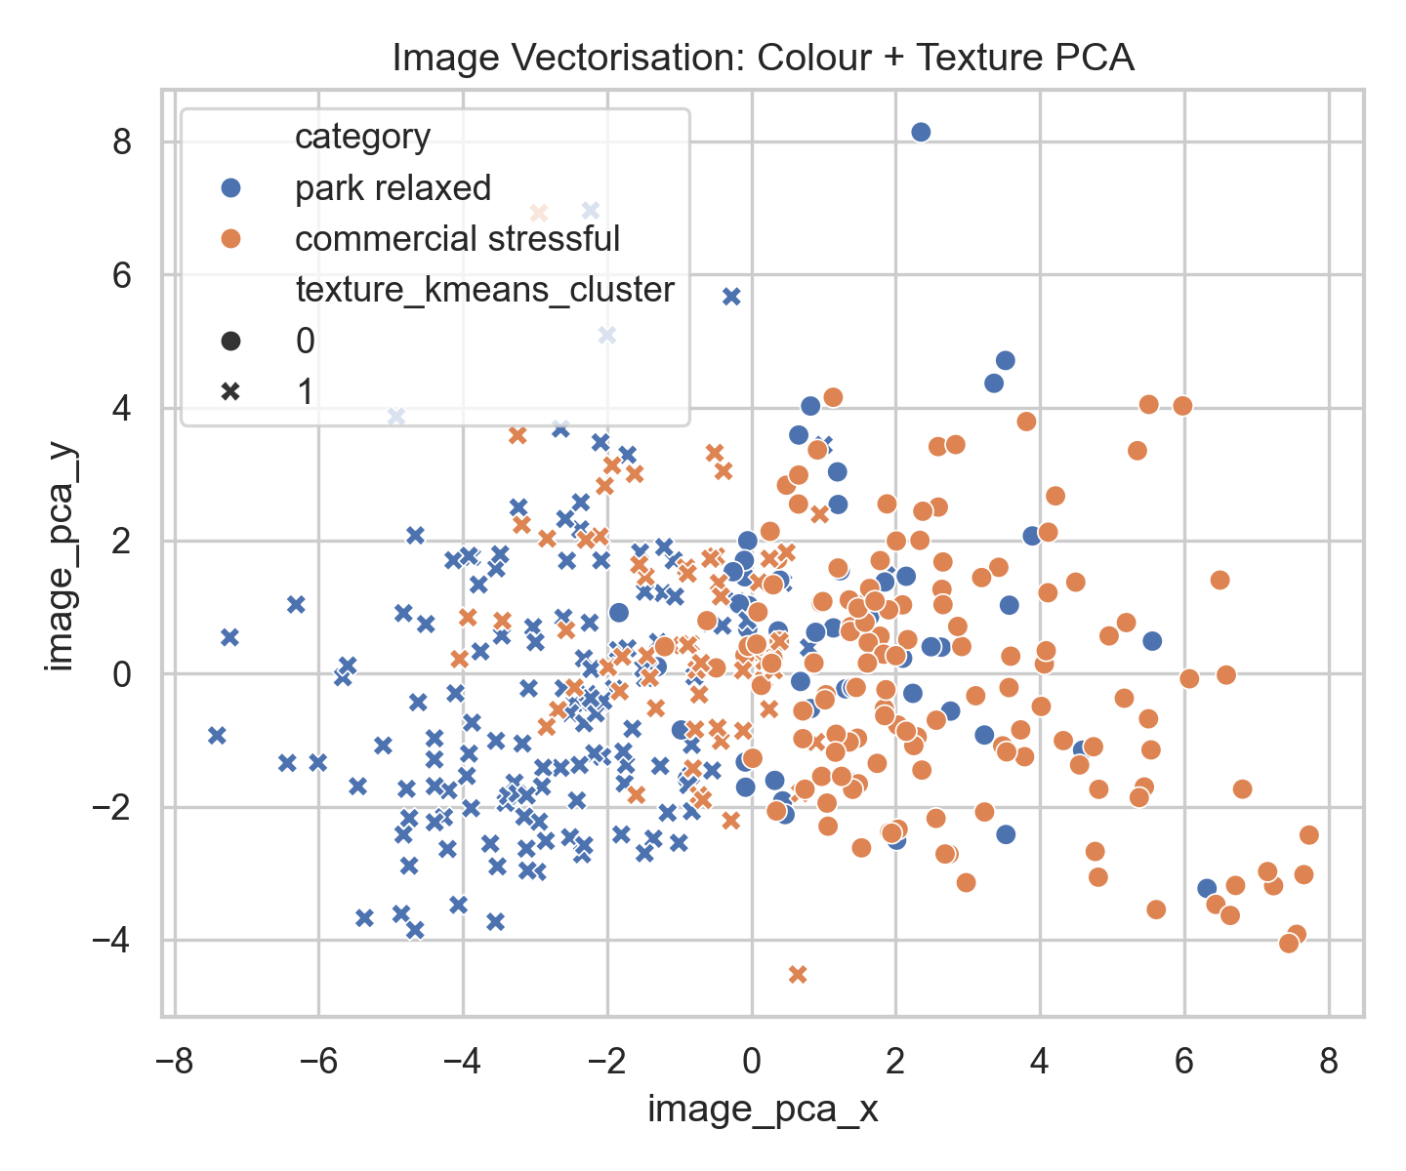
Image PCA

1.3 API Interaction for Structured Data Retrieval
The API interaction component is prepared in:
workflow/01_data_collection/dataset5_api_synthetic_emotion_text/scripts/generate_emotion_text_api.py
This script uses the OpenAI API to generate structured emotional city observations. Each generated item includes:
- sensory observation
- emotional interpretation
- spatial rule
- keywords
The script is designed to augment the scraped and spatial datasets. It creates text that directly connects emotion to spatial grammar, for example:
- relaxed park atmosphere -> horizontal expansion, wide spacing, slow rhythm
- stressful commercial atmosphere -> vertical pressure, dense grid, fast rhythm
- tense transport atmosphere -> directional corridors and compressed waiting
This part requires the user’s own OPENAI_API_KEY. The script is included and ready, but no API key is stored in the project.

1.4 Machine Learning
Two machine-learning models were trained and compared using the OSM POI dataset and vectorised features.
Input:
workflow/03_machine_learning/outputs/osm_ml_clusters_kmeans_vs_gmm.csv
Feature columns:
- value1
- value2
- TF-IDF SVD x/y
- Hashing SVD x/y

Model 1: KMeans Clustering
KMeans was used to group urban elements into emotion-space clusters. It is suitable for this project because the design system needs clear cluster labels that can be mapped into spatial rules.
Result:
- KMeans silhouette: 0.635

Model 2: Gaussian Mixture Model
Gaussian Mixture Model was used as a softer clustering comparison. Unlike KMeans, GMM assumes data can belong to probabilistic distributions. This is conceptually useful for emotional ambiguity, where a place might be partly calm and partly stressful.
Result:
- GMM silhouette: 0.494
Comparison:
KMeans performed better in this dataset because the emotional parameters were clearly separated: relaxed/open elements have low value1/value2, while commercial/stressful elements have high value1/value2. GMM is still valuable as a design idea because it supports transitional emotional zones, but KMeans produced cleaner clusters for direct fragment generation.
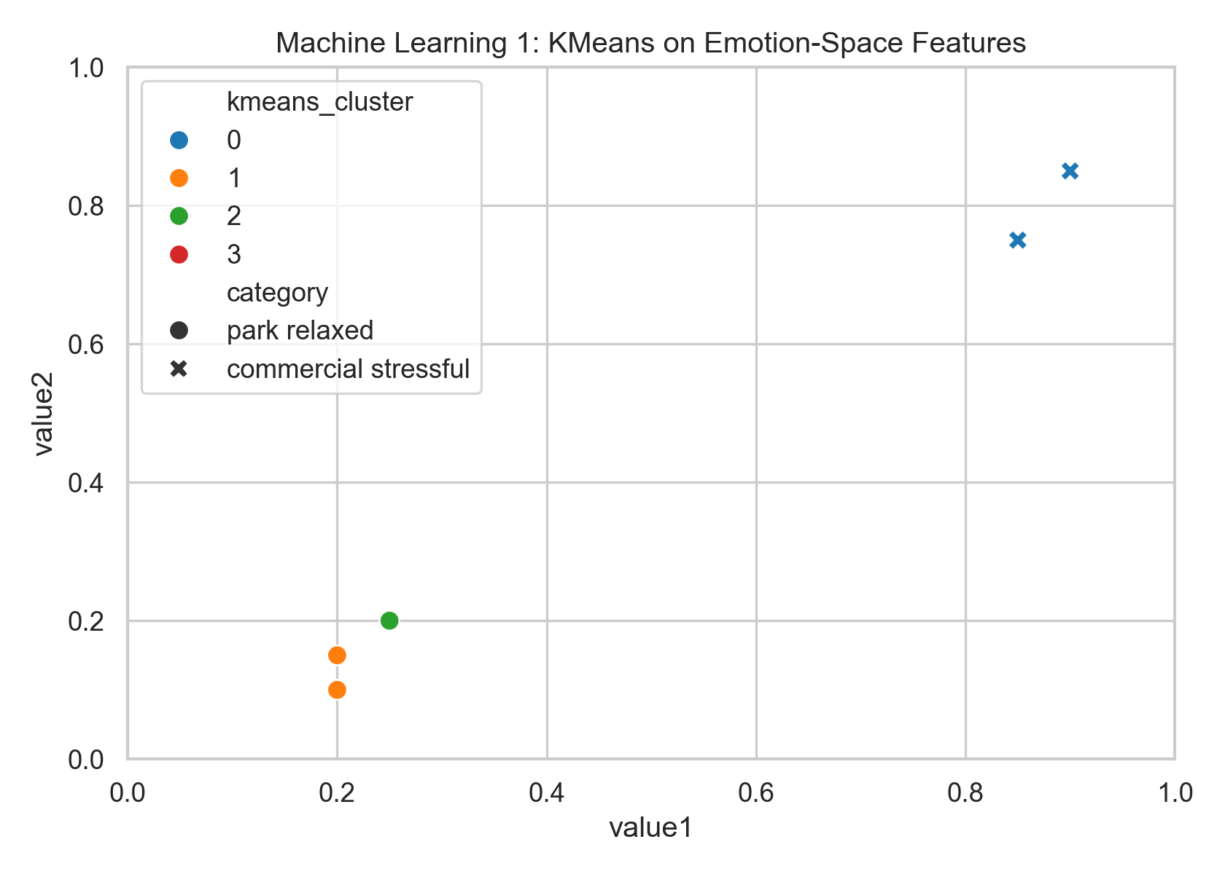
KMeans emotion space
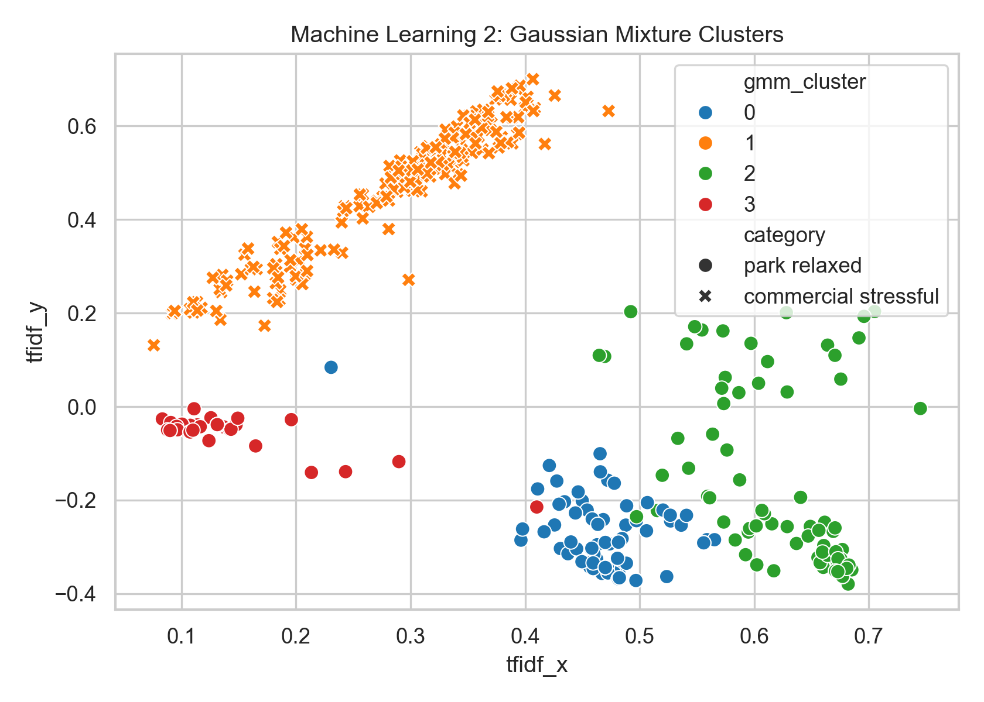
GMM text space
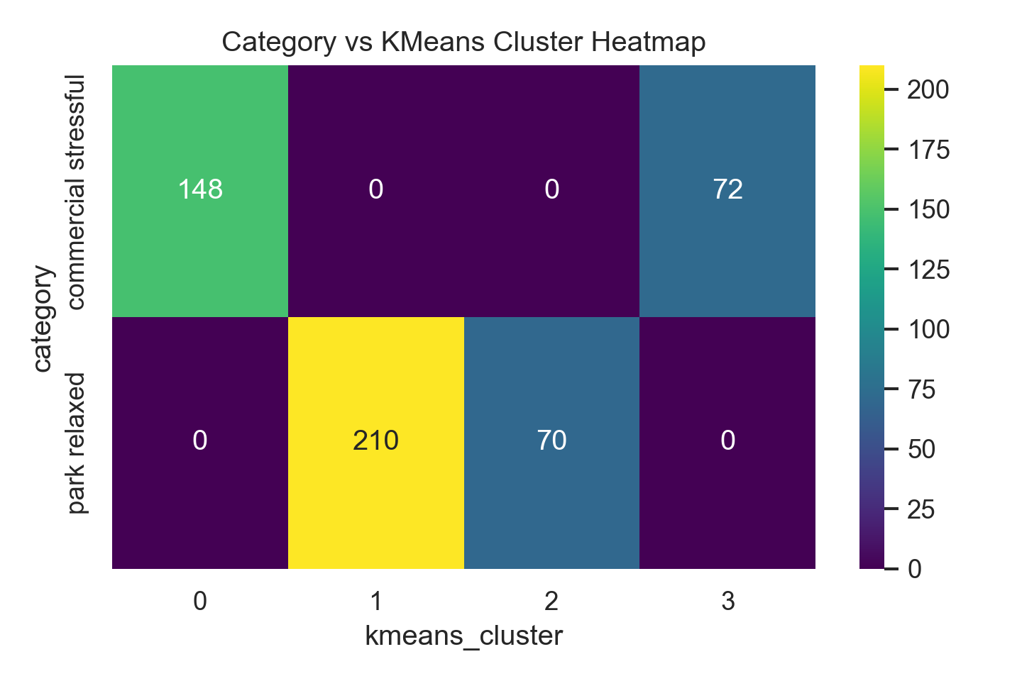
Cluster heatmap

1.5 Visualising and Plotting
Matplotlib and Seaborn were used to create analysis figures. The figures are stored in:
workflow/04_visualisation/outputs/
Main outputs:
- dataset category counts
- TF-IDF vectorisation plot
- Hashing vectorisation plot
- image colour/texture PCA
- KMeans cluster plot
- GMM cluster plot
- category-cluster heatmap
- fragment parameter variation chart
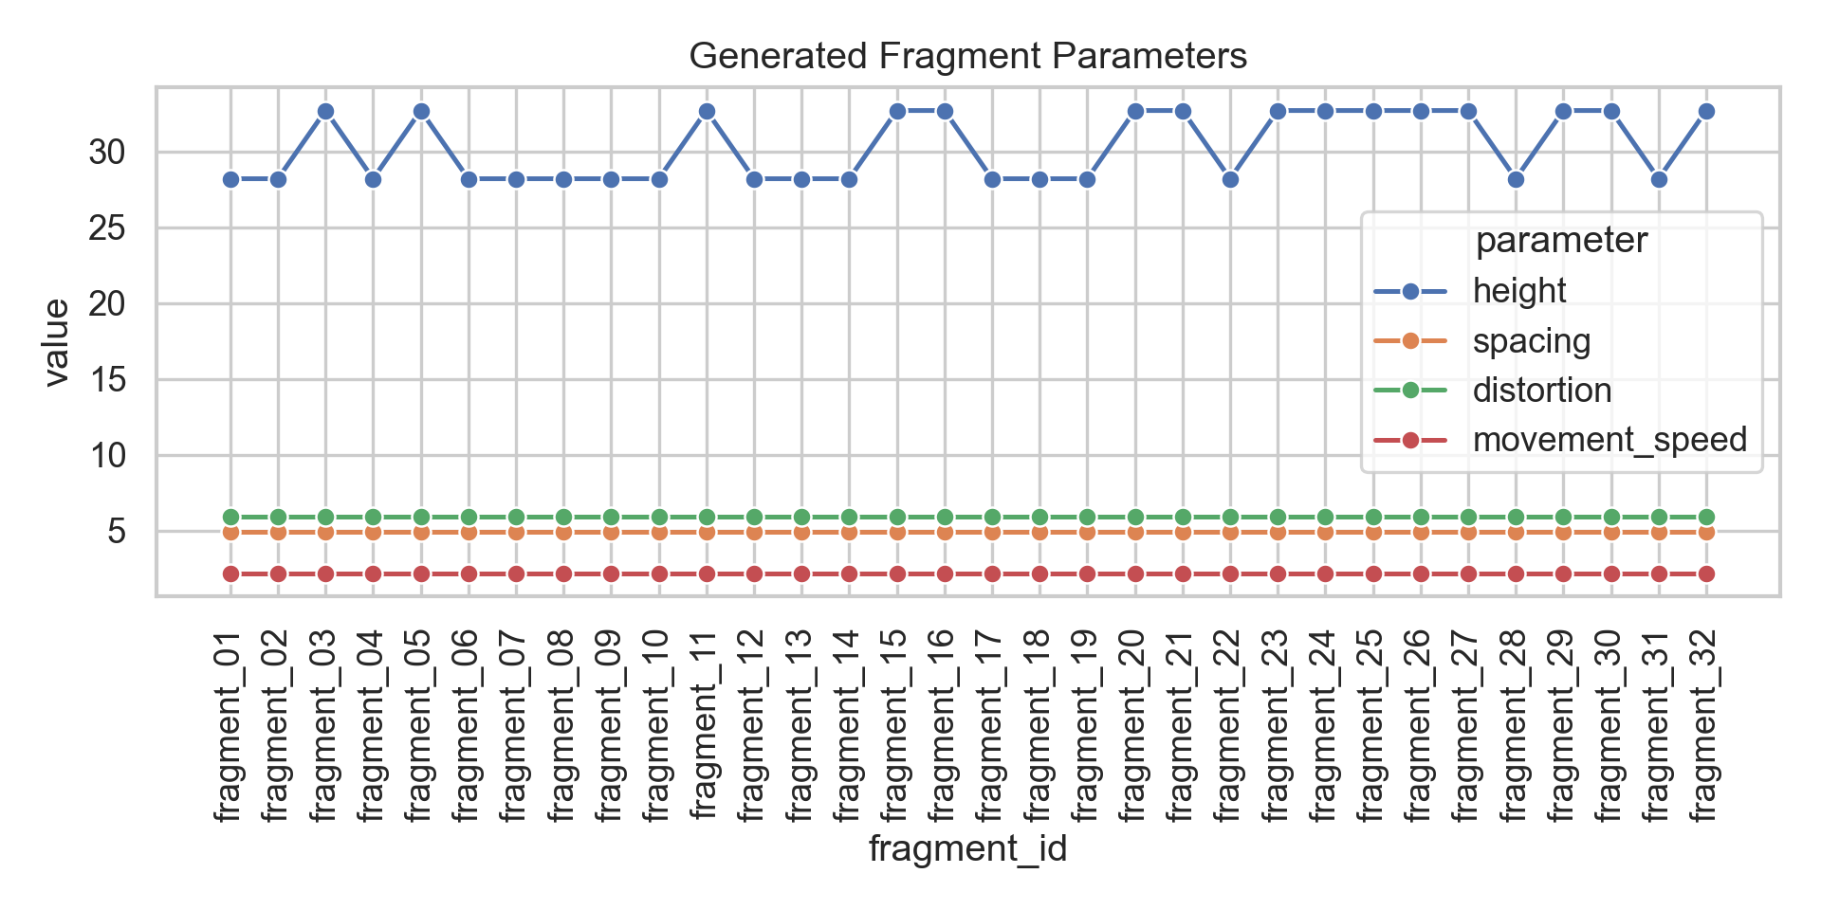
Fragment parameter variation

Part 2: Design Tool Integration

2.1 Project Brief
The design tool workflow uses Python, Cinema 4D, and Processing.
Python is used for data processing, vectorisation, machine learning, and fragment parameter generation. It translates the collected datasets into a CSV of spatial rules.
Cinema 4D is used as the main 3D modelling and animation environment. It reads the fragment parameter CSV and generates 32 architectural fragments with different heights, colours, spacing logic, and animation keyframes.
Processing is used as a real-time animation and interaction environment. It tests the emotional city logic through mouse-controlled emotion and density. Moving the mouse left produces a relaxed/open park city; moving it right produces a dense/stressful commercial city.

2.2 Integrated Workflows

Workflow A: Data to Fragment Parameters
Pinterest images and OSM data are processed in Python. Image colour/texture features and OSM text vectors are clustered. The cluster outputs are translated into height, spacing, distortion, movement speed, colour, and scene position.
Output:
workflow/05_design_tool_integration/fragment_parameters/emotion_city_fragments_32.csv

Workflow B: Fragment Parameters to Cinema 4D
Cinema 4D reads the fragment CSV and generates a 3D scene. Each fragment stores:
- source urban element
- emotional category
- KMeans cluster
- GMM cluster
- height, width, depth
- distortion
- movement speed
- RGB colour
- scene position
Cinema 4D script:
workflow/05_design_tool_integration/cinema4d/generate_emotion_city_c4d.py

Workflow C: Emotion Rules to Processing
Processing uses the same emotional rules in an interactive sketch. The user controls the emotional axis with the mouse:
- left = relaxed, open, park-like
- right = stressful, dense, commercial-like
Processing sketch:
python_processing/python_processing.pde
This sketch demonstrates the rule system live: height, spacing, distortion, colour, pulse, and density all change continuously along the emotional axis.

2.3 Iterative Reconfiguration
The final fragment system contains 32 architectural fragments:
workflow/05_design_tool_integration/fragment_parameters/emotion_city_fragments_32.csv
Each fragment is generated through rule-based transformation. The fragments are not manually modelled one by one. They are generated from machine-learning cluster outputs and emotional design parameters.
Design rules:
- higher value1 -> greater stress -> taller fragments
- higher value2 -> greater density -> tighter spacing and larger mass
- KMeans cluster -> fragment variation group
- emotion category -> colour palette
- movement speed -> animation rhythm
- distortion -> spatial instability
The result is a systematic family of architectural fragments rather than isolated objects.

2.4 3D Scenes and Animation
Cinema 4D animation:
workflow/05_design_tool_integration/cinema4d/generate_emotion_city_c4d.py
This script sets a 1800-frame animation at 30 fps, which equals 60 seconds. It creates a scene with a ground plane, lights, camera movement, and 32 animated fragments.
Processing animation:
python_processing/python_processing.pde
This sketch creates a real-time emotional city where the viewer can move between relaxed/open and stressful/dense urban conditions.
Preview animation:
workflow/06_report_assets/emotion_city_preview_65s.mp4
This preview is 65 seconds long and was generated from the fragment CSV. It can be used as a quick submission/crit preview while a higher-quality Cinema 4D render is prepared.

Project Conclusion
This project converts urban media and spatial datasets into an emotional generation system. Images provide atmosphere, OSM data provides real urban locations, vectorisation translates the datasets into feature spaces, machine learning extracts cluster structures, and the design tools transform those clusters into architectural fragments.
The project demonstrates a continuous workflow:
data collection -> vectorisation -> machine learning -> visual analysis -> fragment rules -> Cinema 4D / Processing animation
The emotional city is therefore not only a visual metaphor. It is a design tool where data-driven emotional categories directly produce spatial variation.

Key File Index
Data:
- photos1/
- photos2/
- metadata/pinterest_future_city_metadata.csv
- metadata/pinterest_business environment_metadata.csv
- workflow/01_data_collection/dataset4_openstreetmap_poi/outputs/openstreetmap_poi_dataset.csv
Vectorisation:
- workflow/02_vectorisation/scripts/run_emotion_city_pipeline.py
- workflow/02_vectorisation/outputs/text_vectorisation_tfidf_vs_hashing.csv
- workflow/02_vectorisation/outputs/image_vectorisation_colour_texture.csv
Machine Learning:
- workflow/03_machine_learning/outputs/osm_ml_clusters_kmeans_vs_gmm.csv
- workflow/03_machine_learning/outputs/ml_metrics.json
Visualisation:
- workflow/04_visualisation/outputs/
- workflow/06_report_assets/
Design Tools:
- workflow/05_design_tool_integration/fragment_parameters/emotion_city_fragments_32.csv
- workflow/05_design_tool_integration/cinema4d/generate_emotion_city_c4d.py
- python_processing/python_processing.pde
- workflow/05_design_tool_integration/processing/emotion_city_fragments_animation/emotion_city_fragments_animation.pde
Animation:
- workflow/06_report_assets/emotion_city_preview_65s.mp4

Submission Checklist
- Include final PDF report.
- Include GitHub repository link.
- Include datasets and scripts.
- Include OneDrive public folder for animation and 3D files.
- Remove all API keys before uploading.
- Do not upload .env files.
- Revoke any API key that was accidentally written in an old notebook.

