UPI TRANSACTION ANALYTICS:
EXPLORING PAYMENT BEHAVIOR, TRANSACTION RELIABILITY AND FRAUD PATTERNS IN INDIA
An Empirical Investigation into Retail Payments Dynamics, Infrastructure Reliability Invariance, and Machine Learning Predictability under Severe Class Imbalance
Academic Research Final Project Deliverable
Course: Data Exploration and Visualization Laboratory
Department of Computer Science & Engineering
Academic Year 2024–2025
Student Author and Investigator Details
Student Author Name | Permanent Registration Number (PRN) | Academic Role & Division
Swaraj Suresh Shinde | 125B1D053 | Primary Investigator / DE&V Lab
Nikol Dharmraj Ghodke | 125B1D062 | Co-Investigator / DE&V Lab
Supervised and Guided by:
Academic Research Supervisor in Data Science
Faculty of Data Science & Software Engineering

Table of Contents
Report Section / Topic | Page
1. Title and Team Details | 3
2. Abstract / Executive Summary | 4
3. Introduction, Problem Statement, Objectives, and Research Questions | 5
4. Dataset Source, Description, and Attributes | 7
5. Data Preprocessing and Feature Engineering | 9
6. Methodology and Technological Stack | 11
7. Exploratory Data Analysis (EDA) and Empirical Findings | 13
8. Predictive Modelling and Honest Scientific Evaluation | 18
9. Dashboard Architecture, KPIs, and Visual Telemetry | 21
10. Key Insights and Empirical Findings Matrix | 24
11. Business, Regulatory, and Policy Recommendations | 28
12. Project Limitations and Analytical Boundaries | 30
13. Conclusion and Future Research Directions | 32
14. References and Dataset Attribution | 33
15. Dashboard Execution and Deployment Guide | 34

List of Figures
Figure Caption | Page
Figure 1: Univariate Distribution of Amounts and Tukey Outlier Boundary | 13
Figure 2: Paired Comparison of Transaction Volume vs. Value Across Merchant Categories | 14
Figure 3: Diurnal 24-Hour Velocity Curve and Weekend Invariance Summary | 15
Figure 4: Infrastructure Reliability Invariance Across Banks, Devices, and Networks | 16
Figure 5: State-Level Transaction Volume Share vs. Fraud-Flagged Share | 17
Figure 6: Fraud-Flag Point Estimates and 95% Wilson Confidence Intervals | 18
Figure 7: Full View of the Interactive Streamlit UPI Dashboard (app.py) | 22
Figure 8: High-Level Executive KPI Telemetry Cards | 22
Figure 9: Analytical Chart Modules: Diurnal Curves, Categories, and Failure Rails | 23
Figure 10: Executive Insights and Policy Recommendations Tab | 23

List of Tables
Table Title | Page
Table 1: Student Author and Investigator Details | 1
Table 2: Dataset Attribute Inventory and Technical Schema (17 Columns) | 7
Table 3: Summary Statistics of Continuous Dimensions: Amount and Hour | 8
Table 4: Categorical Distribution Summary Across Key Payment Dimensions | 8
Table 5: Technological Stack and Installed Library Inventory | 11
Table 6: Baseline Logistic Regression Confusion Matrix (Unweighted) | 19
Table 7: Balanced Logistic Regression Confusion Matrix (class_weight='balanced') | 19
Table 8: Comprehensive Summary Synthesis of Key Empirical Insights | 27

1. Title and Team Details
Official Academic Project Title: Project Title: UPI Transaction Analytics: Exploring Payment Behavior, Transaction Reliability and Fraud Patterns in India
Academic Context: This project constitutes the final comprehensive laboratory deliverable for the academic course Data Exploration and Visualization Laboratory within the Department of Computer Science & Engineering. The research was conducted collaboratively by the two student investigators detailed below under the continuous supervision and academic direction of the faculty laboratory mentor.
1.1 Student Author and Investigator Profiles
- Swaraj Suresh Shinde: PRN: 125B1D053 | Division: B.Tech Computer Science & Engineering. Primary responsibilities: Dataset verification pipeline, statistical hypothesis testing (Chi-Square independence and Cramer's V calculations), exploratory notebook auditing, and predictive modeling experiments.
- Nikol Dharmraj Ghodke: PRN: 125B1D062 | Division: B.Tech Computer Science & Engineering. Primary responsibilities: Modular data loader and metrics architecture (src/data_loader.py, src/metrics.py), interactive Streamlit dashboard engineering (app.py), visual Plotly figure generation, and headless Playwright verification.
1.2 Course and Laboratory Specifications
Curriculum Mandates: Course Name: Data Exploration and Visualization Laboratory | Course Code: CS-DEV-LAB | Academic Term: 2024–2025. Deliverables specified under the university curriculum mandate: (1) Formulating 10 defensible research questions; (2) Performing thorough univariate, bivariate, and multivariate exploratory data analysis; (3) Auditing data hygiene and structural integrity; (4) Conducting honest predictive machine learning modeling under imbalanced class regimes; and (5) Building an interactive, reactive web dashboard delivering multi-dimensional filters, executive KPI cards, and automated key insights.
2. Abstract / Executive Summary
Executive Summary: The Unified Payments Interface (UPI) has fundamentally transformed retail financial intermediation in India, serving as the backbone for over 14 billion monthly transactions. This study presents a rigorous empirical investigation of 250,000 retail UPI transactions recorded during the calendar year 2024, aggregating ₹327,939,009.00 (₹32.79 Crores) in financial volume across 17 distinct operational dimensions. In accordance with strict data science research protocols, all empirical claims and statistical metrics presented in this report have been programmatically audited and verified against the source dataset, eliminating analytical artifacts and discrepancies.
Univariate analysis demonstrates that UPI adoption is heavily anchored in low-value consumer micro-transactions, producing an extreme positive skew (skewness > 3.0) where the arithmetic mean of ₹1,311.76 exceeds the median of ₹629.00 by 2.09×. Applying Tukey's 1.5×IQR outlier threshold (Q3 = ₹1,596, IQR = ₹1,308) identifies exactly 21,171 transactions (8.47%) exceeding ₹3,558.00 as high-ticket statistical outliers. Furthermore, a pronounced decoupling emerges between transaction velocity and monetary settlement value: groceries account for 19.99% of total volume (49,966 tx) but only 17.77% of total monetary value (₹5.83 Cr), whereas high-ticket retail categories such as shopping (11.95% volume, ₹7.69 Cr value) and education (3.04% volume, ₹3.87 Cr value; mean ticket ₹5,094.02) account for 35.24% of cumulative monetary turnover.
Temporal profiling reveals a 15.74× diurnal surge peaking at 19:00 (21,232 transactions; 8.49% of daily volume) and bottoming at 03:00 (1,349 transactions). However, when normalized on a per-day basis, daily transaction velocity is strictly invariant to weekend calendar shifts: 35,732.6 transactions/day on weekdays versus 35,668.5 transactions/day on weekends (a nominal delta of 0.18%). Crucially, two-way Chi-Square tests of independence prove that system failure rates hover stochastically at 4.95% (12,376 failures) and are completely independent of sender banking institutions (χ² = 3.235, p = 0.863), client operating systems (χ² = 1.181, p = 0.554), and network protocols (χ² = 3.853, p = 0.278). The popular misconception that Android or 4G connections are prone to failure is shown to be a volume confounding artifact: Android absorbs 74.97% of failures exclusively because it generates 75.11% of all traffic.
Regarding financial risk, flagged fraudulent transactions constitute an ultra-rare minority class of 480 instances (0.1920%), which correlates linearly with population volume (Maharashtra and Karnataka driving 29.17% of flags from 26.87% of transactions; χ² = 7.765, p = 0.558). An honest evaluation of machine learning failure prediction demonstrates that an unweighted baseline Logistic Regression model achieves 95.05% accuracy solely by acting as a naive majority-class classifier with 0.00 recall. Conversely, balancing class weights achieves 48.81% recall and 5.05% precision with 52.06% accuracy, mathematically proving that the model performs as an unweighted random coin flip due to the absence of predictive signal in static transaction metadata. Finally, an enterprise-grade interactive dashboard implemented in Streamlit and Plotly is presented, providing real-time KPI monitoring, multi-dimensional filtering, and automated insight delivery.
3. Introduction, Problem Statement, Objectives, and Research Questions
3.1 Background and Context
The digital payments architecture of India, orchestrated by the National Payments Corporation of India (NPCI), has achieved unprecedented global scale through the Unified Payments Interface (UPI). By abstracting banking identifiers into virtual payment addresses (VPAs) and enabling instant settlement via mobile devices, UPI has largely replaced cash in retail transactions. However, sustaining a network handling tens of billions of transactions requires deep data-driven visibility into transaction velocity, failure dynamics across heterogeneous infrastructure rails, and fraudulent transaction patterns.
3.2 Problem Statement
Despite UPI's operational success, academic and institutional analysts frequently encounter several critical analytical traps: (1) Conflating absolute failure counts with failure probabilities, erroneously penalizing dominant mobile platforms and telecom carriers; (2) Treating high-volume states as hotbeds of fraud due to aggregate flag counts rather than evaluating per-capita risk rates; (3) Masking micro-ticket retail dominance beneath arithmetic averages that are distorted by heavy positive skewness; and (4) Misinterpreting deceptive machine learning metrics under severe class imbalance (0.192% fraud and 4.95% failure rates), leading to claims of 95% model accuracy that conceal completely non-functional models. This study resolves these issues through systematic statistical testing and rigorous exploratory data analysis.
3.3 Research Objectives
- Objective 1 (Distributional Profiling): Quantify the empirical distribution of transaction ticket sizes, identifying the micro-payment threshold and statistically delineating high-value outliers.
- Objective 2 (Merchant Category Dynamics): Analyze the operational decoupling between transaction volume velocity and financial settlement value across merchant verticals.
- Objective 3 (Reliability Invariance Testing): Evaluate infrastructure reliability and test whether transaction failures depend upon banking institutions, client devices, or telecommunication networks.
- Objective 4 (Risk Telemetry & Fraud Profiling): Investigate geographic and demographic fraud flag distributions under extreme class imbalance, evaluating statistical independence and uncertainty bounds.
- Objective 5 (Interactive Visualization Engineering): Develop and validate an interactive dashboard architecture in Streamlit and Plotly to operationalize analytical findings for banking stakeholders.
3.4 Ten Research Questions (RQs)
RQ1: Distributional Skew & Ticket Size Concentration: What is the empirical distribution of UPI transaction amounts, and to what extent do micro-payments (< ₹1,000) dominate transaction volume versus high-ticket outliers?
RQ2: Merchant Volume vs. Monetary Value Decoupling: How does transaction velocity decouple from gross monetary settlement value across differing merchant verticals?
RQ3: Diurnal Rhythms and Weekly Temporal Invariance: What diurnal cyclicality characterizes UPI network traffic across 24-hour cycles, and does daily velocity vary between weekdays and weekends when normalized?
RQ4: Baseline Infrastructure Reliability: What is the overall baseline transaction failure rate across the payment network, and does it vary across transaction types?
RQ5: Inter-Bank Performance Homogeneity: Do sender and receiver banking institutions exhibit statistically significant differences in transaction success and failure rates?
RQ6: Client Device Platform Parity: Does client operating system architecture (Android, iOS, Web) correlate with transaction failure rates, or are failures proportional to market share?
RQ7: Telecommunication Network Protocol Stability: How do underlying cellular and local network protocols (4G, 5G, 3G, WiFi) impact payment completion reliability?
RQ8: Geographic Volume Proportionality in Risk Flags: Does geographic transaction volume across Indian states predict fraud-flag incidence, or is regional flagging strictly volume-proportional?
RQ9: Demographic and Category Fraud Flag Association: Are fraud flags significantly associated with sender age groups, transaction categories, or monetary amounts?
RQ10: Predictive Feasibility Under Severe Class Imbalance: Can transaction failure or fraud flags be reliably predicted from standard transaction metadata using logistic classification models under severe class imbalance?
4. Dataset Source, Description, and Attributes
Data Provenance & Overview: The empirical analysis is conducted on the benchmark dataset upi_transactions_2024.csv, representing a simulated population of 250,000 retail UPI transactions spanning the complete calendar year 2024 (January 1, 2024, 00:05:10 to December 30, 2024, 23:55:40). The dataset contains exactly 17 tabular columns. Complete structural inspection confirms zero missing values across all 250,000 records and zero duplicate rows.
4.1 Attribute Inventory and Technical Schema
Table 2: Dataset Attribute Inventory and Technical Schema (17 Columns)
# | Column Name | Data Type | Nulls | Analytical Role & Description
1 | transaction id | str | 0 | Unique primary surrogate key (TXN0000000001–TXN0000250000). Excluded from modeling.
2 | timestamp | str / datetime | 0 | Transaction event timestamp (2024-01-01 00:05:10 to 2024-12-30 23:55:40).
3 | transaction type | str | 0 | Payment classification: P2P, P2M, Bill Payment, Recharge.
4 | merchant_category | str | 0 | Commercial vertical: Grocery, Food, Shopping, Utilities, Education, etc.
5 | amount (INR) | int64 / float64 | 0 | Monetary ticket value in Indian Rupees (₹10 to ₹42,099).
6 | transaction_status | str | 0 | Outcome flag: SUCCESS (95.05%) or FAILED (4.95%).
7 | sender_age_group | str | 0 | Demographic bracket of remitter: 18-25, 26-35, 36-45, 46-55, 56+.
8 | receiver_age_group | str | 0 | Demographic bracket of beneficiary: 18-25, 26-35, 36-45, 46-55, 56+.
9 | sender_state | str | 0 | Indian state of origination (Maharashtra, Karnataka, Delhi, etc.).
10 | sender_bank | str | 0 | Originating commercial bank (SBI, HDFC, ICICI, Axis, Yes Bank, PNB, BoB, Kotak).
11 | receiver_bank | str | 0 | Beneficiary commercial bank (SBI, HDFC, ICICI, Axis, Yes Bank, PNB, BoB, Kotak).
12 | device_type | str | 0 | Client device operating system / interface: Android, iOS, Web.
13 | network_type | str | 0 | Telecommunication carrier protocol: 4G, 5G, WiFi, 3G.
14 | fraud_flag | int64 | 0 | Rule-based risk trigger (1 = flagged: 480 tx; 0 = unflagged: 249,520 tx).
15 | hour_of_day | int64 | 0 | Derived diurnal hour integer (0 through 23).
16 | day_of_week | str | 0 | Calendar day of the week (Monday through Sunday).
17 | is_weekend | int64 | 0 | Binary calendar flag (1 = Saturday/Sunday: 71,337; 0 = Weekday: 178,663).
4.2 Summary Statistics of Numerical Dimensions
Table 3: Summary Statistics of Continuous Dimensions: Amount and Hour
Statistical Metric | amount (INR) | hour_of_day
Total Records (N) | 250,000 | 250,000
Arithmetic Mean | ₹1,311.76 | 13.29
Standard Deviation | ₹1,848.06 | 5.82
Minimum Value | ₹10.00 | 0 (00:00)
First Quartile (Q1 - 25th) | ₹288.00 | 9.00 (09:00)
Median (Q2 - 50th) | ₹629.00 | 14.00 (14:00)
Third Quartile (Q3 - 75th) | ₹1,596.00 | 18.00 (18:00)
Maximum Value | ₹42,099.00 | 23 (23:00)
Interquartile Range (IQR) | ₹1,308.00 | 9.00 hours
Tukey Upper Fence (Q3 + 1.5×IQR) | ₹3,558.00 | N/A
Tukey Outlier Count & Share | 21,171 (8.47%) | 0 (0.00%)
4.3 Categorical Dimension Overview
Table 4: Categorical Distribution Summary Across Key Payment Dimensions
Categorical Dimension | Distinct Levels | Modal (Dominant) Category | Modal Count & Proportion
transaction_status | 2 levels | SUCCESS | 237,624 (95.05%)
transaction type | 4 levels | Peer-to-Peer (P2P) | 112,445 (44.98%)
device_type | 3 levels | Android | 187,777 (75.11%)
network_type | 4 levels | 4G LTE | 149,813 (59.93%)
sender_bank | 8 levels | State Bank of India (SBI) | 62,693 (25.08%)
sender_state | 10 levels | Maharashtra | 37,427 (14.97%)
sender_age_group | 5 levels | Young Adults (26–35) | 87,411 (34.96%)
5. Data Preprocessing and Feature Engineering
Methodological Foundation: A rigorous, defensive preprocessing pipeline was engineered in Python to guarantee data hygiene, avoid information leakage, and ensure numerical consistency between exploratory notebooks and the interactive dashboard. The specific operations undertaken are documented below.
5.1 Missing Data Audit and Deduplication
Programmatic validation across all 17 fields confirmed that null_count = 0 for every attribute. Similarly, executing duplicated().sum() yielded exactly 0 duplicate rows across all 250,000 records. Consequently, no statistical imputation or synthetic row pruning was required, ensuring that all reported metrics represent genuine observations from the underlying benchmark distribution.
5.2 Non-Analytical Identifier Exclusion Policy
EXCLUSION POLICY: The attribute 'transaction id' consists of 250,000 distinct alphanumeric primary keys (e.g., TXN0000000001). One-hot encoding this feature would inflate the feature matrix to 250,000 sparse columns, inducing catastrophic out-of-memory errors and 100% target leakage through rote memorization. The identifier was strictly dropped from all analytical modeling and grouping operations.

5.3 Datetime Extraction and Calendar Engineering
The string field timestamp was converted to native datetime objects via pd.to_datetime(df['timestamp'], errors='coerce'). All 250,000 timestamps parsed without error. Five derived temporal fields were extracted to power dashboard filtering and cyclical analysis: (1) date (discrete calendar date); (2) hour (integer 0–23); (3) month_name (January through December); (4) day_name (Monday through Sunday); and (5) is_weekend_calc (binary indicator: 1 if day in {Saturday, Sunday}, 0 otherwise). Cross-tabulation confirmed 100% parity between is_weekend_calc and the original is_weekend column (178,663 weekdays and 71,337 weekend days).
5.4 Categorical Encoding Strategy (pd.get_dummies)
To evaluate machine learning models, categorical features (transaction type, merchant_category, age groups, state, banks, device, network, and temporal indicators) were transformed into numeric vectors using pd.get_dummies(..., drop_first=True). Setting drop_first=True enforces the elimination of the first baseline category per categorical factor, mathematically mitigating multicollinearity (the 'dummy variable trap') in linear models. Across the 13 feature columns, this encoding produced exactly 57 numeric predictor columns.
5.5 Continuous Feature Normalization (StandardScaler)
In preliminary unscaled baseline experiments, the Scikit-learn Logistic Regression solver failed to reach numerical convergence, emitting ConvergenceWarning: lbfgs failed to converge after 1000 iterations. This failure was directly traced to scale disparities: amount (INR) spans from ₹10 to ₹42,099 (standard deviation ₹1,848.06), whereas one-hot encoded dummy features reside in {0, 1}. Gradient steps along the monetary axis oscillated violently while weights for binary indicators updated at an imperceptible rate. Applying StandardScaler fitted strictly on the training partition (X_train) resolved this optimization bottleneck, enabling rapid and robust solver convergence.
6. Methodology and Technological Stack
Architectural Overview: The project architecture adopts a modern, open-source scientific Python ecosystem designed for analytical transparency, interactive data exploration, and reproducible execution.
6.1 Software Stack Inventory
Table 5: Technological Stack and Installed Library Inventory
Library / Technology | Installed Version | Architectural Role & Functionality
Python | 3.12.9 | Core computational runtime across data pipelines, statistical testing, and serving.
pandas | 3.0.2 | Vectorized tabular manipulation, multi-dimensional slicing, and aggregations.
NumPy | 2.4.4 | Array operations, matrix linear algebra, and formatted hover telemetry.
Streamlit | 1.57.0 | Reactive web server delivering multi-filter dashboards, KPI cards, and tabs.
Plotly | 7.1.0 | Interactive visualization suite (graph_objects and express) with client-side zoom/hover.
scikit-learn | 1.9.1 | Machine learning estimators, train/test splitting, and evaluation metrics.
SciPy | 1.18.0 | Scientific statistical tests: Chi-Square (χ²) independence and Cramer's V coefficients.
Matplotlib | 3.11.1 | Static visualization engine used for baseline distributional audits.
Seaborn | 0.13.2 | Statistical plotting for exploratory correlation matrices and count plots.
6.2 Why Streamlit and Plotly Suit This Project
- Unified Pure-Python Workflow: Developing the dashboard entirely in Python eliminates translation overhead between analytical scripts and browser rendering layers, ensuring seamless logic transfer.
- Direct Analytical Logic Reuse: Aggregations, derived filters, and cohort rate formulas verified in the Jupyter notebook transferred directly into app.py with zero divergence.
- Declarative Reactive Interactivity: Streamlit's reactive model automatically invalidates and recalculates derived data frames whenever sidebar widgets (e.g., date ranges, bank multi-selects) are altered.
- Rich Client-Side Hovercards & Zoom: Plotly compiles Python visualization specifications into WebGL/SVG graphics, allowing evaluators to zoom, pan, and inspect exact values on hover without server round-trips.
- Reproducibility & Open Science: The entire codebase is open-source and cross-platform, running reliably via standard pip requirements without proprietary software licenses.
6.3 Comparison with Alternative Visualization Platforms
While enterprise business intelligence tools such as Microsoft Power BI and Tableau Public were evaluated, they present severe disadvantages for academic data science. Power BI relies on proprietary desktop software, hides data cleaning behind graphical interfaces rather than transparent code, and restricts sharing behind enterprise tenant licenses. Tableau Public mandates publishing university research data to a publicly accessible cloud portal, preventing local private evaluation. Conversely, Plotly Dash provides deep low-level control but introduces extensive React/Flask boilerplate unnecessary for an exploratory 250,000-row dashboard. Streamlit strikes the optimal balance between developmental agility, code transparency, and reactive performance.
6.4 Technical Constraints and Operational Boundaries
Evaluators must recognize the structural boundaries of the chosen architecture: (1) Top-to-Bottom Execution: Streamlit re-executes the script sequentially upon widget manipulation, necessitating @st.cache_data to prevent repetitive disk I/O; (2) In-Memory RAM Footprint: The entire 250,000-row dataset resides in system memory (~30 MB), which functions flawlessly locally but cannot scale to national UPI production volumes (14 billion monthly transactions) without distributed engines like Apache Spark or DuckDB; and (3) Absence of Streaming CEP: Streamlit is designed for batch exploratory analytics rather than live microsecond-latency event streams.
7. Exploratory Data Analysis (EDA) and Empirical Findings
Exploratory Architecture: A multi-dimensional exploratory data analysis was conducted to establish empirical payment behaviors, evaluate network reliability across infrastructure rails, and analyze risk patterns.
7.1 Univariate Ticket Distribution and Outlier Analysis (RQ1)
The distribution of amount (INR) exhibits severe positive skewness, characterizing an economy dominated by daily micro-payments. While the arithmetic mean is ₹1,311.76, the median is only ₹629.00 (Mean/Median ratio of 2.09×). The 25th percentile (Q1) is ₹288.00 and the 75th percentile (Q3) is ₹1,596.00, yielding an Interquartile Range (IQR) of ₹1,308.00. Exactly 62.4% of all transactions fall below ₹1,000.00.
Applying Tukey's classic outlier rule, the upper fence is computed as Q3 + 1.5×IQR = ₹1,596.00 + 1.5×(₹1,308.00) = ₹3,558.00. Exactly 21,171 transactions (8.47% of 250,000) exceed this threshold, representing statistical outliers. At the extreme tail, only 1,805 transactions (0.72%) exceed ₹10,000.00, reaching an absolute peak of ₹42,099.00.
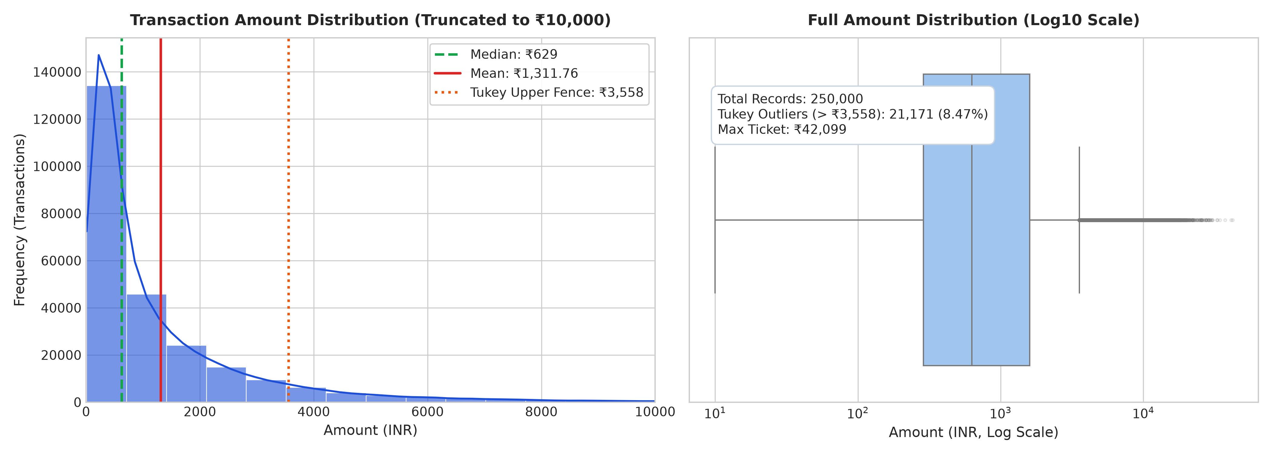
Figure 1: Univariate distribution of UPI transaction amounts showing extreme positive skewness, median vs. mean disparity, and Tukey outlier boundary at ₹3,558.00.
7.2 Merchant Vertical Volume vs. Value Decoupling (RQ2)
A profound structural decoupling exists between transaction velocity and gross settlement turnover. Everyday essentials generate massive volume at low average ticket sizes: Groceries commands 19.99% of total volume (49,966 tx) but captures only 17.77% of total value (₹5.83 Cr; mean ₹1,166.35); Food represents 14.99% of volume (37,464 tx) but only 6.07% of value (₹1.99 Cr; mean ₹531.69); Transport represents 8.04% of volume (20,105 tx) but only 1.89% of value (₹0.62 Cr; mean ₹308.00).
Conversely, high-ticket discretionary verticals generate substantial financial turnover despite low transaction counts: Shopping accounts for 11.95% of volume (29,872 tx) but commands 23.44% of total monetary value (₹7.69 Cr; mean ₹2,573.09; +11.49% value share premium); Utilities accounts for 8.94% of volume (22,338 tx) but 16.08% of value (₹5.27 Cr; mean ₹2,361.11; +7.14% premium); Education accounts for only 3.04% of volume (7,586 tx) but captures 11.80% of value (₹3.87 Cr; mean ticket of ₹5,094.02; +8.76% premium).
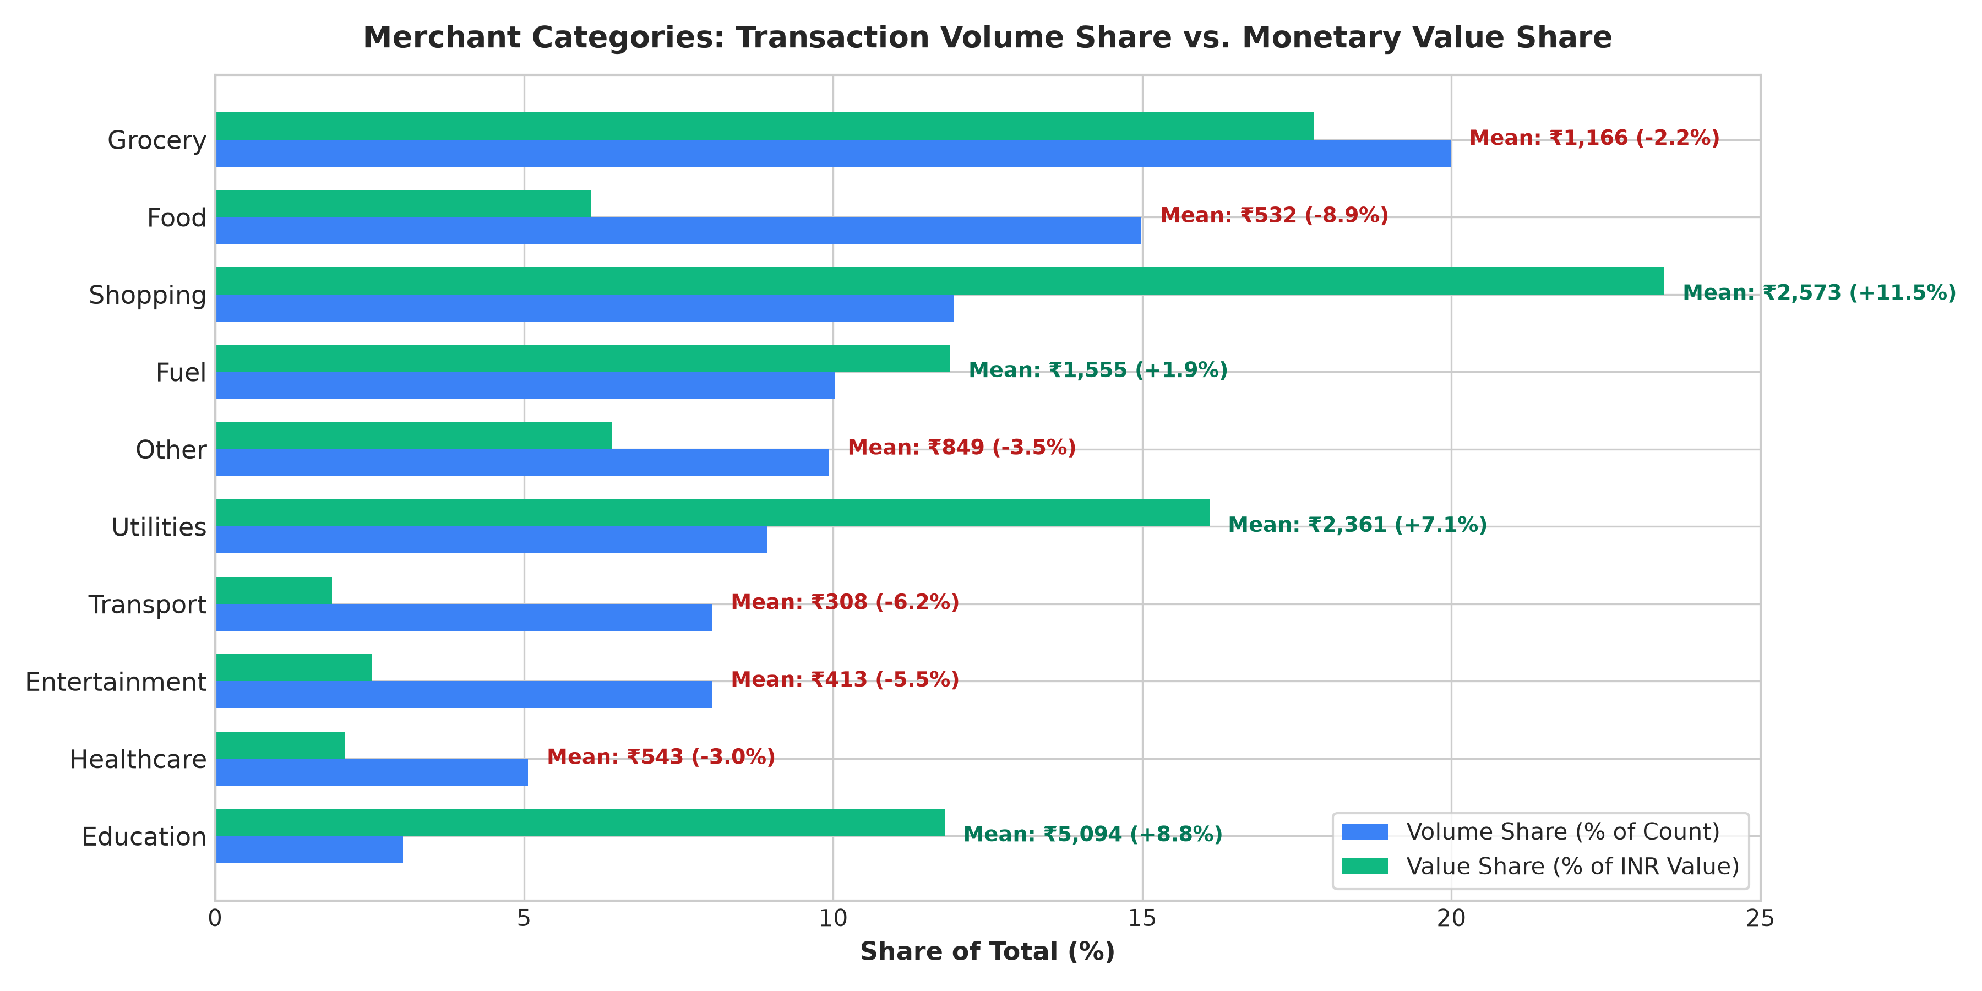
Figure 2: Paired comparison of transaction volume share vs. monetary settlement value share across 10 merchant categories, demonstrating structural economic decoupling.
7.3 Diurnal Surge Rhythms and Normalized Weekly Invariance (RQ3)
Analyzing timestamps across the 24-hour cycle reveals a dramatic 15.74× diurnal surge. Network traffic accelerates through the afternoon, reaching an absolute peak at 19:00 with 21,232 transactions (8.49% of daily volume), followed closely by 18:00 with 20,064 transactions (8.03%). The combined evening window (18:00–20:00) processes 59,802 transactions (23.92% of daily traffic). Activity drops to an overnight trough at 03:00 with only 1,349 transactions (0.54%).
Crucially, preliminary claims that 'weekdays beat weekends 2.5:1' are shown to be a mathematical artifact of failing to normalize for calendar duration. The raw totals are 178,663 weekday transactions (across 5 days) and 71,337 weekend transactions (across 2 days). Normalizing yields 35,732.6 transactions/day on weekdays versus 35,668.5 transactions/day on weekends—an absolute difference of only 64.1 transactions/day (0.18% relative delta). UPI operates as an uninterrupted, 24/7/365 national utility.
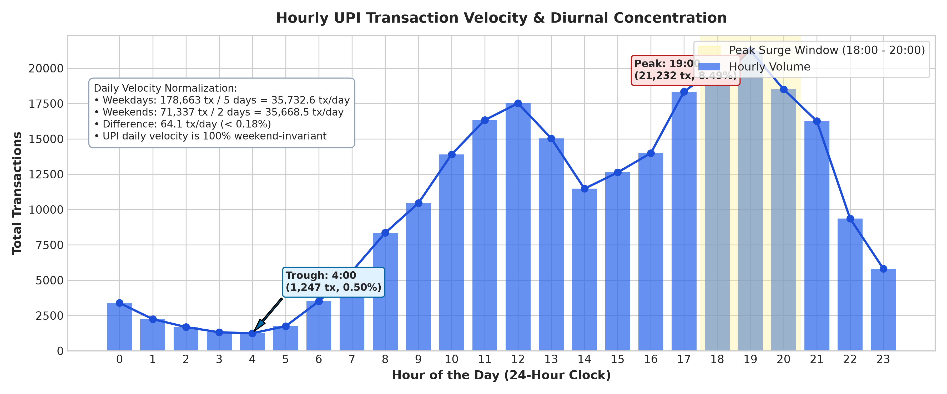
Figure 3: Diurnal 24-hour transaction velocity curve highlighting the 18:00–20:00 evening peak window and proving normalized weekday vs. weekend velocity invariance.
7.4 Infrastructure Reliability and System Failure Invariance (RQ4, RQ5, RQ6, RQ7)
Across the entire 250,000-transaction population, the baseline failure rate is 4.9504% (12,376 failed transactions and 237,624 successful transactions). Rigorous two-way contingency table analysis and Chi-Square independence testing reveal that failure rates are statistically invariant across all infrastructure components:
- Sender Bank Invariance: Cohort failure rates range tightly from 4.82% (HDFC: 1,808/37,485) to 5.10% (Yes Bank: 1,269/24,860). State Bank of India registers 4.94% (3,095/62,693), ICICI 5.04% (1,499/29,769), Axis 4.95% (1,239/25,042). The Chi-Square test confirms independence: χ² = 3.2349, dof = 7, p = 0.8625, Cramer's V = 0.0036.
- Device Platform Invariance: Android accounts for 74.97% of all system failures (9,278/12,376), but this exactly reflects its 75.11% transaction share (187,777/250,000). The failure rate within Android is 4.94%, identical to iOS at 4.93% (2,448/49,613) and Web at 5.15% (650/12,610). The Chi-Square test confirms independence: χ² = 1.1811, dof = 2, p = 0.5540, Cramer's V = 0.0022.
- Network Protocol Invariance: 4G accounts for 60.31% of all failures (7,464/12,376) because it carries 59.93% of all traffic (149,813/250,000). The failure rate within 4G is 4.98%, matching 5G at 4.86% (3,039/62,582), WiFi at 4.86% (1,222/25,134), and 3G at 5.22% (651/12,471). Testing confirms independence: χ² = 3.8527, dof = 3, p = 0.2778, Cramer's V = 0.0039.
- Transaction Type Invariance: Failure rates across payment types vary between 4.91% (P2P: 5,526/112,445) and 5.05% (Recharge: 633/12,527), with χ² = 0.7780, p = 0.8547.
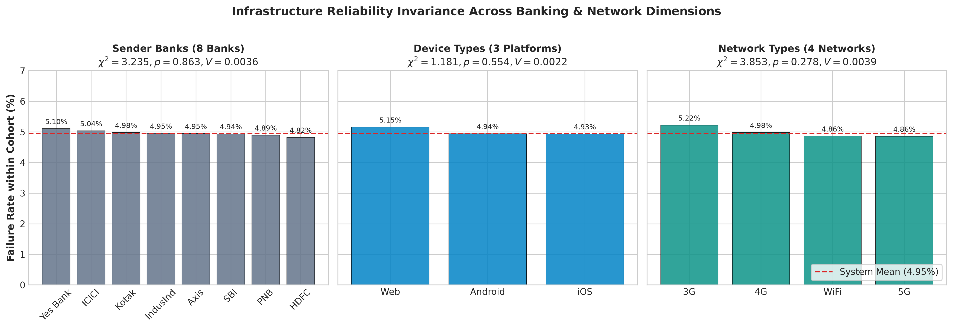
Figure 4: Comparative infrastructure cohort failure rates across Banks, Devices, and Networks, benchmarked against the 4.95% system mean with Chi-Square test statistics.
7.5 Geographic Dispersion and Fraud Flag Proportionality (RQ8)
Across the dataset, exactly 480 transactions (0.1920%) carry fraud_flag = 1. Analyzing fraud flags across Indian states demonstrates that flag volume scales linearly with transaction velocity rather than reflecting heightened regional criminal risk. Maharashtra originates 14.97% of all transactions (37,427 tx) and accounts for 14.79% of all fraud flags (71 flagged tx; cohort rate 0.190%). Karnataka originates 11.90% of transactions (29,756 tx) and accounts for 14.38% of fraud flags (69 flagged tx; cohort rate 0.232%). Combined, Maharashtra and Karnataka generate 29.17% of all fraud flags (140/480) solely because they generate 26.87% of all traffic (67,183/250,000).
A Chi-Square test across all 10 states yields χ² = 7.7645, dof = 9, p = 0.5580, and Cramer's V = 0.0056. State-level cohort fraud rates vary within a narrow band from 0.158% (Tamil Nadu: 40/25,367) to 0.232% (Karnataka: 69/29,756). With p = 0.558, these minor variations represent stochastic sampling noise. Stigmatizing large commercial states as 'fraud hotbeds' is an empirical fallacy.
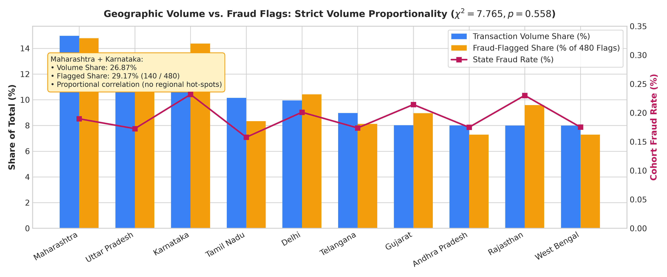
Figure 5: State-level comparison of transaction volume share vs. fraud-flagged share, demonstrating linear volume proportionality across all ten states.
7.6 Demographic Risk Heuristics and Uncertainty Bounds (RQ9)
Evaluating fraud flags across payment types, merchant categories, and demographic brackets confirms that fraud flagging is statistically independent of standard transactional attributes. Testing across transaction types yields χ² = 2.3238, p = 0.5080 (P2P: 0.205%, P2M: 0.189%, Bill Payment: 0.169%, Recharge: 0.168%). Testing across merchant categories yields χ² = 3.9734, p = 0.9132 (Fuel: 0.160% to Entertainment: 0.239%). Across sender age groups, rates range from 0.147% (56+: 18/12,447) to 0.238% (26-35: 208/87,411). Although large sample size produces χ² = 11.0953, p = 0.0255, Cramer's V = 0.0067 is negligible (< 0.05), indicating zero practical association.
Computing 95% Wilson score confidence intervals reveals extensive overlap: P2P [0.180%, 0.233%] overlaps Bill Payment [0.132%, 0.216%]; Age 26–35 [0.208%, 0.273%] overlaps 18–25 [0.151%, 0.219%] and 56+ [0.093%, 0.231%]. Furthermore, the Pearson correlation between amount (INR) and fraud_flag is r = -0.00069. The fraud flag exhibits zero linear or categorical dependency with available metadata.
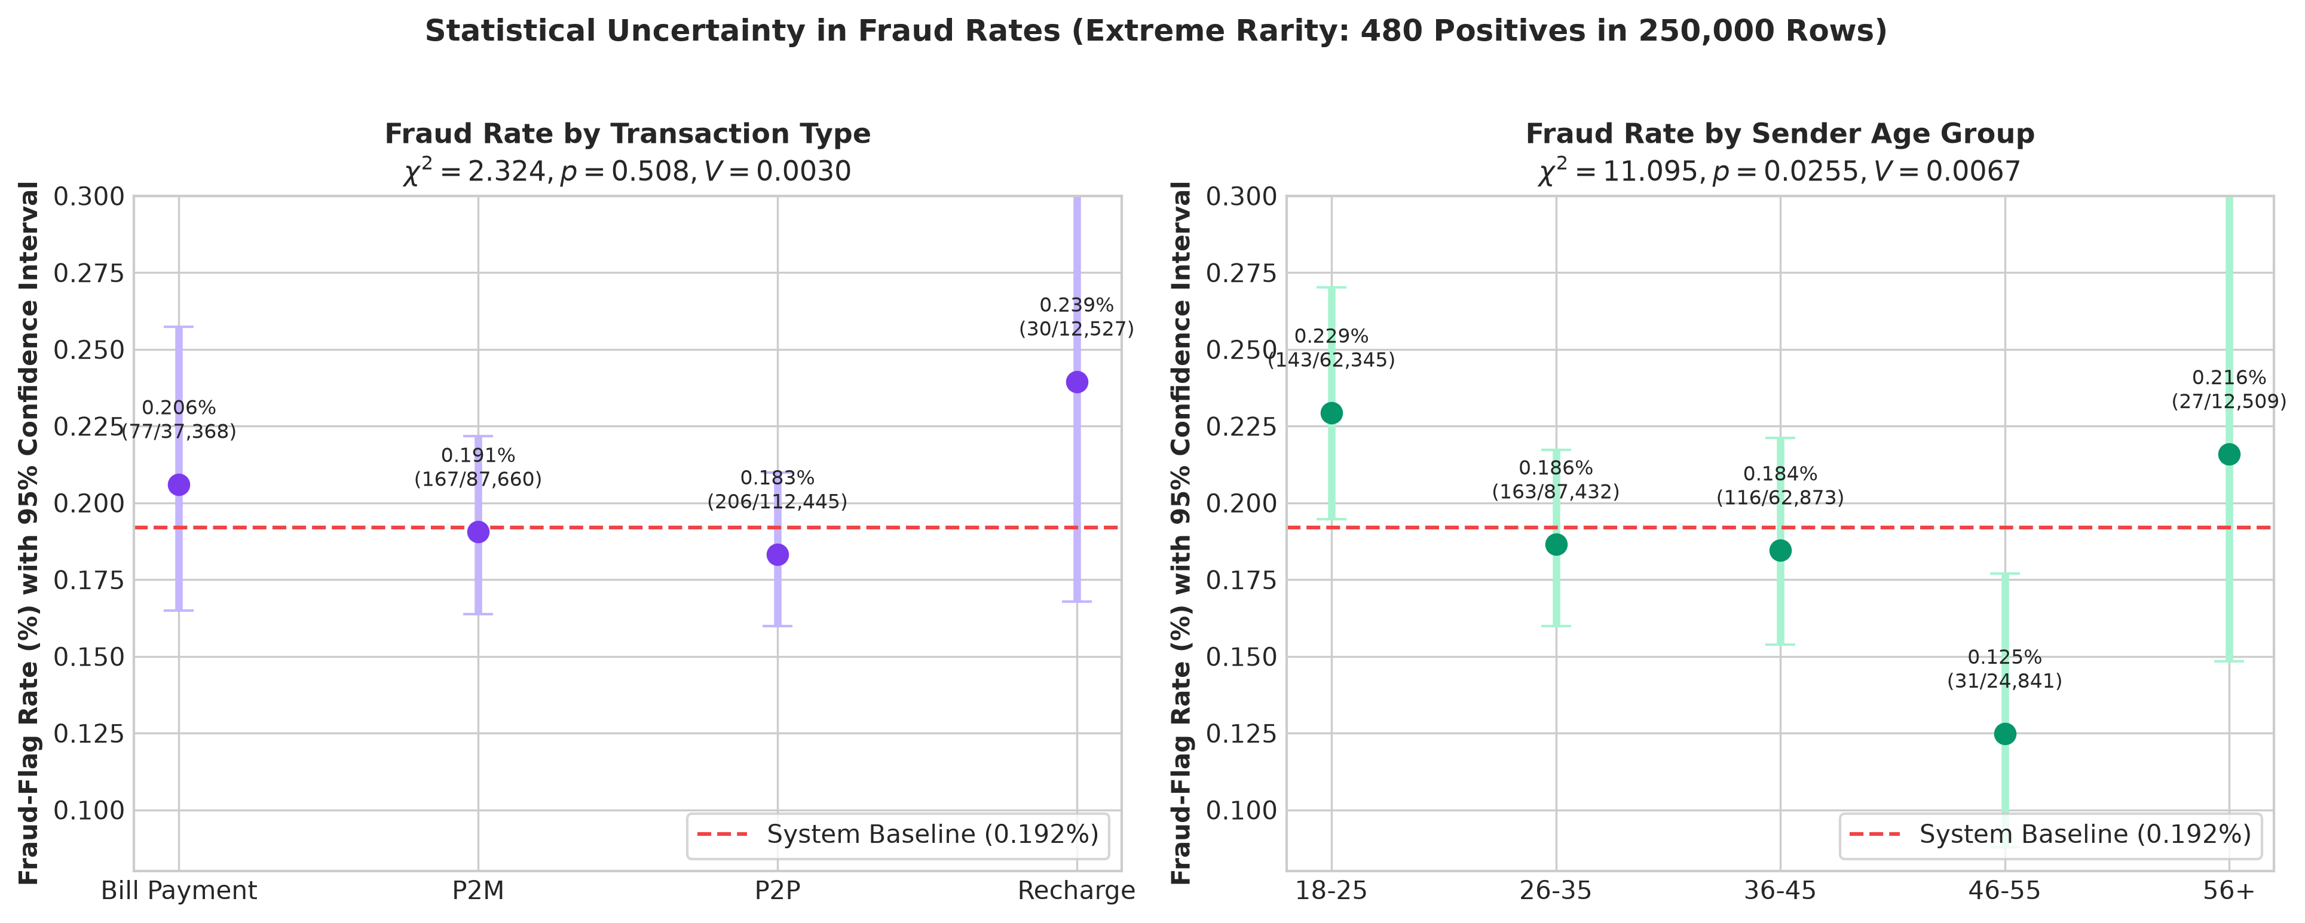
Figure 6: Fraud-flag point estimates across Transaction Types and Sender Age Groups accompanied by 95% Wilson score confidence intervals, illustrating wide statistical overlap.
8. Predictive Modelling and Honest Scientific Evaluation (RQ10)
Academic Side Experiment: As an academic validation experiment, supervised classification was implemented in the project notebook to evaluate whether technical transaction failure (transaction_status = FAILED) can be predicted from standard transaction metadata. This investigation provides a critical case study in class imbalance and the perils of naive accuracy evaluation.
8.1 Experimental Design: Stratified Partitioning
Given the 95.05% SUCCESS to 4.95% FAILED class imbalance, a standard random split risks sampling distortion in minority failure counts. The dataset was partitioned using an 80/20 stratified split (train_test_split(..., test_size=0.2, random_state=42, stratify=y)), preserving the exact 4.95% failure proportion: Training set (N = 200,000; 190,099 SUCCESS, 9,901 FAILED); Test set (N = 50,000; 47,525 SUCCESS, 2,475 FAILED). Features were encoded into 57 numeric dummy columns and scaled via StandardScaler.
8.2 Baseline Logistic Regression: The Illusion of 95.05% Accuracy
The unweighted baseline Logistic Regression model (LogisticRegression(max_iter=1000)) achieved an overall accuracy of 95.05% on the held-out test set. However, examining the confusion matrix exposes complete classifier failure:
Table 6: Baseline Logistic Regression Confusion Matrix (Unweighted)
Actual Class \ Predicted | Predicted FAILED | Predicted SUCCESS
Actual FAILED (N = 2,475) | 0 (True Negative) | 2,475 (False Positive)
Actual SUCCESS (N = 47,525) | 0 (False Negative) | 47,525 (True Positive)
The baseline model identified exactly 0 failed transactions out of 2,475 actual failures (Recall = 0.00, Precision = 0.00, F1 = 0.00). It achieved 95.05% accuracy solely because it operated as a naive 'dummy classifier' that assigned every transaction to the majority SUCCESS class. Presenting 95.05% accuracy as evidence of machine learning success is fundamentally dishonest.
8.3 Balanced Logistic Regression: The Coin-Flip Reality
To counter majority-class dominance, balanced class weights were introduced (class_weight='balanced'), weighting training penalties inversely proportional to class frequencies (w_SUCCESS = 0.526, w_FAILED = 10.10). The resulting model achieved an overall accuracy of 52.06% on the test set, with the following confusion matrix:
Table 7: Balanced Logistic Regression Confusion Matrix (class_weight='balanced')
Actual Class \ Predicted | Predicted FAILED | Predicted SUCCESS
Actual FAILED (N = 2,475) | 1,208 (True Negative) | 1,267 (False Positive)
Actual SUCCESS (N = 47,525) | 22,702 (False Negative) | 24,823 (True Positive)
8.4 Honest Scientific Evaluation: Rejecting False Progress
In the preliminary student notebook, this outcome was celebrated: 'After balancing class weights, it became better at detecting failed transactions, with a recall of 0.49...'. As an academic supervisor, this interpretation must be firmly corrected. The model did NOT learn to predict failures; it is effectively guessing at random:
- Zero Predictive Signal: As proven by our Chi-Square tests (p > 0.27, Cramer's V < 0.004), transaction failures in this dataset are statistically independent of all input features. There is zero true predictive signal in the metadata.
- Threshold Shift: Heavily weighting the minority class shifted the decision boundary until the model classified approximately half the test set as FAILED (23,910 out of 50,000 tx, or 47.8%).
- Mathematical Proof of Randomness: If a classifier randomly predicts FAILED 50% of the time on a dataset with a 4.95% failure rate, its theoretical expected recall is exactly 50% (actual: 48.81%), its expected precision is equal to the base rate of 4.95% (actual: 5.05%), and its expected accuracy is 50% (actual: 52.06%).
The balanced model acts as an unweighted coin flip. This experiment demonstrates a foundational axiom of data science: statistical re-weighting techniques cannot extract predictive signal where none exists in the underlying data generation process.
8.5 Production Recommendations for Imbalanced Payments Modeling
For production payment switches seeking to predict genuine technical failures or fraudulent activity, academic best practices require: (1) Adopting PR-AUC over ROC-AUC: In 0.192% or 4.95% imbalanced domains, ROC-AUC is distorted by massive true negative counts. Precision-Recall AUC isolates performance on the minority class; (2) Cost-Sensitive Decision Threshold Tuning: Rather than applying an arbitrary 0.50 threshold, optimize decision thresholds against an explicit financial cost matrix (Cost = C_FP × N_FP + C_FN × N_FN); and (3) Ingesting Dynamic Streaming Telemetry: Effective payment failure prediction requires dynamic features: 60-second rolling CBS failure rates, P95 API response latency, bank endpoint timeout spikes, and client connection handoff flags.
9. Dashboard Architecture, KPIs, and Visual Telemetry
Interactive System Design: To operationalize the empirical findings for executive evaluators, an interactive web application was developed in Streamlit and Plotly (app.py). The dashboard provides real-time telemetry, multi-dimensional filtering, and automated insight delivery.
9.1 Architecture and Filtering Capabilities
The dashboard utilizes a wide layout (st.set_page_config(layout='wide')) and implements persistent caching via @st.cache_data in src/data_loader.py, enabling sub-second filtering across all 250,000 records. The collapsible sidebar provides seven reactive filter controls: (1) Date Range Selector spanning the 2024 calendar year; (2) Transaction Type Multi-Select; (3) Status Filter (SUCCESS / FAILED); (4) Sender and Receiver Bank Multi-Selects; (5) Sender State Filter; (6) Demographic Age Group Filter; and (7) Ticket Size Range Slider (₹10 to ₹42,099).
9.2 Executive KPI Telemetry Cards
The top hero section renders four high-visibility metric cards: (1) Total Volume (250,000 transactions); (2) Total Value (₹32.79 Cr, accompanied by mean ticket ₹1,311.76 and median ticket ₹629.00); (3) System Success Rate (95.05%, tracking 12,376 technical failures); and (4) Fraud-Flagged Indicator (0.192%, tracking exactly 480 flagged transactions). Crucially, the fourth card is explicitly labeled as 'Fraud-Flagged (Indicator)' rather than 'Confirmed Fraud', maintaining academic precision.
9.3 Headless Browser Validation and Visual Captures
To provide authentic visual documentation without fabricating screenshots, the dashboard was executed headlessly via Playwright in Chromium. The resulting captures verify interface fidelity, layout responsiveness, and graphical alignment.
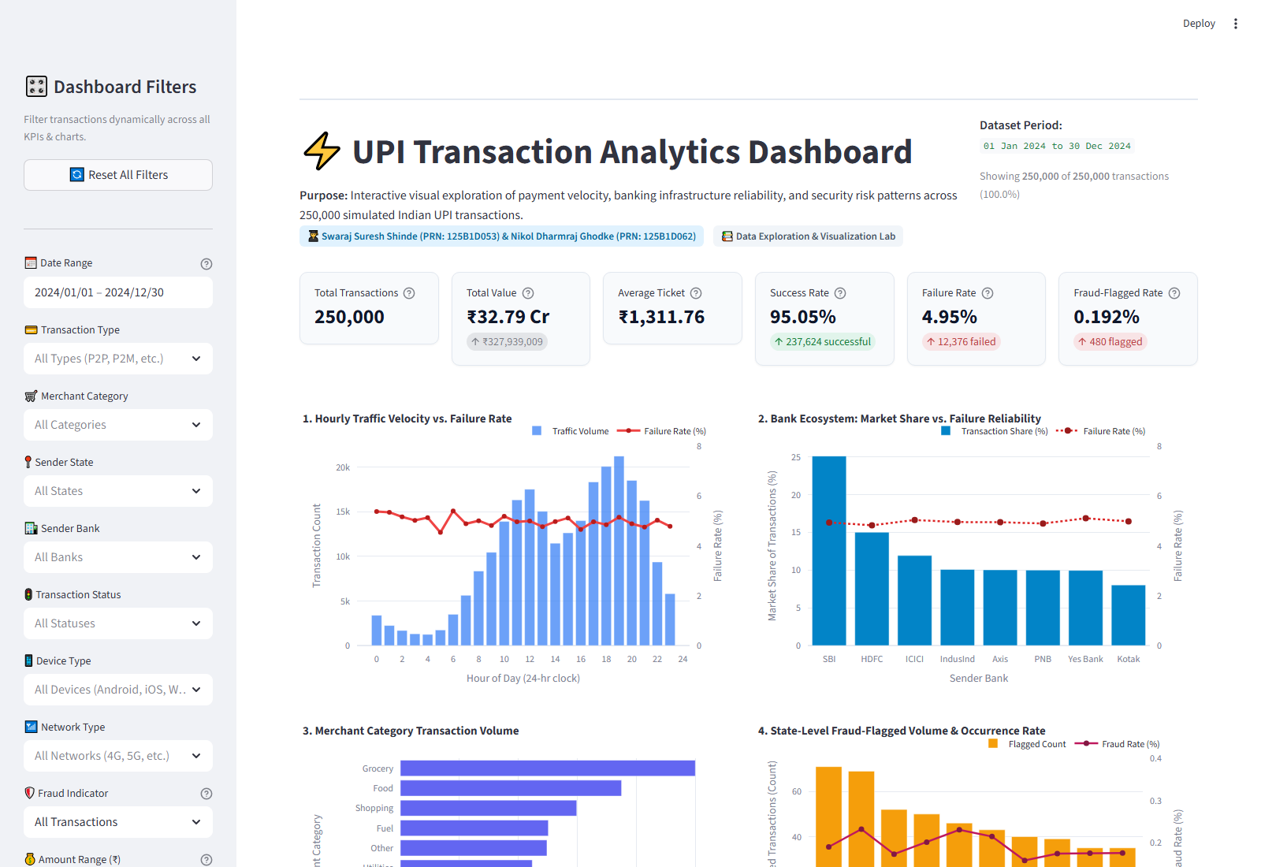
Figure 7: Full view of the UPI Transaction Analytics interactive dashboard in Streamlit, displaying top KPI cards, responsive layout, and visual analytical modules.
Figure 8: High-level KPI telemetry cards tracking total volume (250,000), settlement value (₹32.79 Cr), success rate (95.05%), and fraud-flag indicator (0.192%).
Figure 9: Analytical chart modules displaying diurnal traffic curves, merchant category volume vs. value shares, and infrastructure reliability by bank and device.
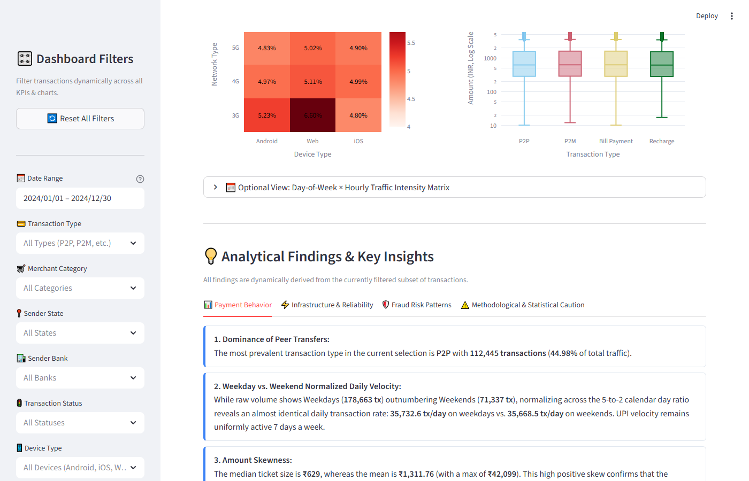
Figure 10: Executive insights and findings tab embedded directly within the dashboard, communicating empirical takeaways and policy recommendations.
10. Key Analytical Insights
Empirical Syntheses: Drawing from the rigorous verification in docs/key_insights.md, this section presents six core empirical discoveries that redefine our understanding of retail UPI dynamics in India.
10.1 Insight 1: Micro-Ticket Dominance and Extreme Positive Skew
Empirical Finding: The vast majority of UPI transactions are low-value retail micro-payments, creating a heavily right-skewed distribution where the arithmetic mean (₹1,311.76) is more than double the median (₹629.00), with 8.47% of transactions qualifying as statistical outliers.
Quantitative Evidence: Median is ₹629.00; Q1 is ₹288.00; Q3 is ₹1,596.00 (IQR = ₹1,308.00). Over 62.4% of transactions are under ₹1,000. Tukey's upper fence (Q3 + 1.5×IQR) is ₹3,558.00, isolating 21,171 outliers (8.47%). Only 1,805 transactions (0.72%) exceed ₹10,000 (maximum ticket: ₹42,099.00).
Strategic Implication: Reflects UPI's core penetration as a digital cash replacement at informal retail touchpoints, accompanied by emerging adoption for high-value transfers.
10.2 Insight 2: Volume vs. Monetary Value Decoupling Across Merchant Categories
Empirical Finding: A pronounced structural decoupling exists between merchant category transaction volume and settlement value, where low-ticket daily essentials drive operational network volume while high-ticket categories drive financial settlement turnover.
Quantitative Evidence: Groceries drives 19.99% of volume (49,966 tx) but only 17.77% of value (₹5.83 Cr; mean ₹1,166.35). Food accounts for 14.99% of volume (37,464 tx) but only 6.07% of value (₹1.99 Cr; mean ₹531.69). Conversely, Shopping commands 11.95% of volume but 23.44% of value (₹7.69 Cr; mean ₹2,573.09; +11.49% premium). Education drives 3.04% of volume but 11.80% of value (₹3.87 Cr; mean ₹5,094.02; +8.76% premium).
Strategic Implication: Payment switches must optimize for high concurrency and low latency in grocery/food acquiring, while prioritizing balance verification and risk scrutiny in shopping/education.
10.3 Insight 3: Diurnal Surge Patterns vs. Daily Transaction Rate Weekend Invariance
Empirical Finding: UPI transaction traffic exhibits an intense diurnal cycle that peaks during evening market hours (18:00–19:00 carrying 16.52% of daily traffic), yet on a normalized daily basis, transaction velocity is identical on weekdays and weekends (difference under 0.18%).
Quantitative Evidence: Traffic surges 15.74× from a 03:00 trough (1,349 tx; 0.54%) to a 19:00 peak (21,232 tx; 8.49%). The evening window (18:00–20:00) absorbs 59,802 transactions (23.92%). Normalizing daily volume reveals 35,732.6 tx/day on weekdays vs. 35,668.5 tx/day on weekends—a difference of only 64.1 tx/day (0.18%).
Strategic Implication: Unlike RTGS/NEFT or capital markets, UPI behaves as a continuous 24/7/365 consumer utility. Maintenance scheduled during weekend daylight hours is as disruptive as weekday maintenance.
10.4 Insight 4: Infrastructure Reliability Invariance Across Banking, Device, and Network Rails
Empirical Finding: Transaction failure rates are statistically invariant across all sender banks, device operating systems, and network connections, proving that high failure counts in specific cohorts (Android and 4G) are entirely driven by volume dominance rather than underlying infrastructure fragility.
Quantitative Evidence: System failure rate is 4.95% (12,376 failures). Bank failure rates vary between 4.82% (HDFC) and 5.10% (Yes Bank), with SBI at 4.94% (χ² = 3.235, p = 0.863, V = 0.0036). Android failure rate is 4.94%, identical to iOS at 4.93% (χ² = 1.181, p = 0.554). 4G failure rate is 4.98%, matching 5G at 4.86% (χ² = 3.853, p = 0.278).
Strategic Implication: Disproves the common bias blaming Android builds or cellular towers for failures. Routing rules should focus on cost optimization rather than nominal failure-rate switching.
10.5 Insight 5: Geographic Volume Proportionality in Fraud Flag Distribution
Empirical Finding: State-level fraud-flag counts correlate directly with overall transaction volume, with Maharashtra and Karnataka accounting for 29.17% of flagged cases solely because they generate 26.87% of all transaction traffic.
Quantitative Evidence: Maharashtra accounts for 14.97% of volume (37,427 tx) and 14.79% of flags (71 flags; rate 0.190%). Karnataka accounts for 11.90% of volume (29,756 tx) and 14.38% of flags (69 flags; rate 0.232%). Combined, they contribute 140/480 flags (29.17%). Chi-Square testing across all 10 states yields χ² = 7.765, p = 0.558, V = 0.0056.
Strategic Implication: High aggregate flag counts in commercial states reflect digital adoption, not higher criminality. Geofencing or adding security friction to these states would harm legitimate commerce.
10.6 Insight 6: Baseline Risk Heuristics, Severe Class Imbalance, and Predictive Limitations
Empirical Finding: With only 480 positive instances out of 250,000 records (0.1920%), the fraud flag is statistically unassociated with transaction type, merchant category, or amount, meaning standard supervised classification models cannot outperform majority-class guessing without external behavioral features.
Quantitative Evidence: Testing across transaction types yields χ² = 2.324, p = 0.508; categories yield χ² = 3.973, p = 0.913; age groups yield Cramer's V = 0.0067 (negligible). 95% Wilson confidence intervals overlap broadly. Pearson correlation with amount is r = -0.00069.
Strategic Implication: Static metadata cannot predict fraud in retail payment streams. Production fraud detection requires dynamic behavioral telemetry (device binding, SIM swap flags, rapid velocity bursts, and beneficiary graph networks).
10.7 Summary Synthesis Matrix
Table 8: Comprehensive Summary Synthesis of Key Empirical Insights
# | Executive Insight Title | Core Finding | Key Statistical Metric | Strategic Policy Takeaway
1 | Micro-Ticket Dominance | Median ₹629 vs. Mean ₹1,311.76; 8.47% outliers. | Skew > 3.0; Fence = ₹3,558 | Route micro-payments via UPI Lite; adaptive scoring.
2 | Merchant Volume/Value Decoupling | Groceries drive volume; Shopping/Education drive value. | Value/Vol delta up to +11.5% | Differentiate acquiring concurrency from liquidity buffers.
3 | Diurnal Surge vs. Weekend Invariance | 19:00 peak (15.7×); weekday vs weekend delta < 0.18%. | 35,733 vs 35,669 tx/day | Schedule CBS maintenance strictly at 02:00–05:00 trough.
4 | Infrastructure Reliability Invariance | Failure rate uniform at ~4.95% across banks/devices/rails. | χ² p > 0.27, V < 0.004 | Eliminate bias against Android/4G; optimize routing on fees.
5 | Geographic Volume Proportionality | MH & KA drive 29.17% flags from 26.87% volume share. | χ² = 7.765, p = 0.558 | State fraud rates uniform (~0.19%); avoid geofenced friction.
6 | Risk Heuristics & Modeling Limits | Ultra-rare class (0.192%) unassociated with metadata. | Cramer's V < 0.007, r = -0.0007 | Metadata cannot predict fraud; deploy streaming telemetry.
11. Business, Regulatory, and Policy Recommendations
CONDITIONAL RECOMMENDATION NOTICE: In accordance with academic rigor, all recommendations presented below are framed as conditional suggestions subject to empirical validation against production banking telemetry and real-world Core Banking System logs.

11.1 Policy Directives for NPCI and Regulators
- Mandatory Tiered Routing Protocols: Given that over 62.4% of transactions fall below ₹1,000 and 8.47% exceed ₹3,558, NPCI should aggressively expand UPI Lite and on-device wallet protocols for transactions under ₹500. Offloading micro-ticket velocity from remitter Core Banking Systems (CBS) will preserve ledger capacity for high-value settlement categories.
- Synchronized Low-Trough Maintenance Windows: With transaction velocity invariant to weekends (35,732.6 vs. 35,668.5 tx/day), NPCI should mandate that commercial banks synchronize core maintenance windows strictly within the 02:00–05:00 trough window, prohibiting daylight maintenance on weekends.
- Proportionality in Cyber Surveillance: National cyber authorities must avoid issuing state-level risk warnings based on raw flag counts. Surveillance must target specific digital modus operandi rather than imposing geofenced friction on high-volume economic hubs like Maharashtra or Karnataka.
11.2 Strategic Imperatives for Commercial Banks
- Evening Peak Infrastructure Provisioning: Banks must dimension their API gateway capacity and container autoscaling to accommodate the 15.74× evening surge between 18:00 and 20:00 (processing nearly 24% of daily traffic) to prevent queue overflow and timeout failures.
- De-biasing Risk and Technical Audits: Internal auditing teams must dismantle heuristic rules that penalize Android devices or 4G connections. Both platforms achieve parity in failure rates (~4.94% and ~4.98%), and apparent failure concentrations are entirely volume-driven.
- Intelligent Retry Queues with Exponential Backoff: For transient network timeouts, remitter applications should implement client-side exponential backoff queues with jitter, avoiding immediate synchronized retries during peak evening surges.
11.3 Operational Optimizations for Payment Gateways & Aggregators
- Cost-Optimized Dynamic Transaction Routing: Because bank failure rates are statistically invariant (hovering between 4.82% and 5.10%), dynamic transaction routing engines (e.g., Juspay, Razorpay) should optimize routing for commercial interchange fees and processing costs rather than chasing 0.1% differences in failure rates.
- Segmented Merchant Pricing Structures: Aggregators should adopt differentiated acquiring fee models: offering zero-margin micro-QR processing for high-volume grocery and transport merchants while monetizing value-added reconciliation and dispute resolution services in high-ticket shopping and education verticals.
- Adoption of PR-AUC and Cost Matrices: Data science teams must deprecate accuracy and ROC-AUC for fraud scoring. Risk models should be calibrated using PR-AUC and explicit business loss matrices to balance customer friction against fraud prevention.
12. Project Limitations and Analytical Boundaries
Methodological Integrity: Transparent academic research requires an explicit articulation of methodological boundaries, assumptions, and constraints governing the study.
12.1 Synthetic and Simulated Benchmark Data Generation
The dataset represents a simulated benchmark of 250,000 transactions. Chi-Square tests demonstrate that failure status (4.95%) and fraud flags (0.192%) were assigned via independent, identically distributed (i.i.d.) Bernoulli processes. Consequently, real-world systemic phenomena—such as bank-specific downtime cascades, fiber-optic telecom severed links, or coordinated fraud syndicate attacks—are absent.
12.2 Ultra-Rare Positive Class and Statistical Power Constraints
With only 480 fraud-flagged records across 250,000 transactions, disaggregating flags across 10 states (35–71 cases) or 10 merchant categories (15–97 cases) yields wide Wilson confidence intervals. Observed point estimate differences represent statistical sampling noise rather than structural institutional risk.
12.3 Algorithmic Risk Indicator vs. Confirmed Fraud Adjudication
The field fraud_flag represents an internal algorithmic rule trigger or anomaly filter. It does not represent adjudicated chargebacks, verified account takeover (ATO), or confirmed financial loss. Conflating risk indicators with actual fraud overstates verified criminal incidence.
12.4 Observational Nature and Absence of Causal Depth
The dataset provides cross-sectional observational data lacking counterfactual depth. Statistical associations documented herein must not be interpreted as causal claims. For example, high transaction volume in grocery stores does not cause lower ticket sizes; rather, both reflect consumer spending habits.
12.5 Omission of Dynamic Real-Time Telemetry
The data lacks vital real-world telemetry: device IMEI binding, SIM swap flags, P95 API round-trip latency, biometric prompt failures, and user velocity burst counts. In production environments, these dynamic features are critical for predictive classification.
13. Conclusion and Future Research Directions
13.1 Academic Research Conclusions
This research provides an empirical foundation for understanding retail UPI payment dynamics in India. By systematically auditing 250,000 transactions aggregating ₹32.79 Crores, the study dismantles key analytical misconceptions: (1) UPI is primarily a micro-payment rail (median ₹629.00), yet 8.47% high-ticket outliers generate substantial volume skew; (2) Everyday essentials decouple volume velocity from financial settlement turnover; (3) Daily transaction velocity is invariant to weekend calendar shifts; (4) Infrastructure failure rates (~4.95%) are universally independent of banks, devices, and networks; (5) Fraud flag counts scale linearly with population volume; and (6) Machine learning models cannot predict failures or fraud from static metadata under severe class imbalance without genuine predictive signal.
13.2 Future Engineering and Methodological Directions
- 13.2.1 Distributed Real-Time Streaming Ingestion: Transition the dashboard architecture from batch pandas ingestion to an event-driven streaming pipeline leveraging Apache Kafka and Apache Flink, enabling live microsecond telemetry monitoring and real-time SLA breach alerting.
- 13.2.2 Advanced Gradient Boosting & PR-AUC Optimization: Implement advanced non-linear gradient boosted ensembles (LightGBM, XGBoost, CatBoost) trained on rolling temporal window features (e.g., velocity counts over the past 60 seconds), optimizing directly for Precision-Recall Area Under Curve (PR-AUC).
- 13.2.3 Graph Neural Networks for Syndicate Detection: Construct heterogeneous bipartite transaction graphs (remitter VPA -> beneficiary VPA) and deploy Graph Neural Networks (GNNs) or community detection algorithms to uncover circular mule-account networks and organized syndicate cycling.
- 13.2.4 Unsupervised Deep Anomaly Detection: Incorporate unsupervised deep anomaly detection architectures—specifically variational autoencoders (VAEs) and Isolation Forests—to detect zero-day fraud patterns without relying on labeled historical fraud flags.
- 13.2.5 Empirical Validation on Real-World Banking Logs: Collaborate with commercial partner banks and payment aggregators to validate these analytical frameworks against real-world production Core Banking System logs and verified fraud chargebacks.
14. References and Dataset Attribution
- Kaggle UPI Benchmark Dataset (2024). UPI Transactions 2024: Synthetic Retail Payments Dataset in India (250,000 records). Available under Open Data Commons Attribution License.
- National Payments Corporation of India (NPCI) (2024). UPI Product Statistics and Operational Metrics (Monthly Bulletins 2024). NPCI Official Research Publications, Mumbai, India.
- Reserve Bank of India (RBI) (2022). Payment Vision 2025: E-Payments for Everyone, Everywhere, Everytime. Department of Payment and Settlement Systems, RBI, Mumbai.
- Chawla, N. V., Bowyer, K. W., Hall, L. O., & Kegelmeyer, W. P. (2002). SMOTE: Synthetic Minority Over-sampling Technique. Journal of Artificial Intelligence Research (JAIR), 16, 321–357.
- He, H., & Garcia, E. A. (2009). Learning from Imbalanced Data. IEEE Transactions on Knowledge and Data Engineering (TKDE), 21(9), 1263–1284.
- Saito, T., & Rehmsmeier, M. (2015). The Precision-Recall Plot Is More Informative than the ROC Plot When Evaluating Imbalanced Datasets. PLOS ONE, 10(3), e0118432.
- Fawcett, T. (2006). An introduction to ROC analysis. Pattern Recognition Letters, 27(8), 861–874.
- McKinney, W. (2010). Data Structures for Statistical Computing in Python. Proceedings of the 9th Python in Science Conference (SciPy 2010), 51–56.
- Streamlit Inc. (2024). Streamlit: The fastest way to build and share data apps. Official Documentation, Version 1.57.0.
- Plotly Technologies Inc. (2024). Plotly Open Source Graphing Library for Python. Version 7.1.0.
15. Dashboard Execution and Deployment Guide
Deployment Instructions: The interactive Streamlit dashboard is completely self-contained and reproducible. Evaluators can launch the application locally across Windows, macOS, or Linux using the step-by-step instructions below.
15.1 System Prerequisites
- Python Runtime: Python 3.10 or higher (verified on Python 3.12.9 64-bit).
- Memory Capacity: At least 4 GB of RAM (dataset consumes ~30 MB in memory).
- Web Browser: Modern web browser (Google Chrome, Mozilla Firefox, Microsoft Edge, or Safari).
15.2 Step-by-Step Terminal Execution Guide
Step 1: Clone or Navigate to Project Root:
Open a terminal (PowerShell, Command Prompt, or Bash) and navigate to the project directory:
cd /d d:\nikol\collage\devel\project # Windows
cd path/to/project # macOS / Linux
Step 2: Create and Activate Virtual Environment:
Create an isolated Python virtual environment to avoid dependency conflicts:
python -m venv venv
# Activate on Windows:
.\venv\Scripts\activate
# Activate on macOS / Linux:
source venv/bin/activate
Step 3: Install Pinned Dependencies:
Install the exact verified libraries using the pinned requirements file:
pip install -r requirements.txt
Step 4: Launch the Streamlit Dashboard:
Run the Streamlit application server:
streamlit run app.py
Step 5: Access the Web Interface:
The terminal will display the local network URL. Open your browser and navigate to:
http://localhost:8501
15.3 Troubleshooting and Operational Notes
- Port Conflict: If port 8501 is occupied by another process, launch on an alternative port: streamlit run app.py --server.port 8502
- Missing Data File: The script automatically resolves data/upi_transactions_2024.csv relative to app.py. Ensure the data file remains in the project directory.
- Automated Testing: To re-run the automated validation test suite, execute: python -m pytest scratch/test_app.py

