**Jam Guitar - Android**

Planning and

Documentation

An app, A companion, that can help you explore, build, and master your guitar improvisation skills. Includes soulful backing tracks from Jack Thammarat.

Sachin Karki

Applied Software Project (CSC 470)

Spring 2019

**INTRODUCTION**

**Objective**

The main idea of this application is to provide guidelines and backing music to practice and expand a guitarist’s vocabulary. Be it a beginner or an enthusiast who wants to explore the foundation the creating guitar solo and improvising. This app can help set him/her on the right track.

As the number of guitar learners increasing day by day, I hope this app help solve the issues and clarify the learners who are stuck in playing the same chords repeatedly and help master guitar soloing further.

**Target Individual:**

* Anyone who is willing to learn and expand guitar soloing vocabulary.
* Age 15 - 35

**My story**

I started playing guitar when I was around 10 years old. I started with basics and after all these years I have come to play with backing tracks and solo over them with my style and my licks. Because making a good guitar solo requires a lot of things i.e. tone, timing, phrasing, etc. It takes a lot of time to master each of the aspects. People keep asking me the same question over and over again. How are you able to play like this? Well, I am going to put everything that I have learned so far that I used to develop my skills onto this app for them and also to all the guitar enthusiasts out there who can learn a thing or two from this app.

**Main Features**

* Lots of backing tracks.
* Lots of guitar scales and guidelines i.e. major, minor.
* Licks playthrough videos.
* Display chords and Scales for the track.
* Including backing tracks from Jack Thammarat.
* With over 50 scales and tips to master the guitar!

**Stakeholders**

|  |  |
| --- | --- |
| Admin (Me) | I will be uploading new materials and video and maintain the app overall. |
| Regular User | User who creates an account through google or using an email will get emails and get exclusive backing tracks and lessons. |
| Guest User | Guest will get the first few scales and some backing tracks to get a head start. |

**System Requirement**

Any android phone with a KitKat version 6 or later.

**Functional Requirement**

* Creating and uploading new content through application updates.
* Guest users will be limited to certain materials.
* Registered users will have access to all the materials.
* Multiple users can login and scroll through every material for practices.
* The software will store login information for future use and save progress (if available).
* The software will provide help and instruction manual to new users.

**Non-Functional Requirement**

* Every unsuccessful login attempt of the user is recorded in the database.
* All the materials are copyright protected.
* Privacy of information, the export of restricted technologies, and intellectual property rights, etc.
* The software will be free from bugs and security loopholes.
* Advertisement banners might be included in the software for both registered and unregistered users.
* Users must agree the License agreement form.

**User Stories **Updated**

* Guest users can login without email address.
* Registered Users, I can login with an email.
* Registered/Guest users, I would get to choose desired backing tracks.
* Registered, I could send help and suggestions via email.
* Registered users, I could be able to get all the items for free.
* Registered users, I could view Videos, Tips, Scales.
* Registered/Guest users, I would be able to logout my account.
* Registered/Guest users, I would be able to login my account.
* Registered, I can scroll through navigation bar and view contents.
* Guest/Registered users, I would be able to play, pause via media controls.
* Registered, I can use “Forgot my Password”.
* Guest Users, I can sign up a new account.

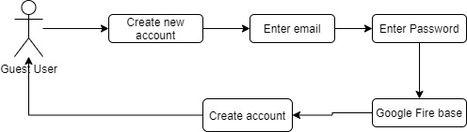

**Figure:** Guest users can create new account.

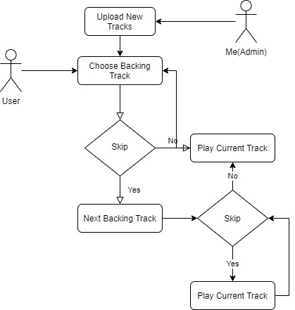

**Figure:** Registered/Guest users, I would get to choose desired backing tracks.

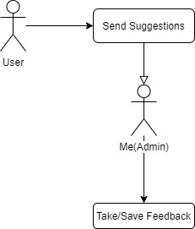

**Figure:** Registered/Guest users, I could send help and suggestions via email.

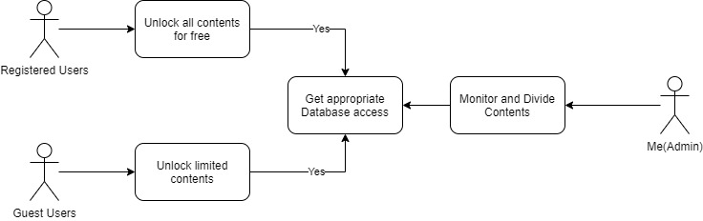

**Figure:** Registered users, I could be able to get all the items for free.

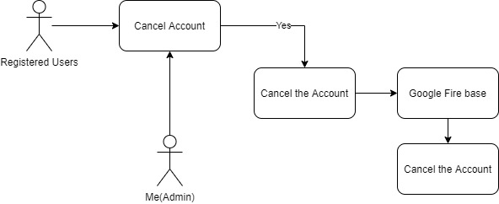

**Figure:** Registered users, I would be able to cancel my account.

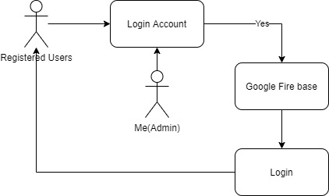

**Figure:** Registered/Guest users, I would be able to logout my account.

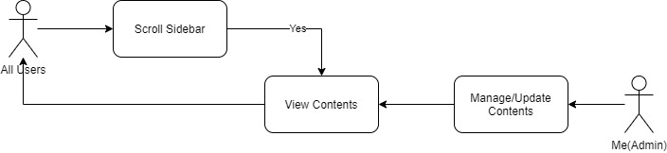

**Figure:** Registered/Guest users, I can scroll through side bar and view lessons and contents.

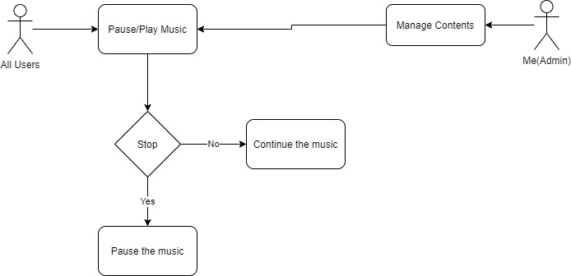

**Figure:** Guest/Registered users, I would be able to play, pause via media controls.

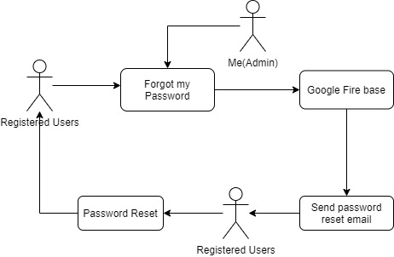

**Figure:** Registered/Guest users, I can use “Forgot my Password”.

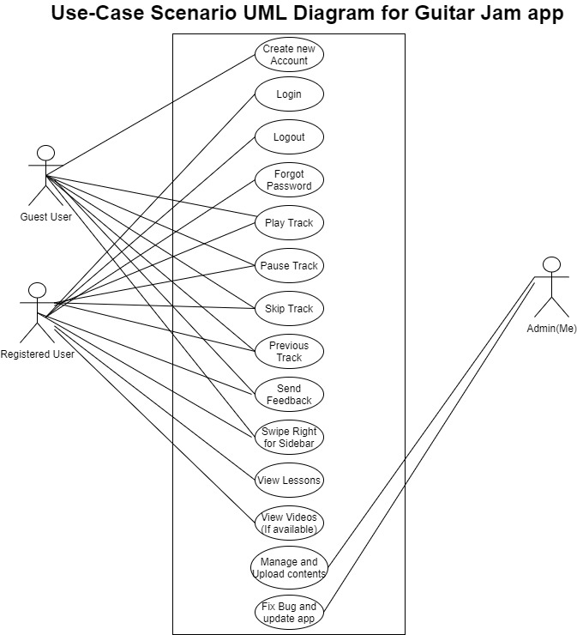

**Use-case Scenarios **Updated**

* Login (email and password) (Registered User)
* Create new account using email (Guest user)
* Forgot Password (will provide through email) (Registered User)
* Play and pause tracks (Both Users)
* Swipe Right for Sidebar (Registered User)
* Logout (Both Users)
* View Tips (Registered User)
* View Videos Links (Registered User)
* View Scales (Registered User)
* View About (Registered User)
* Exit the app (Both Users) via Home Button
* Upload new contents and update the app (Admin) – Me
* Suggest New Tracks (Both Users) from Guest Screen
* View Uploaded Tracks info in database – (Admin) – Me
* Download the database and export to .sql – (Admin) – Me
* View, Delete, manage, User emails from Firebase (Admin) - Me

**Skeletal Architecture View**

**Figure 1:** Flow of the application

**Figure 2:** Overview of the application

**Figure 3:** Detailed view of the Main Screen \*\***Discontinued**

**Figure 4:** View of the Main Screen \*\***Current**

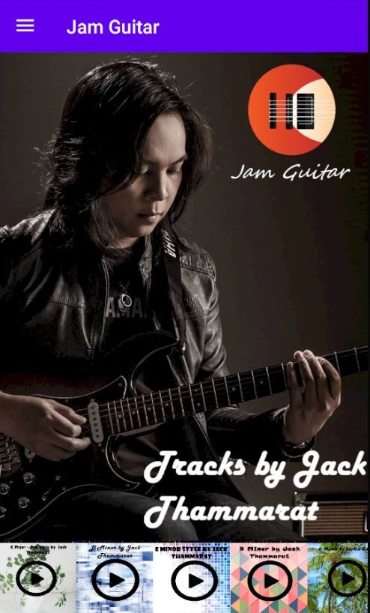

Currently 5 backing tracks and one on the right most is by me.

**Database Structure**

**Figure:** Relational diagram of the database structure

**Tentative Milestone**

|  |  |  |
| --- | --- | --- |
| **S. N** | **Services** | **Estimated Time** |
| **1.** | Requirement Analysis: Explore app requirements. | 1 Week |
| **2.** | Design Mockups: Test and try new designs for the app. | 1 Week |
| **3.** | Android App Development: Start writing code. | 5-6 Weeks |
| **4.** | Testing/Bug fixing: Test every function and fix bugs. | 2 Weeks |

**Testing and Debugging**

* All methods are tested
* Use care scenarios are updated
* SQL injection and password hashed are tested