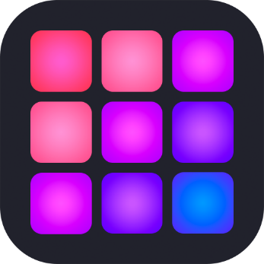

**Pad Drummer**

**(Music & Audio)**

Planning and Documentation – Android & iOS

A quick and entertaining app for everyone!

Sachin Karki

Mobile App Development (CSC 331)

Spring 2020

**Introduction**

A simple Drum Pad Machine app that lets you create beats and experiment with. The main goal of this app is to create beats. There will be plenty of drum kits to choose. One can use app to create a Beat in an instant and might as well use it for rapping.

**Target Individual:**

* Age group of 7-30
* Anyone who likes making music
* Anyone who enjoys making beats

**My Story:**

I was always into music right when I was around 8-9 years old. I grew up listening to different genres and with time I am now interested in electronic genre. Right now, Pop music and Rap music are leading the music industry right now. I wanted to share few of my favorite kits that I use to make music with others. It will be a useful tool for everyone to enjoy and learn a thing or two.

**Main Features:**

* Ability to play kits and sounds
* 2 different style kits (iOS) and 1 in Android

**Chosen Framework:** I choose **Swift** because it is swift for iOS. I used Android Studio for Android development.

**Environment Setup/Project Requirements:** I first did it in Android Studio. Then, I used XCode to transform this app to iOS. I used Swift version 5.0. I had the image/sound assets already and knew what to do for this app already. It was very difficult at first, but I got it used to it eventually. It didn’t have a lot of requirement, anything with a simple mac as MacBook Air or a core i3 computer would suffice! I didn’t need to use external plugins to finish this app for both platforms.

**Instructions:**

* Just tap and create your own music/beat!
* Enjoy!!

**Mockup Screenshots (Not Final Version): Below**

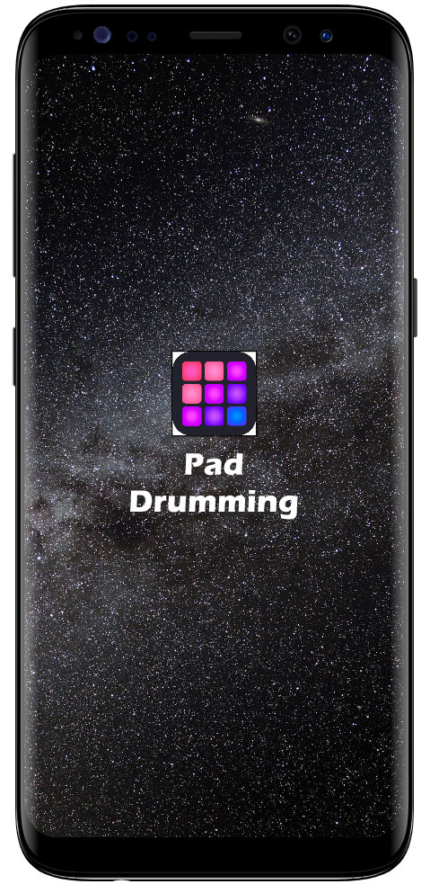 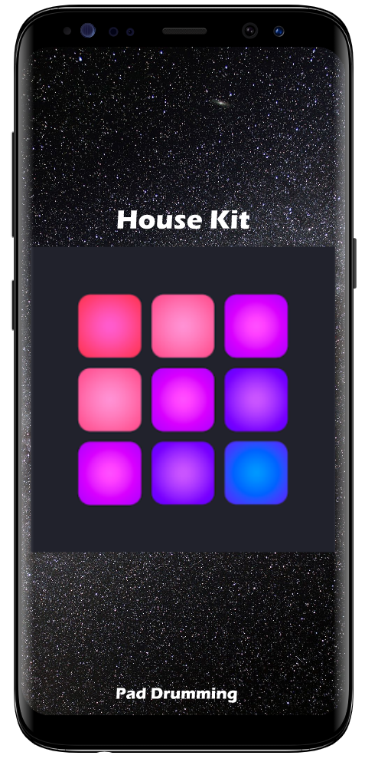

**Figure (Left):** Startup Screen **Figure (Right):** Home Screen Vertical

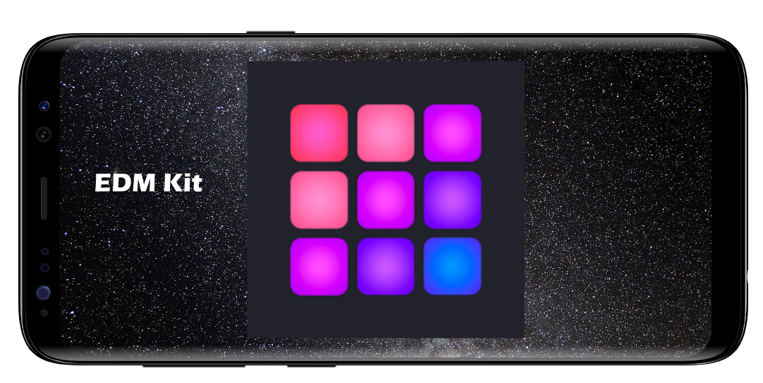

**Figure:** Home Screen Horizontal

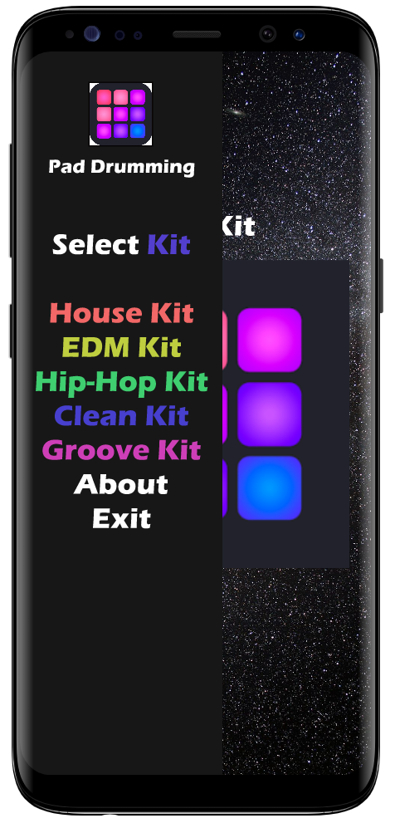

**Figure:** Sidebar with selector buttons

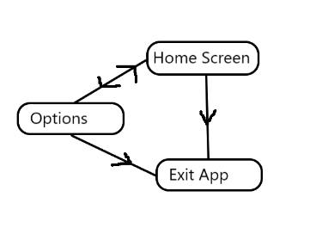

**Figure:** Application hierarchy diagram

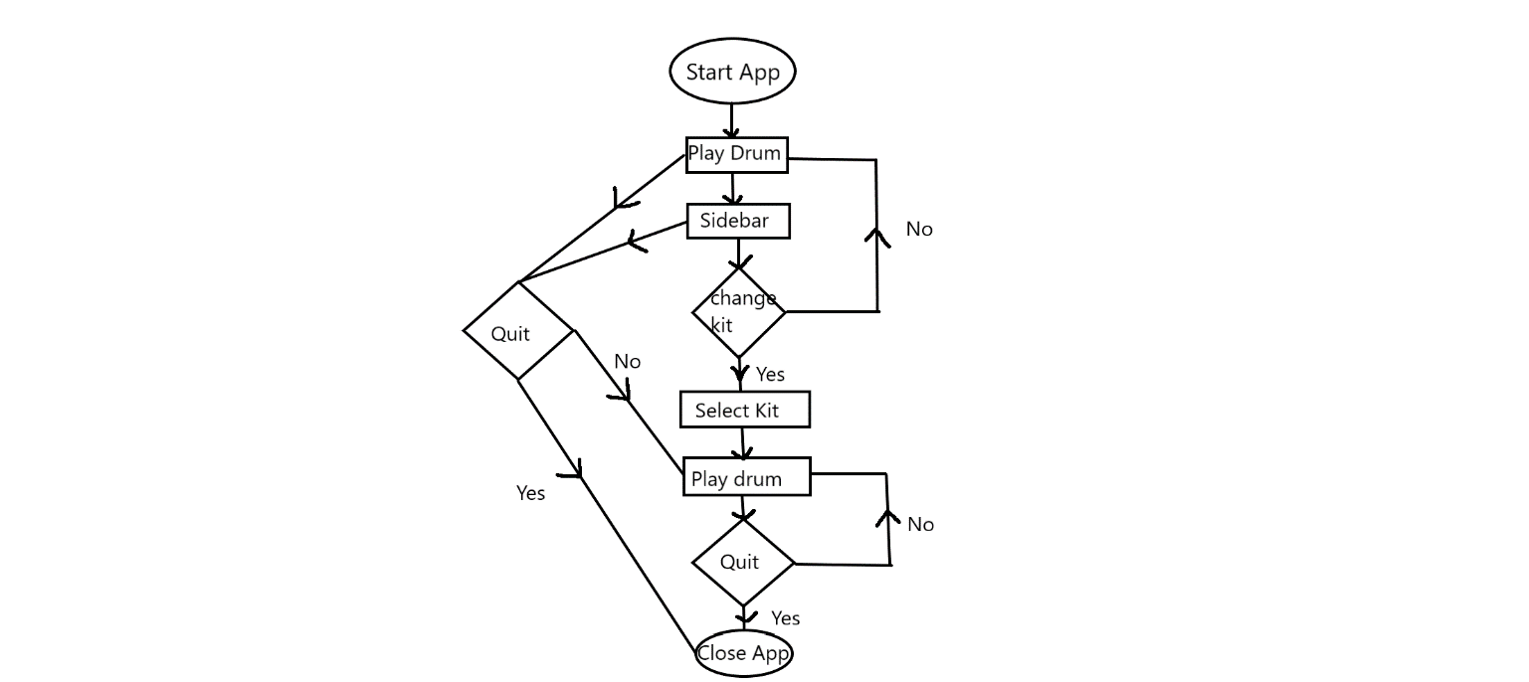

**Figure:** Labeled Flow Chart