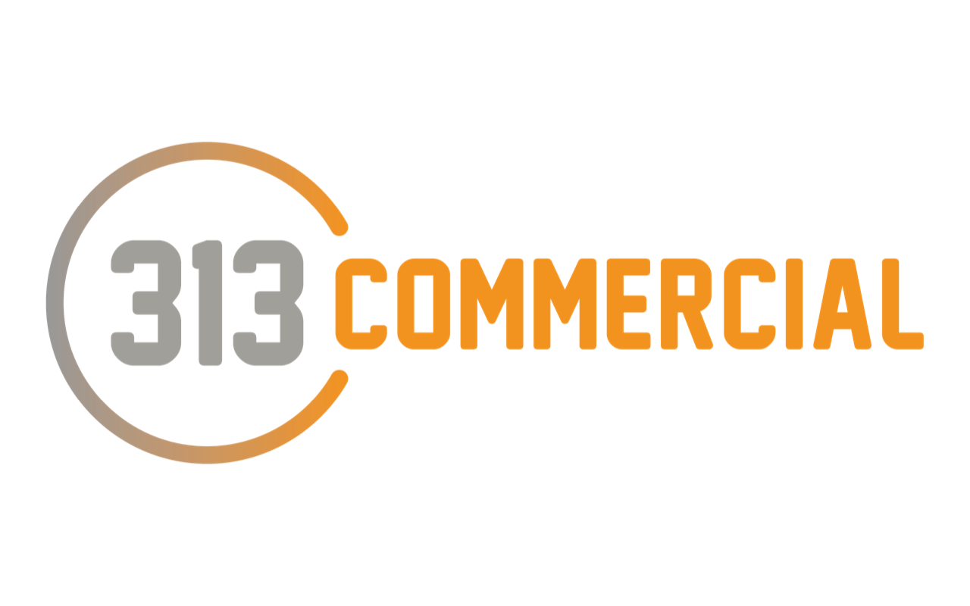

Following our discussion, we are pleased to provide you with a 313 Commercial Agreement in Principle, which will help you when it comes to proceeding with an offer on a property.

Decision details:
This is a certificate to confirm that based on the information you have given; you are able to borrow {{LOAN_AMOUNT}}

We have checked your details, including income and credit file and we can confirm that a decision in principle will be ACCEPTED. A full application will be submitted once an offer for a property has been accepted.

Customer Name(s): {{CUSTOMER_NAMES}}
Company Name:
Decision Date: {{DECISION_DATE}}^{th}
Your Adviser: {{ADVISER_NAME}}

Please note that this does not represent a formal mortgage offer or guarantee of a mortgage as the underwriter has not completed their final checks with your case.

How to Proceed:
- At 313 Commercial we advocate responsible borrowing - if your circumstances change in the meantime or if you wish to discuss your options further please do not hesitate to contact me.
- I am more than happy to speak to your estate agent if required when you are making an offer - please feel free to pass on my contact details.

Finally, I wish you good luck with the property search and we will look forward to speaking to you once your offer is accepted. However, if you have any questions in the meantime please do not hesitate to call.

{{ADVISER_EMAIL}}
Mortgage Adviser
{{ADVISER_PHONE}}

