Report:5 cluster system report.   
Time: 03/07/22 - 21:15

This system consist of **4** clusters.

Total number of anomalies **15** .

# Error overview:

|  |  |  |  |  |
| --- | --- | --- | --- | --- |
| Cluster N | Sensor N | Alarm type | Error begin time: | Error end time: |
| 1 | 052 | discharge anomaly | 2021-06-10 22:12:30 | 2021-06-10 22:16:00 |
| 2 | 104 | discharge anomaly | 2021-06-10 22:14:00 | 2021-06-10 22:16:00 |
| 2 | 148 | discharge anomaly | 2021-06-10 22:16:00 | 2021-06-10 22:16:00 |
| 2 | 237 | discharge anomaly | 2021-06-10 21:26:00 | 2021-06-10 21:48:00 |
| 3 | 024 | discharge anomaly | 2021-06-10 22:15:30 | 2021-06-10 22:16:00 |
| 3 | 228 | discharge anomaly | 2021-06-10 21:26:00 | 2021-06-10 22:14:30 |
| 4 | 029 | discharge anomaly | 2021-06-10 21:26:00 | 2021-06-10 21:37:30 |
| 4 | 050 | discharge anomaly | 2021-06-10 22:14:30 | 2021-06-10 22:16:00 |
| 4 | 051 | discharge anomaly | 2021-06-10 22:16:00 | 2021-06-10 22:16:00 |
| 4 | 052 | discharge anomaly | 2021-06-10 22:13:30 | 2021-06-10 22:16:00 |
| 4 | 053 | discharge anomaly | 2021-06-10 22:16:00 | 2021-06-10 22:16:00 |
| 5 | 099 | discharge anomaly | 2021-06-10 22:16:00 | 2021-06-10 22:16:00 |
| 5 | 100 | discharge anomaly | 2021-06-10 22:14:30 | 2021-06-10 22:16:00 |
| 5 | 116 | discharge anomaly | 2021-06-10 22:16:00 | 2021-06-10 22:16:00 |
| 5 | 159 | discharge anomaly | 2021-06-10 21:26:00 | 2021-06-10 21:26:30 |

# Error overview: Cluster 1 .

This cluster has: **1** voltage anomalies.

This cluster has: **0** temperature anomalies.

## Voltage and Temperature plots over time

Voltage sensor readings:

Temperature sensor readings:

## Voltage and Temperature anomalies plots over time

Voltage anomalies:

Temperature sensor readings:

# Error overview: Cluster 2 .

This cluster has: **3** voltage anomalies.

This cluster has: **0** temperature anomalies.

## Voltage and Temperature plots over time

Voltage sensor readings:

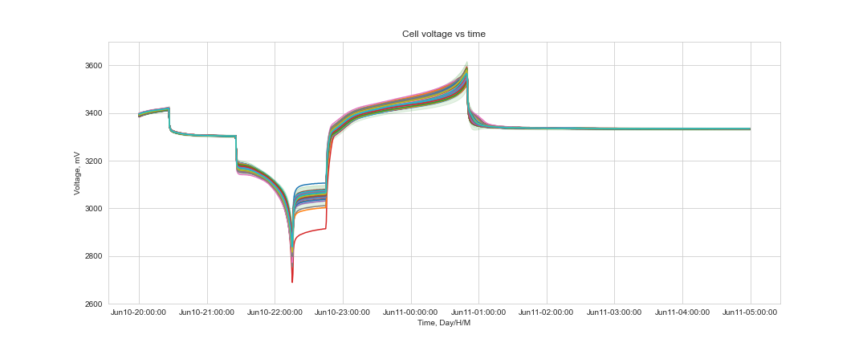

Temperature sensor readings:

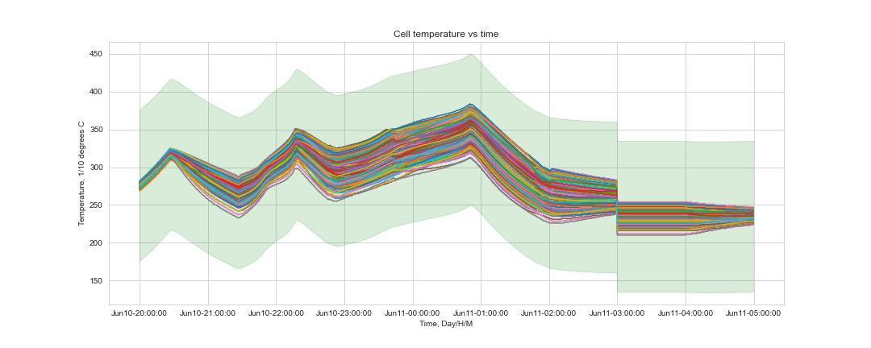

## Voltage and Temperature anomalies plots over time

Voltage anomalies:

Temperature sensor readings:

# Error overview: Cluster 3 .

This cluster has: **2** voltage anomalies.

This cluster has: **0** temperature anomalies.

## Voltage and Temperature plots over time

Voltage sensor readings:

Temperature sensor readings:

## Voltage and Temperature anomalies plots over time

Voltage anomalies:

Temperature sensor readings:

# Error overview: Cluster 4 .

This cluster has: **5** voltage anomalies.

This cluster has: **0** temperature anomalies.

## Voltage and Temperature plots over time

Voltage sensor readings:

Temperature sensor readings:

## Voltage and Temperature anomalies plots over time

Voltage anomalies:

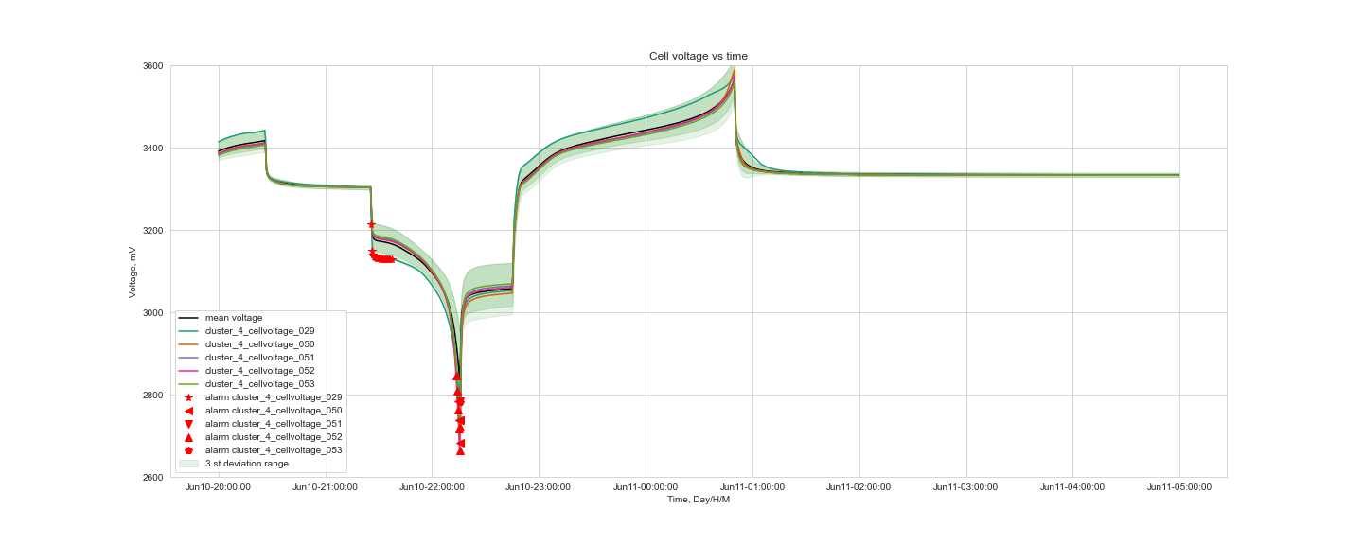

Temperature sensor readings:

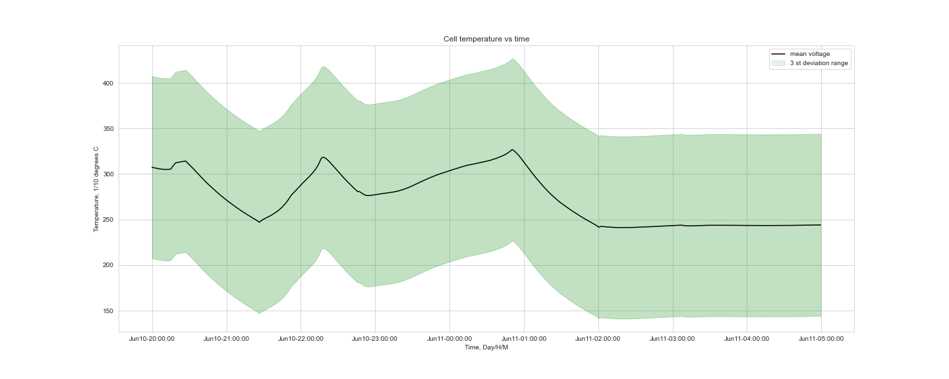

# Error overview: Cluster 5 .

This cluster has: **4** voltage anomalies.

This cluster has: **0** temperature anomalies.

## Voltage and Temperature plots over time

Voltage sensor readings:

Temperature sensor readings:

## Voltage and Temperature anomalies plots over time

Voltage anomalies:

Temperature sensor readings: