项目背景与目的
随着城市化进程的加快，交通拥堵已成为全球许多城市面临的重大挑战。交通流量的预测不仅对城市交通管理至关重要，还能帮助减少交通事故、降低环境污染和提高公共交通的效率。近年来，随着数据科学和机器学习技术的发展，利用历史交通数据进行流量预测的研究逐渐增多。这些研究通常涉及对交通数据的深入分析和建模，以便更准确地预测未来的交通状况。
本项目基于一个公开的交通预测数据集，旨在通过详细的探索性数据分析（EDA）和建模，揭示交通流量的变化规律，并构建有效的预测模型。该数据集包含了多种与交通流量相关的特征，如时间、地点、天气条件等，为研究交通流量的影响因素提供了丰富的信息。
本项目的主要目的是开发一个高效的交通流量预测模型，以便为交通管理部门提供决策支持。
报告分为以下几个部分：
1.探索性分析：通过对数据集的深入分析，识别影响交通流量的关键因素，并可视化这些因素与交通流量之间的关系。此部分将对数据的分布、趋势和潜在的相关性进行详细探讨，以便为后续的模型构建提供基础。
2.数据预处理：对原始数据进行清洗和处理，以确保数据的质量和一致性。
3.建模预测：使用多种机器学习算法（如随机森林、支持向量机、梯度提升等）构建交通流量预测模型。

数据集来源
https://www.kaggle.com/code/muhammadfaizan65/traffic-prediction-detailed-eda-modeling

探索性分析
kaggle官方提供的两个数据集，Traffic.csv和TrafficTwoMonth.csv，包含计算机视觉模型收集的形象。该模型检测四类车辆：汽车、自行车、公共汽车和卡车。数据集包含其他列，例如时间（以小时为单位）、日期、星期几以及每种车辆类型（CarCount、BikeCount、BusCount、TruckCount）的计数。“Total（总计）”列表示在 15 分钟持续时间内检测到的所有车辆类型的总数。此外，该数据集还包括一个列，指示交通状况，分为四类：1-Heavy、2-High、3-Normal 和 4-Low。此信息可以帮助评估拥堵的严重程度，并监控一周中不同时间和日期的交通状况。

3.1数据指标预览
查看数据集个特征字段。
- “Time”（时间）：记录的时间，采用 HH:MM:SS（小时:分钟:秒）格式。
- “Date”（日期）：一个月中的日子。
- “Day of the week”（星期几）：星期几的名称。
- “CarCount”（汽车数量）、“BikeCount”（自行车数量）、“BusCount”（公交车数量）、“TruckCount”（卡车数量）：相应车辆的数量计数。
- “Total”（总数）：车辆总数。
- “Traffic Situation”（交通状况）：分为四类（1 - 拥堵，2 - 繁忙，3 - 正常，4 - 畅通）。 该分析旨在探索这个数据集、预处理数据，并构建一个机器学习模型来预测交通状况。

3.2数据概况
#导入包
import sys

import pandas as pd
import numpy as np
import matplotlib.pyplot as plt
import plotly.express as px
import plotly.graph_objects as go
from plotly.subplots import make_subplots
import seaborn as sns
from scipy.stats import shapiro
from sklearn.preprocessing import QuantileTransformer, StandardScaler, OneHotEncoder, LabelEncoder
from sklearn.model_selection import train_test_split
from sklearn.ensemble import RandomForestClassifier
from sklearn.metrics import classification_report, accuracy_score
from sklearn.compose import ColumnTransformer
from sklearn.pipeline import Pipeline

pd.set_option('display.max_columns', None) #设置显示最大列数
sns.set(style="whitegrid") #设置绘图默认风格参数

3.3数据分布
查看数据的分布，有助于选择合适的处理方法。

3.3.1数据总览
#读取文件
traffic_df = pd.read_csv("E:\GitCode\mms\soft-cup\python\Traffic_analysis\Traffic.csv")
traffic_two_month_df = pd.read_csv("E:\GitCode\mms\soft-cup\python\Traffic_analysis\TrafficTwoMonth.csv")

traffic_df['Traffic Situation'].value_counts()
·计算traffic_df数据框中Traffic Situation列中每个唯一值的计数，并返回一个包含每个分类及其出现次数的Series。
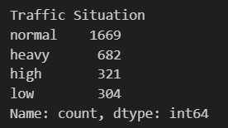
traffic_df['Source'] = 'OneMonth'
traffic_two_month_df['Source'] = 'TwoMonth'
combined_df = pd.concat([traffic_df, traffic_two_month_df], ignore_index=True)
·在traffic_df数据框中创建一个名为Source的新列，并将其值设为'OneMonth'。这用于标识数据集的来源。
·在traffic_two_month_df数据框中创建一个名为Source的新列，并将其值设为'TwoMonth'。这也用于标识该数据集的来源。
·使用pandas的concat函数将两个数据框traffic_df和traffic_two_month_df按行合并，形成一个新的数据框combined_df。ignore_index=True确保合并后重新生成索引。

3.3.2车辆计数分布图
fig = make_subplots(rows=2, cols=2, subplot_titles=("Car Counts", "Bike Counts", "Bus Counts", "Truck Counts"))
#直方图
fig.add_trace(go.Histogram(x=combined_df['CarCount'], name='Car Counts', marker_color='#1f77b4'), row=1, col=1)
fig.add_trace(go.Histogram(x=combined_df['BikeCount'], name='Bike Counts', marker_color='#ff7f0e'), row=1, col=2)
fig.add_trace(go.Histogram(x=combined_df['BusCount'], name='Bus Counts', marker_color='#2ca02c'), row=2, col=1)
fig.add_trace(go.Histogram(x=combined_df['TruckCount'], name='Truck Counts', marker_color='#d62728'), row=2, col=2)

fig.update_layout(title_text='Distribution of Vehicle Counts', title_x=0.5, showlegend=False, template='plotly_white')
fig.update_xaxes(title_text="Count")
fig.update_yaxes(title_text="Frequency")
fig.show()

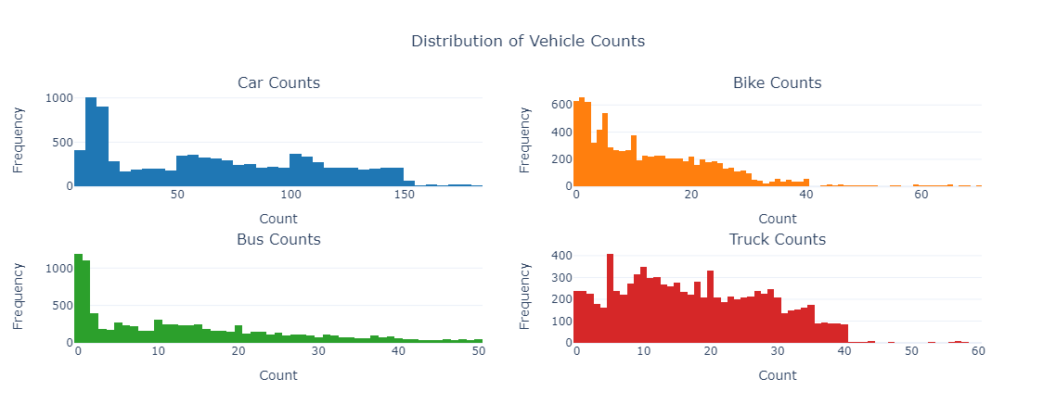

3.3.3交通状况分布
fig = px.pie(combined_df, names='Traffic Situation', title='Traffic Situation Distribution', color_discrete_sequence=px.colors.sequential.RdBu)
fig.update_layout(title_text='Traffic Situation Distribution', title_x=0.5, template='plotly_white')
fig.show()
·使用Plotly Express创建饼图，展示combined_df中Traffic Situation的分布，使用RdBu色谱为不同的交通状况上色。
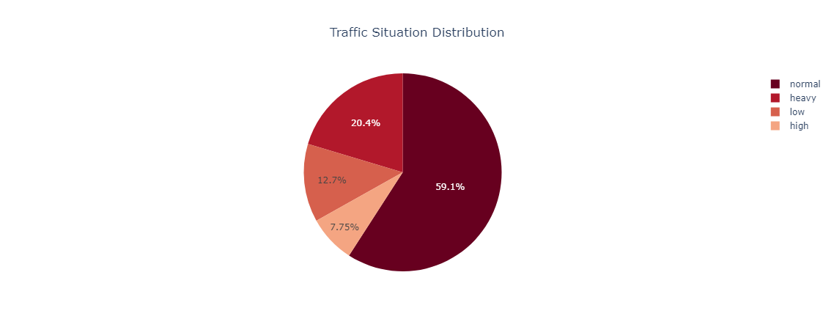

3.3.4按星期几的车辆计数
fig = make_subplots(rows=2, cols=2, subplot_titles=("Car Counts by Day", "Bike Counts by Day", "Bus Counts by Day", "Truck Counts by Day"))

fig.add_trace(go.Box(x=combined_df['Day of the week'], y=combined_df['CarCount'], name='Car Counts', marker_color='#1f77b4'), row=1, col=1)
fig.add_trace(go.Box(x=combined_df['Day of the week'], y=combined_df['BikeCount'], name='Bike Counts', marker_color='#ff7f0e'), row=1, col=2)
fig.add_trace(go.Box(x=combined_df['Day of the week'], y=combined_df['BusCount'], name='Bus Counts', marker_color='#2ca02c'), row=2, col=1)
fig.add_trace(go.Box(x=combined_df['Day of the week'], y=combined_df['TruckCount'], name='Truck Counts', marker_color='#d62728'), row=2, col=2)

fig.update_layout(title_text='Vehicle Counts by Day of the Week', title_x=0.5, showlegend=False, template='plotly_white')
fig.update_xaxes(title_text="Day of the Week")
fig.update_yaxes(title_text="Count")
fig.show()
·创建一个2行2列的子图，绘制不同类型车辆在每周日的盒图，分析不同类型车辆的日间分布情况。
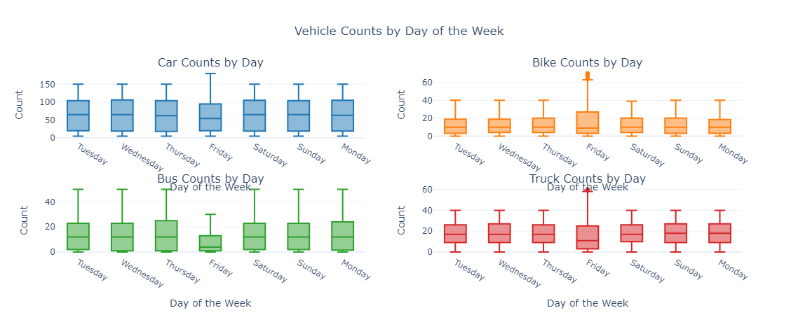

3.3.5车辆计数与交通状况之间的关系
fig = make_subplots(rows=2, cols=2, subplot_titles=("Car Counts by Traffic Situation", "Bike Counts by Traffic Situation", "Bus Counts by Traffic Situation", "Truck Counts by Traffic Situation"))

fig.add_trace(go.Box(x=combined_df['Traffic Situation'], y=combined_df['CarCount'], name='Car Counts', marker_color='#1f77b4'), row=1, col=1)
fig.add_trace(go.Box(x=combined_df['Traffic Situation'], y=combined_df['BikeCount'], name='Bike Counts', marker_color='#ff7f0e'), row=1, col=2)
fig.add_trace(go.Box(x=combined_df['Traffic Situation'], y=combined_df['BusCount'], name='Bus Counts', marker_color='#2ca02c'), row=2, col=1)
fig.add_trace(go.Box(x=combined_df['Traffic Situation'], y=combined_df['TruckCount'], name='Truck Counts', marker_color='#d62728'), row=2, col=2)

fig.update_layout(title_text='Vehicle Counts by Traffic Situation', title_x=0.5, showlegend=False, template='plotly_white')
fig.update_xaxes(title_text="Traffic Situation")
fig.update_yaxes(title_text="Count")
fig.show()
·绘制4个盒图，分析不同类型的车辆数量与交通状况之间的关系，帮助识别哪些交通状况下某种车辆的数量更为集中或分散。
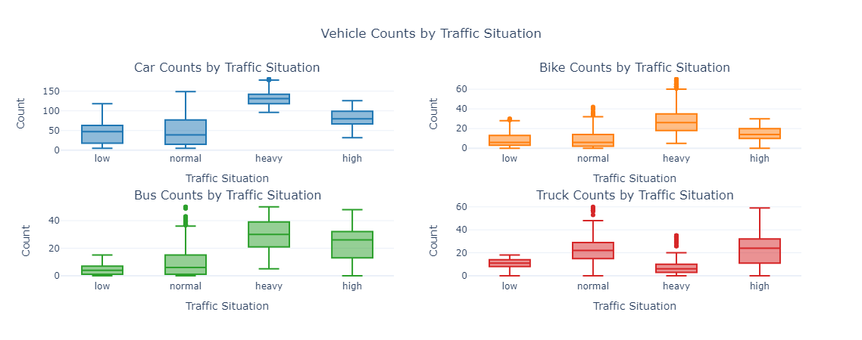
3.3.6 按交通状况的车辆总数
fig = px.box(combined_df, x='Traffic Situation', y='Total', title='Total Vehicle Count by Traffic Situation', color_discrete_sequence=px.colors.sequential.RdBu)
fig.update_layout(title_text='Total Vehicle Count by Traffic Situation', title_x=0.5, xaxis_title='Traffic Situation', yaxis_title='Total Count', template='plotly_white')
fig.show()
·使用盒图描绘不同交通状况下的车辆总数分布，从而分析车辆集中情况。

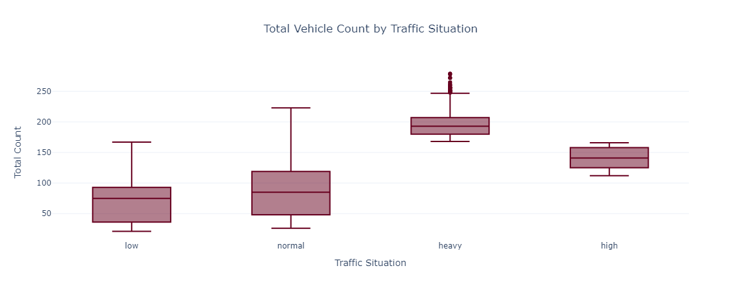
3.3.7按数据源的车辆计数
fig = make_subplots(rows=2, cols=2, subplot_titles=("Car Counts by Source", "Bike Counts by Source", "Bus Counts by Source", "Truck Counts by Source"))

fig.add_trace(go.Box(x=combined_df['Source'], y=combined_df['CarCount'], name='Car Counts', marker_color='#1f77b4'), row=1, col=1)
fig.add_trace(go.Box(x=combined_df['Source'], y=combined_df['BikeCount'], name='Bike Counts', marker_color='#ff7f0e'), row=1, col=2)
fig.add_trace(go.Box(x=combined_df['Source'], y=combined_df['BusCount'], name='Bus Counts', marker_color='#2ca02c'), row=2, col=1)
fig.add_trace(go.Box(x=combined_df['Source'], y=combined_df['TruckCount'], name='Truck Counts', marker_color='#d62728'), row=2, col=2)

fig.update_layout(title_text='Vehicle Counts by Source', title_x=0.5, showlegend=False, template='plotly_white')
fig.update_xaxes(title_text="Source")
fig.update_yaxes(title_text="Count")
fig.show()
·通过箱形图展示每种交通工具按数据源的分类，以比较不同来源数据中车辆的数量差异。
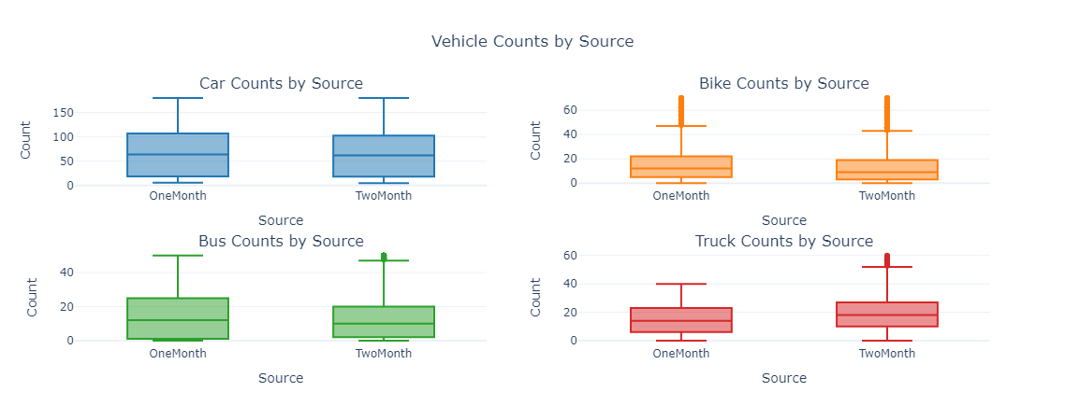

3.3.7一天中的最繁忙小时的交通
combined_df['Hour'] = pd.to_datetime(combined_df['Time'], format='%I:%M:%S %p').dt.hour
fig = px.box(combined_df, x='Hour', y='Total', title='Total Vehicle Count by Hour', color_discrete_sequence=['#9467bd'])
fig.update_layout(title_text='Total Vehicle Count by Hour', title_x=0.5, xaxis_title='Hour', yaxis_title='Total Count', template='plotly_white')
fig.show()
·通过将时间转换为小时，并使用盒形图显示每小时的车辆总数，从而识别最繁忙的时段。
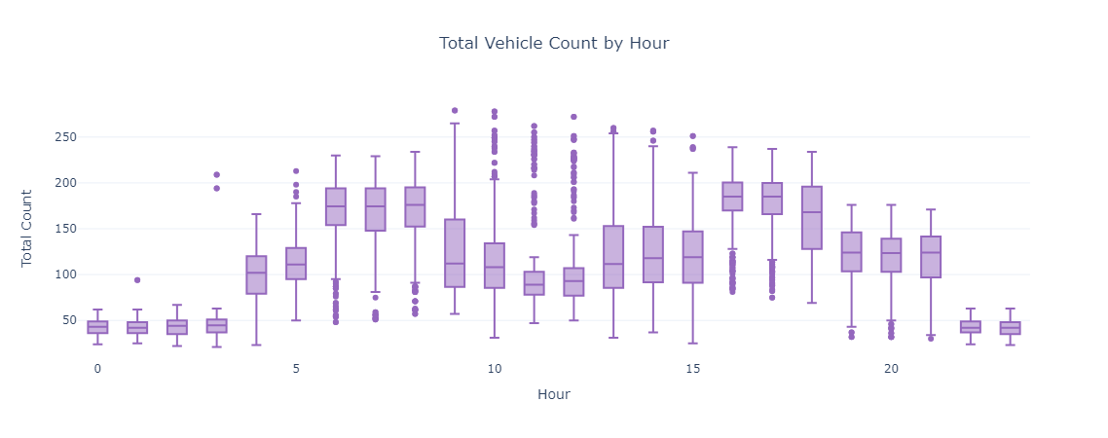

3.3.8按星期几的交通状况分布
fig = px.box(combined_df, x='Day of the week', y='Traffic Situation', title='Traffic Situation by Day of the Week', color_discrete_sequence=px.colors.sequential.RdBu)
fig.update_layout(title_text='Traffic Situation by Day of the Week', title_x=0.5, xaxis_title='Day of the Week', yaxis_title='Traffic Situation', template='plotly_white')
fig.show()
·使用盒形图显示每周的交通状况，从而分析不同日子的交通模式是否存在差异。

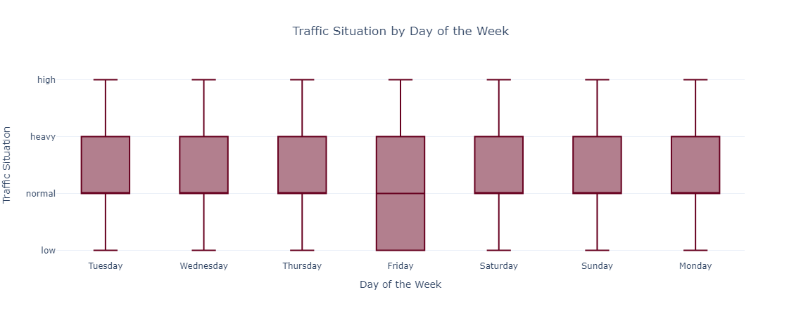

3.3.9不同车辆类型之间的相关性
corr_matrix = combined_df[['CarCount', 'BikeCount', 'BusCount', 'TruckCount', 'Total']].corr()
sns.heatmap(corr_matrix, annot=True, cmap='coolwarm')
plt.title('Correlation Matrix of Vehicle Counts')
plt.show()
·计算不同车辆类型的 count (数) 之间的相关性，并使用seaborn的热图展示结果。通过热图可以直观了解车辆类型间的关系，例如，是否存在某种车辆数量增加时其他类型车辆数量也增加的趋势。
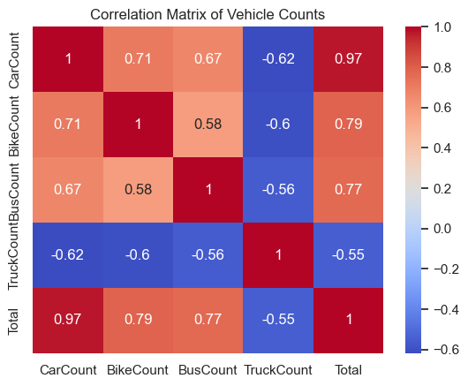

3.3.10工作日与周末的车辆计数分布
combined_df['Weekend'] = combined_df['Day of the week'].isin(['Saturday', 'Sunday'])
fig = make_subplots(rows=2, cols=2, subplot_titles=("Car Counts by Weekend", "Bike Counts by Weekend", "Bus Counts by Weekend", "Truck Counts by Weekend"))

fig.add_trace(go.Box(x=combined_df['Weekend'], y=combined_df['CarCount'], name='Car Counts', marker_color='#1f77b4'), row=1, col=1)
fig.add_trace(go.Box(x=combined_df['Weekend'], y=combined_df['BikeCount'], name='Bike Counts', marker_color='#ff7f0e'), row=1, col=2)
fig.add_trace(go.Box(x=combined_df['Weekend'], y=combined_df['BusCount'], name='Bus Counts', marker_color='#2ca02c'), row=2, col=1)
fig.add_trace(go.Box(x=combined_df['Weekend'], y=combined_df['TruckCount'], name='Truck Counts', marker_color='#d62728'), row=2, col=2)

fig.update_layout(title_text='Vehicle Counts by Weekend', title_x=0.5, showlegend=False, template='plotly_white')
fig.update_xaxes(title_text="Weekend")
fig.update_yaxes(title_text="Count")
fig.show()

·创建一个子图，比较工作日和周末不同车辆类型的数量分布。通过对Weekend列的构造，可以直观地看到不同车型在周末与工作日的集中程度。
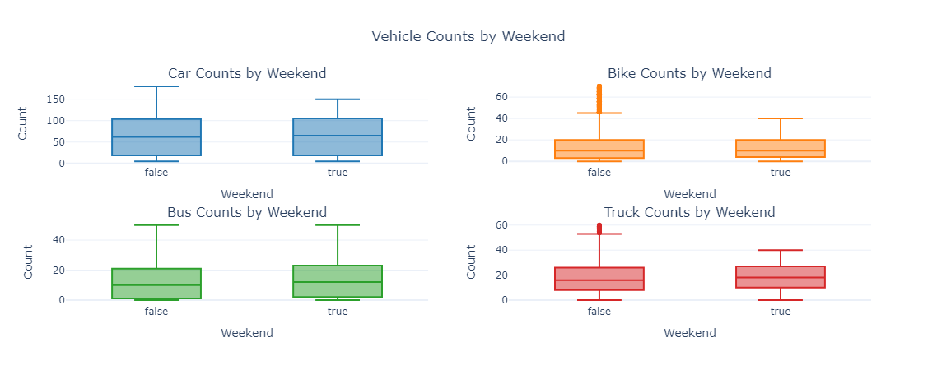

3.3.11按小时的交通状况分布
fig = px.box(combined_df, x='Hour', y='Traffic Situation', title='Traffic Situation by Hour', color_discrete_sequence=px.colors.sequential.RdBu)
fig.update_layout(title_text='Traffic Situation by Hour', title_x=0.5, xaxis_title='Hour', yaxis_title='Traffic Situation', template='plotly_white')
fig.show()

·使用盒形图显示每小时的交通状况分布，帮助分析在不同时间点交通情况的变化与趋势。
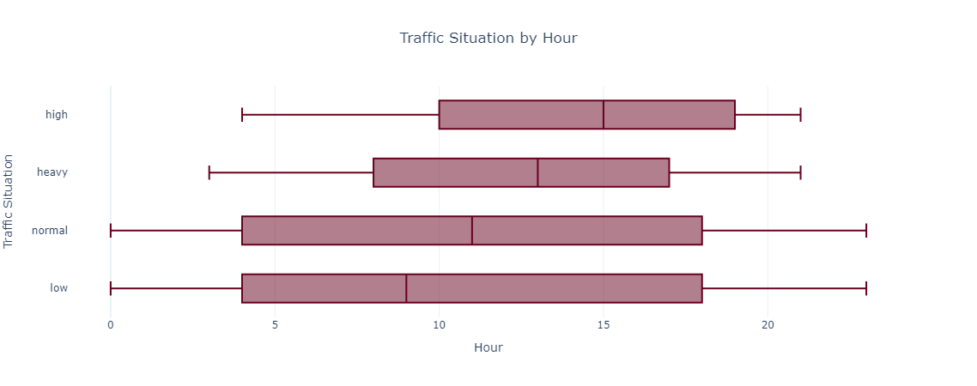
3.3.12按来源计算每种车辆总数的平均值
combined_df['Traffic Situation'] = combined_df['Traffic Situation'].astype('category').cat.codes
avg_source_counts = combined_df.groupby('Source').mean(numeric_only=True).reset_index()
fig = px.bar(avg_source_counts, x='Source', y='Total', title='Average Total Vehicle Count by Source', color_discrete_sequence=['#1f77b4'])
fig.update_layout(title_text='Average Total Vehicle Count by Source', title_x=0.5, xaxis_title='Source', yaxis_title='Average Total Count', template='plotly_white')
fig.show()
·计算并展示按来源分组的平均车辆总数，利用条形图清晰地呈现每个数据来源的车辆数量信息，旨在找出主要数据来源。
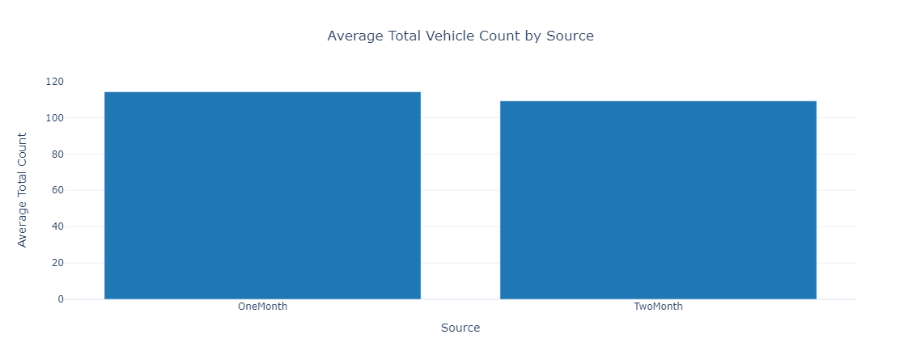

3.3.13每周各天的车辆总数分布
fig = px.box(combined_df, x='Day of the week', y='Total', title='Total Vehicle Count by Day of the Week', color_discrete_sequence=['#9467bd'])
fig.update_layout(title_text='Total Vehicle Count by Day of the Week', title_x=0.5, xaxis_title='Day of the Week', yaxis_title='Total Count', template='plotly_white')
fig.show()
·通过盒形图展示不同星期几的车辆总数分布，这将为识别高峰日和低峰日提供重要依据。
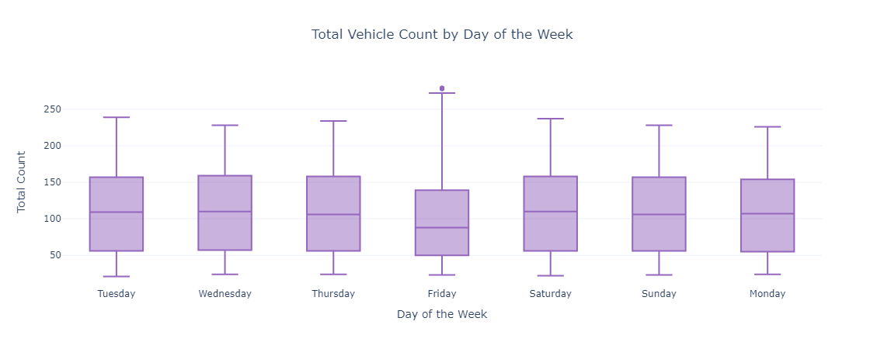

3.3.14车辆类型间的方差分析
variance_df = combined_df[['CarCount', 'BikeCount', 'BusCount', 'TruckCount']].var().reset_index()
variance_df.columns = ['Vehicle Type', 'Variance']
fig = px.bar(variance_df, x='Vehicle Type', y='Variance', title='Variance in Vehicle Counts', color_discrete_sequence=['#ff7f0e'])
fig.update_layout(title_text='Variance in Vehicle Counts', title_x=0.5, xaxis_title='Vehicle Type', yaxis_title='Variance', template='plotly_white')
fig.show()
·计算不同车辆类型的方差并展现，通过条形图揭示不同类型车辆数量的波动程度，进而了解哪些车辆类型更为稳定或不稳定。
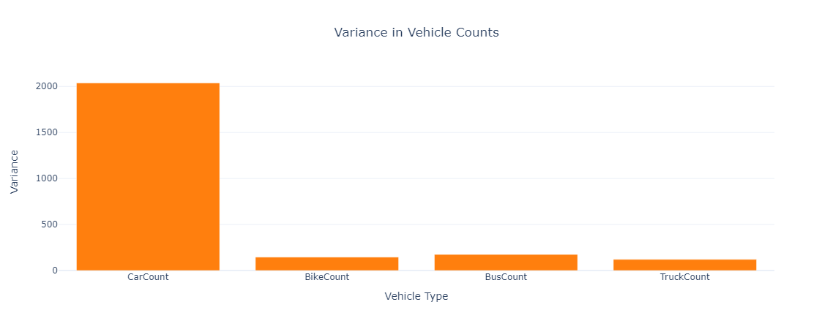

3.3.15按来源和星期几的车辆数量分布
fig = make_subplots(rows=2, cols=2, subplot_titles=("Car Counts by Source and Day", "Bike Counts by Source and Day", "Bus Counts by Source and Day", "Truck Counts by Source and Day"))

fig.add_trace(go.Box(x=combined_df['Day of the week'], y=combined_df['CarCount'], name='Car Counts', marker_color='#1f77b4'), row=1, col=1)
fig.add_trace(go.Box(x=combined_df['Day of the week'], y=combined_df['BikeCount'], name='Bike Counts', marker_color='#ff7f0e'), row=1, col=2)
fig.add_trace(go.Box(x=combined_df['Day of the week'], y=combined_df['BusCount'], name='Bus Counts', marker_color='#2ca02c'), row=2, col=1)
fig.add_trace(go.Box(x=combined_df['Day of the week'], y=combined_df['TruckCount'], name='Truck Counts', marker_color='#d62728'), row=2, col=2)

fig.update_layout(title_text='Distribution of Vehicle Counts by Source and Day of the Week', title_x=0.5, showlegend=False, template='plotly_white')
fig.show()
·创建一个2行2列的子图，比较不同车辆类型在不同星期几的数量，这将有助于揭示在不同日期、不同来源车辆的数量变化情况。
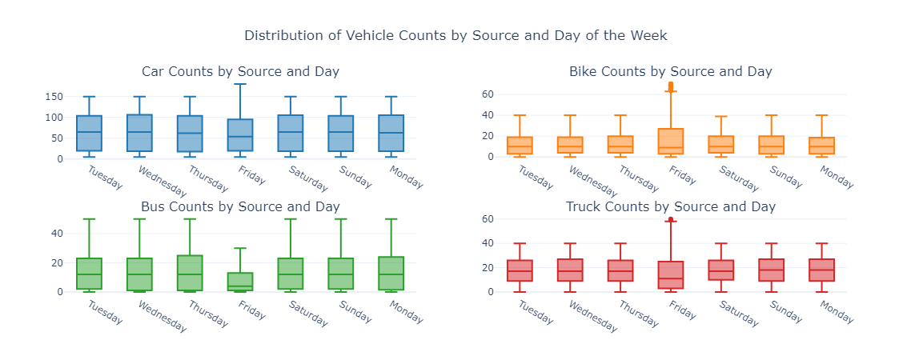

3.3.16高峰交通时段分析
fig = make_subplots(rows=2, cols=2, subplot_titles=("Car Counts by Hour", "Bike Counts by Hour", "Bus Counts by Hour", "Truck Counts by Hour"))

fig.add_trace(go.Box(x=combined_df['Hour'], y=combined_df['CarCount'], name='Car Counts', marker_color='#1f77b4'), row=1, col=1)
fig.add_trace(go.Box(x=combined_df['Hour'], y=combined_df['BikeCount'], name='Bike Counts', marker_color='#ff7f0e'), row=1, col=2)
fig.add_trace(go.Box(x=combined_df['Hour'], y=combined_df['BusCount'], name='Bus Counts', marker_color='#2ca02c'), row=2, col=1)
fig.add_trace(go.Box(x=combined_df['Hour'], y=combined_df['TruckCount'], name='Truck Counts', marker_color='#d62728'), row=2, col=2)

fig.update_layout(title_text='Vehicle Counts by Hour', title_x=0.5, showlegend=False, template='plotly_white')
fig.update_xaxes(title_text="Hour")
fig.update_yaxes(title_text="Count")
fig.show()
·功能：通过盒形图分析每种车辆类型在不同时间的分布情况。此图有助于识别高峰时段，说明在哪些时段车辆数量较多。
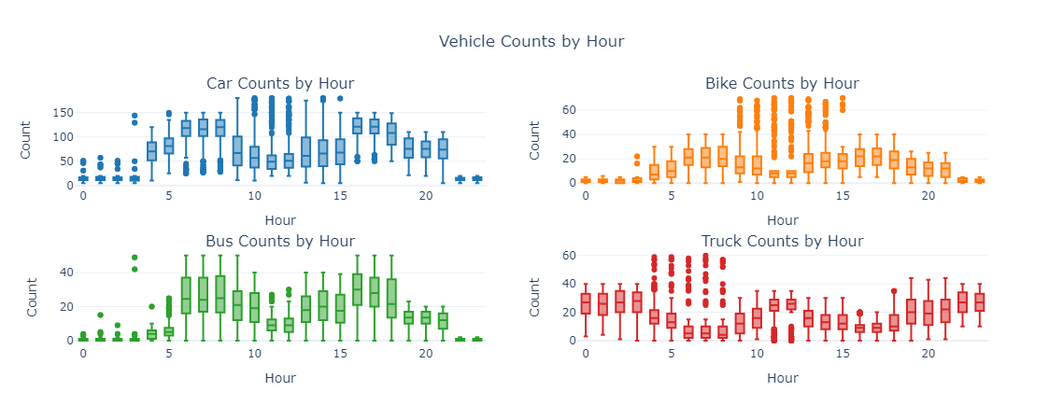

3.3.17 根据日期的交通情况分布
# Exclude non-numeric columns from the mean calculation
numeric_cols = combined_df.select_dtypes(include=['number']).columns

# Group by 'Time' and calculate the mean for numeric columns
avg_time_counts = combined_df.groupby('Time')[numeric_cols].mean().reset_index()

# Create the line plot
fig = px.line(avg_time_counts, x='Time', y=['CarCount', 'BikeCount', 'BusCount', 'TruckCount'], title='Average Vehicle Counts Over Time')
fig.update_layout(title_text='Average Vehicle Counts Over Time', title_x=0.5, xaxis_title='Time', yaxis_title='Average Count', template='plotly_white')

# Display the plot
fig.show()
·功能：通过盒形图展示每日交通情况的分布，帮助分析不同日期的交通情况波动，识别高峰和低谷时间段。
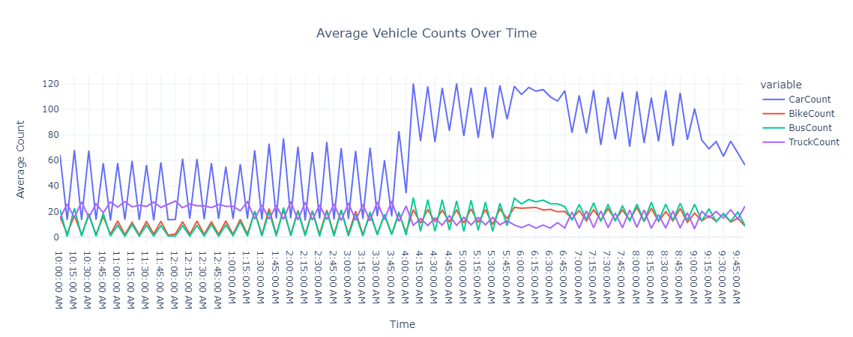

3.3.18根据日期的交通情况分布
fig = px.box(combined_df, x='Date', y='Traffic Situation', title='Traffic Situation by Date', color_discrete_sequence=px.colors.sequential.RdBu)
fig.update_layout(title_text='Traffic Situation by Date', title_x=0.5, xaxis_title='Date', yaxis_title='Traffic Situation', template='plotly_white')
fig.show()
·功能：通过盒形图展示每日交通情况的分布，帮助分析不同日期的交通情况波动，识别高峰和低谷时间段。

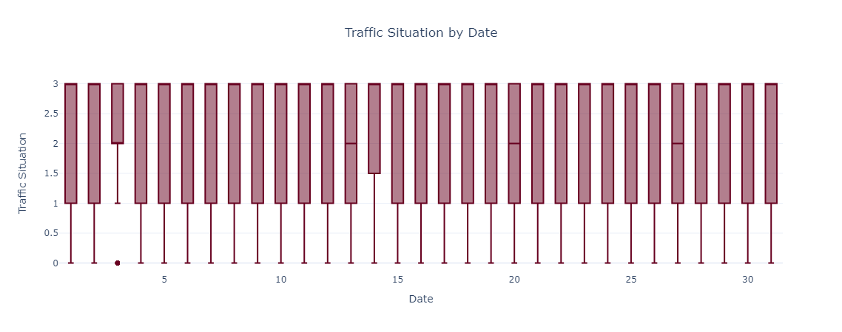

数据预处理
根据探索性分析中观察到的结果，需要对数据进行预处理。

4.1识别和移除异常值
def remove_outliers(df, columns):
for col in columns:
Q1 = df[col].quantile(0.25)
Q3 = df[col].quantile(0.75)
IQR = Q3 - Q1
lower_bound = Q1 - 1.5 * IQR
upper_bound = Q3 + 1.5 * IQR
df = df[(df[col] >= lower_bound) & (df[col] <= upper_bound)]
return df

vehicle_counts = ['CarCount', 'BikeCount', 'BusCount', 'TruckCount']
combined_df = remove_outliers(combined_df, vehicle_counts)
·功能：定义一个函数用于检测并移除列中车辆计数的异常值，采用四分位数(IQR)方法，确保数据的质量，提高分析的准确性。

4.2检查缺失值和重复值
print("Missing values in each column:")
print(combined_df.isnull().sum())

print(f"Number of duplicate rows: {combined_df.duplicated().sum()}")
·功能：此部分代码用于检查数据集中是否存在缺失值和重复的数据行，确保后续分析基于完整和独特的数据。
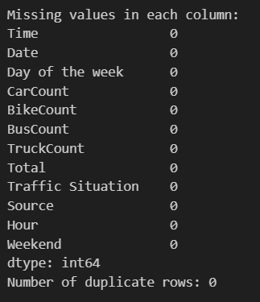

4.3使用箱型图可视化异常值
fig, axes = plt.subplots(2, 2, figsize=(15, 10))
sns.boxplot(data=combined_df, x='CarCount', ax=axes[0, 0], color='#1f77b4')
sns.boxplot(data=combined_df, x='BikeCount', ax=axes[0, 1], color='#ff7f0e')
sns.boxplot(data=combined_df, x='BusCount', ax=axes[1, 0], color='#2ca02c')
sns.boxplot(data=combined_df, x='TruckCount', ax=axes[1, 1], color='#d62728')
axes[0, 0].set_title('Car Count')
axes[0, 1].set_title('Bike Count')
axes[1, 0].set_title('Bus Count')
axes[1, 1].set_title('Truck Count')
plt.tight_layout()
plt.show()
·功能：使用seaborn库的箱型图可视化各车型的数量分布，确认异常值的存在，并观察各车型的数量分布特征。
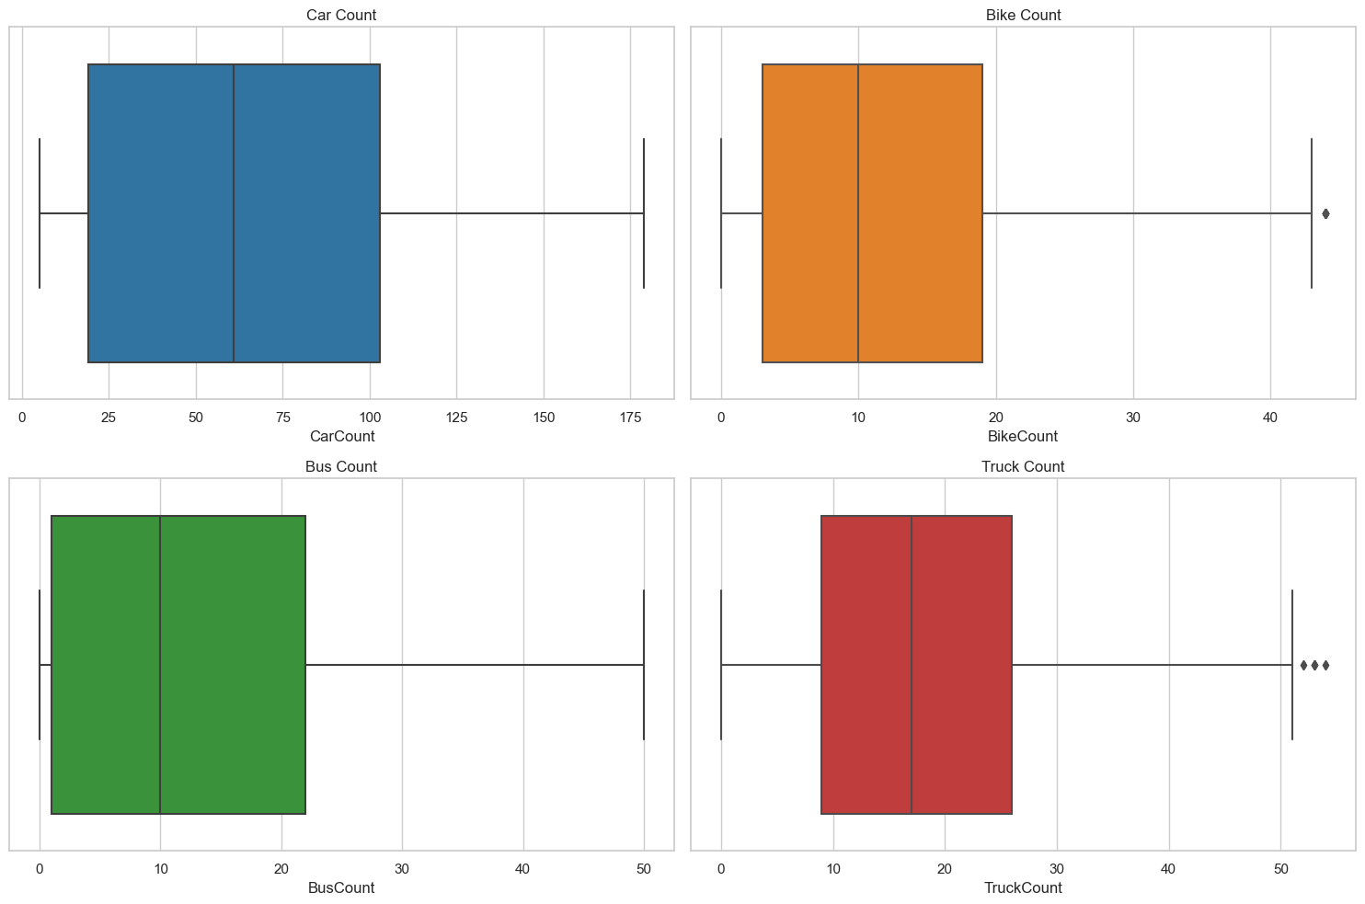

4.4正态性检查
在这部分代码中，使用Shapiro-Wilk检验来检查车辆计数（汽车、摩托车、公共汽车和卡车）在进行任何转换之前是否符合正态分布。
def check_normality(data):
stat, p = shapiro(data)
return p > 0.05

print("Normality check before normalization:")
car_normal = check_normality(combined_df['CarCount'])
bike_normal = check_normality(combined_df['BikeCount'])
bus_normal = check_normality(combined_df['BusCount'])
truck_normal = check_normality(combined_df['TruckCount'])

print(f"Car count normality: {car_normal}")
print(f"Bike count normality: {bike_normal}")
print(f"Bus count normality: {bus_normal}")
print(f"Truck count normality: {truck_normal}")
·功能：check_normality函数使用Shapiro-Wilk检验来判断数据是否呈正态分布。
·输出：布尔值表示每种车辆计数是否遵循正态分布。

4.5数据归一化
接下来，使用QuantileTransformer对车辆计数进行归一化，目的是将特征分布转化为均匀或正态分布。
scaler = QuantileTransformer(output_distribution='normal')
combined_df[['CarCount', 'BikeCount', 'BusCount', 'TruckCount']] = scaler.fit_transform(combined_df[['CarCount', 'BikeCount', 'BusCount', 'TruckCount']])

# Check normality for each vehicle count after normalization
print("Normality check after normalization:")
car_normal = check_normality(combined_df['CarCount'])
bike_normal = check_normality(combined_df['BikeCount'])
bus_normal = check_normality(combined_df['BusCount'])
truck_normal = check_normality(combined_df['TruckCount'])

print(f"Car count normality: {car_normal}")
print(f"Bike count normality: {bike_normal}")
print(f"Bus count normality: {bus_normal}")
print(f"Truck count normality: {truck_normal}")
·归一化：这一步通过量化归一化将计数转化为更适合建模的格式。

4.6归一化后的可视化
这部分代码使用直方图展示归一化后的车辆计数分布。
fig, axes = plt.subplots(2, 2, figsize=(15, 10))
sns.histplot(combined_df['CarCount'], ax=axes[0, 0], kde=True, color='#1f77b4')
sns.histplot(combined_df['BikeCount'], ax=axes[0, 1], kde=True, color='#ff7f0e')
sns.histplot(combined_df['BusCount'], ax=axes[1, 0], kde=True, color='#2ca02c')
sns.histplot(combined_df['TruckCount'], ax=axes[1, 1], kde=True, color='#d62728')
axes[0, 0].set_title('Normalized Car Count')
axes[0, 1].set_title('Normalized Bike Count')
axes[1, 0].set_title('Normalized Bus Count')
axes[1, 1].set_title('Normalized Truck Count')
plt.tight_layout()
plt.show()
·可视化：带有核密度估计（KDE）的直方图提供了归一化后车辆计数分布的视觉洞察。
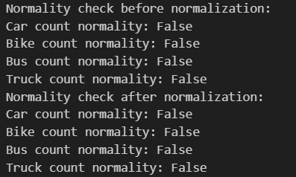
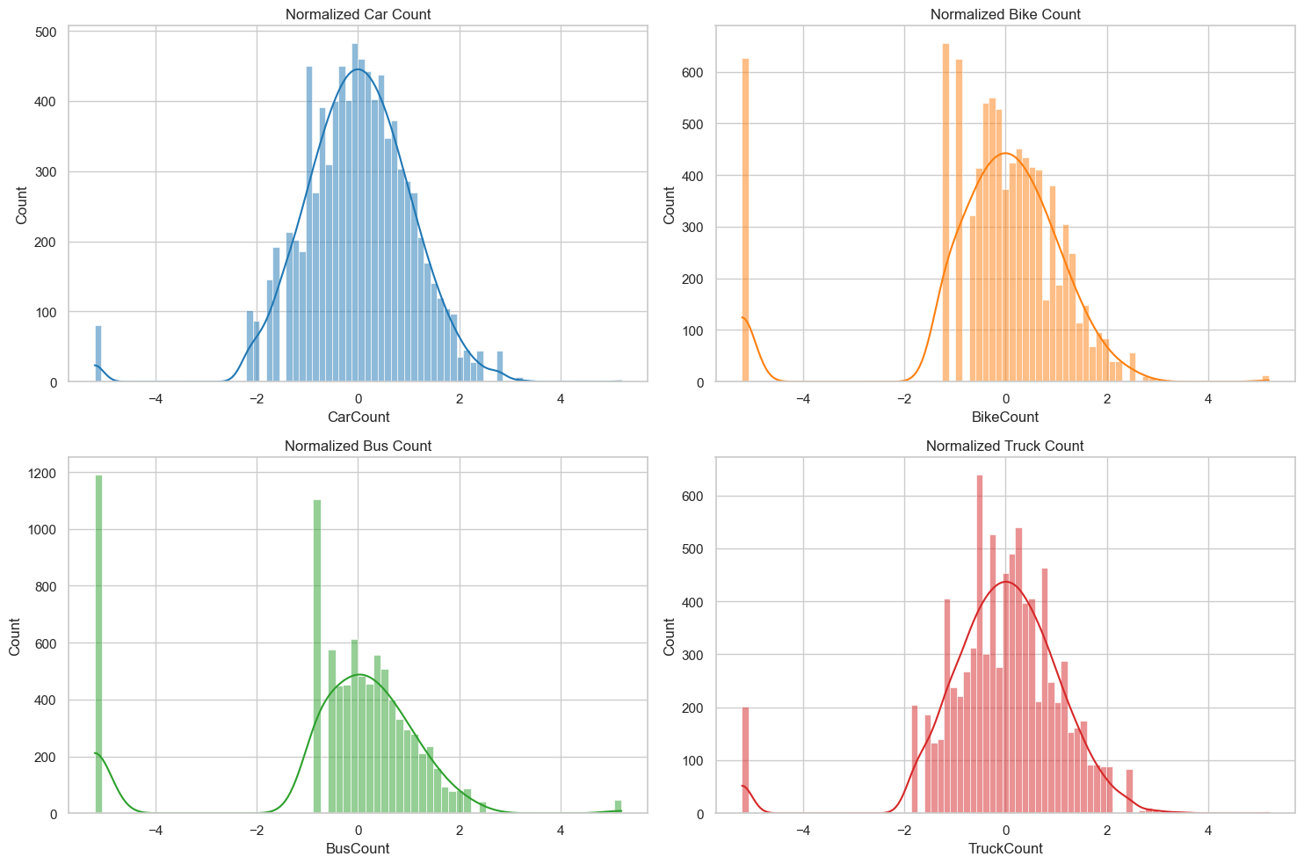

4.7特征和目标变量准备
在这一步中，提取特征（X）和目标变量（y）以进行建模。
X = combined_df.drop(columns=['Traffic Situation'])
y = combined_df['Traffic Situation']

建模预测
数据准备
X_train, X_test, y_train, y_test = train_test_split(X, y, test_size=0.2, random_state=42)

创建预处理管道
preprocessor = ColumnTransformer(
transformers=[
('num', StandardScaler(), numeric_features),
('cat', OneHotEncoder(), categorical_features)
])

5.1随机森林
#定义模型管道
rf_model = Pipeline(steps=[
('preprocessor', preprocessor),
('classifier', RandomForestClassifier(random_state=42))
])
#训练模型
rf_model.fit(X_train, y_train)
#进行预测
rf_y_pred = rf_model.predict(X_test)
#评估模型
print("Random Forest Model Accuracy:", accuracy_score(y_test, rf_y_pred))
print("Random Forest Classification Report:")
print(classification_report(y_test, rf_y_pred))

输出结果
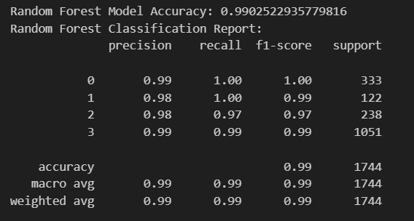

5.2XGBoost
#定义模型管道
xgb_model = Pipeline(steps=[
('preprocessor', preprocessor),
('classifier', xgb.XGBClassifier(random_state=42))
])
#训练模型
xgb_model.fit(X_train, y_train)
#进行预测
xgb_y_pred = xgb_model.predict(X_test)
#评估模型
print("XGBoost Model Accuracy:", accuracy_score(y_test, xgb_y_pred))
print("XGBoost Classification Report:")
print(classification_report(y_test, xgb_y_pred))

输出结果
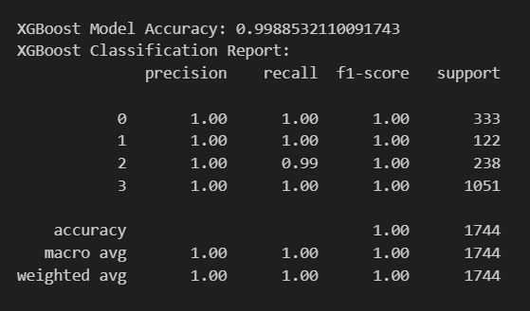

5.3支持向量机
#定义模型管道
svm_model = Pipeline(steps=[
('preprocessor', preprocessor),
('classifier', SVC(random_state=42))
])
#训练模型
svm_model.fit(X_train, y_train)
#进行预测
svm_y_pred = svm_model.predict(X_test)
#评估模型
print("Support Vector Machine Model Accuracy:", accuracy_score(y_test, svm_y_pred))
print("Support Vector Machine Classification Report:")
print(classification_report(y_test, svm_y_pred))

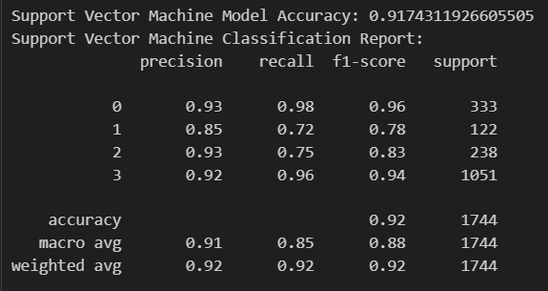

5.4梯度提升
#定义模型管道
gb_model = Pipeline(steps=[
('preprocessor', preprocessor),
('classifier', GradientBoostingClassifier(random_state=42))
])
#训练模型
gb_model.fit(X_train, y_train)
#进行预测
gb_y_pred = gb_model.predict(X_test)
#评估模型
print("Gradient Boosting Model Accuracy:", accuracy_score(y_test, gb_y_pred))
print("Gradient Boosting Classification Report:")
print(classification_report(y_test, gb_y_pred))

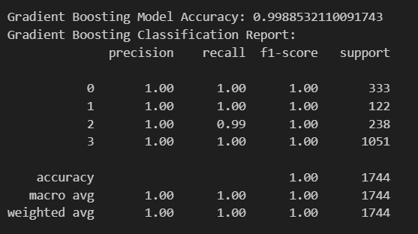

5.5模型比较
from sklearn.metrics import accuracy_score,classification_report,f1_score,precision_score,recall_score

results = {
'Model': ['Random Forest', 'XGBoost', 'Support Vector Machine', 'Gradient Boosting'],
'Accuracy': [
accuracy_score(y_test, rf_y_pred),
accuracy_score(y_test, xgb_y_pred),
accuracy_score(y_test, svm_y_pred),
accuracy_score(y_test, gb_y_pred)
],
'Precision': [
precision_score(y_test, rf_y_pred, average='weighted'),
precision_score(y_test, xgb_y_pred, average='weighted'),
precision_score(y_test, svm_y_pred, average='weighted'),
precision_score(y_test, gb_y_pred, average='weighted')
],
'Recall': [
recall_score(y_test, rf_y_pred, average='weighted'),
recall_score(y_test, xgb_y_pred, average='weighted'),
recall_score(y_test, svm_y_pred, average='weighted'),
recall_score(y_test, gb_y_pred, average='weighted')
],
'F1 Score': [
f1_score(y_test, rf_y_pred, average='weighted'),
f1_score(y_test, xgb_y_pred, average='weighted'),
f1_score(y_test, svm_y_pred, average='weighted'),
f1_score(y_test, gb_y_pred, average='weighted')
],
}

# 将结果转化为DataFrame
results_df = pd.DataFrame(results)

# 打印模型比较结果
print(results_df)

