# 算法模型评估报告

## 前馈神经网络模型

|  |  |  |  |  |
| --- | --- | --- | --- | --- |
| label | Precision | Recall | F1-score | support |
| 0 | 0.92 | 0.74 | 0.82 | 1014 |
| 1 | 0.56 | 0.84 | 0.67 | 206 |
| 2 | 0.68 | 0.63 | 0.65 | 333 |
| 3 | 0.68 | 0.89 | 0.77 | 198 |
| 4 | 0.70 | 0.96 | 0.81 | 98 |
| 5 | 0.81 | 0.92 | 0.86 | 151 |
| accuracy | / | / | 0.77 | 2000 |
| macro avg | 0.72 | 0.83 | 0.76 | 2000 |
| weighted avg | 0.80 | 0.77 | 0.77 | 2000 |

## 决策树模型

###### 最佳参数： max_depth=None, max_features=sqrt, min_samples_leaf=1, min_samples_split=2

|  |  |  |  |  |
| --- | --- | --- | --- | --- |
| label | Precision | Recall | F1-score | support |
| 0 | 0.91 | 0.92 | 0.92 | 1019 |
| 1 | 0.83 | 0.84 | 0.83 | 216 |
| 2 | 0.84 | 0.83 | 0.84 | 324 |
| 3 | 0.89 | 0.87 | 0.88 | 174 |
| 4 | 0.89 | 0.87 | 0.88 | 107 |
| 5 | 0.92 | 0.91 | 0.92 | 160 |
| accuracy | / | / | 0.89 | 2000 |
| macro avg | 0.88 | 0.87 | 0.88 | 2000 |
| weighted avg | 0.89 | 0.89 | 0.89 | 2000 |

## 随机森林模型

###### 最佳参数： max_depth=15, n_estimators=300

|  |  |  |  |  |
| --- | --- | --- | --- | --- |
| label | Precision | Recall | F1-score | support |
| 0 | 0.94 | 0.99 | 0.96 | 1030 |
| 1 | 0.90 | 0.85 | 0.88 | 212 |
| 2 | 0.94 | 0.86 | 0.90 | 333 |
| 3 | 0.96 | 0.91 | 0.93 | 178 |
| 4 | 0.99 | 0.98 | 0.99 | 106 |
| 5 | 0.99 | 0.94 | 0.96 | 141 |
| accuracy | / | / | 0.94 | 2000 |
| macro avg | 0.95 | 0.92 | 0.94 | 2000 |
| weighted avg | 0.94 | 0.94 | 0.94 | 2000 |

## 模型准确率对比

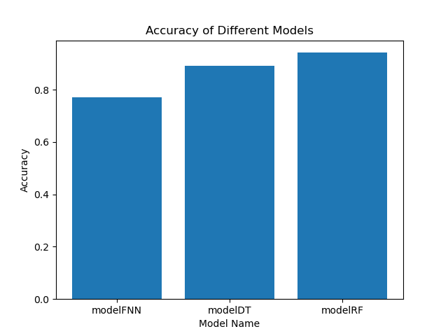

## 模型f值对比

