# 算法模型评估报告

## 决策树模型

###### 最佳参数： {'max_depth': None, 'max_features': 'sqrt', 'min_samples_leaf': 1, 'min_samples_split': 2}

|  |  |  |  |  |
| --- | --- | --- | --- | --- |
| label | Precision | Recall | F1-score | support |
| 0 | 0.91 | 0.91 | 0.91 | 1054 |
| 1 | 0.84 | 0.80 | 0.82 | 204 |
| 2 | 0.79 | 0.85 | 0.82 | 318 |
| 3 | 0.81 | 0.81 | 0.81 | 170 |
| 4 | 0.86 | 0.88 | 0.87 | 98 |
| 5 | 0.87 | 0.80 | 0.83 | 156 |
| accuracy | / | / | 0.87 | 2000 |
| macro avg | 0.85 | 0.84 | 0.84 | 2000 |
| weighted avg | 0.87 | 0.87 | 0.87 | 2000 |



## 模型准确率对比

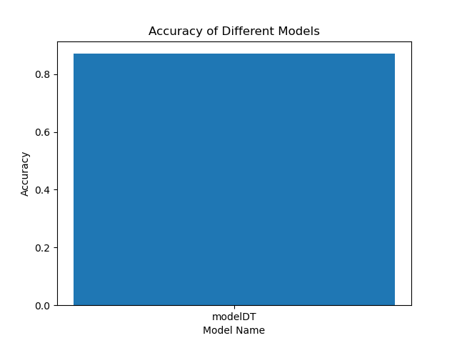

## 模型f值对比

