**Python note**

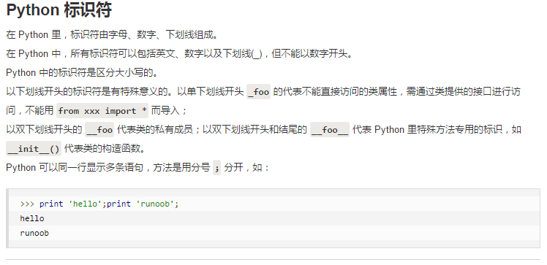

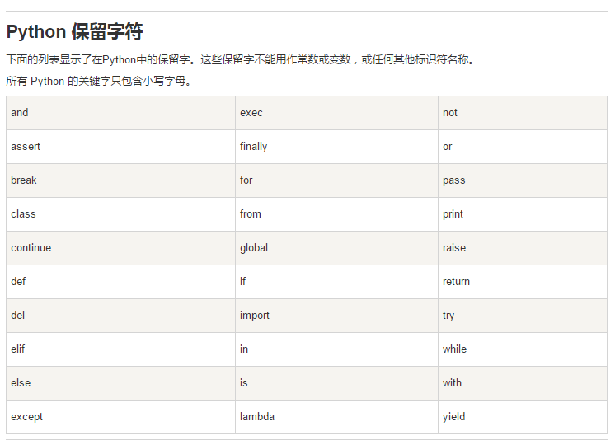

* XlsxWriter用法
* <https://blog.csdn.net/AuserBB/article/details/79267607>
* <https://xlsxwriter.readthedocs.io/working_with_autofilters.html?highlight=autofilter>
* **@staticmethod和@classmethod的作用与区别**

[**https://blog.csdn.net/handsomekang/article/details/9615239**](https://blog.csdn.net/handsomekang/article/details/9615239)

* **python中os模块用法**

[**https://blog.csdn.net/lygzscnt12/article/details/52470017**](https://blog.csdn.net/lygzscnt12/article/details/52470017)

* **常见文件操作函数示例**

**https://blog.csdn.net/scelong/article/details/6971917**