**TITLE OF THE PAPER**

ALL THE AUTHOR NAMES

DEPARTMENT NAME

COLLEGE NAME

EMAIL ID OF ALL THE AUTHORS

ABSTRACT:

KEYWORDS-

YOUR FULL PAPERS DETAILS :

Like -

Introduction

Literature survey

Problem statement

Conclusion

References and so on

**\* NOTE -**

Text should be in Times New Roman and should be justified.

Title - bold and size 14

Body and abstract - size 12

**For better understanding a sample paper is given below.**

**PROLONGED NETWORK LIFETIME TO REDUCE ENERGY CONSUMPTION USING CLUSTER BASED WIRELESS SENSOR NETWORK**

Sagargouda S.Patil

Department of Computer Science and Engineering Shaikh college of engineering and technology,Belagavi

Email-id:sagapat@sgibgm.org

Anand Gudnavar

Department of Computer Science and Engineering Shaikh college of engineering and technology,Belagavi

Email-id:anangud@sgibgm.org*

***Abstract*—**Efficient utilization of energy for each sensor node is the key to prolong the network lifetime. The balance of energyconsumption among the nodes located at central and edge areas also play another important role in the situation of lifetime extension. In earlier work, LEACH algorithm has been investigated in the existing cluster head (CH) selection and the edge sub-clustering (ESC) scheme is further developed to ease the effect of non-uniform node distribution on the edge, but it has not covered entire coverage area of network due to failure of some nodes. The proposed work uses partition around medoid (PAM) algorithm to improve optimization of number and size of sub-clusters along with the communication range for better improvement in cluster head selection and overcoming failure of edge nodes. Thus, it improves not only the energy conservation but also drastically improve the balance energy consumption, which can contribute to longer network lifetime and outage probability.

***Keywords*—**clustering, energy consumption, node connectivity, network lifetime, sensor node

**I** **INTRODUCTION**

Wireless sensor system comprises of sensor hubs which are set above a large geographical area and have wireless communication. Sensor node is a node which is small, low cost, and low down energy communication [1]. Each sensor node has 3 components namely-(i) Sensing data from environment (ii) Processing or analyzing sensed data (iii) Storing data until it sends data to base station. Each sensor node is battery oriented, the capacity of battery is very limited to use and it is also impossible to replace battery because of harsh environment in wireless sensor network. So, we aim at improving the maximizing network lifetime. It is very important to inspect and approximate how protracted network is working properly or lifetime of a system. Remote sensor system comprises of sensor hubs and base station. Each sensor node is distributed in a larger geographical environment [2]. It is also used in various fields like war, healthcare, polyhouse monitoring systems, transport etc. The key dispute of WSN is to build the lifetime of the system by minimizing the energy consumption [3].Energy consumption is the amount of consumption of energy or power while transmitting data from one location to another location. Studying from previous years, a variety of changes have been made to limit the energy requirement in WSN, as mainly energy consumption is more for wireless transmission and response. Main approaches proposed so far focused at making the changes at MAC layer and network layer to minimize the energy consumption. Two more major challenges are how to place the cluster heads over the network and how many clusters would be there in a network. If the cluster heads are properly placed over the network and sufficient clusters are formed, it will help to minimize the utilization of vitality and would expand the lifetime of the network. To deal with all the above mentioned challenges clustering is always been referred as an effective technique to improve the lifetime of remote sensor system. Clustering is a method which consists of group of sensor nodes and cluster head, where some sensor nodes are selected as cluster head at the time of cluster creation. Sensor node in each cluster transmits their information to separate bunch head and group head sends such total information to base station.

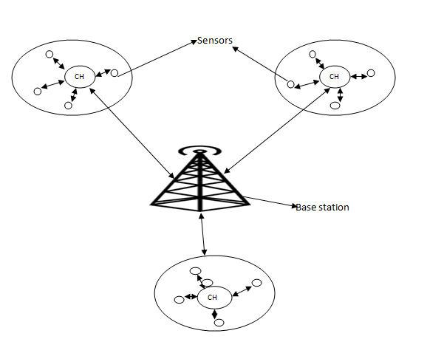

Few key terms related to clustering are discussed below:

**1] Sensor node**: A sensor centre point is the principal part of a WSN. Sensor centers perform capacities, for example, detecting, informationstoring, routing and information preparing.

**2] Clusters**: Clusters are the assorted leveled units for WSN. Significant sensor systems should be separated into bunches to abbreviateassignments, for example, correspondence between the base station and the group head [4].

**3] Cluster head**: Cluster head is the expert of a bunch. Bunch head is habitually required to sort out exercises in the group. These assignmentsincorporate information accumulation, pressure and correspondence to base station [5].

**4] Base Station**: The base station (BS) gives the correspondence join between the sensor framework and the end-customer. It is basically thesink in a WSN.

**II** **PROBLEM STATEMENT**

To minimize the vitality utilization of sensor hubs and expanding the system lifetime are the two vital considerations in the WSN. Since sensor nodes are outfitted with battery powered devices it is impracticable to change the battery for all nodes if the network is implemented for a huge area with a numerous nodes. In the existing method inefficient selection of size of cluster and cluster head is used and edge connectivity to cover all nodes which affect energy consumption as well as network lifetime to improve network in wireless sensor network.

**III** **LITERATURE SURVEY**

**1] Low-Energy Adaptive Clustering Hierarchy (LEACH):**

LEACH is one of the primary progressive directing conventions for sensor systems. It is a self arranging, versatile bunching convention. It decreases the vitality radically. The LEACH is a group based convention and arbitrarily chooses the cluster-sets out towards every bunch. It is discarding in proposing works due to the following drawbacks.

1] Cluster heads are not consistently dispersed inside group that implies a cluster head, situated at the edges of a group

2] Many applications need large coverage area so it does not work well with large area network in WSN.

**2] Weighted residual energy and distance (WRED) and Edge sub clustering (ESC):**

Clustering is only based on geography effect of poison point process, this leads to consume more energy because PPP is suitable for only finding location and distance of nodes but not the communication range. More complex scheme for cluster head and cluster selection is that the weighted lingering vitality and separation (WRED) calculation is wanted to draw out and determine the bunch head. Utilizing WRED, hubs with more energy are placed near cluster centre [6]. The edge sub-grouping (ESC) plan is created to advance and enhance the impact of non-uniform circulation of hubs on the edge.

We have 2 existing algorithms for reducing energy consumption: WRED and ESC although both have disadvantages like 1] No optimal number of clusters formed leads to increase in energy consumption and leads to decrease in network lifetime.

2] Increased number of hops.

**3] EECS (energy efficient clustering scheme in wireless sensor networks)**

The hubs with more remaining vitality have more likelihood to be chosen as group heads. On the off chance that hub does not discover with more lingering vitality, it turns into a bunch hub. In group development stage, LEACH utilizes the base separation of hubs to equal their bunch head. In this manner EECS determines the issue that groups at a more prominent separation from the sink, requires more imperativeness for transmission than those that are ever closer to low message overheads and to the uniform assignment of gathering head stood out from LEACH.

*Advantage-*The calculation builds multilevel groups and the hubs in every bunch achieve the bunch head by hand-off through different hubs.

**4] K-means**

Creators have depicted that k-mean grouping scientific system is emphatically indistinguishable to the system bunching issue; some energizing k-implies bunching changes were recently connected to the specially appointed systems. Up till now what makes the view we ponder not the same as others is the truth that the measure of going before information is little than it is in average k- implies applications.

Hubs are just ready to quantify separations to their one jump neighbor’s positions are obscure and the system design does not offer the

unified learning required for fundamental k-implies calculation applications.

**5] Survey of various clustering methods**

Ameer Ahmed Abbasi provides a review of a variety of clustering algorithms that are exclusively planned for WSNs. Here discussion is about a choice of convergence time algorithms. Convergence time is the time required before all the cluster heads attain conformity about the topology of the WSN. Classified clustering algorithms are in two categories- variable convergence time algorithms and constant [7] convergence time algorithms. Variable convergence time algorithms are helpful when number of nodes in WSN is low, while constant convergence time algorithms are useful when number of nodes in WSNs is high.

**IV. SYSTEM ARCHITECTURE**

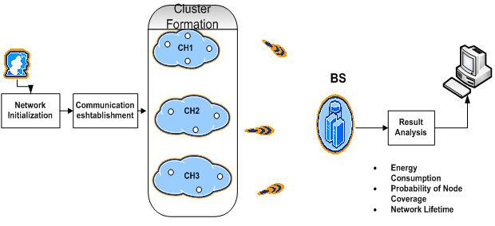

Figure 2. System Design Architecture

**Overview of system architecture**

* **Network initialization**: is an input phase with which the network parameters namely x-dim, y-dim, initial energy of node, number ofnodes, MAC type, antenna model, transmission speed, area of simulation are initialized.
* **Communication establishment**: Once Initializations are completed, the next step is to compute the average, individual energy andlocation of each and every node along with the distance of all nodes and hence it establishes communication in the network.
* **Cluster formation**: It is done by using input parameter such as energy and distance gathering data from slave nodes to master nodes andtransmit data from master node to base station with minimum distance to reduce energy consumption in wireless sensor network.
* **Result analysis: From our “novel approach” that is PAM algorithm which results in,**

1] **Energy consumption**

The power utilization level of a hub can be controlled by finding the contrast between the present energy E C and during imitation energy Ei. On the off chance that a energy level of a hub achieves zero, it can't get or transmit any longer parcels. The measure of vitality utilization in a hub can be imprinted in the following record. The vitality level of a system can be controlled by summing the whole hub's energy level in the system [8][9]. The average Power Consumption of the application traffic n, which is denoted by PC, is obtained as



2] **Probability of node coverage**

This mainly tells about how much area is covered by sensors .It is very important to measure in terms of connectivity. Connectivity means that each data collected in the sensor nodes is to stretch connection within cluster that it should cover the range to all respected nodes in cluster [10].

3] **Network lifetime**

Life time of wireless sensor node depends on battery life so that those batteries which cannot be rechargeable or removable, so that the optimal clustering solution to overcome these types of problems to reduce energy consumption in increase network lifetime. Lifetime of network is determined using formulae,

**Lifetime= (residual energy – distance covered)/100**

**V. PROPOSED RESEARCH MODEL**

Let us discuss proposed model algorithm to overcome existing problems to efficiently reduce energy consumption and increased in lifetime of network.

**Partition around medoid** is the most common insight of K-medoid clustering algorithm. This algorithm is used for partitioning aroundmedoid. Partition Around (PAM) medoid algorithm is a clustering algorithm that attempt to minimize the distance between leaf nodes and points from centre [11][12]. It also makes use of prospect maximization (EM) strategy to unite to a minimum error condition. It starts from initial set of medoids and iteratively replaces a medoid by a non-medoid as and when it improves total distance of resulting clustering. Integration of range model based mechanism and distance based mechanism helps in node distribution technique. Nodes are distributed dynamically that is it is based on non-uniform network.

**Algorithm Steps:**

**Step 1**.Initialization randomly selecting K-**mediod from ‘n’ datapoints (nodes).**

**Step 2**.Associate each data point to closest medoid or nearest medoid (cluster head).

**Step 3**.Network improvements can be done using following steps: **for each medoid “m” and for each nomedoid “o”.**

a) Swapping “m” and “o”, re-computing cost.

Cost is nothing but sum of distances and energy of data points to closest medoid.

1. If any node is out of range then we communicate edge node and add to respected cluster based on Euclidean distance.
2. If total cost of above process is greater than original value then we can undo using swap process.

**Step 4**. Repeat step until cost decreases, in each cluster make point that minimize sum of distance within cluster and finally reassign eachpoint to respective cluster.

**Step 5**. Selecting appropriate cluster head with respect to medoids.

**Advantages of PAM algorithm over LEACH protocol and ESC scheme**

1] Enhancement of number and sizes of sub-groups.

2] Reduced energy consumption and increased network lifetime.

3] Solves problem of number of hops and communication range.

4] Better maintainability of system.

5] It finds more accurate centres of clusters.

**VI. EXPERIMENTAL RESULTS**

Simulations are conducted using MATLAB (R2013a) tool and we have used true time simulator to implement partition around medoid algorithm to get better results. We have assumed following network parameters for our simulation:

TABLE 1. Network parameters

|  |  |
| --- | --- |
| Number of nodes | 100 |
|  |  |
| Area of simulation | 100*100m |
|  |  |
| Initial energy of node | 100 joules |
|  |  |
| k-value | Trial and error |
|  |  |
| Number of sink | 1 |
|  |  |
| Deployment model | Random |
|  |  |

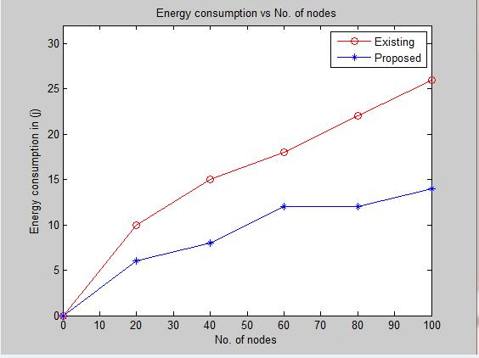

Existing: LEACH

Proposed: PAM

Proposed: PAM

Figure 3. Energy consumption in WSN

Above Figure 3 shows that energy consumption with respect to number of nodes in the simulation. As the number of nodes increases consumption of energy decreases. Suppose if number of nodes are 40, consumption of energy around 15 Joules in existing system likewise if nodes are 100, consumption of energy in existing system is 26 Joules, but using our proposed algorithm we are consuming few joules of energy compared to existing system about 13%.

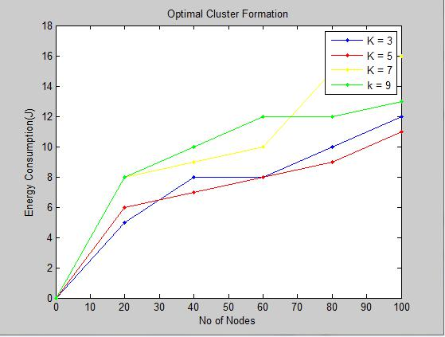

Figure 4. Optimal cluster formation in WSN

Above Figure 4 shows that energy consumption with respect to the number of nodes is for optimal cluster formation. Here, choosing K-value is key thing to efficiently convey optimization scenario in wireless sensor network. With the lack of optimization in existing system to overcome this, PAM algorithm can be used by changing k-value using trial and error method until we get optimized k-value. In above Fig we are taking up to k=9 iterations with respect to energy consumption, we get reduction in energy consumption and efficient optimization at k=5 that increase in optimization of number and size of sub-cluster.

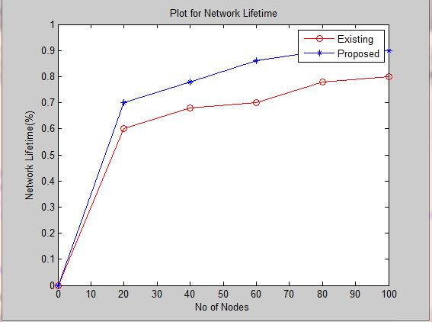

Existing: LEACH

Proposed: PAM

Figure 5. Network lifetime in WSN

Above figure 5 shows that lifetime of network in percentage (%) with respect to number of nodes in the simulation. Lifetime of network increases when energy of node decreases, at the node 100 lifetimes is about 0.78% in existing system but using our proposed system with 100 nodes lifetime of network increased about 0.9 that means it increased by 0.12% drastically in network.

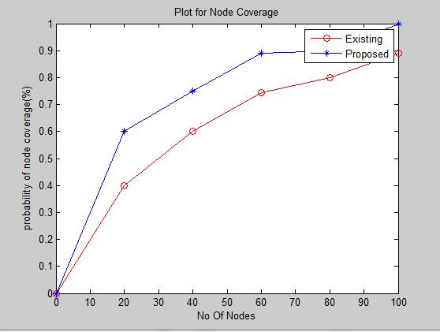

Existing: ESC

Proposed: PAM

Figure 6. Probability of node coverage in WSN

Above figure 6 shows that probability of node coverage in percentage with respect to number of nodes in the simulation. It has been concluded that percentage of probability of node coverage in proposed system should be increases when compared with an existing system. The main logic involved in this graph is increasing connectivity of all nodes which are there in network that is covering all the nodes which are on edges and non-communication range, when we are considering 60 nodes in existing system it covers around 0.72% of coverage but using our coverage algorithm we are covering around 0.2% of improvement for better communication in network.

**VII.** **CONCLUSION**

Energy factor in wireless sensor network is a major challenge; most of sensor nodes are equipped with very limited power. The lifetime of wireless sensor nodes depend upon battery lifetime and these batteries are neither easily removable nor rechargeable. The paper proposes a protocol, partition around medoid which helps in formation of efficient optimization number and size of sub-clustering that confirms minimum energy consumption. Connectivity among nodes on edges or out of range is very important into consideration for better communication establishment among all nodes, which is evident through the simulation that exhibits better results compared to existing LEACH and ESC algorithms. Hence improvement in reduction of energy consumption and increased network lifetime increases overall performance of wireless sensor networks.

**REFERENCES**

1. D. Takaishi, H. Nishiyama, N. Kato, and R. Miura, “Towards energyefficient big data gathering in densely distributed sensor networks,”

IEEE Transactions on Emerging Topics in Computing, vol. 2, no. 3, Sept. 2014, pp. 388–397.

1. S. H. Shah, F. K. Khan, W. Ali, and J. Khan, “A new framework to integrate wireless sensor networks with cloud computing,” in IEEE

Aerospace Conference, March 2013, pp. 1–6.

1. I. F. Akyildiz,W. Su, Y. Sankarasubramaniam, and E. Cayirci, “A survey on sensor networks,” IEEE Communications Magazine, vol. 40, no. 8, Aug. 2002, pp. 102–114.
2. Tao, Y., and Zheng, Y.: ‘The combination of the optimal number of cluster-heads and energy adaptive cluster-head selection algorithm in wireless sensor networks’. Int. Conf. on Wireless Communications, Networking and Mobile Computing, Wuhan, China, 2006, pp. 1–4
3. Chan, T.J., Chan, M.U., Huang, Y.F., Lin, J.Y., and Chen, T.R.: ‘Optimal cluster number selection in ad-hoc wireless sensor networks’,

WTOC, 2008, 7, (8), pp. 837–846

1. Dorsey, D.J., and Kam, M.: ‘Non-uniform deployment of nodes in clustered wireless sensor networks’. 43rd Annual Conf. on Information Scienc