1. GET ALL PRODUCT [GET]

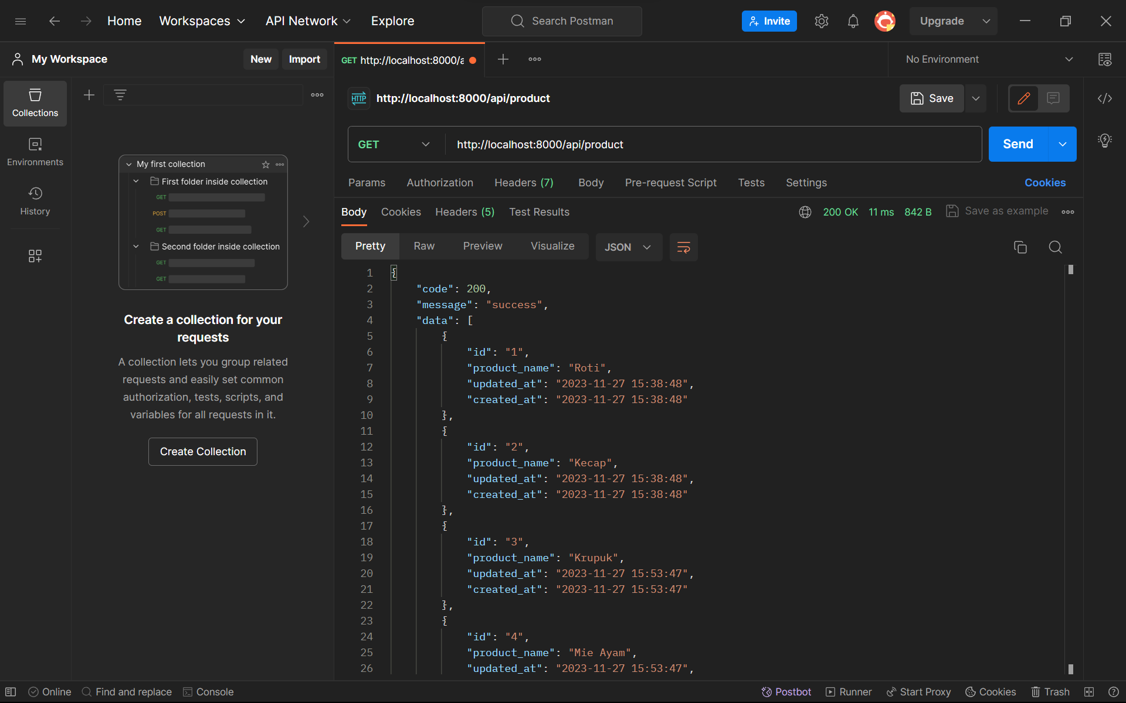 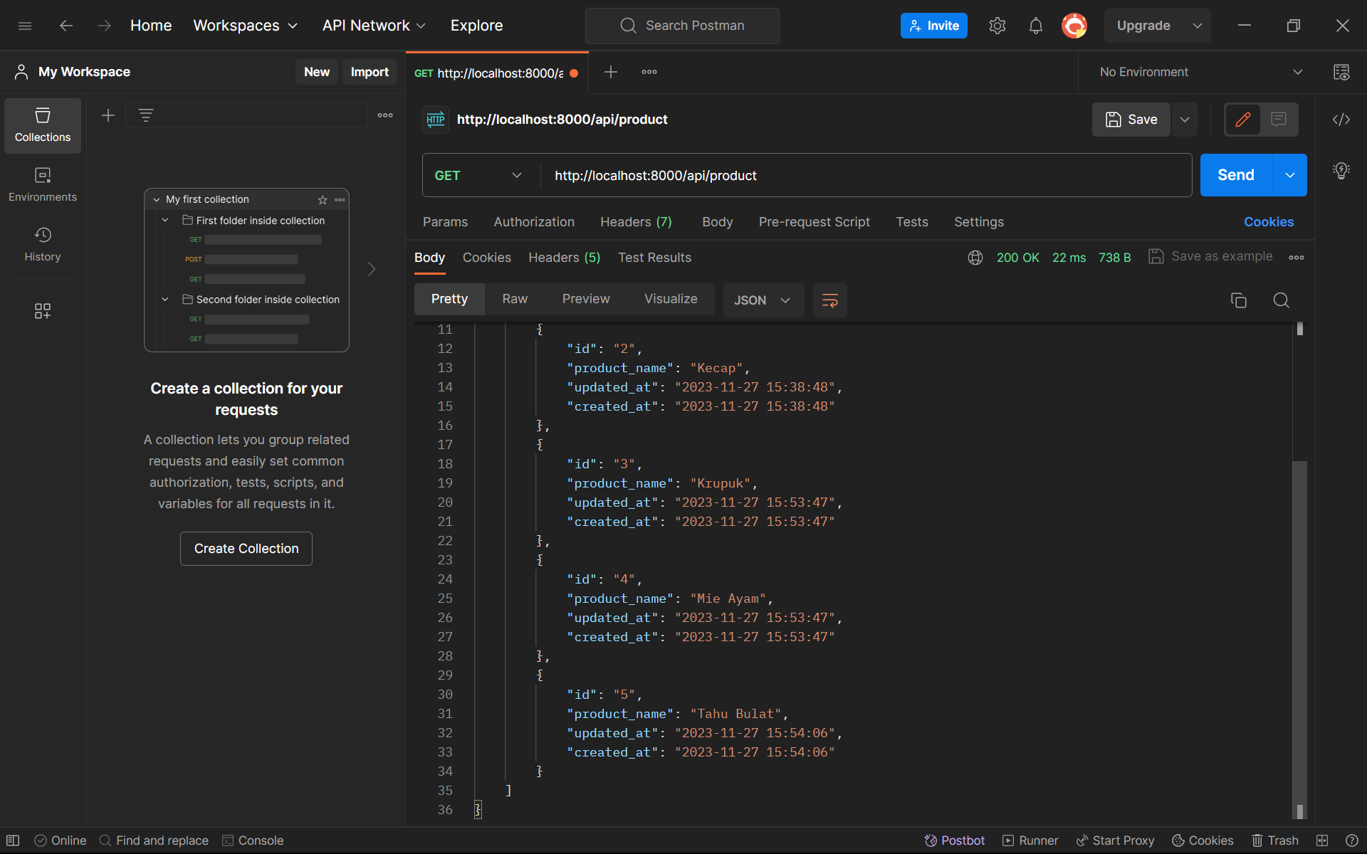

1. GET PRODUCT BY ID [GET]

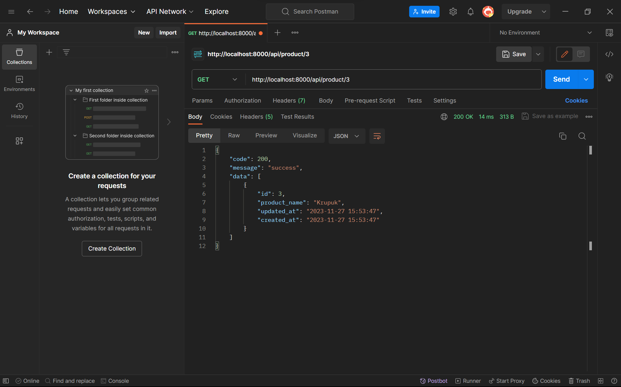

1. CREATE PRODUCT [POST]

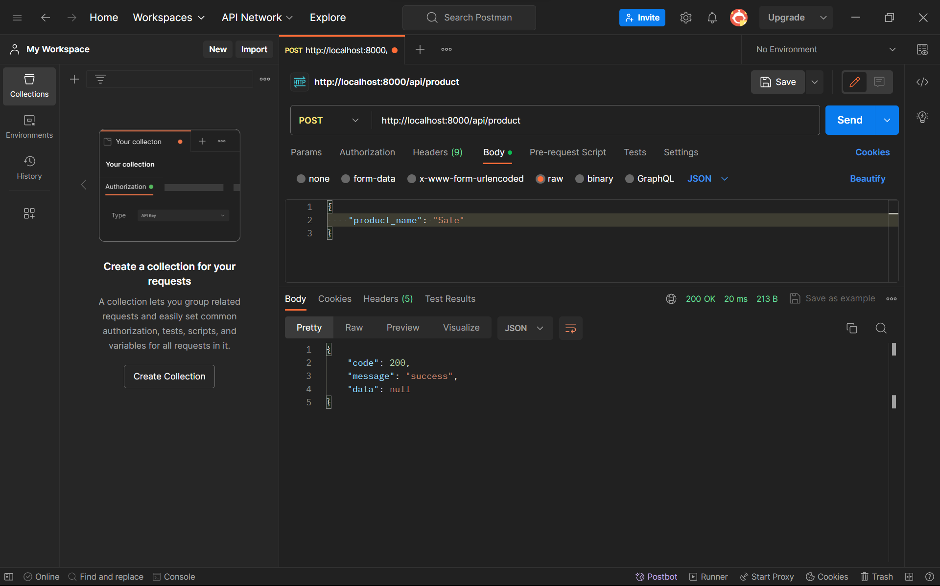

1. UPDATE PRODUCT BY ID [PUT]

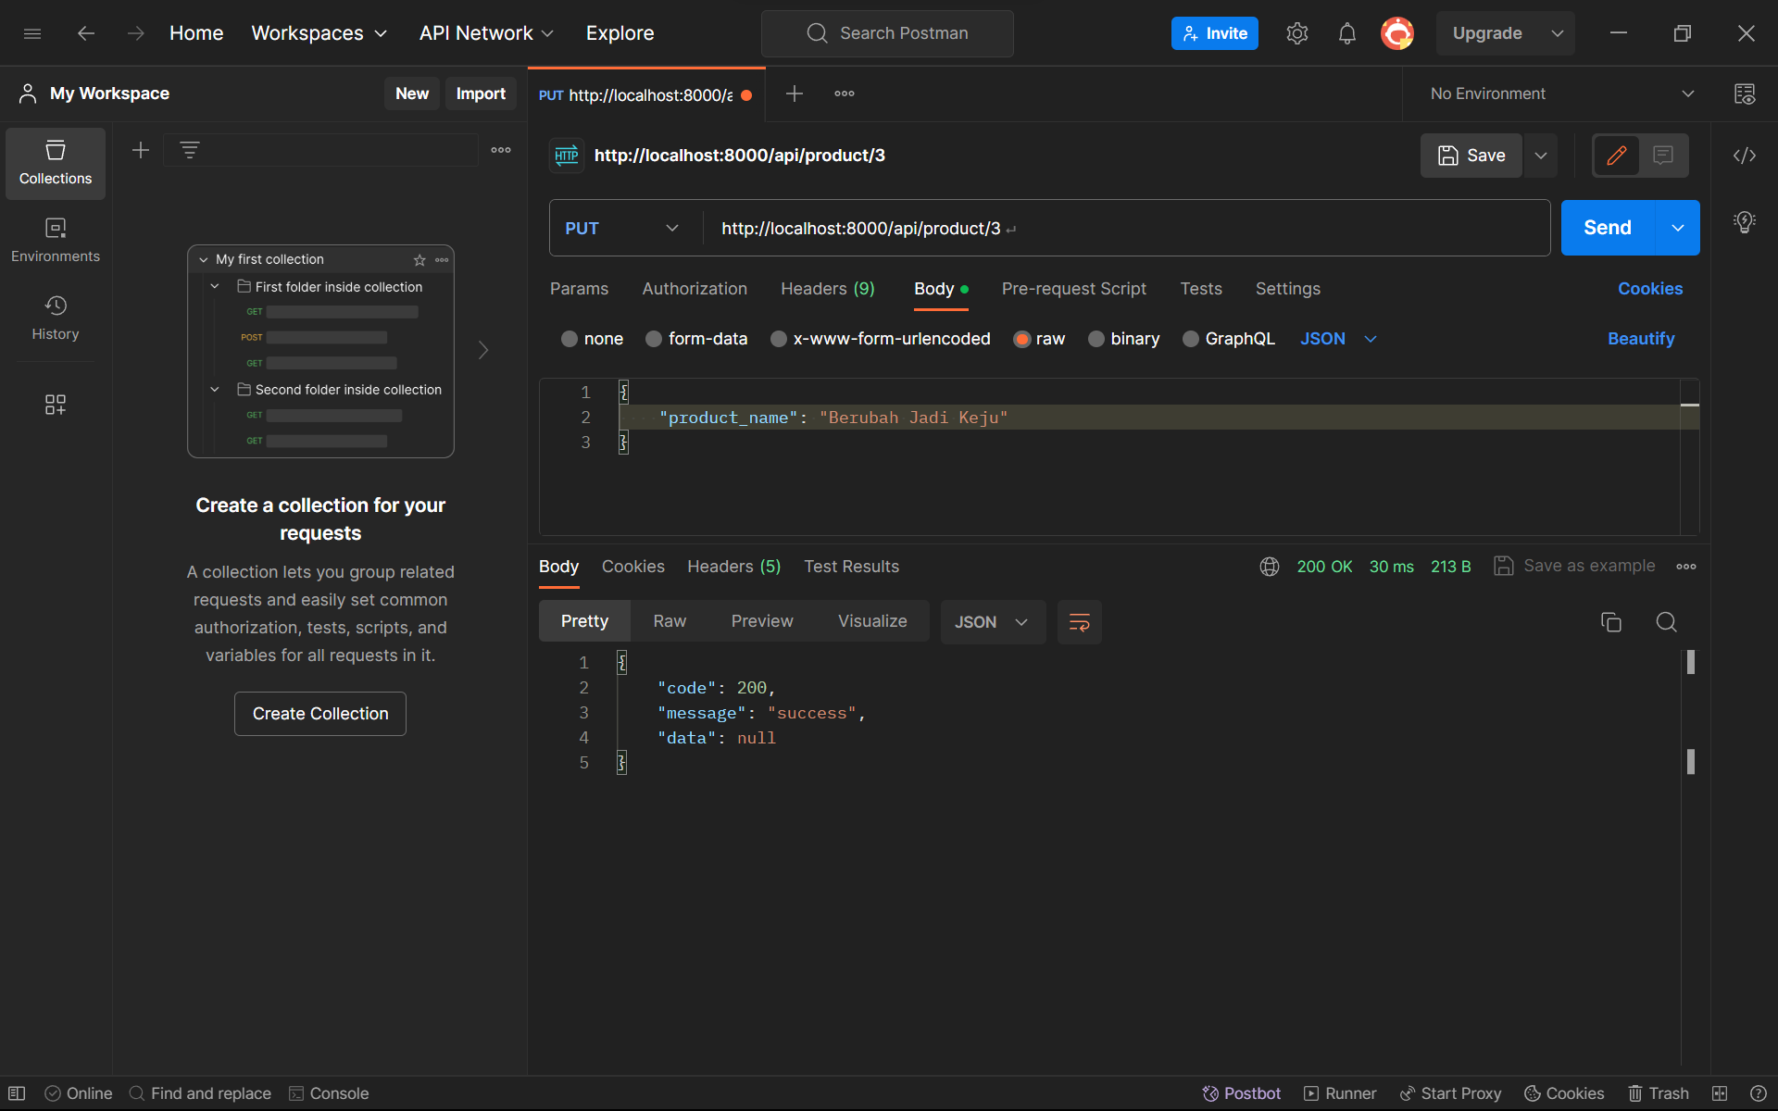

1. DELETE PRODUCT BY ID [DELETE]

