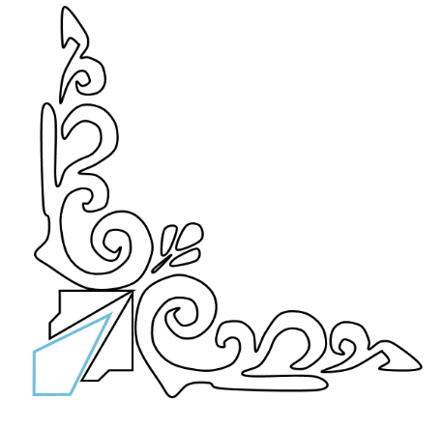

**ILLUMINATED, SOLITARY, INFINITE**

**PERFECTLY IMMOVABLE**

**FILLED WITH PRECIOUS VOLUMES**

**USELESS, INCORRUPTIBLE, SECRET**

**THE LIBRARY WILL LAST FOREVER**

**INVITATION**

