1.make sure you have python 3.9.13 installed in your laptop

If not ,I will give you the installer amd64 ,

Note .Click on checkbox that says Add to path when you first time install ,

And click on install ,then next ,next and close.

Now check inside command promt .

Note:To predict face landmarking we have use (shape_predictor_68_face_landmarks.dat)

This Is dat file ,for this we need dlib to process this file which donot support for pyton greater than

Python v-11,so we need every thing in 3.9.1 ,most stable ,and don’t go for Conda

*To open the folder in vscode

C:\path…\ Drowsiness-Detection>code .

Then after enter, vscode window will open with folder structure.

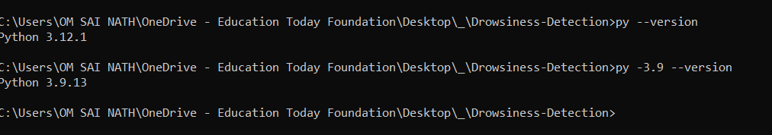

Normal version will show like python 3.12.1

But we want 3.9 also, In the global path.so make sure to check that add to path.

2)after extracting the folder make sure to remain inside your project folder ,because know we will make virtual env, package venv comes preinstalled ,no need to pip install venv

C:\path…\ Drowsiness-Detection>py -3.9 -m venv env39

This will create folder name env39,project folder structure will be this,later after running datset folder will be formed ,you can delete it again and again ,if not needed.

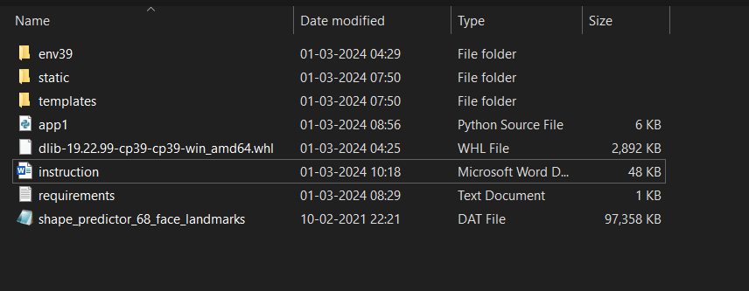

Now activate your virtual environment

C:\path…\ Drowsiness-Detection>env39\Scripts\activate

(env39) C:\path…\ Drowsiness-Detection> like this will come it means you are in virtual env

To deactivate ->>(env39) C:\path…\ Drowsiness-Detection> deactivate

3)Install required package

(env39) C:\path…\ Drowsiness-Detection>pip install -r requirements.txt

(env39) C:\path…\ Drowsiness-Detection>python -m pip install dlib-19.22.99-cp39-cp39-win_amd64.whl

This file dlib-…….amd64.whl will be given in compressed file

4)Now simpliy run the website by python app1.py

(env39) C:\path…\ Drowsiness-Detection>python app1.py

5)If any error comes like this cv2 not found then take a look over requirements.txt ,

And manually install each package seperatly by pip install <package name>

For example:cv2 not found

(env39) C:\path…\ Drowsiness-Detection>pip install opencv-python

(env39) C:\path…\ Drowsiness-Detection>pip install opencv-contrib-python

(env39) C:\path…\ Drowsiness-Detection>pip install opencv-python-headless

For cv2 we need to install 3 packages and <package name> are given in requirements.txt

opencv-contrib-python==4.9.0.80

opencv-python==4.9.0.80

opencv-python-headless==4.9.0.80

5) again after installation (env39) C:\path…\ Drowsiness-Detection>python app1.py

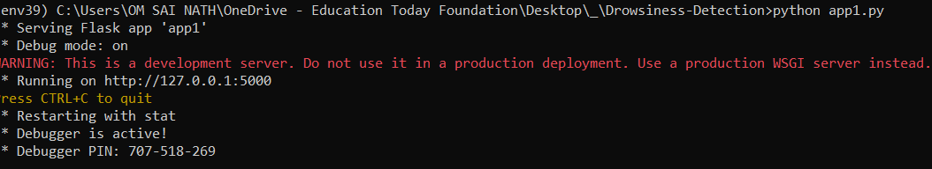

Open <https://127.0.0.1:5000/> in browser and scroll down ,you can see the get ,post request in cmd.

6) in cmd to kill the process enter ctrl+C so that you will come out of ongoing process

7)Make sure to deactivate command. Otherwise it will still run somewhere venv.