**Recruitment Management System**

***This project report is submitted to***

**Yeshwantrao Chavan College of Engineering, Nagpur**

***(An Autonomous Institution Affiliated to Rashtrasant Tukdoji Maharaj Nagpur University)***

***In partial fulfillment of the requirement***

***For the award of the degree***

***Of***

**Bachelor of Engineering in Information Technology**

**By**

**Mr. Shubham Ganvir**

**Mr. Mayur Choure**

**Mr. Cassablonka Pimpalapure**

**Mr. Siddhant Khandwe**

**VIII Sem. B.E. (IT)**

***Under the guidance of***

***Prof. Nisha Wankhede And***

***CO-Guide***

***Mr. Kushal Shah***

***Undertaken at***

 Arista Infotech Pvt. Ltd.

**DEPARTMENT OF INFORMATION TECHNOLOGY**

**Nagar Yuwak Shikshan Sanstha’s**

**YESHWANTRAO CHAVAN COLLEGE OF ENGINEERING**

**(An autonomous institution affiliated to Rashtrasant Tukadoji Maharaj Nagpur University)**

**NAGPUR – 441 110**

**2018-2019**

**CERTIFICATE OF APPROVAL**

Certified that the project report entitled “**Recruitment Management System**” has been successfully completed by **Mr. Shubham Ganvir, Mr. Mayur Choure, Mr. Cassablonka Pimpalapure, Mr. Siddhant Khandwe** under the guidance of **Prof. Nisha Wankhede and Mr. Kushal Shah** in recognition to the partial fulfillment for the award of the degree of Bachelors of Engineering in Information Technology, **Yeshwantrao Chavan College of Engineering *(An Autonomous Institution Affiliated to Rashtrasant Tukdoji Maharaj Nagpur University).*** The work has beencarried out under our supervision of *Mr. Kushal Shah* at ***Arista Infotech Pvt. Ltd.***

|  |  |
| --- | --- |
| **Mr. Kushal Shah**  Technical Head  Arista Infotech Pvt. Ltd.  Nagpur | **Prof. Nisha Wankhede**  Assistant Professor  Department of Information Technology Y.C.C.E, Nagpur |

|  |  |
| --- | --- |
| **Prof. B. U. Bawankar**  In-charge, Projects  Department of Information Technology Y.C.C.E, Nagpur | **Prof. R. C. Dharmik**  Head of Department,  Department of Information Technology Y.C.C.E, Nagpur |

Signature of External Examiner

Name:

Date of Examination:

**DECLARATION**

We certify that

1. The work contained in this project has been done by me under the guidance of my supervisor(s).
2. The work has not been submitted to any other Institute for any degree or diploma.
3. We have followed the guidelines provided by the Institute in preparing the project report.
4. We have conformed to the norms and guidelines given in the Ethical Code of Conduct of the Institute.
5. Whenever we have used materials (data, theoretical analysis, figures, and text) from other sources, we have given due credit to them by citing them in the text of the report and giving their details in the references. Further, we have taken permission from the copyright owners of the sources, whenever necessary.

Signature of the Students

Shubham Ganvir

Mayur Choure

Cassablonka Pimpalapure

Siddhant Khandwe

**ACKNOWLEDGEMENT**

We take this opportunity to express a deep sense of gratitude towards our guide **Prof. Nisha Wankhede and Mr. Kushal Shah** for providing excellent guidance, encouragement, and inspiration throughout the project work. Without their valuable guidance, this work would never have been a successful one. He/she is one of the best mentors, we will always be thankful to them.

We would like to extend our special thanks to our Project Coordinator Mr**. Bhushan U. Bawankar** who has helped us directly or indirectly to complete this project work.

We would like to thank **Prof. R. C. Dharmik**, Head of the Department of Information Technology. He was very helpful and encouraging while doing research work.

We would like to thank **Dr. U. P. Waghe**, Principal (YCCE) who has provided all institutional facilities as and when needed.

We would also like to thank all our classmates for their valuable suggestions and helpful discussions. Our thanks also goes to everyone who has supported us to complete the research work directly or indirectly.

Finally, we are extremely grateful to our parents for their love, prayers, care and sacrifices for educating and preparing us for our future.

**CONTENTS**

|  |  |  |  |
| --- | --- | --- | --- |
|  | |  | **Page No.** |
|  | | Title page |  |
|  | | Certificate of Approval |  |
|  | | Declaration |  |
|  | | Acknowledgement |  |
|  | | Industry Certificate |  |
|  | | List of Figures | i |
|  | | List of Abbreviations | iii |
|  | | Abstract | v |
|  | |  |  |
| **Chapter 1** | | **Introduction** | 1 |
|  | | * 1. Overview | 1 |
|  | | * 1. Problem Definition | 1 |
|  | | * 1. Thesis Objectives | 2 |
|  | | * 1. Thesis Contribution | 3 |
|  | |  |  |
| **Chapter 2** | | **Literature Review** | 4 |
|  | |  |  |
| **Chapter 3** | | **Work Done** | 6 |
|  | | 3.1 Eclipse IDE | 6 |
|  | | 3.2 XAMPP | 8 |
|  | | 3.2.1 XAMPP installation steps | 9 |
|  | |  |  |
|  | | 3.3 Tomcat server | 12 |
|  | | 3.3.1 Tomcat server installation steps | 13 |
|  | | 3.4 Integrating Apache tomcat with Eclipse IDE | 14 |
|  | | 3.5 Project Flowchart | 15 |
|  | | 3.6 Creating Tables in database | 16 |
|  | |  |  |
|  | |  |  |
|  | |  |  |
|  | |  |  |
|  | |  |  |
|  | |  |  |
|  | |  |  |
| **Chapter 4** | | **Results and Discussions** | 24 |
|  | | 4.1 Login page | 24 |
|  | | 4.2 Home page | 28 |
|  | | 4.3 Edit form  4.4 Application form  4.5 In | 29 |
|  | |  |  |
| **Chapter 5** | | **Summary and Conclusions** | 35 |
|  | 5.1 Summary | 35 |
|  | 5.2 Conclusions | 35 |
|  | 5.3 Future Scope | 35 |
|  |  |  |
| **Chapter 6** | **Appendix** | 36 |
|  |  |  |
| **Chapter 7** | **References** | 37 |
|  |  |  |
|  |  |  |
|  |  |  |

**LIST OF FIGURES**

|  |  |  |
| --- | --- | --- |
| **Fig No.** | **Figure Title** | **Page No.** |
| Fig 3.1 | Eclipse IDE | 6 |
| Fig 3.1.1 | Eclipse .exe file permission | 8 |
| Fig 3.1.2 | Selection of eclipse workspace folder | 9 |
| Fig 3.1.3 | Loading eclipse workbench | 12 |
| Fig 3.2 | Xampp welcome wizard | 13 |
| Fig 3.2.1 | Components to install | 14 |
| Fig 3.2.2 | Choosing install location | 14 |
| Fig 3.2.3 | Xampp Control Panel | 15 |
| Fig 3.3 | Choosing Tomcat components to install | 16 |
| Fig 3.3.1 | Tomcat configuration window | 17 |
| Fig 3.3.2 | Setting up path of JRE | 17 |
| Fig 3.3.3 | Choose install location | 18 |
| Fig 3.3.4 | Installing Tomcat | 18 |
| Fig 3.3.5 | Successful installation of Tomcat | 19 |
| Fig 3.4 | Selecting Tomcat version in Eclipse | 19 |
| Fig 3.4.1 | Specify the installation directory | 20 |
| Fig 3.4.2 | Starting the server | 21 |
| Fig 3.5 | Project flowchart | 21 |
| Fig 3.6 | Job application table in database | 22 |
| Fig 3.6.1 | Job opening table | 23 |
| Fig 3.6.2 | Login table | 24 |
| Fig 3.6.3 | Interview table | 24 |
| Fig 4.1 | Login page | 24 |
| Fig 4.2 | Home page | 25 |
| Fig 4.2.1 | Page with eligible candidates | 25 |
| Fig 4.3 | Edit form | 25 |
| Fig 4.4 | Application form | 26 |
| Fig 4.5 | Interview page | 26 |
| Fig 4.5.1 | Interview Round0 | 26 |
| Fig 4.5.2 | Interview Round1 | 26 |
| Fig 4.5.3 | Interview Round2 | 27 |
| Fig 4.5.4 | Final Interview Round | 27 |
| Fig 4.5.5 | Feedback page | 28 |
| Fig 4.6 | Classes in the project | 28 |
| Fig 4.6.1 | Project overview |  |
| Fig 4.6.2 | Methods in Login bean |  |
| Fig 4.6.3 | Method details |  |

**LIST OF ABBREVIATIONS**

|  |  |
| --- | --- |
| JSP | Java Server Pages |
| CSS | Cascaded Style Sheet |
| HR | Human Resource |
| RMS | Recruitment Management System |
| HTML | Hypertext Markup Language |
| SQL | Structured Query Language |
| PHP | Hypertext Processor |
| MVC | Modal View Controller |
| IDE | Integrated Development Environment |
| XAMPP | Cross Platform(X) Apache(A) MySQL(M) PHP(P) and Perl(P) |
| JRE | Java Runtime Environment |
| HTTP | Hypertext Transfer Protocol |

**ABSTRACT**

The present recruitment process at Arista Infotech is fairly manual. The HR has to manually conduct interviews, organize applications, sort the applications if they meet different criteria corresponding to different job profiles and maintain applicant records for future. This process involves rigorous paper work which makes it tedious and complex.

The main objective of the system is to simplify and effectively automate the recruitment process of Arista Infotech. The system will provide functionalities such as job posting and editing, saving applications, sorting applications, calling candidates for interviews and updating status of different stages of interviews.

The system is developed using java language involving both the core and advanced concepts of the language. Inputs are taken and outputs displayed with the help of Java server pages and the values are saved in the mysql database. CSS is used to enhance the appearance of the pages.

**Keywords:** Recruitment process, HR, job vacancy, applications

**Chapter 1**

**Introduction**

**Chapter 1. Introduction**

**1.1 Overview**

A recruitment management system (RMS) is a set of tools designed to manage the recruiting process. It is the most important core human resource (HR) system. Recruiting is competitive, especially for those with high-demand technical skills, and its driving interest in sophisticated recruiting systems. These systems are designed to improve the efficiency of recruiters as well as job seekers.

In this project, we are developing a recruitment management system which will help the HR in managing the recruitment process of the company effectively. Right from posting active vacancies in the company and updating them to sorting out all the incoming applications and organizing different interview rounds for the same, the recruitment system will have all that is needed to make the HR recruiting process hassle free. The approach used in the building of this project is known as MVC i.e. modal, view and controller. The modal consists of database connection and all the methods relevant to the code. The modal basically is the repository for inputs, source or storage. Controller contains the actual business logic. We have incurred the controller for the login functionality of our project whereas for the navigation between different pages, we have adopted simple navigation through jsp pages. The view contains the jsp and html files of the web pages.

**1.2 Problem Definition**

Recruitment is a function of human resources and is devoted to finding the right candidates for open positions, and also for managing the hiring process. A successful recruitment process **attracts a deep well of talent**from which to choose; it includes everything from a compelling job description to an efficient and engaging interview process – to the ultimate job offer. Although most companies invest a great deal of time, energy and money into creating an effective process that attracts the most qualified candidates, the recruitment process itself has several **inherent weaknesses**that can affect how well it works.

The current recruitment process at Arista Infotech involves rigorous manual work. At certain instances, candidates fill up applications even being aware they don’t fulfill the respective job criteria. This adds to the existing workload of the HR where along with shortlisting candidates, the HR has to also eliminate irrelevant applications manually. The process is time consuming. Also, after a candidate goes through different stages of interviews, the HR has to manually maintain each form and update the interview result during each stage

**1.3 Thesis Objectives**

The objectives of the recruitment management system for providing different functionalities with respect to the recruitment process of the company. The usage rights would be exclusive to the company HR. The HR will have various operations at its disposal. Adding, updating and deleting job vacancy is one of the many functionalities. The applications received would be displayed in a list. The HR can edit or delete the applications from the system which would ultimately result in its removal from the database. The additional feature of the system is that of sorting the applications. The logic for filtering the incoming applications has been implemented using java in the backend. Each row of a job vacancy would contain details regarding that very job and links to edit or delete the job. Additionally the ‘eligible’ link when clicked upon would filter and display a list of candidates who satisfy the criteria corresponding to that job.

**1.4 Thesis Contribution**

**Chapter 1. Introduction –** This chapter gives a lucid overview and objectives of the project.

It gives a brief introduction about need of Recruitment Management System. Problem definition gives a detailed description that pin points a specific problem.

**Chapter 2. Review of Literature –** This chapter gives the list and description of the literature studied. The review describes, summarizes, evaluate and clarify the literature cited.

**Chapter 3. Work Done –** This chapter gives the information about the results of comparison between the previous approach and the advantages of using Recruitment Management System.

**Chapter 4. Result and Discussion –** This chapter discuss about the results of comparison between the previous approach and the advantages of using Recruitment Management System.

**Chapter 6. Appendix –** This chapter gives the detail about design pattern.

**Chapter 7. References –** This chapter gives detail about references and publication details.

**Chapter 2**

**Review of Literature**

**Chapter 2. Review of Literature**

There are various recruitment portals available online which we helmed as reference to build our recruitment system which are mentioned below.

[1] Naukri.com

Naukri.com is an Indian [job portal](https://en.wikipedia.org/wiki/Job_portal) operating in [India](https://en.wikipedia.org/wiki/India) founded in March 1997. The website follows Business-to-Business and Business-to-Consumer model which simply implies that the website acts as a beneficiary to both recruiters as well as job seekers. It enables its recruiters to streamline their recruitment process taking away the hassles of clogged email boxes. Their aim is to enhance, simplify and reduce the recruitment cycle. We mainly referred the website to understand the user interface aspects for our project. [7]

[2] Indeed.com

Indeed is an American worldwide employment-related search engine for job listings launched in November 2004. The site aggregates job listings from thousands of websites, including job boards, staffing firms, associations, and company career pages. It enables its recruiters to enhance, simplify and reduce the recruitment cycle. [9]

[3] W3schools.com

W3Schools is a web developers’ site, with tutorials and references on web development languages such as HTML, CSS, JavaScript, PHP, SQL, Python, jQuery, Java, W3.CSS, and Bootstrap, covering most aspects of web programming. W3schools presents thousands of code examples. By using their online editor, ‘Try It Yourself’, we can edit examples and execute computer code experimentally, to see what works and what does not, before implementing it. We referred W3Schools layout and presentation over alternative sites for HTML, CSS, SQL, and basic JavaScript concepts. [1]

[4] Tutorialspoint.com

Tutorialspoint.com is a dedicated website to provide quality online education in the domains of Computer Science, Information Technology, Programming Languages, and other Engineering as well as Management subjects. It provides great content on a host of domains and subjects. With respect to our work, we referred the website regarding html, CSS and java concepts. [3]

[5] Javatpoint.com

JavaTpoint provides easy and point to point learning of various online tutorials such as Java Tutorial, Core Java Tutorial, Android, Design Pattern, JavaScript, AJAX, SQL, Cloud Computing, Python etc. JavaTpoint’s java server pages (JSP) tutorial contains different modules like like JSP crud, JSP life cycle among others. [2]

[6] Head First Servlets & JSP

Head First Servlets & JSP is a book authored by Bryan Basham, Kathy Sierra and Bert Bates. The book focuses more on the importance and role of servlets and JSPs in building web applications. The book also emphasizes on the MVC approach in building a web application. There are host of other different topics discussed in detailed in the book such as web app deployment, web app security, custom tag development and session management. [4]

**Chapter 3**

**Work Done**

**Chapter 3. Work Done**

The software requirements necessary for the implementation of the project work are described in the section below.

**3.1 Eclipse IDE**



Fig. 3.1 Eclipse IDE (2018-12) Software

Eclipse is an integrated development environment (IDE) used in computer programming, and is the most widely used Java IDE. It contains a base workspace and an extensible plug-in system for customizing the environment. Eclipse is written mostly in Java and its primary use is for developing Java applications, but it may also be used to develop applications in other programming languages.

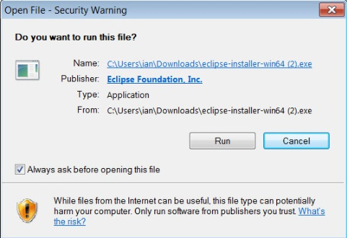

Fig.3.1.1 Eclipse .exe file run permission

The above figure shows the window which appears when you run the downloaded .exe type eclipse file.

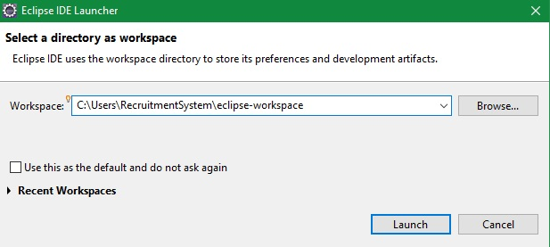

Fig. 3.1.2 Selection of eclipse workspace folder



Fig.3.1.3 Loading Eclipse Workbench

Above figures 3.1.3 and 3.1.4 shows the launching of Eclipse workbench which will then open the workspace window where we can open our existing projects or create new ones.

**3.2 XAMPP**

XAMPP stands for Cross-Platform (X), Apache (A), MySQL (M), PHP (P) and Perl (P). It is a simple, lightweight Apache distribution that makes it extremely easy for developers to create a local web server for testing purposes. Everything you need to set up a web server – server application (Apache), database (MySQL), and scripting language (PHP) – is included in a simple extractable file. XAMPP is also cross-platform, which means it works equally well on Linux, Mac and Windows. Since most actual web server deployments use the same components as XAMPP, it makes transitioning from a local test server to a live server is extremely easy as well.

XAMPP has four primary components. These are:

**1. Apache:** Apache is the actual web server application that processes and delivers web content to a computer. Apache is the most popular web server online, powering nearly 54% of all websites.

**2. MySQL:** Every web application, howsoever simple or complicated, requires a database for storing collected data. MySQL, which is open source, is the world’s most popular database management system. It powers everything from hobbyist websites to professional platforms like WordPress.

**3. PHP:** PHP stands for Hypertext Preprocessor. It is a server-side scripting language that powers some of the most popular websites in the world, including WordPress and Facebook. It is open source, relatively easy to learn, and works perfectly with MySQL, making it a popular choice for web developers.

**4. Perl**: Perl is a high-level, dynamic programming language used extensively in network programming, system admin, etc. Although less popular for web development purposes, Perl has a lot of niche applications.

**3.2.1 XAMPP installation steps**

**Step 1:** Start the installation process by double-clicking on the XAMPP installer. Click ‘Next’ after the splash screen.

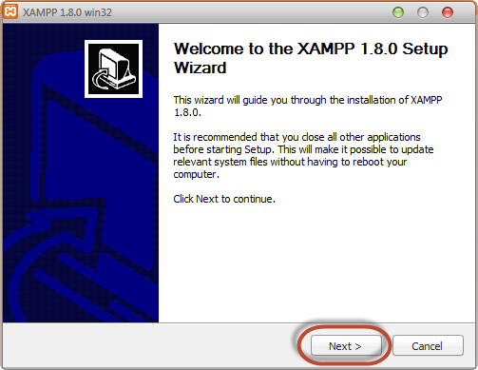

Fig. 3.2 Xampp Welcome Wizard

**Step 2**: Here, you can select the components you want to install. Choose the default selection and click ‘Next’.

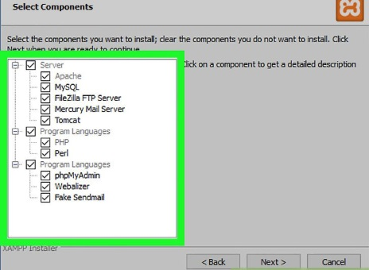

Fig. 3.2.1 Selecting components to install

**Step 3**: Choose the folder you want to install XAMPP in. This folder will hold all your web application files, so make sure to select a drive that has plenty of space.

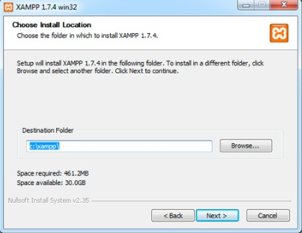

Fig. 3.2.2 Choosing install location

**Step 4:** Setup is now ready to install XAMPP. Click Next and wait for the installer to unpack and install selected components. This may take a few minutes. You may be asked to approve Firewall access to certain components (such as Apache) during the installation process.

**Step 5:** Installation is now complete! Select the ‘Do you want to start the Control Panel now?’ checkbox to open the XAMPP control panel.

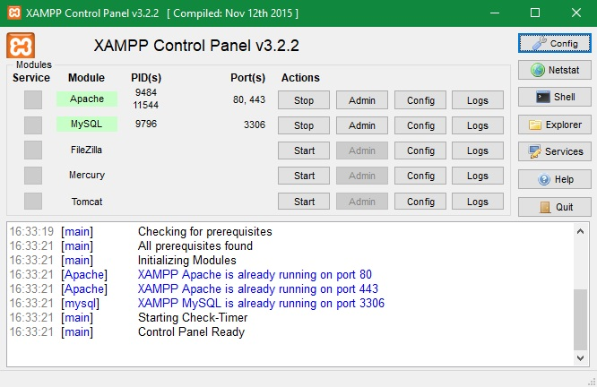

Fig. 3.2.3 XAMPP Control Panel

The above Fig. 3.2.4 shows the control panel which opens after the successful installation of XAMPP.

To launch mysql database and Apache Tomcat server, click on the respective admin buttons of both the modules.

**3.3 Tomcat Server**

Tomcat is an [application server](https://searchsqlserver.techtarget.com/definition/application-server) from the Apache Software Foundation that executes Java [servlet](https://searchmicroservices.techtarget.com/definition/servlet)s and renders Web pages that include [Java Server Page](https://www.theserverside.com/definition/Java-Server-Page-JSP) coding. Described as a "reference implementation" of the Java Servlet and the Java Server Page specifications, Tomcat is available from the Apache website in both binary and source versions. Tomcat can be used as either a standalone product with its own internal [Web server](https://whatis.techtarget.com/definition/Web-server) or together with other Web servers. Tomcat requires a Java Runtime Enterprise Environment that conforms to JRE 1.1 or later.

**3.3.1. Tomcat server installation steps**

**Step 1:** Download and install tomcat version 9 from <https://tomcat.apache.org> .

**Step 2:** Selection of components (features) of Apache Tomcat which we want to install.

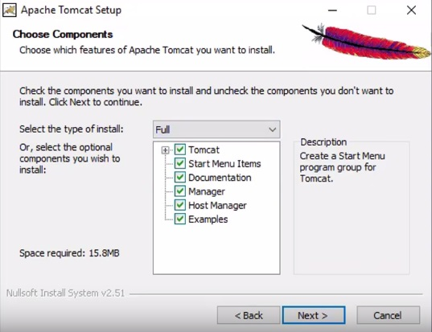

Fig. 3.3 Choose Tomcat components to install

**Step 3:** Setting up basic Tomcat configuration

Here we can set the service name, the shutdown port and the running port of tomcat, by default tomcat runs on port 8080, so we can keep the default configuration as it is, or we can always change this configuration after the installation.

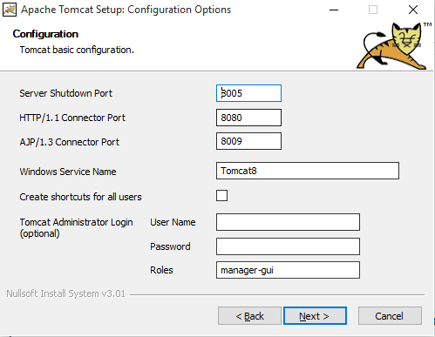

Fig. 3.3.1 Tomcat configuration window

**Step 3:** Specify the path to the Java Runtime environment

Tomcat will need to know where you have installed java. To do this, you will need to set the environment variable (where you installed java).

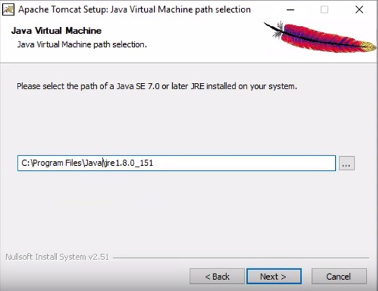

Fig. 3.3.2 Setting up path of Java Runtime Environment

**Step 4:** Choose the folder in which we want to install Apache Tomcat

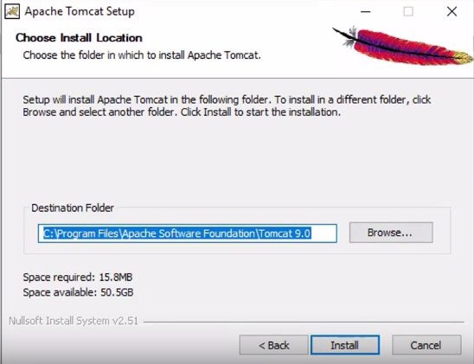

Fig.3.3.3 Choose install location

**Step 5:** Click on install to start the installation process

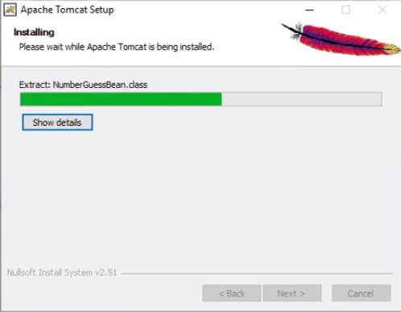

Fig.3.3.4 Installing tomcat

**Step 6:** Click finish when installation is complete

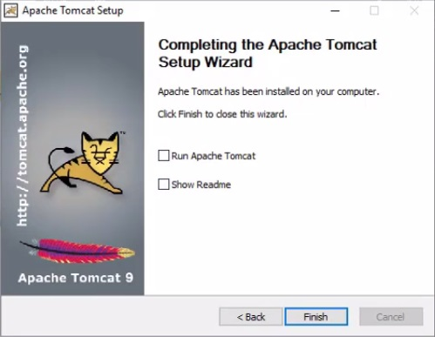

Fig.3.3.5 Successful installation of Tomcat

**3.4 Integrating Apache Tomcat with Eclipse IDE**

**Step 1:** Open Eclipse Environment. Click on ‘servers’ tab. Then click on the ‘No servers are available’ link. Select tomcat version 9.0 server and click next.

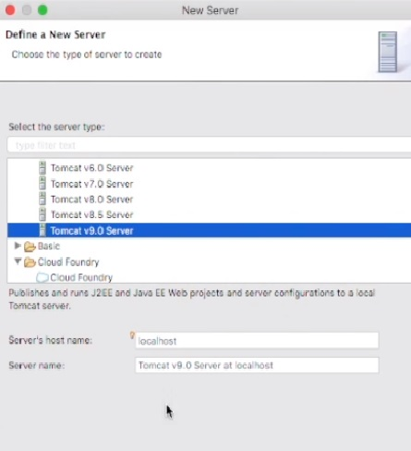

Fig.3.4 Select tomcat version in Eclipse

**Step 2:** Select Apache installation directory along with the installed JRE and click finish.

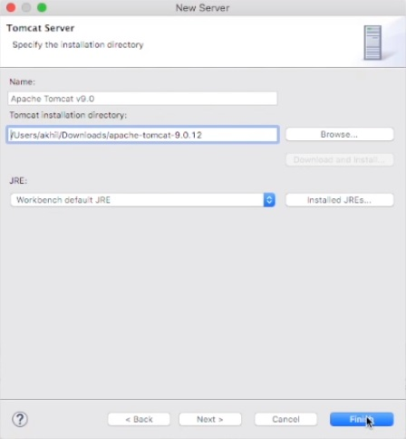

Fig.3.4.1 Specify the installation directory

**Step 3:** We’ll see ‘Tomcat version9.0 at localhost [Stopped, Republish] under the ‘servers’ tab. Double click on it and verify HTTP ports information and then start the server.

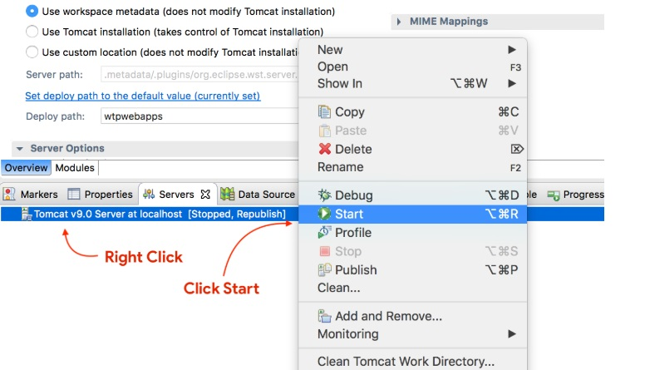

Fig.3.4.2 Starting the server

**3.5 Project Flowchart**

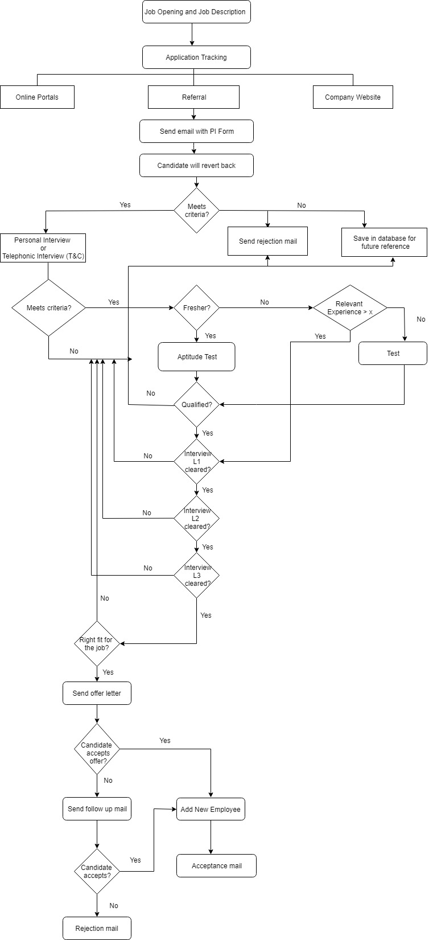

Fig.3.5 Project Flowchart

The given flowchart describes the current recruitment process at Arista Infotech. Our aim is to build a system that would effectively aid in automating the whole process.

**3.6 Creating tables in the database**

Our project will need database to store and retrieve values and data from different forms such as job opening, job application and interview forms. The tables formed are-

* Jobapp Table (Job Application)

- Contains attributes that correspond to the fields in job application form such as job application id, applicant name, salary, applicant gender etc.

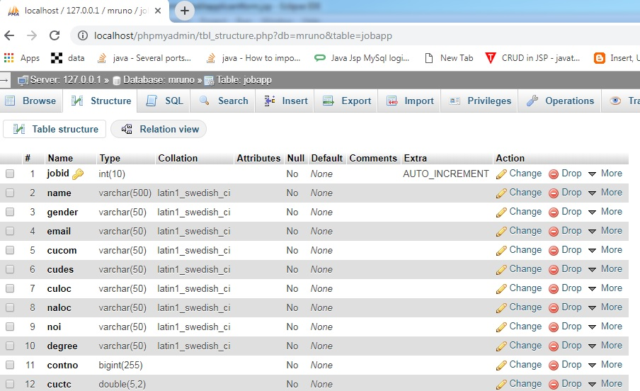

Fig. 3.6 Job Application table in database

* Jobop Table (Job Opening)

- Contains attributes that correspond to the fields in job opening form such as vacancy, required experience, skills required etc.

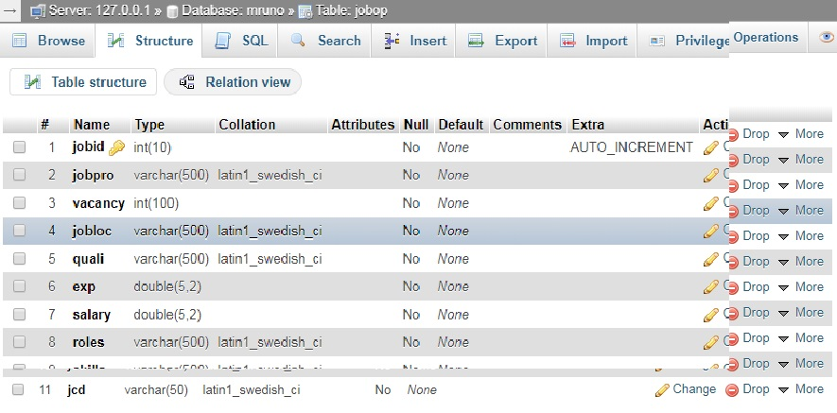

Fig. 3.6.1 Job Opening table

* Login Table

- The login table would primarily store the details username and password. These two fields will contain the details i.e. username and password of the person (in our project, the HR) who is authorized to get access to the fully functional system.

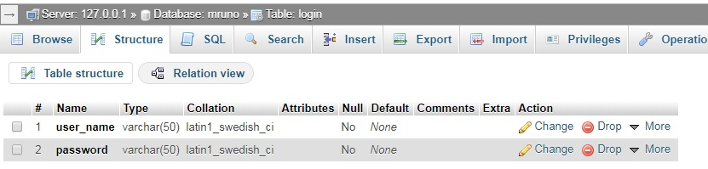

Fig. 3.6.2 Login table

* Interview Table

- The interview table would store details of different stages of the interviews such as round date, name of the person taking the interview, additional comments and status of that particular interview round. The status field is implemented as a drop down menu in the interview forms and has two fields- ‘accept’ and ‘reject’ except the final round form which has four fields, namely- ‘hired’, ‘rejected’, ‘hold’ and ‘future ‘reference’. Each interview stage also has an interview id associated with it which is the primary key in the table. While the job application id acts as the foreign key in the table. Job id will be used to fetch details of the respective applicant from the job application table so that we don’t have to add the details of applicant at each stage.

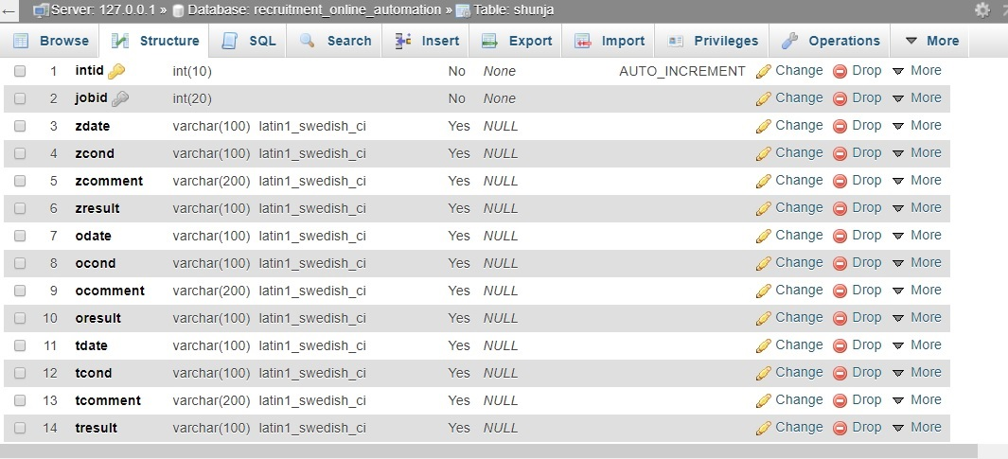

Fig. 3.6.3 Interview table

**Chapter 4**

**Results and Discussions**

**Chapter 4. Results and Discussions**

**4.1 Login page**



Fig. 4.1 Login page

The page displayed above will allow the user (the HR) to login. The page is designed using HTML and its appearance enhanced using CSS. If correct credentials are entered, the user will gain access to the system and would navigate ahead. In case the user enters incorrect credentials, a message asking them to enter the correct details would be displayed and they will be kept on the same page.

**4.2 The home page**

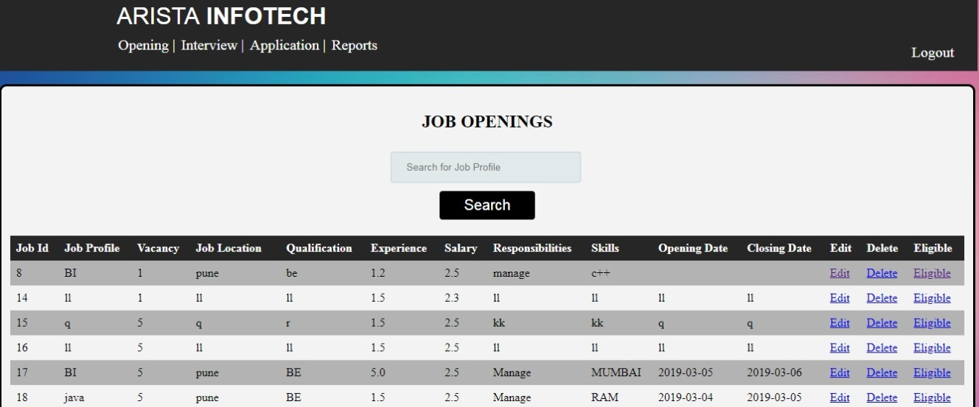Fig.4.2 Home Page

The home page indicates the page the page where user will be taken after a successful login. As per the requirements specified by the client i.e. the HR, the page will contain reports of different job openings in the company. This will enable the user to edit, delete or get a detailed list of qualified candidates who have applied to every respective active opening without going on a separate tab. Additionally, there’s a search button on the page. It allows the user to search a job name which in turn would give out list of all applicants (whether eligible or not) who have applied for that vacancy.

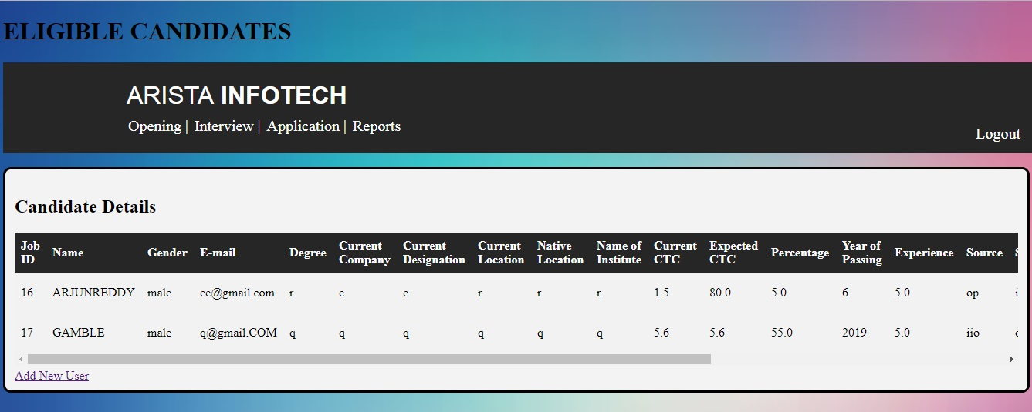

Fig. 4.2.1 List of eligible candidates

The above figure shows the page displays the list of candidates who have been found to be eligible for a particular job. Each row will have a candidate with his details and an interview link associated which when clicked will initiate his/her interview process i.e. the first round.

**4.3 Edit form**

The figure below shows the edit form developed using HTML, CSS and javascript. The form includes fields exactly identical to the form used to add new openings. The form will be used to update details of an existing job positions at the company such as closing date, opening date, no. of vacancies among others. An update button is given at the bottom of the page to save the changes. Any new changes made would be reflected in the database and values updated.

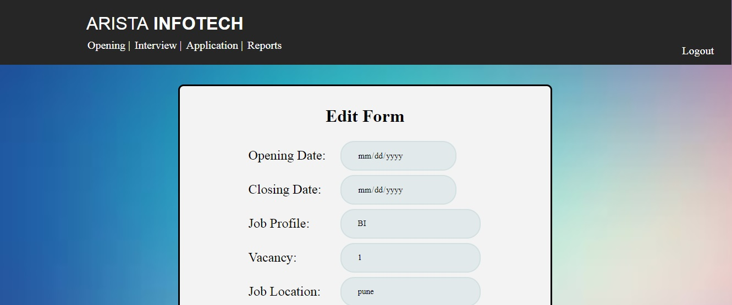

Fig. 4.3 Edit Form

**4.4 Application form**

This form refers to the form that the candidate would fill up while applying for a job vacancy in the company. The fields of the applicant form are- applicant’s name, gender, email, job profile, qualifications, current company and salary, expected salary etc. The corresponding job application table would be updated in the database when the applicant clicks the submit button on the form.

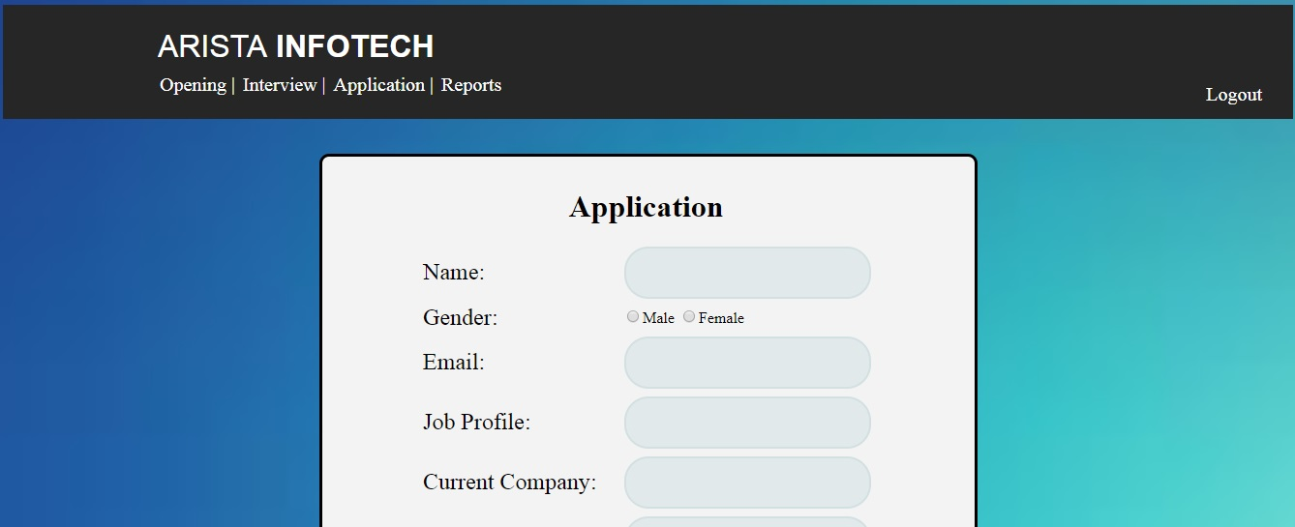

Fig. 4.4 Application Form

**4.5 Interview**

Once the list eligible candidates are discovered, they would consequently need to go through the interview process. With respect to the interview process at Arista Infotech, each candidate will go through four rigorous interview rounds which are round0, round1, round2 and the final round. Round0 refers to the HR round, Round1 would be a technical round, round2 will be conducted by the manager of the respective domain followed by the final round taken by the company head.

Each round of interview will have identical fields such as date, comments, name of the person who undertook the interview and finally the result of the same. The result of each interview would be updated according to the candidate’s status at each round/stage. Also, the candidate’s latest progression status of the interview process would be saved. If a candidate appears for two stages of interviews on different days, the system will have his status updated and will take the HR to the latest concerned round of the interviewing process. If an applicant fails to clear the first round, the HR would be navigated to the last page i.e. the feedback page.

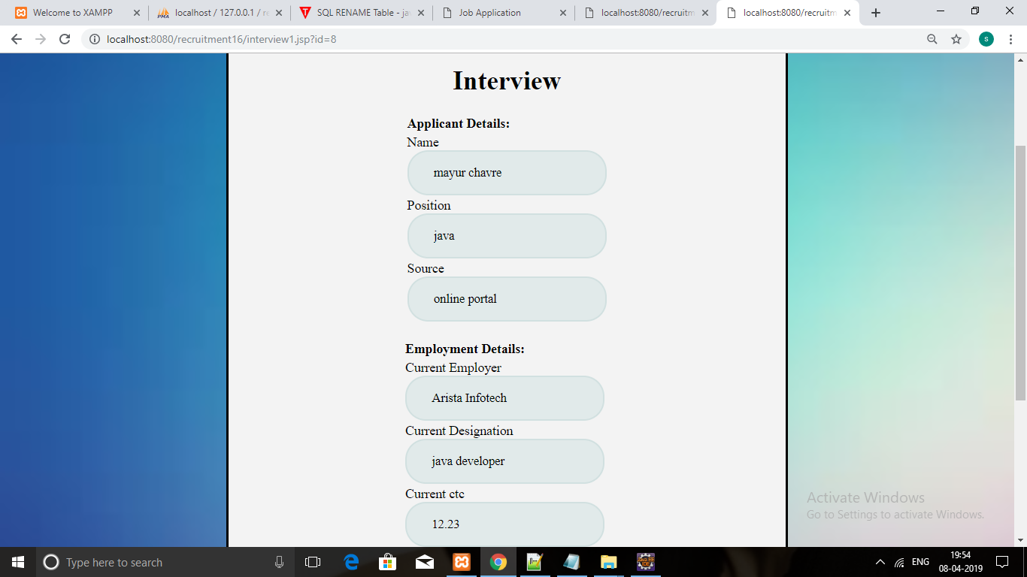

Fig. 4.5 Interview page

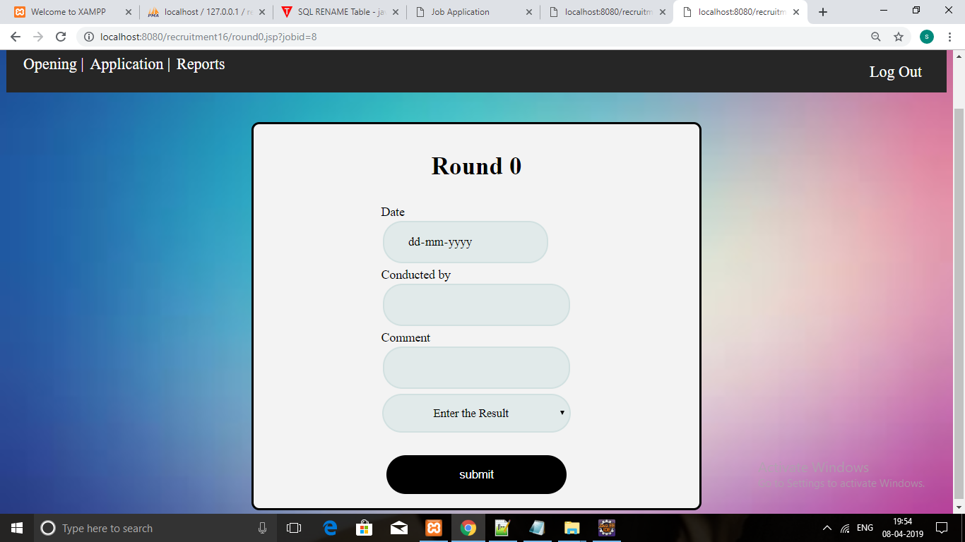

Fig.4.5.1 Interview Round0

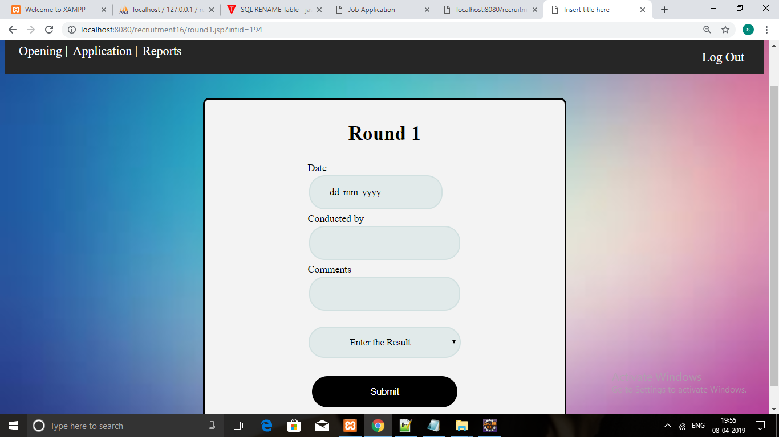

Fig.4.5.2 Interview Round1

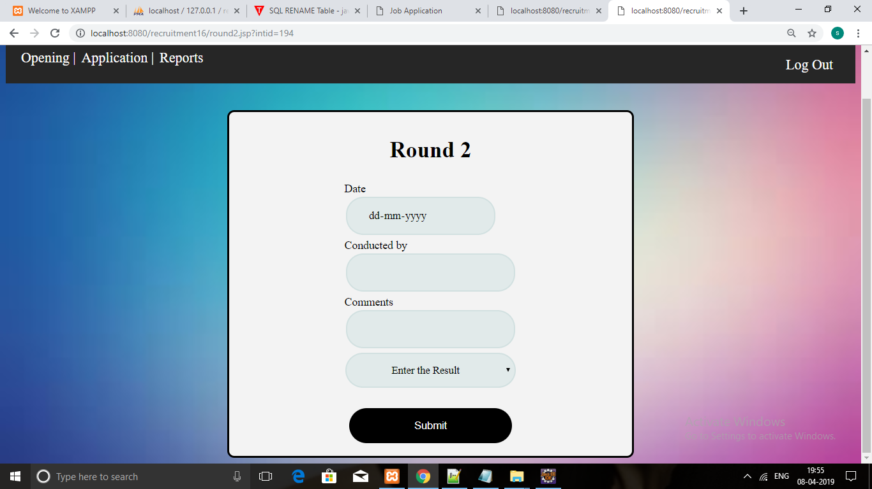

Fig.4.5.3 Interview Round3

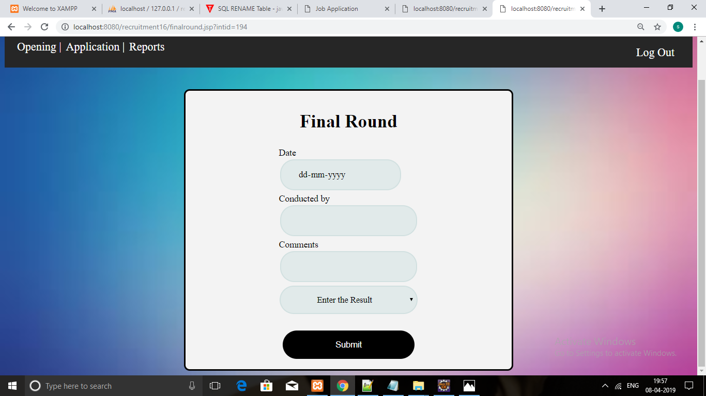

Fig.4.5.4 Final Interview Round

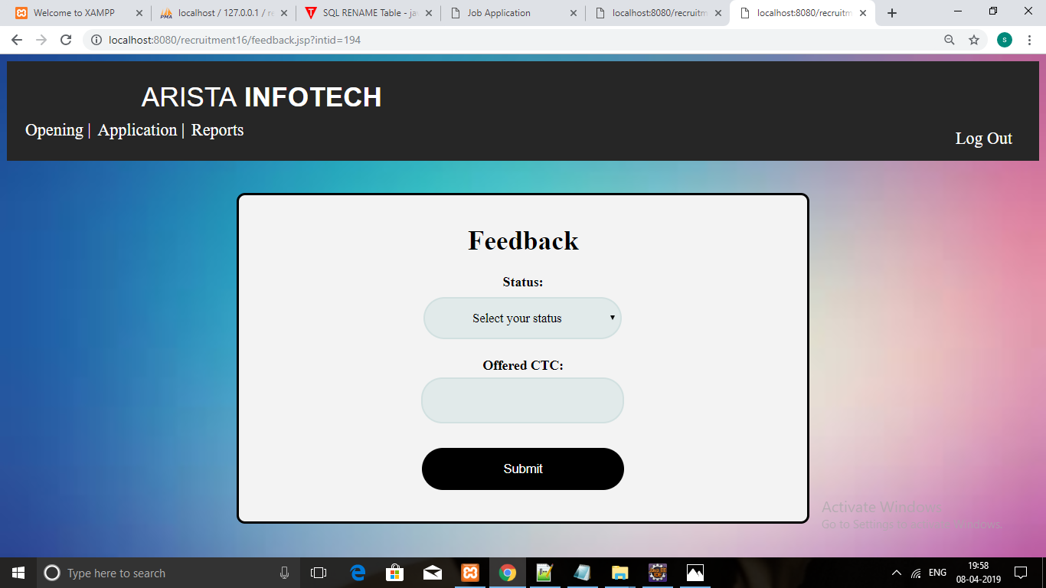

Fig.4.5.5 Feedback page

**4.6 Codes**

The code structure of the project is shown in the figure below. There are various code modules in the project such as bean class which contains variables along with their ‘getter’ and ‘setter’ methods, modal class that contains the database connection. The business logic is present in the controller. An important thing to note is that we’ve used the controller only to fulfil the login purpose of the system. So the term ‘controller’ here is relative to the login module only. With respect to navigation in the rest of the system, we’ve relied on a number of jsp pages. Each page would have a link of the page where it has to navigate. Since this is live project and the company will have it under use in the future, the exact code of the same cannot be disclosed due to its confidentiality. Therefore a sample of the code structure of the project is shown below along with links of other document files. The documentation can be obtained by clicking on the ‘project’ tab in eclipse and then clicking on ‘get documentation’.

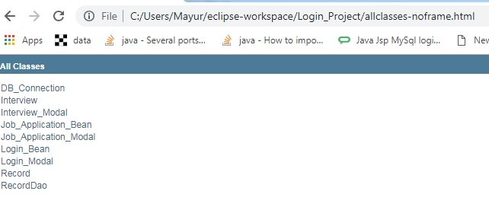

Fig.4.6 Classes in the project

The figure above shows all the classes involved in the project.

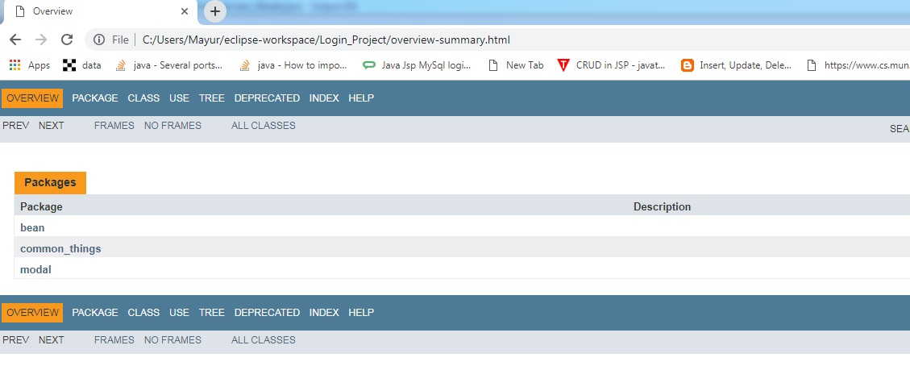Fig.4.6.1 Project Overview

The above figure displays the overview of the project and the packages involved. There are three main packages involved-

* Bean
* Common_things
* Modal

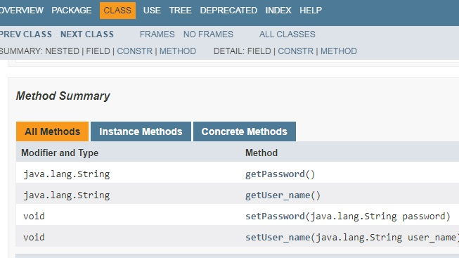

Fig.4.6.2 Methods in Login bean

The above figure shows the methods involved in the login module of the project.

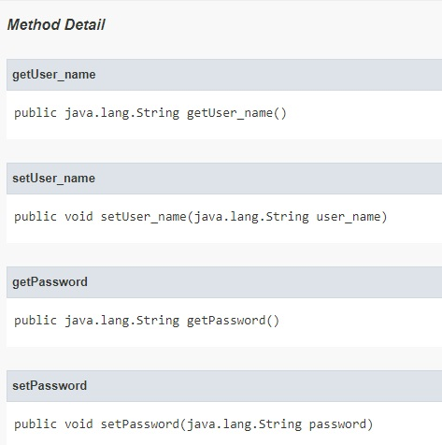

Fig.4.6.3 Method details

The links to other Javadoc files (on our local system) are given below-

* C:/Users/Mayur/eclipse-workplace/Login_Project/bean/Interview.html
* C:/Users/Mayur/eclipse-workplace/Login_Project/bean/Interview_Modal.html
* C:/Users/Mayur/eclipse-workplace/Login_Project/bean/Job_Application_Bean.html
* C:/Users/Mayur/eclipse-workplace/Login_Project/bean/Job_Application_Modal.html
* C:/Users/Mayur/eclipse-workplace/Login_Project/bean/Login_Bean.html
* C:/Users/Mayur/eclipse-workplace/Login_Project/bean/Login_Modal.html
* C:/Users/Mayur/eclipse-workplace/Login_Project/bean/Record.html
* C:/Users/Mayur/eclipse-workplace/Login_Project/bean/RecordDao.html
* C:/Users/Mayur/eclipse-workplace/Login_Project/common_things/DB_Connection.html

**Chapter 5**

**Summary and Conclusions**

**Chapter 5. Summary and Conclusions**

**5.1 Summary**

Recruitment Management System is used for managing various operations regarding recruiting candidates to fill up different positions in a firm. The system will be used to effectively automate and manage the recruitment process at Arista Infotech. The system allows the HR to post new job vacancies, update and delete the existing job vacancies, allows deleting and shortlisting the received applications according to the job profile and years of experience and get reports of applications received corresponding to each job vacancy.

**5.2 Conclusion**

The design and implementation of recruitment management system providing various functions and services to the HR with regards to the recruitment process of the company is described in the project. As the database has been configured and its connection with the java codes successfully established, the HR can add, delete or update new job vacancies, the changes of which would be reflected in the database. When clicked on the eligible link besides a job profile, the predefined criteria programmed at the backend using java does all the work to filter the applications based on the profile they’ve applied to and years of experience they hold.

**5.3 Future Scope**

* Automatic email notification functionality can be added into the system.
* Online test module can be merged along with the system.

**Chapter 6**

**Appendix**

**Chapter 6. Appendix**

1. Development tools:

* Eclipse IDE (for ‘JAVA’ programming)

2. Software Requirements

* Java Development Kit
* Java Runtime Environment
* XAMPP server
* Tomcat server
* Mysql database

**Chapter 7**

**References**

**Chapter 7. References**

[1] “Browser Statistics HTML5 Tutorial”, Accessed on December 2018[Online] Available: <http://w3schools.com>

[2] “Learn JSP Tutorial”, Accessed on January 2019. [Online]

Available: <https://www.javatpoint.com/jsp-tutorial>

[3] “Java Tutorial”, Accessed on December 2019.[Online]

Available: <https://www.tutorialspoint.com/java>

[4] Bryan Basham, Kathy Sierra and Bert Bates, “Head First Servlets and JSP”, Oreilly, 2nd edition, 2008

[5] “JSP Login example”, Accessed on January 2019.[Online]

Available: <https://www.chillyfacts.com/jsp-login-tutorial>

[6] [www.google.com](http://www.google.com)

[7] [www.naukri.com](http://www.naukri.com)

[8] [www.youtube.com](http://www.youtube.com)

[9] [www.indeed.com](http://www.indeed.com)