AI Teaching Studio
Project Blueprint: Requirements, Architecture, Workflows & Execution Plan
Version 1.11 — maths lessons with real-life photos, 2D and 3D pictures
3 October 2026

Item | Detail
Project | AI Teaching Studio — AI-assisted teaching with simulations, animations and an AI tutor
Owner / teacher | Santosh
Prepared by | Claude Code (AI engineering assistant), with the owner
Codebase location | D:\Santosh\Data Science\Entrepreneur journey\Tuition study app
Status | Approved by owner (03-Oct-2026). Phase 0 complete; Phase 1 complete with improvements (04-Oct-2026); Phase 2 built with 3 pilot lessons awaiting owner review (05-Oct-2026). Next: Phase 3 (videos & narration)

Document Control
Version | Date | Change | Status
1.0 | 03-Oct-2026 | First complete blueprint: requirements from owner answers, architecture, model strategy, workflows, phased plan | Superseded
1.1 | 03-Oct-2026 | Owner security guidelines after the March 2026 LiteLLM supply-chain incident: new Section 14 (pinning, hash-locked installs, API-key isolation, egress control); updates to stack, setup steps, NFR-06, Phase 0, risks and decisions D10–D11 | Superseded
1.11 | 09-Oct-2026 | Maths lessons (§8.6, D41–D44): concepts with the textbook’s examples re-computed by the app (HCF, LCM, primes, angle pairs, one-variable equations), hand-written 2D/3D maths player (factor tree, Venn, division, runners, sieve, balance, drag-the-ray angles, 3D ramp/door/laptop/scissors/clock), real-life examples with free-licence photos found on Wikimedia Commons / Wikidata / Openverse and checked by the local vision model, Visualise toolbar in Lesson Studio and Teach Mode; a file with several chapters split into one lesson per chapter; answers judged only when certain; tested end to end on Class 7 Maths Ch. 3–4 (2 lessons, 3.6 ¢; photos for 34 of 38 examples, free) | Current
1.10 | 09-Oct-2026 | Autopilot (§8.6, D38–D40): automatic page quality check, clean pages searchable at once, chapter title detection, one draft lesson per chapter written automatically (whole chapter), flagged pages listed with reasons and a cloud re-read on request, rebuild notice; tested end to end (history chapter: 3 jobs, ≈ 2 min, 2.6 ¢, no clicks) | Superseded
1.9 | 07-Oct-2026 | History lessons (§8.6, D34–D37): two-column reading order, whole-chapter lesson writing without exercise pages, timeline/period/people/place/cause-effect extraction checked against the textbook, offline map of India (Natural Earth India view + GeoNames), textbook pictures with captions, history player; tested end to end on Class 9 History Ch. 4 | Superseded
1.8 | 07-Oct-2026 | 3D Chemistry Lab (electron transfer, electron sharing, atoms rearranging — computed, no AI), simulations tested in a real browser + picture review, p5.js 2 fix, ready-made experiment setups, review of free image/3D AI models (§8.6, D30–D33); all 5 simulations regenerated | Superseded
1.7 | 05-Oct-2026 | Labelled 3D molecules (atom symbols + charges, ion tags, legend, charge note) and fix for ions hidden inside each other (§8.6, D29) | Superseded
1.6 | 05-Oct-2026 | Lab kit for simulations after the owner’s review (overlapping labels, no stir animation): §8.6 extended, decision D28, folder structure; all 5 lesson simulations regenerated | Superseded
1.5 | 05-Oct-2026 | Phase 2 built (§8.6): lesson planner, equation checker, molecules 2D/3D, checked AI simulations, Lesson Studio, Teach Mode; 3 pilot lessons generated; stack table and pinned versions (rdkit, p5.js, 3Dmol.js), data model, folder structure, progress, decisions D24–D27 and open items updated. Learning log docs/Claude Interactions.docx started | Superseded
1.4 | 04-Oct-2026 | Phase 1 complete (owner reviewed the chapter). Improvements built and measured (§8.5): review preview & lossless table repair, OCR prompt clean-up, optional cloud re-read (gpt-5.4-mini, benchmarked), page summaries & table/figure descriptions as search aids only, answer-model switch, semantic answer cache (calibrated), stale-index bug fixed, schema migration; routing table, data model, folder structure, progress, decisions D19–D23 and open items updated | Superseded
1.3 | 04-Oct-2026 | Phase 1 built and tested on the owner’s chapter: new §8.4 (ingestion & tutor as built, with measurements); 3-level de-duplication; OCR model changed to qwen3-vl:2b-instruct (§7.2, D16); vector store SQLite + NumPy (D15, for approval); new packages pymupdf, python-docx, pillow, numpy (§5.1); data model, folder structure, progress tracker, decisions D15–D18 and open items updated; diagrams updated | Superseded
1.2 | 03-Oct-2026 | Owner approved the plan. Phase 0 built and verified: exact installed versions (§5.1); local text model changed to qwen3:4b-instruct (§7.2); OpenAI models and prices fixed after cross-checking two sources (§7.3); real setup steps (§6.2) and configuration (§7.5); actual folder structure (§11); progress tracker (§12.2); LiteLLM hardening details (§14.6); decisions D12–D14 | Superseded

How to use this document: it is the single reference for what we are building, why, and how. When a decision changes, update the Decision Log (Section 16), bump the version and keep the old file for history. Diagrams are also saved as high-resolution PNG and editable SVG in docs/diagrams/.

(If the contents list is empty, right-click it in Word and choose “Update Field”.)

1. Project Overview

1.1 Vision
Build an AI-powered teaching studio that runs on the owner’s laptop and turns textbook chapters into ready-to-teach lessons: clear explanations, accurate chemistry visuals, interactive experiment simulations, narrated animated videos, quizzes, and an AI tutor that answers students’ doubts from the textbook itself.

1.2 Users and context
- Now (Phases 0–4): the owner teaches students at home, presenting from the laptop on a screen or projector.
- Later (Phase 5): students may use the app directly (web/mobile). Cloud hosting will be decided after Phase 4.

1.3 Scope
- Board-agnostic: the app does not hard-code any syllabus. All content comes from the syllabus and textbook pages the owner uploads (currently State Board).
- Subject-agnostic, chemistry-strong: chemistry gets dedicated tools (equations, molecules, reactions); physics, biology and maths are covered through simulations, animations and the tutor.
- Languages: English by default; Hindi and Marathi only when explicitly requested.
- Out of scope for now: student accounts, payments, cloud deployment, mobile apps (Phase 5 or later).

2. Requirements

2.1 Functional requirements
Priority: Must = required for the phase to be complete; Should = planned, can slip; Could = optional.
ID | Requirement | Priority | Phase
FR-01 | Upload syllabus and chapter content as PDFs or photos / snapshots of textbook pages | Must | 1
FR-02 | Extract text from photos (OCR); owner reviews and corrects the text before it is used | Must | 1
FR-03 | Organise content by Class → Subject → Chapter → Topic, keeping page numbers | Must | 1
FR-04 | AI tutor answers doubts grounded in the uploaded textbook (RAG) and cites chapter + page | Must | 1
FR-05 | Generate a lesson for a topic: explanation, key points, examples, slides | Must | 2
FR-06 | Chemistry visualizer: balanced equations, 2D structures, rotatable 3D molecules | Must | 2
FR-07 | Interactive simulations of experiments (sliders, buttons), usable offline once generated | Must | 2
FR-08 | Teach Mode: full-screen, presenter-friendly view for the projector | Must | 2
FR-09 | Owner previews, edits and approves every lesson before it is saved or presented | Must | 2
FR-10 | Animated explainer videos (Manim) with narration | Should | 3
FR-11 | English by default; Hindi / Marathi narration, labels or answers only on explicit request | Must | 1 (chat), 3 (narration)
FR-12 | AI-generated illustrations, off by default and cost-gated | Could | 3
FR-13 | Quiz generation (MCQ + short answer) with answer key | Should | 4
FR-14 | Lesson library: reuse, search, versions | Should | 4
FR-15 | Export notes and quizzes as PDF | Could | 4
FR-16 | Choose AI provider / model per task through configuration, without code changes | Must | 0
FR-17 | Cost dashboard: tokens and cost per call, monthly totals, budget status | Must | 0–1
FR-18 | Student logins and progress tracking | Could | 5

2.2 Non-functional requirements
ID | Quality | Requirement
NFR-01 | Low cost | Local / free models first. Hard monthly cap on paid API spend (configurable; proposed default USD 5). An identical request is never paid for twice (cache + lesson library).
NFR-02 | Accuracy | Science visuals are drawn by code (Manim, RDKit, JS), not by image/video-generating AI. Equations are checked by chempy. Tutor answers cite textbook pages. Owner approves before use.
NFR-03 | Runs on this laptop | Windows 11, Intel Core 5 210H, 32 GB RAM, NVIDIA RTX 3050 (4 GB VRAM). No Docker or Redis needed for Phases 0–4.
NFR-04 | Offline-tolerant | Saved lessons, simulations (JS libraries stored locally) and local models work without internet. Internet is needed only for cloud models and PubChem/PhET lookups.
NFR-05 | Responsiveness (targets) | Tutor answer starts within ~5 s on local model; lesson text within ~1 min; video renders 1–3 min in the background with a progress bar.
NFR-06 | Security & privacy | API keys never in code or .env: stored in Windows Credential Manager (Section 14.4). All dependencies pinned and hash-verified via uv.lock; LiteLLM pinned to a clean version ≥ 1.83.0. Model calls only to allow-listed provider hosts. AI-generated code runs sandboxed (browser iframe or separate process with timeout). App listens on localhost only. No student personal data sent to free-tier providers.
NFR-07 | Maintainability | Python 3.12, type hints, configuration-driven, automated tests for core services, dependencies pinned in uv.lock.
NFR-08 | Future-ready | Layered design so a FastAPI backend and cloud deployment can be added in Phase 5 without rewriting services.

3. Guiding Design Principles
- Accuracy first — the AI writes code, Python draws. Models generate Manim scripts, simulation code and chemistry data; deterministic libraries render them. Image/video-generating AI often draws wrong bonds, labels and reactions, so it is used only for decorative illustrations.
- Cost first — local → cheap cloud → premium. Every task has a default model and a fallback chain. Paid calls are logged, capped and cached.
- Teacher in control. Nothing is shown to students until the owner has previewed and approved it.
- Textbook-grounded. The tutor and lesson generator use the uploaded chapters as their source and show citations, so content matches what students study.
- Configuration over code. Models, budgets, languages and voices live in config/*.yaml and .env — never secrets, which go to Windows Credential Manager.
- Thin vertical slices. Every phase ends with something usable in a real class.

4. System Architecture
The Integrated Architecture Diagram (IAD) below shows all six layers. Each layer talks only to the layer below it, which keeps the design simple now and lets us replace the Streamlit UI with a FastAPI + web front end later without touching the services.
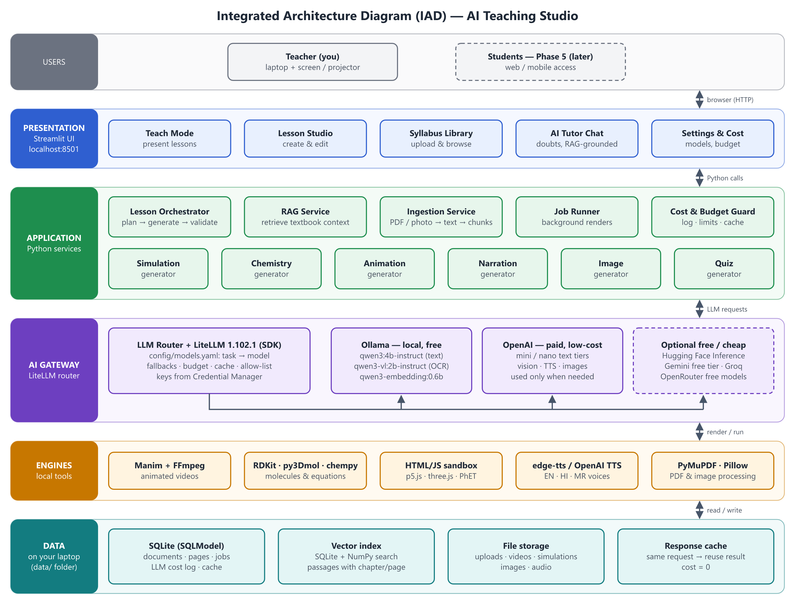
Figure 1 — Integrated Architecture Diagram (IAD)

4.1 Components and responsibilities
Layer | Component | Responsibility
Presentation | Teach Mode | Full-screen presentation of an approved lesson: slides, simulations, 3D molecules, videos
Presentation | Lesson Studio | Generate, preview, edit, regenerate sections, approve
Presentation | Syllabus Library | Upload PDFs/photos, review OCR text, browse chapters and topics
Presentation | AI Tutor Chat | Doubt solving grounded in the textbook, with citations and language on request
Presentation | Settings & Cost | Model selection per task, budget cap, cost dashboard, voices
Application | Lesson Orchestrator | Plans a lesson (JSON), calls generators, runs validator, assembles the lesson package
Application | RAG Service | Retrieves the most relevant textbook chunks for a question or topic
Application | Ingestion Service | PDF split, OCR, review queue, chunking, tagging, embedding, indexing
Application | Generators | Simulation, chemistry, animation, narration, image, quiz — one module each, same interface
Application | Job Runner | Runs slow work (video renders, bulk OCR) in the background with progress and timeouts
Application | Cost & Budget Guard | Logs every model call, enforces the monthly cap, serves cached responses
AI Gateway | LiteLLM | One Python API over Ollama, OpenAI, Hugging Face, Gemini, Groq, OpenRouter; retries and fallbacks
Engines | Manim, RDKit, py3Dmol, chempy, HTML/JS sandbox, TTS, PyMuPDF | Deterministic rendering and processing on the laptop
Data | SQLite (documents, pages, passages + vectors, jobs, cost log, cache), file storage | All data stays on the laptop: data/ (database) and source/ (your files) — both excluded from Git

5. Technology Stack and Versions
Version policy: this table fixes the major choices and minimum versions. The exact versions of every package are resolved during Phase 0, checked on this Windows laptop, and pinned in uv.lock, which becomes the source of truth.
Area | Choice | Why this choice | Cost
Language | Python 3.12.x (latest patch), installed and managed by uv | Most mature Windows wheels for RDKit, Manim, ChromaDB, PyMuPDF; security support until Oct 2028. 3.13 works for most packages but some scientific/audio libraries lag; 3.14 is too new. | Free
Environment & packages | uv (already installed: 0.12.11) | Fast installs, lockfile, installs Python itself — no conflict with other Pythons | Free
User interface | Streamlit (≥ 1.40) | Pure-Python UI, wide/full-screen layout, embeds HTML simulations, 3D viewers and video | Free
AI gateway | LiteLLM Python SDK, exact-pinned to a clean release ≥ 1.83.0 (never 1.82.7 / 1.82.8), hash-locked; used in-process only — the LiteLLM Proxy Server is not used | Single API for all providers, cost tracking, fallbacks; change models in YAML. Hidden behind our own LLMRouter / Backend interface so it can be replaced (Section 14) | Free
Secrets | keyring → Windows Credential Manager | API keys encrypted per Windows user; never stored in files | Free
Supply-chain checks | pip-audit (run via uvx) | Checks locked dependencies against known-vulnerability databases before each upgrade and phase sign-off | Free
Local AI runtime | Ollama (installed: 0.34.4) | Runs local models on the RTX 3050 / CPU; already has OCR and embedding models | Free
Cloud AI | OpenAI (owner has keys) + optional Hugging Face, Gemini, Groq, OpenRouter | Higher-quality code generation, translation and vision when local models are not enough | Pay-per-use / free tiers
Vector store | SQLite + NumPy (decision D15; ChromaDB optional later) | Exact cosine search over a few thousand passages in milliseconds; no server, no extra heavy packages (ChromaDB would add ~30, incl. Kubernetes, gRPC, ONNX Runtime, OpenTelemetry) | Free
Database | SQLite + SQLModel (Pydantic v2) | Zero setup, single file; upgrade path to PostgreSQL in Phase 5 | Free
Configuration | pydantic-settings, YAML, .env | Typed, validated settings; secrets kept out of code | Free
PDF & images | PyMuPDF, Pillow | Fast text extraction and page rendering; photo cleanup before OCR. Note: PyMuPDF is AGPL — fine for personal use; review before selling the app (Phase 5). | Free
Chemistry | RDKit (structures, 2D/3D) + in-house equation checker + 3Dmol.js viewer (stored locally) + reviewed local molecule table | Built in Phase 2. Replaces the planned py3Dmol (loads 3Dmol.js from the internet), chempy (pulls SciPy/SymPy/Matplotlib just to check equations) and PubChemPy (needs internet in class) — decision D24 | Free
Animation | Manim Community Edition (≥ 0.19) | Precise, programmable science/maths animations rendered to MP4 | Free
Video/audio tools | FFmpeg (system install) | Merge narration with video, convert formats | Free
Typesetting | MiKTeX | Formulas in Manim (MathTex, chemistry via mhchem) | Free
Text-to-speech | edge-tts (primary), OpenAI TTS (fallback) | Natural English, Hindi and Marathi voices at no cost; paid fallback if the free service changes | Free / paid fallback
Simulations | p5.js 2.3.3 (stored locally, SHA-256 verified); PhET embedding optional later | AI-written interactive experiments in a sealed frame without network access; checked before the teacher sees them (D25) | Free
Background jobs | Python thread/process pool + SQLite jobs table | Avoids Redis/Celery, which are awkward on Windows | Free
Quality | pytest, ruff, loguru | Tests, linting/formatting, readable logs | Free
Version control | Git (installed: 2.51) + optional private GitHub repo | History, safe experiments, backup | Free

5.1 Pinned versions (installed and verified; updated 4 Oct 2026)
Direct Python dependencies are pinned with == in pyproject.toml; all 113 packages (including transitive ones) are pinned with SHA-256 hashes in uv.lock. Release cooldown: nothing published after 26 Sep 2026 is allowed (exclude-newer). Vulnerability audit (pip-audit): no known vulnerabilities. Packages for later phases (RDKit, Manim, edge-tts…) are added only when their phase starts, to keep the installed surface small. Phase 1 added only 3 new packages in total (pymupdf, python-docx, lxml).
Component | Version | Notes
Python | 3.12.14 | Installed and managed by uv
litellm | 1.102.1 | SDK only; ≥ 1.83.0 clean line. Pulls in boto3, uvicorn, tokenizers etc. as dependencies — all hash-locked
streamlit | 1.64.0 | UI; bound to 127.0.0.1, usage statistics off
sqlmodel / pydantic-settings | 0.0.47 / 2.15.0 | Database models (timezone-aware UTC timestamps) / typed settings
keyring | 25.7.0 | Backend: Windows Credential Manager (WinVaultKeyring)
httpx · pyyaml · loguru | 0.28.1 · 6.0.3 · 0.7.3 | Health checks · config · logging
pymupdf · python-docx (Phase 1) | 1.28.2 · 1.2.0 | PDF text/rendering (AGPL — fine for personal use; review before selling) · Word files
rdkit (Phase 2) | 2026.3.6 | Molecule structures, 2D drawings, 3D coordinates (needs only numpy + pillow)
p5.js · 3Dmol.js (Phase 2, browser) | 2.3.3 · 2.5.5 | Installed from npm with --ignore-scripts and a lockfile; copied to assets/vendor; SHA-256 checked before every use
pillow · numpy (Phase 1) | 12.3.0 · 2.5.3 | Image handling for OCR · vector search (were already installed as dependencies; now pinned directly)
pytest · ruff · pip-audit (dev) | 9.1.1 · 0.16.9 · 2.10.1 | Tests · lint/format · vulnerability audit
Ollama | 0.34.4 | Local model runtime
FFmpeg | 9.0.2 (Gyan full build) | Installed via winget; installer hash verified
MiKTeX | 25.12 | Installed via winget (per-user); installer hash verified
uv / Git | 0.12.11 / 2.51 | Already present

6. Local Environment Setup (Phase 0)

6.1 Laptop profile (checked on 3 Oct 2026)
Item | Status
Operating system | Windows 11 Home Single Language
CPU / RAM | Intel Core 5 210H / 32 GB
GPU | NVIDIA GeForce RTX 3050 Laptop, 4 GB VRAM (+ Intel integrated graphics)
Free disk space on D: | ≈ 117 GB (project needs ~15–25 GB incl. models and videos)
Installed (Phase 0) | Python 3.12.14 (uv) · FFmpeg 9.0.2 · MiKTeX 25.12 · uv 0.12.11 · Git 2.51 · Ollama 0.34.4 · Node.js 24.16 (not required)
Ollama models | Used: qwen3:4b-instruct · qwen3-vl:2b-instruct · qwen3-embedding:0.6b. Not used: qwen3:4b, qwen3-vl:4b, qwen3-vl:2b (Thinking variants), qwen3-vl:4b-instruct (too slow on 4 GB), deepseek-r1:1.5b

6.2 Setup steps (also in README.md)
Steps 1–3 were done in Phase 0. On a new laptop, repeat all of them from the project folder:
- Tools: uv python install 3.12 · winget install --id Gyan.FFmpeg -e · winget install --id MiKTeX.MiKTeX -e --scope user
- Local models: ollama pull qwen3:4b-instruct · ollama pull qwen3-vl:2b-instruct · ollama pull qwen3-embedding:0.6b
- Packages, only from the lockfile (checks every SHA-256 hash): uv sync --locked
- Settings (no secrets): copy .env.example .env
- In the OpenAI dashboard, create a Project “ai-teaching-studio” with its own restricted key and a monthly budget limit.
- Store the key in Windows Credential Manager (input hidden): uv run python -m app.core.secrets set openai — or use the Settings & Cost page.
- Security checks: uv run python -m app.core.startup_checks (all lines OK) · Models & prices: uv run python -m app.tools.verify_models
- Start: uv run streamlit run ui/Home.py → http://localhost:8501

7. AI Model Strategy and Cost Control
The app never hard-codes a model. Each task (tutor chat, OCR, Manim code, translation…) is mapped in config/models.yaml to a primary model and a fallback chain. The LiteLLM gateway applies the mapping, enforces the budget and logs cost.

7.1 Providers and their constraints
Provider | Cost | Strengths | Constraints
Ollama (local) | Free | Private, offline, no per-token cost; good for OCR, embeddings, simple Q&A | 4 GB VRAM ⇒ ~4B-parameter models run fully on GPU; 7–8B models spill to RAM and run several times slower; one model loaded at a time (switching takes seconds); weaker at long code and Marathi
OpenAI | Pay per token | Strong code generation, reasoning, vision, TTS, images | Costs money; needs internet; prices and model names change — verified in Phase 0 and kept in config
Hugging Face | Free hub; small monthly free inference credit, then pay-as-you-go | (a) Source of open models to run in Ollama; (b) hosted inference for larger open models | Credits are limited; model availability varies by provider
Free cloud tiers (Gemini API, Groq, OpenRouter “:free”) | Free with rate limits | Fast, capable models at zero cost | Per-minute/day limits; terms can change; prompts may be used for training ⇒ send textbook content only, never student personal data

7.2 What fits on this laptop
Local model | Disk | Fits 4 GB GPU? | Use in this project
qwen3:4b-instruct (installed) | ≈ 2.5 GB | Yes | Used. Qwen3-4B-Instruct-2507: tutor chat, summaries, quiz drafts. Measured: ~22 tokens/s; direct answers
qwen3:4b (installed) | ≈ 2.5 GB | Yes | Not used. This tag is Qwen3-4B-Thinking-2507: it always reasons first (≈ 190 tokens and 15–25 s for a one-line answer) and ignores the “thinking off” switch
qwen3-vl:2b-instruct (installed) | 1.9 GB | Mostly (≈ 66 % GPU) | Used for OCR. Measured on a real A4 textbook page at 1600 px: ≈ 16–40 s/page, accurate text
qwen3-vl:4b-instruct (installed) | 3.3 GB | No (≈ 25–40 % GPU) | Not used. Same page: 64 s (1280 px) to 178 s (1600 px), no better text
qwen3-vl:4b · qwen3-vl:2b (installed) | 3.3 / 1.9 GB | — | Not used. Thinking variants: reason before answering even with thinking off (≈ 90 s for 3 lines)
qwen3-embedding:0.6b (installed) | 0.6 GB | Yes | Embeddings for RAG (multilingual)
deepseek-r1:1.5b (installed) | 1.1 GB | Yes | Not used — too small for reliable teaching answers
7–8B models (optional, e.g. qwen3:8b) | ≈ 5 GB | Partly (CPU offload) | Better offline quality when speed is not critical

7.3 Default task → model routing (as configured in Phase 0)
OpenAI tiers chosen: cheapest = gpt-5-nano (USD 0.05 in / 0.40 out per 1M tokens) · mini = gpt-5.4-mini (0.75 / 4.50) · premium = gpt-5.2 (1.75 / 14.00, only with your approval). These names and prices were confirmed in two independent sources on 3 Oct 2026: the OpenAI pricing page and LiteLLM’s bundled price list.
Task | Primary | Fallback | Reason
OCR of pages / photos | ollama/qwen3-vl:2b-instruct (num_ctx 8192) | openai/gpt-5-nano (≈ .0003/page) | Free; cloud only if the local model fails
Embeddings | ollama/qwen3-embedding:0.6b | — | Free and multilingual. The same model must be used for the whole index (changing it means re-indexing).
Tutor answers (English) | ollama/qwen3:4b-instruct + RAG | openai/gpt-5-nano | Grounded answers are short and simple
Tutor answers (cloud switch) | openai/gpt-5-nano | ollama/qwen3:4b-instruct | Optional per question; better with tables (≈ $0.001)
OCR cloud re-read | openai/gpt-5.4-mini | — (page unchanged if it fails) | Only when you click it; ≈ $0.005/page
Page summaries & descriptions | ollama/qwen3:4b-instruct (JSON) | openai/gpt-5-nano | Free; used only to find pages, never as answer evidence
Tutor answers (Hindi / Marathi) | openai/gpt-5.4-mini | ollama/qwen3:4b-instruct | Only on request; small local models are weak in Marathi
Lesson plan & explanations | openai/gpt-5.4-mini | ollama/qwen3:4b-instruct | Quality matters; generated once, then cached
Manim & simulation code | openai/gpt-5.4-mini | openai/gpt-5.2 (asks first) | Small local models often produce broken code
Quiz generation | openai/gpt-5-nano | ollama/qwen3:4b-instruct | Structured output, low token count
Hindi / Marathi translation | openai/gpt-5.4-mini | — (Gemini free tier optional) | Small local models are weak in Marathi
Narration (TTS) | edge-tts | OpenAI TTS | Free en-IN, hi-IN, mr-IN voices (Phase 3)
Images | Off by default | — | Expensive relative to text; rarely needed (Phase 3)
Science validation | chempy rules + openai/gpt-5-nano | ollama/qwen3:4b-instruct | Rules catch most errors at zero cost

Model names are configuration, not code. Run uv run python -m app.tools.verify_models (or *Verify models* on the Settings page) to confirm every configured model is installed (Ollama) or available to your OpenAI key, and that prices still match. If a model is retired or a cheaper one appears, only config/models.yaml changes.
GPT-5 family note: these are reasoning models — hidden reasoning tokens are billed as output and count inside max_tokens. Tasks therefore set reasoning_effort (minimal for chat, low for generation) and generous max_tokens. For Ollama, the same setting switches Qwen3 “thinking” off.

7.4 Cost-control mechanisms
- Monthly hard cap (ATS_MONTHLY_BUDGET_USD in .env, default USD 5): when reached, paid calls are downgraded to local/free models or require your approval.
- Response cache keyed by task + model + prompt: an identical request costs nothing the second time.
- Lesson library: a topic is generated once and reused across batches and years.
- Small prompts: only the top few textbook chunks are sent, and every task has a max_tokens limit.
- Premium needs approval: the most expensive tier is never used silently.
- Cost dashboard: per-call tokens, cost, model and latency; monthly totals.
- Expected pattern: day-to-day use (tutor chat, OCR, embeddings) runs locally for free; paid calls happen mainly once per new lesson.

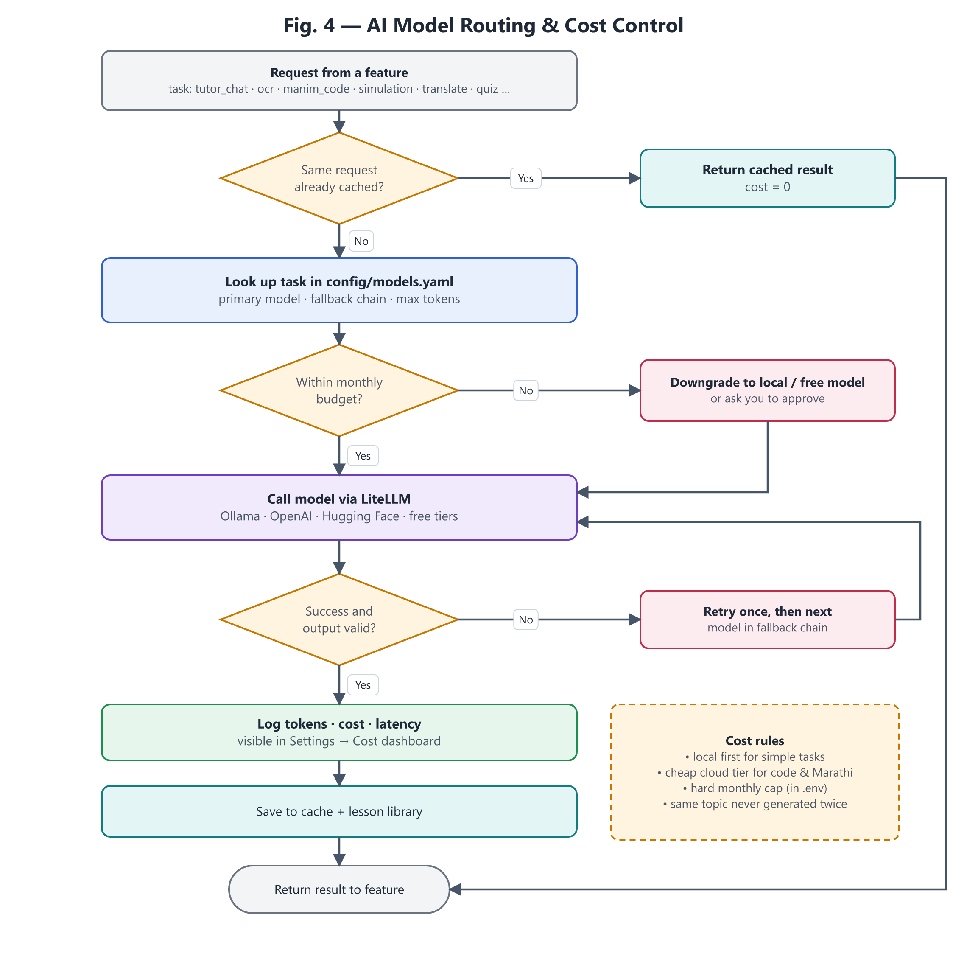
Figure 4 — AI model routing and cost control

7.5 Configuration file (excerpt of config/models.yaml)
budget:
monthly_usd_cap: 5.00 # ATS_MONTHLY_BUDGET_USD in .env overrides
premium_requires_approval: true
allowed_hosts: ["127.0.0.1:11434", "api.openai.com"] # egress allow-list
providers:
ollama:
litellm_prefix: ollama_chat
api_base: http://127.0.0.1:11434
paid: false
openai:
litellm_prefix: openai
api_base: https://api.openai.com/v1
secret: openai # key from Credential Manager
paid: true
premium_models: [openai/gpt-5.2]
prices: # USD per 1M tokens (input / output)
openai/gpt-5-nano: { input_per_million: 0.05, output_per_million: 0.40 }
openai/gpt-5.4-mini: { input_per_million: 0.75, output_per_million: 4.50 }
openai/gpt-5.2: { input_per_million: 1.75, output_per_million: 14.00 }
tasks:
ocr:
primary: ollama/qwen3-vl:2b-instruct
fallbacks: [openai/gpt-5-nano]
ollama_options: { num_ctx: 8192 }
ocr_retry: # only when OCR gets stuck repeating
primary: ollama/qwen3-vl:2b-instruct
ollama_options: { num_ctx: 8192, repeat_penalty: 1.1 }
embed: { kind: embedding, primary: ollama/qwen3-embedding:0.6b }
tutor_answer:
primary: ollama/qwen3:4b-instruct
fallbacks: [openai/gpt-5-nano]
tutor_answer_indic: # Hindi / Marathi on request
primary: openai/gpt-5.4-mini
fallbacks: [ollama/qwen3:4b-instruct]
manim_code:
primary: openai/gpt-5.4-mini
fallbacks: [openai/gpt-5.2] # premium: asks before use
max_tokens: 6000
reasoning_effort: low

8. Workflows

8.1 Teaching workflow (home tuition)
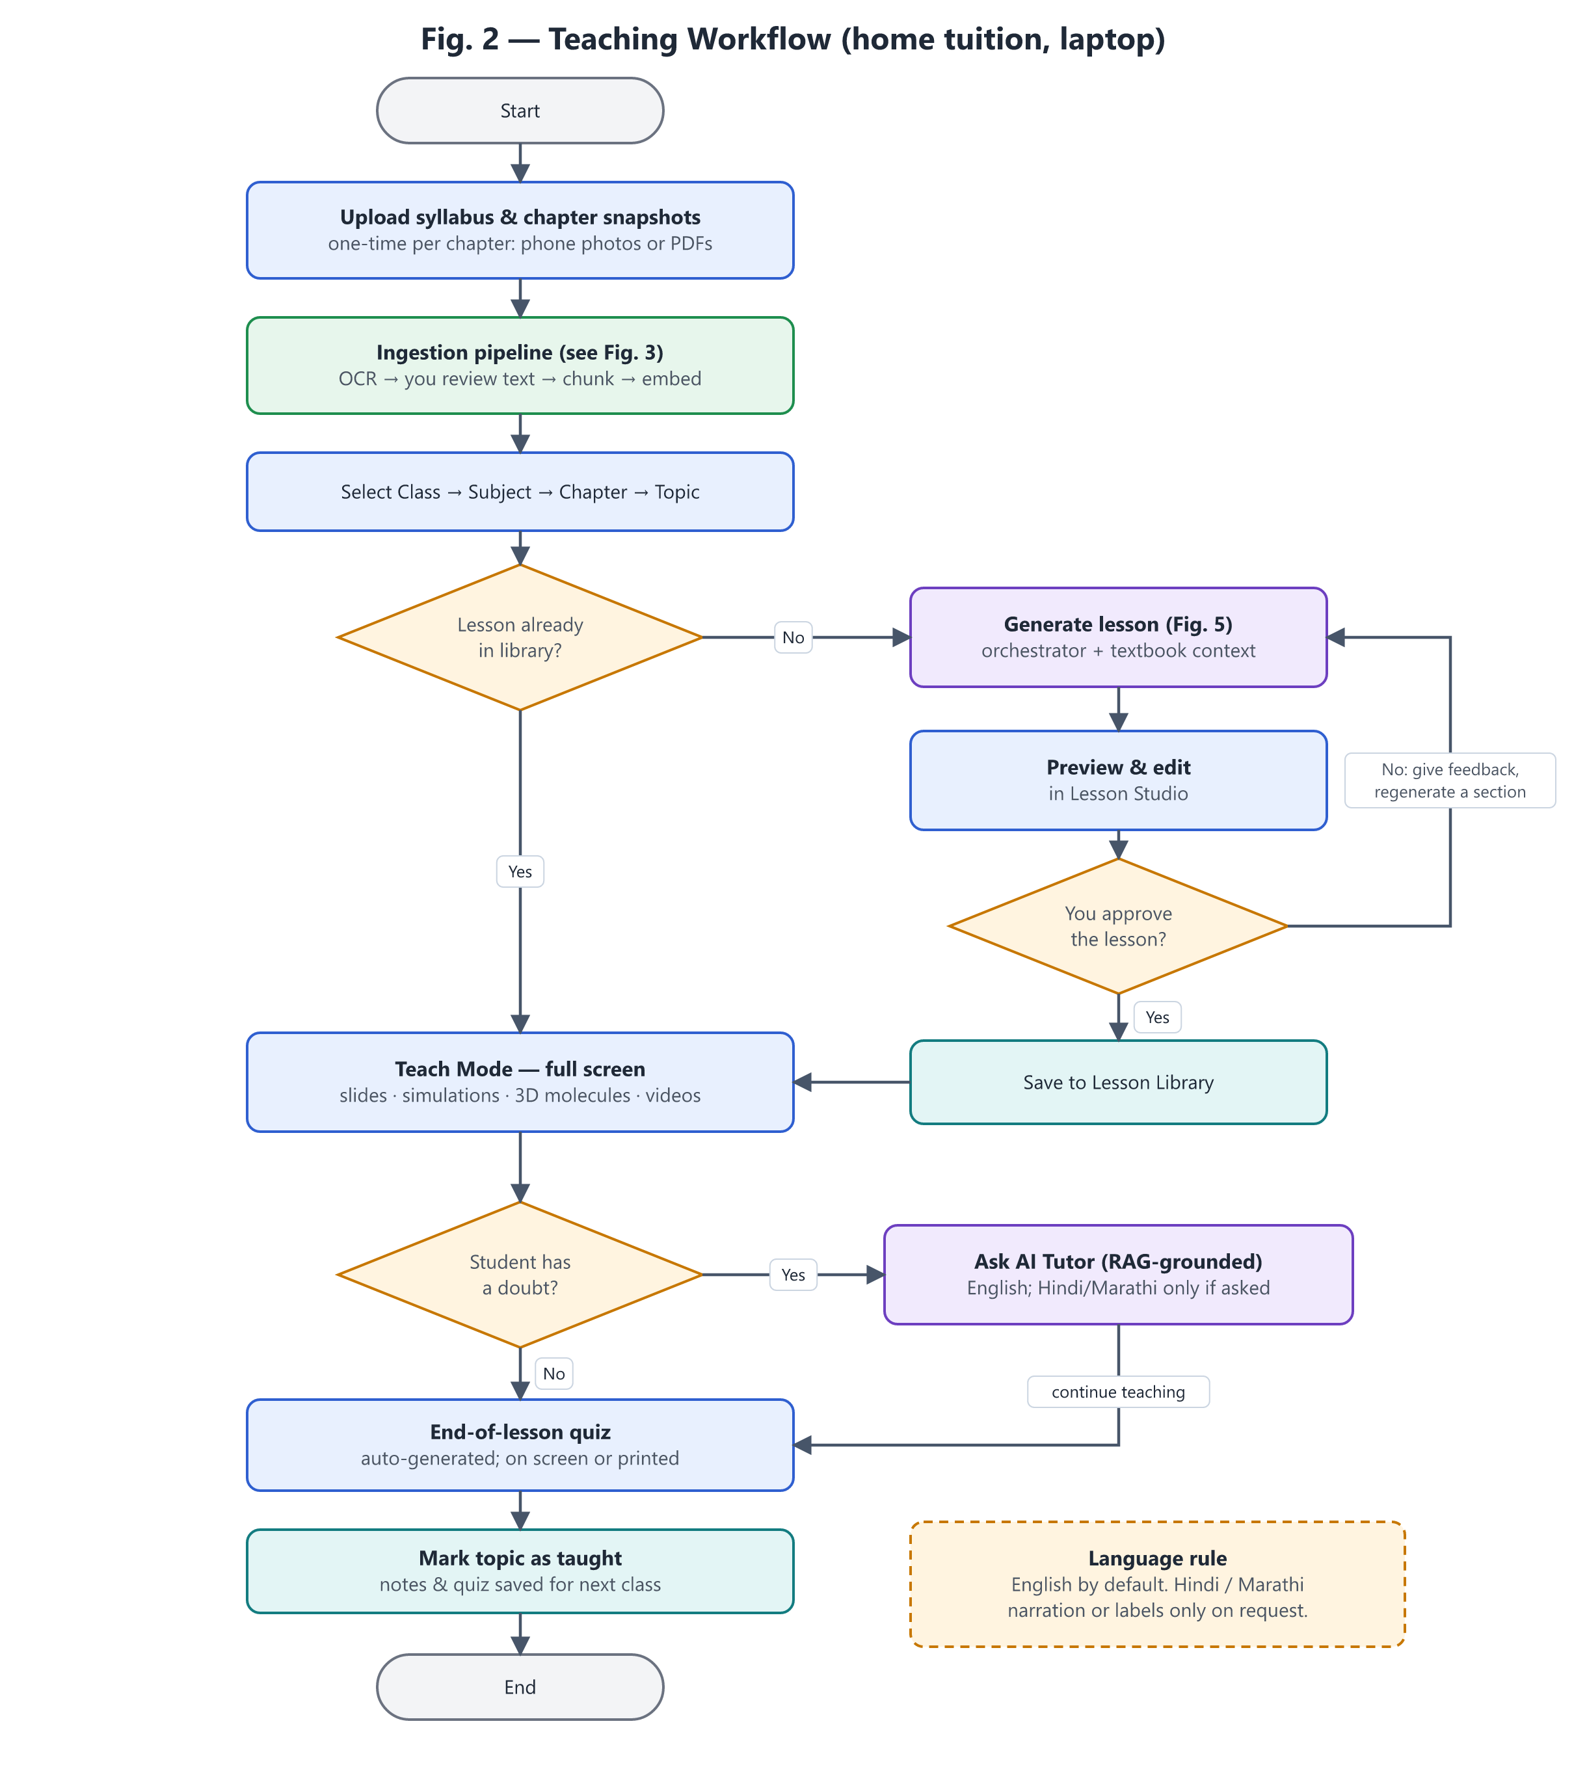
Figure 2 — Teaching workflow
- Once per chapter: upload photos/PDFs, review the extracted text, confirm the topic tags.
- Before class: pick a topic; open it from the library or generate it, then preview, edit and approve.
- In class: present in Teach Mode; ask the AI tutor when a doubt comes up; finish with the quiz.

8.2 Syllabus ingestion and RAG pipeline
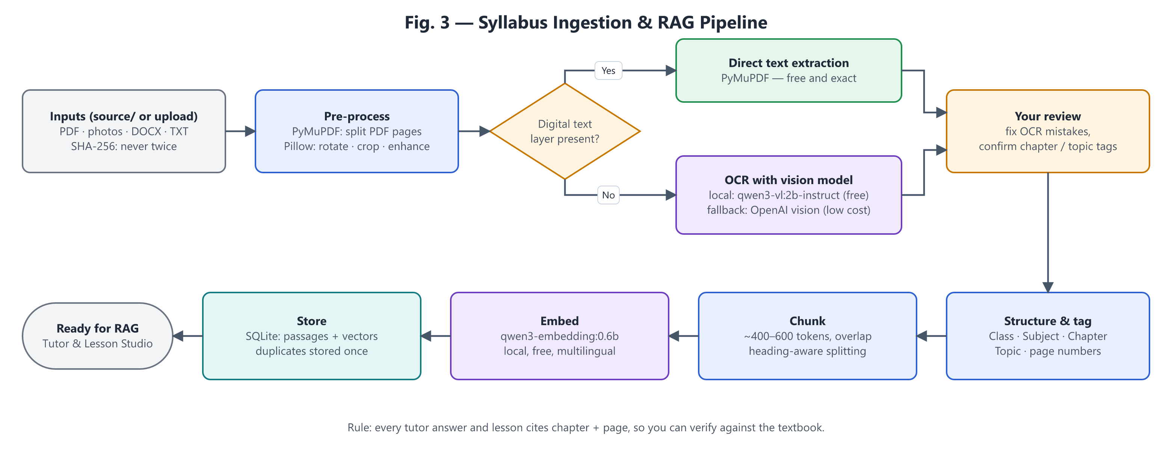
Figure 3 — Syllabus ingestion & RAG pipeline
- Photo tips for good OCR: good light, page flat, one page per photo, phone held parallel to the page.
- Your review step is mandatory: OCR errors in formulas (e.g. subscripts in H₂SO₄) would otherwise flow into lessons.
- Citations: every chunk keeps its chapter and page number, so answers can say “Chapter 3, page 42”.

8.3 Lesson generation pipeline
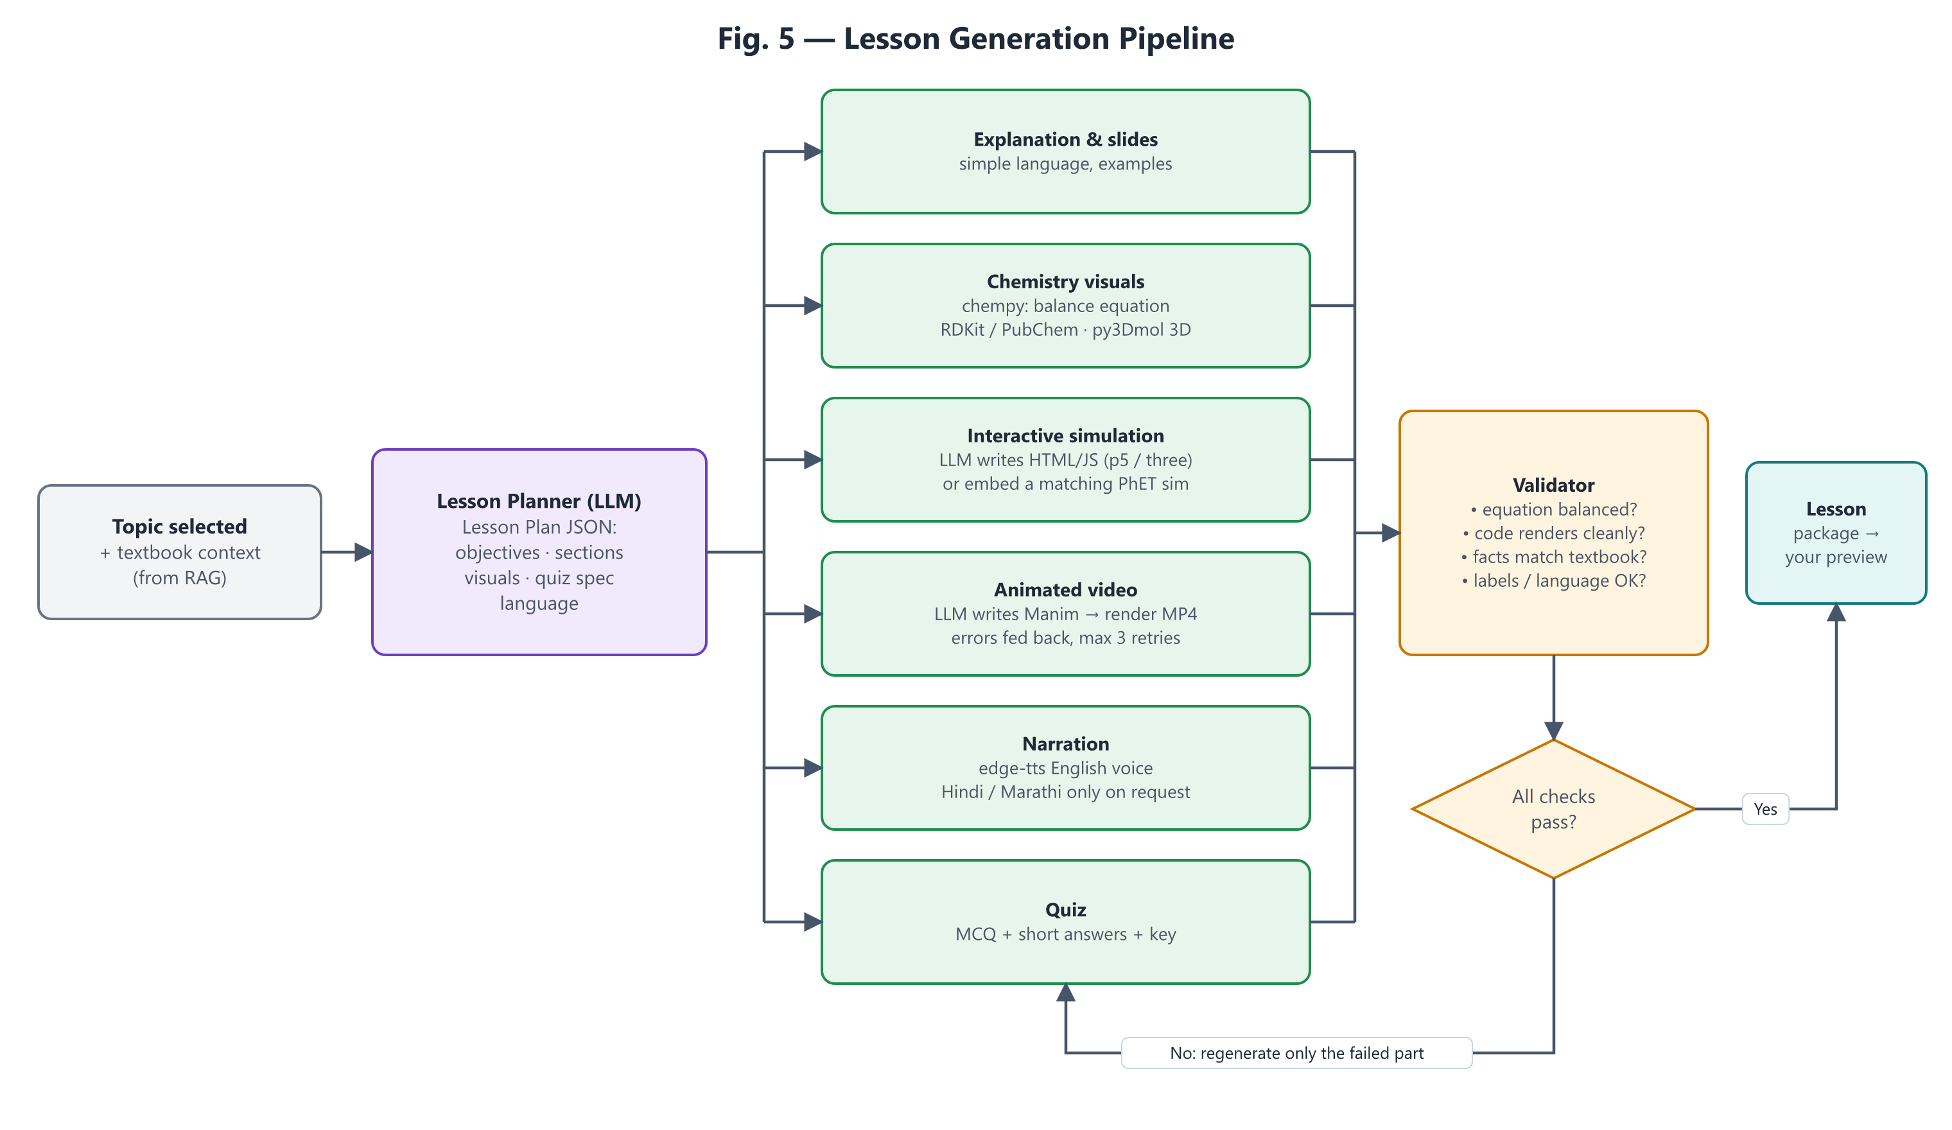
Figure 5 — Lesson generation pipeline
The planner produces a structured Lesson Plan (JSON) so every generator gets precise instructions. The validator checks results; failures regenerate only the failing part. The Manim generator feeds render errors back to the model up to 3 times before asking you.

8.4 Phase 1 as built: ingestion and AI tutor
Area | Behaviour
Inputs | PDF, images (PNG, JPG, WEBP, BMP, TIFF incl. multi-page), DOCX (paragraphs + tables), TXT/MD. Dropped into source/ or uploaded in Syllabus Library (saved into source/). Office lock files and hidden files are ignored; unsupported types are listed.
Automatic processing | Opening Syllabus Library scans source/, registers new files and queues extraction; a background worker (one at a time, GPU-friendly) processes the queue. Same work from the command line: uv run python -m app.ingestion scan.
De-duplication (3 levels) | File: SHA-256 of the bytes — the same file (even renamed or re-uploaded) is never registered twice; an upload with known content is not even saved. Page image: an identical page image is OCR’d once and reused. Passage: identical text (whitespace/case-insensitive) is embedded and stored once across all documents.
Page extraction | PDF page with ≥ 25 words in its text layer → read directly (exact, instant). Otherwise rendered at 1600 px and OCR’d by qwen3-vl:2b-instruct with a textbook-specific prompt (formulas, tables as Markdown, “[Figure: …]” lines). DOCX/TXT → parts of ~3,000 characters.
Resumable jobs | Jobs are stored in the database with progress and heartbeat. Closing the app mid-way is safe: a job without heartbeat for 3 minutes is re-queued and continues; finished pages are never redone.
Review (mandatory by default) | Review Text shows the page image next to the editable text; pages become searchable only after you approve them (ATS_REQUIRE_REVIEW=false skips this). Editing an already-indexed page re-indexes only that page.
Indexing | Paragraph-aware passages of ~1,500 characters with 200-character overlap; each embedded with a heading (subject · class · chapter · title) by qwen3-embedding:0.6b and stored as a normalised float32 vector in SQLite.
Search & answers | The question is embedded with a retrieval instruction; top 5 passages by cosine similarity (filters: class, subject, chapter). Passages below the relevance threshold are discarded; if none remain the tutor replies “This is not covered in the uploaded textbook pages.” without calling a chat model. Otherwise qwen3:4b-instruct answers only from the numbered extracts and cites them [1], [2]; the UI shows each source passage with chapter and page.
Languages | English by default; Hindi or Marathi only when selected for a question (task tutor_answer_indic, scientific terms kept in English in brackets).

Measured on the owner’s chapter (Class 9 Science, Chapter 5, 17 scanned pages)
Measure | Result
Extraction | 17 scanned pages (no text layer) — all OCR’d locally by qwen3-vl:2b-instruct: median 27 s/page, ≈ 9 min in total, cost $0. Page 16 got stuck repeating one line 196 times; this is now detected automatically and retried with repeat_penalty 1.1, which recovered the full page. One call aborted by Ollama (“token repeat limit”) was retried automatically.
Indexing | 37 passages from 17 pages embedded in 14 s (local, $0). Re-indexing unchanged pages does nothing (0 s).
Re-scan of the same folder | File recognised as already registered (0 new) — no re-processing
Relevance threshold | Questions answered in the chapter scored 0.70–0.84 with the correct page ranked first; unrelated questions scored 0.22–0.34 → threshold set to 0.50 (middle of the gap).
Test questions | 11/11 chapter questions answered from the right pages with [n] citations (5–33 s, local, $0). 6/6 unrelated questions → “not covered” in ≈ 1 s without calling a chat model. Marathi answer via gpt-5.4-mini correct, cost $0.002. Improved after testing: stricter prompt (no invented analogies) and removal of a stray “not covered” sentence.

8.5 Phase 1 improvements: tables, diagrams, summaries, reused answers (as built, measured)
Requested by the owner after reviewing the chapter: tables looked broken in the review box, one page had a placeholder “[Figure: … no figure is present]” line, and diagrams/tables should be better represented for search. Each item was benchmarked on the owner’s own pages before it was enabled.

OCR benchmark on the owner’s pages 3, 4, 5 and 16 (1600 px)
Reader | Table page (61) | Figures & text | Speed | Cost
Local qwen3-vl:2b-instruct | Text correct; table header 6 cells vs 7 data cells (last column lost when displayed) → now auto-repaired | Invented figure details on one page (“10 ml lemon juice in 10 ml water”) | 30–110 s/page | $0
gpt-5-nano | Subscripts lost (H2SO4, Ca(OH)2); table flattened into plain lines | Dumped scale markings as text; small typos | 6–7 s/page | ≈ $0.0004/page
gpt-5.4-mini (chosen) | All subscripts; correct 7-column table with blank exercise rows | Accurate, honest figure lines | 3–4 s/page | ≈ $0.005/page (≈ 8–9 ¢ per chapter)

What was built
Item | Behaviour | Evidence
Review preview | Review Text has ✏️ Edit and 👁️ Preview tabs; Preview shows tables as real tables (repaired for display only). | All pages render with the real library (UI tests).
OCR clean-up | New OCR prompt (figure lines only for real figures; proper table rows; blank cells kept). Placeholder figure lines removed; Markdown tables repaired losslessly (rows padded to equal width, separator added). Applied to new OCR results and, on request, to pages you have not edited (clean). Reviewed text is never changed silently; search passages use the repaired tables. | Real page-61 table: all 7 columns and blank rows kept; gpt-5.4-mini output unchanged by the repair.
Cloud re-read (optional, paid) | Per page (Review Text) or for pages with tables / all OCR pages (Syllabus Library), with the cost shown before clicking. Uses task ocr_cloud (gpt-5.4-mini, no fallback). Re-read pages must be reviewed again. | Benchmark above; budget guard and cost log apply.
Page summaries & table/figure descriptions | When a page is indexed, the local model writes a 2–3 sentence summary and one description per table and figure (JSON output). They are stored as extra search entries linked to the page. Free; failures never block indexing. | 17 summaries, 15 table and 19 figure descriptions for the chapter; chapter questions still ranked the right page first; unrelated questions stayed below the threshold (max 0.38).
Safety: originals only | A generated description once swapped “acidity” and “basicity”, and the tutor repeated the error. Now descriptions are used only to FIND a page; the tutor receives the best ORIGINAL passages of that page instead (“found via table description” is shown in the sources). | The wrong answer disappeared; automated test proves descriptions never reach the tutor.
Answer model switch | AI Tutor: Local (free) or Cloud gpt-5-nano (≈ $0.001 per answer, task tutor_answer_cloud). | “Which bases are listed in the acidity table?”: local 4B said “not covered”; gpt-5-nano and gpt-5.4-mini listed all 7 bases correctly from the same evidence.
Similar-question answers (semantic cache) | A question that means the same as an earlier one gets the stored answer instantly (♻️, $0). Only with the same filters and language, only while the index is unchanged, and never when the questions differ by contrast words (cathode/anode, strong/weak, acid/base, dilute/concentrated…). Threshold 0.97. | Calibration: same-meaning pairs 0.88–0.99; different-but-similar pairs up to 0.94 (“cathode” vs “anode”) → 0.97 merges 4/6 paraphrases and 0/7 different pairs; repeated question answered in 0.4 s.
Bug found & fixed | SQLite reuses row ids after deletes, so “count + max id” did not detect a re-indexed page: the search engine’s in-memory vectors (and cached answers) could stay stale. Replaced by a change counter (IndexState.generation). | Regression test added.
Database migration | Small additive migration adds the new chunk.kind column to existing databases automatically. | Tested on an old-format database.

Applied to the owner’s library (04-Oct-2026): after the owner reviewed all 17 pages, the chapter was re-indexed with the new features in 350 s (local, $0): 37 text passages + 17 page summaries + 15 table and 19 figure descriptions = 88 search entries. Reviewed text was not changed (the clean-up skips reviewed pages; table repair is applied only to search passages and the preview).

8.6 Phase 2 as built: lessons, chemistry, simulations, Teach Mode
Part | How it works
Lesson planner | Topic → the 8 most relevant ORIGINAL reviewed passages of the chosen chapter (never generated summaries) → gpt-5.4-mini writes a JSON lesson: title, objectives, 3–5 sections with [n] citations, key points, equations, molecules, a simulation brief, vocabulary. Citations are mapped to textbook pages; a section without citations is flagged.
Equation checker | In-house parser (brackets, hydrates, ions, electrons, state symbols, Unicode sub/superscripts) checks atoms AND charge. An unbalanced equation is sent back to the model once with the exact finding; if still wrong it is shown with ⚠️ and the reason. Teacher edits are re-checked on save.
Molecules | Reviewed local table (formula/name → structure) → RDKit 2D drawing and 3D coordinates → 3Dmol.js viewer (rotate/zoom), all offline. Hydrates show the salt with a note that the water molecules are not drawn. Unknown substances are reported, never guessed.
Simulations | The model writes only a p5.js sketch. Checks before the teacher sees it: forbidden capabilities (network, storage, eval, access to the surrounding app, loading files), structure (setup/draw/createCanvas, length) and node --check syntax. Problems are sent back for up to 2 automatic fixes. The page is shown in a separate frame with a Content-Security-Policy that blocks all network access; the libraries are local and SHA-256 verified.
Lesson Studio | Create (any topic, or the 3 pilot buttons) → background job writes the plan, then the simulation → tabs Content / Equations & molecules / Simulation / Textbook sources → edit & save (versioned) → regenerate the simulation with a change request → approve.
Teach Mode | Approved lessons as slides: title & objectives → sections (with page numbers) → equations → 3D molecules → simulation → key points & vocabulary; large fonts for the projector; Previous/Next.

Pilot lessons generated from the owner’s Chapter 5 (05-Oct-2026)
Lesson | Content check | Simulation check | Cost / time
Neutralization Reaction | 4 sections (pages 8, 9, 11); 4 equations incl. ionic and net-ionic forms — all balanced | pH rises towards 7 as NaOH is added; pH paper turns green at 7 (matches page 8; simplified model that stops at 7) | $0.020 · 27 s
Electrolysis of Water | 4 sections (pages 14–16); cathode and anode half-reactions — balanced in atoms and charge | Gas volumes H₂ : O₂ = 2 : 1 (matches page 16); no bubbles without enough ions | $0.019 · 20 s
Water of Crystallisation | 4 sections (page 12 activity with blue vitriol and alum); CuSO₄·5H₂O → CuSO₄ + 5H₂O — balanced | Blue crystals turn white on heating and regain colour with water (matches page 12) | $0.022 · 21 s

All 3 simulations passed every check on the first attempt (0 automatic fix rounds). Molecules used by the lessons that were missing from the local table (ferrous sulphate, washing soda, alum) were added after review.

Lab kit (added 05-Oct-2026 after the owner’s review)
Owner’s finding: in a Neutralization simulation, labels overlapped (“Solution details” over “Dropper with dilute NaOH”, “Glass rod” over “Stirs: 0”, scale lines through “25 ml”) and *Stir* only increased a counter — nothing moved. Root cause: the AI placed every text by absolute pixel position without seeing the result; the checks covered safety and syntax but not layout or animation.
Fix | What it guarantees
Hand-written lab kit assets/labkit.js (owns setup/draw) | Fixed areas: title band, experiment area (drawing is clipped to it), readings panel (lines stacked, wrapped and shrunk to fit), Observe band. The AI cannot place text in the panel or bands.
labLabel() — the only way to write text in the experiment | A label that would overlap another is moved to the nearest free spot inside the area and linked with a leader line; a white background stops lines crossing text. Tested in Node.js: 12 labels requested at the same spot → 0 overlaps, 0 outside the area.
Animation timers labStart / labProgress / labActive / labEase | Each control starts a timed animation (e.g. Stir → rod circles and liquid swirls for 1.8 s).
New automatic rules (rejected code is sent back to the AI) | No direct text(); no own setup/draw/createCanvas; must have drawApparatus and panel; if there are controls, labStart + labProgress/labActive must be used. Older stand-alone simulations keep working.
Runtime errors shown, not hidden | If the AI code fails while running, a red message appears inside the experiment area instead of a blank canvas.

Labelled molecules (added 05-Oct-2026 after the owner’s request)
Owner’s request: show atom names and charges in the 3D diagrams for easier teaching. Bug found at the same time (in the owner’s screenshot): the Cu²⁺ ion of copper sulphate was invisible — RDKit places every separate ion around the same centre, so Cu ended up 0.04 Å from S, hidden inside it (all ionic compounds were affected); captions under the viewers were also cut off.
Change | Result
Ions laid out side by side with a 2.5 Å gap | Cu²⁺ is now 3.44 Å from the nearest atom; every ion of NaOH, Na₂CO₃, alum etc. is visible (automatic test).
Atom labels: symbol + formal charge on every atom | e.g. Cu²⁺, S, O, O⁻, Na⁺, H — can be switched off in Lesson Studio and Teach Mode.
Ion labels from a hand-checked list | Blue tag above each ion with school notation (Cu²⁺, SO₄²⁻, CO₃²⁻, HCO₃⁻, Al³⁺ …), not computed formulas.
Legend and teaching note under each model | Full element names (Cu = Copper, S = Sulphur …); for charged polyatomic ions: “the 2⁻ charge belongs to the whole SO₄²⁻ ion; the marked atoms show one common way to draw it”.
Caption moved outside the 3D frame; no auto-spin | Captions are never cut; labels stay readable (rotate by dragging).

All 5 lessons’ simulations were regenerated with the lab kit: every one passed all checks on the first attempt (≈ $0.015 each). Final visual judgement remains the teacher’s preview in Lesson Studio — the kit guarantees non-overlapping labels and the presence of animations, not the beauty of every scene.

3D Chemistry Lab and browser-tested simulations (added 07-Oct-2026)
Owner’s requests: students should *see* atoms giving, taking and sharing electrons (valency) during reactions in 3D; experiments may stay 2D; “few of the simulations not working” (screenshot: *Electrolysis of Water* showed “Cannot read properties of undefined (reading ‘option’)”); and an evaluation of free AI models (Gemini, Stable Diffusion/FLUX, Stable Video 3D, GPT-4o images, Leonardo AI).
Root cause of the broken simulation: in p5.js 2, select.option() returns nothing, so the AI’s chained createSelect().option(a).option(b) crashed. node --check only reads code; it cannot see errors that appear when code runs. Screenshots then showed further, purely visual faults that no check could see: liquid outside a beaker, an upside-down tripod, blue vitriol drawn white before heating, a battery inside the water, electrodes through the closed tops of gas tubes.
Change | What it guarantees
Run-time check in a hidden Edge/Chrome (browser_check.py) | The exact sealed page is opened; every button, list choice, slider and box is used while frames are drawn at screen speed (a hidden browser draws none by itself — measured). Errors and controls that change nothing are sent back to the AI.
Picture review (simulation_review, gpt-5.4-mini vision, ≈ 1–2 ¢) | Pictures at the start and DURING / AFTER each control are checked against the textbook facts (apparatus, colours, labels). Remaining notes are shown to the teacher; they do not hide the simulation.
p5.js 2 compatibility + control helpers | Chained element calls work again (fixes old lessons without regenerating); labButton/labSelect/labSlider/labCheckbox are required for new code.
Hand-drawn apparatus and complete setups | Beaker, test tube (also inverted for gas), burner, tripod, dish, dropper, glass rod, electrodes, battery, wires, bubbles, pH paper, thermometer; complete setups for electrolysis, heating, conductivity and neutralisation (indicator colours from school charts). Each checked by eye in screenshots.
3D Chemistry Lab (reactions.py + assets/chem3d.js) | Ionic bonds (electron transfer, ions, attraction), covalent bonds (shared pairs, full shells) and reactions (bonds break, atoms move, atom count and charge stay equal). Electrons keep their atom’s colour. Computed from Z (2, 8, 8, 2), the reviewed molecule table and balanced equations — no AI, no cost; unsupported cases get a reason. Shown in Lesson Studio, Teach Mode and the new 3D Chemistry Lab page.

Free AI image / 3D models — evaluated, not adopted for chemistry (D33): image generators (Gemini, GPT-4o images, FLUX, Stable Diffusion, Leonardo) draw *pictures*; they regularly get electron counts, charges and text labels wrong and are not interactive, so they cannot teach valency precisely. Stable Video 3D needs far more graphics memory than the laptop’s 4 GB (one user measured ≈ 19.5 GB peak on a 24 GB card); FLUX needs a larger card too; Stable Diffusion 1.5 runs on 4 GB but slowly. They remain an option later for decorative, clearly-marked illustrations only.

Autopilot: upload a chapter, get a draft lesson (added 09-Oct-2026)
Owner’s problem: every new chapter needed manual review of each page, a click to index and a lesson created by hand — the owner had been sending PDFs to Claude to get the careful treatment. Owner’s decisions: clean pages automatic, others wait; one lesson per chapter automatically; cloud re-read only on request.
Step | What happens automatically
Quality check (ingestion/quality.py) | Each page: no/very little text, unreadable font characters, mostly symbols, split words, OCR warnings, tables read by the local OCR, Marathi/Hindi text → ⚠️ with the reason; else ✅. Exercise pages are labelled. On the owner’s chapters: history 8/8 clean; scanned science 4 of 17 flagged (all with local-OCR tables — where tables went wrong before).
Clean pages searchable (IngestionService.autopilot_check) | Marked reviewed (🤖 auto-checked, shown separately from the teacher’s ✅) and indexed; a teacher edit or review replaces the automatic mark. Cloud re-read pages are checked again.
Chapter title | Found on page 1 (“4 Economic Development” → Economic Development); all 3 of the owner’s chapters were found correctly.
Lesson (LessonService.auto_create_for_document) | One draft lesson per chapter, once, from the whole chapter (also for science); the teacher approves. Pages reviewed later → “became searchable after this lesson” notice with Rebuild.

End-to-end (copy of the data, history chapter treated as a new upload): extract → check (8/8 clean) → index → lesson in 129 s with no clicks, 2.6 ¢: 4 sections (pages 1–7), 12 timeline events, 9 plans, 10 people, 16 places, 3 cause-effect charts. 284 automated tests pass.

Maths lessons with real-life photos, 2D and 3D pictures (added 09-Oct-2026, tested on Class 7 Maths Ch. 3–4)
Owner’s request: very dynamic visual teaching per subject — for maths, 2D/3D pictures of algebra and geometry and where, why and how each idea is used in real life; buttons for real-life examples with images, 2D and 3D; photos taken from Wikimedia and other free internet sources by tools attached to the project; free (Hugging Face) models considered. Owner’s choice: maths first; history story map, English, geography and physics follow.
Part | What it does / what was measured
Maths lesson plan (maths.py, planner.lesson_profile) | Concepts in textbook order with the textbook’s worked examples (numbers, angles, equations), explanation and 2–3 everyday Indian real-life examples, each with a concrete photo phrase. ≈ 1.8 ¢ per chapter (gpt-5.4-mini).
Answers re-computed (maths.verify, check_example, solve_linear) | HCF, LCM, prime factors, co-primes, twin primes, complement/supplement, one-variable linear equations with step-by-step reasons. A wrong AI answer is replaced only when the comparison is certain; word problems and questions that do not name the operation are shown as written. First run: 3 correct answers were wrongly “corrected” (a reverse GCD/LCM question, a fraction to simplify, an equation whose answer was the two angles) — rules tightened; final run: all 15 computed answers agree with the book, no false warnings.
Chapters inside one file (quality.find_chapters, LessonService.page_range) | Chapter starts found on the pages (number + title, numbers must follow on, first on page 1). The owner’s file “3rd and 4th chapter” → HCF and LCM (pages 1–9) and Angles and Pairs of Angles (pages 10–19): two lessons, each from its own pages. The other 4 files stay single chapters.
Maths player (assets/mathkit.js, viewers.math_html) | Hand-written, offline: factor tree, Venn of prime factors (HCF/LCM; co-primes), Euclid division, runners meeting after the LCM, sieve/twin primes, balance scale with equation steps, drag-the-ray angles, triangle with draggable corner (sum 180°, exterior angle), polygon split into triangles, and a tiny 3D renderer for a ramp, door, laptop, scissors and clock (drag to turn, angle slider). Every scene screenshotted and checked by eye.
Real-life photos (app/media/finder.py, job “media”) | Wikidata P18 for named things, Wikimedia Commons search, Openverse fallback; CC0/PD/CC BY/CC BY-SA only; allow-listed hosts; titles with logo/icon/map/chart skipped; thumbnails ≤ 1.5 MB streamed with a 30 s limit (one Commons download once trickled for 19 minutes); 150 s per search. The local qwen3-vl describes each photo; the description must match the phrase by meaning (embedding similarity, calibrated). Credit line always shown; teacher can reject a photo.
Lesson Studio / Teach Mode | Tab “Concepts & visuals”: per concept explanation, checked examples and a Visualise toolbar (🌍 Real life · 🖼️ Photos · 📐 2D · 🧊 3D), “More real-life examples” (≈ 0.2 ¢), “Find photos now”, “Wrong photo”. Teach Mode: one slide per concept with the same toolbar.

End-to-end result (copy of the data): 19 pages from the text layer (18 auto-checked, 1 flagged), indexed in ≈ 5 min (local), 2 lessons with 13 concepts for 3.6 ¢; photos for 34 of 38 examples in ≈ 9 min (free), 24 of 27 distinct photos clearly right on inspection (one publisher logo → title rule added). Lesson Studio and Teach Mode rendered the real lessons without errors. Free 3D/image generators were evaluated and not used for maths (D42): TripoSR needs ≈ 6 GB, Hunyuan3D ≥ 10 GB and SV3D ≈ 20 GB of graphics memory (the laptop has 4 GB), and image models draw numbers and angles wrongly.

History lessons (added 07-Oct-2026, tested end to end on Class 9 History Ch. 4 “Economic Development”)
Owner’s request: apps for history, geography, physics and maths chapters; first test with a history chapter, checked end to end. Design: the AI only extracts facts from the reviewed chapter; every fact is checked against the textbook text; all pictures are drawn by hand-written code or taken from the textbook itself.
Part | What it does / what was measured
Column-aware reading (extract.py) | Two-column pages read left column then right, line by line; “Do you know?” boxes kept whole; paragraphs from indents. Measured: plain PDF text put page 18’s right column first.
Whole chapter, no exercises (planner.py, store.document_text_hits) | A topic search found only 3 of 8 pages; a chapter (≤ 60 000 characters) is now given complete. Exercise passages (blanks, deliberately wrong pairs) are removed to the end of their page.
History lesson plan | Sections + timeline, periods, people, places (with a nearby-city hint), causes → effects. ≈ 2.5 ¢ with gpt-5.4-mini.
Fact checks (history.verify) | Date numbers + month + event words must appear together in the cited text; names must appear; duplicates merged; ranges become periods. Unproven items are removed and listed as warnings (first run: a real year paired with the wrong event).
Map (geo.py, assets/geo/) | Natural Earth India point-of-view boundaries + GeoNames (563 000 places), offline, SHA-256 checked. Placed only when unambiguous; first runs chose Shirdi for “Shivdi” and villages for “Paral”/“Damodar” — rules tightened (state hints only for real towns, spelling matches only near a named city or for big cities). Result on the chapter: 11 of 16 placed, none wrong; 4 shown with reasons for the teacher’s hint.
Textbook pictures (figures.py) | The 4 captioned pictures (Bhilai Steel Plant, Textile Mill, P. V. Narasimha Rao, Dr Manmohan Singh) reused; decorations skipped; portraits matched to people.
Player (assets/historykit.js) | Timeline (events revealed in order, plans as numbered bars + legend, empty decades squeezed with ≈), map (labels never overlap), causes → event → effects; Next/Back/Play/All, keys.

End-to-end result (on a copy of the data, so the owner’s own review stays untouched): 8 pages extracted from the text layer (0 OCR, 0 ¢), indexed in ≈ 2 min (local models), lesson in ≈ 25 s: 4 sections (pages 1–7), 11 verified timeline events (1882 → 1995), 9 plans, 10 people, 3 cause-effect charts; Lesson Studio (6 tabs) and Teach Mode (13 slides) rendered without errors; the AI Tutor answered 3 chapter questions with page references and refused an off-topic one. Known limit: the free local model’s long answers (e.g. causes of the strike) are weaker — the Cloud answer model is better for those.
All 5 lesson simulations were regenerated through the new pipeline (≈ $1.2 in total including the measurement rounds; $1.43 spent this month of the $5 cap) and pass every check; each was also checked by eye in the checker’s pictures.

9. Multilingual Design (English, Hindi, Marathi)
- English is the source of truth. All lessons are generated and stored in English first.
- Hindi / Marathi only on explicit request: a language selector on narration and labels (“English / हिंदी / मराठी”, default English) or a request in chat (“explain this in Marathi”).
- Translations are cached per language, so each one is paid for only once.
- Scientific terms keep the English term in brackets, e.g. “सोडियम (Sodium)”, so students still learn the textbook terminology.
- Voices (edge-tts): en-IN, hi-IN (e.g. SwaraNeural, MadhurNeural), mr-IN (e.g. AarohiNeural, ManoharNeural); OpenAI TTS as fallback.
- Devanagari in videos: Manim Text (Pango) with the Nirmala UI font, which ships with Windows; LaTeX is used only for formulas.

10. Data Model
Tables marked † exist since Phase 1; the others are added in later phases.
Entity | Key fields | Purpose
Document † | SHA-256 (unique), filename, path, kind, pages, class, subject, chapter no. & title, status | Every unique source file; the syllabus tree comes from its class/subject/chapter
Page † | document, page no., method (text_layer / ocr / ocr_reused / docx / text), image SHA-256, raw text, reviewed text, reviewed, indexed | Extracted text, your corrections and approval
Chunk † | document, page, text, text SHA-256, embed model, vector (float32, normalised) | Searchable passages; identical passages stored once
Lesson † | topic, source document, title, status (generating/draft/approved/failed), plan JSON (sections with pages, equations with check result, molecules, simulation brief, sources), simulation code + check results, version, cost | One lesson per topic, editable and versioned
LessonAsset | lesson, type (slide/simulation/molecule/video/audio/image/quiz), file path, model, cost | Everything a lesson contains
Job † | kind (extract / index), document, status, progress, message, heartbeat, error | Resumable background work
LLMCall † | task, model, input/output tokens, cost (USD), cached, success, latency, time | Cost dashboard and budget guard
CacheEntry † | key (task + model + prompt hash), response, created | Never pay twice for the same request
AnswerCache † | question, question vector, scope (filters + language), index version, answer, sources | Reuse answers to questions that mean the same
MediaAsset | search phrase, lesson, concept, source (commons/wikidata/openverse), page link, title, author, licence + link, SHA-256, local file, vision caption, fits, check note | Real-life photos with their credit line; rejected candidates kept so they are not checked twice
IndexState † | generation (change counter) | Detect any change to the search index

11. Project Folder Structure
As built after Phase 1 (folders marked “later” are added in their phase):
Tuition study app/
├── app/
│ ├── core/ config.py · secrets.py · logging.py · startup_checks.py
│ ├── db/ models.py · session.py (WAL mode) · migrations.py
│ ├── llm/ router.py · config.py · backend.py · litellm_backend.py
│ │ service.py · health.py
│ ├── ingestion/ files.py · extract.py · ocr.py · chunking.py
│ │ enrich.py · service.py · __main__.py (CLI)
│ ├── rag/ store.py (SQLite + NumPy) · tutor.py
│ │ answer_cache.py
│ ├── jobs/ runner.py (background worker)
│ ├── tools/ verify_models.py
│ └── lessons/ planner.py · chemistry.py · molecules.py
│ simulation.py · viewers.py · service.py
│ browser_check.py · reactions.py (3D scenes)
│ history.py · geo.py · figures.py (history lessons)
│ maths.py (maths lessons)
│ ├── media/ finder.py (free-licence photos, checked locally)
├── assets/ labkit.js · labkit_example.js · chem3d.js · historykit.js · mathkit.js
│ geo/ (map + places, SHA-256) · vendor/ (p5, 3Dmol, SHA-256)
├── ui/ Home.py · common.py · pages/1_…7_*.py
├── config/ models.yaml
├── tests/ automated tests (offline, no cost)
├── scripts/ audit.ps1 (vulnerability audit) · build_geo.py (offline map data)
├── docs/ blueprint .docx · diagrams/ · _source/ · archive/
├── .streamlit/ config.toml (localhost only, no usage stats)
├── source/ NOT in Git: your textbook files
├── data/ NOT in Git: app.db, logs/ (created at runtime)
├── .env.example non-secret settings only
├── pyproject.toml uv.lock .python-version .gitignore
└── README.md short setup & daily-use guide

Key rule: only app/llm/litellm_backend.py imports LiteLLM. Everything else calls LLMRouter.complete(task, messages).

12. Execution Plan
Durations are indicative and assume regular working sessions together. Each phase starts with a short plan review and ends with a demo and your sign-off.
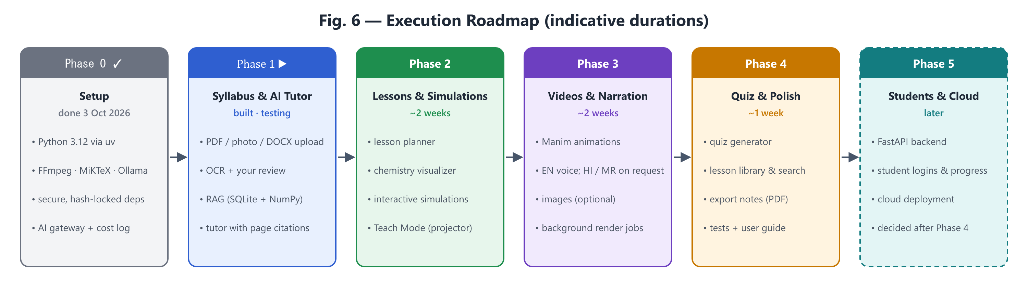
Figure 6 — Execution roadmap

12.1 Phase deliverables and acceptance criteria
Phase | Deliverables | Done when…
0 — Setup  ~3–4 days | Tools installed; repo skeleton; hash-locked dependencies (uv.lock) with LiteLLM pinned ≥ 1.83.0; keyring secrets; startup security checks; host allow-list; settings & models.yaml; LLMRouter gateway with routing, cache, cost log and budget cap; Streamlit shell (localhost only) with the five pages; Git repository | App opens with uv run streamlit run; one test prompt each to Ollama and OpenAI is routed and logged with cost; budget cap blocks paid calls when exceeded (tested); uv sync --locked succeeds; no API key exists in any project file; a call to a non-allow-listed host is refused (tested); pip-audit clean
1 — Syllabus & AI Tutor  ~1.5 weeks | Upload page; PDF + photo ingestion; OCR with review screen; chunk / embed / index; tutor chat with citations; Hindi/Marathi answers on request | One real chapter is uploaded from photos and corrected; the tutor answers 10 test questions with correct page citations and says clearly when something is not in the textbook
2 — Lessons & Simulations  ~2 weeks | Lesson planner; explanation & slides; chemistry visualizer; simulation generator + PhET embedding; Teach Mode; preview/edit/approve; basic library | For 3 pilot topics, a lesson is generated, edited, approved and presented full-screen; simulations work offline; all equations verified balanced
3 — Videos & Narration  ~2 weeks | Manim generator with auto-fix loop; narration (EN; HI/MR on request); audio-video merge; job runner with progress; optional images | A 60–90 s narrated video renders without manual code edits for at least 2 of 3 pilot topics; Marathi narration produced when requested
4 — Quiz & Polish  ~1 week | Quiz generator; library search & versions; PDF export of notes/quiz; automated tests; user guide | A full class is run end-to-end with the app as a dry run
5 — Students & Cloud  later | FastAPI backend; student logins & progress; PostgreSQL; cloud storage; deployment; licence review | Scope decided after Phase 4

12.2 Progress tracker
Phase | Status | Evidence / remaining
0 — Setup | Complete (03-Oct-2026; OpenAI key verified 04-Oct-2026) | Done: tools installed; uv sync --locked OK (110 packages, SHA-256 verified); pip-audit clean; 6/6 security checks OK; 48/48 automated tests pass (router, budget, cache, fallback, premium approval, allow-list refusal, key redaction, no network on LiteLLM import, all pages render); local test prompt answered end-to-end and logged at $0, repeat served from cache; app listens on 127.0.0.1 only. OpenAI key stored in Credential Manager by the owner; verify_models: all configured models available, prices match; a paid call (gpt-5.4-mini) logged at $0.002.
1 — Syllabus & AI Tutor | Complete (04-Oct-2026) incl. improvements (§8.5) | Done: any PDF / image / DOCX / TXT from source/ or upload; 3-level de-duplication; resumable background jobs; review screen with table preview; SQLite + NumPy search with page summaries and table/figure descriptions; optional cloud re-read; tutor with citations, filters, Hindi/Marathi on request, local/cloud answer switch and safe answer reuse. The owner reviewed all 17 pages and made them searchable. Retrieval 11/11, out-of-scope 6/6. 109 automated tests pass; pip-audit clean.
2 — Lessons & Simulations | Built (04/05-Oct-2026); owner review of the 3 pilot lessons pending | Done: lesson planner from reviewed passages with page citations; in-house equation checker (atoms + charge) with one automatic correction round; molecules in 2D/3D (RDKit + offline 3Dmol.js); AI-written p5.js simulations with safety/structure/syntax checks and up to 2 automatic fixes, shown in a sealed frame; Lesson Studio (edit, regenerate, approve) and Teach Mode (slides). Pilot lessons generated from Chapter 5: Neutralization, Electrolysis of Water, Water of Crystallisation — all equations balanced, all simulations passed on the first try, ≈ $0.06 in total. 175 automated tests pass; pip-audit clean. Simulations rebuilt on the lab kit (05-Oct). Remaining (owner): review, adjust and approve the lessons; present one in class.
3 — Videos & Narration | Planned | —
4 — Quiz & Polish | Planned | —
5 — Students & Cloud | Later | Decided after Phase 4

13. Risks and Mitigations
Risk | Impact | Mitigation
AI-generated code (Manim/JS) fails to run | Missing visuals | Error-feedback retry loop (max 3); tested templates; fall back to a simpler visual or a PhET sim
Scientifically wrong content | Students learn errors | Code-drawn visuals; chempy checks; textbook grounding with citations; owner approval before use
4 GB VRAM limits local models | Weaker local answers | Use local only for suitable tasks; cloud “mini” tier for code and translation; optional 8B model on CPU
Poor OCR on photos | Wrong text in RAG | Photo tips; mandatory review screen; cloud vision fallback for hard pages
Cloud cost overrun | Budget exceeded | Hard cap; cache; lesson reuse; dashboard; OpenAI dashboard limit
edge-tts (unofficial service) stops working | No free narration | Automatic fallback to OpenAI TTS; narration cached once generated
Weak Marathi quality | Confusing narration | Cloud model for translation; English term kept in brackets; owner review
Slow video rendering on laptop | Waiting in class | Render in background before class; low-quality preview first; cache results
Free-tier terms change or use data | Service loss / privacy | Optional only; never send student data; switch provider in config
Textbook copyright | Legal issue when going public | Personal teaching use now; review licences before distributing to students (Phase 5)
Compromised package on PyPI (as with LiteLLM, March 2026) | API keys and files stolen | Exact pins, hash-locked installs, 7-day cooldown, pip-audit, startup version check, keys outside files, scoped low-budget keys (Section 14)

14. Security: Dependencies, LiteLLM and API Keys

14.1 Why this section exists
On 24 March 2026, LiteLLM versions 1.82.7 and 1.82.8 were published to PyPI by an attacker who had stolen the maintainers’ publishing token through a compromised CI security scanner. They were live for about 40 minutes and contained a credential stealer targeting cloud keys, SSH keys and LLM API keys; 1.82.8 added a .pth file that runs whenever Python starts. Versions before 1.82.7 and 1.83.0 and later are not affected. The owner’s rules (Decision D10) apply to LiteLLM, and this project applies the same discipline to every dependency.

14.2 How this project uses LiteLLM
- Python SDK only, in-process. The LiteLLM Proxy Server (the standalone gateway the incident payload targeted in proxy_server.py) is not installed or run.
- Behind our own interface. The rest of the app calls LLMRouter.complete(task, messages) (app/llm/router.py), which talks to a small Backend interface; only app/llm/litellm_backend.py imports litellm. If LiteLLM ever becomes untrustworthy, it can be replaced by a thin client over the official openai SDK (Ollama, OpenAI, Hugging Face, Gemini, Groq and OpenRouter all offer OpenAI-compatible endpoints) without touching other code.
- No third-party callbacks. LiteLLM logging/telemetry callbacks stay disabled; cost logging is done by our own code into SQLite.

14.3 Dependency rules (all packages)
Rule | How it is enforced
Pin exactly | litellm==<clean version ≥ 1.83.0> in pyproject.toml (exact version chosen in Phase 0 after checking advisories). All other packages pinned through uv.lock.
Lockfile with SHA-256 hashes | uv.lock stores the hash of every package file. Installs use uv sync --locked, which fails if the lock is stale or any hash does not match.
Never install loosely | No pip install <name> into the project; packages are added only with uv add <name>==<version> and the lockfile change is reviewed and committed.
Release cooldown | [tool.uv] exclude-newer is set to a date at least 7 days in the past, so brand-new releases (when malicious uploads are usually caught) are never selected.
Deliberate upgrades | One package at a time: read changelog and security advisories → uv lock --upgrade-package <name> → review uv.lock diff → uvx pip-audit → run tests → commit.
Startup check | On launch the app verifies the installed LiteLLM version is the pinned one, refuses known-bad versions (1.82.7, 1.82.8) and flags unexpected .pth files such as litellm_init.pth in the environment.

14.4 API-key isolation
- No keys in files: not in code, not in .env, not in Git. Keys are stored in Windows Credential Manager via the keyring library (encrypted per Windows user) and read into memory only when a call is made. This is the local-laptop equivalent of a secrets manager; AWS Secrets Manager or HashiCorp Vault are considered for the cloud phase (Phase 5).
- Scoped, low-limit keys: a dedicated OpenAI Project for this app with a restricted key (only the endpoints we use) and a project budget limit, so a leaked key has limited value.
- Rotation: rotate keys every 90 days and immediately after any suspicion. (OpenAI keys for normal API use are long-lived; short-lived ephemeral tokens apply only to special APIs such as Realtime, so scoping + low budget + rotation is the practical substitute.)
- Never logged: keys are redacted from logs and error messages; LiteLLM verbose/debug logging stays off.
- Local services need no keys: Ollama binds to 127.0.0.1:11434 only (OLLAMA_HOST must not be set to 0.0.0.0).

14.5 Network egress
- In-app allow-list: the gateway sends model requests only to hosts listed in config — e.g. api.openai.com, 127.0.0.1:11434 (Ollama), router.huggingface.co, generativelanguage.googleapis.com, api.groq.com, openrouter.ai. Any other base URL is refused and logged.
- Firewall rules: because we do not run the Proxy Server, there is no separate gateway process to firewall. A Windows per-program rule on python.exe is not practical, since the same interpreter must also reach PubChem, PhET and the TTS service. When the app moves to the cloud (Phase 5), the gateway container’s outbound traffic will be restricted at the firewall / network-policy level to the official provider endpoints only.
- Local-only UI: Streamlit is bound to 127.0.0.1, so other devices on the home Wi-Fi cannot open the app.

14.6 LiteLLM hardening as built (Phase 0)
Measure | Where / how verified
No downloads at start-up | LiteLLM normally fetches its price list and an Anthropic-headers file from GitHub when imported. litellm_backend.py sets LITELLM_LOCAL_MODEL_COST_MAP=True and LITELLM_LOCAL_ANTHROPIC_BETA_HEADERS=True before import, so bundled copies are used. Test test_litellm_import_and_call_make_no_unexpected_network_connections blocks all sockets and proves import + a mocked call make zero connections.
No callbacks / telemetry | litellm.callbacks, success_callback, failure_callback emptied; telemetry=False; debug info suppressed. Cost logging is our own (SQLite LLMCall table).
Explicit endpoint and key per call | Every call passes api_base from models.yaml and the key from Credential Manager; LiteLLM never reads keys from environment variables (startup check warns if any are set).
Security checks before import | startup_checks.py inspects package metadata and files only (never imports LiteLLM): pinned version, blocked versions 1.82.7/1.82.8, litellm_init.pth, keys in .env, Ollama/Streamlit binding, keyring backend. Any error disables all AI features.
Retries owned by our router | LiteLLM num_retries=0; the router retries once, then moves down the fallback chain, logging each failure with keys redacted.
Ollama “thinking” off | Router passes reasoning_effort → LiteLLM maps it to Ollama think=false; any leftover reasoning text is stripped.

15. Ways of Working
- Work in phases; each feature is built as a thin, working slice and demoed to you.
- Every change is committed to Git with a clear message; nothing is pushed to the internet without your approval.
- API keys live only in Windows Credential Manager; .env holds non-secret settings; generated data stays in data/ (excluded from Git).
- Dependencies change only through the controlled upgrade procedure in Section 14.3.
- This blueprint is updated at the end of each phase (version 1.1, 1.2, …).

16. Decision Log
# | Decision | Status | Date
D1 | Board-agnostic: content comes from the syllabus and textbook pages the owner uploads (currently State Board) | Decided by owner | 03-Oct-2026
D2 | Primary user: the owner teaching at home from the laptop | Decided by owner | 03-Oct-2026
D3 | English by default; Hindi and Marathi only when explicitly requested | Decided by owner | 03-Oct-2026
D4 | Multi-provider AI via configuration: OpenAI (existing keys) + Ollama local + optional Hugging Face / free tiers; minimise cost | Decided by owner | 03-Oct-2026
D5 | Run locally on the laptop first; decide cloud after Phase 4 | Decided by owner | 03-Oct-2026
D6 | Stack: Python 3.12 via uv, Streamlit, LiteLLM, SQLite (+ vector store), Manim, RDKit/py3Dmol/chempy, edge-tts | Approved by owner | 03-Oct-2026
D7 | Accuracy-first: science visuals drawn by code; image/video-generating AI only for decoration | Approved by owner | 03-Oct-2026
D8 | Default monthly cap on paid API spend: USD 5 (adjustable any time) | Approved by owner | 03-Oct-2026
D9 | Phase plan 0–5 as in Section 12 | Approved by owner | 03-Oct-2026
D10 | LiteLLM safety rules: exact pin to a clean version ≥ 1.83.0; SHA-256 hash-locked installs via uv; API keys isolated from files; network egress restricted to provider endpoints | Decided by owner | 03-Oct-2026
D11 | How D10 is implemented on the laptop: SDK in-process (no Proxy Server) behind our own LLMRouter / Backend interface; keys in Windows Credential Manager + scoped, budget-capped OpenAI project key; in-app host allow-list; 7-day release cooldown; vault/firewall egress rules in Phase 5 | Approved by owner | 03-Oct-2026
D12 | Local text model is qwen3:4b-instruct (Qwen3-4B-Instruct-2507), not qwen3:4b (Thinking-2507, always reasons first — measured 15–25 s and ~190 tokens for a one-line answer) | Decided in Phase 0 (evidence-based) | 03-Oct-2026
D13 | OpenAI tiers: gpt-5-nano (cheapest), gpt-5.4-mini (mini), gpt-5.2 (premium, approval required); prices confirmed in two sources | Decided in Phase 0 | 03-Oct-2026
D14 | Python packages for later phases are added only when that phase starts (smaller attack surface); each addition follows §14.3 | Decided in Phase 0 | 03-Oct-2026
D15 | Vector store = SQLite + NumPy instead of ChromaDB (same results at this scale; avoids ~30 heavy packages incl. Kubernetes, gRPC, ONNX Runtime, OpenTelemetry and telemetry). Behind a small interface, so ChromaDB can be added later if the library grows very large | Proposed — awaiting owner approval | 04-Oct-2026
D16 | OCR model = qwen3-vl:2b-instruct at 1600 px with an 8,192-token context (measured ≈ 20–30 s/page vs 64–178 s for 4b-instruct; Thinking variants not usable) | Decided in Phase 1 (evidence-based) | 04-Oct-2026
D17 | Ingestion: any PDF / image / DOCX / TXT from source/ or upload; 3-level de-duplication (file, page image, passage); review before search by default | Requested by owner, built | 04-Oct-2026
D18 | source/ (textbook files) excluded from Git — copyright and size; files stay on the laptop | Proposed — owner may revert in .gitignore | 04-Oct-2026
D19 | No Unstructured / LangChain / Redis: scanned pages need a vision model anyway (Tesseract handles subscripts poorly), they add large dependency trees, and Redis needs WSL/Docker on Windows. Equivalent features built on the existing stack (§8.5) | Discussed with owner; owner asked to implement | 04-Oct-2026
D20 | Cloud re-read model = gpt-5.4-mini (benchmark: only option with correct subscripts and tables); optional, per page or per document, cost shown first | Decided (evidence-based) | 04-Oct-2026
D21 | Generated summaries/descriptions are search aids only — never answer evidence (a description swapped acidity/basicity) | Decided (evidence-based) | 04-Oct-2026
D22 | Semantic answer cache: threshold 0.97 + contrast-word guard + scope/index-version checks; on by default, toggle per question | Decided (calibrated) | 04-Oct-2026
D23 | AI Tutor answer-model switch: local (free, default) or cloud gpt-5-nano (≈ $0.001/answer, better with tables) | Decided (evidence-based) | 04-Oct-2026
D24 | Chemistry without chempy / py3Dmol / PubChemPy: in-house equation checker (fully tested), RDKit + locally stored 3Dmol.js, reviewed local molecule table (works offline in class) | Decided in Phase 2 | 04-Oct-2026
D25 | Simulation safety: model writes only the p5.js sketch; rules (no network/storage/eval/parent access), structure checks and node --check syntax check, ≤ 2 automatic fix rounds; page served with a no-network Content-Security-Policy in a separate frame; teacher previews before approving | Decided in Phase 2 | 04-Oct-2026
D26 | Pilot topics: Neutralization reaction, Electrolysis of water, Water of crystallisation (Chapter 5) | Chosen by owner (“use the suggested 3”) | 04-Oct-2026
D27 | Background workers only claim job kinds they support (an app started before an update failed two new jobs) | Decided (incident) | 04-Oct-2026
D29 | Molecule models: separate ions laid out side by side; atom labels (symbol + charge) and hand-checked ion labels; element legend and charge note | Requested by owner; Cu²⁺ visibility bug fixed | 05-Oct-2026
D30 | Every new simulation is run in a hidden Edge/Chrome (all controls used) and its pictures are reviewed by a vision model before the teacher sees it | p5.js 2 crash found by owner; visual faults found in screenshots | 07-Oct-2026
D31 | Lab kit provides hand-drawn apparatus and complete setups (electrolysis, heating, conductivity, neutralisation); the AI places and switches them | Measured: AI-drawn glassware was wrong in several ways | 07-Oct-2026
D32 | 3D bonding and reaction scenes are computed (shells, table, balanced equation) and drawn by a hand-written player — no AI, no new library | Owner’s request: see valency electrons move | 07-Oct-2026
D38 | Autopilot: pages passing an explainable automatic quality check count as reviewed and become searchable; flagged pages wait for the teacher with reasons (owner’s choice; switch: ATS_AUTO_REVIEW_CLEAN) | Owner: “every time I need to share the PDF” — 08-Oct-2026 | 09-Oct-2026
D39 | Autopilot writes one draft lesson per chapter from the whole chapter as soon as pages are searchable; approval stays manual (switch: ATS_AUTO_LESSON) | Owner’s choice | 09-Oct-2026
D40 | Cloud re-read of flagged scanned pages only on the teacher’s click, with the cost shown | Owner’s choice | 09-Oct-2026
D41 | Maths lessons: the AI only extracts concepts, the textbook’s examples and real-life ideas; every computable answer (HCF, LCM, primes, angle pairs, linear equations) is re-computed by code and wrong AI answers are replaced and listed | Owner: maths first; accuracy rule as for history (D35) | 09-Oct-2026
D42 | Maths 2D and 3D pictures are drawn by a hand-written player (mathkit.js) from computed values — no AI image or 3D generators | Image models mis-draw numbers/angles; TripoSR ≈ 6 GB, Hunyuan3D ≥ 10 GB, SV3D ≈ 20 GB VRAM vs 4 GB | 09-Oct-2026
D43 | Real-life photos only from Wikimedia Commons / Wikidata (Openverse as fallback), free licences only (CC0, PD, CC BY, CC BY-SA), allow-listed hosts, thumbnails ≤ 1.5 MB, credit line always shown | Owner: “upload from Wikimedia, common places from internet using tools” | 09-Oct-2026
D44 | Every photo is checked by the local vision model: its caption must match the wanted subject by meaning (embedding similarity ≥ 0.72, or ≥ 0.60 when it also says yes) | Measured: the 2B model’s yes/no contradicted its own caption; calibrated on 12 pairs | 09-Oct-2026
D34 | Lessons get a subject profile (history / science); history lessons read the whole chapter (exercise passages removed) and extract timeline, periods, people, places and causes-effects | Measured: topic search missed 5 of 8 pages; exercise page has deliberately wrong pairs | 07-Oct-2026
D35 | Every history fact shown is checked against the cited textbook text (date numbers + month + event words together; names present); unproven items are removed and listed | AI paired a real year with the wrong event in the first test | 07-Oct-2026
D36 | Maps offline: Natural Earth India point-of-view boundaries (public domain) + GeoNames places (CC BY 4.0); a place is drawn only when unambiguous (major town, or within 40 km of a named city), else the teacher gives a hint | Wrong villages were chosen with state-only hints in testing | 07-Oct-2026
D37 | Textbook PDFs read column-aware (line level); the textbook’s own captioned pictures are reused for slides and people cards | Owner’s two-column history chapter | 07-Oct-2026
D33 | Free image/3D generators not used for chemistry diagrams (inaccurate electrons/labels, not interactive, too large for 4 GB); possible later for marked illustrations | Owner asked to evaluate | 07-Oct-2026
D28 | Simulations run inside a hand-written lab kit that owns layout, labels (overlap-free) and animation timers; the AI only writes the experiment (SIM); layout/animation rules are checked automatically | Decided after owner’s review (overlapping labels, no stir animation) | 05-Oct-2026

17. Open Items for the Owner
- Restart the app (it was started before Phase 2 and still runs the old code).
- Review the 3 pilot lessons in Lesson Studio (content, equations, molecules, simulation), adjust and approve them; present one in Teach Mode.
- Ask ~10 real questions on AI Tutor (try a table question with the *Cloud* answer model) and report any wrong answers.
- Approve or change D15 (vector store) and D18 (source/ kept out of Git).
- Optional: free ~10 GB by removing unused models: ollama rm qwen3:4b qwen3-vl:4b qwen3-vl:2b qwen3-vl:4b-instruct deepseek-r1:1.5b.

Appendix A — Glossary
Term | Meaning
LLM | Large Language Model — the AI that writes text and code (e.g. OpenAI models, Qwen)
RAG | Retrieval-Augmented Generation — the AI first looks up relevant textbook passages, then answers using them
OCR | Optical Character Recognition — reading text from photos of pages
Embedding | A list of numbers that represents the meaning of a text, used to find similar passages
Vector store | Storage + search of embeddings (here: SQLite + NumPy) for meaning-based search
Token | A piece of a word; cloud AI providers charge per token
Fallback chain | The ordered list of models to try if the first one fails or is unavailable
Ollama | Software that runs open AI models locally on the laptop
LiteLLM | A Python library that gives one common interface to many AI providers
Manim | A Python library for precise mathematical/scientific animations
Streamlit | A Python library for building web app interfaces quickly
VRAM | Memory on the graphics card; limits which local models run fast
Supply-chain attack | An attacker publishes a poisoned version of a trusted package, so installing or upgrading it runs their code
Lockfile / hash | A file (uv.lock) recording the exact version and SHA-256 fingerprint of every package, so a tampered file is rejected
Egress filtering | Allowing a program to connect only to approved internet addresses

