AI Teaching Studio
Project Blueprint: Requirements, Architecture, Workflows & Execution Plan
Version 1.1 — Draft for owner approval
3 October 2026

Item | Detail
Project | AI Teaching Studio — AI-assisted teaching with simulations, animations and an AI tutor
Owner / teacher | Santosh
Prepared by | Claude Code (AI engineering assistant), with the owner
Codebase location | D:\Santosh\Data Science\Entrepreneur journey\Tuition study app
Status | Draft — decisions D6–D9 and D11 in Section 16 await approval

Document Control
Version | Date | Change | Status
1.0 | 03-Oct-2026 | First complete blueprint: requirements from owner answers, architecture, model strategy, workflows, phased plan | Superseded
1.1 | 03-Oct-2026 | Owner security guidelines after the March 2026 LiteLLM supply-chain incident: new Section 14 (pinning, hash-locked installs, API-key isolation, egress control); updates to stack, setup steps, NFR-06, Phase 0, risks and decisions D10–D11 | Draft for approval

How to use this document: it is the single reference for what we are building, why, and how. When a decision changes, update the Decision Log (Section 16), bump the version and keep the old file for history. Diagrams are also saved as high-resolution PNG and editable SVG in docs/diagrams/.

(If the contents list is empty, right-click it in Word and choose “Update Field”.)

1. Project Overview

1.1 Vision
Build an AI-powered teaching studio that runs on the owner’s laptop and turns textbook chapters into ready-to-teach lessons: clear explanations, accurate chemistry visuals, interactive experiment simulations, narrated animated videos, quizzes, and an AI tutor that answers students’ doubts from the textbook itself.

1.2 Users and context
- Now (Phases 0–4): the owner teaches students at home, presenting from the laptop on a screen or projector.
- Later (Phase 5): students may use the app directly (web/mobile). Cloud hosting will be decided after Phase 4.

1.3 Scope
- Board-agnostic: the app does not hard-code any syllabus. All content comes from the syllabus and textbook pages the owner uploads (currently State Board).
- Subject-agnostic, chemistry-strong: chemistry gets dedicated tools (equations, molecules, reactions); physics, biology and maths are covered through simulations, animations and the tutor.
- Languages: English by default; Hindi and Marathi only when explicitly requested.
- Out of scope for now: student accounts, payments, cloud deployment, mobile apps (Phase 5 or later).

2. Requirements

2.1 Functional requirements
Priority: Must = required for the phase to be complete; Should = planned, can slip; Could = optional.
ID | Requirement | Priority | Phase
FR-01 | Upload syllabus and chapter content as PDFs or photos / snapshots of textbook pages | Must | 1
FR-02 | Extract text from photos (OCR); owner reviews and corrects the text before it is used | Must | 1
FR-03 | Organise content by Class → Subject → Chapter → Topic, keeping page numbers | Must | 1
FR-04 | AI tutor answers doubts grounded in the uploaded textbook (RAG) and cites chapter + page | Must | 1
FR-05 | Generate a lesson for a topic: explanation, key points, examples, slides | Must | 2
FR-06 | Chemistry visualizer: balanced equations, 2D structures, rotatable 3D molecules | Must | 2
FR-07 | Interactive simulations of experiments (sliders, buttons), usable offline once generated | Must | 2
FR-08 | Teach Mode: full-screen, presenter-friendly view for the projector | Must | 2
FR-09 | Owner previews, edits and approves every lesson before it is saved or presented | Must | 2
FR-10 | Animated explainer videos (Manim) with narration | Should | 3
FR-11 | English by default; Hindi / Marathi narration, labels or answers only on explicit request | Must | 1 (chat), 3 (narration)
FR-12 | AI-generated illustrations, off by default and cost-gated | Could | 3
FR-13 | Quiz generation (MCQ + short answer) with answer key | Should | 4
FR-14 | Lesson library: reuse, search, versions | Should | 4
FR-15 | Export notes and quizzes as PDF | Could | 4
FR-16 | Choose AI provider / model per task through configuration, without code changes | Must | 0
FR-17 | Cost dashboard: tokens and cost per call, monthly totals, budget status | Must | 0–1
FR-18 | Student logins and progress tracking | Could | 5

2.2 Non-functional requirements
ID | Quality | Requirement
NFR-01 | Low cost | Local / free models first. Hard monthly cap on paid API spend (configurable; proposed default USD 5). An identical request is never paid for twice (cache + lesson library).
NFR-02 | Accuracy | Science visuals are drawn by code (Manim, RDKit, JS), not by image/video-generating AI. Equations are checked by chempy. Tutor answers cite textbook pages. Owner approves before use.
NFR-03 | Runs on this laptop | Windows 11, Intel Core 5 210H, 32 GB RAM, NVIDIA RTX 3050 (4 GB VRAM). No Docker or Redis needed for Phases 0–4.
NFR-04 | Offline-tolerant | Saved lessons, simulations (JS libraries stored locally) and local models work without internet. Internet is needed only for cloud models and PubChem/PhET lookups.
NFR-05 | Responsiveness (targets) | Tutor answer starts within ~5 s on local model; lesson text within ~1 min; video renders 1–3 min in the background with a progress bar.
NFR-06 | Security & privacy | API keys never in code or .env: stored in Windows Credential Manager (Section 14.4). All dependencies pinned and hash-verified via uv.lock; LiteLLM pinned to a clean version ≥ 1.83.0. Model calls only to allow-listed provider hosts. AI-generated code runs sandboxed (browser iframe or separate process with timeout). App listens on localhost only. No student personal data sent to free-tier providers.
NFR-07 | Maintainability | Python 3.12, type hints, configuration-driven, automated tests for core services, dependencies pinned in uv.lock.
NFR-08 | Future-ready | Layered design so a FastAPI backend and cloud deployment can be added in Phase 5 without rewriting services.

3. Guiding Design Principles
- Accuracy first — the AI writes code, Python draws. Models generate Manim scripts, simulation code and chemistry data; deterministic libraries render them. Image/video-generating AI often draws wrong bonds, labels and reactions, so it is used only for decorative illustrations.
- Cost first — local → cheap cloud → premium. Every task has a default model and a fallback chain. Paid calls are logged, capped and cached.
- Teacher in control. Nothing is shown to students until the owner has previewed and approved it.
- Textbook-grounded. The tutor and lesson generator use the uploaded chapters as their source and show citations, so content matches what students study.
- Configuration over code. Models, budgets, languages and voices live in config/*.yaml and .env — never secrets, which go to Windows Credential Manager.
- Thin vertical slices. Every phase ends with something usable in a real class.

4. System Architecture
The Integrated Architecture Diagram (IAD) below shows all six layers. Each layer talks only to the layer below it, which keeps the design simple now and lets us replace the Streamlit UI with a FastAPI + web front end later without touching the services.
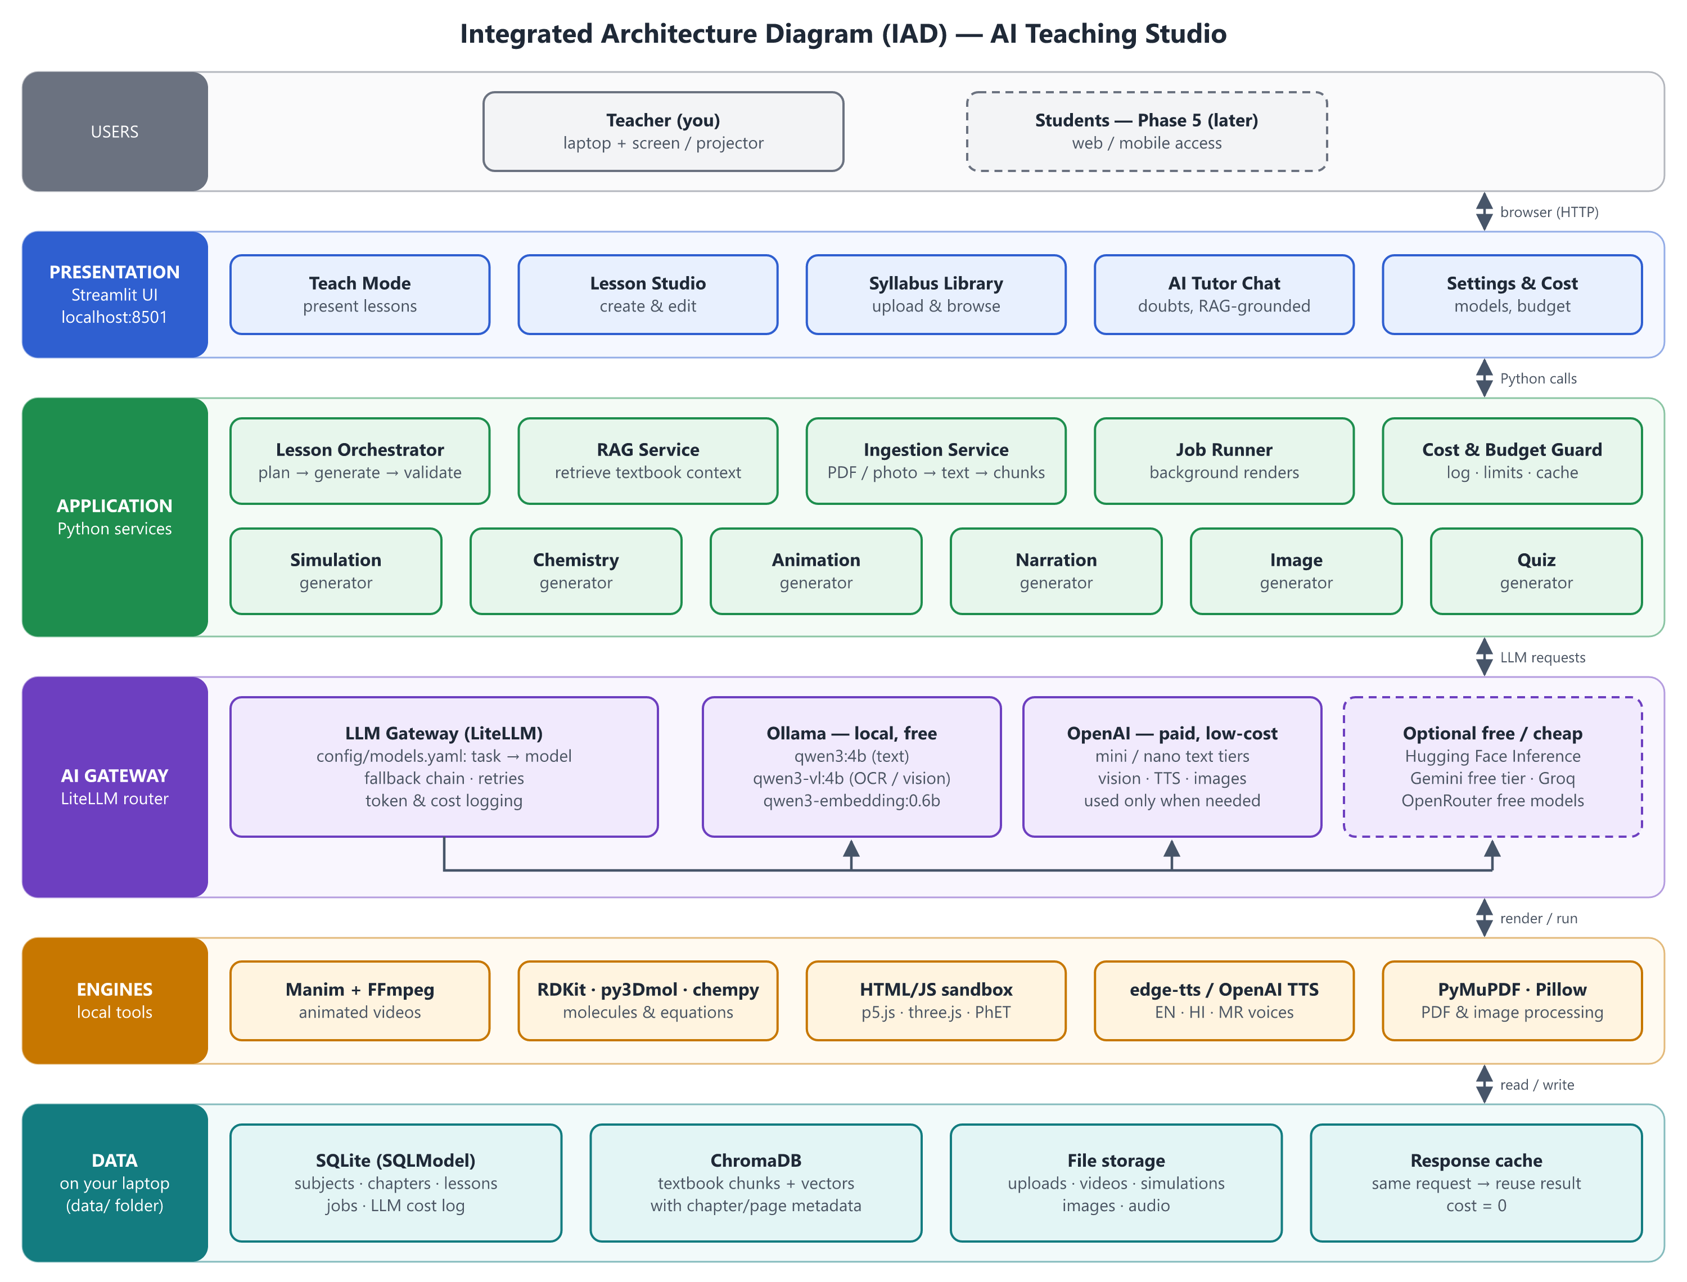
Figure 1 — Integrated Architecture Diagram (IAD)

4.1 Components and responsibilities
Layer | Component | Responsibility
Presentation | Teach Mode | Full-screen presentation of an approved lesson: slides, simulations, 3D molecules, videos
Presentation | Lesson Studio | Generate, preview, edit, regenerate sections, approve
Presentation | Syllabus Library | Upload PDFs/photos, review OCR text, browse chapters and topics
Presentation | AI Tutor Chat | Doubt solving grounded in the textbook, with citations and language on request
Presentation | Settings & Cost | Model selection per task, budget cap, cost dashboard, voices
Application | Lesson Orchestrator | Plans a lesson (JSON), calls generators, runs validator, assembles the lesson package
Application | RAG Service | Retrieves the most relevant textbook chunks for a question or topic
Application | Ingestion Service | PDF split, OCR, review queue, chunking, tagging, embedding, indexing
Application | Generators | Simulation, chemistry, animation, narration, image, quiz — one module each, same interface
Application | Job Runner | Runs slow work (video renders, bulk OCR) in the background with progress and timeouts
Application | Cost & Budget Guard | Logs every model call, enforces the monthly cap, serves cached responses
AI Gateway | LiteLLM | One Python API over Ollama, OpenAI, Hugging Face, Gemini, Groq, OpenRouter; retries and fallbacks
Engines | Manim, RDKit, py3Dmol, chempy, HTML/JS sandbox, TTS, PyMuPDF | Deterministic rendering and processing on the laptop
Data | SQLite, ChromaDB, file storage, cache | All data stays in the project’s data/ folder on the laptop

5. Technology Stack and Versions
Version policy: this table fixes the major choices and minimum versions. The exact versions of every package are resolved during Phase 0, checked on this Windows laptop, and pinned in uv.lock, which becomes the source of truth.
Area | Choice | Why this choice | Cost
Language | Python 3.12.x (latest patch), installed and managed by uv | Most mature Windows wheels for RDKit, Manim, ChromaDB, PyMuPDF; security support until Oct 2028. 3.13 works for most packages but some scientific/audio libraries lag; 3.14 is too new. | Free
Environment & packages | uv (already installed: 0.12.11) | Fast installs, lockfile, installs Python itself — no conflict with other Pythons | Free
User interface | Streamlit (≥ 1.40) | Pure-Python UI, wide/full-screen layout, embeds HTML simulations, 3D viewers and video | Free
AI gateway | LiteLLM Python SDK, exact-pinned to a clean release ≥ 1.83.0 (never 1.82.7 / 1.82.8), hash-locked; used in-process only — the LiteLLM Proxy Server is not used | Single API for all providers, cost tracking, fallbacks; change models in YAML. Hidden behind our own LLMClient interface so it can be replaced (Section 14) | Free
Secrets | keyring → Windows Credential Manager | API keys encrypted per Windows user; never stored in files | Free
Supply-chain checks | pip-audit (run via uvx) | Checks locked dependencies against known-vulnerability databases before each upgrade and phase sign-off | Free
Local AI runtime | Ollama (installed: 0.34.4) | Runs local models on the RTX 3050 / CPU; already has OCR and embedding models | Free
Cloud AI | OpenAI (owner has keys) + optional Hugging Face, Gemini, Groq, OpenRouter | Higher-quality code generation, translation and vision when local models are not enough | Pay-per-use / free tiers
Vector store | ChromaDB (embedded, persistent) | No server; stores vectors and metadata on disk | Free
Database | SQLite + SQLModel (Pydantic v2) | Zero setup, single file; upgrade path to PostgreSQL in Phase 5 | Free
Configuration | pydantic-settings, YAML, .env | Typed, validated settings; secrets kept out of code | Free
PDF & images | PyMuPDF, Pillow | Fast text extraction and page rendering; photo cleanup before OCR. Note: PyMuPDF is AGPL — fine for personal use; review before selling the app (Phase 5). | Free
Chemistry | RDKit, py3Dmol, chempy, PubChemPy | Structures, interactive 3D molecules, equation balancing, name → structure lookup (PubChem needs internet) | Free
Animation | Manim Community Edition (≥ 0.19) | Precise, programmable science/maths animations rendered to MP4 | Free
Video/audio tools | FFmpeg (system install) | Merge narration with video, convert formats | Free
Typesetting | MiKTeX | Formulas in Manim (MathTex, chemistry via mhchem) | Free
Text-to-speech | edge-tts (primary), OpenAI TTS (fallback) | Natural English, Hindi and Marathi voices at no cost; paid fallback if the free service changes | Free / paid fallback
Simulations | p5.js, three.js (stored locally), PhET HTML5 sims (embedded) | AI-written interactive experiments; ready-made PhET sims for standard experiments (CC-BY, online) | Free
Background jobs | Python thread/process pool + SQLite jobs table | Avoids Redis/Celery, which are awkward on Windows | Free
Quality | pytest, ruff, loguru | Tests, linting/formatting, readable logs | Free
Version control | Git (installed: 2.51) + optional private GitHub repo | History, safe experiments, backup | Free

6. Local Environment Setup (Phase 0)

6.1 Laptop profile (checked on 3 Oct 2026)
Item | Status
Operating system | Windows 11 Home Single Language
CPU / RAM | Intel Core 5 210H / 32 GB
GPU | NVIDIA GeForce RTX 3050 Laptop, 4 GB VRAM (+ Intel integrated graphics)
Free disk space on D: | ≈ 117 GB (project needs ~15–25 GB incl. models and videos)
Already installed | uv 0.12.11 · Git 2.51 · Node.js 24.16 (not required) · Ollama 0.34.4
Ollama models present | qwen3-vl:4b · qwen3-vl:2b · qwen3-embedding:0.6b · deepseek-r1:1.5b
Missing | Python (will be installed by uv) · FFmpeg · MiKTeX

6.2 Installation steps
- Install Python 3.12 through uv: uv python install 3.12
- Install FFmpeg: winget install --id Gyan.FFmpeg -e
- Install MiKTeX: winget install --id MiKTeX.MiKTeX -e, then in MiKTeX Console enable “install missing packages on-the-fly”.
- Pull the local text model: ollama pull qwen3:4b. Keep qwen3-vl:4b, qwen3-vl:2b and qwen3-embedding:0.6b. deepseek-r1:1.5b is not used and can be removed to free 1.1 GB.
- Create the project: uv init, add dependencies with uv add …, and run git init.
- Install dependencies only from the lockfile: uv sync --locked (verifies SHA-256 hashes; fails on any mismatch). Confirm litellm is the pinned clean version (≥ 1.83.0).
- In the OpenAI dashboard, create a dedicated Project “ai-teaching-studio” with its own restricted API key and a monthly budget limit.
- Store the key in Windows Credential Manager (not in any file): uv run keyring set ai-teaching-studio openai and paste the key when prompted. Copy .env.example to .env for non-secret settings such as MONTHLY_BUDGET_USD.
- Verify: uv run streamlit run ui/Home.py opens the app at http://localhost:8501.

7. AI Model Strategy and Cost Control
The app never hard-codes a model. Each task (tutor chat, OCR, Manim code, translation…) is mapped in config/models.yaml to a primary model and a fallback chain. The LiteLLM gateway applies the mapping, enforces the budget and logs cost.

7.1 Providers and their constraints
Provider | Cost | Strengths | Constraints
Ollama (local) | Free | Private, offline, no per-token cost; good for OCR, embeddings, simple Q&A | 4 GB VRAM ⇒ ~4B-parameter models run fully on GPU; 7–8B models spill to RAM and run several times slower; one model loaded at a time (switching takes seconds); weaker at long code and Marathi
OpenAI | Pay per token | Strong code generation, reasoning, vision, TTS, images | Costs money; needs internet; prices and model names change — verified in Phase 0 and kept in config
Hugging Face | Free hub; small monthly free inference credit, then pay-as-you-go | (a) Source of open models to run in Ollama; (b) hosted inference for larger open models | Credits are limited; model availability varies by provider
Free cloud tiers (Gemini API, Groq, OpenRouter “:free”) | Free with rate limits | Fast, capable models at zero cost | Per-minute/day limits; terms can change; prompts may be used for training ⇒ send textbook content only, never student personal data

7.2 What fits on this laptop
Local model | Disk | Fits 4 GB GPU? | Use in this project
qwen3:4b (to pull) | ≈ 2.5 GB | Yes | Tutor chat with RAG, short summaries, quiz drafts
qwen3-vl:4b (installed) | 3.3 GB | Yes (tight) | OCR of textbook photos, describing diagrams
qwen3-vl:2b (installed) | 1.9 GB | Yes | Faster OCR for clean, printed pages
qwen3-embedding:0.6b (installed) | 0.6 GB | Yes | Embeddings for RAG (multilingual)
deepseek-r1:1.5b (installed) | 1.1 GB | Yes | Not used — too small for reliable teaching answers
7–8B models (optional, e.g. qwen3:8b) | ≈ 5 GB | Partly (CPU offload) | Better offline quality when speed is not critical

7.3 Default task → model routing
Task | Primary | Fallback | Reason
OCR of photos | Local qwen3-vl:4b | OpenAI low-cost vision tier | Free for most pages; cloud only for hard pages
Embeddings | Local qwen3-embedding:0.6b | — | Free and multilingual. The same model must be used for the whole index (changing it means re-indexing).
Tutor chat (English) | Local qwen3:4b + RAG | OpenAI cheapest tier | Grounded answers are short and simple
Lesson plan & explanations | OpenAI low-cost “mini” tier | Local qwen3:4b | Quality matters; generated once, then cached
Manim & simulation code | OpenAI “mini” tier | OpenAI premium tier (asks before use) | Small local models often produce broken code
Quiz generation | OpenAI cheapest tier | Local qwen3:4b | Structured output, low token count
Hindi / Marathi translation | OpenAI “mini” tier | Gemini free tier | Small local models are weak in Marathi
Narration (TTS) | edge-tts | OpenAI TTS | Free en-IN, hi-IN, mr-IN voices
Images | Off by default; OpenAI image (low quality) on request | — | Expensive relative to text; rarely needed
Science validation | chempy rules + cheapest cloud tier | Local qwen3:4b | Rules catch most errors at zero cost

Model names are configuration, not code. Exact OpenAI model names and prices are checked against OpenAI’s current model list and pricing page during Phase 0 and written into config/models.yaml. If a model is retired or a cheaper one appears, only that file changes.

7.4 Cost-control mechanisms
- Monthly hard cap (MONTHLY_BUDGET_USD): when reached, paid calls are downgraded to local/free models or require your approval.
- Response cache keyed by task + model + prompt: an identical request costs nothing the second time.
- Lesson library: a topic is generated once and reused across batches and years.
- Small prompts: only the top few textbook chunks are sent, and every task has a max_tokens limit.
- Premium needs approval: the most expensive tier is never used silently.
- Cost dashboard: per-call tokens, cost, model and latency; monthly totals.
- Expected pattern: day-to-day use (tutor chat, OCR, embeddings) runs locally for free; paid calls happen mainly once per new lesson.

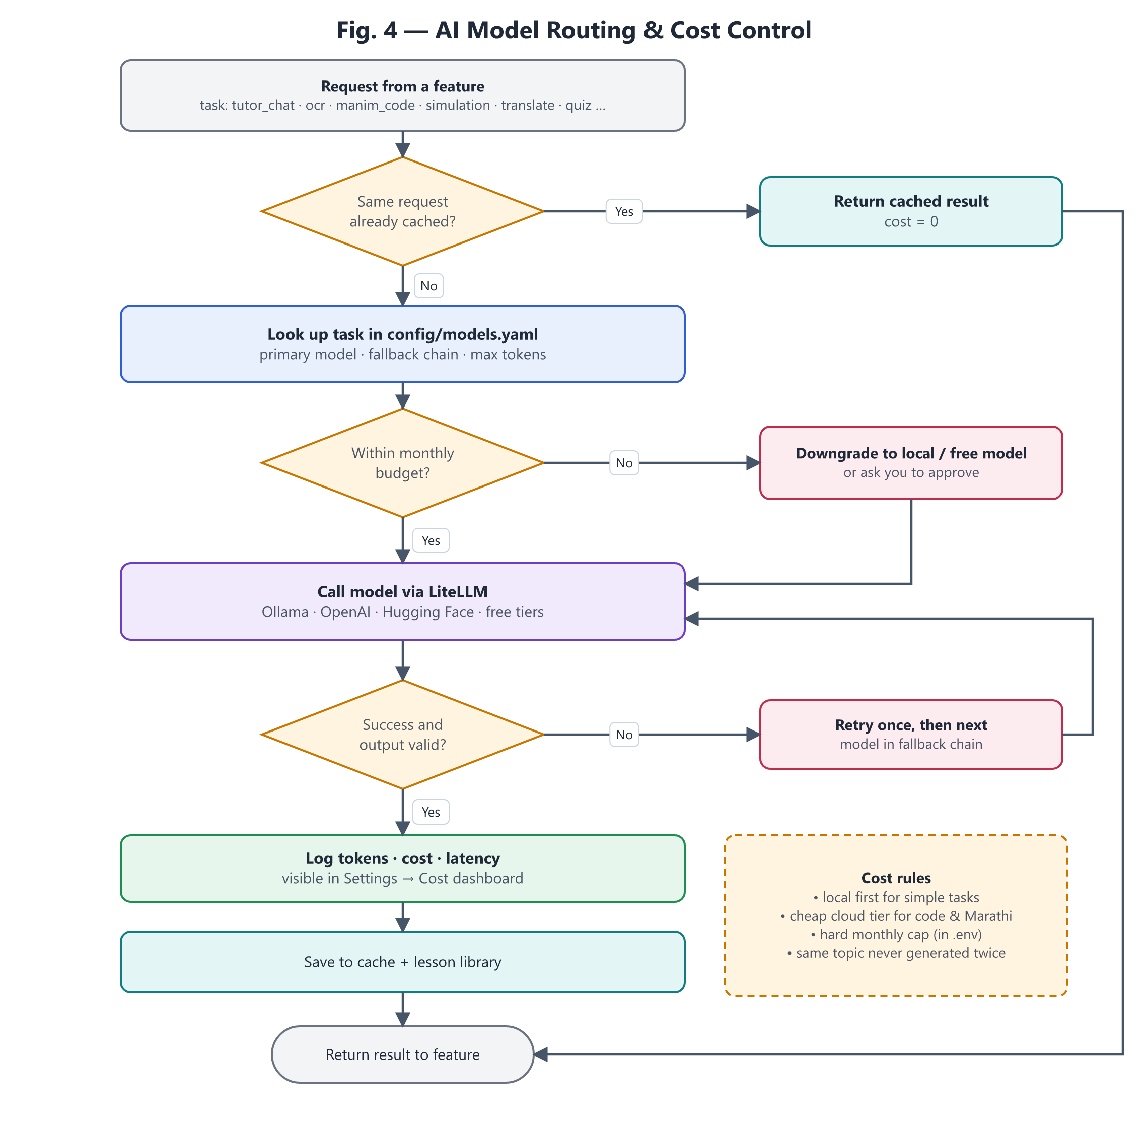
Figure 4 — AI model routing and cost control

7.5 Example configuration (illustrative)
# config/models.yaml (model names finalised in Phase 0)
budget:
monthly_usd_cap: 5.00 # can be overridden in .env
premium_requires_approval: true
providers:
ollama: { base_url: "http://localhost:11434" }
openai: { api_key_secret: openai } # read from Windows Credential Manager
tasks:
tutor_chat:
primary: ollama/qwen3:4b
fallbacks: [openai/<cheapest-tier>]
max_tokens: 800
ocr:
primary: ollama/qwen3-vl:4b
fallbacks: [openai/<low-cost-vision-tier>]
manim_code:
primary: openai/<mini-tier>
fallbacks: [openai/<premium-tier>] # asks before use
max_tokens: 4000
embeddings:
primary: ollama/qwen3-embedding:0.6b

8. Workflows

8.1 Teaching workflow (home tuition)
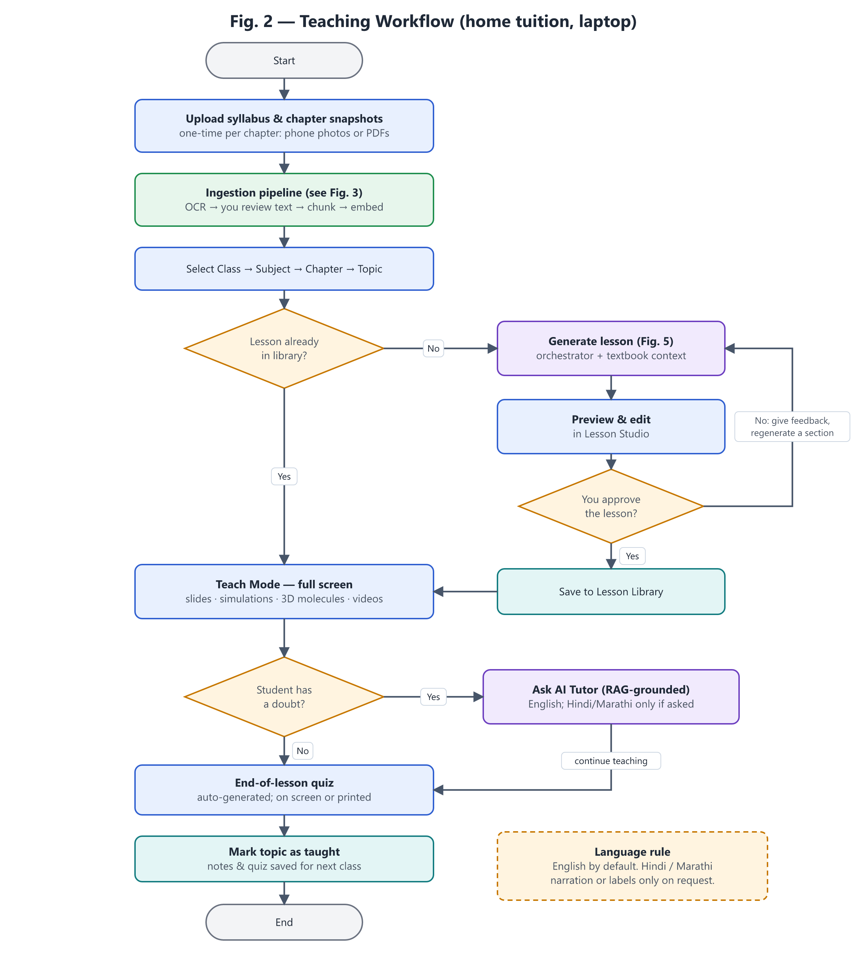
Figure 2 — Teaching workflow
- Once per chapter: upload photos/PDFs, review the extracted text, confirm the topic tags.
- Before class: pick a topic; open it from the library or generate it, then preview, edit and approve.
- In class: present in Teach Mode; ask the AI tutor when a doubt comes up; finish with the quiz.

8.2 Syllabus ingestion and RAG pipeline
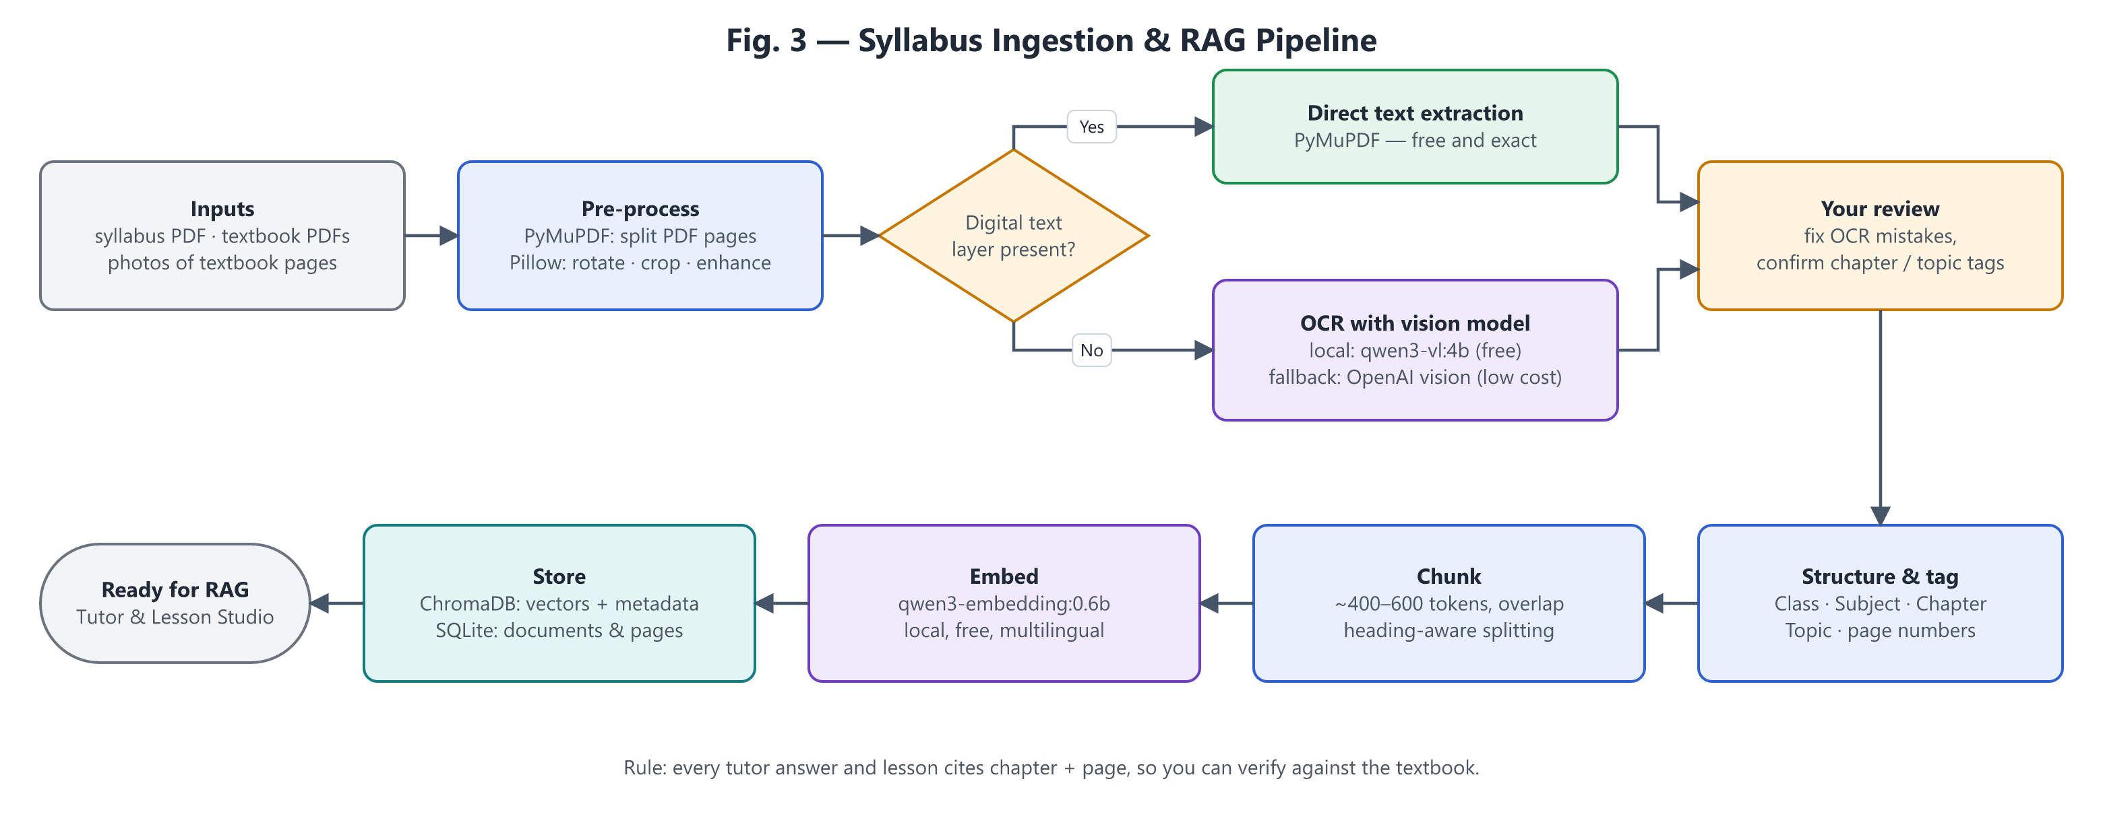
Figure 3 — Syllabus ingestion & RAG pipeline
- Photo tips for good OCR: good light, page flat, one page per photo, phone held parallel to the page.
- Your review step is mandatory: OCR errors in formulas (e.g. subscripts in H₂SO₄) would otherwise flow into lessons.
- Citations: every chunk keeps its chapter and page number, so answers can say “Chapter 3, page 42”.

8.3 Lesson generation pipeline
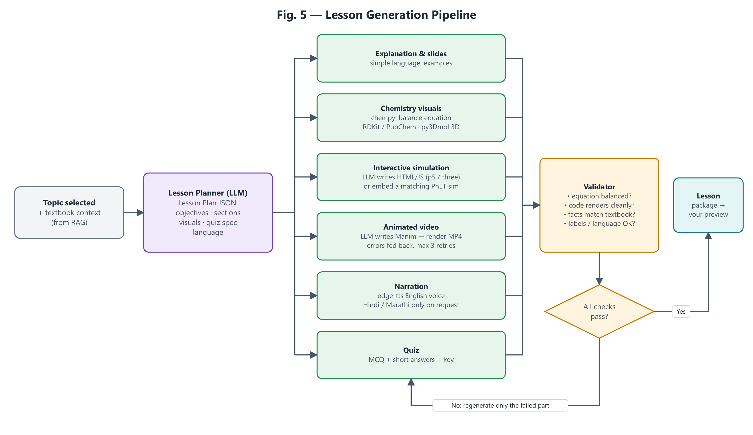
Figure 5 — Lesson generation pipeline
The planner produces a structured Lesson Plan (JSON) so every generator gets precise instructions. The validator checks results; failures regenerate only the failing part. The Manim generator feeds render errors back to the model up to 3 times before asking you.

9. Multilingual Design (English, Hindi, Marathi)
- English is the source of truth. All lessons are generated and stored in English first.
- Hindi / Marathi only on explicit request: a language selector on narration and labels (“English / हिंदी / मराठी”, default English) or a request in chat (“explain this in Marathi”).
- Translations are cached per language, so each one is paid for only once.
- Scientific terms keep the English term in brackets, e.g. “सोडियम (Sodium)”, so students still learn the textbook terminology.
- Voices (edge-tts): en-IN, hi-IN (e.g. SwaraNeural, MadhurNeural), mr-IN (e.g. AarohiNeural, ManoharNeural); OpenAI TTS as fallback.
- Devanagari in videos: Manim Text (Pango) with the Nirmala UI font, which ships with Windows; LaTeX is used only for formulas.

10. Data Model
Entity | Key fields | Purpose
Subject / Chapter / Topic | class_level, subject, chapter no. & title, topic title | The syllabus tree you teach from
SourceDocument | file path, type (PDF/photo), page count, OCR status | Every uploaded file
PageText | document, page no., text, reviewed (yes/no) | Extracted text after your review
Chunk (ChromaDB) | text, vector, chapter, topic, page | Searchable pieces for RAG
Lesson | topic, version, status (draft/approved), language | One lesson per topic, versioned
LessonAsset | lesson, type (slide/simulation/molecule/video/audio/image/quiz), file path, model, cost | Everything a lesson contains
Job | type, status, progress, error, timestamps | Background renders and bulk OCR
LLMCall | task, provider, model, input/output tokens, cost (USD), cached, latency, time | Cost dashboard and budget guard
CacheEntry | key (task + model + prompt hash), response, created | Never pay twice for the same request

11. Project Folder Structure
Tuition study app/
├── docs/ # this blueprint + diagrams (PNG/SVG)
├── app/
│ ├── core/ # settings, logging, secrets, startup checks
│ ├── llm/ # LLMClient, LiteLLM backend, router, budget
│ ├── ingestion/ # PDF split, OCR, review queue, chunking, tagging
│ ├── rag/ # embeddings, ChromaDB store, retriever
│ ├── lessons/ # planner, assembler, validator
│ ├── generators/ # one sub-package per visual/asset type
│ ├── jobs/ # background job runner
│ └── db/ # SQLModel models and repositories
├── ui/ # Streamlit: Home.py + pages/
├── config/ # models.yaml, app.yaml, voices.yaml
├── assets/vendor/ # p5.js, three.js (offline copies)
├── data/ # NOT in Git: sqlite db, chroma/, uploads/, generated/
├── tests/
├── .env.example # non-secret settings only; real .env never committed
├── pyproject.toml / uv.lock
└── README.md

12. Execution Plan
Durations are indicative and assume regular working sessions together. Each phase starts with a short plan review and ends with a demo and your sign-off.
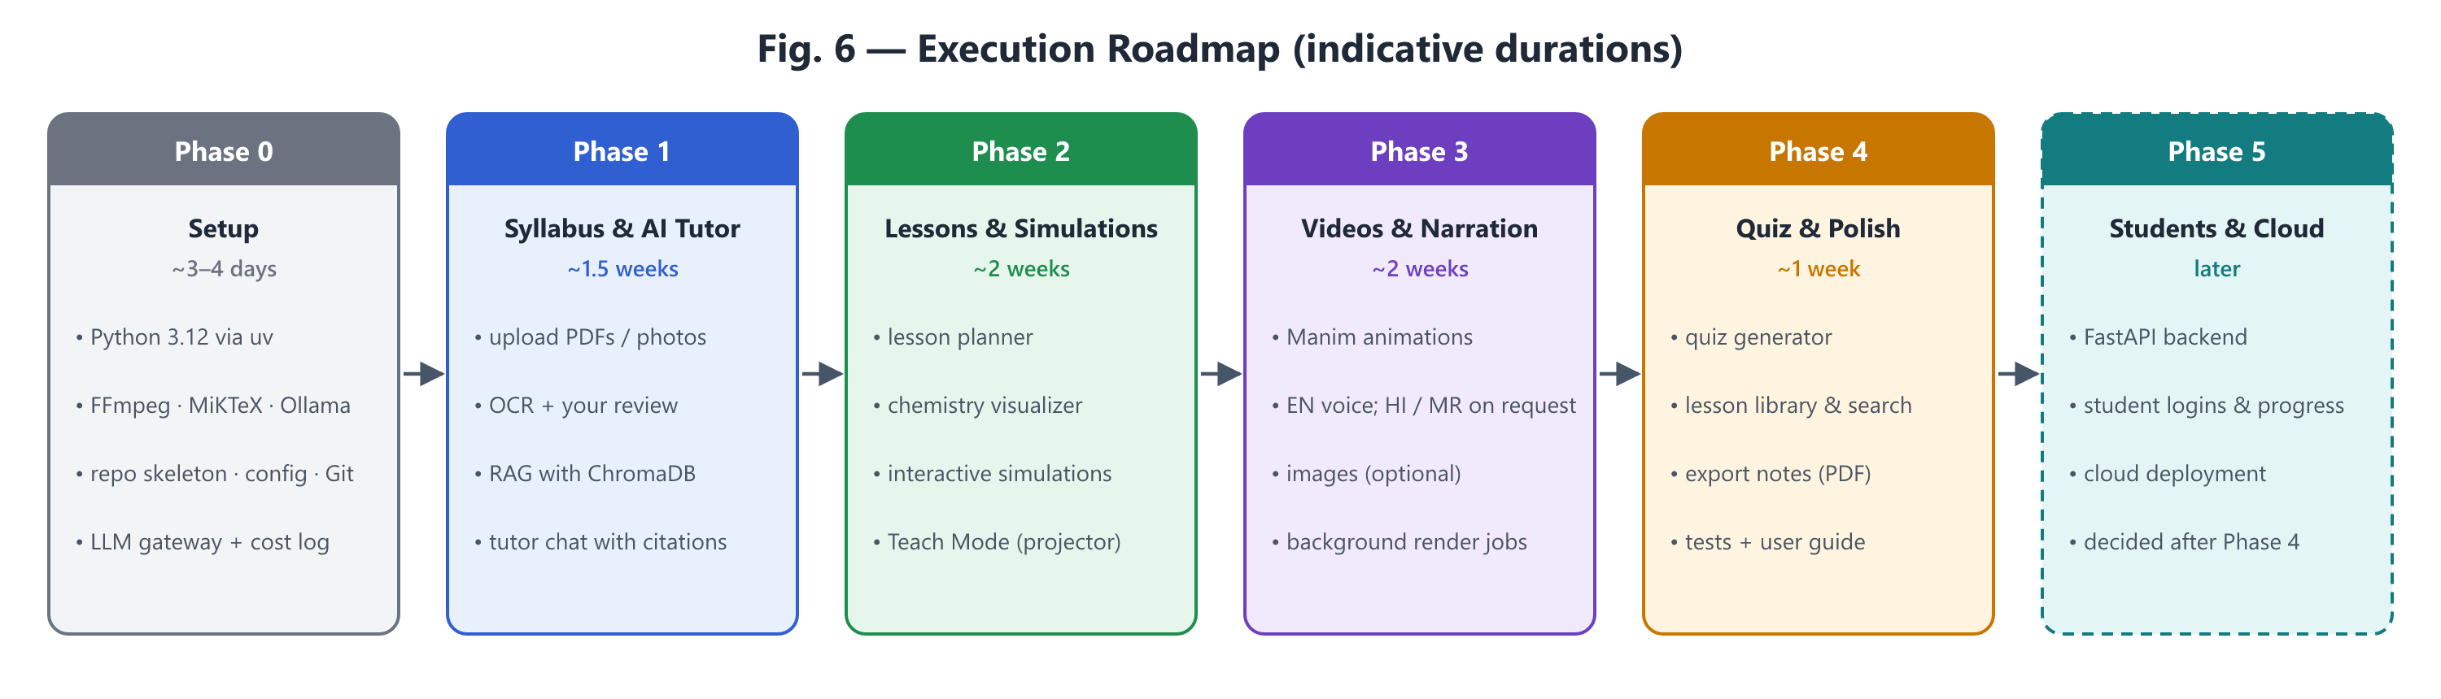
Figure 6 — Execution roadmap

12.1 Phase deliverables and acceptance criteria
Phase | Deliverables | Done when…
0 — Setup  ~3–4 days | Tools installed; repo skeleton; hash-locked dependencies (uv.lock) with LiteLLM pinned ≥ 1.83.0; keyring secrets; startup security checks; host allow-list; settings & models.yaml; LLMClient gateway with routing, cache, cost log and budget cap; Streamlit shell (localhost only) with the five pages; Git repository | App opens with uv run streamlit run; one test prompt each to Ollama and OpenAI is routed and logged with cost; budget cap blocks paid calls when exceeded (tested); uv sync --locked succeeds; no API key exists in any project file; a call to a non-allow-listed host is refused (tested); pip-audit clean
1 — Syllabus & AI Tutor  ~1.5 weeks | Upload page; PDF + photo ingestion; OCR with review screen; chunk / embed / index; tutor chat with citations; Hindi/Marathi answers on request | One real chapter is uploaded from photos and corrected; the tutor answers 10 test questions with correct page citations and says clearly when something is not in the textbook
2 — Lessons & Simulations  ~2 weeks | Lesson planner; explanation & slides; chemistry visualizer; simulation generator + PhET embedding; Teach Mode; preview/edit/approve; basic library | For 3 pilot topics, a lesson is generated, edited, approved and presented full-screen; simulations work offline; all equations verified balanced
3 — Videos & Narration  ~2 weeks | Manim generator with auto-fix loop; narration (EN; HI/MR on request); audio-video merge; job runner with progress; optional images | A 60–90 s narrated video renders without manual code edits for at least 2 of 3 pilot topics; Marathi narration produced when requested
4 — Quiz & Polish  ~1 week | Quiz generator; library search & versions; PDF export of notes/quiz; automated tests; user guide | A full class is run end-to-end with the app as a dry run
5 — Students & Cloud  later | FastAPI backend; student logins & progress; PostgreSQL; cloud storage; deployment; licence review | Scope decided after Phase 4

13. Risks and Mitigations
Risk | Impact | Mitigation
AI-generated code (Manim/JS) fails to run | Missing visuals | Error-feedback retry loop (max 3); tested templates; fall back to a simpler visual or a PhET sim
Scientifically wrong content | Students learn errors | Code-drawn visuals; chempy checks; textbook grounding with citations; owner approval before use
4 GB VRAM limits local models | Weaker local answers | Use local only for suitable tasks; cloud “mini” tier for code and translation; optional 8B model on CPU
Poor OCR on photos | Wrong text in RAG | Photo tips; mandatory review screen; cloud vision fallback for hard pages
Cloud cost overrun | Budget exceeded | Hard cap; cache; lesson reuse; dashboard; OpenAI dashboard limit
edge-tts (unofficial service) stops working | No free narration | Automatic fallback to OpenAI TTS; narration cached once generated
Weak Marathi quality | Confusing narration | Cloud model for translation; English term kept in brackets; owner review
Slow video rendering on laptop | Waiting in class | Render in background before class; low-quality preview first; cache results
Free-tier terms change or use data | Service loss / privacy | Optional only; never send student data; switch provider in config
Textbook copyright | Legal issue when going public | Personal teaching use now; review licences before distributing to students (Phase 5)
Compromised package on PyPI (as with LiteLLM, March 2026) | API keys and files stolen | Exact pins, hash-locked installs, 7-day cooldown, pip-audit, startup version check, keys outside files, scoped low-budget keys (Section 14)

14. Security: Dependencies, LiteLLM and API Keys

14.1 Why this section exists
On 24 March 2026, LiteLLM versions 1.82.7 and 1.82.8 were published to PyPI by an attacker who had stolen the maintainers’ publishing token through a compromised CI security scanner. They were live for about 40 minutes and contained a credential stealer targeting cloud keys, SSH keys and LLM API keys; 1.82.8 added a .pth file that runs whenever Python starts. Versions before 1.82.7 and 1.83.0 and later are not affected. The owner’s rules (Decision D10) apply to LiteLLM, and this project applies the same discipline to every dependency.

14.2 How this project uses LiteLLM
- Python SDK only, in-process. The LiteLLM Proxy Server (the standalone gateway the incident payload targeted in proxy_server.py) is not installed or run.
- Behind our own interface. The rest of the app calls app/llm/LLMClient; only one module imports litellm. If LiteLLM ever becomes untrustworthy, it can be replaced by a thin client over the official openai SDK (Ollama, OpenAI, Hugging Face, Gemini, Groq and OpenRouter all offer OpenAI-compatible endpoints) without touching other code.
- No third-party callbacks. LiteLLM logging/telemetry callbacks stay disabled; cost logging is done by our own code into SQLite.

14.3 Dependency rules (all packages)
Rule | How it is enforced
Pin exactly | litellm==<clean version ≥ 1.83.0> in pyproject.toml (exact version chosen in Phase 0 after checking advisories). All other packages pinned through uv.lock.
Lockfile with SHA-256 hashes | uv.lock stores the hash of every package file. Installs use uv sync --locked, which fails if the lock is stale or any hash does not match.
Never install loosely | No pip install <name> into the project; packages are added only with uv add <name>==<version> and the lockfile change is reviewed and committed.
Release cooldown | [tool.uv] exclude-newer is set to a date at least 7 days in the past, so brand-new releases (when malicious uploads are usually caught) are never selected.
Deliberate upgrades | One package at a time: read changelog and security advisories → uv lock --upgrade-package <name> → review uv.lock diff → uvx pip-audit → run tests → commit.
Startup check | On launch the app verifies the installed LiteLLM version is the pinned one, refuses known-bad versions (1.82.7, 1.82.8) and flags unexpected .pth files such as litellm_init.pth in the environment.

14.4 API-key isolation
- No keys in files: not in code, not in .env, not in Git. Keys are stored in Windows Credential Manager via the keyring library (encrypted per Windows user) and read into memory only when a call is made. This is the local-laptop equivalent of a secrets manager; AWS Secrets Manager or HashiCorp Vault are considered for the cloud phase (Phase 5).
- Scoped, low-limit keys: a dedicated OpenAI Project for this app with a restricted key (only the endpoints we use) and a project budget limit, so a leaked key has limited value.
- Rotation: rotate keys every 90 days and immediately after any suspicion. (OpenAI keys for normal API use are long-lived; short-lived ephemeral tokens apply only to special APIs such as Realtime, so scoping + low budget + rotation is the practical substitute.)
- Never logged: keys are redacted from logs and error messages; LiteLLM verbose/debug logging stays off.
- Local services need no keys: Ollama binds to 127.0.0.1:11434 only (OLLAMA_HOST must not be set to 0.0.0.0).

14.5 Network egress
- In-app allow-list: the gateway sends model requests only to hosts listed in config — e.g. api.openai.com, 127.0.0.1:11434 (Ollama), router.huggingface.co, generativelanguage.googleapis.com, api.groq.com, openrouter.ai. Any other base URL is refused and logged.
- Firewall rules: because we do not run the Proxy Server, there is no separate gateway process to firewall. A Windows per-program rule on python.exe is not practical, since the same interpreter must also reach PubChem, PhET and the TTS service. When the app moves to the cloud (Phase 5), the gateway container’s outbound traffic will be restricted at the firewall / network-policy level to the official provider endpoints only.
- Local-only UI: Streamlit is bound to 127.0.0.1, so other devices on the home Wi-Fi cannot open the app.

15. Ways of Working
- Work in phases; each feature is built as a thin, working slice and demoed to you.
- Every change is committed to Git with a clear message; nothing is pushed to the internet without your approval.
- API keys live only in Windows Credential Manager; .env holds non-secret settings; generated data stays in data/ (excluded from Git).
- Dependencies change only through the controlled upgrade procedure in Section 14.3.
- This blueprint is updated at the end of each phase (version 1.1, 1.2, …).

16. Decision Log
# | Decision | Status | Date
D1 | Board-agnostic: content comes from the syllabus and textbook pages the owner uploads (currently State Board) | Decided by owner | 03-Oct-2026
D2 | Primary user: the owner teaching at home from the laptop | Decided by owner | 03-Oct-2026
D3 | English by default; Hindi and Marathi only when explicitly requested | Decided by owner | 03-Oct-2026
D4 | Multi-provider AI via configuration: OpenAI (existing keys) + Ollama local + optional Hugging Face / free tiers; minimise cost | Decided by owner | 03-Oct-2026
D5 | Run locally on the laptop first; decide cloud after Phase 4 | Decided by owner | 03-Oct-2026
D6 | Stack: Python 3.12 via uv, Streamlit, LiteLLM, SQLite + ChromaDB, Manim, RDKit/py3Dmol/chempy, edge-tts | Proposed — awaiting approval | 03-Oct-2026
D7 | Accuracy-first: science visuals drawn by code; image/video-generating AI only for decoration | Proposed — awaiting approval | 03-Oct-2026
D8 | Default monthly cap on paid API spend: USD 5 (adjustable any time) | Proposed — awaiting approval | 03-Oct-2026
D9 | Phase plan 0–5 as in Section 12 | Proposed — awaiting approval | 03-Oct-2026
D10 | LiteLLM safety rules: exact pin to a clean version ≥ 1.83.0; SHA-256 hash-locked installs via uv; API keys isolated from files; network egress restricted to provider endpoints | Decided by owner | 03-Oct-2026
D11 | How D10 is implemented on the laptop: SDK in-process (no Proxy Server) behind our LLMClient interface; keys in Windows Credential Manager + scoped, budget-capped OpenAI project key; in-app host allow-list; 7-day release cooldown; vault/firewall egress rules in Phase 5 | Proposed — awaiting approval | 03-Oct-2026

17. Open Items for the Owner
- Approve or change decisions D6–D9 and D11.
- Choose the first class, subject and chapter for Phase 1 testing and keep its photos/PDFs ready.
- Choose 3 pilot topics for Phase 2 (suggestion: one chemical reaction, one physical process, one concept-heavy topic).
- Set a monthly usage limit in the OpenAI dashboard as a second safety net.

Appendix A — Glossary
Term | Meaning
LLM | Large Language Model — the AI that writes text and code (e.g. OpenAI models, Qwen)
RAG | Retrieval-Augmented Generation — the AI first looks up relevant textbook passages, then answers using them
OCR | Optical Character Recognition — reading text from photos of pages
Embedding | A list of numbers that represents the meaning of a text, used to find similar passages
Vector store | A database of embeddings (here: ChromaDB) for fast meaning-based search
Token | A piece of a word; cloud AI providers charge per token
Fallback chain | The ordered list of models to try if the first one fails or is unavailable
Ollama | Software that runs open AI models locally on the laptop
LiteLLM | A Python library that gives one common interface to many AI providers
Manim | A Python library for precise mathematical/scientific animations
Streamlit | A Python library for building web app interfaces quickly
VRAM | Memory on the graphics card; limits which local models run fast
Supply-chain attack | An attacker publishes a poisoned version of a trusted package, so installing or upgrading it runs their code
Lockfile / hash | A file (uv.lock) recording the exact version and SHA-256 fingerprint of every package, so a tampered file is rejected
Egress filtering | Allowing a program to connect only to approved internet addresses

