**CentOS运用mysql搭建学生管理系统**

**详细实验步骤：**

1. **建立数据库**

mysql -uroot -p

CREATE DATABASE student_sys

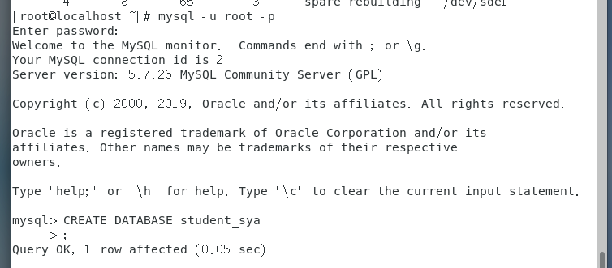

**2.根据需求建立《学生信息表》《学生成绩表》**

学生信息表：

CREATE TABLE IF NOT EXISTS `studentinfo`(

`stu_id` INT UNSIGNED AUTO_INCREMENT,

`stu_name` VARCHAR(25) NOT NULL,

`stu_sex` VARCHAR(10) NOT NULL,

`stu_num` VARCHAR(100)NOT NULL,

`stu_code` VARCHAR(100)NOT NULL,

PRIMARY KEY ( `stu_id` )

)ENGINE=InnoDB DEFAULT CHARSET=utf8;

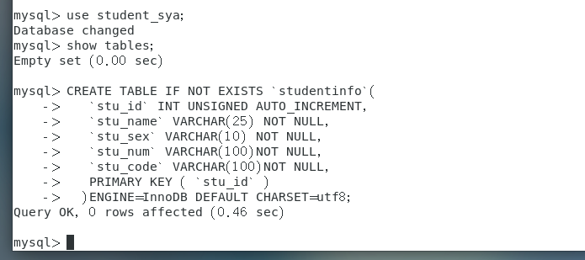

学生成绩表

CREATE TABLE IF NOT EXISTS `studentrecord`(

`record_id` INT UNSIGNED AUTO_INCREMENT,

`stu_num` VARCHAR(100)NOT NULL,

`match_record` INT NOT NULL,

`datasec_record` INT NOT NULL,

PRIMARY KEY ( `record_id` )

)ENGINE=InnoDB DEFAULT CHARSET=utf8;

**3.查看表**

SHOW TABLES;

SHOW COLUMNS FROM studentinfo;

SHOW COLUMNS FROM studentrecord;

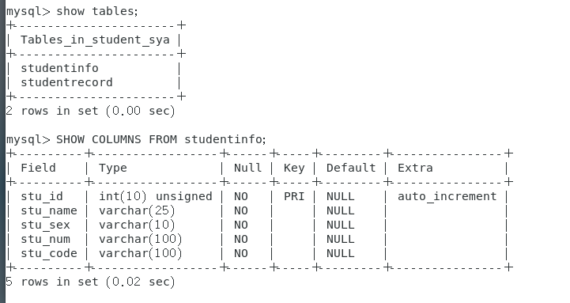

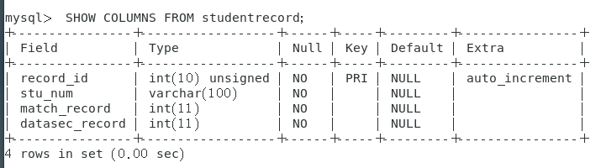

**4.插入数据**

**学生信息表**

单条数据输入：

INSERT INTO studentinfo

( stu_name,stu_sex,stu_num,stu_code)

VALUES

("李三", "男","AT08474","62513257312636");

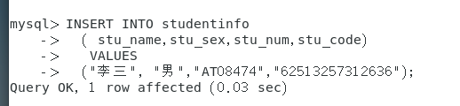

多条数据输入：

INSERT INTO studentinfo

(stu_name,stu_sex,stu_num,stu_code)

VALUES

("黄三", "男","AT08908","67346873246878"),

("张小丽", "女","AT08490","73984732984783");

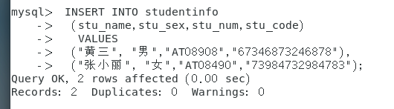

**学生成绩表**

多条数据输入：

INSERT INTO studentrecord

(stu_num,match_record,datasec_record)

VALUES

("AT08908", "80","85"),

("AT08474", "90","70"),

("AT08490", "95","95");

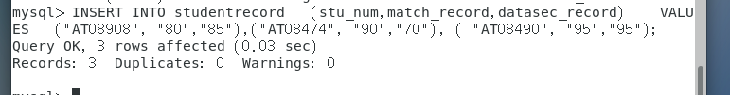

**5.查询数据**

SELECT COUNT(*) FROM studentinfo;

SELECT * FROM studentinfo;

SELECT stu_id,stu_name,stu_sex,stu_num,stu_code FROM studentinfo;

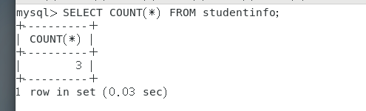

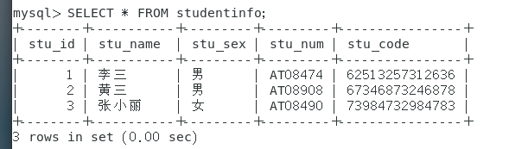

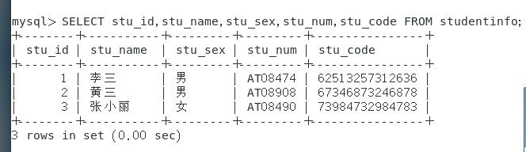

显示条数查询

SELECT * FROM studentinfo LIMIT 0,100;

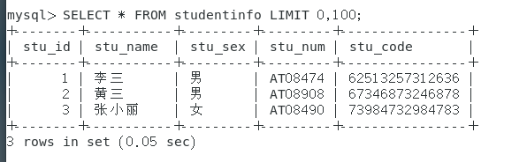

联合查询

SELECT stu_id,stu_name,stu_sex,stu_num,stu_code

FROM studentinfo

UNION

SELECT * FROM studentrecord;

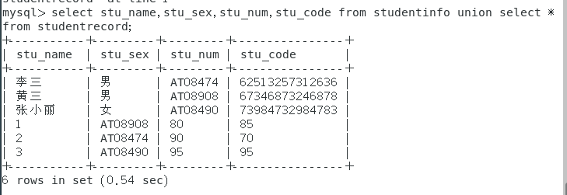

带条件查询

SELECT * FROM studentinfo LIMIT 0,100;

SELECT *

FROM studentinfo

WHERE stu_name = "黄三";

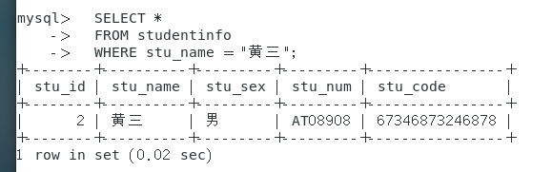

模糊查询 LIKE

SELECT * FROM studentinfo LIMIT 0,100;

SELECT *

FROM studentinfo

WHERE stu_name LIKE "黄%";

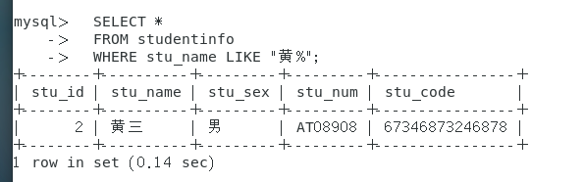

SELECT * FROM studentinfo LIMIT 0,100;

SELECT *

FROM studentinfo

WHERE stu_name LIKE "%黄%";

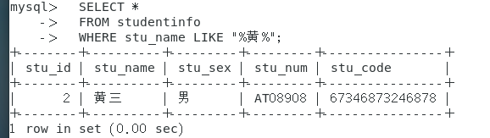

排序 ORDER BY

SELECT field1, field2,...fieldN table_name1, table_name2...

ORDER BY field1 [ASC [DESC][默认 ASC]], [field2...] [ASC [DESC][默认 ASC]]

如 SELECT stu_num,match_record,datasec_record

FROM studentrecord

WHERE match_record >= 90

ORDER BY match_record;

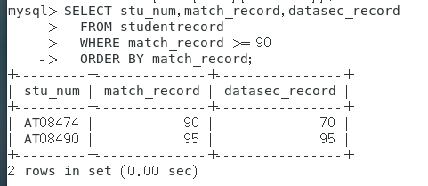

分组 GROUP BY

SELECT match_record,COUNT(*) datasec_record

FROM studentrecord

GROUP BY match_record;

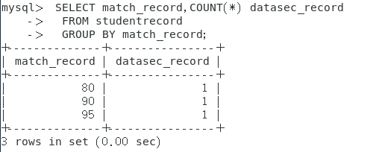

**6.删除数据**

DELETE FROM studentinfo WHERE stu_name = "黄三";



**7.更新数据**

UPDATE table_name SET field1=new-value1, field2=new-value2 [WHERE Clause]

例UPDATE studentinfo

SET stu_name="黄四"

WHERE stu_name = "黄三";

