**[Your REPORT TITLE]**

**Evaluative Report**

By [Su Yingshui]

Table of Contents

Introduction 3

Application or website evaluated 3

Evaluation 3

User Interface & Interactivity 3

User Experience 3

Discussion 3

Conclusion 3

References 4

Appendix 4

# Introduction

This e-book has helped people with reading needs. The top of the e-book is equipped with navigation, which can provide users with various needs, such as purchase and feedback on books. The layout and interaction design of this e-book gave me inspiration.

# Application or website evaluated

*[Provide link to site, or if evaluating an app, you should include screen shots in the Appendix.*

*Provide a brief factual description of the app/site (‘to set the scene’ for the subsequent findings (analysis and/or evaluation) conclusions and recommendations).]*

*https://www.ebooks.com/en-cn/*

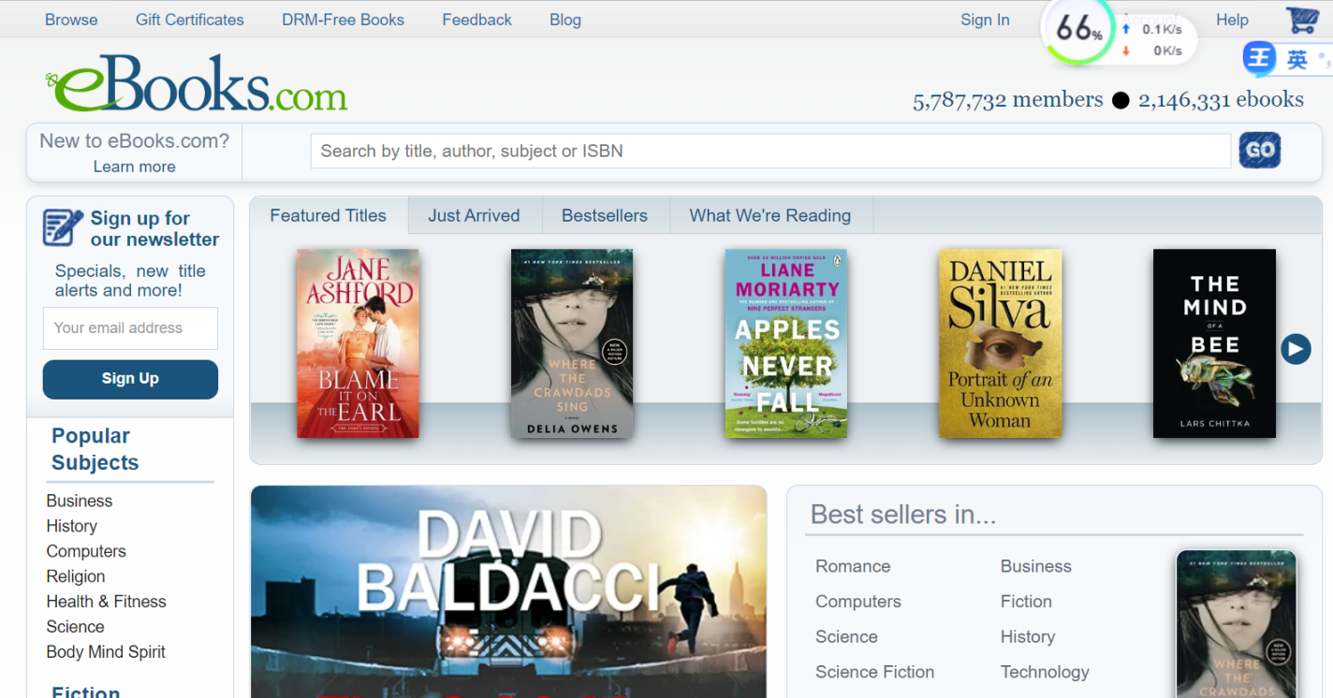

You can see this e-book through the picture. There is a login window in the upper right corner, which is convenient for users to use and buy. And click the small arrow to scroll the picture, so that the user can better understand the type of the book and save the layout space.

# Evaluation

*[Evaluate the website or app in terms of both what you have learnt about best practice and other aspects of the user interface, as well as commenting on your experience as the user.*

## User Interface & Interactivity

*[Describe the app/site in terms of the below areas.]*

* *Consistency*: in layouts, navigation, use of design patterns (for mobile and PC if known)
* *Aesthetics*: Colour, balance, white space
* *Visual/Graphical* elements: icons, images, containers e.g. group boxes, accordions, tab controls.
* *Text*: font, colour of on-screen text, tooltips, notifications, message boxes, popups
* *Navigation*: menus, search functions, breadcrumbs, pagination buttons, icons
* *Input Controls*: buttons, text fields, checkboxes, radio buttons, dropdown lists, list boxes, toggles, date field
* *Feedback*: Sound, animation
* 1. This e-book is evenly distributed in terms of space occupation, and the allocation position and size of each plate are reasonable. The text part is mainly light blue, giving a harmonious feeling.From the text, the text design of this web page is relatively simple and clear.
* 2.This e-book has multiple interactive elements, which enhance the user's experience. First, the home page has a navigation bar and a search bar at the top. So that users can find books more quickly and conveniently. Secondly, the webpage is equipped with sliding icons, which can let users see more pictures, enhance the attraction of the webpage, and let users browse for a longer time.
* 3.This e-book has a login button, which enhances the security of users. After successful registration, the web page is set with message notification. Provide the user with the latest book information through the user's email. Secondly, there is a drop-down list on the right side of the e-book, and the list is well classified, which can allow users to make better choices.
* 5. In the design of this web page, unified graphic design principles are used, and the same elements are reused. It looks beautiful.

## User Experience

*[How did you feel about the app/site?]*

*After using this e-book, I have the following user experience.*

*Through several parts of this web design, I think my user experience is still very good.*

*1.The sense of security is enhanced. The e-book design includes login help and other buttons, which provides convenience for users to buy and read, and also ensures user information, so that users can better achieve their expectations.*

*2.It makes users feel convenient to use, the service link is clear, and the navigation and framework are complete. There is no need for users to think and choose.*

*3.Let users feel novel. E-books include dynamic banners, which users can choose from. Moreover, sliding pictures can make users excited and satisfy their curiosity.*

# Discussion

*[Comment on the above, discussing your findings]*

1. *I think adding sounds or videos to the website can better enhance the user's experience.*
2. *This e-book uses banners and navigation in its design. I think it can better attract users.*

# Conclusion

*[A summary of your evaluation, optional recommendations, and conclusion.]*

*Through the study and use of this website, I summarized the following points.*

*1. Design login, banners and other elements to enable users to better experience interactio*

*2. Many layout principles should be considered in the design of web pages, such as the most commonly used unification principle. Each page is provided with the same logo and navigation, which can make users feel that the web page is harmonious.*

*3. I have a suggestion. In addition to including pictures, you can match appropriate sounds or add video and other elements when designing web pages. This can give users a better sense of experience.*

# References

Optional to reference website(s) evaluated. Text in this section is not included in maximum word count of 600 words.

https://www.itcast.cn/news/20190715/15500838107.shtml

# Appendix

Include screen shots – essential if evaluating an application. Text in this section is not included in maximum word count of 600 words.

