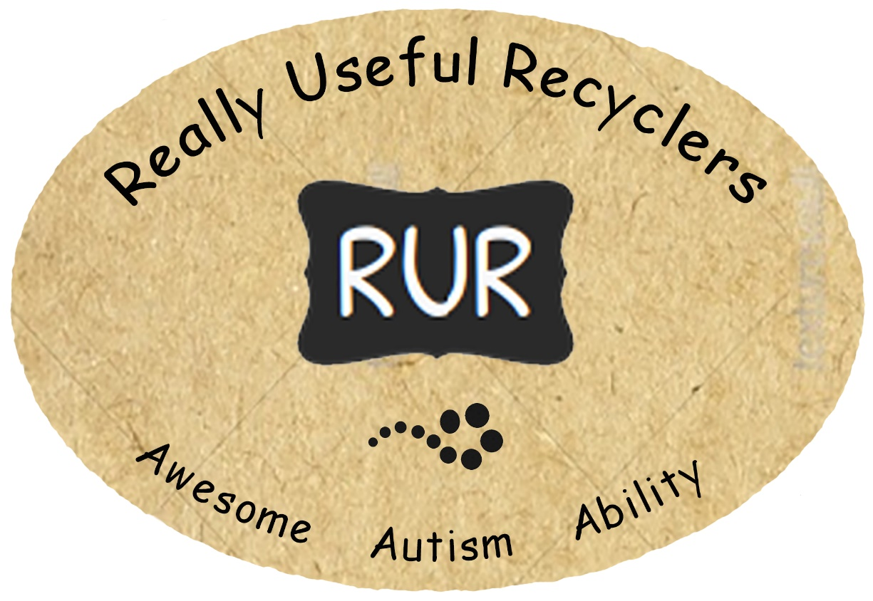

**Really Useful Recyclers** was born in the wonderfully creative heart and mind of Deb Flintoff – bringing together two great passions of her son Joshua – Disney Pixar’s Wall-E the Recycling Robot and Thomas the Tank Engine who is really useful.   
  
These passions were the inspiration behind the creation of a small business enterprise, Really Useful Recyclers – where, from that small seed a beautiful vision grew. Josh began first recycling used newspaper and packaging, and then began creation of unique artwork from recycled newspaper. Soon after, Deb and Josh invited Courtney Smith to join this really useful enterprise team – Courtney also has loved Wall-E and Thomas his whole life.  
  
This enterprise has given both Josh and Courtney valued roles in the community, a strong sense of purpose, and enormous pride in knowing they have done “good work”.   
  
The support of their parents, dedicated support teams and so many individuals, organisations and businesses in the community has ensured they have flourished – their very specific skillsets, range of abilities and recycling talents have continued to evolve.   
  
Passion, positivity, pride, patience, planning & preparation have enabled Josh & Courtney to REDUCE, REUSE and RECYCLE newspapers and various other recyclable magazines collected from the local community, into a stunning collection of uniquely innovative handcrafted PaperArt pieces.  
  
At the end of 2018 Josh, Deb and their family moved to Melbourne and a brand new seedling has been planted and is being nurtured – a small business enterprise **Purposeful PaperArt**.   
Find PP on Facebook [www.facebook.com/PurposefulPaperArt](http://www.facebook.com/PurposefulPaperArt) and Instagram @purposeful_paperart   
  
In 2019, Really Useful Recyclers’ Courtney Smith, supported by his very dedicated support team, continues to thrive in his WA community recycling newspapers into gorgeous WallArt, Jewellery, bowls, coasters, trivets and more.   
  
We invite you to follow us on Facebook [www.facebook.com/reallyusefulrecyclersWA](http://www.facebook.com/reallyusefulrecyclersWA)