**sbi三、多表连接查询**

**1．实践目的**

（1）掌握SELECT语句在多表查询中的应用。

（2）掌握多表连接的几种连接方式及应用。

（3）能够灵活运用多表连接查询解决实际问题。

**2．实践内容和要求**

完成下面查询。

*Into outfile’C:/ProgramData/MySQL/MySQL Server 5.7/Uploads/cx2.txt’;*

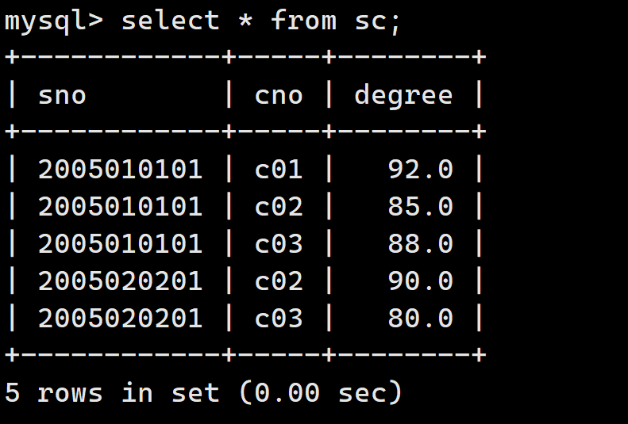

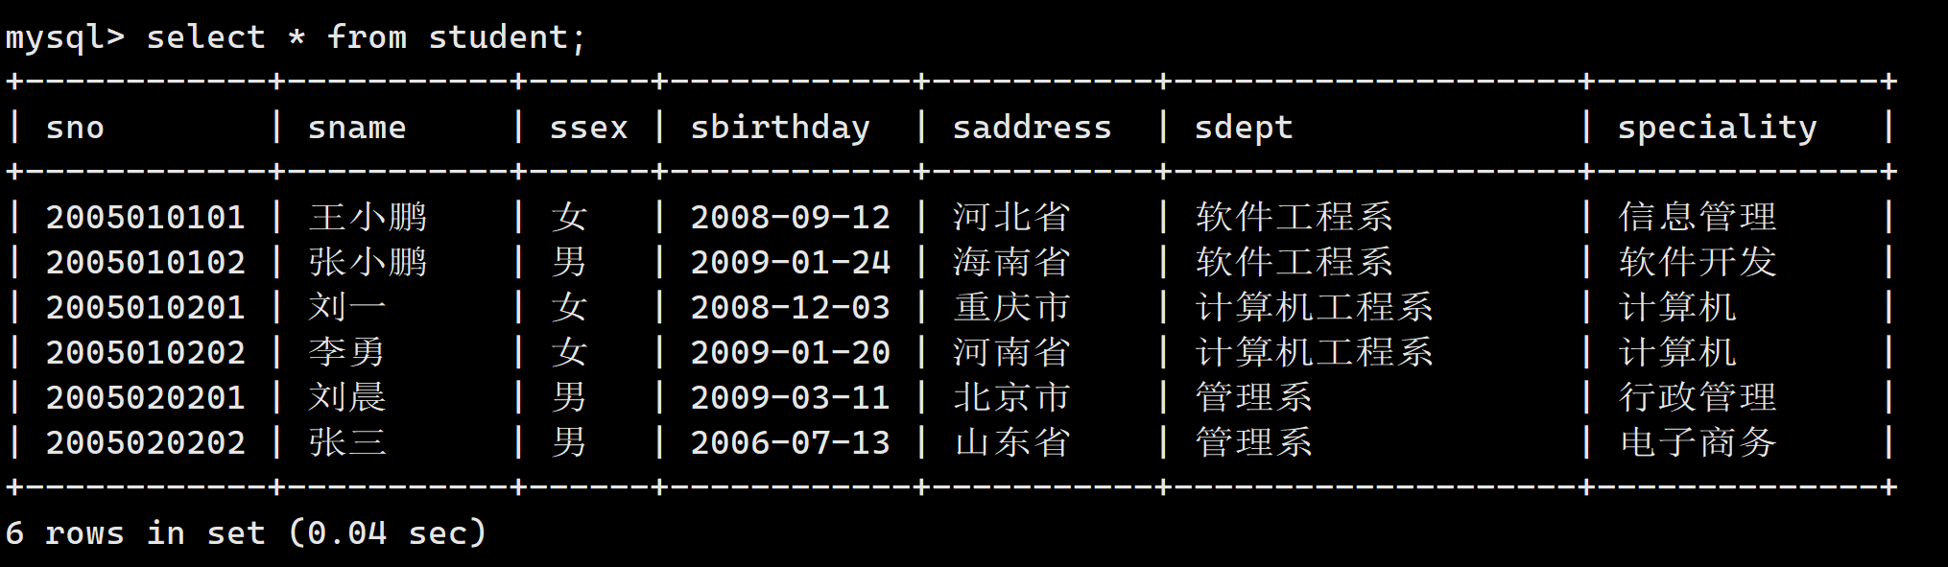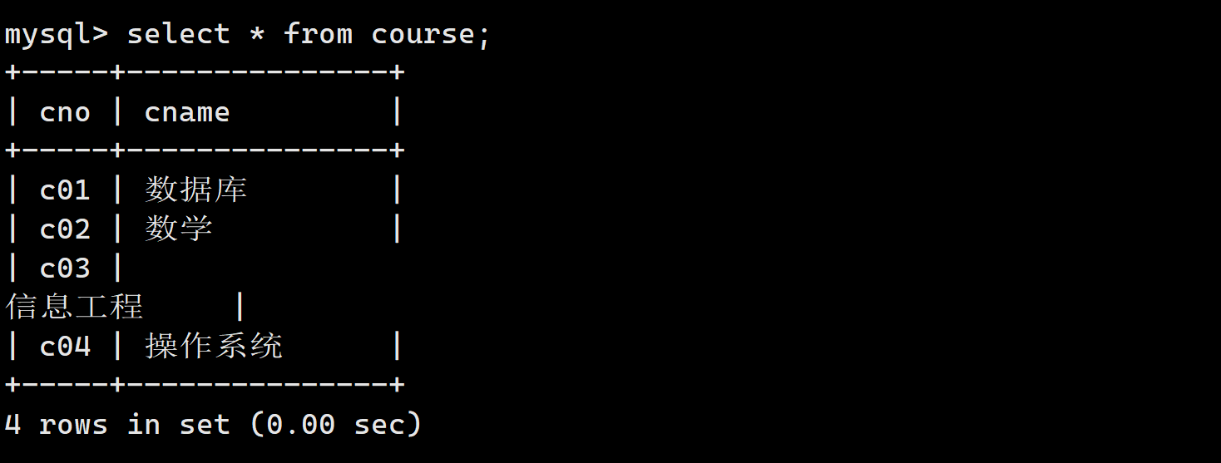

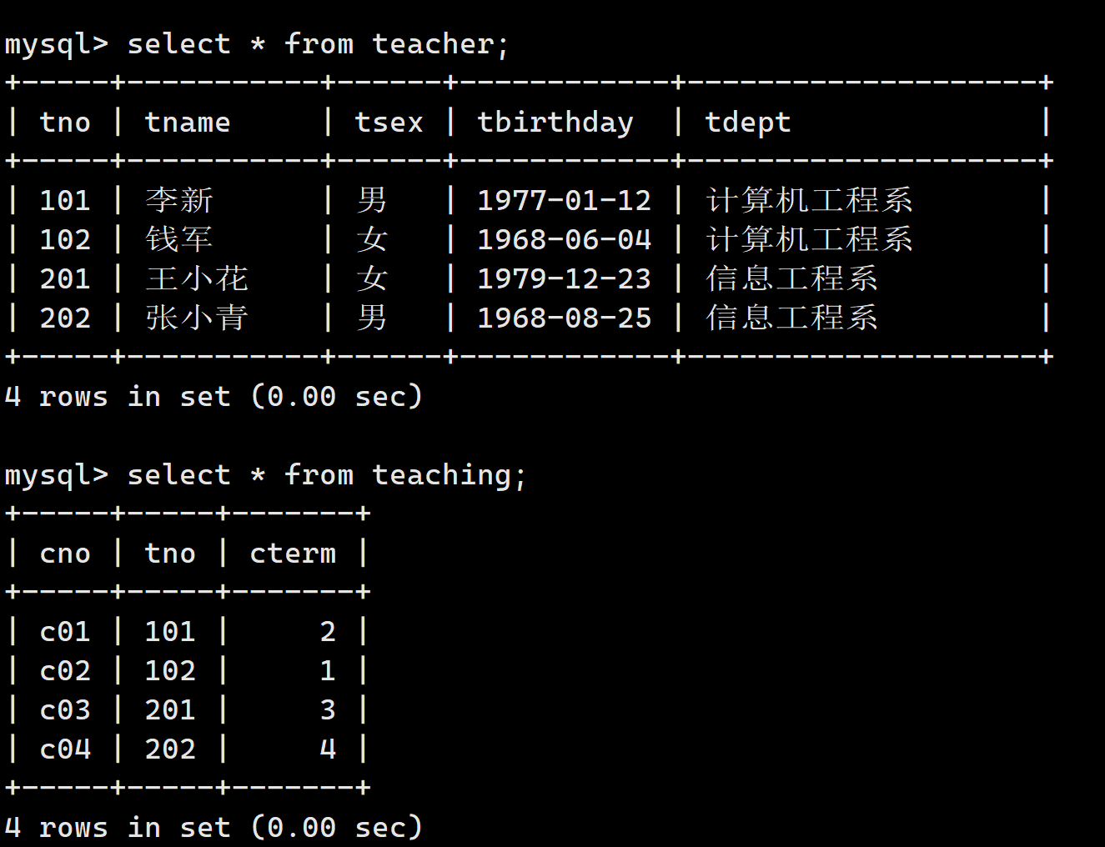

（3）查询“李新”老师所授课程的课程名称。

**Select teaching.cno from teacher join teaching where teacher.tname=’李新’ and teaching.tno = teacher.tno;**

（4）查询女教师 所授课程的课程号及课程名称。

**Select teaching.cno,teaching.tno from teaching join teacher where teacher.tsex = ’女’and teaching.tno = teacher.tno;**

（5）查询至少选修一门课程的女学生姓名。

**Select student.sname,sc.cno from sc join student where student.ssex = ‘女’ ；**

（6）查询姓“王”的学生所学的课程名称。

**Select student.sname,course.cname from student join sc join course where student.sname like‘王%’and student.sno= sc.sno and sc.cno = course.cno;**

（7）查询选修“数据库”课程且成绩在80～90分的学生学号及成绩。

**Select course.cno,sc.sno,sc.degree from sc join course where sc.cno = course.cno and sc.degree between 80 and 90;**

（8）查询课程成绩及格的男同学的学生信息及课程号与成绩。

**Select sc.sno,sc.cno,sc.degree,student.sname from sc join student where sc.degree > 60 and sc.sno = student.sno and ssex = ‘男’；**

（9）查询选修“C04”课程的学生的平均年龄。

**Select * from student**

（10）查询选修课程名为“数学”的学生学号和姓名。

**Select course.cname,student.sno,student.sname from student join sc join course where student.sno = sc.sno and sc.cno = course.cno and course.cname = ‘数学‘；**

（11）查询“钱军”教师任课的课程号，选修其课程的学生的学号和成绩。

**Select teacher.tname,course.cno,student.sno,sc.degree from student join sc join teacher course where student.sno = sc.sno and sc**

（12）查询在第3学期所开课程的课程名称及学生的成绩。

**select cname,sno,degree from teaching join sc on teaching.cno=sc.cno join course on sc.cno=course.cno where cterm=3;**

（13）查询“C02”课程不及格的学生信息。

**select * from student join sc on student.sno=sc.sno where cno=C02 and degree<60;**

（14）查询软件系成绩在90分以上的学生姓名、性别和课程名称。

**select sname,ssex,cname from student join sc on student.sno=sc.sno join course on sc.cno=course.cno where sdept='软件工程系' and**

**degree>90;**

（15）查询同时选修了“C04”和“C02”课程的学生姓名和成绩。

**select sname,degree from student join sc on student.sno=sc.sno where cno='C04' and cno='C02';**

**四、嵌套查询**

**1．实践目的**

（1）掌握嵌套查询的使用方法。

（2）掌握相关子查询与嵌套子查询的区别。

（3）掌握带IN谓词的子查询的使用方法。

（4）掌握带比较运算符的子查询的使用方法。

（5）掌握带ANY或ALL谓词的子查询的使用方法。

（6）了解带EXISTS谓词的子查询的使用方法。

**2．实践内容和要求**

完成下面查询。

（1）查询“李勇”同学所选课程的成绩。

**Select student.sname,sc.degree from sc join student where sc.sno = student.sno and student.sname = '刘一';**

**Select sno,degree fromm sc where sno in(select sno form student where sname = '李勇');**

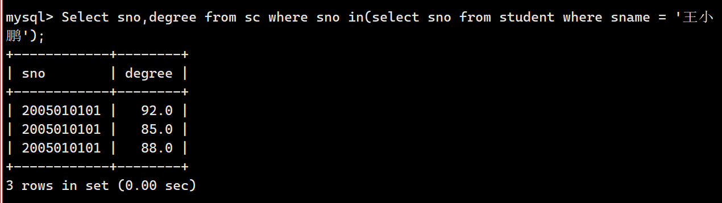

**没有数据，可以使用王小鹏验**

（2）查询“李新”老师所授课程的课程名称。

**select cno,tno （select tname from teacher tname = ‘李新‘） from teaching where tno in(select tno from teacher where tname = '李新');**

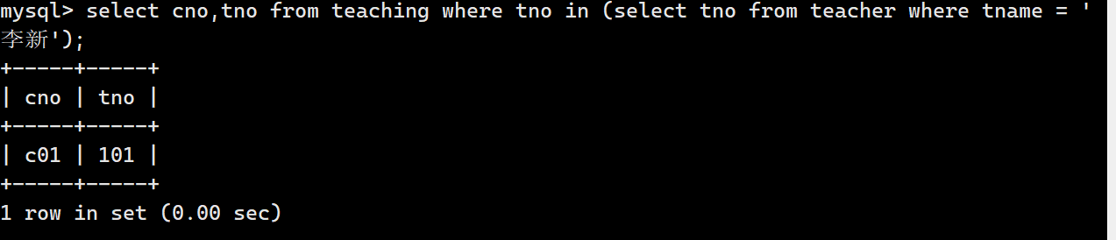

（3）查询女教师所授课程的课程号及课程名称。

**Select cno,cname from course where cno in(select teaching.cno from teaching join teacher where teaching.tno = teacher.tno and tsex = ‘女生’);**

**#没有数据，可以使用not in 验证下**

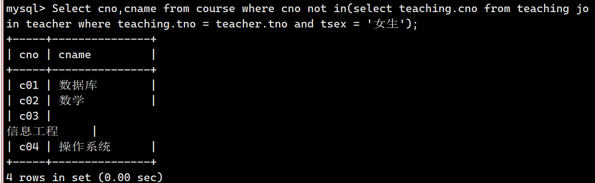

（4）查询姓“王”的学生所学的课程名称。

**#使用模糊查询**

**Select cno,cname from course where cno in(select sc.cno from sc join student where student.sname like'王%' and student.sno = sc.sno);**

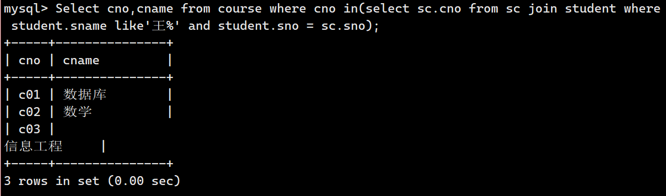

（5）查询“C02”课程不及格的学生信息。

**Select * from student where sno in(select sno from sc where cno = 'c02' and degree>=>=60);**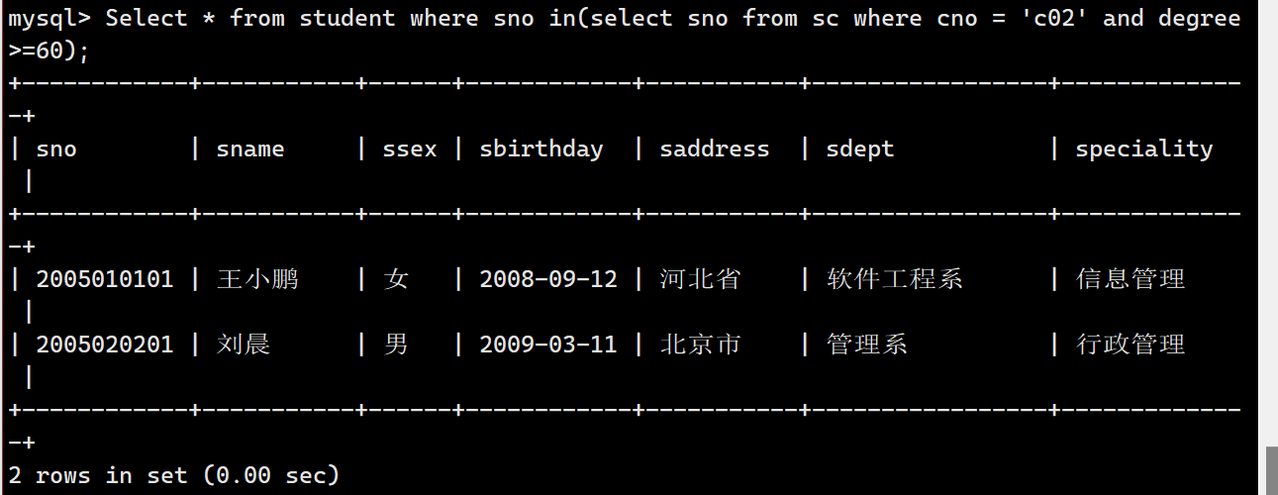

（6）查询选修“数据库”课程且成绩在80～90分的学生学号及成绩。

**Select sno,degree from sc where cno in(select cno from course where cname = '数据库') and degree between 80 and 90;**

**无结果，用数学测试：**

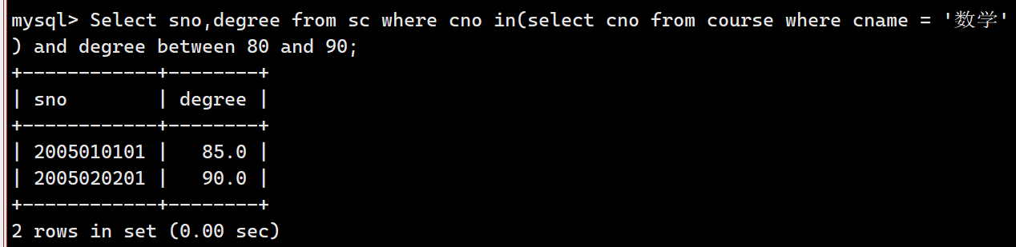

（7）查询选修“C04”课程的学生的平均年龄。

**select avg(ABS(year(sbirthday) - year(now()))) as '年龄' from student where sno in(select a.sno from sc a join course b where a.cno = b.cno and a.cno = 'c03');**

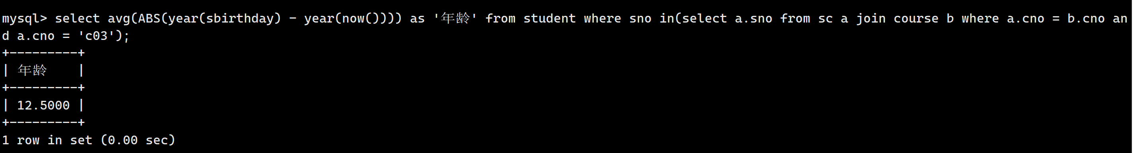

**select avg(A.年龄) from  
(select name as 姓名,(year(getdate())-year(出生日期)) as 年龄 from [表名] )A**

**year(birthday)-year(now()) as age**

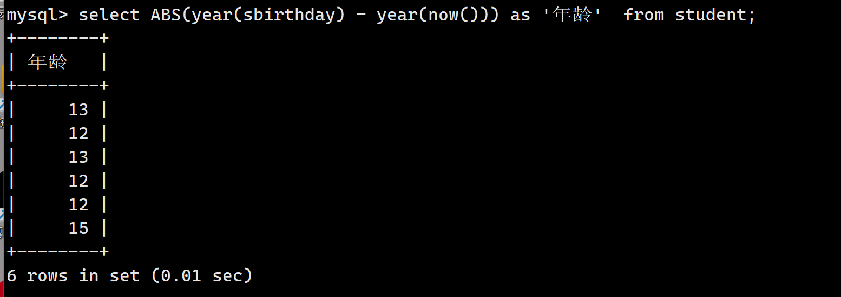

**补充：ABS：求绝对值**

（8）查询选修课程名为“数学”的学生学号和姓名。

**Select sno,sname from student where sno in(select sc.sno from course join sc where course.cno = sc.cno and course.cname = ‘数学’);**

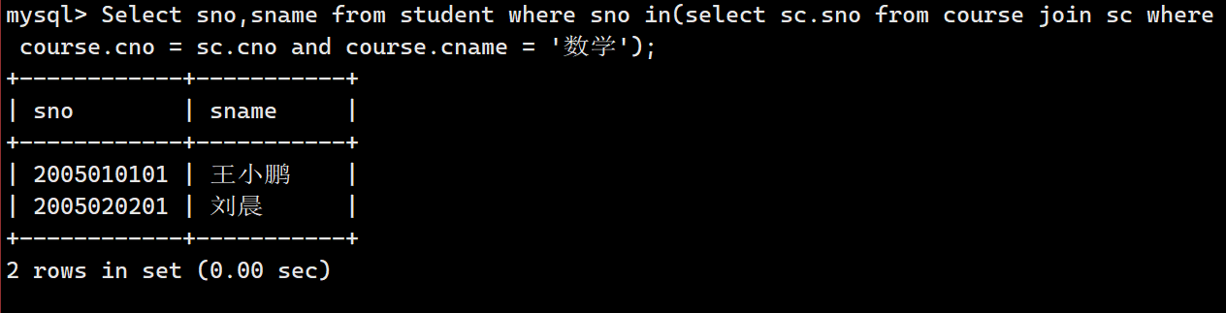

（9）查询“钱军”教师任课的课程号，选修其课程的学生的学号和成绩。

**Select teacher.tname,teaching.cno,teacher.tno,student.sno From teacher join teaching join sc join student Where teacher.tno = teaching.tno and teaching.cno = sc.cno and sc.sno = student.sno and teacher.tname = '钱军';**

**使用多表查询**

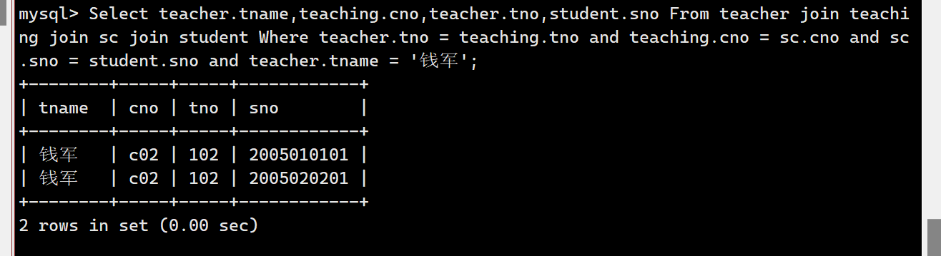

（10）查询在第3学期所开课程的课程名称及学生的成绩。

**Select Course.cname,sc.degree from sc join teaching join course where sc.cno = teaching.cno and teaching.cno = course.cno and teaching.cterm = '3';**

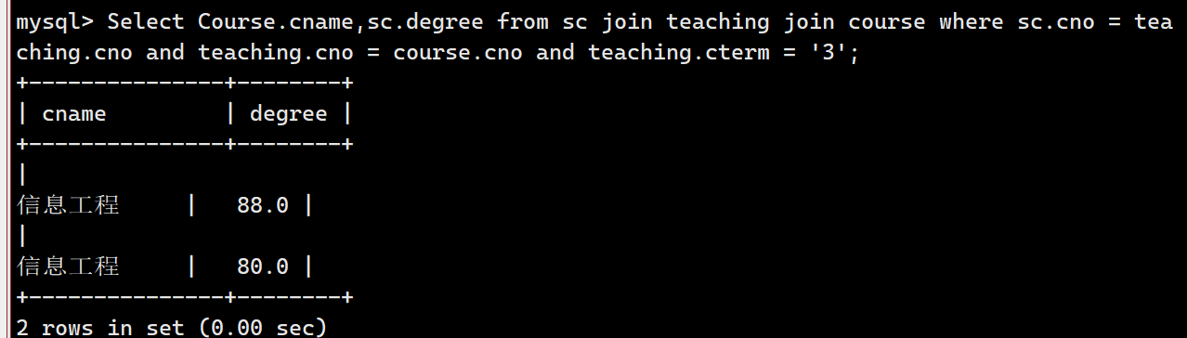

（11）查询与“李勇”同一个系的同学姓名。

**在同一张表**

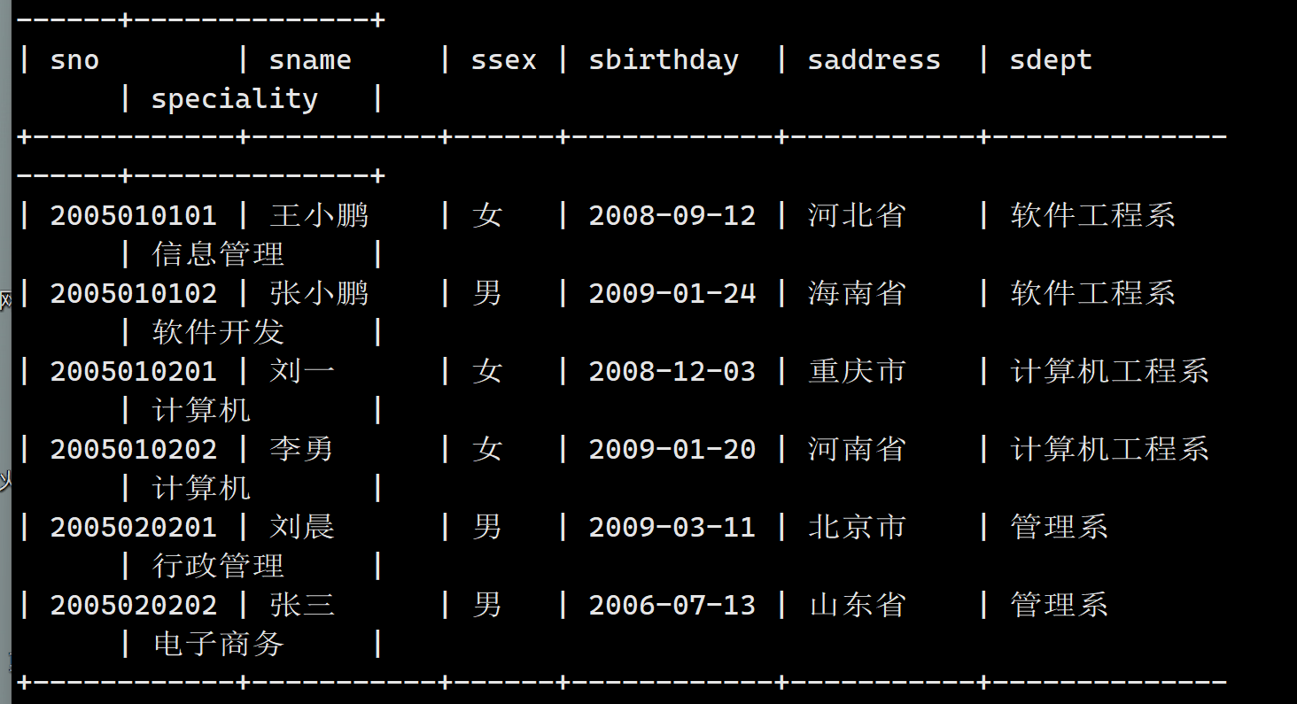

**但是需要使用两张表**

**Select sno,sname from student sdept in(select sdept from student where sname = ‘李勇’);**

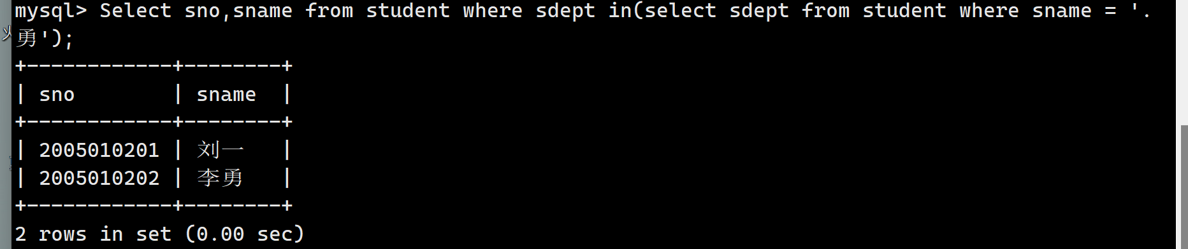

**有次可见，查询出来的结果包含李勇，如果想要不包含李勇怎么办呢/**

**Select sno,sname from student where sdept in(select sdept from student where sname = '李勇') and sname != '李勇';**

**或者采用起别名，两表连接，非嵌套：**

**Select a.sno,a.sname from student a,student b where a.sdept = b.sdept and b.sname = '李勇' and a.sname != '李勇';**

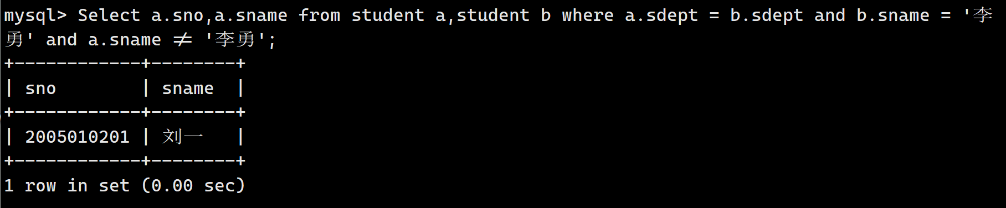

（12）查询学号比“刘晨”同学大，而出生日期比她小的学生姓名。

**select sname from student where sno>(select sno from student where sname='刘晨')and year(sbirthday)<(select year(sbirthday)from student where sname ='刘晨');**

（13）查询出生日期大于所有女同学出生日期的男同学的姓名及系别。

**select sname,sdept from student where ssex='男' and year(sbirthday)<all(select year(sbirthday) from student where ssex='女');**

（14）查询成绩比该课程平均成绩高的学生的学号及成绩。

**select sno,degree from sc where degree>(select avg(degree) from sc);**

（15）查询不讲授“C01”课的教师姓名。

**SELECT tname FROM teacher WHERE tno IN ( SELECT tno FROM teaching WHERE cno !='C01');**

（16）查询没有选修“C02”课程的学生学号及姓名。

**select sno,sname from student where sno not in (select sno from sc where cno='C02');**

（17）查询选修了“数据库”课程的学生学号、姓名及系别。

**select sno,sname,sdept from student where sno in(select sno from sc,course where sc.cno=course.cno and cname='数据库');**