SLIDE 26
Hidden Terminal Problem — Simple Explanation
Imagine three nodes in a wireless network:
A — B — C
A and C cannot hear each other, but both can hear/talk to B.
What happens
- A is sending data to B.
C is too far from A, so C cannot detect A’s transmission.
- C wants to send to B, so it listens to the channel.
Since it cannot hear A, it thinks:
➝ “Medium is free.”
This means Carrier Sensing (CS) fails.
- C starts sending to B at the same time.
At B, the signals from A and C collide.
- A cannot detect this collision, because A is also too far from C.
➝ Collision Detection (CD) fails.
- Therefore, A is hidden from C → C doesn’t know A is already transmitting.

Key Points to write in exam
- Hidden terminal occurs when two nodes cannot sense each other, but both communicate with a common receiver.
- Both transmit → collision at the receiver.
- CS fails because the channel appears free to the hidden node.
- CD fails because transmitter cannot detect collision.
- Leads to low throughput and high collision probability.
SLIDE 28
MACA (Multiple Access with Collision Avoidance)
MACA is designed to avoid the hidden terminal problem by using short control packets before sending actual data.

How MACA Works
MACA uses two small packets to coordinate access:
1. RTS — Request To Send
- Sender asks permission to transmit.
- Contains:
✓ Sender address
✓ Receiver address
✓ Intended packet size
- Since RTS is short, even if it collides, the cost is small.
2. CTS — Clear To Send
- Receiver replies when it is ready and the channel is free.
- All nearby nodes that hear the CTS know they must remain silent.

Why This Prevents Collisions
- Nodes that hear RTS → stay silent because sender is about to transmit.
- Nodes that hear CTS → stay silent because receiver is about to receive.
- Even hidden terminals avoid interrupting, because CTS reaches them.

MACA Characteristics
- No carrier sensing like in CSMA.
- No collision detection (wireless can’t detect collisions).
- Uses RTS/CTS handshake to avoid collisions instead of detecting them after they happen.
SLIDE 34
Q2. What is the purpose of using small cells in cellular networks? Explain how reducing cell size increases system capacity.
Answer (Full 5 Marks)
Cellular networks divide a large service area into smaller regions called cells, each with its own base station.
When traffic increases, the operator cannot get more spectrum, so capacity must be improved by reducing cell size.
Smaller cells allow the same set of frequencies to be reused more often because adjacent cells still use different frequencies, but non-adjacent cells can reuse the same ones without interference.
As the number of cells increases, the reuse distance decreases, meaning the same frequency channels appear multiple times in the network.
Thus:
- More cells → more reuse → more channels available per unit area
- Fewer users per cell → less congestion
- Higher overall system capacity with the same spectrum
Therefore, shrinking cell size directly increases capacity by enabling more frequent frequency reuse
Q3. Describe frequency reuse and its role in improving capacity in cellular systems.
Answer (Full 5 Marks)
Frequency reuse is a fundamental principle of cellular systems where the total available spectrum is divided into groups of frequencies, and the same frequency groups are reused in cells that are sufficiently far apart.
Adjacent cells use different frequencies to avoid interference, but cells separated by a safe distance can reuse the same frequencies without affecting each other.
This reuse pattern forms a cluster that repeats across the service area.
Frequency reuse increases capacity because:
- The same spectrum supports many simultaneous users
- Total number of available channels in the network increases
- Operators can serve a larger population without needing additional bandwidth
Thus, frequency reuse allows efficient utilization of the limited spectrum and is the reason cellular systems can scale to millions of users.

⭐ Q4. Why can’t adjacent cells use the same frequencies? Explain with the cellular layout used in AMPS.
Answer (Full 5 Marks)
Adjacent cells cannot use the same frequencies because their coverage areas overlap, causing co-channel interference.
If two neighboring cells transmit on the same frequency, a mobile near the cell boundary will receive signals from both base stations, making communication unreliable.
In AMPS, the cellular layout assigns different frequency sets to adjacent hexagonal cells.
Only cells separated by a minimum reuse distance (i.e., not touching each other) are permitted to use the same frequencies safely.
This layout ensures:
- No interference between neighboring cells
- Clear call quality
- Efficient distribution of limited frequency spectrum
Thus, frequency separation in adjacent cells is essential to maintain signal quality, while reuse in distant cells maximizes capacity.
Remember the main point is frequency reuse
SLIDE 41-46
⭐ Q1. Explain the architecture of GSM with a neat diagram.
(From Slides 41–42)
Answer (Full Marks)
GSM architecture consists of three major subsystems:
- Radio Subsystem (RSS) – Handles all radio-related functions. It includes:
  - BTS (Base Transceiver Station): Handles transmission, reception, antennas
  - BSC (Base Station Controller): Controls multiple BTSs, manages handover and radio resources
- Network and Switching Subsystem (NSS) – Heart of GSM, responsible for:
  - Call routing and switching
  - Mobility management
  - Databases for user management
Main components:
  - MSC (Mobile Switching Centre)
  - HLR (Home Location Register)
  - VLR (Visitor Location Register)
  - EIR (Equipment Identity Register)
  - AUC (Authentication Center)
- Operation Subsystem (OSS) – Handles network management and maintenance.
  - Includes OMC (Operation and Maintenance Centre)
Together, these subsystems enable seamless mobile communication, mobility, authentication, and handover.
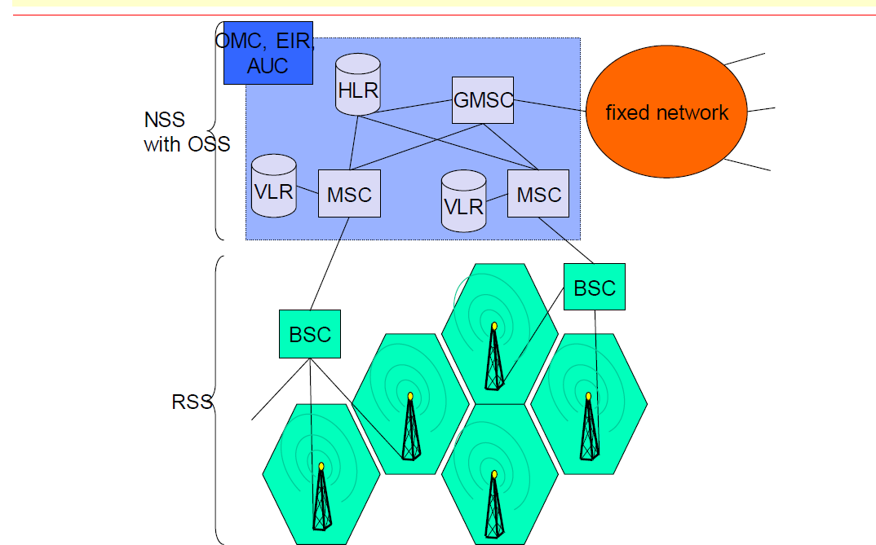

⭐ Q2. Describe the functions of the Radio Subsystem (RSS).
(From Slide 43)
Answer (Full Marks)
The Radio Subsystem (RSS) comprises all components between the mobile station and the switching center. It handles transmission, reception, and radio resource management.
Components:
1. BTS (Base Transceiver Station)
- Contains radio equipment (transmitters, receivers, antennas)
- Handles encryption, signal processing, and radio transmission
2. BSC (Base Station Controller)
- Controls several BTSs
- Performs handover control, power control, frequency hopping
- Allocates radio channels and manages BTS resources
Function
RSS provides the physical radio link and ensures efficient use of radio resources.
It is responsible for radio communication between the subscriber and the network.

⭐ Q3. Explain the components of a Mobile Station (MS).
(From Slide 44)
Answer (Full Marks)
A Mobile Station (MS) is divided into four functional parts:
- MT (Mobile Terminal):
  - Endpoint of the radio interface
  - Handles communication with the BTS
- TA (Terminal Adapter):
  - Adapts terminal equipment to GSM standards
  - Hides radio-specific characteristics
- TE (Terminal Equipment):
  - Device used by the user (phone, laptop, etc.)
  - Does not contain GSM-specific functions
- SIM (Subscriber Identity Module):
  - Stores subscriber information: IMSI, authentication keys, user profile
  - Personalizes the device for the subscriber
The MS provides user access to GSM services and performs authentication and mobility functions.

⭐ Q4. What are the main components and functions of the Network and Switching Subsystem (NSS)?
(From Slide 45)
Answer (Full Marks)
The NSS controls call processing, mobility management, and interconnection with other networks.
Components:
- MSC (Mobile Switching Centre):
  - Performs call switching
  - Manages location updates, handovers, paging
- HLR (Home Location Register):
  - Central database storing permanent subscriber data
  - Stores IMSI, service profile, current location
- VLR (Visitor Location Register):
  - Temporary database storing data of roaming subscribers within MSC area
  - Reduces load on HLR
- EIR (Equipment Identity Register):
  - Stores IMEI of mobile equipment
  - Identifies stolen or invalid devices
- AUC (Authentication Center):
  - Stores authentication keys
  - Provides security and user identity verification
Function
NSS enables routing, mobility support, authentication, billing, and interworking with PSTN/ISDN.

⭐ Q5. Explain the role and functions of the Mobile Switching Center (MSC).
(From Slide 46)
Answer (Full Marks)
The MSC is the central component of GSM, responsible for:
- Switching
  - Establishes, maintains, and releases calls
  - Routes calls between mobile users and external networks
- Mobility Management
  - Handles location registration, paging, and handover
  - Works with HLR and VLR to track subscriber movement
- Interworking Functions
  - Connects GSM to PSTN, ISDN, other MSCs
  - Gateway MSC (GMSC) routes incoming calls to correct MSC
- Service Management
  - Supports SMS
  - Performs call forwarding, roaming, and supplementary services
- Billing and Accounting
  - Generates charging information for each call
MSC is the “brain” of the GSM network and ensures seamless communication and mobility.

Point of Difference | HLR (Home Location Register) | VLR (Visitor Location Register)
1. Definition | Central, permanent subscriber database of the home network. | Temporary database storing information of subscribers currently roaming in an MSC area.
2. Type of Data Stored | IMSI, Ki (authentication key), service profile, MSISDN, billing info, current VLR address. | TMSI, LAI, temporary authentication data, subscriber’s current status, and copied service info from HLR.
3. Purpose | Authentication, mobility management, and call routing for all subscribers. | Reduces HLR load by handling local mobility and call setup for roaming users.
4. Data Lifetime | Permanent (stored for lifetime of subscription). | Temporary (deleted when user leaves the MSC area or powers off).
5. Access Frequency | Accessed during registration, call/SMS setup, authentication, roaming updates. | Accessed during paging, local handover, call/SMS delivery within the visited area.
6. Relationship with MSC | Communicates with Gateway MSC (GMSC) for routing incoming calls. | Directly linked with its associated MSC for fast call handling.
7. Dependency | Independent; does not rely on VLR. | Dependent; obtains subscriber details from HLR.
8. What happens during roaming? | Stores the address of the VLR currently serving the subscriber. | Stores temporary subscriber details while the user is in its area.
9. Security Functions | Provides authentication keys to MSC/VLR via AUC. | Uses temporary identities (TMSI) to protect subscriber identity from eavesdropping.
10. Example Scenario | Even if a user moves, HLR in home city always holds their permanent record. | When user roams to another city, that city’s VLR stores their temporary info until they leave.
11. Number per Network | One logical HLR per GSM operator. | Multiple VLRs (one for each MSC region).
12. Role in Call Setup | Provides routing and location information to locate subscriber. | Helps MSC deliver calls/SMS quickly without querying HLR repeatedly.

SLIDE 53,54
Q1. Explain how CDMA works using chip sequences (Code Division Multiple Access)
Answer (Full Marks)
In CDMA, each user occupies the entire frequency spectrum simultaneously, but separation is achieved using unique orthogonal codes.
Each bit period is divided into multiple smaller intervals called chips. Every user is assigned a unique m-bit chip sequence.
- To transmit a 1, the user sends its chip sequence.
- To transmit a 0, the user sends the negative (inverse) of its chip sequence.
Since all chip sequences are pairwise orthogonal, their inner product is zero.
Thus, signals from multiple users can overlap without interference.
Receivers can isolate a particular user by computing the inner product of the received signal with that user's chip sequence.
This allows multiple users to share the same frequency spectrum simultaneously.

⭐ Possible Exam Question 2
Q2. Why must chip sequences in CDMA be orthogonal?
Answer (Full Marks)
Orthogonality means the inner product of two chip sequences is zero.
This property ensures:
- No interference between users
- Each user’s signal can be recovered independently
- Even if many signals overlap in time and frequency, they remain mathematically separable
When the receiver multiplies the combined signal with a specific user’s code, all other users’ contributions cancel out.
Thus, orthogonality guarantees reliable decoding and maximizes CDMA capacity.

⭐ Slide 54 – How to Recover the Signal
What the slide says
To recover a specific user's data:
- Receiver must know the chip sequence of the sender
- Compute inner product:
$$(A+B+C)⋅C=C⋅C=1$$
because
  - C·C = 1 (self dot product)
  - A·C = 0, B·C = 0 (orthogonal)

⭐ Possible Exam Question 3
Q3. Explain how a receiver recovers a user’s signal in CDMA.
Answer (Full Marks)
In CDMA, the receiver extracts a particular user’s signal using correlation (inner product).
Since all users transmit simultaneously on the same channel, the receiver receives a combined signal:
$$R=A+B+C+…$$
To decode user C, the receiver multiplies the received signal with C's chip sequence and computes the inner product:
$$R⋅C=(A+B+C)⋅C=A⋅C+B⋅C+C⋅C$$
Because chip sequences are orthogonal:
- A·C = 0
- B·C = 0
- C·C = 1 (if C sent bit ‘1’) or –1 (if C sent bit ‘0’)
Thus the receiver recovers the original bit.
This correlation process enables simultaneous multi-user communication.

⭐ Possible Exam Question 4
Q4. Demonstrate with an example how CDMA decoding works.
Answer (Full Marks)
Consider users A, B, and C transmitting simultaneously.
The received signal is:
$$R=A+B+C$$
To decode user C:
$$R⋅C=(A+B+C)⋅C=C⋅C=1$$
Because:
- A·C = 0
- B·C = 0
- C·C = 1
Hence the receiver concludes user C transmitted a 1.
If the result was –1, the transmitted bit was 0.
This example shows how orthogonal chip sequences allow lossless separation of overlapping signals.

⭐ Slide 65 — CSMA/CA Access Method II (with ACK)
🔥 Possible Question 1 (5 marks)
Q1. Explain the CSMA/CA access mechanism in IEEE 802.11 with timing diagram.
✅ Perfect Answer
CSMA/CA (Carrier Sense Multiple Access with Collision Avoidance) is used in WLANs because collision detection (CD) is not possible in wireless channels.
Mechanism:
- A station senses the medium.
- If the medium is free for DIFS, the station sends data.
- The receiver replies with ACK after SIFS if the frame was received correctly.
- If the medium is busy, the station waits for a random backoff period before retrying.
- If no ACK is received, retransmission occurs.
This avoids collisions by using sensing + backoff + positive ACK.

⭐ Slide 66 — DFWMAC (RTS/CTS mechanism)
🔥 Possible Question 2 (5 marks)
Q2. Explain the RTS/CTS mechanism in IEEE 802.11. How does it avoid hidden terminal problems?
✅ Perfect Answer
RTS/CTS is an optional enhancement in DFWMAC-DCF for collision avoidance.
Steps:
- Sender waits for DIFS and then transmits RTS (Request To Send).
- Receiver replies with CTS (Clear To Send) after SIFS.
- Sender sends data.
- Receiver confirms with ACK.
All other stations hearing RTS or CTS update their NAV (Network Allocation Vector) and remain silent.
⭐ Hidden terminal solved:
A hidden node may not hear RTS, but it will hear CTS from the receiver and thus stay silent.
This reduces collisions, especially in large or obstructed wireless networks.

⭐ Slide 67 — Fragmentation in 802.11
🔥 Possible Question 3 (5 marks)
Q3. What is fragmentation in IEEE 802.11? Why is it used? Explain the process.
✅ Perfect Answer
Fragmentation breaks a large MAC frame into multiple smaller fragments to reduce the cost of retransmission in noisy wireless channels.
Process:
- Sender first sends RTS/CTS.
- Data is split into fragments: frag1, frag2, frag3…
- Each fragment is individually acknowledged with ACK after SIFS.
- If one fragment fails, only that fragment is retransmitted, not the whole frame.
Advantages
- Reduces retransmission overhead.
- Improves reliability in high-error environments.
- Ensures faster recovery from bit errors.

⭐ Slide 68 — DFWMAC-PCF (Point Coordination Function)
🔥 Possible Question 4 (5 marks)
Q4. What is PCF in IEEE 802.11? Explain its operation.
✅ Perfect Answer
PCF (Point Coordination Function) is an optional centralized polling-based access method in 802.11.
- The Point Coordinator (PC) at the Access Point controls channel access.
- PCF works during the Contention-Free Period (CFP) and uses PIFS, which has higher priority than DCF stations.
- The AP polls stations one-by-one, giving them permission to transmit without collisions.
- Data (D) and uplink (U) frames alternate, separated by SIFS.
- After the CFP ends, normal contention-based DCF resumes.
Use-case:
Time-sensitive applications (voice, video) needing guaranteed access.
Q1. Why can’t a mobile host simply change its IP address when it moves to a new network? Explain the problems.
✅ Perfect Answer

SLIDE 80, 81
Q1. Explain how Mobile IP solves the IP mobility problem.
Changing the IP address to match the foreign network’s prefix seems like a solution, but it creates major problems:
- Breaks ongoing TCP connections
TCP connections are identified by
$$(IPsrc,IPdst,Portsrc,Portdst)$$If the IP changes, the connection becomes invalid.
- DNS update overhead
Every movement requires updating the DNS server with the new IP.
This adds heavy load and propagation delays.
During this time, the host may be unreachable.
- Applications are not designed for changing IPs
Most application protocols assume the IP address is stable throughout a session.
Changing IP would require rewriting major parts of TCP/IP.
- Not scalable
Mobile users move frequently. Constant DNS updates would overwhelm the network.
Thus, simply changing IP is impractical. A new mobility solution is needed → Mobile IP.

⭐ Possible Exam Question 2 (5 marks)
Q2. Explain why active TCP connections break if a mobile node changes its IP address.
✅ Perfect Answer
TCP connections are identified by a 4-tuple:
$$(IP_{src},IP_{dst},Port_{src},Port_{dst})$$
When a mobile node changes its IP address after moving to a new network:
- The IPsrc value changes
- The connection no longer matches the receiver’s existing TCP session
- Packets belonging to the old session are discarded
- The connection resets or times out
Since TCP assumes the sender’s and receiver’s IPs remain constant throughout the session, mobility breaks connection stability.
Q1. Explain how Mobile IP solves the IP mobility problem.
✅ Perfect 5-Mark Answer
Mobile IP allows a mobile node (MN) to keep its permanent home IP address while roaming across different networks.
To support this, Mobile IP introduces a two-tier addressing system:
1. Home Address (Permanent)
- Assigned by the home network
- Used by all applications
- Does not change, even when the user moves
2. Care-of-Address (CoA) (Temporary)
- Obtained from the foreign network the MN is visiting
- Identifies the MN’s current point of attachment to the network
How it works:
- The Home Agent (HA) in the home network maintains a mapping between Home Address → CoA
- Packets for the user are intercepted by the HA and tunneled to the CoA
- The MN receives packets regardless of its physical location
- Applications and TCP remain unaware of mobility, ensuring session continuity
Thus, Mobile IP solves mobility in a scalable and transparent way without modifying existing protocols.

SLIDE 83
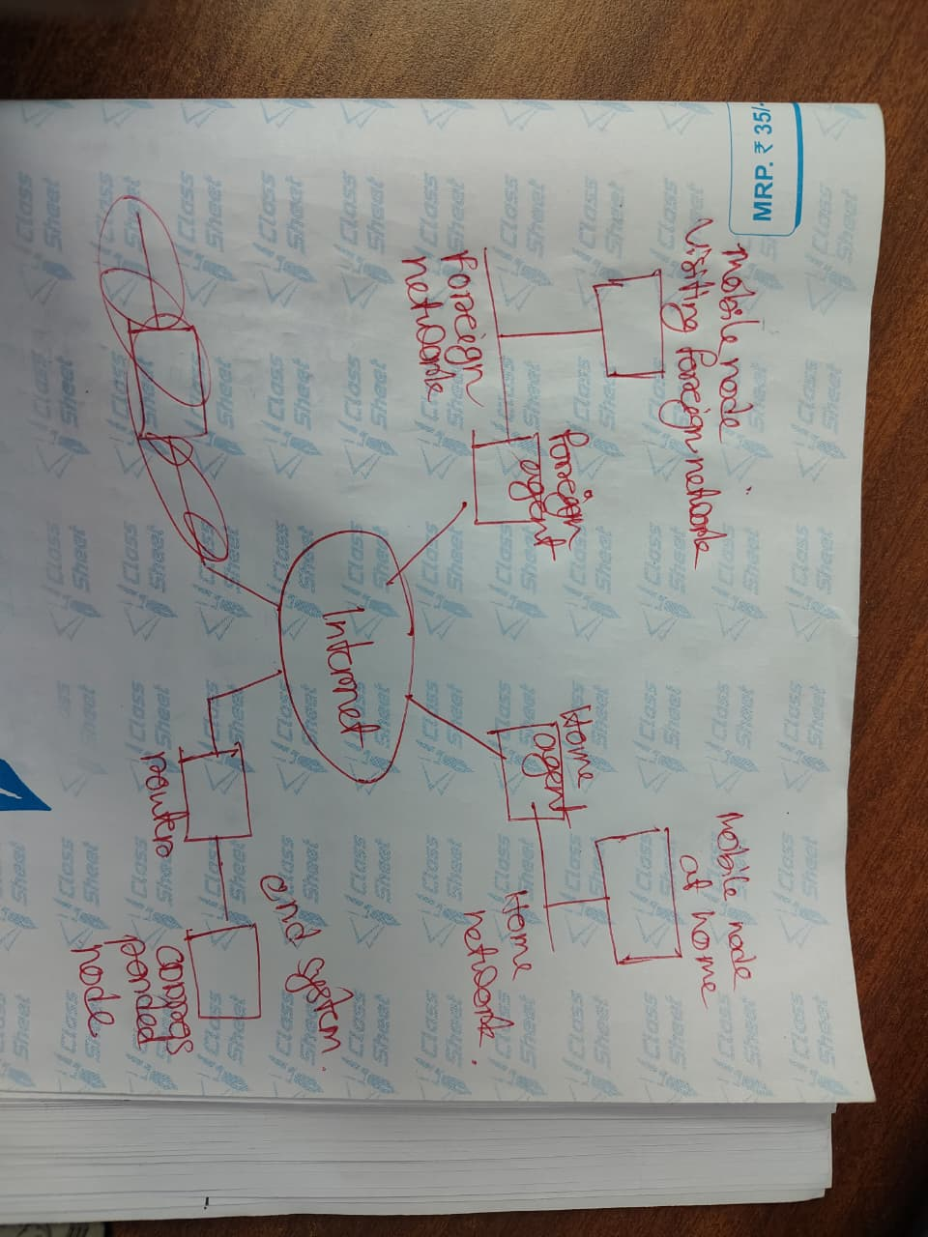
⭐ Slide 83 — Mobile IP Components
The slide shows the three main entities involved in Mobile IP:
- Mobile Node (MN)
- Home Agent (HA)
- Foreign Agent (FA)
- (Plus Correspondent Node (CN), the node communicating with MN)
Let’s turn this into exam-ready answers.

⭐ Possible Exam Question 1 (5 marks)
Q1. Explain the components of Mobile IP with a neat diagram.
✅ Perfect Answer
Mobile IP enables a mobile node (MN) to maintain continuous Internet connectivity while moving between networks. The architecture consists of:

1. Mobile Node (MN)
The mobile device (laptop, phone) that changes its point of attachment to the Internet.
Functions:
- Obtains a temporary Care-of-Address (CoA) in the foreign network
- Registers its CoA with the Home Agent
- Sends and receives tunneled packets

2. Home Agent (HA)
A router on the mobile node’s home network that maintains the MN’s permanent Home Address.
Functions:
- Keeps a mapping of Home Address → Care-of-Address
- Intercepts packets for the MN (proxy ARP)
- Tunnels packets to the MN’s CoA
- Decapsulates packets when MN sends data

3. Foreign Agent (FA)
A router in the foreign network where the MN is visiting.
Functions:
- Provides the MN with a Care-of-Address
- Forwards registration messages to the HA
- Delivers tunneled packets to the MN
- Acts as the default router for outgoing packets

4. Correspondent Node (CN)
The device communicating with the mobile node.
Functions:
- Sends packets to the MN’s home address
- Receives packets normally from MN
SLIDE 84
When a Mobile Node (MN) enters a foreign network, it must register its current location with its Home Agent (HA). Registration ensures that packets are routed correctly to the MN’s Care-of-Address (CoA).
There are two cases:

1. Foreign Network has a Foreign Agent (FA)
- MN discovers the FA through agent advertisements.
- The MN sends a Registration Request to the FA.
- FA assigns a foreign agent Care-of-Address (shared CoA).
- FA forwards the registration request to the HA.
- HA updates its mobility binding:
Home Address → FA’s CoA
- HA sends a Registration Reply back to the FA.
- FA delivers the reply to the MN.

2. Foreign Network does NOT have a Foreign Agent
- MN uses DHCP to obtain a temporary IP address.
- This is called a co-located CoA.
- MN directly sends a registration request to the Home Agent.
- HA updates its mobility binding table.
In both cases, registration ensures the HA knows the MN’s current CoA and can tunnel packets appropriately.
Q2. What is the difference between a Foreign Agent CoA and a Co-located CoA?
✅ Answer
Foreign Agent CoA | Co-located CoA
Provided by the FA in the foreign network | Obtained directly via DHCP
Shared by multiple mobile nodes | Unique to the mobile node
FA forwards packets to MN | MN receives packets directly
MN registers through the FA | MN registers directly with HA
SLIDE 88, 89
Q1. Explain route optimization in Mobile IPv4. Why is it needed?
✅ Perfect Answer
In basic Mobile IP, all traffic to a Mobile Node (MN) must pass through the Home Agent (HA), causing triangle routing. This results in longer delays and increased load on the HA.
To solve this, Mobile IPv4 supports route optimization, where the Correspondent Node (CN) learns the MN’s current Care-of-Address (CoA).
Mechanism:
- The CN initially sends packets to the MN’s home address.
- The HA intercepts these packets and tunnels them to the CoA.
- After tunneling the first packet, the HA sends a Binding Update (BU) to the CN, informing it of the MN’s current CoA.
- The CN stores this in its Binding Cache.
- Subsequent packets are sent directly from CN → CoA, eliminating triangle routing.
This reduces latency, decreases network load, and improves performance.
Q2. Explain route optimization in Mobile IPv6. How is it different from IPv4?
✅ Perfect Answer
Mobile IPv6 integrates route optimization as a built-in feature (mandatory), unlike IPv4 where it is optional.
Route optimization allows the Correspondent Node (CN) to send packets directly to the Mobile Node’s Care-of-Address (CoA), bypassing the Home Agent.
Mechanism:
- CN sends a packet to the MN's home address.
- HA tunnels the first packet to the MN’s CoA.
- Upon receiving the tunnelled packet, the MN sends a Binding Update (BU) directly to the CN.
- CN stores the binding (Home Address → CoA) in its Binding Cache.
- All subsequent packets are sent directly CN → MN (CoA) without involving the HA.
Difference from MIPv4:
- In IPv6, the MN sends the BU (not the HA).
- Route optimization is always available in MIPv6.
- IPv6 uses Routing Header instead of encapsulation, reducing overhead.
- No Foreign Agents exist in MIPv6.
SLIDE 103
Q. Describe the major problems in Ad-hoc Networks. (5 marks)
Ad-hoc networks face several challenges due to their decentralized and mobile nature:
- No dedicated routing devices:
There are no fixed routers; all nodes must participate in routing. This increases overhead and complexity since every node acts as both host and router.
- Highly dynamic topology:
Nodes frequently change their positions, causing routes to break often. Routing protocols must constantly update routes, leading to instability and high control traffic.
- Asymmetric links:
Wireless links may not be bidirectional. A node may receive a signal from another node but cannot transmit back with equal strength. Many traditional routing algorithms assume symmetric links and fail in such environments.
- High power consumption:
Nodes rely on battery power. Forwarding packets and maintaining routing tables drain energy, and dead nodes disrupt routes.
- Low bandwidth and high error rates:
Wireless channels offer limited bandwidth and are susceptible to interference and noise. This leads to packet loss, high latency, and reduced performance.

SLIDE 104
The slide shows how MANET (Mobile Ad-hoc Network) routing protocols are classified.
⭐ 1. Proactive Routing Protocols (Table-Driven)
Examples: DSDV
Characteristics:
- Every node maintains full routing tables for all possible destinations.
- Tables are updated periodically, even if no data is being sent.
- Routes are always available (no delay in finding route).
- Consumes more bandwidth → because of periodic updates.
Best when:
- Mobility is low
- Network size is small
- You need quick route availability

⭐ 2. Reactive Routing Protocols (On-Demand)
Examples: DSR, AODV
Characteristics:
- Routes are discovered only when needed.
- No periodic routing-table broadcasts.
- Reduces overhead → good for dynamic networks.
- Initial delay occurs during route discovery.
Best when:
- High mobility
- Large and dynamic networks
- Want to save bandwidth & battery

SLIDE 115
Q. How does DSDV avoid loops and the count-to-infinity problem? Explain with sequence numbers.
Answer:
DSDV avoids loops by associating a destination sequence number with every route. When a link breaks, the detecting node increments the sequence number by 1 (making it an odd number) and advertises the route as unreachable (metric = ∞). Other nodes compare the received sequence number with their stored one. A route update is accepted only if the sequence number is newer.
Since nodes reject older updates, stale routing information cannot propagate. This prevents nodes from repeatedly increasing hop counts to a destination (the count-to-infinity problem). Thus, using sequence numbers and triggered updates, DSDV ensures loop-free and stable routing in ad-hoc networks.
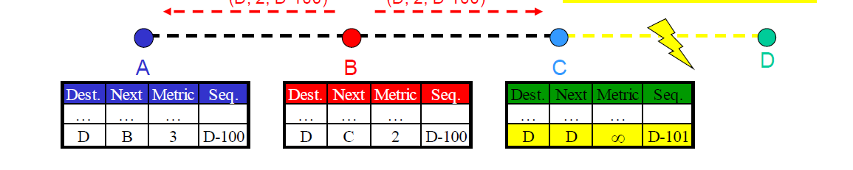
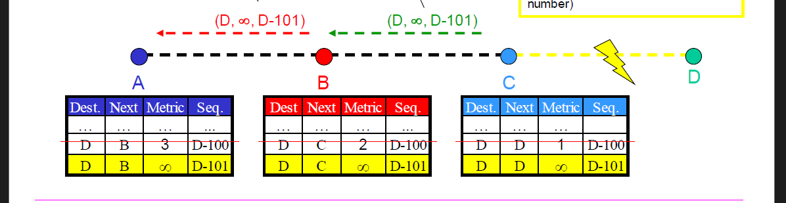
SLIDE 127
⭐ Slide 127 — AODV: Route Discovery (Detailed Explanation)
This slide explains how AODV discovers a route when a node wants to send data but has no route to the destination.
I’ll break it down into simple steps for you:

⭐ 1. Route discovery starts only when needed (On-demand)
AODV is a reactive routing protocol.
It does NOT maintain full routing tables like DSDV.
It only finds a route when a communication request arises.

⭐ 2. Sender broadcasts an RREQ (Route Request)
When a node wants to reach destination D but has no route, it broadcasts an RREQ packet containing:
- S → Source address
- ID → Broadcast ID (unique for each request)
- Seq No. → Source’s sequence number
- D → Destination address

⭐ 3. Every node maintains two counters
Each node keeps:
✔ Sequence Number
Used to decide freshness of routes (higher = newer).
✔ Broadcast-ID
Used to identify duplicate RREQ packets.

⭐ 4. Behavior of neighbor nodes
A receiving node can do one of two things:
Option A: Forward the RREQ
It forwards (broadcasts) the RREQ to its neighbors if it cannot satisfy it.
Option B: Send an RREP (Route Reply)
If the receiving node:
- is the destination, OR
- has a fresh enough route in its routing table
then it unicasts a Route Reply (RREP) back to the source.

⭐ 5. Duplicate RREQs are discarded
Nodes track already-seen RREQs using:
<source address, request ID>
If the same combination comes again → discard.
This avoids flooding loops.

⭐ Why is this mechanism important?
- Reduces unnecessary broadcasting
- Ensures loops do not form
- Ensures freshest route is found
- Enables scalability even in large ad-hoc networks

⭐ Exam-Ready 5-Mark Answer (You can write this)
AODV uses an on-demand route discovery mechanism. When a source node requires a route to a destination but lacks one, it broadcasts a Route Request (RREQ) packet containing the source address, broadcast ID, source sequence number, and destination address. Each node maintains two counters—sequence number and broadcast-ID—to ensure freshness and avoid duplicate processing.
Upon receiving the RREQ, a node either rebroadcasts it or replies with a Route Reply (RREP) if it is the destination or has a fresh route. Duplicate requests are discarded using the <source address, broadcast ID> pair. This process ensures loop-free, efficient, and scalable route discovery in ad-hoc networks.
SLIDE 142
⭐ Wireless Issues Impacting TCP Performance
These are characteristics of wireless networks that cause TCP to perform poorly.

💛 1. High Bit Error Rate (BER)
Wireless links suffer from:
- noise
- interference
- fading
- path loss
This causes many packet errors.
👉 TCP mistakenly thinks errors = congestion.
👉 So it reduces its sending rate → poor throughput.

💛 2. Handoff
When a mobile device moves from one cell or AP to another, a handoff occurs.
During handoff:
- connection may pause
- packets get delayed or lost
TCP again misinterprets this as congestion → slows down unnecessarily.

💛 3. Frequent Disconnection
Wireless links can drop due to:
- mobility
- weak signal
- battery saving
- interference
TCP treats disconnection like a network failure → starts retransmissions, timeouts, and shrinks its congestion window.
This kills performance.

💛 4. Large and Varying Delays
Wireless networks experience:
- fluctuating RTT
- buffering in the base station
- unpredictable latency during mobility
TCP is very sensitive to delay variation → it triggers retransmission timers incorrectly.

💛 5. Limited Spectrum
Wireless networks share very small bandwidth.
- Multiple devices compete
- Collisions occur
- Throughput decreases
TCP is not designed for shared-medium behavior → performance drops heavily.

💛 6. Limited Energy
Mobile devices run on battery.
- They sleep often
- Reduce transmission power
- Perform duty cycling
This causes random delays and packet loss → TCP misbehaves because it thinks congestion happened.

💛 7. Path Asymmetry
Wireless uplink and downlink often have different:
- bandwidth
- delays
- reliability
TCP assumes symmetric paths, so asymmetry leads to:
- delayed ACKs
- slow start delays
- misestimated RTT

SLIDE 143
⭐ What is pseudo-congestion?
In wireless networks, packets are often lost due to:
- fading
- interference
- mobility
- handoff
- random bit errors
These losses are NOT caused by congestion, but TCP does not know that.
👉 TCP assumes:
“Packet lost → network is congested → reduce sending rate.”
This wrong assumption is called pseudo-congestion.

⭐ Why this is a big problem?
TCP’s congestion control reacts like this:
- reduces congestion window
- slows down transmission
- increases timeout
- takes very long to recover
Even though the network is not congested.
So wireless performance becomes extremely poor.
Q. Explain the problem of pseudo-congestion in TCP over wireless networks.
Answer:
TCP was designed assuming that packet losses occur only due to congestion. Therefore, whenever loss is detected, TCP reduces its congestion window. In wireless networks, however, packets can be lost due to high bit error rate, fading, interference, mobility, or handoff. These losses are unrelated to congestion, but TCP cannot distinguish them because it relies purely on end-to-end observations. As a result, TCP unnecessarily reduces its sending rate, leading to poor throughput. The key challenge is to differentiate congestion-loss from wireless-loss, which is difficult since the TCP sender only observes packet loss and has no information about the underlying cause.
SLIDE 149
⭐ 1. What is Handoff?
When a mobile device moves from one cell to another, the network switches it from:
Old Base Station → New Base Station
During this brief period:
- packets may be delayed
- packets may be lost
- connection may pause
TCP does not know a handoff is happening.

⭐ 2. What is Frequent Disconnection?
Wireless devices often face:
- weak signal
- mobility
- interference
- temporary link breaks
These cause sudden disconnections.

⭐ 3. Why TCP gets confused
TCP assumes:
Packet loss = congestion
So when packets are lost during handoff or disconnection, TCP thinks:
“The network is congested!”
Then it reacts aggressively:
- cuts congestion window (cwnd)
- slows down sending rate
- retransmits packets
- enters timeout state
Even though there was no congestion at all.

⭐ 4. Blackouts → Multiple Timeouts
A “blackout” means:
- network goes unreachable for a short time
- no ACKs come back to the sender
TCP response:
- First timeout → retransmit
- Still no ACK → increase timeout interval
- Timeout again → increase interval even more
- This continues…
This exponential backoff makes recovery very slow even after the wireless link comes back.
SLIDE 198
⭐ Slide 198 — TCP Snoop: Disadvantages
The slide lists the limitations of the TCP Snoop mechanism.
Here is the full breakdown in simple, exam-ready points:

💛 1. Cannot be used if wireless RTT is high
TCP Snoop works by locally retransmitting lost packets from the Base Station (BS).
This only works well when:
- wireless round-trip time is small
- BS can quickly detect a duplicate ACK
- BS can retransmit before the TCP sender triggers Fast Retransmit
If wireless RTT is large, Snoop reacts too slowly → sender times out → mechanism fails.

💛 2. Cannot be used if IPSec is used
IPSec encrypts:
- TCP headers
- sequence numbers
- ACKs
Snoop needs to read TCP headers to:
- detect lost packets
- drop DUPACKs
- retransmit locally
But with IPSec encryption, the BS cannot inspect TCP packets, so Snoop becomes impossible.

💛 3. Cannot be used in asymmetric links
Snoop assumes that:
- downlink (data) and uplink (ACKs) are similar
- BS can observe ACK flows clearly
But in many wireless networks:
- downlink bandwidth >> uplink bandwidth
- ACKs may be delayed or aggregated
- BS may not see all ACKs correctly
If BS cannot reliably track ACKs → it cannot detect losses → Snoop fails.

💛 4. BS requires larger buffer space
Snoop stores (“buffers”) all un-ACKed TCP packets so that:
- if a packet is lost in wireless link → BS retransmits immediately
This demands large memory in the Base Station.
High-traffic scenarios → BS becomes overloaded.

💛 5. Link layer needs to be TCP-aware
Snoop breaks the strict layering principle.
It requires:
- link layer entity at BS to understand TCP
- inspect TCP headers
- identify DUPACKs
- drop certain ACKs
- trigger retransmission
This violates modular design, making implementation more complex.
2022
5)
a)
i)
Feature | Source Routing | Hop-by-Hop Routing
Who decides the entire path? | Source node decides full route | Each node decides next hop independently
Routing info stored where? | In packet header (entire route listed) | Each router/node keeps its own routing table
Control overhead | High (route stored in packet → large header) | Low (only next-hop info needed)
Flexibility | Path fixed from source → less adaptable mid-route | Dynamic; each hop can change based on network changes
Used in | DSR (Dynamic Source Routing) | AODV, DSDV
Routing table requirement | Not needed at intermediate nodes | Needed at every node
Scalability | Poor for large paths | Better scalability
ii)
⭐ ii) Why is routing in multi-hop ad-hoc networks complicated? What are the special challenges?
Routing in ad-hoc networks is difficult because:
1. Dynamic topology
Nodes move frequently → links break often → routes become invalid quickly.
2. Limited bandwidth
Wireless medium is shared; routing overhead consumes precious bandwidth.
3. Limited energy
Nodes depend on battery → routing consumes power → nodes may die suddenly.
4. No centralized controller
Every node acts as router + host → must discover/maintain routes themselves.
5. Unidirectional / asymmetric links
Wireless links may work only one way → routing becomes unpredictable.
6. Hidden terminal & interference
Wireless collisions cause packet loss → route discovery becomes unreliable.
7. Scalability issues
As the network grows, maintaining routing information becomes difficult.
In short:
Routing breaks easily, consumes bandwidth, and must constantly adapt to frequent topology changes.
iii)

💛 1. DSR (Dynamic Source Routing)
DSR is a reactive (on-demand) routing protocol for ad-hoc networks.
✔ Key Characteristics:
- Source Routing:
The entire route (all hops) is written in the packet header.
- Route Discovery:
When needed, source sends RREQ and receives RREP.
- Route Cache:
Nodes store multiple routes to a destination.
- No periodic hello messages
→ reduces overhead.
- Routes maintained only when needed
✔ Advantages:
- Multiple alternative routes available
- No routing tables needed
- Very low control overhead
✔ Disadvantages:
- Large headers (because full route stored in packet)
- Not good for very large networks

💛 2. AODV (Ad-hoc On-demand Distance Vector)
AODV is also reactive, but uses hop-by-hop routing.
✔ Key Characteristics:
- Hop-by-hop routing:
Nodes only store next hop in routing tables.
- Sequence numbers:
Used to maintain fresh routes.
- Route Discovery:
Uses RREQ / RREP like DSR.
- Periodic hello messages:
To maintain neighbor connectivity.
✔ Advantages:
- Small packet headers
- Scales better than DSR
- Uses sequence numbers → avoids loops
✔ Disadvantages:
- Only one active route maintained
- Depends on routing tables → becomes stale in high mobility
- More frequent route breakages

Now that DSR and AODV are defined properly…

⭐ Now: Why does DSR perform better than AODV in a very dynamic environment?
Here is the clean, fully explained logic:

💛 1. DSR has ROUTE CACHE (multiple routes available)
When a link breaks:
- DSR quickly switches to another cached route
- No need for immediate RREQ flooding
- Faster recovery
- Lower overhead
AODV:
- Stores only one route
- If it breaks → must redo Route Discovery
- More delays, more flooding, more breakages

💛 2. DSR has NO periodic HELLO messages
AODV sends hello messages to maintain neighbor tables.
In highly mobile networks:
- hello messages often become outdated
- routes break rapidly
- more processing overhead
- more routing table churn
DSR avoids this completely → fewer control packets → more stable.

💛 3. DSR’s source routing avoids stale routing tables
In DSR:
- the entire path is included inside the packet
- intermediate nodes don’t need to maintain up-to-date routing tables
- route breaks are localized and quickly detected
AODV:
- depends on routing tables
- in high mobility, these tables become outdated every few seconds
- frequent rediscovery required

💛 4. DSR adapts faster to topology changes
Because of:
- route cache
- no dependency on periodic updates
- immediate fallback to alternate routes
AODV:
- slower recovery
- must always start new discovery
DSR- akbar routing path banay
AODV- jeta constantly routing table tairi korte thake

b)
i)
i) DSR Functionalities: Route Discovery & Route Maintenance
💛 Route Discovery
Used when a source node wants to send data but has no route to the destination.
Steps:
- Source broadcasts RREQ (Route Request)
Contains source address, destination address, and request ID.
- Intermediate nodes append their address
Every node adds its own address to the route record inside RREQ.
- Destination receives RREQ
It sends back an RREP (Route Reply) following the reverse of the accumulated path.
- Route cached
Source stores this route in its route cache.
Key points:
- Entire route is included in packet header (source routing)
- Multiple routes may be stored
- No routing tables needed at intermediate nodes

💛 Route Maintenance
Used while communication is ongoing to detect and handle link failures.
Steps:
- Each hop monitors link status using ACKs or link-layer feedback.
- If a link breaks, a node sends a Route Error (RERR) to the source.
- Source deletes all routes using that broken link from the cache.
- If no alternate cached route exists → source performs new Route Discovery.
Key points:
- Quick detection of broken links
- Uses Route Error messages
- Cached alternate routes allow fast recovery
ii)
ii) Compare DSDV, DSR, and AODV
Feature | DSDV | DSR | AODV
Type | Proactive (table-driven) | Reactive (on-demand) | Reactive (on-demand)
Routing info | Full routing table | Full path in packet header | Next-hop routing table
Periodic messages | Yes | No | Yes (hello messages)
Sequence numbers | Yes (destination-based) | No | Yes (destination-based)
Loop-free? | Yes | Yes | Yes
Best for | Low mobility, stable networks | Small, highly mobile networks | Larger dynamic networks
Overhead | High (regular updates) | Medium (large headers) | Medium (control packets)
Multiple routes | No | Yes (route cache) | No
iii)
iii) What do you mean by promiscuous receive mode?
💛 Promiscuous Mode Definition:
In promiscuous receive mode, a network interface listens to and accepts all packets on the wireless channel, even those not addressed to it.
Why is it used?
- DSR uses promiscuous mode to learn routes passively
- A node overhears packets from neighbors and extracts route information
- Reduces route discovery overhead
- Helps build route cache without sending control packets
Example:
Node B overhears a packet from A to C → B learns the path A → C even though it was not meant for B.
iv)
iv) Example Areas Where Ad-Hoc Networks Can Be Used
Ad-hoc networks are useful where infrastructure is unavailable, unreliable, or expensive.
✔ 1. Military communication
Soldier units, vehicles, and drones forming instant networks.
✔ 2. Disaster recovery
During earthquakes, floods, when cellular towers fail.
✔ 3. Sensor networks
Environmental monitoring, forest fire detection.
✔ 4. Vehicular networks (VANETs)
Cars sharing safety and traffic information.
✔ 5. Temporary events
Conferences, concerts, festivals.
✔ 6. Remote rural areas
Where no fixed infrastructure exists.
✔ 7. Personal Area Networks
Bluetooth-based device-to-device connections.

Q.6)
a)
(i) TCP Reaction to Packet Loss + Why It Works + Why It Fails in Wireless + Can UDP Replace TCP?

💛 A. Reaction of Standard TCP in Case of Packet Loss
TCP assumes packet loss = network congestion.
So when a packet is lost, TCP reacts by:
✔ 1. Reducing congestion window (cwnd)
Slows down sending rate → increases RTT spacing.
✔ 2. Entering congestion control mechanisms
- Fast Retransmit
- Fast Recovery
- Slow Start
- Timeout and exponential backoff
✔ 3. Retransmitting the lost packet
This is TCP’s core congestion-avoidance behaviour.

💛 B. When does this reaction make sense?
It makes sense in wired networks, because:
- Packet loss normally occurs ONLY due to congestion
- Bit errors, interference, and random losses are extremely rare
- Dropping packets is a signal that routers are overloaded
👉 So reducing the sending rate genuinely helps stabilize the network.

💛 C. Why is this problematic in wireless networks?
In wireless networks, packet loss is NOT caused by congestion, but by:
- high bit error rate
- fading
- handoff
- interference
- temporary disconnections
- weak signal
TCP still interprets these losses as congestion, causing:
❌ Unnecessary cwnd reduction
❌ Timeouts
❌ Very slow throughput
❌ Poor performance after handoff
❌ Repeated backoff even when the network is NOT congested
So TCP becomes too conservative and performs very poorly over wireless links.

💛 D. Can we solve these problems by replacing TCP with UDP?
✔ In theory?
UDP avoids congestion control completely.
So it won’t slow down when packets are lost.
✔ Where could this be useful?
Applications that tolerate some packet loss, such as:
- voice (VoIP)
- video streaming
- gaming
- real-time communication
These applications prefer timely delivery over reliable delivery.
So UDP performs well there.

❌ But using UDP is often dangerous
UDP has no congestion control.
If many users send heavy traffic over UDP:
- the network can become congested
- routers will drop packets
- flows will not slow down
- this can cause network collapse (congestion collapse)
This is why large data transfers using UDP are dangerous and often disallowed.
(ii) Localization Approach to Improve TCP Performance in Wireless Networks
This refers to techniques where loss recovery is handled near the wireless link, instead of letting the TCP sender (far away) slow down.
The goal is to hide wireless losses from TCP.

💛 Localization Approach: Key Idea
Place an intelligent agent near the wireless link (usually at the base station or access point) to:
- detect wireless losses quickly
- retransmit locally
- prevent TCP sender from misinterpreting the loss
Examples of localization approaches include:
✔ 1. TCP Snoop (Snoop Agent)
- runs at base station
- caches unacknowledged packets
- locally retransmits lost packets over wireless
- suppresses duplicate ACKs to prevent TCP fast retransmit
This improves performance by handling wireless errors locally.

✔ 2. Split Connection (Indirect TCP)
- Break connection into two parts:
  - wired segment: reliable TCP
  - wireless segment: optimized protocol
- Base station acts as intermediary
Wireless loss doesn’t propagate to the original TCP sender.

✔ 3. Forward Error Correction (FEC)
- Add redundancy so receiver can fix bit errors without retransmission
- Reduces the number of packet drops seen by TCP
b)
i) How does handoff affect TCP performance?
(When a mobile device crosses cell boundary → handoff occurs)
When a mobile moves from one cell to another, the network performs handoff:
- connection pauses briefly
- packets are delayed or dropped
- ACKs stop arriving for a short period
🔥 How TCP reacts (the problem):
TCP assumes “packet loss = congestion.”
So during handoff, TCP sees missing ACKs and:
- Shrinks the congestion window (cwnd)
- Enters slow start
- Retransmits packets
- Triggers timeouts
- Reduces sending rate severely
Even though there is no congestion, only a temporary disconnection.
🔥 Why this is bad:
After handoff completes, the wireless link becomes normal again,
but TCP remains in:
- low cwnd
- slow growth
- long recovery phase
This causes very poor throughput, especially if handoffs happen often (high mobility).
⭐ Exam line to include:
“TCP misinterprets handoff-induced losses as congestion and unnecessarily reduces cwnd, leading to long recovery time and degraded performance.”

⭐ ii) How do high wireless loss rates affect TCP performance?
(When most packets are lost due to wireless errors)
Wireless channels suffer from:
- fading
- interference
- high BER
- weak signals
- multipath
These losses are not congestion losses, but TCP cannot differentiate.
🔥 TCP’s reaction:
TCP again assumes the worst:
packet loss → congestion → reduce rate
So:
- Congestion window collapses
- Slow start restarts frequently
- Many timeouts occur
- Throughput drops dramatically
- TCP oscillates between slow start and recovery
This makes TCP very inefficient over wireless links.

⭐ Mechanism to Improve TCP Performance under Wireless Loss
(You MUST mention one of these: Snoop, Split-Connection, FEC, Explicit Notifications.)
The best answer from your syllabus is:

💛 TCP Snoop Mechanism (Local Recovery)
How it works:
- A Snoop agent runs at the base station (BS).
- It caches unacknowledged TCP packets.
- If a packet is lost in the wireless section, the BS:
  - detects duplicate ACKs
  - locally retransmits the lost packet
- It suppresses duplicate ACKs so they don’t reach the TCP sender.
Why this improves performance:
- TCP sender never learns about wireless loss
- Does NOT reduce cwnd
- No slow start
- Fast local recovery
- Much higher throughput

