Installation -> sudo apt-get install libsdl2-dev (for UBUNTU)

Compilation –> g++ -o myprogram myprogram.cpp `sdl2-config --cflags --libs`

setting window size -> SDL_WINDOW_RESIZABLE = 0x00000020, /**< window can be resized */

Create a window->
SDL_Window *name = SDL_CreateWindow(const char *title,
int x, int y, int w,
int h, Uint32 flags);

Surface->
the file is first loaded into surface(temp loader) then its converted to texture(permanent display) for viewing.
edits are performed on the surface texture is just for viewing.

Updating the window surface->
SDL_UpdateWindowSurface(my_win);

getting a color->
SDL_MapRGB(my_sur->format, 255, 0, 0);
my_sur->format givess us the surface color storing format then using SDL_MapRGB
we can get the color like red here in unit32 format.

Filling the window with color->
int SDL_FillRect(SDL_Surface * dst, const SDL_Rect * rect, Uint32 color);
const SDL_Rect * rect | the SDL_Rect structure representing the rectangle to fill, or NULL to
fill the entire surface.

SDL_FillRect(my_sur, NULL, color); fills the whole window with color.
Getting the recangle(pixel)->
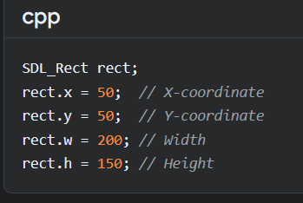
Rect is a structure.
File Read->
file.read(data.data(), size); // this is used to read binary data

