DATA ENGINEEERING
- Take the data -> refine it -> deliver it in the form of Data Models
--------------------------------------------------------------------------------------------------------------
Data engineering is about:
- Collecting data (from apps, websites, sensors, logs)
- Cleaning it (removing junk, fixing formats)
- Storing it (databases, data warehouses)
- Moving it fast and safely so others can use it
--------------------------------------------------------------------------------------------------------------
CSV = Comma-Separated Values
It’s just plain text where:
- each row = one line
- each column = values separated by commas
Example
name,age,city
Bikram,21,Kolkata
Amit,22,Delhi
Riya,20,Mumbai
- First line → column names (header)
- Every next line → one record
Three main pillers-
- Data production -> Data Transformation -> Data Serving
--------------------------------------------------------------------------------------------------------------
Data Upstream – DBA
Data Downstream – Manager, Data Analyst
OLTP - Online transactional processing.
OLAP – Online Analytical processing.
OLTP(Online transactional processing.)
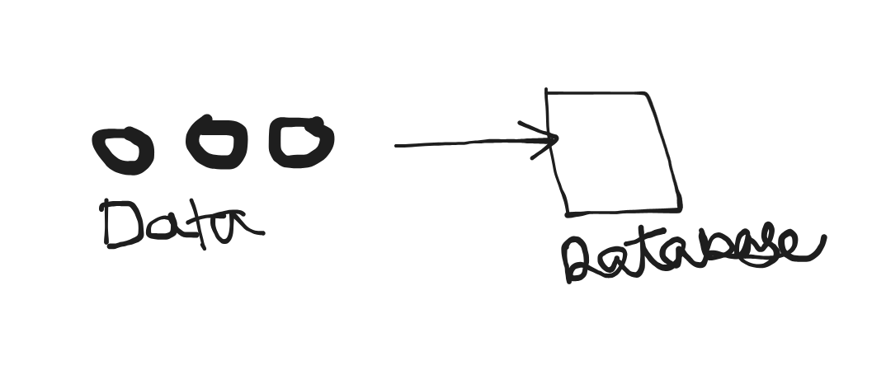
- Database which is very much efficient for writes and updates.
- Cause we will be storing data in chunks in smaller quantity.
- An OLTP database is designed to handle a large number of small, fast, day-to-day transactions where data is frequently inserted, updated, or deleted.

Typical OLTP actions:
- Add a new user
- Update account balance
- Place an order
- Book a ticket
- Mark attendance
- Transfer money
Each action is:
- Quick
- Small
- Critical (must be accurate)
For example MYSQL, POSTGRESQL
- OLTP data bases will be managed by DBA we will treat that as source.
- Technique used to model our data in OLTP is called Normalisation.
- We use till 3rd Normal form.

OLAP(Online Analytical processing)-
These databases isalso caleed data Warehouse.
- Here we try to make it efficient enough for read.
- Ex. wherescapeRed, Snowflake, Redchip.
- An OLAP database is built for analysis, not daily operations.
It helps you study large amounts of historical data to find patterns, trends, and insights.

Key characteristics
- Read-heavy (almost no updates)
- Works on huge datasets (millions/billions of rows)
- Complex queries with joins, aggregates, GROUP BY
- Optimized for fast analysis, not transactions
- Data is usually denormalized (star/snowflake schema)

OLTP | OLAP
Real-time operations | Historical analysis
Inserts / Updates | Mostly SELECT
Small data per query | Massive data per query
Normalized tables | Denormalized tables
Fast transactions | Fast analytics

ETL ( EXTRACT TRANSFORM LOAD )
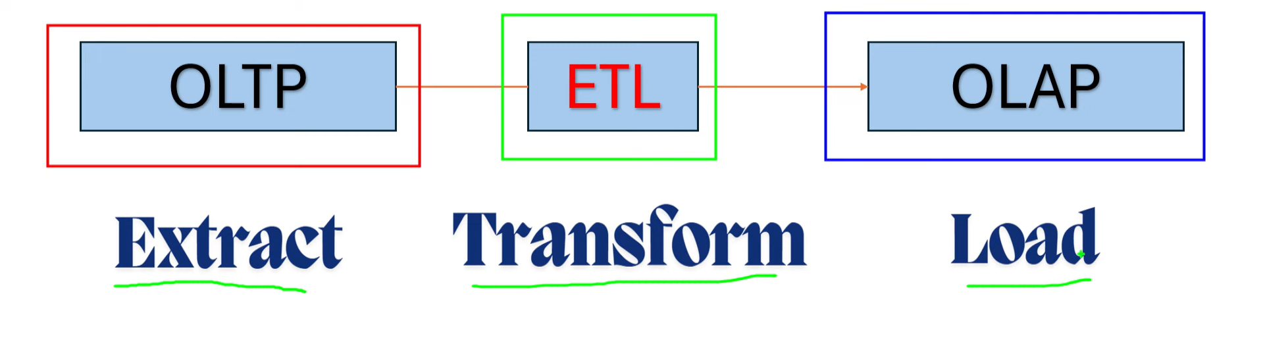

- Do this 3 operation through pipelines, we don’t wanna convert OLTP to OLAP manually every time.
DATA WAREHOUSE AND LAYERS –
There are two layers staging and Core
- In Staging Layer we just dump the data from OLTP data base so that we don’t have to apply query to OLTP databases which might slow that down.
- There are two types of staging Transient and Persistent. Transient is when after using the Data we just truncate it but in Persistent we preserve the history. Here we store the data and keep updating the history.
- In Core layer there is only Facts and Dimensions or Dimensional Data Model.
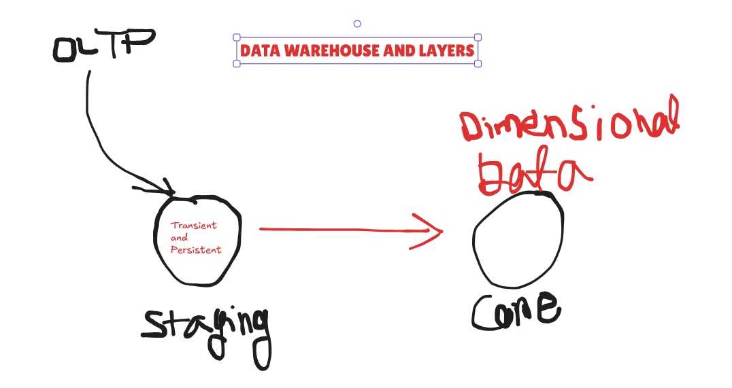
INCREMENTAL LOADING-
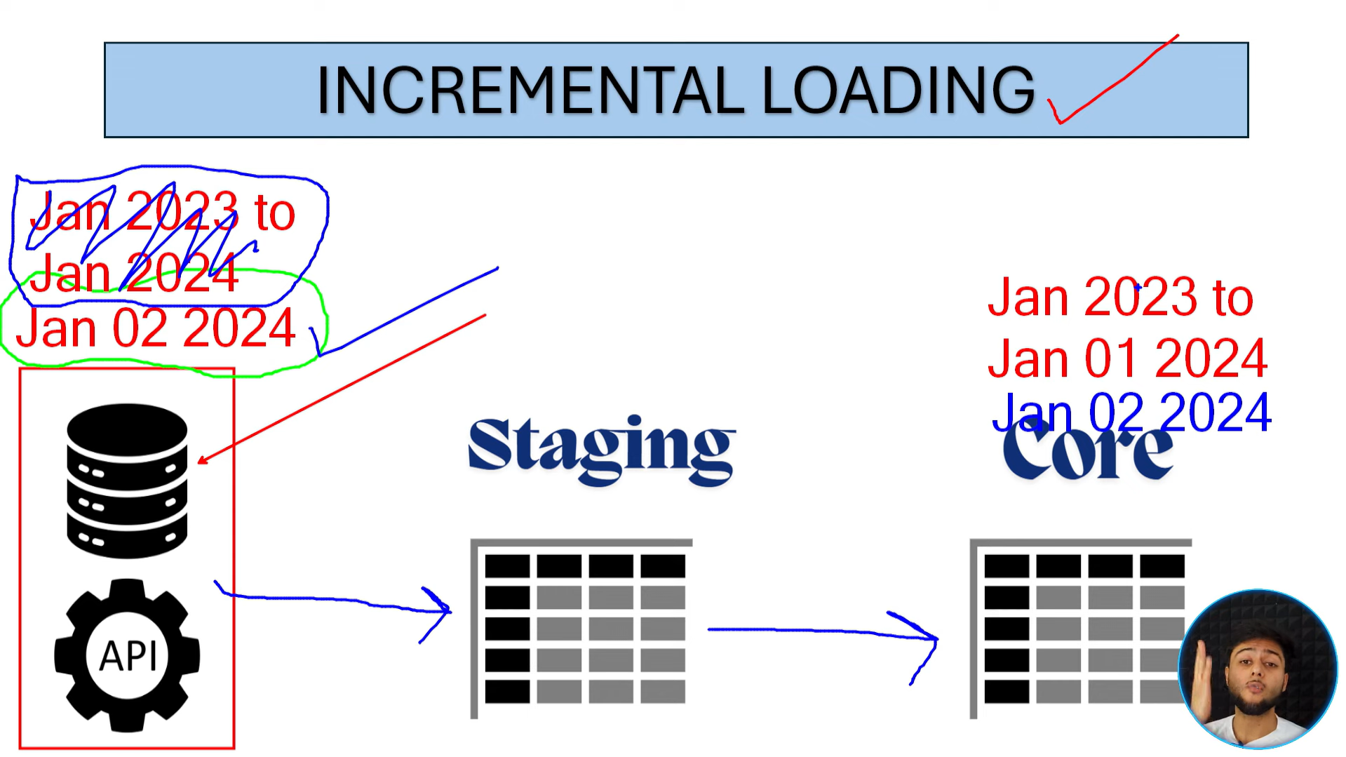
Instead of loading all the data from OLTP we only load the data that hasn’t already been loaded in the Staging or Core Layer. That way we don’t waste space or time by loading data that we already have this is called incremental loading.
DIMENSIONAL DATA MODELING –
In this modelling technique we just store data in the form of Facts and Dimension.
Dimensional Data Modeling is a way of designing databases for analytics (OLAP) so that data is:
- easy to understand
- fast to query
- perfect for reports & dashboards
Dimensional data modelling has two parts Facts Schema and Dimension Schema.
1. Fact Table
- Stores numbers / measurements
- Things you want to analyze
- Very large
Examples:
- sales_amount
- quantity_sold
- revenue
- clicks
2. Dimension Tables
- Stores descriptive information
- Used for filtering, grouping, slicing data
- Relatively small
Examples:
- time (date, month, year)
- product (name, category, brand)
- customer (age, city)
- location (country, region)
Star Schema ⭐ (most important)
- One fact table in the center
- Multiple dimension tables around it
- Looks like a star
Why it’s loved:
- Simple joins
- Fast queries
- Easy to explain to analysts
This is the default choice in most data warehouses.

Snowflake Schema ❄️
- Dimensions are further normalized
- More tables, more joins
Pros:
- Saves storage
Cons:
- Slower queries
- Harder to understand
Why not use OLTP-style modeling?
Because OLTP designs are for:
- avoiding redundancy
- frequent updates
Analytics needs:
- speed
- clarity
- aggregations
Dimensional modeling sacrifices purity for performance and sanity.
How dimensional data modeling makes OLAP fast (bullet points)
- Fewer joins → one fact table + few dimensions
- Denormalized dimensions → no join chains
- Fact tables store only numeric, aggregatable data
- Clear fact vs dimension separation
- Optimized for GROUP BY, SUM, COUNT
- Append-only loads → no locking issues
- Predictable query patterns → better query planning
- Works perfectly with columnar storage
- Easy partitioning (usually by date)
- Business-friendly structure → simpler SQL, fewer mistakes
SLOWLY CHANGING DIMENSIONS –
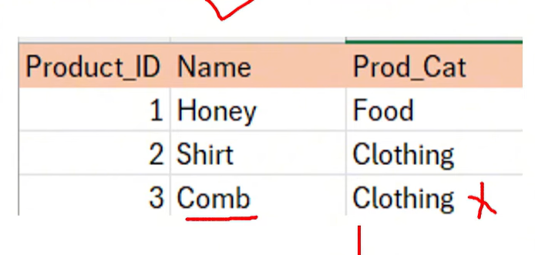
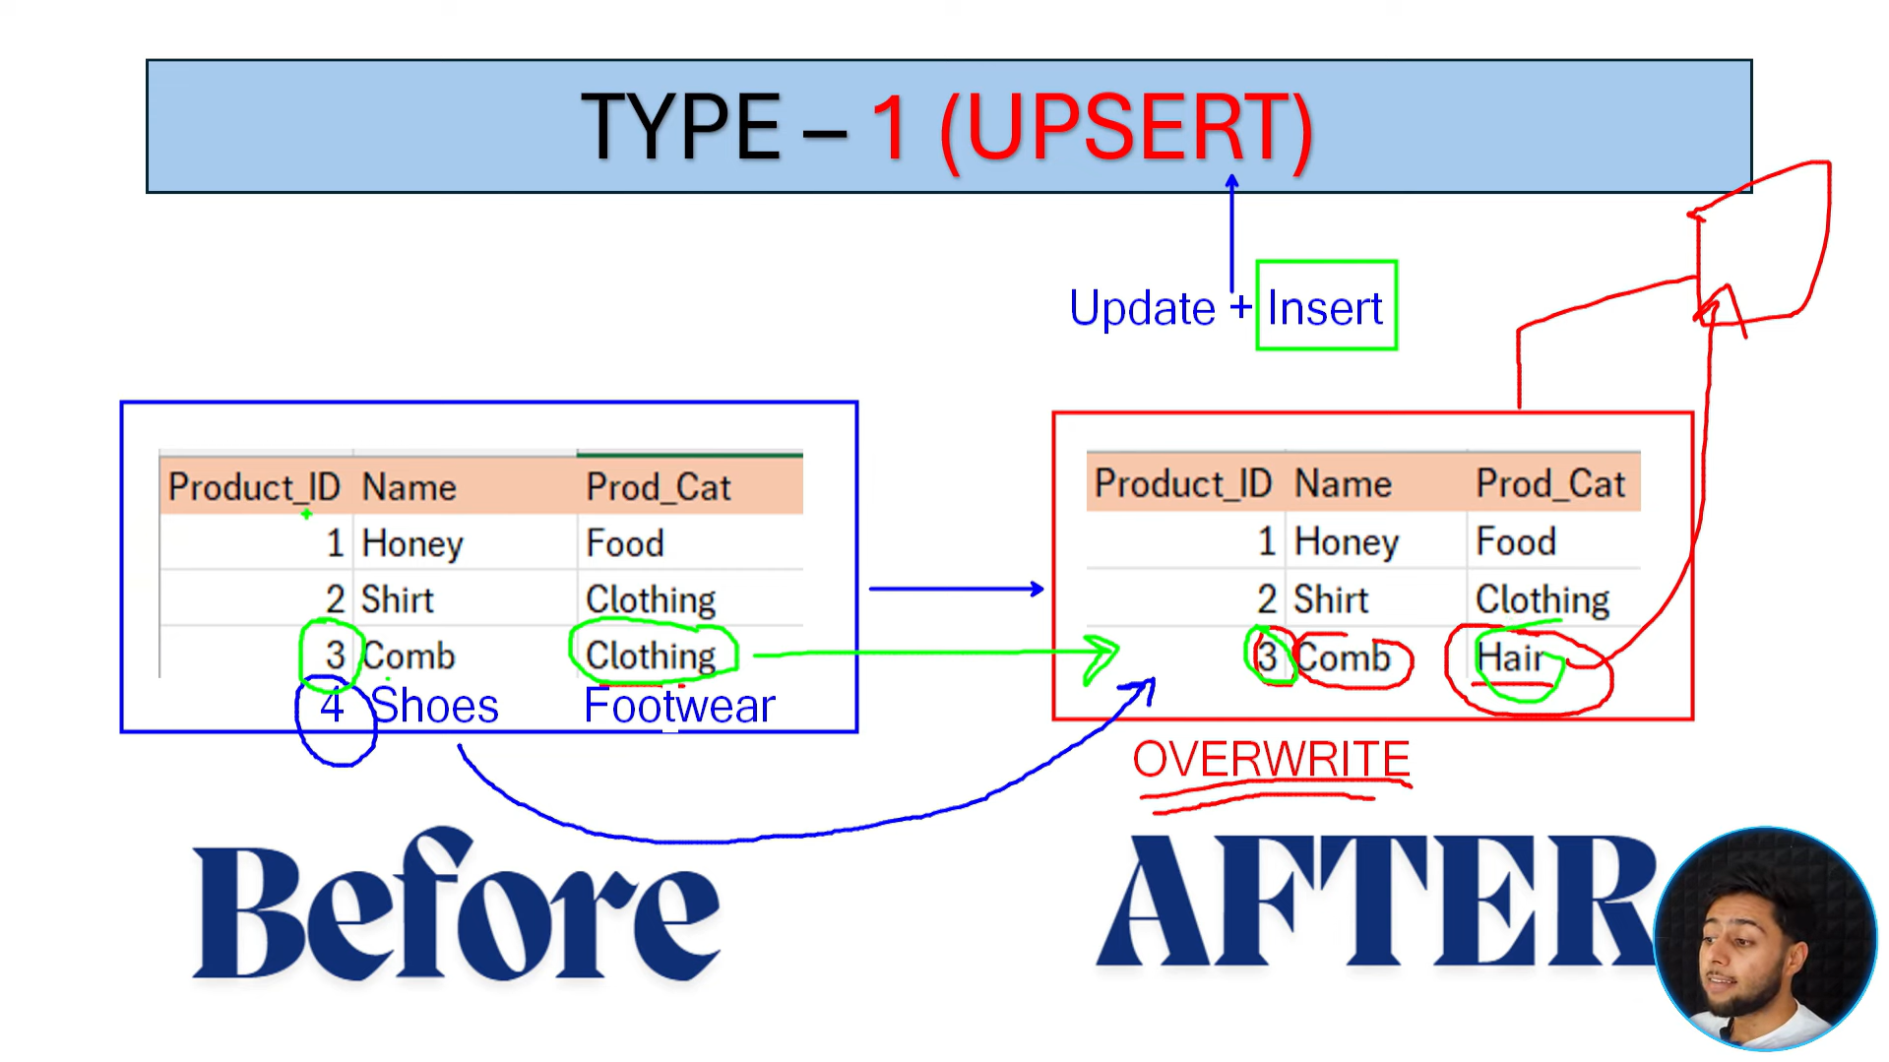 Type-1 does update as well as insert that’s why ‘UPSERT’ is used. It updates row 1,2,3 and insert row 4. Look that even there is no change in row 1 and 2 still those two row will be updated. But it doesn’t keep the history that the comb was previously a clothing updating through type 1 that history wont be kept.
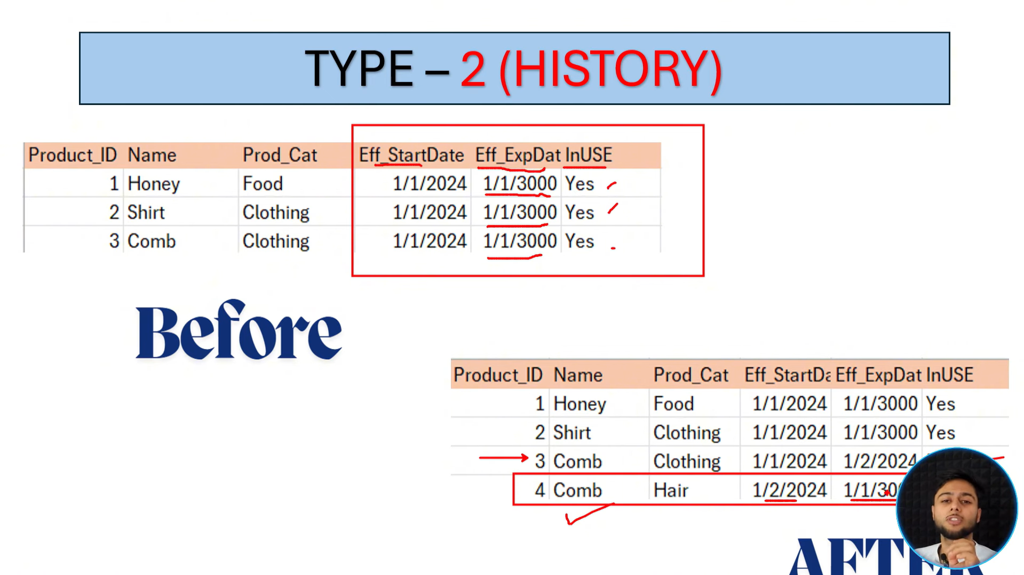 Type -2 we keep two new column and when new update is made only a row is inserted and old value is made expired with inuse as – NO. Type -2 keeps the old history as well as updates by inserting.
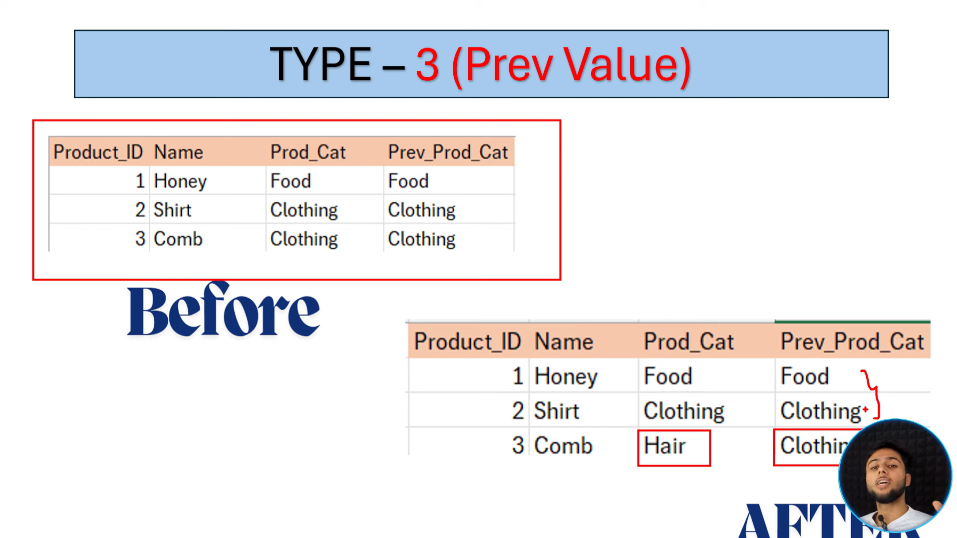 Type-3 is kind of same as 2 it is also used to store the previous values. But instead of using dates and inuse we just store the previous values in a column.
DATA LAKE-
Data warehouse only takes structured data like in relational table format.
Data lake also works with semi structured or unstructured data.
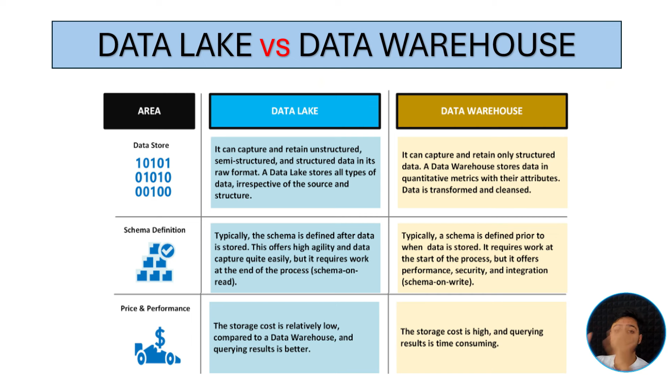
DATA LAKEHOUSE –
A data lakehouse is an architecture that combines the low-cost storage of data lakes with the reliability, performance, and structure of data warehouses.
A data lakehouse is basically the best of both worlds:
- Data Lake → cheap storage, raw data, flexible
- Data Warehouse → fast queries, structure, reliability
- What a Lakehouse gives you
- ✔ Stores raw + processed data in one place
✔ SQL-friendly (analysts are happy)
✔ ACID transactions (no broken tables)
✔ Works for BI + ML + streaming
✔ Much cheaper than classic warehouses
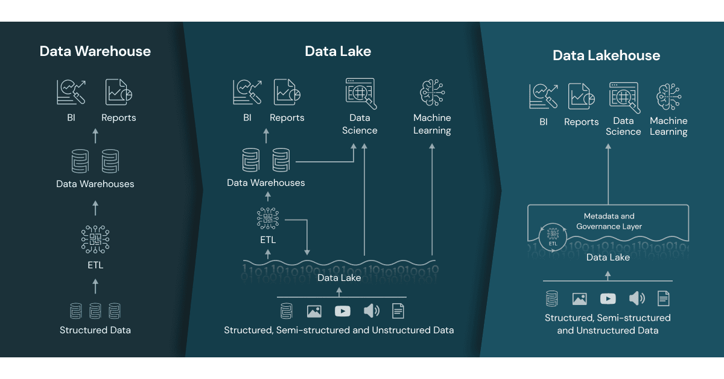
COLUMN BASED AND ROW BASED FILE FORMATS-
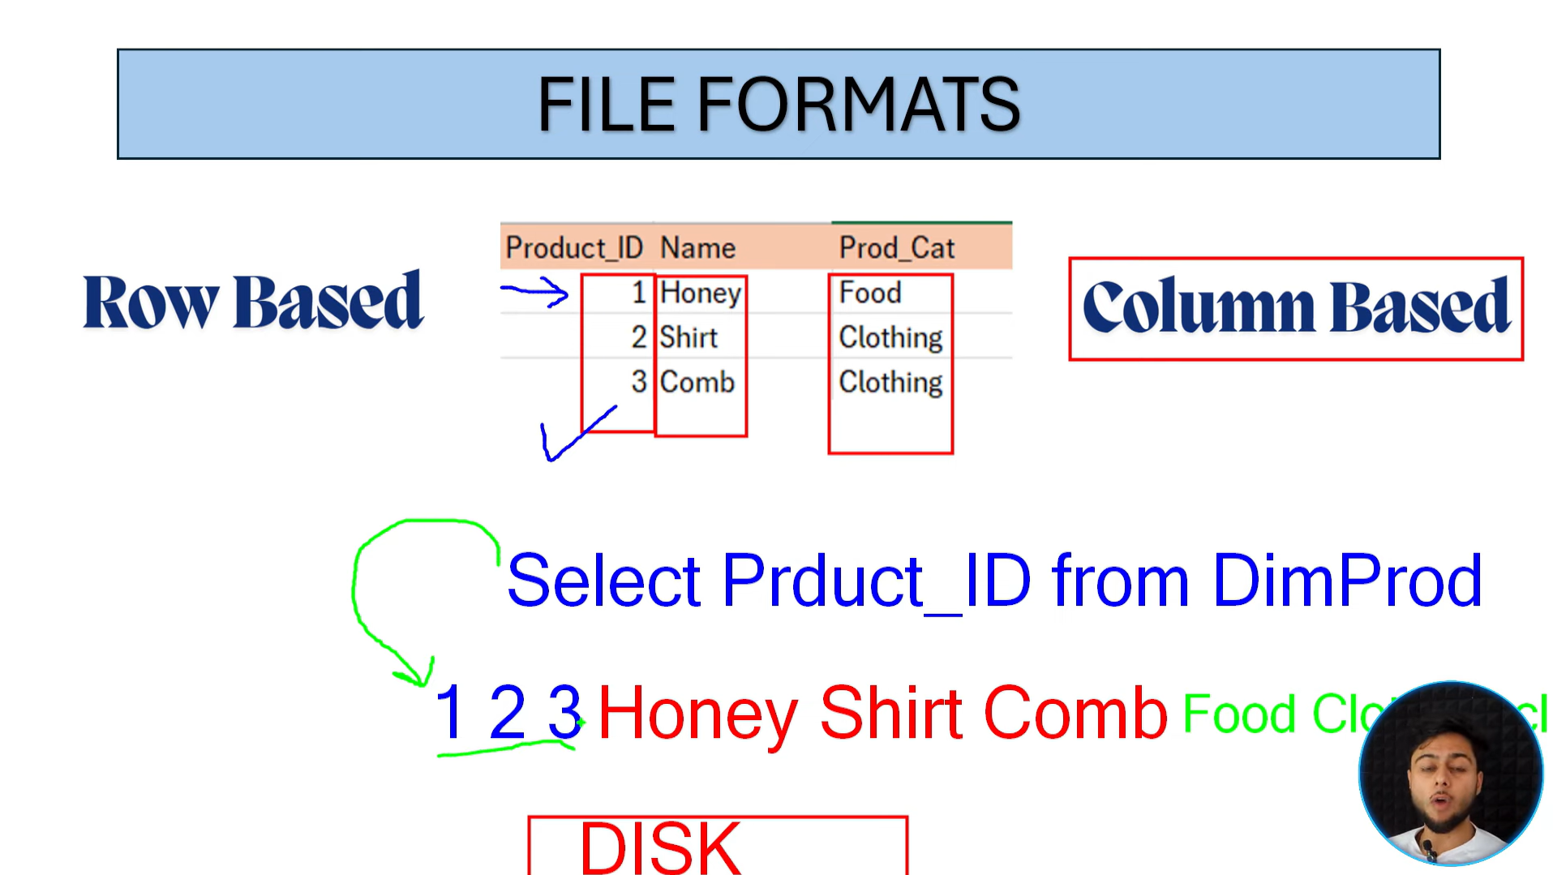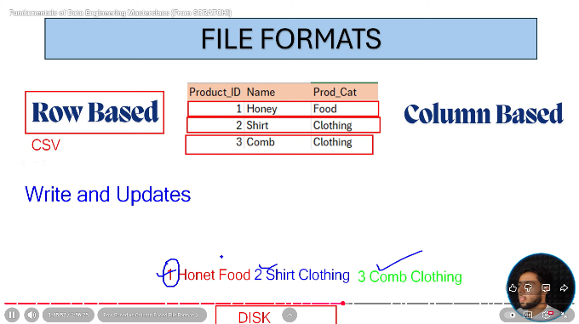
Column based is good for querying since we can directly access the value in column base( PARQUET ), in row base its easier to enter because we just enter one after another. So its easier to write but query is messy. Row base( SQL, POSTGRES) is easier to write in cause we can just write one after another we don’t need to group by characteristics.
Column base
ID column → [1, 2]
Product column → [Honey, Shampoo]
Category column → [Food, Hair]
Key difference (one glance)
- Row-based → good for single record access
- Column-based → good for analytics & aggregation
Example:
- SELECT * WHERE id = 1 → row-based 🚀
- SELECT COUNT(*) WHERE category='Food' → column-based 🚀
DELTA FORMAT –
Parquet file (by itself)
- Just a columnar storage format
- Stores data only
- ❌ No transaction history
- ❌ No ACID guarantees
- ❌ No idea who changed what, when
Parquet is like a notebook with pages, but no diary of edits.

🟦 Delta Lake = Parquet + Transaction Log
Delta Lake still stores data as Parquet files, but adds:
📁 _delta_log/ folder
This is the brain of Delta. Which stores the log of changes which helps to maintain ACID properties used for Rollback purpose.
When delta format is used on top of data lake its really hard to separate its behiviour to traditional databases.
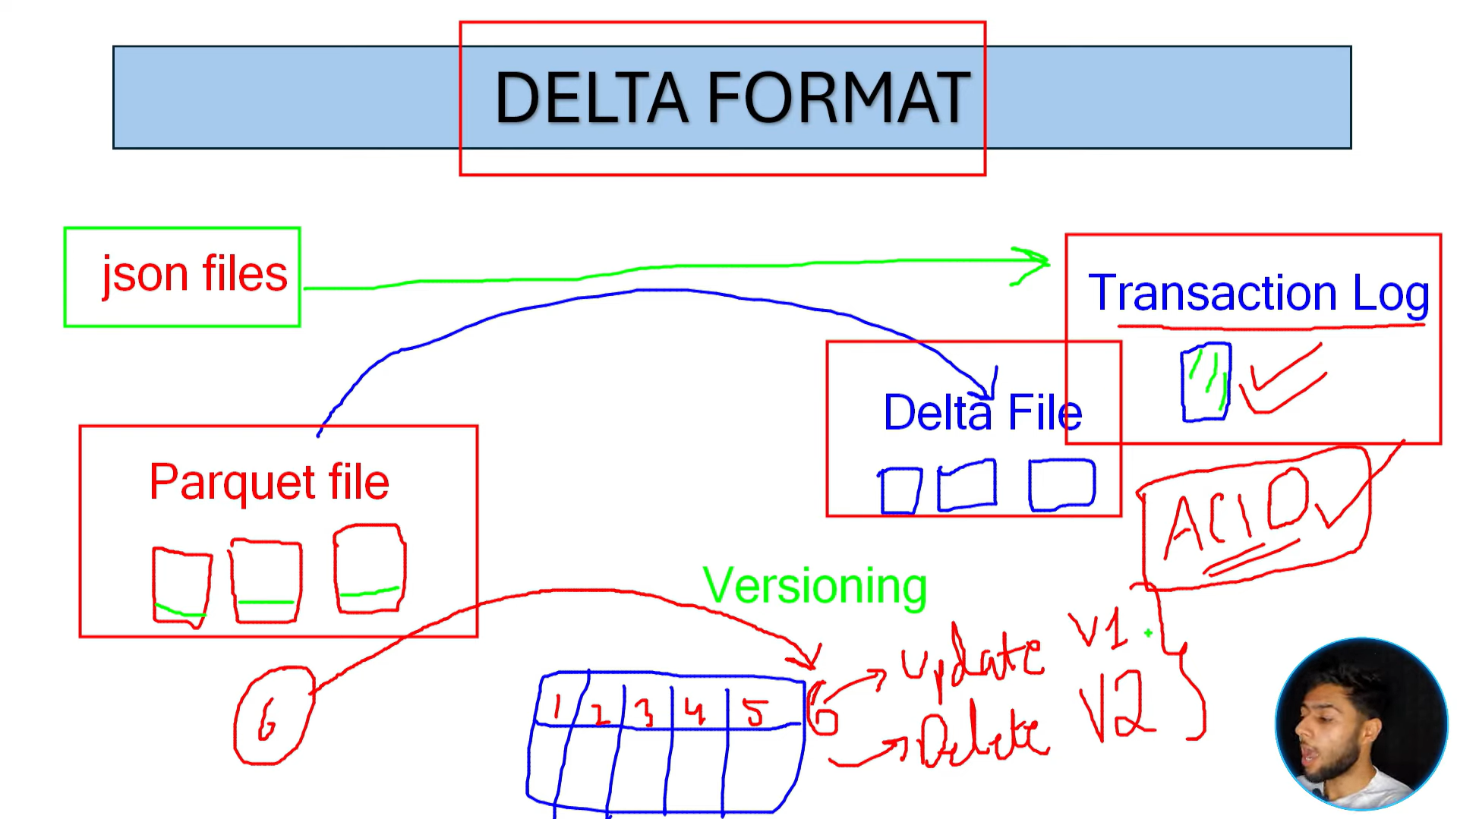
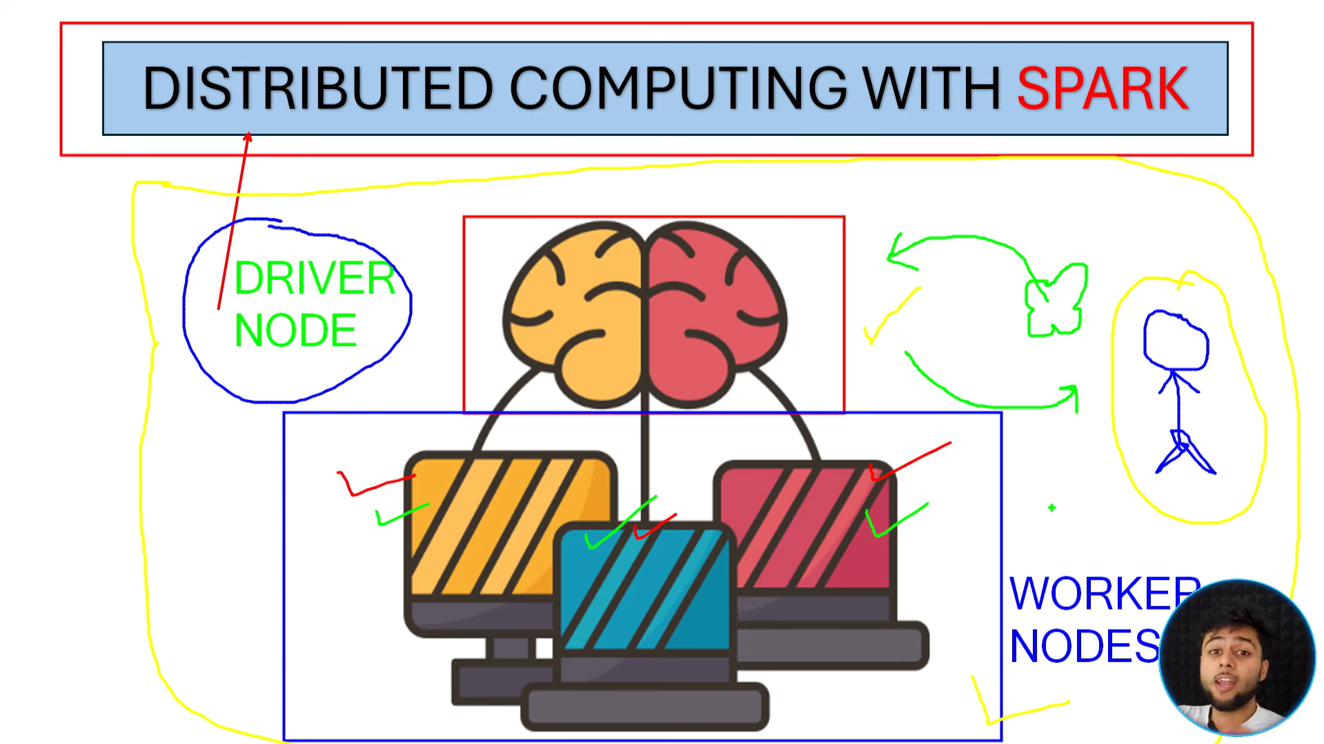 Distributed computing contains a cluster of computer and there is one driver node and multiple worker node. When an engineer submits a job, the driver node divides the job into tasks and distributes those tasks to the worker nodes for parallel execution.
What Spark specifically handles
✔ Task scheduling
✔ Fault tolerance (re-run failed tasks)
✔ In-memory computation
✔ Data shuffling
✔ Lazy evaluation
✔ Optimization (Catalyst + Tungsten)
Without Spark, you’d have to manage all this manually
- POWER BI is a data reporting tool which takes data from olap and transforms into reports.
Medallion Architecture-
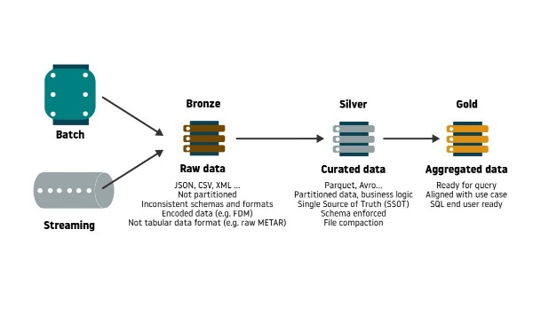
🥉 Bronze Layer — Raw data
What it contains:
- Raw, ingested data
- Logs, CSV, JSON, streaming data
- No major cleaning
Purpose:
- Data ingestion
- Full data history (audit & replay)
🥈 Silver Layer — Cleaned & structured
What happens here:
- Remove duplicates
- Fix data types
- Handle nulls
- Apply basic business rules
- Join related tables
Purpose:
- Reliable data for analysis
- Structured & consistent datasets
🥇 Gold Layer — Business-ready
What it contains:
- Aggregated data
- KPIs, metrics
- Data for dashboards & reports
Purpose:
- BI tools
- Decision making
- Fast queries

