insert into Employee values(newid(), 'Margus', 'Pole')

insert into Employee values(newid(), 'Kuido', 'Beibut')

insert into Employee values(newid(), 'Gustav', 'Nimits')

insert into Employee values(newid(), 'Taavi', 'Mittemees')

insert into Employee values(newid(), 'Gerta', 'Nägus')

insert into Employee values(newid(), 'Maria', 'Liis')

insert into Employee values(newid(), 'Alex', 'Niismiis')

insert into Employee values(newid(), 'Mathias', 'Must')

insert into Employee values(newid(), 'Ubundu', 'Quuy')

insert into Employee values(newid(), 'Kersti', 'Roos')

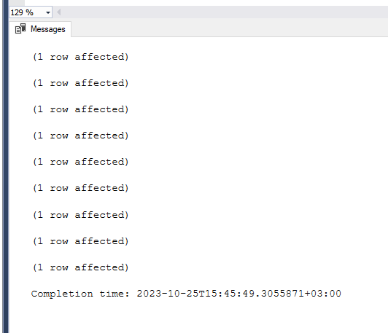

insert into Specialists values(NEWID())

insert into Specialists values(NEWID())

insert into Specialists values(NEWID())

insert into Specialists values(NEWID())

insert into Specialists values(NEWID())

insert into Specialists values(NEWID())

insert into Specialists values(NEWID())

insert into Specialists values(NEWID())

insert into Specialists values(NEWID())

insert into Specialists values(NEWID())

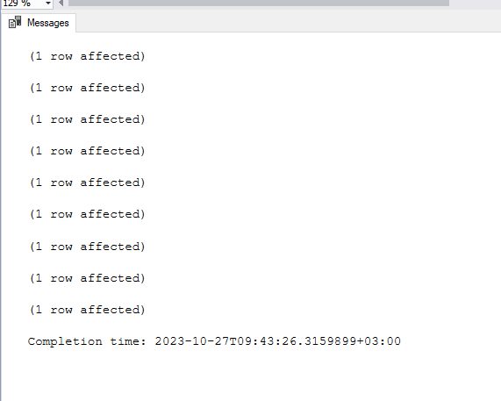

insert into Projects (ProjectID, UniqueProjectnr, SpecialistId) values(NEWID(), 333, 'C7BA6E2F-C58B-4F7C-8567-04A5B00C73BD')

insert into Projects (ProjectID, UniqueProjectnr, SpecialistId) values(NEWID(), 211, 'E412045D-53AD-428E-B807-13585588C35D')

insert into Projects (ProjectID, UniqueProjectnr, SpecialistId) values(NEWID(), 421, '86B8961C-EA30-48E4-8E0E-1E71EF3E4276')

insert into Projects (ProjectID, UniqueProjectnr, SpecialistId) values(NEWID(), 411, '508DFB9C-E006-48EE-A392-24EF346EBCC4')

insert into Projects (ProjectID, UniqueProjectnr, SpecialistId) values(NEWID(), 565, '15872137-85BA-4137-B17F-72DAA972228F')

insert into Projects (ProjectID, UniqueProjectnr, SpecialistId) values(NEWID(), 777, '206C0BED-F8C7-428E-BAF6-7606683C5642')

insert into Projects (ProjectID, UniqueProjectnr, SpecialistId) values(NEWID(), 442, 'E136F436-93D2-41CC-A3EB-76068C1CF080')

insert into Projects (ProjectID, UniqueProjectnr, SpecialistId) values(NEWID(), 774, '1594A3F7-24ED-4E92-8D80-A2DEB1B1886B')

insert into Projects (ProjectID, UniqueProjectnr, SpecialistId) values(NEWID(), 994, '5D1E271C-FB80-4C2F-A95E-BC04AFEE3C0C')

insert into Projects (ProjectID, UniqueProjectnr, SpecialistId) values(NEWID(), 115, '15EE121B-8E7F-46E5-AB19-CF9B12C91AFD')



Insert into ConstructionCompanies (Id, Name, Address, ProjectID) values(NEWID(), 'Unga', 'Muuliku tee 5', 'DB13C0DA-5D2A-42A6-8470-20A2E6AEA33D')

Insert into ConstructionCompanies (Id, Name, Address, ProjectID) values(NEWID(), 'Tululu', 'Postra tee 111', '3BF2924F-E9A4-4C48-BD82-22A41A185AB3')

Insert into ConstructionCompanies (Id, Name, Address, ProjectID) values(NEWID(), 'Xium', 'Banansi tee 1', 'B6E93521-6140-42FB-919C-2DFFF1F8BE56')

Insert into ConstructionCompanies (Id, Name, Address, ProjectID) values(NEWID(), 'Nuhmu', 'Kannu tee 23', 'F0F6C5F7-5F22-4EE0-BC74-61C515D65849')

Insert into ConstructionCompanies (Id, Name, Address, ProjectID) values(NEWID(), 'Pagar', 'Tuule tee 7', 'A2A47B65-8EEF-4F66-A405-8907552F650C')

Insert into ConstructionCompanies (Id, Name, Address, ProjectID) values(NEWID(), 'Kooki', 'Kanuhni tee 432', 'BF1833C6-BE2E-47EF-88CF-9A659325EA43')

Insert into ConstructionCompanies (Id, Name, Address, ProjectID) values(NEWID(), 'Apple', 'Manna tee 123', '17A97B16-C9E9-418F-BC50-BAF61CEFDE92')

Insert into ConstructionCompanies (Id, Name, Address, ProjectID) values(NEWID(), 'Pooliku', 'Apelsiini tee 56', '78411837-5C0B-4197-862C-C3B0E1E8C30F')

Insert into ConstructionCompanies (Id, Name, Address, ProjectID) values(NEWID(), 'Quix', 'Vabaduse tee 8', 'DA9963DF-F03B-4FC9-AB0D-D96B2ADF1517')

Insert into ConstructionCompanies (Id, Name, Address, ProjectID) values(NEWID(), 'Juhva', 'Kure tee 76', '80980F3D-7260-4CEE-AE36-E9A052B02A3D')

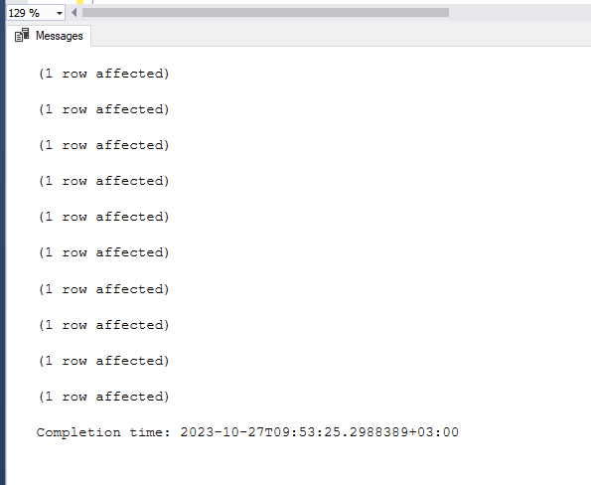

select \* from ConstructionCompanies

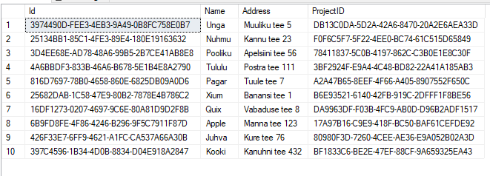

select \* from Specialists

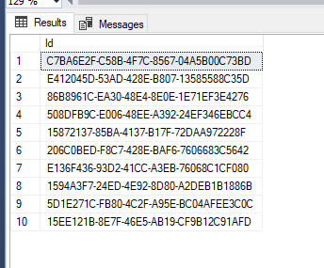

select \* from Employee

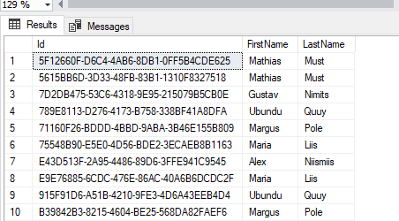

select \* from Projects

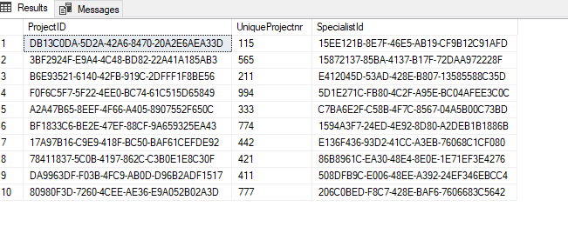

CREATE PROCEDURE GetConstructionCompanyByProjectID

@ProjectID uniqueidentifier

AS

BEGIN

SELECT cc.Name, cc.Address

FROM ConstructionCompanies cc

WHERE cc.ProjectID = @ProjectID;

END;

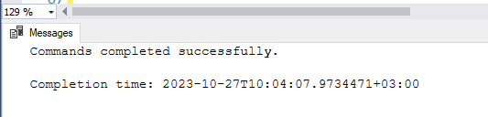

exec GetConstructionCompanyByProjectID 'DB13C0DA-5D2A-42A6-8470-20A2E6AEA33D'

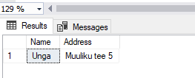

SELECT cc.Name, cc.Address, p.ProjectID

FROM ConstructionCompanies cc

INNER JOIN Projects p ON cc.ProjectID = p.ProjectID;

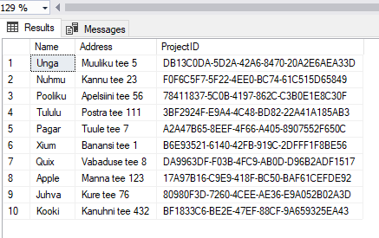

SELECT cc.Name, cc.Address, e.FirstName

FROM ConstructionCompanies cc

LEFT JOIN Employee e ON cc.Id = e.Id;

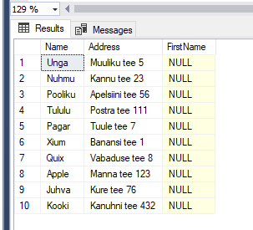

SELECT p.UniqueProjectnr, s.Id

FROM Projects p

FULL OUTER JOIN Specialists s ON p.SpecialistID = s.Id;

