**Project Report on Website Development**

**HOW CAN WE ADD LIVE SEARCH MODULE IN OUR OPENCART?**

* Get the extension of live search in the attached.
* Now go to the opencart and then go to Extensions/installer.

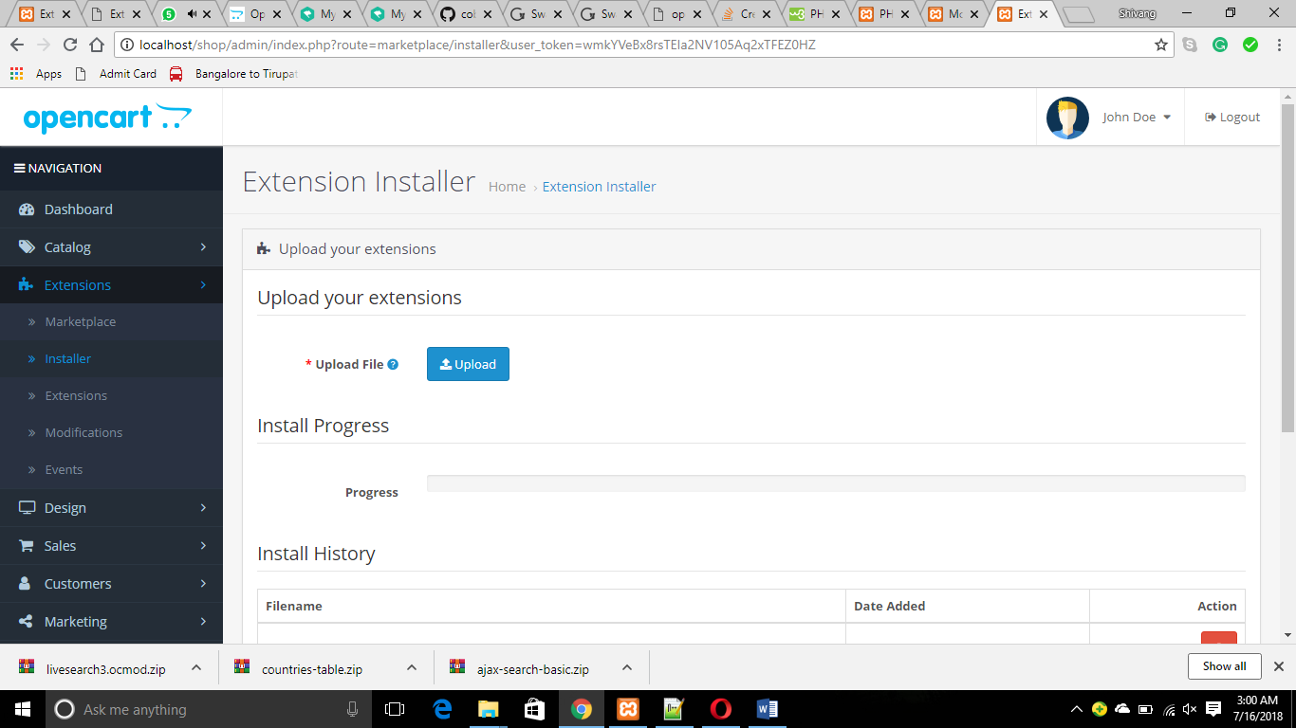

* Upload the zip file here.
* Now go to Extensions/Extensions/Modules.

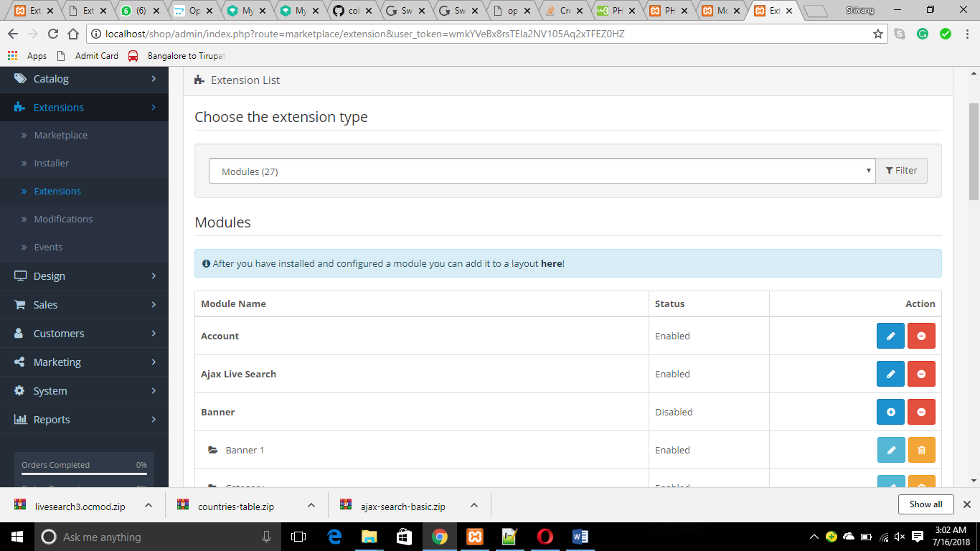

* Here you can find Ajax Live Search
* Click on ‘+’ sign and edit it.
* Enable all the functions which are disable.
* Now go to modifications and check that our extension is installed successfully.

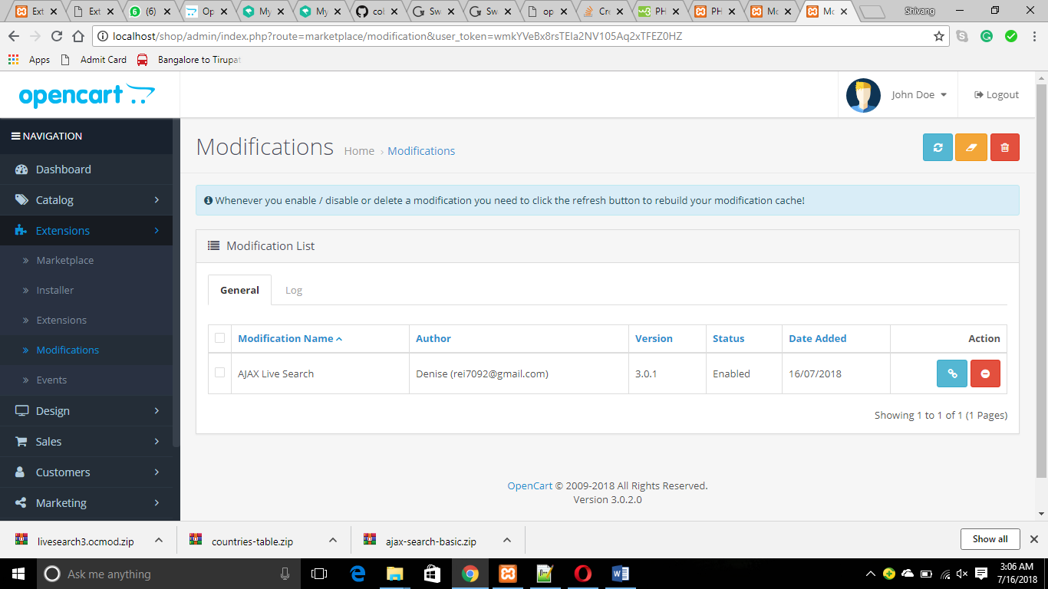

* Now go to the site and check the changes.

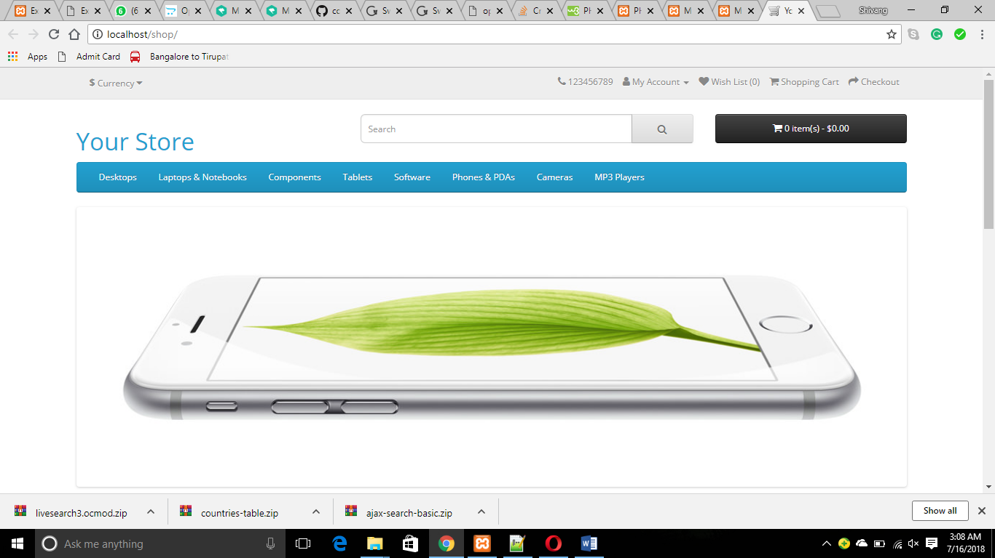

* Now search for anything in the search text field.

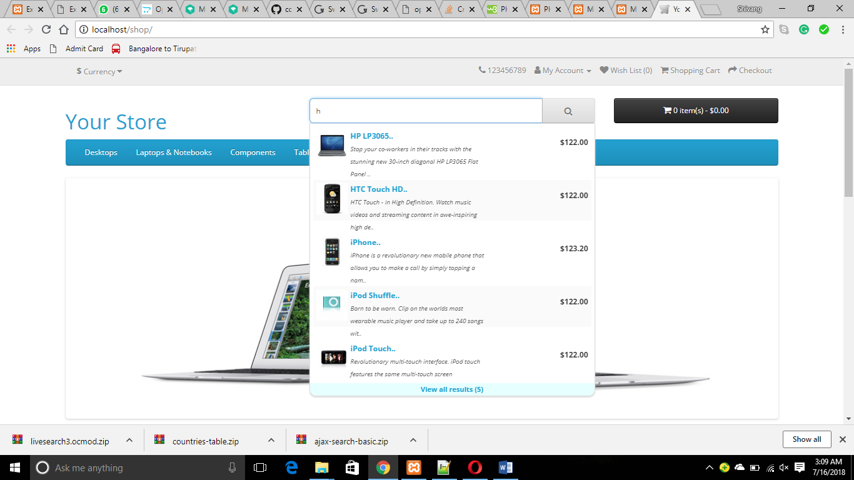

* Now we can see in the screenshot, we get the live search and working well.