**Neurawall**

|  |
| --- |
|  |

**By:**

**Muhammad Ubaid Ullah**

**32602**

**Umar Abdullah**

**33073**

**Hamza Gulzar**

**31621**

**Supervised by:**

**Mr. Osama Raza**

**Mr. Awais Nawaz**

**Faculty of Computing**

**Riphah International University, Islamabad**

**Fall 2024**

**Submitted To**

**Faculty of Computing,**

**Riphah International University, Islamabad**

**As a Partial Fulfillment of the Requirement for the Award of the Degree of**

**Bachelors of Science in Cyber Security**

**Faculty of Computing**

**Riphah International University, Islamabad**

**Final Approval**

This is to certify that we have read the Report submitted by ***Muhammad Ubaid Ullah (32602), Umar Abdullah (33073),*** *and* ***Hamza Gulzar (31621),*** for the partial fulfillment of the requirements for the degree of the Bachelor of Science in Cyber Security (BS CYS). It is our judgment that this Report is of sufficient standard to warrant its acceptance by Riphah International University, Islamabad for the degree of Bachelor of Science in Cyber Security (BS CYS).

**Committee:**

|  |  |
| --- | --- |
| **1** | Mr. Osama Raza  (Supervisor) |
| **2** | Mr. Awais Nawaz  (Supervisor) |
|  |  |
| **3** | Dr. Jawaid Iqbal  (Head of Department of Cyber Security) |

**Declaration**

We hereby declare that this document “**Neurawall**” neither as a whole nor as a part has been copied out from any source. It is further declared that we have done this project with the accompanied Report entirely on the basis of our personal efforts, under the proficient guidance of our teachers especially our supervisor **Mr. Osama Raza** and **Mr. Awais Nawaz**. If any part of the system is proved to be copied out from any source or found to be reproduction of any project from anywhere else, we shall stand by the consequences.

**___________________________**

**Muhammad Ubaid Ullah**

**32602**

**___________________________**

**Umar Abdullah**

**33073**

**___________________________**

**Hamza Gulzar**

**31621**

**Dedication**

We dedicate this work to our families, whose unwavering support, love, and encouragement have been our foundation to our parents, for their guidance, patience, and belief in our potential; to our friends, for their understanding and constant motivation; and to our mentors, who inspired us with their knowledge, insight, and dedication.

And this book is dedicated to all those who share the desire for knowledge, innovative spirit, and excellence. Together we look forward to making a meaningful difference and contributing to a better and more secure world.**Acknowledgement**

First of all we are obliged to Allah Almighty the Merciful, the Beneficent and the source of all knowledge, for granting us the courage and knowledge to complete this project.

[Students will acknowledge here anyone who has helped in the project. It can include Supervisor(s), Teachers, Class mates, Friends and Family]

**___________________________**

**[Name of Student 1]**

**[SAP Id]**

**___________________________**

**[Name of Student 2]**

**[SAP Id]**

**___________________________**

**[Name of Student 3]**

**[SAP Id]**

**___________________________**

**[Name of Student 4]**

**[SAP Id]**

**___________________________**

**[Name of Student 5]**

**[SAP Id]**

**Abstract**

This project is a new approach to improve traditional firewalls by using artificial intelligence to improve network security and give the firewall the capability to detect real-time malicious traffic and integrate with VPN and wazuh for secure communication for enhanced security and use wazuh for real-time alert generation and mitigation. Traditional firewalls rely on a rule-based approach to detect and mitigate known attack patterns or signatures which makes traditional firewalls reactive and not proactive. This allows the firewall to detect and block malicious traffic in real-time. The VPN provides a secure communication channel for enhanced security and the wazuh allows real-time logging and alerting functionality. This project showcases how AI can be integrated with network security to enhance threat detection and sets a new standard for network security.

Table of Contents

Chapter 1: 2

1.1 Introduction 2

1.2 Opportunity & Stakeholders 3

1.3 Motivations and Challenges 4

1.3.1 Motivation 4

1.3.2 Challenges 5

1.4 Significance of Study 7

1.5 Goals and Objectives 8

1.6 Scope of the Project 8

1.7 Chapter Summary 9

Chapter 2: 11

2.1 Introduction 11

2.2 Technologies & Products Overview 11

2..1 Traditional Firewalls 11

2..2 Artificial Intelligence in Cyber Security 11

2..3 AI-Powered Firewall Solution 12

2.3 Research Gaps 12

2.4 Problem Statement 13

2.5 Chapter Summary 13

Chapter 3: 15

3.1 Introduction 15

3.2 System Architecture 15

3.3 Functional Requirements 16

3.4 Non-Functional Requirements 17

3.5 Design Diagrams 18

3.6 Hardware and Software Requirements 20

3.7 Threat Scenarios (Threat Handling) 21

3.8 Threat Modeling Techniques 21

3.9 Threat Resistance Model 22

3.10 Chapter Summary 22

Chapter 4: 24

4.1 Introduction 24

4.2 Proposed Model 24

4.3 Data Collection 25

4.4 Data Pre-Processing 25

4.5 Tools and Techniques 26

4.6 Evaluation Metrics 27

4.7 Chapter Summary 27

**List of Figures**

|  |  |
| --- | --- |
| 3.1 Use Case Diagram | 18 |
| 3.2 Data Flow Diagram | 19 |
| 3.3 Sequence Diagram | 19 |
| 3.4 Architecture Diagram | 20 |

Chapter 1:

Introduction

# Chapter 1:

## Introduction

Cyber threats are becoming more and more advanced, and traditional firewalls that work on a rule-based approach cannot keep up with the advancing threats. This dependency on rules makes it difficult for the traditional firewall to detect new threats and can easily bypass the firewall. This advancing threat landscape requires a new and modern approach that can detect these new threats to overcome the issues of a rule-based approach. This project introduces an AI-driven approach to provide improved threat detection and improve the overall network security of a system.

Through a function of network traffic pattern analysis and abnormality detection that implies malicious behavior, the AI-based firewall solution aims to provide a robust yet flexible solution set that adapts itself to live and future threats. The AI model uses the ability to independently classify safe and dangerous traffic, thus automating the threat detection and response processes. There is a VPN Integration Module, meaning safe data transfer, an AI Traffic Analysis Module to monitor unencrypted network traffic in real-time, and a Wazuh Integration for recording irregularities and making real-time alerts. By combining these modules, they offer a holistic approach to network defense that can protect against various kinds of attacks with zero human intervention.

This project focuses on unencrypted communication to achieve low latency and high processing rates, which are essential for detection as well as prevention in real time. It trains a machine learning model with a log dataset to learn from past events to refine its detections over time. This firewall AI can evolve its content over the emergent patterns of the data trends concerning threat signatures. It improves security while reducing administrative burden for the cybersecurity staff. This is opposite to traditional firewalls, which are usually harder to set up and update rules manually.

## Opportunity & Stakeholders

The growing sophistication of cyber threats combined with their frequency poses a serious challenge, especially for businesses and individuals who utilize predominantly rule-based traditional firewalls that may have problems identifying new or fast-changing attack patterns. Traditional systems are less responsive to emerging threats to the extent that their static rules make possible security breaches. This would open the window for developing an AI firewall capable of using machine learning algorithms for the adaptive sensing of threats and adaptive response towards the threat sensed for the improvement of security. An intelligent firewall may complement the gaps found in traditional firewall technology by automatically incorporating real-time traffic monitoring and predictive threat identification.

One of the objectives of an AI-based firewall solution project is to provide a proactive defense solution that may identify hostile network traffic without depending on pre-defined rules. Instead of depending on traditional techniques, the AI-based traffic analysis within the system will adapt to novel or unexpected patterns used by attackers, thus providing better protection. Moreover, integration with Wazuh features to support real-time anomaly monitoring and alerting in addition to supporting VPN connections provides safe data transfer, enhancing the firewall's effectiveness and making it among the most appealing protection solutions for business organizations with rife cyber threats.

**Key stakeholders involved in the project**

The following are the significant stakeholders in the project:

**Cybersecurity Analysts:** It helps analysts respond to serious threats faster without having to sort through a lot of benign traffic data by using Wazuh integration, which monitors abnormalities and provides real-time alerts.

**Businesses and Organizations:** Businesses of all kinds rely on secure networks to store sensitive data. A firewall powered by AI helps keep the important data, hence assuring the integrity of data and business continuance.

**Compliance Officers:** The intelligent firewall solution can benefit organizations subject to high data security standards by automated detection and significantly lowering the potential of an unnoticed data breach, thus earning compliance standards.

Indeed, our AI-based firewall solution project would resonate with the cybersecurity needs of many stakeholders because it offers a solution that adapts to changing threat profiles and offloads the burden of manual network security oversight.

## Motivations and Challenges



### Motivation

The limitation of traditional rule-based firewalls in the highly dynamic cyber world today presents a driving force toward an AI-driven firewall. The traditional firewalls use predefined rules to identify and block the threat, which does not seem too effective in newly developed attack methods. Whereas, on the other hand, an AI-driven firewall solution provides a dynamic, learning-based approach to adapt itself against threats and patterns noticed in the network traffic flow. The ability to automatically recognize and respond to new assault signatures provides a far more flexible and robust defense.

Besides the above, cybersecurity experts have a lot of network traffic data in addition to the requirement of detecting threats in real time and defeating them. This project proposes making network defenses more proactive and efficient by saving labor, optimizing security processes, and speeding up detection using machine learning to recognize malicious activity. Another driving force behind this is the need for an intelligent system that would be scalable to different network sizes and could allow the management of complexity without regular manual updates. This AI-driven firewall solution will fulfill these needs and offer businesses a more autonomous and versatile security solution.

### Challenges

Although the advantages of an AI-driven firewall solution are innumerable, implementing it is quite challenging.

**The kind of traffic the network will be controlling:** The pattern of traffic is different depending on the applications used, the number of users, devices, and the reason behind the network, which could be corporate public or home network. Hence, unpredictability creates the need for a firewall solution to react to various forms of traffic, like online browsing, file sharing, email streaming, video, or VoIP. A one-size-fits-all approach will hardly suffice to distinguish benign from malicious communications.

**Impact:** A firewall that is insensitive to diverse network behaviors might either overblock legitimate traffic, hence causing service interruptions, or underblock malicious traffic, hence letting destructive data through. The firewall needs to be dynamic and learn the normal flow of traffic on a given network.

**Real-Time Processing:** Real-time management of traffic is an important issue for firewall systems. As the traffic moves constantly, the firewall must analyze each packet in real time to allow decisions on whether to accept or reject the packet. Delays of high magnitudes coming from the firewall may even affect the performance of the network or crash major applications dependent on the traffic.

**Impact:** High latency can lead to communication delay, slow communication, or even complete system failure. Very efficient algorithms that process a large amount of data in minimal time are required for real-time processing without introducing latency.

**Integration to Wazuh and VPN:** In addition, a firewall needs to integrate amicably with other aspects of security elements, such as Wazuh, for intrusion detection and monitoring, and VPNs for secure encrypted connections. Its integration will certainly provide a guarantee that the firewall operates under an all-inclusive security framework, which impacts positively on the effective monitoring of the devices and threat detection.

Wazuh and VPN integration with the firewall may be technically challenging. Firewalls cannot inspect the contents of encrypted VPN communications, nor can they inspect the contents of any packets. Likewise, making sure that Wazuh warnings and logs are impacted by firewall actions, like blocking the evil IP, increases the complexity of the system.

**False Positives:** A firewall may mistake legal traffic for malicious traffic. This can cause real business-stoppage problems, which may include the failure of legitimate users to access some services or applications.

**Impact:** High false-positive rates weaken the firewalls' potential because users or administrators will be annoyed by the rate of legitimate requests that are denied. Furthermore, this also boosts the workload for the security team, who will have to clear and respond to all false alarms.

**False Negatives:** The firewall fails to detect malicious traffic and allows it to pass through without interruption. This means that attacks will go undetected passing through the firewall, resulting in data leakage or other intrusions.

**Impact:** Concerning because false negatives compromise the security of the network. False positives are inconvenient because they cause interruptions in services or communication. True negatives are not threats to the system yet they expose the system to threats that the firewall does not detect.

**Shifting Baselines with Scaling Networks**: As networks increase in size, so also does the baseline of normal traffic. New devices, applications, and protocols constantly come online; hence, the firewall's evolving perception of what constitutes "normal" net traffic needs to adapt in order not to misclassify legitimate activity as hostile.

**Impact:** Failure of the firewall to evolve using new baselines means that potentially it might not correctly identify malice in its traffic and thereby elevate false positives or negatives. Some new legitimate patterns of traffic might be flagged down and listed as attacks since the firewall has not updated its understanding of the regular traffic baseline.

These issues mean that to design an efficient and reliable AI-based firewall solution for a real scenario, tests, optimizations, and development must be performed in depth. Since all the above challenges were also overcome by the firewall, it can provide robust highly intelligent adaptive defense systems against Internet attacks.

## Significance of Study

A cybersecurity innovation is the artificial intelligence-driven firewall solution, which will help in healing a few of the most important flaws with traditional network defense systems. Traditional firewalls operate upon pre-defined rule sets. The ability of such systems to resist advanced attacks, which are constantly modified to evade detection, is constrained by their reliance on static rules. An AI-based firewall solution can identify threats based on patterns that aren't categorized by static rules because it utilizes machine learning to identify dangerous patterns in network traffic. In contrast, traditional firewalls rely on patterns that are categorized using static rules.

This Report demonstrates a dynamic and adaptive security solution, one that learns with every input piece of data by tying together machine learning with firewall technology. Since the firewall is inherently capable of reacting to threats, without the need for frequent updates to the rule base, this adaptive feature not only enhances the current state of security but also reduces the burden on administrative security teams in the process.

The second part is Advanced Scalable Architecture, which advances cybersecurity by providing an architecture that can scale up or down depending on the network size and complexities. Enhanced firewall functionality with Wazuh functionality for real-time warnings and anomaly detection, and VPN to process traffic securely make this a robust and versatile solution for modern-day enterprises in addressing their needs. Thus, the Report demonstrates how AI-based solutions may provide much more proactive forms of defense mechanisms and hence, prove to be vital in the battle against new cyber threats.

## Goals and Objectives

The project aims to develop a machine learning-based AI-driven firewall solution that can dynamically classify and remove hazardous traffic. It is thus meant to significantly strengthen network security. The novelty of this firewall is based on getting rid of the prerequisite of static rule sets hence providing a more flexible detecting manner of threats. Some of the goals include:

**Implementation of AI-Based Data Analysis:** Develop and deploy an AI model capable of showing network traffic in real-time which would reveal trends such as abnormal patterns of behavior indicating harmful intent.

**Real-Time Threat Response Integration:** Avoid latency associated with threat responses by ensuring the firewall can accept or decline traffic with low latency according to the predictions provided by the AI model.

**Use a VPN to Process Data Securely:** To maintain privacy and integrity with flows of traffic, add a VPN for secure data handling.

**Real-Time Alert and Anomaly Logging:** Wazuh can be used to generate alerts and log unusual events that will assist in monitoring them and responding more promptly to potential security breaches.

**Scale and Performance:** Scale the firewall architecture to accommodate various network sizes as well as performance demands while ensuring the ability to continue good operation across the possible operating settings.

## Scope of the Project

This project is intended to design an AI-enabled firewall, which can be programmed to analyze network data. Not relying on traditional rule-based techniques, this project is meant to develop an AI-driven approach that can automatically identify and delete any potential threats through insight from machine learning. The firewall will also feature integration with Wazuh for real-time anomaly monitoring and alerting. A VPN module will also be available for safe traffic management.

This plan will not make use of encrypted traffic inspection. The scope is only bounded for the analysis of unencrypted traffic. In addition, the logs dataset from the current generation of firewalls is used for the training of the AI model of the firewall. It is after this approach to ensure getting a high detection accuracy, that is bounded within the dataset. Although the system architecture is scalable, the current implementation is optimized for small- to medium-sized networks.

## Chapter Summary

This chapter, by introducing the project, allowed the possibility of an AI-based firewall solution as a more flexible security solution. We presented the motives behind such a strategy, like the inadequacy of rule-based firewalls and the need for a dynamic, data-driven solution. Identifying key stakeholders in such a project was demonstrated by showing possibly what this project may offer to compliance officers, enterprises, or even network security teams. This chapter also discussed the importance of the study to suggest how AI can be used in improving network security. Finally, we defined the scope of the project and set specific goals and objectives as a basis for laying a framework for technical developments and implementation covered in later chapters.

**Chapter 2:**

**Market Survey**

# Chapter 2:

**Market Survey**

## Introduction

Due to the increasing sophistication of cyber threats, attackers have been able to bypass traditional firewalls. For this reason, AI-powered systems recently hit the use for cybersecurity purposes. They are designed to improve detection capabilities and lessen dependencies on preset rules. AI-driven firewalls, by using ML for deep analysis of network traffic patterns, can detect emerging threats that would have gone unnoticed by traditional firewalls. This chapter, based on the gap in the research area, contrasts traditional techniques with AI-based ones, and products available in the market, current technology, and products concerned with AI-driven firewalls; it further describes the problem this project intends to solve.

## Technologies & Products Overview



### Traditional Firewalls

Traditional firewalls are very effective at countering known attacks because they use static rule-based filtering. They do not have the flexibility to handle new, unidentified attack patterns. According to numerous reports from studies, the maintenance overhead of traditional firewalls is high because they require updating quite frequently to adapt to changing threats. Furthermore, especially in complex network environments, these firewalls give rise to a very high number of false positives that can demoralize security personnel and therefore reduce the efficiency of responses as a whole.

### Artificial Intelligence in Cyber Security

AI has developed significantly in so many industries. Cyber security is one area where AI has gained tremendous growth. Pattern and anomaly-recognizing models can be developed for AI using machine learning approaches, especially supervised and unsupervised learning. It particularly finds excellent utility in detecting undefined rule-based threats. Most recent studies depict how precise and versatile the AI-driven systems are in the detection of dangers and prevention when compared to the traditional ones.

### AI-Powered Firewall Solution

This firewall solution is an enhancement to conventional firewalls in the sense that they learn automatically from data to identify dangerous patterns. As this solution does not rely on preset rules, they can detect new patterns of attacks which reduces the false positive rate. While many still retain some rule-based elements, many products available today have started making use of AI for enhanced security.

|  |  |  |
| --- | --- | --- |
| **Feature** | **Traditional Firewalls** | **AI-Driven Firewall Solution** |
| **Detection Method** | |  | | --- | |  |  |  | | --- | | Rule-based | | Pattern recognition using machine learning |
| **Adaptability** | |  | | --- | |  |  |  | | --- | | Limited (requires manual rule updates) | | High (learns from new data and evolves) |
| **False Positives** | High, especially in dynamic environments | Lower, due to continuous learning and adaptation |
| **Maintenance** | Low | Reduced need for manual updates |

AI-powered firewall solutions offer some advantages over traditional firewalls due to flexibility and the ability to identify unidentified threats, though they may consume more processing power and require higher-quality training data to achieve the best results in busy environments.

## Research Gaps

Although there is huge potential in AI-driven firewall solutions, many research gaps need to be met to make them widely used in the market. To begin with, real-time processing capabilities are indispensable for a firewall's success and are quite compromised in most current solutions. Next, the majority of AI-based security models train on a pretty small amount of data which they compromise when facing a variety of threats; larger datasets are required for more proper training of the models. Moreover, even though AI-based solutions decrease false positives considerably, it is not immune to them entirely; much research is required to discover the best approach to balance detection accuracy with false positives to be reduced. Lastly, the overwhelming majority of AI-driven firewalls currently available in the market still carry a component of rule-based filtering and those that are fully autonomous AI-driven remain an exception.

## Problem Statement

The problem that the current research aims to solve is the traditional firewall's incapability of sensing and responding to threats along with the unknown cyberspace. Traditional firewalls based on rule-set criteria are static, and they don't give effective detection for new attack patterns. This research project was aimed at establishing an AI Firewall that can detect malicious activities without static rule sets by learning from network traffic patterns. The objective is to design a proactive defense solution to modern network security challenges with high adaptability and real-time threat detection, coupled with low false positives.

## Chapter Summary

This chapter discussed the shortcomings of traditional firewalls, opportunities for AI in cyber defense, and the present market scenario of AI-based firewalls. It demonstrated, through comparison, the advantages of AI-based approaches such as flexibility and fewer false positives. There are many questions left unanswered that highlight the need for better real-time processing, more detailed training datasets, and completely autonomous solutions. To cap off the chapter, an issue statement that described the challenges that this project's AI-driven firewall solution would aim to solve laid out the context for a solution that will be described in detail later in the chapters.

**Chapter 3:**

**Requirements and System Design**

# Chapter 3:

**Market Survey**

## Introduction

In this chapter, we shall discuss the system requirements and design considerations of such a system. For instance, we shall report an AI-based firewall system whose learning is found within its architecture to achieve improved network security. Conventional firewalls focus on static rule-based detection methods that are usually too simplistic for detecting evolving threats. Hence, the system proposed here incorporates two AI models, in the sense that it operates on real-time traffic capture, feature extraction, and dynamic IP blocking; this therefore implies a flexible solution. We propose a thorough study of the system architecture, functional and non-functional requirements, and design diagrams. We will discuss threat scenarios and resistance models for the firewall to be more resilient against new and known cyber-attacks.

## System Architecture

The system architecture of the firewall is AI-based, which uses various modules in a cooperative way to catch, analyze, and respond to network traffic:

**VPN Module:** The module, on the front side, provides a secure communication tunnel, thereby ensuring that all traffic entering and exiting the network is encrypted before reaching the AI-based firewall system. This thus reduces the initial vulnerability that comes about due to external attackers and network traffic.

**Traffic Collect Module:** This module makes use of ***Dumpcap*** which captures the raw network traffic data in real-time from the network interface. ***Dumpcap*** is configured to run in promiscuous mode, thus enabling it to capture the traffic from all the network devices and thereby providing the full data for analysis.

**Feature Extraction:** ***CICFlowMeter*** aggregates raw traffic data and extracts relevant features such as packet count, flow length, source and destination ports, and other metadata. These flow-based properties are used as inputs to AI algorithms.

**AI models:** The architecture consists of two AI models:

**One-Class SVM Model:** This model is trained on only benign network traffic from the existing network environment and creates a behavioral baseline against which changes can be identified. The model detects traffic significantly deviating from any known benign behavior as a potential threat.

**Supervised Model:** This supervised model works on CIC IDS 2017 and 2018 data sets. It identifies known harmful patterns and attacks like DDoS brute force attacks and port scanning. The supervised model improves threat detection significantly from labeled past data.

**Wazuh Monitoring and Logging:** It is integrated to log and notify on observed abnormalities; the system monitors activity, giving real-time notifications when suspicious behavior is found, an aspect that brings much-needed context into incident response and auditing.

**Firewall Module:** It will dynamically blacklist IP addresses identified by AI models in combination with Windows Firewall. Whenever there is malicious traffic observed, it will put that IP address into the block list of the firewall so that subsequently, communication won't happen.

**GUI (Graphical User Interface):** The system uses a friendly GUI to present information in real-time, such as the blocked IP, malicious activity log, and system alarms. In addition, the administrators can simply evaluate the system's current status, including those threats that have been identified and actions performed.

## Functional Requirements

Functional requirements give the general functionality of AI-based firewall systems.

**Traffic collection:** Round-the-clock gathering of traffic on the network from all devices connected, that deliver a real-time stream of data for analysis.

**Feature extraction:** Making use of traffic collected, extract with precision relevant network properties to produce reliable input for AI models.

**Anomaly detection:** The one-class SVM model must create a consistent baseline of benign traffic and must recognize anomalies as potential threats.

**Threat Identification:** The supervised model should be able to identify labeled data with high accuracy so it identifies known threats, as well as trends towards malicious traffic, and hence, the system must block identified malicious IPs dynamically. In addition, it adds the related entries to the block list of the Windows Firewall without human intervention.

**Logging and Alerting:** Wazuh should log all suspicious occurrences and pass alert messages in real time to the network administrators so they can take appropriate steps at once.

**User Interface:** The user interface should be user-friendly. Clear visibility of blacklisted IP addresses along with real-time alarms through traffic logs for a complete view of system monitoring.

## Non-Functional Requirements

This system is ensured to gain criteria around performance, usefulness, and adaptability.

**Accuracy:** AI models must be very accurate to avoid false positives-cases of legal traffic labeled as harmful-and false negatives-malicious traffic that goes undetected.

**Real-time feature extraction:** Model analysis, and traffic capture with minimal delay must occur so that fast responses can be made to threats.

**Scalability:** It should be able to scale up the volume of traffic as well as network size without loss of performance.

**Reliability:** The system should reliably and consistently identify threats, even in conditions of high traffic.

**Usability:** The GUI must be easy to use, and have meaningful information such as blocked IP addresses, alarms, and logs, so that it does not require technical expertise for non-technical persons.

**Adaptability:** AI models are to be continuously updated with new datasets so that they continue to perform well despite the appearance of new dangers.

## Design Diagrams

The design diagrams reveal the interactions and data flow within the system.

The **Use Case Diagram** shows the interactions that the system may have with users on handling their tasks concerning viewing blacklisted IP addresses, being alarmed, and being logged in.

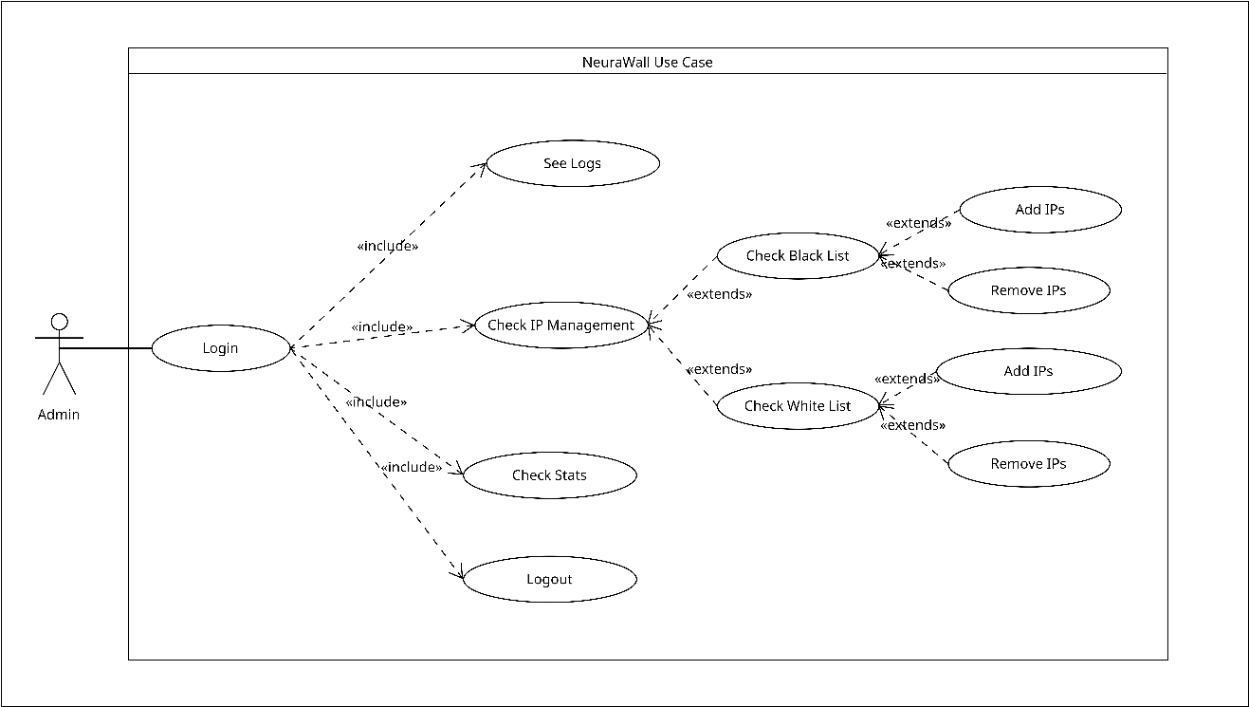

***3.1 Use Case Diagram***

This is depicted in the **Data Flow Diagram** shows data flow from initial capture of traffic from the network to feature extraction into the AI model processor and then on to firewall blocking.

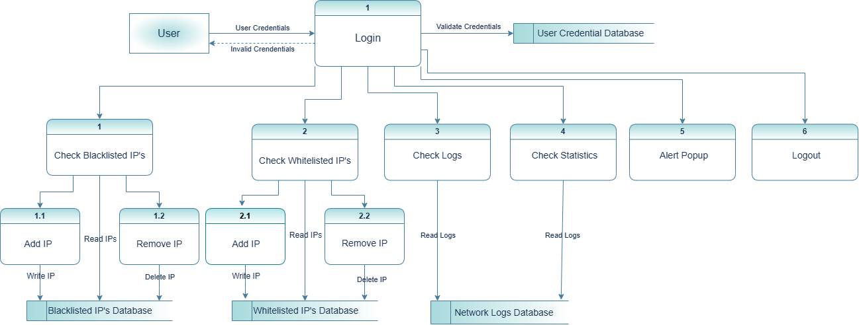

***3.2 Data Flow Diagram***

**Sequence Diagram:** This diagram shows the step-by-step process of how the process happens from gathering traffic, then analyzing features, making a model prediction, and updating the firewall.

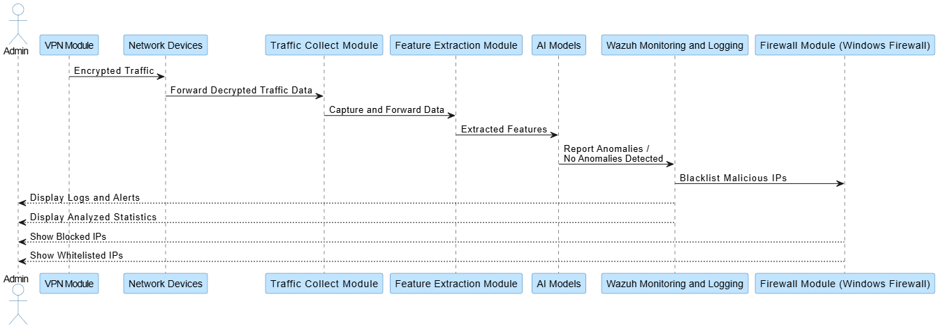

***3.3 Sequence Diagram***

**Architecture Diagram:** Comprehensive View of All Components, with VPN, Traffic Capture, AI Models, Wazuh, Firewall, and the Interconnecting Points among them.

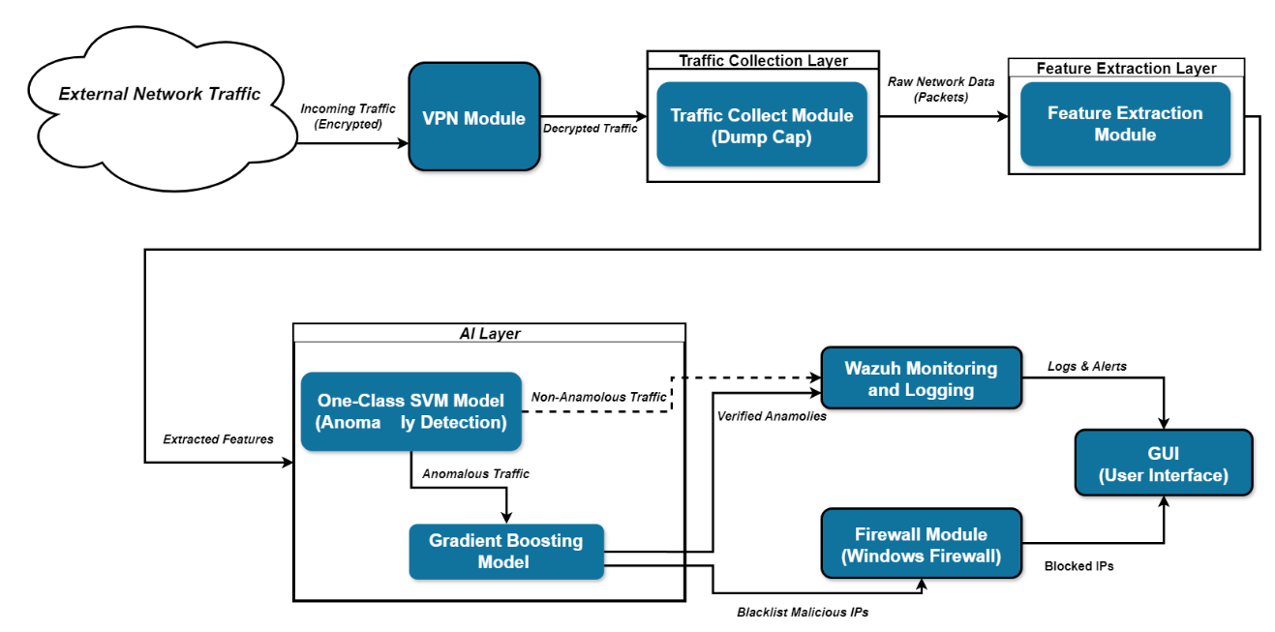

***3.4 Architecture Diagram***

## Hardware and Software Requirements

**Hardware Requirements:**

**CPU:** Multi-core processor: Intel i5 or higher, to handle data processing and parallel real-time analysis

**RAM:** At least 8GB to handle traffic and model processing

Storage: 256 GB SSD: for logs, datasets, and extracted traffic features

**Network Adapter**: It is the network card with the network adapter to enable the process of capturing traffic in promiscuous mode and monitoring it in all ways.

Required software:

Software Requirements:

**Operating System:**

* Windows OS to ensure compatibility with Windows Firewall.
* Programming language that supports machine learning frameworks and is integrated with CICFlowMeter.

**Tools:**

* It includes tools like ***Dumpcap*** to capture network data in real-time.
* ***CICFlowMeter*** can extract features from PCAP files.
* Monitoring and alerting through Wazuh.
* ***Windows Firewall*** to dynamically limit IP addresses.

## Threat Scenarios (Threat Handling)

All threat scenarios involve a type of attack and model or approach used to detect and prevent it.

* **Port scanning:** It is detected using a supervised model trained on CIC IDS data that recognizes features typical of a port scan, and flags all such IP addresses are blocked by the firewall.
* **DDoS attacks**: It detects DDoS attacks with a combination of Wazuh alerts of traffic spikes and also with the supervised algorithm for suspicious connection patterns. The algorithm then dynamically prohibits affected IP addresses.
* **Brute Force Attacks:** Identified based on an anomalous login pattern and detected by Wazuh logging as well as the supervised model. Those IP addresses, attempting brute force attacks multiple times, are blacklisted.
* **Network Probing:** It is identified by the One-Class SVM model, where IP addresses identified with atypical communication patterns are reported as possible probes.

## Threat Modeling Techniques

Such problems can be modeled and tackled with the help of the following strategies:

* **STRIDE:** This detects Spoofing, Tampering, Repudiation, Information Disclosure, Denial of Service, and Elevation of Privilege for every component for deep threat analysis.
* **Attack Trees:** Presently, it is of essence that there exists a map of potential attack vectors, detailing areas of weakness, and the possibility of risk mitigation solutions.
* **MITRE ATT&CK Framework:** Leverage widely known attack tactics/techniques from MITRE to further develop skills in model ability to identify particular types of adversary tactics.



## Threat Resistance Model

The threat resistance model describes the defenses for every threat scenario:

**Proactive Detection:** Using One-Class SVM and a supervised model, there would be early detection of known as well as new threats.

**Layered Defense:** Each layer-VPN, Wazuh, AI models, and Windows Firewall-will increase the defense and the likelihood of a successful attack being limited.

**Self-Adaptation:** It updates itself regularly with new samples of traffic and responds to developing risks.

**Real-Time Response:** With immediate IP blocking, a firewall is capable of providing a rapid response to the damage originating from known malicious sources.

## Chapter Summary

It includes topics such as architecture, functional and non-functional requirements, hardware and software requirements, threat scenarios, and modeling methods of an AI-driven firewall system. A guarantee in this system is the multi-layer approach; in it, the combination of anomaly detection/threat classification processes with dynamic IP blocking ensures a robust, adaptive response to a wide range of network threats.

**Chapter 4:**

**Proposed Solution**

# Chapter 4:

**Proposed Solution**



## Introduction

It describes a solution for creating a machine learning-enabled AI-driven firewall system to enrich network security. The proposed solution is a multi-layered dynamic identification and mitigation system of network threats through observing traffic, the extraction of feature information, and learning-based threat identification. The system is composed of anomaly detection with the supervised classification that will be used for identifying known patterns as well as previously unknown attack patterns, which will make the system quite potent and multifaceted for a network-based attack-defense system.

## Proposed Model

The proposed model is hybrid, implementing the methods of quantitative and experimental approaches as given below:

**Quantitative Approach:** The strategy involves training machine learning models on a labeled dataset (CIC IDS 2017 and 2018) to determine the accuracy and threat detection in a controlled environment. Objectively measuring the model's classification capacity of harmful traffic patterns will be reflected using metrics such as accuracy, false positive rate, and response time.

**Qualitative Observations:** Based on the types of threats and attack patterns identified by the model, qualitative observations will be made to understand how well the model generalizes to new attack vectors and behaviors.

**Experimental Design:** In the model, two machine learning models have been used:

* **One-class SVM model** trained only on benign traffic from the current network environment. In this model, aberrant traffic patterns are highlighted as deviations from a learned baseline.
* **A Supervised Classification Model** was trained on CIC IDS datasets to detect common threats like DoS, brute force, and port scanning. This model classifies fraudulent traffic using patterns learned from training data.

Anomaly-based and signature-based detection can be used together to target the threat in a wider range while reducing false positives.

## Data Collection

For data collection of this project, both benign and malicious traffic data would be collected to train the AI model along with its evaluation.

* **Network Traffic Log Generation:** The ***Dumpcap*** creates network traffic logs by gathering real-time network packets from a network interface. This helps in actually analyzing baseline learning for the model as it treats actual, benign traffic.
* **Benchmark Datasets:** For supervised model training, it utilizes the benchmark datasets CIC IDS 2017 and CIC IDS 2018. These datasets contain a variety of labeled network traffic, such as many sorts of assaults like DDoS, port scanning, brute force, and other standard intrusion attempts. In this way, supervised models can identify and classify dangerous patterns correctly.
* **Malicious IP Samples:** The model is tested against malicious IP samples to evaluate its capacity to block known threats.

This combination of real-time and synthetic data makes the model adaptive to actual traffic patterns and resilient against known as well as emerging threats.

## Data Pre-Processing

Data Preprocessing: Getting clean and consistent inputs is really important for any machine learning model. The process involves the following:

* **Outlier Removal:** To avoid false alarms, data on any traffic with values highly deviating (big enough to skew the outcome) should be removed from the original dataset.
* **Filtering:** It would ensure that only the relevant features are preserved for analysis. For example, parameters such as packet count, duration, source and destination IP addresses, and protocol type are selected to focus on characteristics of traffic that may likely reveal suspicious activity.
* **Classification and Labelling:** This supervised model has used already attack categories-labeled data from CIC IDS 2017 and 2018. In training, such data aids in learning particular dangerous patterns while on the other side; benign traffic is classified separately to enhance the classification.
* **Clustering and Prioritization:** It groups the traffic flows according to similarity in the detection of behavioral trends in between the traffic sessions and gives priority to unusual patterns in the traffic to ensure potential risks are addressed immediately.

## Tools and Techniques

This project combines various tools and techniques to achieve the required functionality and accuracy in threat detection.

**Traffic Capture:** Using ***Dumpcap*** captures real-time network traffic, and returns raw packet data for monitoring and feature extraction in real-time.

**CICFlowMeter:** It makes use of flow-based parameters of raw PCAP files like duration, packet count, and IP address. These properties form the backbone of integrating structured data into AI algorithms.

**Machine learning models:**

**One-Class SVM:** Anomaly-based detection model that trains to depict only benign traffic and marks differences from normal behavior.

**Supervised Model:** Classification model where CIC IDS datasets are used for training to identify specific types of attacks.

**Wazuh** is a real-time logging, alerting, and threat-monitoring tool that provides visibility as well as clarity.

**Windows Firewall**: Integrated with the ability to dynamically block IP addresses recognized as malicious. This allows for rapidly blocking detected threats.

**GUI:** This kind of design allows the network manager to track actual logs, blocked IP addresses, and different sorts of alerts for system status, through a simple and intuitive user interface.

## Evaluation Metrics

The following assessment metrics are used in determining the performance of the AI-powered firewall system.

* **Accuracy:** It gives the percentage of threats identified correctly compared to benign traffic. Therefore, it provides a picture of the reliability of the model.
* **Rate of False Positives:** This deals with the number of times harmless traffic is identified as dangerous. Low rate of false positives- prevents over-blocking an IP.
* **False Negative Rate:** It determines the rate at which malicious traffic goes unnoticed. Low false negatives are always essential to neutralize threats successfully.
* **Detection Speed:** It determines how long the model will take to process traffic data, extract features, make predictions, and block the particular IP address. To achieve real-time threat response, detection speed is an important factor.
* **Security Robustness:** It pertains to testing for how robust the model is in terms of security dealing with many different types of threat scenarios, including DDoS, port scans, and brute force attacks, and its ability to manage both known and new threats.

## Chapter Summary

This chapter presented the proposed AI-enabled firewall solution, its model structure, data gathering, preprocessing tools, and procedures, and an assessment metric. The anomaly-based and supervised learning models of the proposed solution will identify harmful traffic patterns across a wide range and will have a layered defense approach with the help of VPN, Wazuh, and Windows Firewall. Data gathered from real-time network traffic and benchmark datasets can be flexible and resilient to real-world challenges. In addition, there are many different techniques and metrics of pre-processing as well as evaluation metrics that are applied to ensure effectiveness, accuracy, and reliability in threat identification.