A short description to explain the meaning of Software Development Life Cycle (SDLC). Do ensure that you include three (3) software development models in your explanation. 【5 marks】

Software Development Life Cycle

**Analysis & Design**

**Testing**

**Requirements**

**Implementation**

**Deployment**

**SDLC**

Software Development Life Cycle is a process used by software industry to design, develop and test high quality software. The SDLC aims to produce a high quality software that meets or exceeds customer expectations, reaches completion within times and cost estimates. It consists of a detailed plan describing how to develop, maintain, replace and alter or enhance specific software.

## 3 Models

Waterfall model

Requirements

Analysis/Design

.

Coding

Testing

Deployment

In a waterfall model, each phase must be completed fully before the next phase can begin. This type of model is basically used for the for the project which is small and there are no uncertain requirements. At the end of each phase, a review takes place to determine if the project is on the right path and whether or not to continue or discard the project.

|  |  |
| --- | --- |
| Advantages | Disadvantages |
| * Divide complex task into smaller and hence more *manageable* tasks   (maintain control)   * Each task produces a well-defined deliverable (documentation driven) * Easy to control and monitor because you deal with one activity at a time * Tasks are processed and completed one at a time, task do not overlap. | * One an application is in the testing stage, it’s very difficult to go back and change something that was no well thought out in the design stage. * Not suitable for the project where requirements are at a moderate to high risk changing * Does not stress the need for anticipating changes |

**Prototyping**

Prototype is a working model of software with some limited functionality. Its an extra effort to be considered under effort estimation. This model allow the user evaluate developer proposals and try them out before implementation. At the same time also help understand the requirements which are user specific and may not have been considered by the developer during product design.

Critique

prototype

Build prototype

Requirements

Analysis/Design

.

Coding

Testing

Deployment

|  |  |
| --- | --- |
| Advantage | Disadvantage |
| * Clarify user requirements * Specifications can be developed incrementally, opportunity for user to change their mind. | * Estimating, planning and managing a prototype project can be difficult because there are no regular deliverables * Continual changes tend to corrupt software structure. Changes become more costly and difficult |

**Agile methods**

Agile model is a combination of iterative and incremental process models with focus on process adaptability and customer satisfaction by rapid delivery of working software product. Agile Methods break the product into small incremental builds. These builds are provided in iterations.

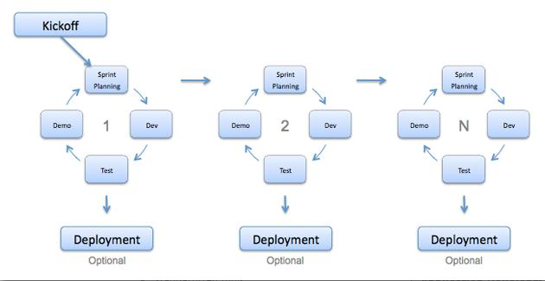

|  |  |
| --- | --- |
| **Advantage** | **Disadvantage** |
| * Customer satisfaction by rapid, continuous delivery of useful software. * People and interactions are emphasized rather than process and tools. Customers, developers and testers constantly interact with each other. * Working software is delivered frequently (weeks rather than months). * Face-to-face conversation is the best form of communication. * Close, daily cooperation between business people and developers. * Continuous attention to technical excellence and good design. * Regular adaptation to changing circumstances. * Even late changes in requirements are welcomed | * In case of some software deliverables, especially the large ones, it is difficult to assess the effort required at the beginning of the software development life cycle. * There is lack of emphasis on necessary designing and documentation. * The project can easily get taken off track if the customer representative is not clear what final outcome that they want. * Only senior programmers are capable of taking the kind of decisions required during the development process. Hence it has no place for newbie programmers, unless combined with experienced resources. |