HTML Validated Screenshot

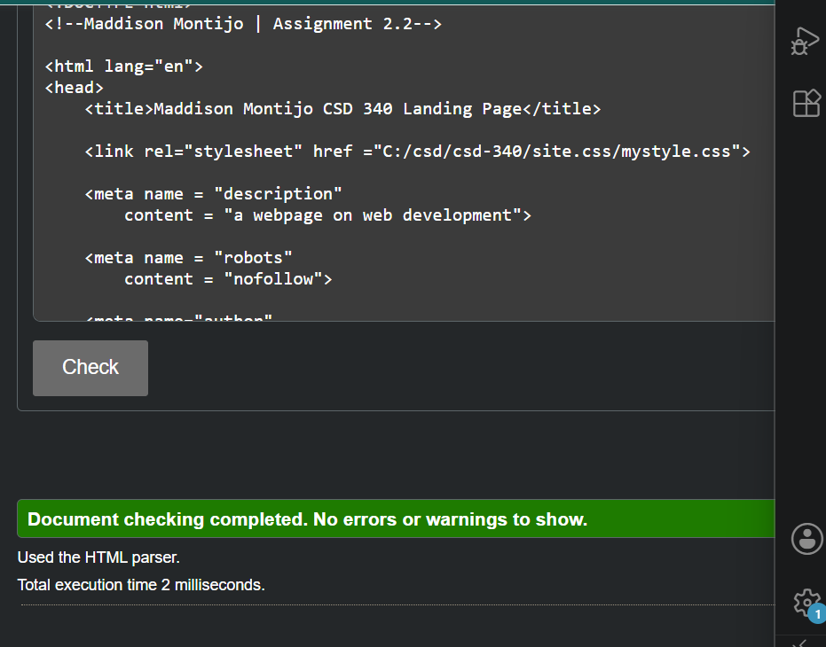
CSS Validated Screenshot

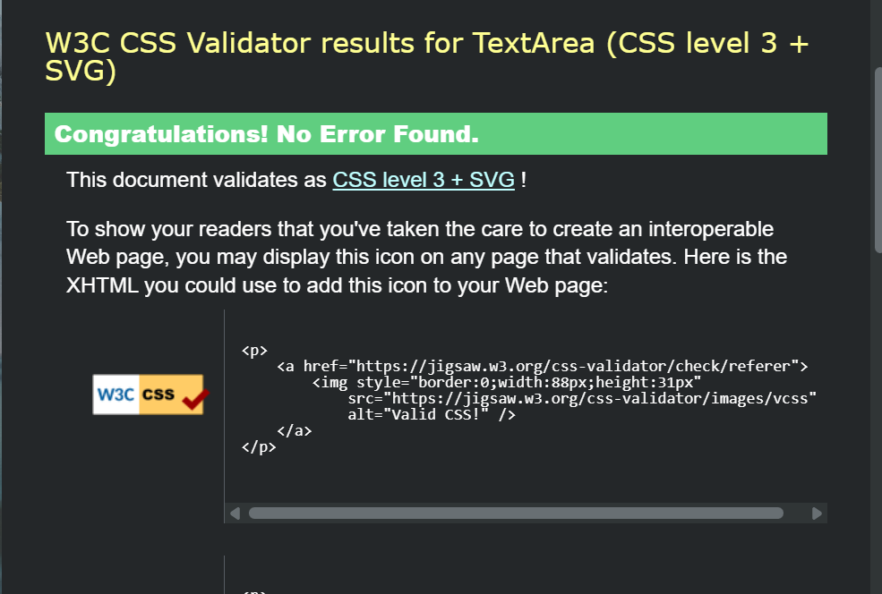
Webpage

Link to Github
https://github.com/333Artist/csd-340/blob/main/README.md

