Screenshots

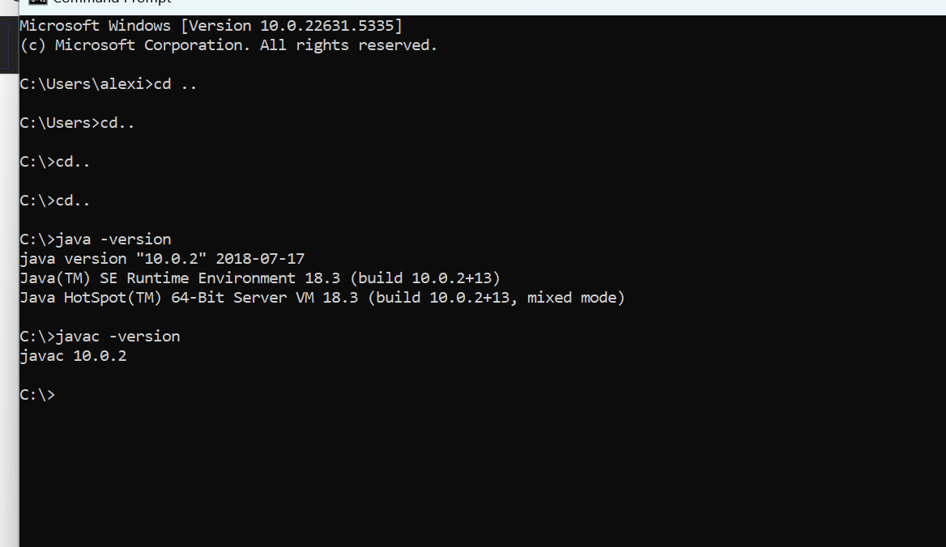

Link
333Artist/csd-402: Module 1.2 Assignment, Repo for Class Code.

