VaqPack

Database Package
(Architecture)

Team 01 (Team Black)
Elijah Lopez, Juan Delgado, Josue Rodriguez, Jose Morales, Michelle Garcia

Introduction:
The database package is intended to assist in the creation and management of databases and tables, the collection of user data (names, passwords) and the management of xml, pdf and html files. Since this package in itself does not utilize a GUI, the architecture for this package is designed around user cases/functionality and will presented and organized as such.

Package Functionality:
This package focuses on and enables the following functionality

- User Credentials (Registration)
- User Login (Verification)
- User Data
- Database Initialization

User Credentials (Registration )

Design Logic:

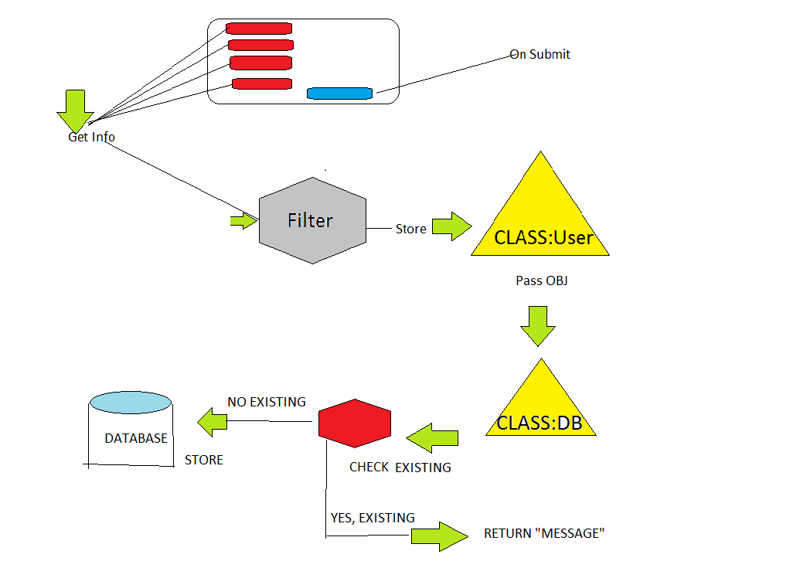

Class Architecture:

CLASS:: User
Variables:
- Name
- password (encrypted, return from CLASS::Utilities)
- Email
- POS
Constructors:
- default ()
- (name, password (encypted), Email, POS)

Functions:
- Getters/Setters

CLASS::DB::DB_Store
Variables:
- Host_name (inherited)
- password (inherited)
- user_login (inherited)
- database (inherited)
Constructors:
- default()

Functions:
- Register(OBJ::user)
//Check if user info exist on database, store if not exist, return message if yes exist

User Login (Verification)

Design Logic:
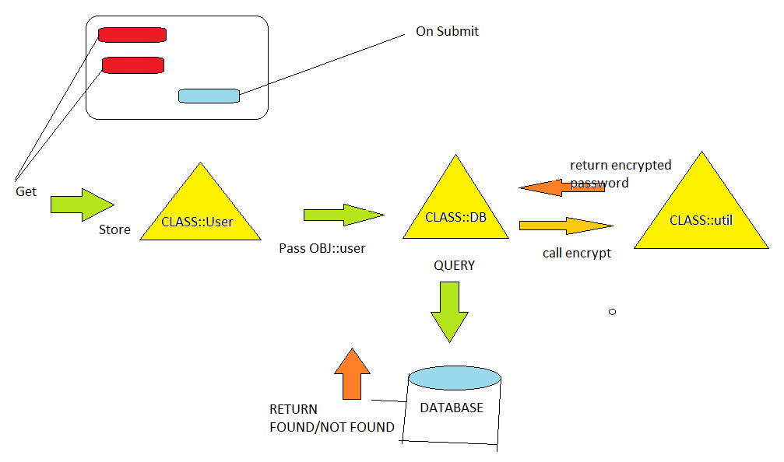

Class Architecture:

CLASS::User
Variables:
- userName
- password (encrypted, return from CLASS::util)
Constructors:
- User(password, username)
Functions:

CLASS::DB::DB_query
Variables:

- Host_name (inherited)
- password (inherited)
- user_login (inherited)
- database (inherited)

Constructor:

Functions:
login(OBJ::user)
//Request from database info of user, checks encrypted //password and return found or not found depending on match

CLASS::util
Variables:

- Cypher
- salt
- key

Constructor:

Functions:
encrypt(string password)
//encrypts a given string and returns

decrypt(takes a encrypted string and encrypts using a key)

User Data

Design Logic:
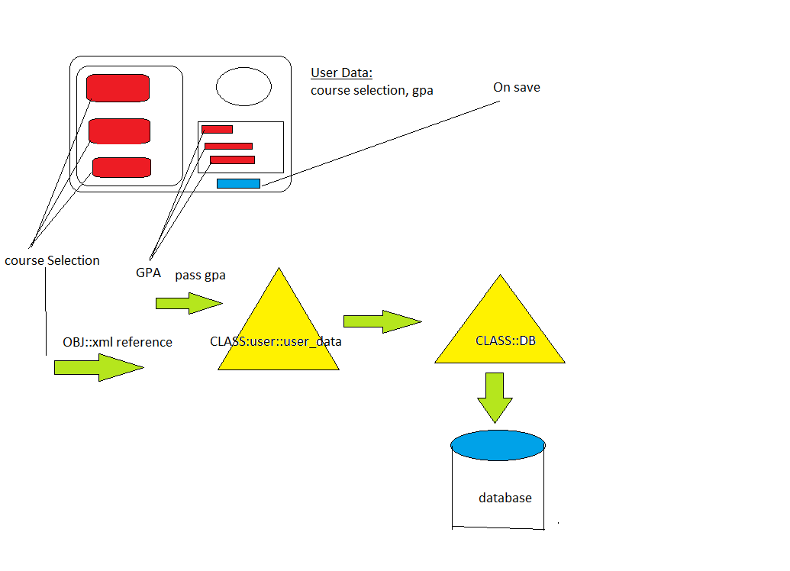
Class Architecture:

CLASS::user::user_Data
Variables:

Constructors:

Functions:
- prepareGPA()
- courseSelection()
CLASS::DB::DB_Store

Variables:

Constructors:

Functions:

Database Initialization
Design Logic:
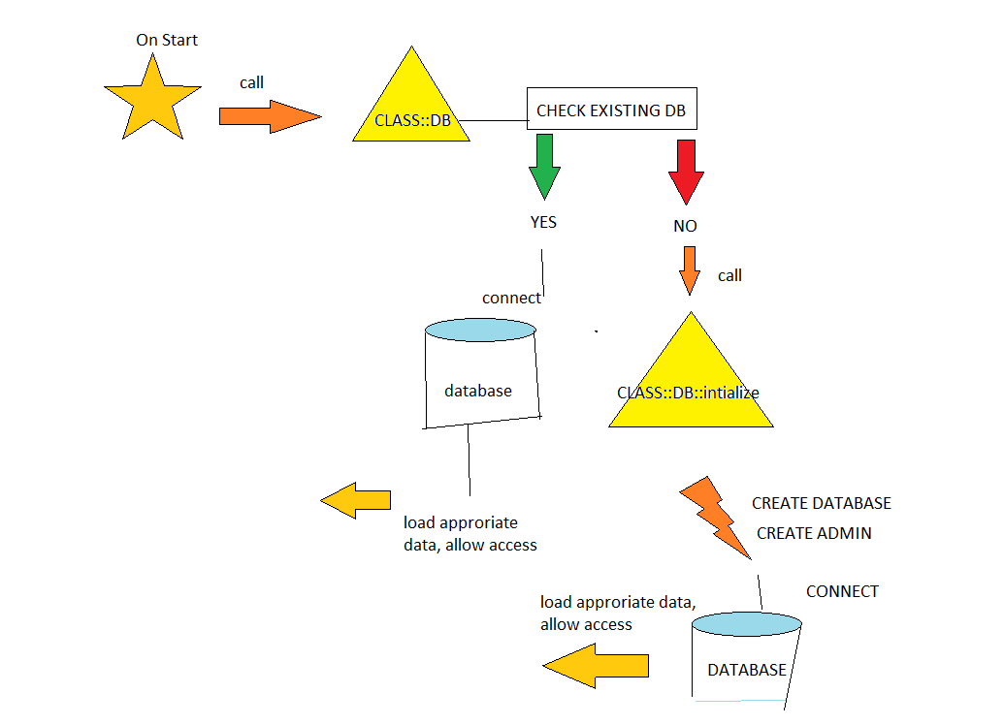
Class Architecture:

CLASS::DB
Variables:
- Host_name
- password
- user_login
- database
Constructors:
- default()

Functions:
- connect()
//attempts to connect to database on host, if exist. If not,
//calls init().
- Init()
//creates a database on the above listed host

