INF101TC Semester 2: Pre-Submission 1
Group Number: 12
Project Title: Mesh Supply Chain Intelligence System
Team Deliverable Support: Codex-assisted engineering implementation

Section 1: The Problem Definition
The business problem is the trust and traceability gap inside complex fresh-food supply chains, where multiple upstream tiers, cold-chain execution, and quality variation make incident response too slow. The system engineering challenge is to turn a fragmented supplier network into a tier-aware digital mesh that can trace batches, forecast demand, and simulate disruption recovery in near real time.

Section 2: Project Scope
This submission delivers a Python repository backed by MySQL and a PySide6 desktop front end. The current prototype models 79 organisations, 97 facilities, 200 active supply links, 154 upstream lots, 418 finished-goods batches, 746 shipments, and 35040 demand observations.
The semester scope includes L1/L2/L3 supplier visualisation, batch traceability, risk scoring, demand forecasting, and scenario-based recovery planning. The future scope is to connect live IoT telemetry, supplier portals, and recall workflows.

Section 3: Engineering Requirements
Functional requirements: The application must map the full network, display L1/L2/L3 suppliers, trace finished batches to upstream lots, show shipment and inspection history, forecast product demand, and simulate node disruption recovery.
Non-functional requirements: Core screens should respond within two seconds on local hardware, maintain consistent tier labelling, and support operational decisions with quantitative metrics such as risk score, fill-rate recovery, and reorder point.

Section 4: The Framework / Process
The team process used six engineering phases: requirement extraction from the original brief, supply-network domain modelling, MySQL schema design, synthetic dataset generation, analytics model training, and PySide6 interface validation. Instead of building a static mock-up, the system was developed as a working digital twin with seeded operational data.

Section 5: The Selected Approach
A Python code repository was selected because it allows direct integration between MySQL data engineering, machine learning analytics, simulation logic, and a deployable desktop interface. Compared with slideware or a purely conceptual design, this approach demonstrates executable engineering value and leaves a reusable platform for later expansion.

Section 6: Tools Justification
MySQL was selected for relational traceability and supplier-network storage, PySide6 for a rich desktop operations interface, and open-source Python analytics libraries for forecasting and risk modelling. This stack balances realism, maintainability, and speed of implementation while supporting future integration into enterprise systems.

Section 7: Progress on Semester Deliverables
Current dashboard snapshot: 73 supplier facilities, 200 active links, 418 product batches, 54.83% on-time rate, and 8 active alerts.
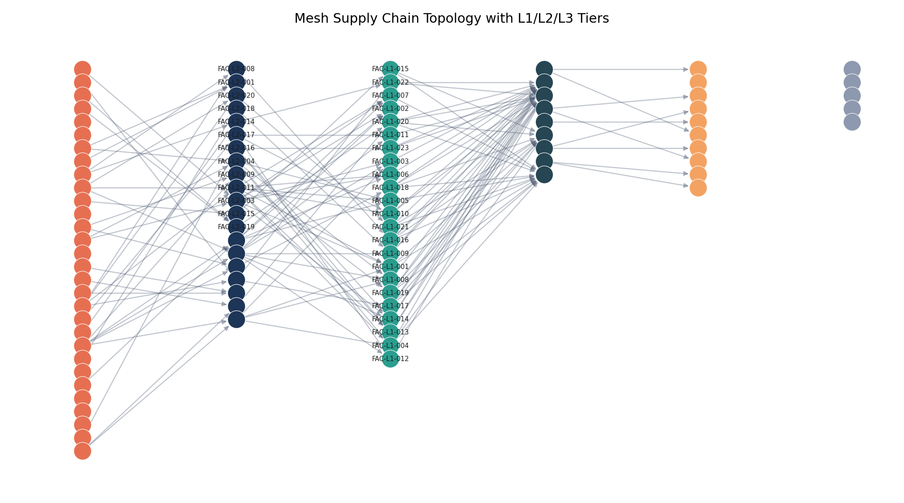
Caption: The network topology visualises the mesh structure and explicitly highlights L1, L2, and L3 supplier tiers connected to core plants and downstream fulfilment hubs.
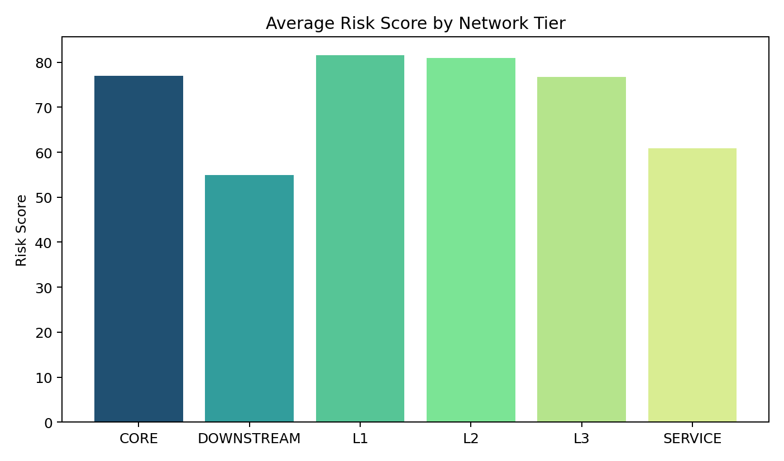
Caption: The risk distribution chart demonstrates that the system does not only store nodes, but also scores operational exposure by tier to support mitigation decisions.
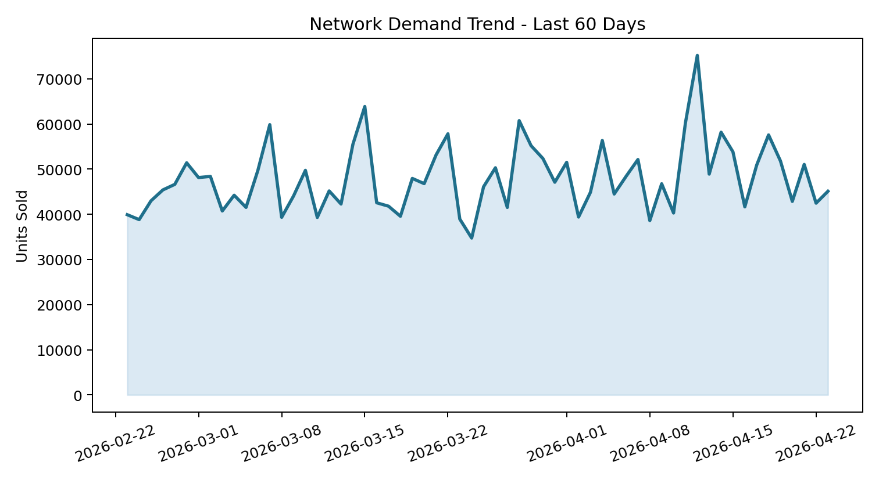
Caption: The demand trend figure demonstrates the forecasting dataset and provides evidence that the system tracks temporal network demand instead of static records only.

